Software requirements specification

This is a description of a software system to be developed. This specifies what is required by the system and specifies functional and non-functional requirements. Use cases can be used to describe how users interact with the system.

Requirements specification
This is an order of an IT system specifying the requested functions and properties.

Functional Dependency
These are requirements that describe how input is linked to output. For example, they can describe what happens when a button is pressed.

Non-functional Dependency
These are requirements that a software product must have certain characteristics. An example of this is that only registered users are allowed to use the system or that a web page is adapted for mobile users.

Useful diagrams for SRS
- Use-case
- Entity-relation
- Flowchart

Prototype
This is an incomplete version of a software system. Usually they only contain specific parts of the complete system.

Illustrate the different UML components that are useful in use case diagrams
There are four major components of a use case diagram that connect together to specify the use of a system.
Actor
An actor is a person, an external hardware or another system. These actors are the users of the system that interact with use cases. An actor can take on multiple roles, such as user and admin or teacher and parent. Actors are illustrated using stick figures that are named using nouns, as illustrated below:
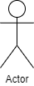
Use Case
A use case is used to basically represent all uses a user can use in a system. All actors must be linked to a use case, but all use cases must not be linked to an actor, which means use cases can be linked to each other using relationships. It is illustrated with an oval shape that usually contains a verb and noun, as depicted below:
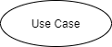
Communication link
To connect an actor and a use case, or use cases with each other a communication link is used. It can be just a simple link or a relationship such as include or extends. A communication link is just a simple line, as depicted below:
System boundary
And lastly we have the system boundary. The inside of this boundary contain use cases meanwhile the actors are placed outside of the boundaries. This boundary usually contains the whole system. A system boundary is illustrated using a rectangle and the name of the system, as depicted below:
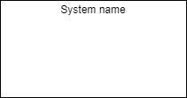
Complete example
So if you combine all of these components together with a made up scenario it could look like this:
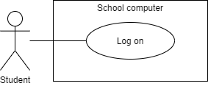

Describe how a well-made use case diagram is composed. Give examples from your project
A well made use case diagrams is not overly complicated, so it should not be very in-depth for each part of the system. Meaning it should not have too many use cases, cause if there are too many it will be hard to read and it defeats the purpose of a use case diagram. And it should follow a good naming convention and good verbs and descriptions for the use cases. It does not number or in any way show the order that the use cases are used. It is only supposed to represent the functional requirements of a system. [2]

Here we see a login example for the Admin as a part of the system that helps run the business at Antons Skafferi. This show the include relationship between two use cases, where you need to verify your password to login. It just displays a simple scenario with two use cases how a log in works. It does not have extra use cases for storage of data, verification of all other information or other surrounding elements that does not belong here.
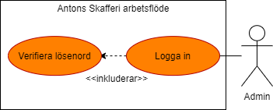

Another example here is where multiple actors are connected to the same use case. They all have different roles, but can interact with the same use case. It display in a simple way that the work schedule can be administered by waiters, kitchen staff and admin. It does not include extra steps or how in detail each person interacts with it.
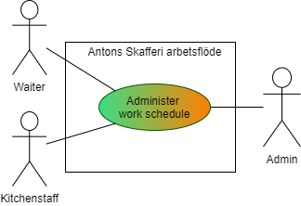

List the activities that Unified Process contains. Describe in detail how they were implemented in your project
Unified Process contains four phases:
- Inception
It was implemented quickly at the beginning of the project by developing an approximate vision of the system and defining the scope and objectives.
- Elaboration (milestone)
In this stage, we captured most of the system requirements through meetings with our client. Then we established and elaborated system architecture for all parts of the project - app, web and database, by creating Use case diagrams.
- Construction (release)
During this large phase of the project we implemented all system features needed and presented regularly parts of the product to the client. UML diagrams were created to visualize all parts of the system.
- Transition (final production release)
This phase aims to deliver the final product and deployed it to the client. it also includes presenting it and writing a report.

Describe what distinguishes Agile development. Describe in detail how you apply agile development
Agile development is based on iterative development, where requirements and solutions are developed through collaboration between self-organizing cross-functional teams and adapted to customer needs. It usually promotes disciplined project management, continual improvement, teamwork, self-organization and dividing responsibilities. The Agile development enables teams to make part deliveries of functional product faster, with higher quality and greater opportunity to respond to changes. Scrum and Kanban are two of the most widely used Agile methods.
The project has been developed by applying the SCRUM method. We have divided the work into six sprints and each sprint has generally been one to two weeks long. We have started each sprint with a meeting with planning and prioritization of what to do in that sprint. Each sprint has been completed with a retrospective meeting to evaluate the work. The group meets 3-4 times a week. Each day has started with a Scrum meeting on planning and prioritizing today's tasks. Regular meetings with both the client and the teacher were held weekly during the project. Scrum tables in Trello were created for each Web, App and Database part of the project, which contain backlogs with user stories and requirements.

Single responsibility principle
This principle means that a software module that fulfills a certain function only can be changed for one and only one reason. An example of such a module may have the function of reporting payroll data to a database. For such a module functionality may be needed to calculate the salary amount depending on the hours worked. If it then happens that the algorithm for calculating payroll is changed, the reporting module must not be changed.

Open closed principle
The Open-closed principle is a desired attribute in object-oriented programming where we want the source code to be open for extension, but closed for modification. Its implementation is often seen when we’re dealing with polymorphism, where an object extends features of a previously defined object without changing that objects source code.

Substitution principle (Liskov substitution principle)
The substitution principle (Liskov substitution principle) is the principle, that Barbara Liskov defines in 1987 in her conference keynote named “Data abstraction and hierarchy”. The principle states that:
- Objects in a program should be replaceable with instances of their subtypes without altering the correctness of that program.
That requires the objects of the subclasses to behave in the same way as the objects of the superclass.
- You should be able replace any instances of a parent class with an instance of one of its children without creating any unexpected behaviours.

Sources:
Open-closed links:
Wikipedia [Internet]. St. Petersburg (FL): Wikimedia Foundation, Inc; 2001 - .
Open-closed principle; [revised 2019 Jan 18; cited 2020 Feb 13]. Available from: https://en.wikipedia.org/wiki/Open–closed_principle

Use-case Diagrams [2]:
Visual Paradigm [Internet]. What is Use Case Diagram?
https://www.visual-paradigm.com/guide/uml-unified-modeling-language/what-is-use-case-diagram/ (Retrieved: 2020 Feb 23)

