Android construction

Specification.
The main purpose of this specification is to show the Android projects purpose and content. Antons Skafferi ordered a digital order application and a new website. The website requirements was to develop one frontend to handle the public information and one admin backend to handle other internal information. The application was primary for staff only (waiters and chefs). This application uses the same database as the website but has other features to be able to handle orders and make table reservations.
Android
- Show all all food and drink items
- Show available tables
- Show all orders for kitchen
- Make table reservations
- Remove table reservations
- Add menu orders to a orderlist
- Post menu orders
- Delete orders
- Modify orders
- All menu items should be dynamically updated with a database connection
- All table reservations should be dynamically updated with a database connection

User-interface
The Interface for the application is made to be as simple and effective as possible Each view is designed to fit the specific needs for that section and to only show the correspondent needed UI-components. Every graphical component except for bitmap backgrounds are vector shapes in xml which gives the best visual quality possible and can easily adapt to different screen resolutions. Design templates were also used to keep the interface design consistent and easy to maintain.
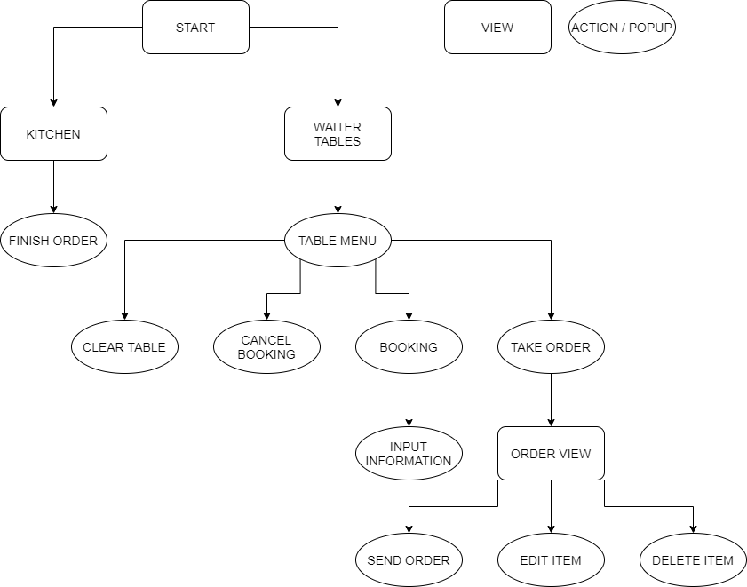Figure 1: Flow-chart over all application views and actions

Start view
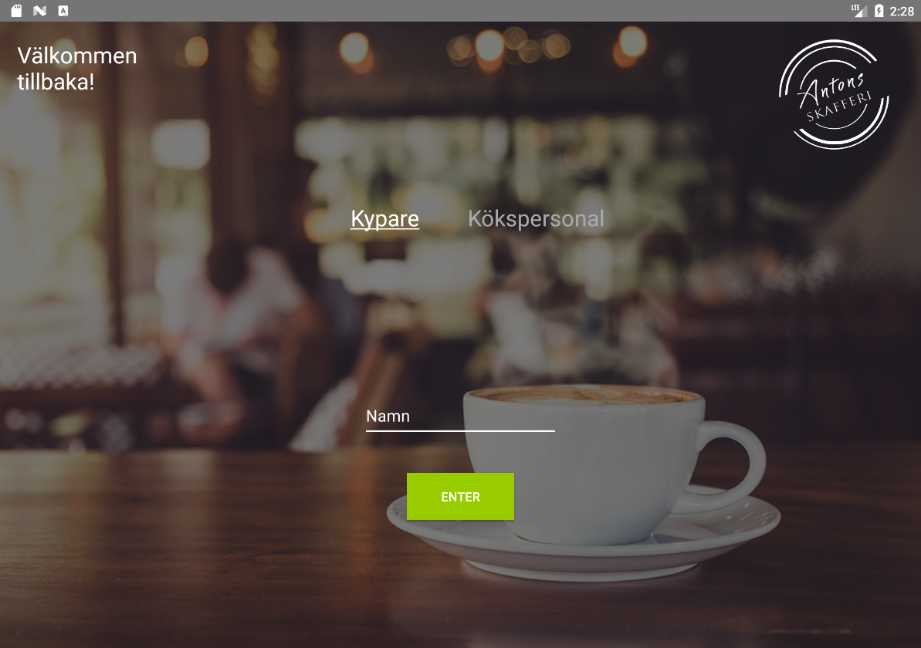Figure 2: Android start view
The startpage has two options: waiter or kitchen area. The design is simple and functional and also includes one input for staff names to be used in the applications order system.
Waiter tables view
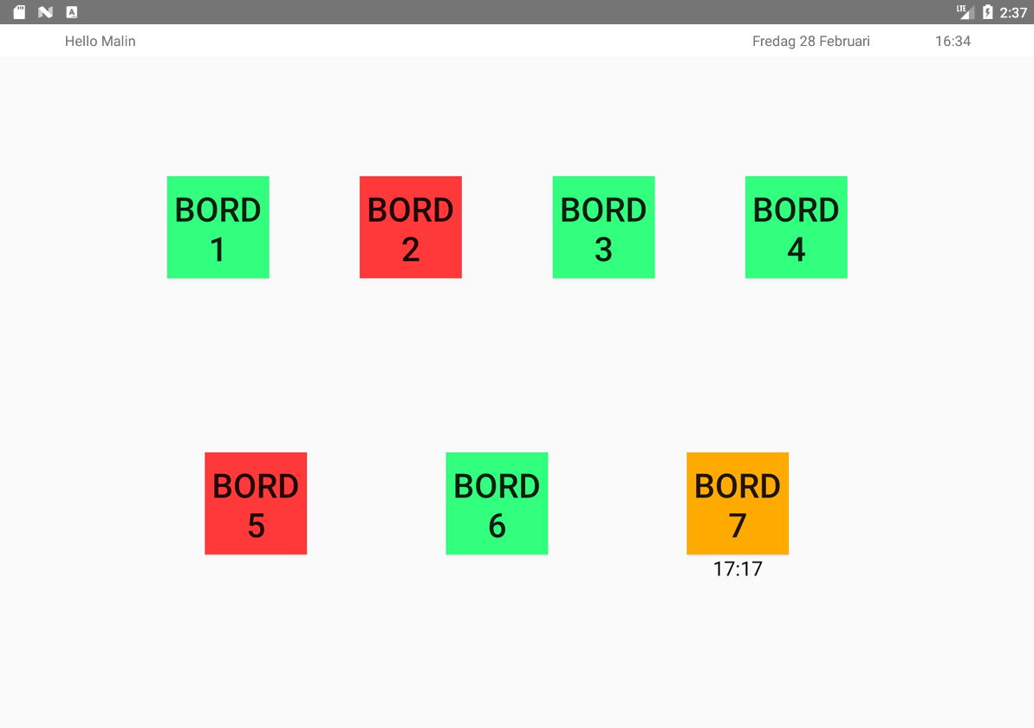Figure 3: Android waiter tables view
The core idea for the waiter tables is to visually get an overview of free tables and booked tables as this will aid the waiters in their daily work. A booked table is indicated by a time and a yellow colour. A full table is indicated by a red colour. It is also possible to modify and make table reservations in this area. The selected table also gives the option to take orders which navigates to the table menu page.

Table menu view
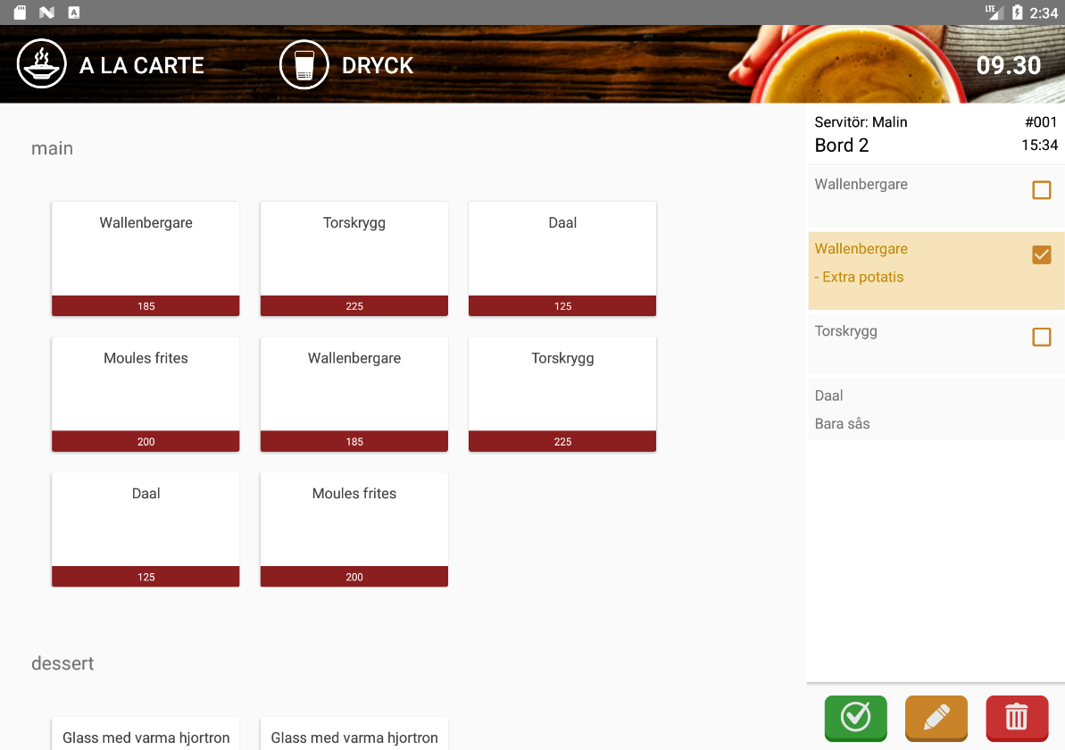Figure 4: Android table menu view
The table menu is divided into three main sections; header which has two categories to choose from and a menu list that shows selected category items and lastly a orderlist to the right. The main purpose is to present an easy manageable order system that utilizes a clear and understandable design by for example using colored icons with symbols instead of text. Some subtle animation is also used when an order is added to the list to enhance visual feedback to the user.
Kitchen view
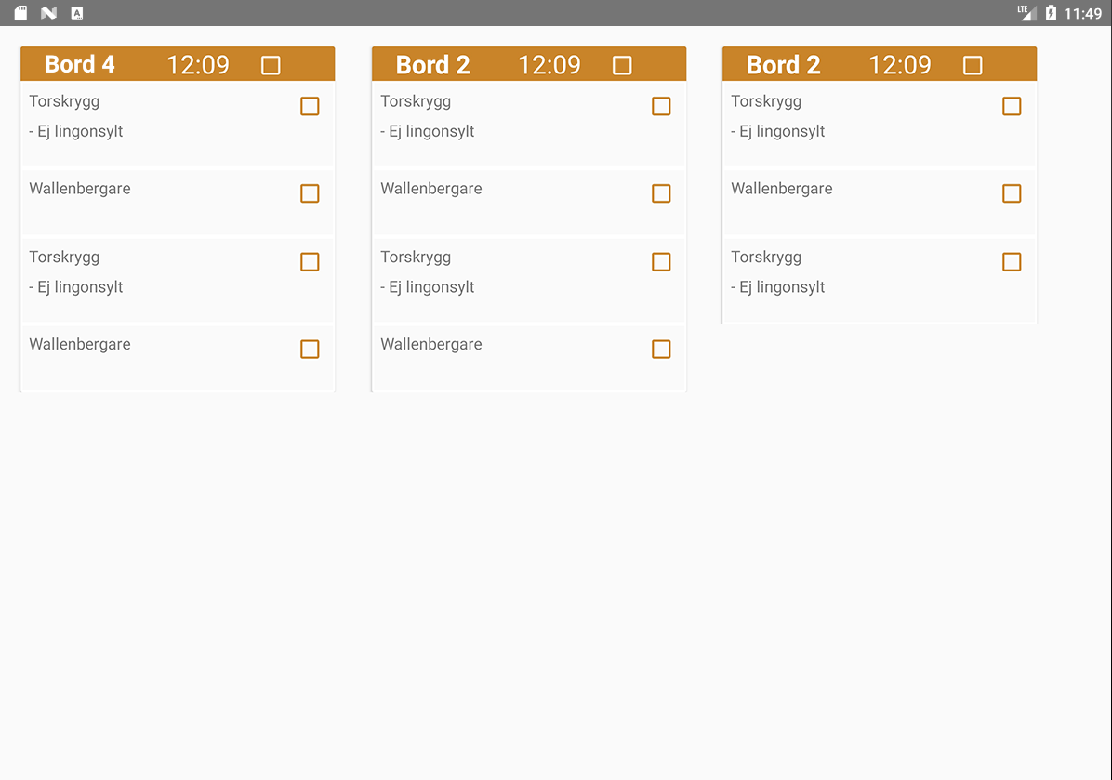Figure 5: Android kitchen view
Every order is displayed like an ordinary bonglist. With a simple and effective design the kitchen staff can keep an eye on all incoming orders.

Software documentation
Our software is divided into three parts. First of all, we have the website which consists of two parts; one public-facing and one internal admin part. Then we have the Android application which consists of two main features; handling orders for serving staff and display bong orders for kitchen staff.
Web
The public-facing web allows potential guests to view today’s lunch and the full à la carte menu as well as upcoming events. Here is also where the restaurant’s contact information can be found.
The admin part, on the other hand, offers several different options. The restaurant’s administrator can manage the different food and drink offerings, upcoming events (including uploading an event image), the current employees and their schedule as well as reserve tables for guests.
All this is saved in the central database and parts (namely the menu items and the reservations) are also used by the Android app.
Android
The Android app also has two parts, one to be used by the serving staff and another to be used by the kitchen staff.
The part used by the serving staff (henceforth known as the waiter view) is designed to be used on tablets by the waiters. They are (after logging in) presented by a stylized map of the restaurant’s tables which are all colour-coded depending on their status. A green table means that it is neither booked nor occupied while an orange table means there is an upcoming reservation the same day. Thus, depending on the time left before the reservation, these tables may be used to seat guests. A red table, on the other hand, means that it is currently occupied.
Both orange and red tables may have a timestamp beneath them that indicates the time of the nearest reservation.
Tapping on the desired table gives the waiter four choices. You can reserve a table, clear a reservation, take an order or clear a table (removes any still open reservations).
When taking a reservation there is an option to add a name and a required field to enter a phone number (to be used as a reservation number).
When taking an order the app switches to a new design where on the left you get a card view showing everything on the menu. Tapping on these adds them to the order slip on the right (where they can be deleted or modified as needed). There is also an option to switch between food and drink at the top.
Finally we have the kitchen view. This is meant to be permanently opened on a tablet visible in the kitchen. This is continually updated and pulls new orders as soon as they are created (actually with a slight delay but more on that in upcoming chapters). This allows the chef to get a quick and easy view of what each table has ordered.
This is also presented in a card view where you can check each item on an order to mark it as done. When the header of the order is marked as done that entire order card is permanently hidden from the kitchen view.

Prototype
I guess Mockups go here???

Implementation
Android
We began the construction of the Android application by making rough sketches of how employees will interact with the application depending on their occupation. These sketches included user navigation, essential features, and use-cases. The kitchen staff will interact with the application primarily via the kitchen view. The waiter staff is interacting with the application primarily via the table overview and order view.
This subchapter shows a brief overview of the most important functions that the application uses.

Welcome screen
The welcome screen is an Activity that presents the user with a choice, where the user can either click the “kypare” button or the “kökspersonal” button. Clicking the “kökspersonal” button directly navigates the user to the kitchen view. If the user chooses “kypare” instead, a text field will appear and the user can enter their name and click the “enter” button to navigate to the table view. When the user clicks the “enter” button, depending on the user’s choice it will either launch a new Activity for the table view or a new Activity for the kitchen view.
Kitchen View
The kitchen view is an Activity that serves to show all active orders that have not yet been finished. When the kitchen Activity is created a timer is started, the purpose of which is to, at an interval of 5 seconds, get orders from the database. The way that orders are fetched in the app is by getting all order rows and, from the order ID attribute in each order row, create complete orders. To keep track of orders that have already been fetched previously a HashMap belonging to a shared view model is used. To create the new orders that haven’t already been built a separate HashMap is filled where the key is order ID and the value is an ArrayList of order rows. When this HashMap is filled a check is made to make sure that only order rows containing food, and not drinks, are added.
To build the orders a method is called where the HashMap containing the new orders are iterated over. For each order in the HashMap, a new container representing a kitchen bong is created. This container is added to the kitchen view and also put in the HashMap belonging to the shared view model to mark the current order as already built.
Table view
The table view inherits from the Fragment class. This allows us to use a NavGraph and auto-generated navigation code. The table view displays seven table buttons that are continuously updated by a timer which makes requests to the database for all reservations on each tick. This allows all waiter staff to have a synchronized state and view of the current status of all tables, orders and reservations.
All tables are colour-coded which represents their current status according to a priority list. If a table is both occupied and has a reservation today, it’s red; if a table is only occupied, it’s red; if a table only has a reservation for today, it’s orange, and if a table is vacant for today, it’s green. A table can only have one reservation a day. If a table has a reservation, then the reservation time is displayed underneath the table button. Pressing a table button will open the table popup.
Table popup
The table dialogue is a DialogFragment. The dialogue appears when a user clicks on a table in the table view where a text field shows the user information about the table’s status, such as if the table is booked today and also who booked it and their phone number. This is done by fetching the reservations from the database and updating the UI with all reservations that exist for today. Underneath the text field there exist four buttons. These four are labelled: “rensa bord”, “avboka, “boka” and “ta en order”, and the first two buttons are greyed out by default.
The button labelled “rensa bord” will only be available if there exists an order for the table that the user has selected. When the user clicks the button labelled “rensa bord” an AlertDialog will appear to make sure the user actually intends to clear the table. If the user presses “yes”, then the database will be called telling it to delete all orders and corresponding order rows related to that table.
Similarly, the button labelled “avboka” will only be available if there already exists a reservation for the table on the current date. If the user presses the button labelled “avboka”, a call will be made to the database informing it that today's reservation for this table should be removed. By clicking the button labelled “boka”, a new AlertDialog is created. This dialogue window will be described below. If the user chooses to click the button labelled “ta en order” they will be directed to the order view via the navigation graph.
Booking popup
The dialogue where bookings are handled is an AlertDialog. The window appears when a user selects the button labelled “boka” from the table dialogue window. The user is then shown two text fields, one for the name, and the other for the phone number. The phone number is required because it’s used as a unique identifier. Then come two buttons, one for the date and one for the time. When the date button is clicked a DatePickerDialog window is launched. A calendar is displayed inside the new dialogue window allowing the user to select a date from a grid-like view. Once the user has selected a date the application asks the database if this date already has a reservation on it. If it does, the user will receive an error message. If not, the date is selected for a pending booking. Then the user chooses a time for which the customer is expected to arrive at. The time and date are then formatted into a string that the database will understand. If all went well, then the application sends the reservation to the database where it will update its reservation table.
Order view
The order view is a Fragment that is used for taking orders. It consists of three parts, a navigation bar that lets the user choose between showing food menu items and drink menu items, a container that shows available menu items of the chosen category and sidebar that shows what menu items have been chosen.
The navigation bar shows two buttons that, when clicked, initiates the fetching of menu items from the database. The type of item that is received corresponds to whether the user chose to click on “food” or “drink”.
The menu items in the application are represented by CardViews that show the menu item’s name and price. The CardViews are put in FlexBoxes that are separated into the categories “starter”, “main” and “dessert”. A listener is added to each CardView to handle user interaction with the menu items.
When the order view is started, if there exist any previous orders belonging to the chosen tables current session, these are retrieved from the database and shown in the sidebar. The user can’t interact with these order rows, they are there to show what the customers sitting at the table have ordered previously. To exemplify, if the user enters the order view to take an order for dessert, the sidebar will show what main courses the customers had ordered. New rows will be added to the sidebar as the user clicks on menu items. These rows have checkboxes that let the user choose what row to interact with.
At the foot of the sidebar, there are three buttons that let the user edit a row, remove a row and send the order to the database. If the user has marked an order row as checked and clicks on the edit button a popup is shown that lets the user make changes to a menu item. If the user has marked one or more order rows and clicks on the remove button, these items are removed from the sidebar. If the user clicks on the send button, a new order is created in the database and the order rows are posted with their order ID belonging to this order.

