STM32 Complete Professional Reference
Definitive Technical Textbook and Practical Training Manual
From STM32CubeIDE 2.2.0 and STM32CubeMX 6.18.1 configuration to deterministic real-time data acquisition: HAL, interrupts, DMA, timers, UART/SPI/I²C, ADC, reusable sensor drivers, digital filtering and FreeRTOS.

Document Information
Table 0.1 — Document information and baseline
Attribute | Specification | Scope and notes
Title | STM32 Complete Professional Reference | Consolidated university-level textbook and field manual
Version | 5.0 (consolidated master edition) | Supersedes the seven source documents listed in Appendix A
Toolchain baseline | STM32CubeIDE 2.2.0, STM32CubeMX 6.18.1, GNU Arm Embedded toolchain (arm-none-eabi-gcc) | Menu names may differ slightly between tool releases; see Appendix B
Primary hardware | STM32F103C8T6 (Cortex-M3, 72 MHz max) | All worked numbers use this part unless stated otherwise
Secondary hardware | STM32F4 (Cortex-M4F), notes for G0/G4/L4/H7/U5 | Differences are called out explicitly
Audience | Embedded and robotics students, instructors, junior firmware engineers | Self-study or a 90-minute, 2.5-hour or 6-hour workshop
Method | Problem → concept → decision → CubeMX → code → verify → debug | Every topic follows this loop (Section 1.3)
[!IMPORTANT] Every listing is a pattern, not a drop-in. STM32 is a family of families. Pin mappings, clock trees, DMA request routing, ADC trigger sources, HAL function availability and register names differ between parts. Before wiring hardware or trusting a calculation, open the datasheet and reference manual for your exact part number. Items that must be checked on your device are marked Verify and collected in Appendix B.

1. Introduction, Learning Objectives and the System View

1.1 What an STM32 Really Is
An STM32 is a system on chip (SoC), not just a CPU. Inside one package you find:
- an ARM Cortex-M processor core (with NVIC interrupt controller and SysTick timer),
- on-chip Flash (program and constants) and SRAM (variables, stacks, buffers),
- a bus matrix that connects bus masters (CPU, DMA) to memories and peripherals,
- a clock system (oscillators, PLL, prescalers) that feeds every block,
- peripherals: GPIO, timers, ADC/DAC, UART/USART, SPI, I²C, CAN, USB and more,
- a debug port (SWD/JTAG) used by ST-LINK or J-Link.
Firmware is the code that configures these blocks and moves data between them. Almost every embedded problem is one of three problems: configuring hardware correctly, moving data without losing it, or meeting a deadline.
Table 1.1 — STM32 families and cores (selected)
Core | Example families | Characteristics
Cortex-M0 / M0+ | STM32C0, G0, L0, F0 | Low cost, low power, small footprint
Cortex-M3 | STM32F1, F2, L1 | Deterministic, no FPU; F103 is the classic 72 MHz part
Cortex-M4F | STM32F3, F4, G4, L4 | Hardware FPU and DSP instructions
Cortex-M7 | STM32F7, H7 | L1 caches, dual-issue pipeline, up to hundreds of MHz
Cortex-M33 | STM32U5, H5, L5 | TrustZone security, FPU/DSP
Reading a part number (example STM32F103C8T6): F1 = family and core generation, 03 = line/feature set, C = 48 pins, 8 = 64 KB Flash, T = LQFP package, 6 = −40 to 85 °C. Always confirm the exact variant on the chip marking and in the datasheet; Flash and SRAM sizes drive linker scripts.

1.2 Learning Objectives
After studying this reference you should be able to:
- Use the toolchain: create, configure, generate, build, flash and debug an STM32 project in CubeMX/CubeIDE, and keep your own code safe across regenerations.
- Explain HAL, LL and register access and choose the right level for a task.
- Choose between polling, interrupts and DMA using CPU load, latency and data-rate arguments, and implement each.
- Configure timers (periodic events, PWM, input capture, output compare, ADC triggering) and compute PSC/ARR/CCR values.
- Implement and select UART, SPI and I²C, including framing, modes, addressing, pull-up sizing and recovery.
- Acquire analog and digital sensor data in real time: ADC equations, sampling time, buffers, filtering and data integrity.
- Write reusable sensor drivers with clean APIs, error handling and hardware abstraction.
- Decide when an RTOS is justified and use FreeRTOS tasks, queues, semaphores and mutexes correctly alongside interrupts.
- Debug systematically from power and clocks up to application policy, including HardFault analysis.

1.3 How to Use This Reference

1.3.1 The seven-step engineering loop
The central teaching idea of the session is that learners need technical judgment, not a vocabulary list. A representative student remark (Arabic, from the session overview) captures it: the goal is not to explain DMA and ADC from scratch, but to know when to think about DMA and when plain ADC reads are enough. Every topic therefore follows the same loop:
- Define the hardware problem: what physical signal exists, what must firmware produce, how often, and what happens on failure.
- Understand the mechanism: why the hardware block exists and which bottleneck it removes.
- Apply decision criteria: polling vs. interrupt vs. DMA, UART vs. SPI vs. I²C, superloop vs. RTOS.
- Consult the datasheet and reference manual, then configure in CubeMX.
- Implement modular C that checks every status, respects buffer ownership and never blocks critical paths.
- Verify with instruments: oscilloscope, logic analyzer, multimeter or a diagnostic GPIO. A calculation without a measurement is a hypothesis.
- Anticipate failure modes: configuration traps, electrical faults, race conditions, bus lockups.

1.3.2 Suggested delivery schedules
Table 1.2 — Six-hour evening workshop plan
Time | Block | Minutes | Key topics
18:00–18:30 | Arrival and toolchain check | 30 | CubeIDE, CubeMX, MCU packages, ST-LINK drivers, hardware
18:30–19:10 | Part 1: workflow and architecture | 40 | .ioc, clock tree, GPIO limits, code generation, HAL vs. LL vs. registers
19:10–20:00 | Part 2: interrupts, DMA, timers | 50 | Polling vs. IRQ vs. DMA, NVIC, timer math, TRGO → ADC → DMA
20:00–20:30 | Prayer and rest break | 30 | Adjust to local prayer times; informal Q&A
20:30–21:10 | Part 3: UART, SPI, I²C | 40 | Framing, baud math, SPI modes, I²C pull-ups, protocol selection
21:10–21:45 | Part 4: sensors, ADC, DSP | 35 | ADC equations, source impedance, MPU6050, throughput, filters
21:45–22:20 | Part 5: reusable drivers | 35 | Layered architecture, dependency injection, status codes
22:20–22:45 | Part 6: FreeRTOS | 25 | Superloop vs. RTOS, tasks, queues, semaphores, mutexes, ISR rules
22:45–23:15 | Part 7: integrated capstone | 30 | Multi-sensor monitoring system
23:15–00:00 | Debugging, labs, buffer | 45 | Live troubleshooting, logic analyzer, HardFault, Q&A
Table 1.3 — Condensed schedules
Module | 2.5-hour session | 90-minute session
CubeIDE, CubeMX, .ioc | 15 min (workflow, USER CODE preservation) | 10 min (essential .ioc, clocks, codegen)
Timers, interrupts, DMA | 30 min (selection criteria, timer + ADC + DMA) | 25 min (polling vs. IRQ vs. DMA, timer math)
Communication protocols | 20 min (trade-offs, scenarios) | 15 min (decision matrix, pitfalls)
Sensors and acquisition | 25 min (ADC math, sampling, buffering) | 15 min (scaling, source impedance, ping-pong)
Reusable drivers | 25 min (architecture, C pattern) | 15 min (header/source API)
DSP and FreeRTOS | 25 min (10 min filters + 15 min RTOS) | 10 min (overview)
Integrated system and Q&A | 10 min | Included in wrap-up
[!NOTE] Instructor rule. Do not spend the session explaining every feature of every peripheral. Spend it explaining how to choose the right feature for a real engineering problem. End by giving the class a realistic requirement and asking them to design the STM32 architecture and justify each choice.

1.4 The System as a Ten-Layer Chain
Firmware does not “talk to a sensor” in one step. It configures analog and digital silicon so that a physical quantity becomes a conditioned electrical signal, then a code in a peripheral register, then a word in SRAM, then a validated value in SI units, and finally an actuation command or telemetry packet. If you cannot sketch this chain on paper, you cannot debug it systematically.
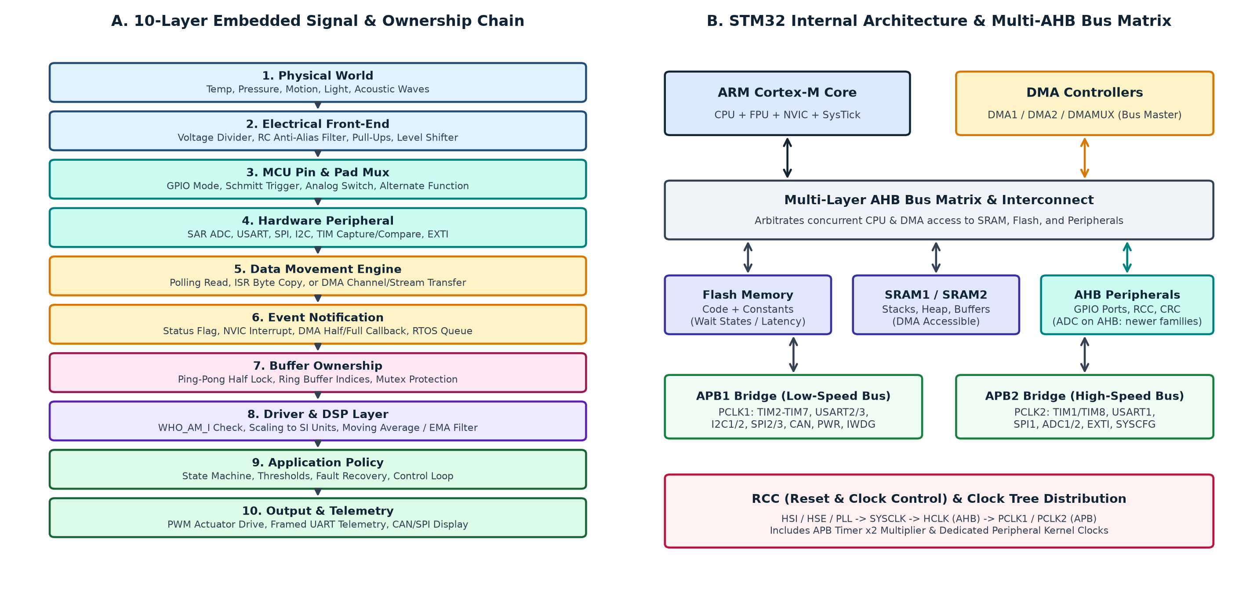
Figure 1.1 — Ten-layer signal and ownership chain, and STM32 internal bus matrix
Figure 1.1 — (A) Ten-layer physical-to-application chain; (B) STM32 internal multi-layer AHB bus matrix and clock distribution.
Table 1.4 — The ten layers, their questions and typical failures
Layer | Core engineering question | Failure if ignored | Concrete STM32 example
1. Physical world | What quantity, range and bandwidth? | Sensor saturates; vibration aliases | NTC over 0–100 °C; 1 kHz motor-current ripple
2. Electrical network | What impedance, voltage range, filtering, grounding? | ADC sample capacitor never settles; 5 V damages a 3.3 V pin | 100 kΩ divider without buffer; missing I²C pull-ups
3. Pin and pad mux | Which pin, mode and alternate function? | Schmitt trigger loads an analog signal; peripheral not connected | ADC pin left in digital input mode instead of GPIO_MODE_ANALOG
4. Peripheral engine | Which block converts or shifts the signal, at what clock? | Wrong baud, SPI phase or ADC clock | ADC channel 5 configured, sensor wired to channel 4
5. Data movement | Polling, ISR copy or DMA? | CPU misses deadlines; DMA writes the wrong width | 32-bit DMA words into a 16-bit array corrupt adjacent RAM
6. Event notification | When is data valid and how is software told? | Callback never fires because the IRQ is disabled | DMA half-transfer (HT) and transfer-complete (TC) interrupts
7. Buffer ownership | Which context owns the region until when? | Torn reads; circular DMA overwrites live data | Main loop reads adc_buf[] while DMA wraps
8. Driver and DSP | How are raw codes validated, scaled, filtered? | Stale data after a NACK; raw 2048 treated as 20.48 °C | WHO_AM_I check, two’s-complement decode, EMA filter
9. Application policy | What states, thresholds and recovery? | System hangs when a sensor is unplugged | Hysteresis alarm with bounded retries
10. Output / telemetry | How is the result delivered; can the link keep up? | Blocking UART print in a 10 kHz ISR destroys timing | Framed CSV (seq,t_ms,temp_c,flags) via non-blocking DMA
[!WARNING] Data ownership is a first-class design item. Ownership defines which execution context (main loop, ISR, DMA controller, RTOS task) may read or write a buffer at any instant. A volatile ready flag is not a lock: it neither freezes a circular DMA controller nor makes multi-byte reads atomic. Use ping-pong buffers, single-writer/single-reader ring buffers, or RTOS queues and mutexes.

1.5 Conventions Used in This Reference
- Reference part: STM32F103C8T6 at 72 MHz (HSE 8 MHz crystal, PLL ×9). Numbers for other families are labeled.
- Code style: C99, STM32 HAL naming, static for file-local state, volatile only for ISR-shared flags, explicit return-status checks. Generated CubeMX names (hadc1, htim3, huart2, hi2c1, hspi1) are assumed; adapt them to your project.
- Callouts: Key concept, Engineering note, Practical tip, Warning, Common mistake / danger.
- Units: frequencies in Hz, times in seconds (µs, ms, ns), voltages in volts, data rates in bytes per second unless stated.
- Verification policy: statements about silicon that differ across families are flagged, never silently generalized.

