Task 3

Objectives:
- Learn how to use TIMERS, UltraSonic in HAL level
- Suggested Course: Ahmed Eldeeb –
- STM website stm32mcu
- Reference Manual Link : Book
- UltraSonic DataSheet : US
- Don’t forget the YouTube tutorials

Deliverables:
- Read the distance from the Ultrasonic and then display it on LCD

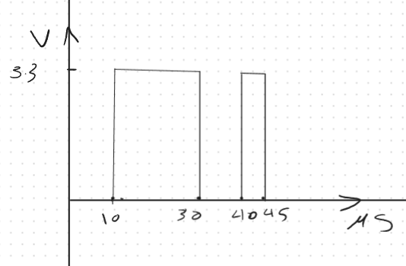
- Produce this signal periodically on any pin and inspect it using O-scope.

- Perform the Prev task without writing any line inside the super Loop.

Notes:
- All tasks must be implemented in Proteus and Submitted in a .rar file contains the code project and simulation on Proteus.
- Write the whole functions related to Ultrasonic in an external files .h/.c to enhance the readability, also use DOXIGEN doc.
- If I can’t understand your code it is you fault.

