Antony Roshan

**ANGULAR**

**EVENT HANDLING**

**app.component.html**

<!-- Event Handling -->

<h2 style="text-align: center;">Event Handling</h2>

<h2 style="text-align: center;">Hey Friends {{str}}<h2>

<button (click) = "FunctionCalling()">Good Morning</button>

<button (click) = "FunctionCalling1()">Good Afternoon</button>

<div style="text-align: center; line-height: normal;">

<h2>Count = {{count}}</h2>

<h3>Count number is {{OddOrEven}}</h3>

<button (click) = "Increment()">Increment</button>

<button (click) = "Decrement()">Decrement</button>

</div>

**app.component.ts**

import { Component } from '@angular/core';

@Component({

selector: 'app-root',

templateUrl: './app.component.html',

styleUrls: ['./app.component.css']

})

export class AppComponent {

public title1= 'Angular Training';

str = " ";

FunctionCalling(){

console.log("Hey button clicked")

this.str = "Good Morning";

}

FunctionCalling1(){

console.log("Hey button clicked 1")

this.str = "Good Afternoon";

}

public count = 0;

Increment(){

// this.count = this.count + 1;

this.count+= 1;

if(this.count % 2 == 0){

this.OddOrEven = "Even";

}

else{

this.OddOrEven = "Odd";

}

}

Decrement(){

this.count = this.count - 1;

if(this.count % 2 == 0){

this.OddOrEven = "Even";

}

else{

this.OddOrEven = "Odd";

}

}

public OddOrEven = "Even";

}

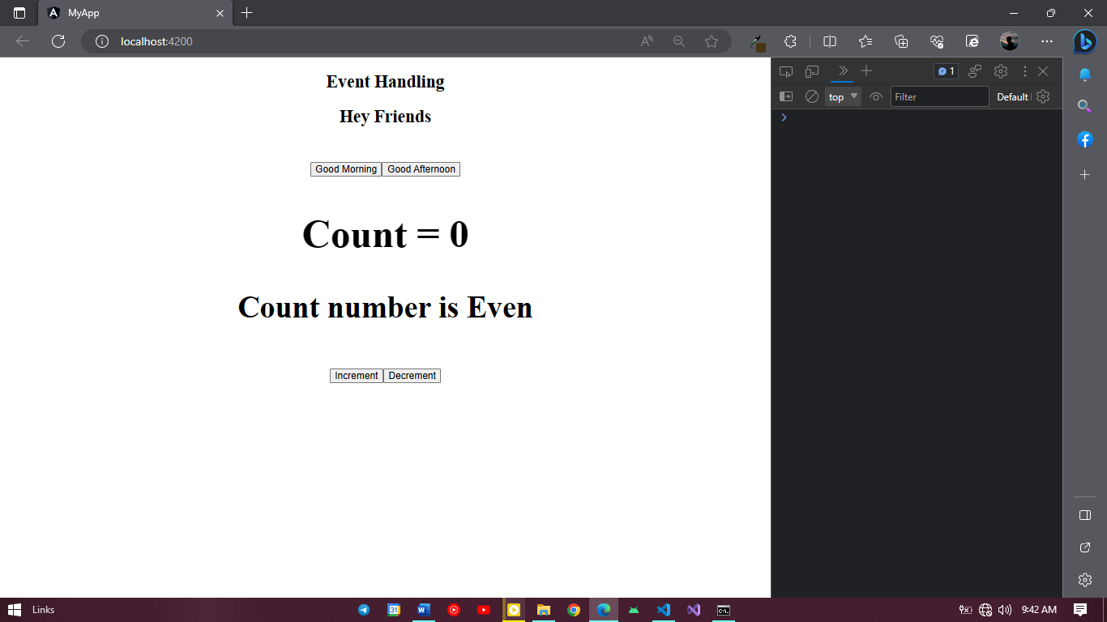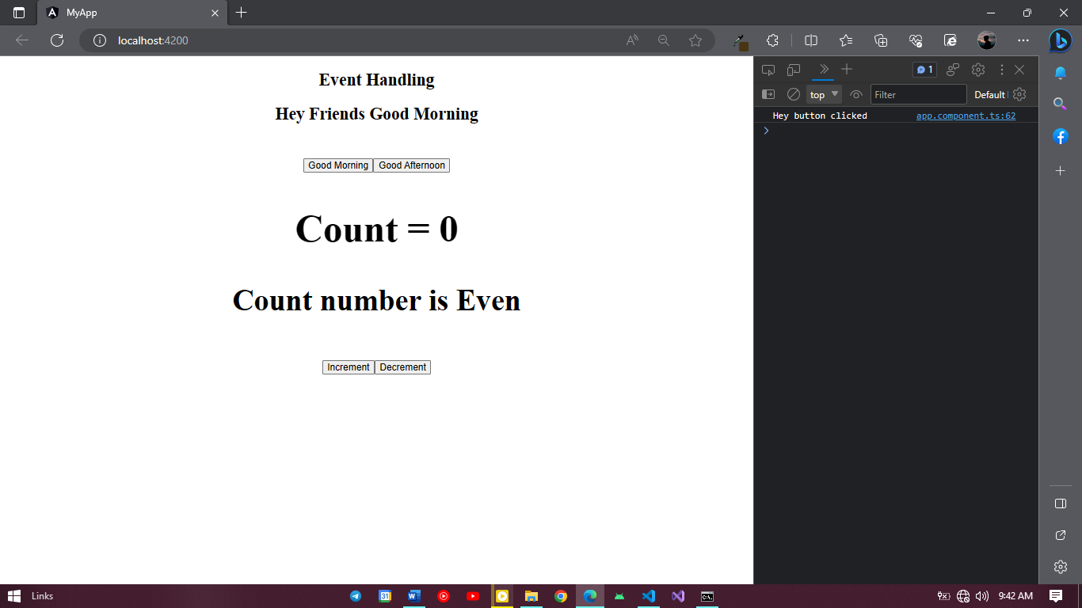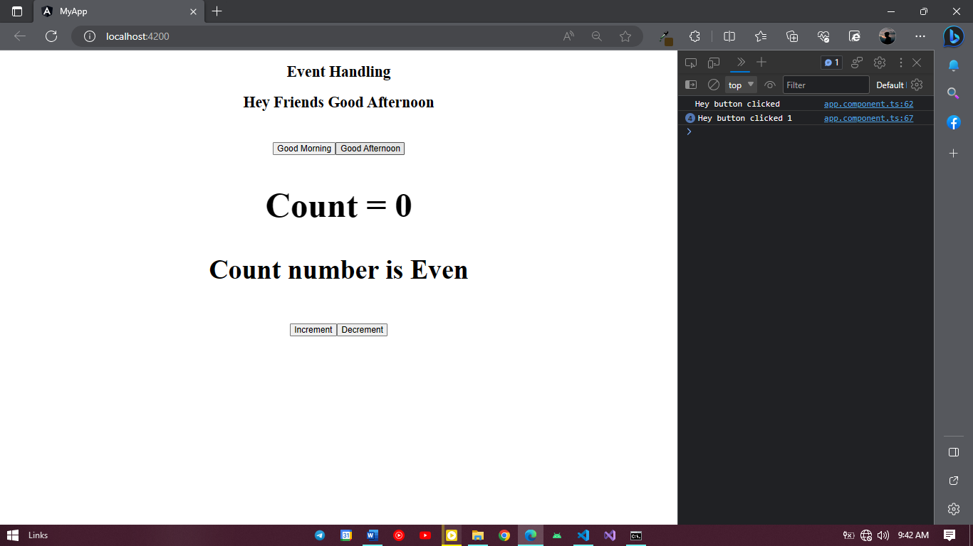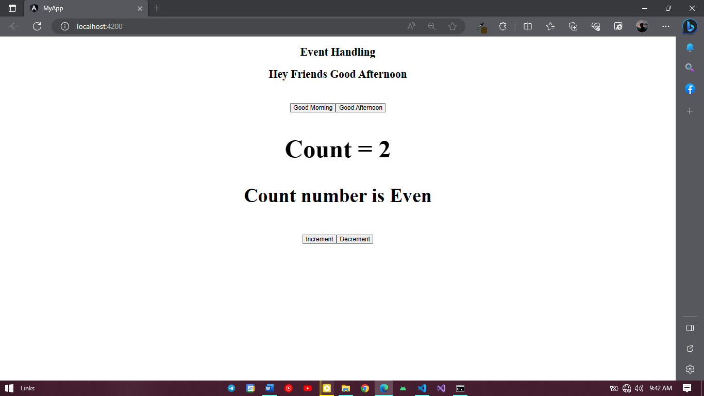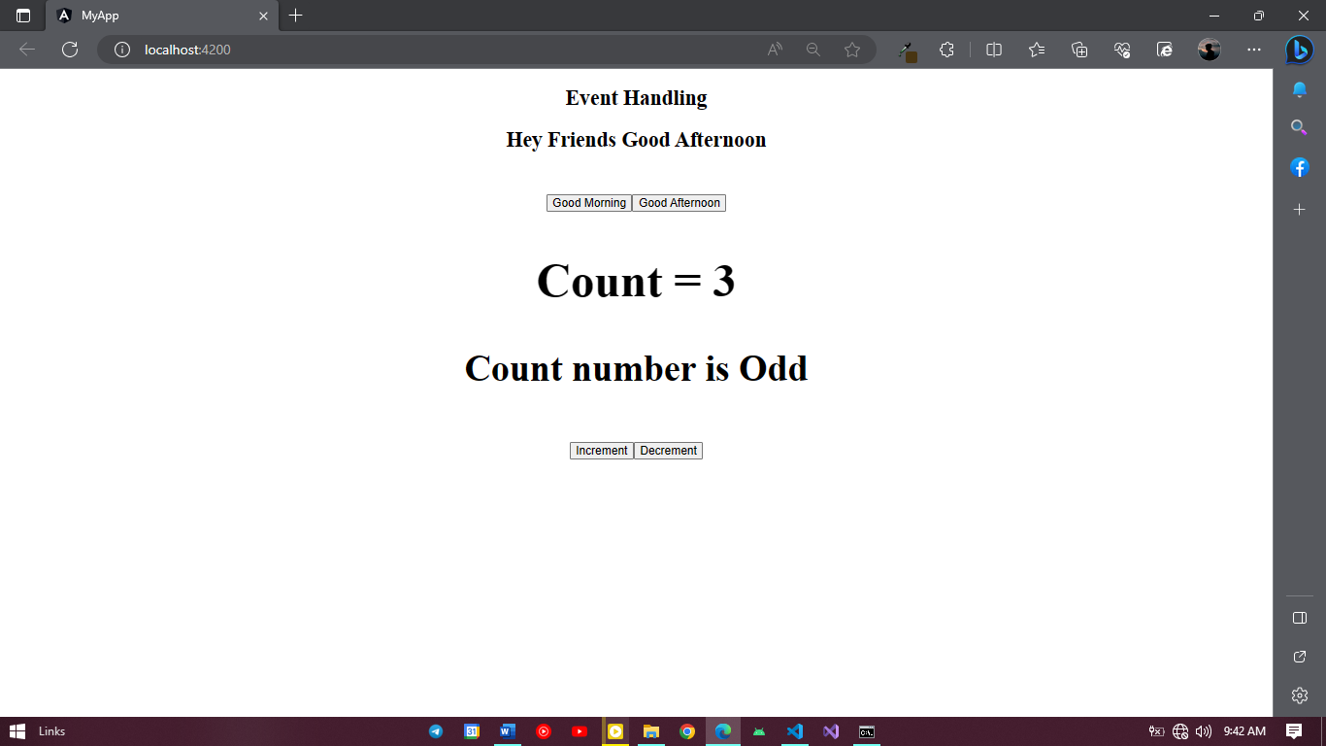

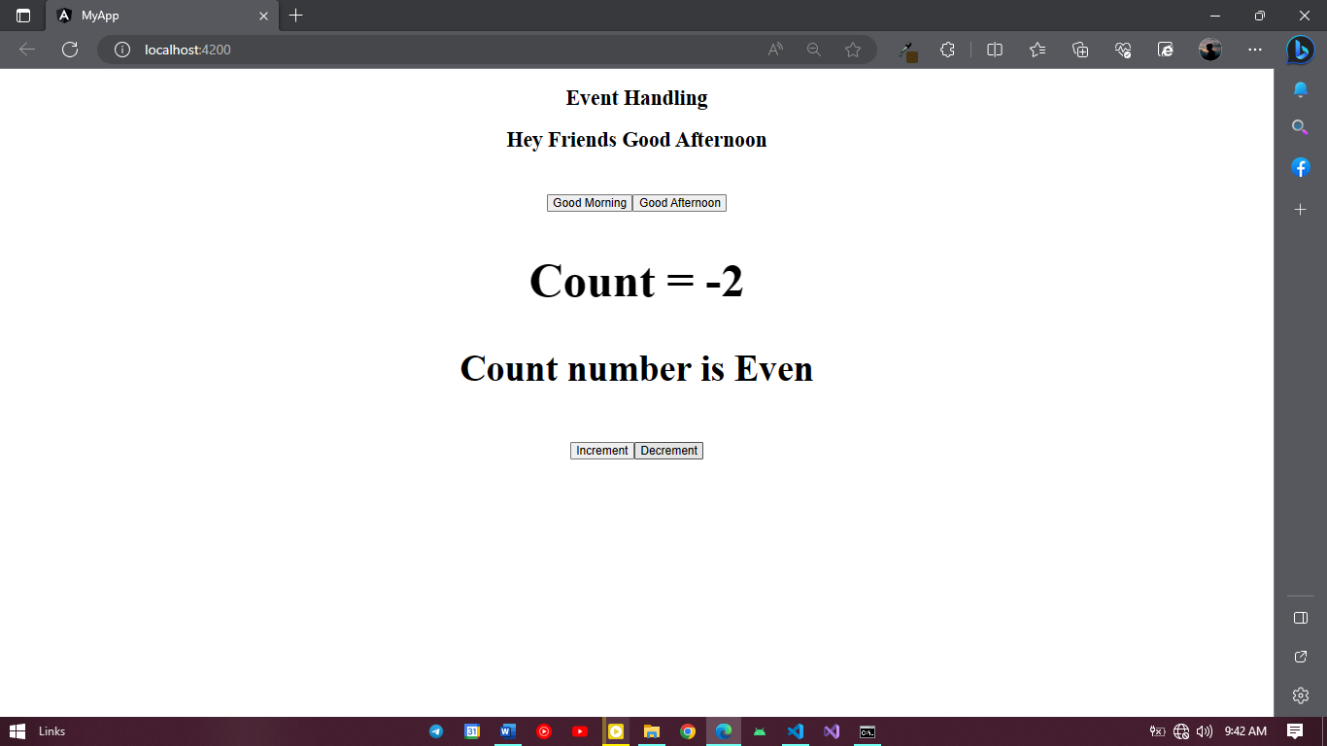

**TWO WAY DATA BINDING**

**app.component.html**

<h2 style="text-align: center;">Two Way Data Biniing</h2>

<div style="text-align: center;">

<input type="number" [(ngModel)]="count"> <button (click) = check()>CheckCount</button> <button (click) = Clear()>Clear</button>

</div>

<div style="text-align: center;">

<h1 [hidden]="is_hidden">{{count}} = {{str}}</h1>

</div>

**app.component.ts**

import { Component } from '@angular/core';

@Component({

selector: 'app-root',

templateUrl: './app.component.html',

styleUrls: ['./app.component.css']

})

export class AppComponent {

public title1= 'Angular Training';

public count = 0;

public str = " ";

public is_hidden = true

check(){

this.is_hidden = false

if(this.count % 2 == 0){

this.str = "Even";

}

else{

this.str = "Odd";

}

}

Clear(){

this.is_hidden = true

}

}

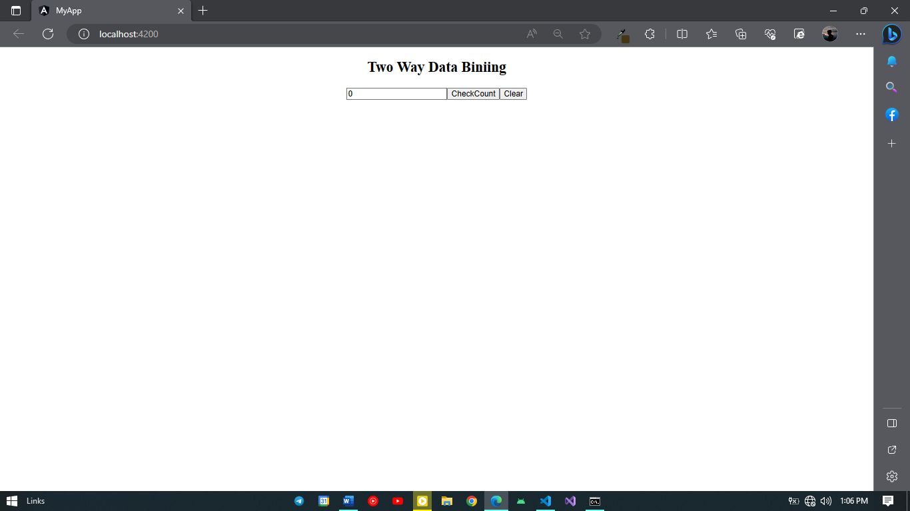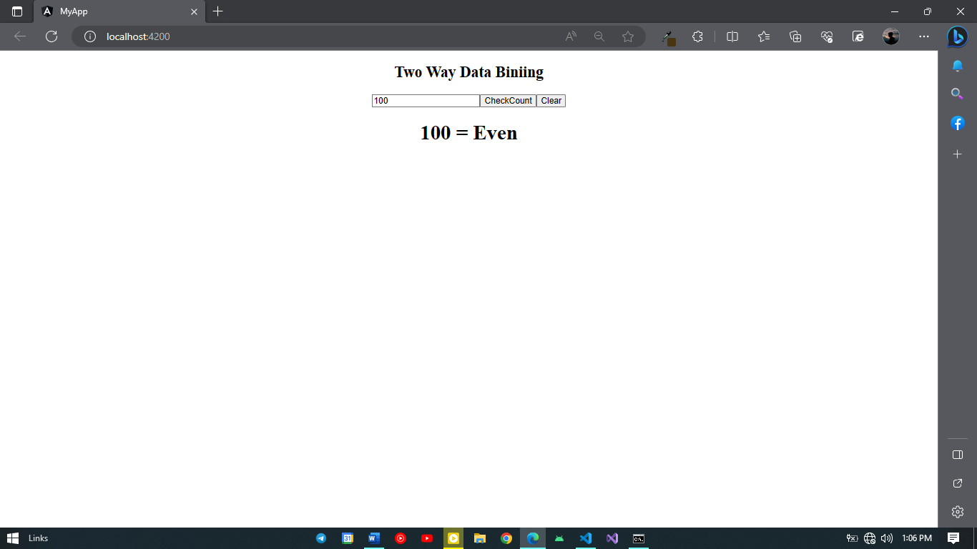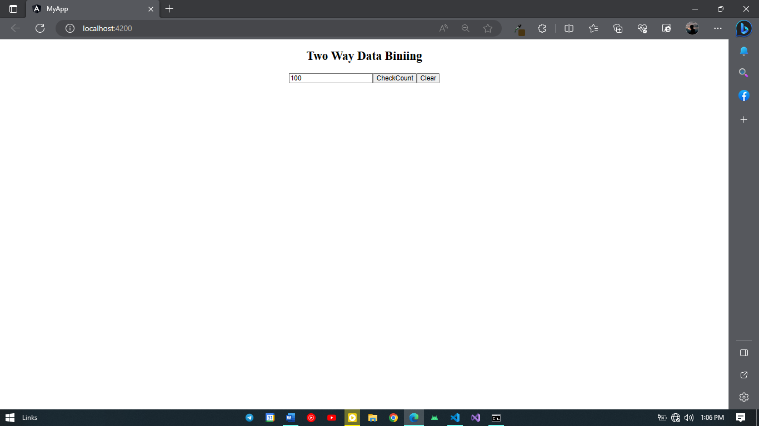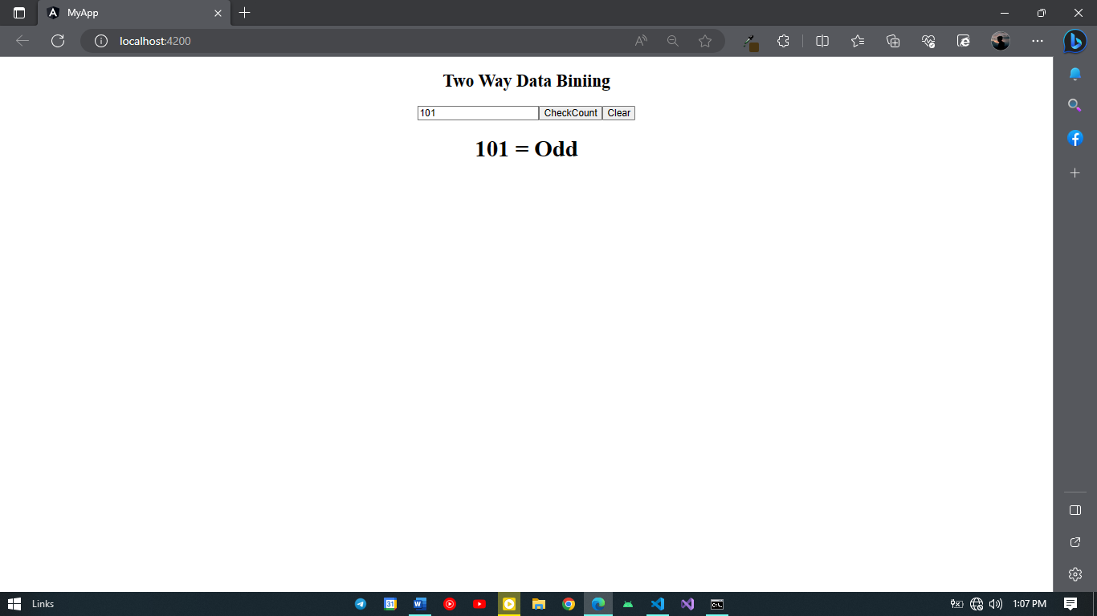

**IF & FOR LOOP**

**app.component.html**

<h2 style="text-align: center;">Structural Directives</h2>

<table>

<thead>

<th>Name</th>

<th>Price</th>

</thead>

<tbody *ngFor = "let item of fruits">

<tr *ngIf = "item.price > 300">

<td>{{item.name}}</td>

<td>{{item.price}}</td>

</tr>

</tbody>

</table>

**app.component.ts**

import { Component } from '@angular/core';

@Component({

selector: 'app-root',

templateUrl: './app.component.html',

styleUrls: ['./app.component.css']

})

export class AppComponent {

public fruits = [

{ name : "Orange" , price : 100},

{ name : "Apple" , price : 200},

{ name : "Mango" , price : 300},

{ name : "Kivi" , price : 400},

{ name : "Banana" , price : 500},

{ name : "Grapes" , price : 600}

];

}

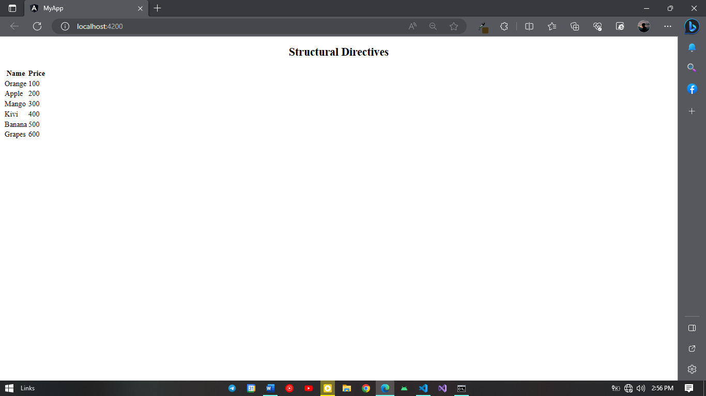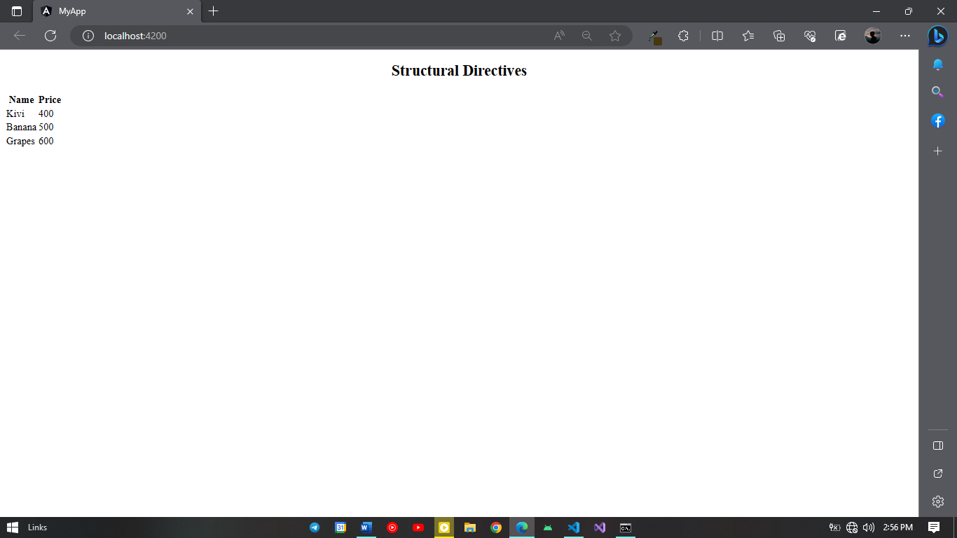

**ANGULAR ROUTING**

**app.component.html**

<nav class="navbar navbar-light bg-light">

<div class="main-div">

<div>

Angular Routing

</div>

<div>

<ul class="ul-div">

<li [routerLink]="'/Home'">Home</li>

<li [routerLink]="'/About-us'">About us</li>

<li [routerLink]="'/Contact-us'">Contact us</li>

</ul>

</div>

</div>

</nav>

<router-outlet></router-outlet>

**app.module.ts**

import { NgModule } from '@angular/core';

import { BrowserModule } from '@angular/platform-browser';

import { AppRoutingModule } from './app-routing.module';

import { AppComponent } from './app.component';

import { FormsModule } from '@angular/forms';

import { HomeComponent } from './home/home.component';

import { ContactUsComponent } from './contact-us/contact-us.component';

import { AboutUsComponent } from './about-us/about-us.component';

@NgModule({

declarations: [

AppComponent,

HomeComponent,

ContactUsComponent,

AboutUsComponent

],

imports: [

BrowserModule,

AppRoutingModule,

FormsModule

],

providers: [],

bootstrap: [AppComponent]

})

export class AppModule { }

**app.module.ts**

.main-div{

display: flex;

justify-content: space-between;

align-items: center;

background-color: aqua;

}

.ul-div{

display: flex;

list-style: none;

}

.ul-div>li{

padding: 5px;

}

**app-routing.module.ts**

import { Component, NgModule } from '@angular/core';

import { RouterModule, Routes } from '@angular/router' ;

import { HomeComponent } from './home/home.component';

import { AboutUsComponent } from './about-us/about-us.component';

import { ContactUsComponent } from './contact-us/contact-us.component';

const routes: Routes = [

{path:'Home', component:HomeComponent},

{path:'About-us', component:AboutUsComponent},

{path:'Contact-us', component:ContactUsComponent},

];

@NgModule({

imports: [RouterModule.forRoot(routes)],

exports: [RouterModule]

})

export class AppRoutingModule { }

[**home.component.html**](http://home.component.html)

<h3>Hey Welcome to Home</h3>

<button (click)="gotoContact()">Go to Contact us component</button>

[**home.component.ts**](http://home.component.ts)

import { Component } from '@angular/core';

import { Router } from '@angular/router';

@Component({

selector: 'app-home',

templateUrl: './home.component.html',

styleUrls: ['./home.component.css']

})

export class HomeComponent {

constructor(private router:Router){ }

gotoContact(){

this.router.navigate(['Contact-us'])

}

}

**contact-us.component.html**

<h3>Welcome to Contact us component</h3>

**about-us.component.html**

<h3>Welcome to About us component</h3>

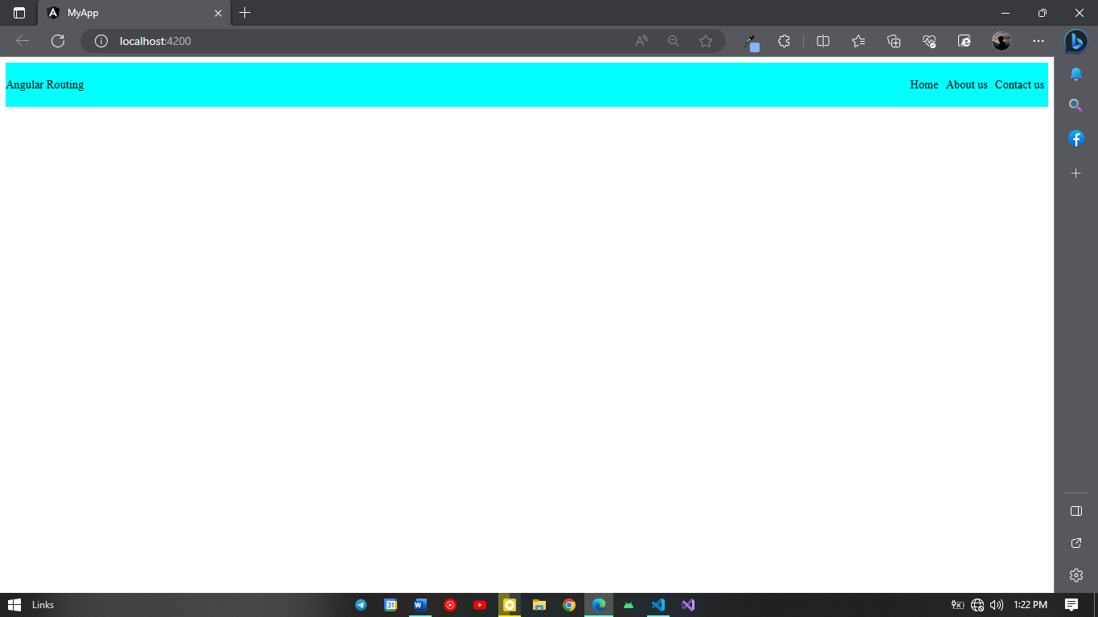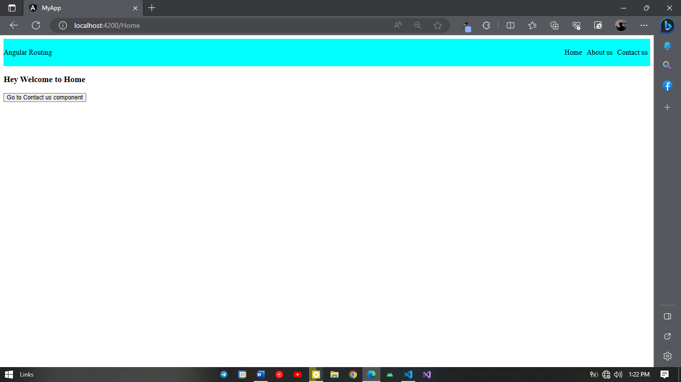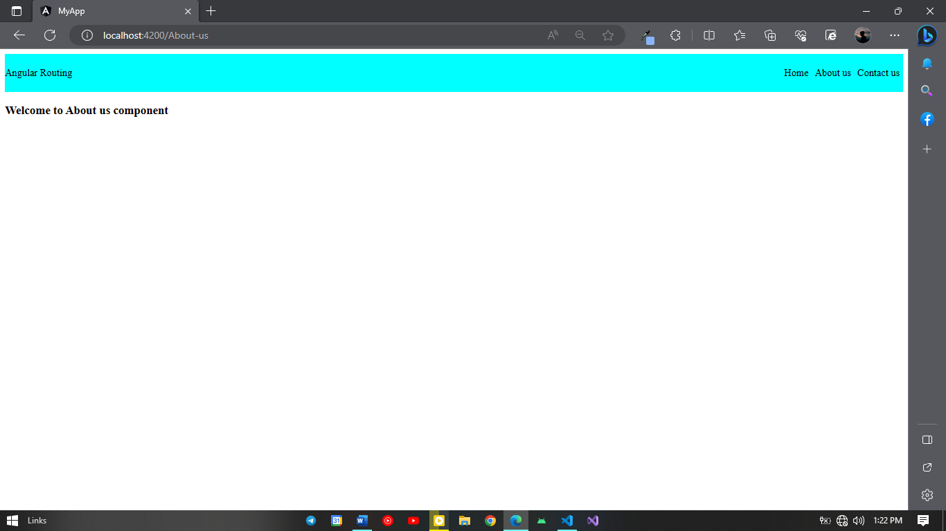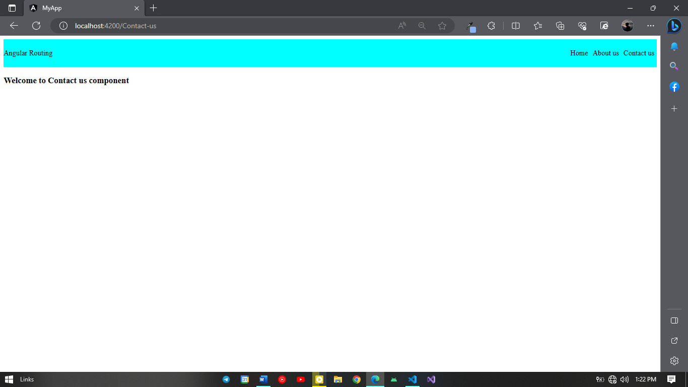

**ANGULAR API CALLING**

**app.component.html**

<h3 style="text-align: center;">Api Calling in Angular</h3>

<h3 style="text-align: center;">Get Method</h3>

{{getArray | json}}

<h3 style="text-align: center;">Post Method</h3>

{{postArray | json}}

**app.component.ts**

import { Component,OnInit } from '@angular/core';

import { ApiCallService } from './api-call.service';

import { HttpClient } from '@angular/common/http';

@Component({

selector: 'app-root',

templateUrl: './app.component.html',

styleUrls: ['./app.component.css']

})

export class AppComponent {

public title= 'Angular Training';

constructor(private getApi:ApiCallService){}

postArray = [];

getArray = [];

ngOnInit(){

this.getApi.getMethod().subscribe((res) => {

console.log(res)

this.getArray = res;

});

this.getApi.postMethod().subscribe((res) => {

console.log(res)

this.postArray = res;

});

}

}

**api-call.services.ts**

import { Injectable } from '@angular/core';

import {HttpClient} from '@angular/common/http'

@Injectable({

providedIn: 'root'

})

export class ApiCallService {

constructor(private http:HttpClient) { }

getMethod(){

return this.http.get<any>('https://jsonplaceholder.typicode.com/posts/1');

}

postMethod(){

return this.http.get<any>('https://jsonplaceholder.typicode.com/posts/',{});

}

}