***Title*:** ***"Creating a Serverless IoT Data Processing Solution with IBM Cloud Functions and Device Integration"***

1. **Set Up an IBM Cloud Account:**

If you don't have one already, sign up for an IBM Cloud account.

2. **Create an IoT Platform:**

Use IBM Watson IoT Platform to manage your IoT devices. Add your smart devices and configure them to send data to the platform.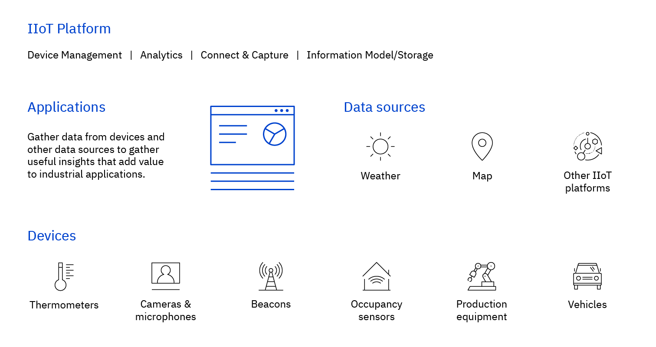

3. **Set Up Cloud Functions:**

- In IBM Cloud, navigate to "Functions" and create a new namespace.

- Install the IBM Cloud CLI and the Cloud Functions plugin.

- Connect your CLI to IBM Cloud.

4. **Create Functions:**

- Design and create serverless functions that will process IoT data. These functions can be written in Node.js, Python, or other supported languages.

- You can use the IBM Cloud Functions web console or CLI to create and deploy your functions.

5. **Integrate IoT Data:**

- Create an MQTT trigger for your functions. This trigger listens to incoming data from your IoT devices.

- When data arrives at the MQTT topic, it triggers the associated function to process the data.

6. **Data Processing:**

- Within your functions, process the incoming IoT data. You can filter, transform, or perform any required operations on the data.

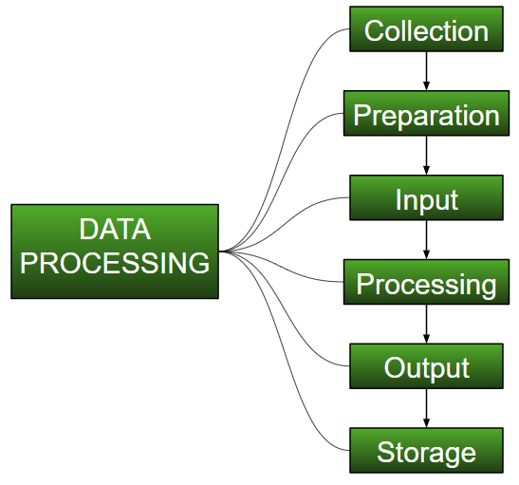

7. **Store Data:**

- You can store processed data in databases like IBM Cloudant or other data storage solutions offered by IBM Cloud.

8. **Monitoring and Logging:**

- Set up monitoring and logging to keep track of function executions, errors, and system health.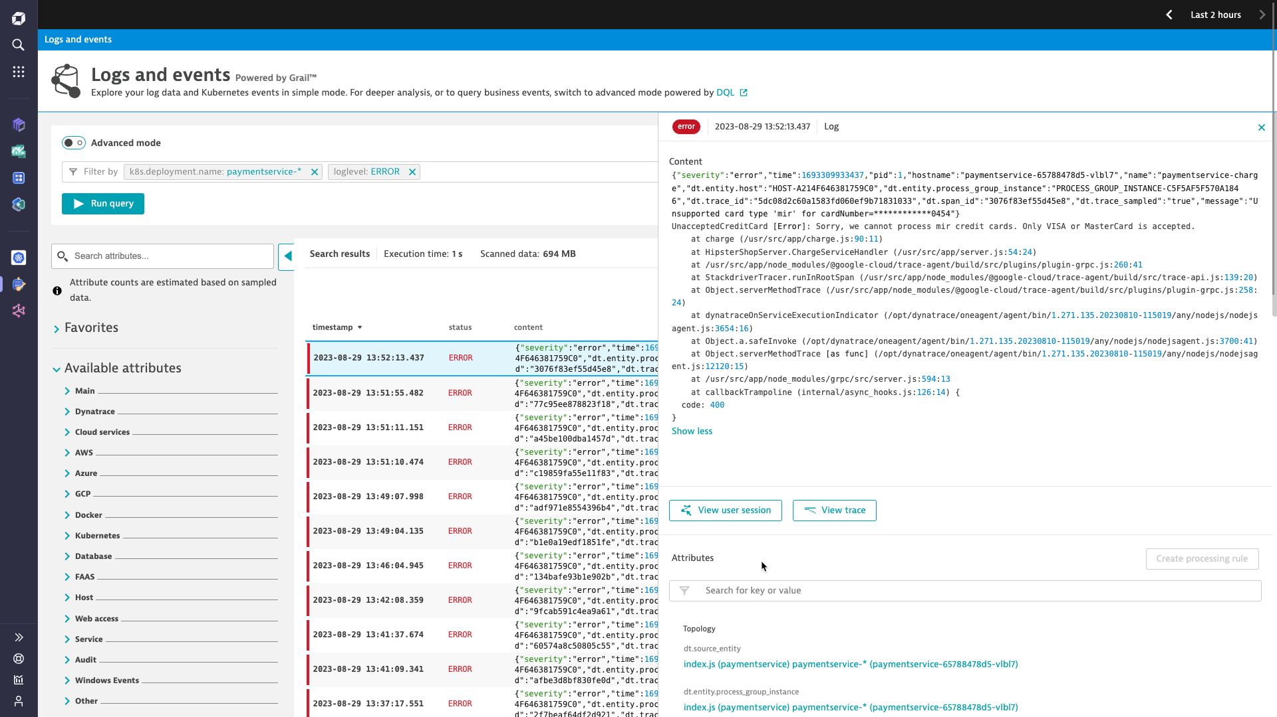

9. **Security:**

- Ensure that your IoT data and functions are secure. IBM Cloud provides security features to help protect your solution.

10. **Scaling:**

- IBM Cloud Functions can automatically scale based on the number of incoming requests, so you don't need to worry about managing server resources.

11. **Testing and Deployment:**

- Test your serverless solution with simulated data or actual IoT devices.

- Deploy your solution to production when you're satisfied with its performance.

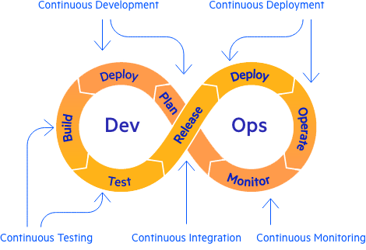

12. **API Integration (optional):**

- If you need to expose APIs to access processed IoT data, you can use API Gateway services in IBM Cloud.

13. **Continuous Improvement:**

- Monitor your solution's performance and make improvements as needed. You can update your functions or scale your resources as your IoT data processing needs grow.

