Conception Phase: Design and Implementation of a Batch-Processing Data Architecture for NYC Taxi Trip Data Using Python and Docker

Introduction and Project Motivation
The increasing availability of transportation datasets creates opportunities for practical data engineering systems. Managing millions of time-referenced records requires reliable ingestion, storage, preprocessing, and aggregation. NYC taxi records provide pickup times, locations, distances, and charges for this purpose (TLC, n.d.). This project proposes a batch-processing architecture that transforms these records into structured information. The motivation is to develop practical data engineering competencies while implementing maintainable, reproducible processing and documenting the limitations of a local system.

Project Aim and Objectives
The primary aim is to design and implement a reliable batch-processing architecture for large volumes of time-referenced transportation data. Objectives are to automate ingestion, establish persistent PostgreSQL storage, validate and clean records, and generate hourly, daily, and quarterly features for downstream machine learning applications. The project will also document reproducibility, source provenance, data protection, processing time, and reconciliation between accepted and rejected records.

Dataset Selection and Characteristics
The project uses the NYC Yellow Taxi Trip Records dataset for January 2025, published by the New York City Taxi and Limousine Commission. The downloaded Parquet file contains 3,475,226 records, exceeding the assignment minimum of one million. Fields include pickup and drop-off timestamps, distances, passenger counts, taxi zones, and charges (TLC, n.d.). Raw records will be retained before validation because the publisher does not guarantee their accuracy. The complete Parquet file will remain available locally, while selected analytical columns will be loaded into PostgreSQL. Source checksums and row counts will support provenance and repeatable processing.
https://d37ci6vzurychx.cloudfront.net/trip-data/yellow_tripdata_2025-01.parquet

Proposed Data Architecture and Technologies
Python will coordinate ingestion, validation, transformation, and delivery. An optional Google Colab notebook will support exploration, while the runtime infrastructure will remain local. Docker Compose will define separate ingestion, PostgreSQL, transformation, and export services, with database health checks controlling startup (Docker, n.d.). The application image will use python:3.12.9-slim-bookworm and storage will use postgres:17.4-bookworm. Ingestion will stream Parquet batches into raw database tables; transformation will create clean tables and aggregate views. Monthly batches will be started through a documented host schedule, while quarterly delivery will require three processed source months. Git will version the source and configuration, with GitHub publication required before the portfolio link is submitted.

Reliability, Scalability, and Data Protection
Reliability will use checksums, schema checks, transactional replacement of each source month, exception handling, and structured logs. PostgreSQL COPY will load streamed rows efficiently (PostgreSQL Global Development Group, n.d.). Arrow batches will bound Python loading memory. Accepted and rejected counts will reconcile to the source total. Credentials will remain outside Git; an internal database network and a separate reader account will restrict access. This design supports reproducible local processing, but its single database does not provide distributed scalability or high availability.

Implementation Plan and Expected Outcomes
Implementation will begin with source inspection and the development of independent Python services. Ingestion will read Parquet incrementally rather than loading the complete file into Python memory (Apache Arrow, n.d.). Local Docker containers will connect the services, preserve database storage, and export CSV snapshots with source manifests. Tests will examine cleaning rules, repeated execution, aggregation, and incomplete-quarter handling. January alone will produce a clearly labelled partial-quarter result. Modularity and traceable outputs are principal advantages, while batch latency and single-machine capacity remain limitations. Docker execution and GitHub publication must be evidenced separately from application tests before submission.

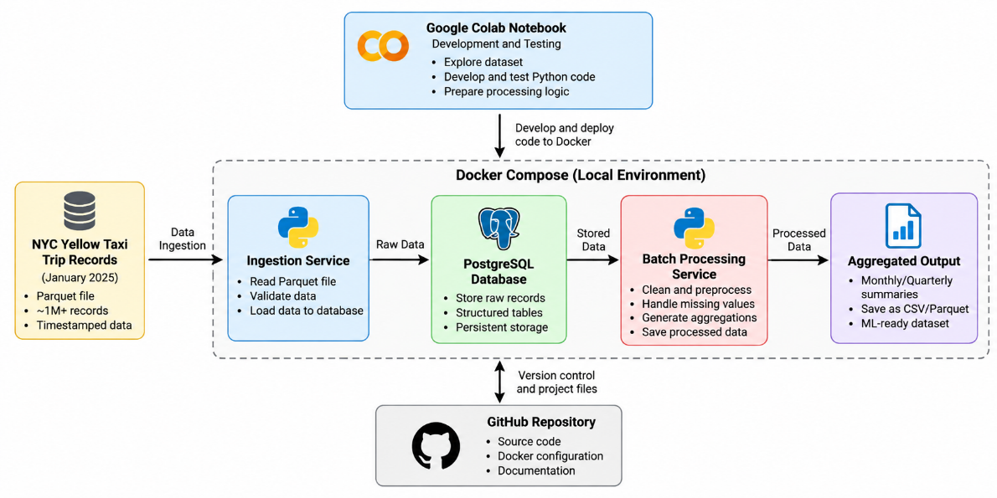
Figure 1 Proposed Docker-based batch-processing data architecture for NYC Yellow Taxi Trip Records

References
Apache Arrow (n.d.). Reading and writing Parquet files. [Online] Available at: https://arrow.apache.org/docs/python/parquet.html (Accessed: 29 October 2026).
Docker (n.d.). Control startup and shutdown order in Compose. [Online] Available at: https://docs.docker.com/compose/how-tos/startup-order/ (Accessed: 29 October 2026).
PostgreSQL Global Development Group (n.d.). PostgreSQL 17 documentation COPY. [Online] Available at: https://www.postgresql.org/docs/17/sql-copy.html (Accessed: 29 October 2026).
TLC (n.d.). TLC trip record data. New York City Taxi and Limousine Commission. [Online] Available at: https://www.nyc.gov/site/tlc/about/tlc-trip-record-data.page (Accessed: 29 October 2026).

