CA2 - MSc in Data Analytics

Author: Tony Walsh
e-mail: sba22238@student.cct.ie
Student ID: sba22238

Abstract
This report examines Butter production and Raw Milk collected in Ireland. Raw Milk collected is the amount of milk collected at creameries, it is the raw material for all milk products (Cream, Drinking Milk). Butter is one of the main products produced from Raw Milk. I will show how Raw Milk produced influences Butter production. I will compare Irish Butter production with other European countries. Finally I will forecast Raw Milk collected and Butter for the next 12 months.

Data Acquisition
The data acquisition part of the project was an iterative process.
First step was to decide a basic problem space. I decide to look at Irish milk and Butter production compared to the rest of the Europe.
I initially looked at Irish Government data sources. They only had Irish data so a google search led me to Eurostat. I found this to be a treasure trove of EU data. All data was acquired from Eurostat. Eurostat has a policy of encouraging free use of its data, both for non-commercial and commercial purposes. The full copyright notice can be found at
https://ec.europa.eu/eurostat/web/main/about-us/policies/copyright

First stage of the process was to import the annual data for the EU Milk Products. This raw data set contained the Raw Milk collected at creameries and various manufactured outputs. I was able to download this dataset as a CSV file.
This data set was small and I decided that I needed more data for Machine Learning so I downloaded a file with the same data with monthly data. Looking at this data set I wanted more independent variables for ML and downloaded a CSV file with the monthly Raw Milk selling price.
The Eurostat site was a positive as it contained all the datasets used in this project readily downloadable as CSV files. The challenge was deciding what data was relevant and useful for the project.
The final piece of Raw data used in the project are samples I took of Butter shelf life dates from 2 supermarkets in Dublin.

Exploratory Data Analysis
I drew up a basic plan for what I wanted to extract from the raw data files. Note this is a plan I did not what data would be interesting but I wanted make sure to have enough data to at least start my analysis.
The first step was to decide what variables to extract. The first variable was Raw Milk collected which is what the creameries collect from farmers and it is the raw material. The second variable was Butter produced. I then decided to also extract Cream produced and Drinking Milk produced. This was done to have more variables to examine and to look at the relationships between the variables.
I had data from 1970 for Ireland and 7 other countries. I excluded Germany because of re-unification. Then picked France and Belgium as they were close to Ireland and I want one country close to Ireland in size and one bigger (as first pass). I had Raw Milk selling price for Ireland from 1977.
The initial plan was to produce the following datasets.
Annual Data | Raw Milk collected, Butter produced, Milk produced, Cream produced all EU countries from 1970
Annual Data | Raw Milk collected, Butter produced, Milk produced, Cream produced for Ireland from 1970
Annual Data | Raw Milk collected, Butter produced, Milk produced, Cream produced for Belgium from 1970
Annual Data | Raw Milk collected, Butter produced, Milk produced, Cream produced for France from 1970
Monthly Data | Raw Milk collected, Butter produced, Milk produced, Cream produced for Ireland from 1970
Monthly Data | Raw Milk collected, Butter produced, Milk produced, Cream produced for Belgium from 1970
Monthly Data | Raw Milk collected, Butter produced, Milk produced, Cream produced for France from 1970
Monthly Data | Raw Milk collected, Butter produced, Milk produced, Cream produced and Raw Milk selling price for Ireland from 1977

The Geo codes in the raw data were in alpha-2 or two letter country codes. Many of the Python graphing tools use the three letter codes. To fix this problem I copied from Wikipedia the codes into an excel file, read this file as a CSV and did a Merge of the two datasets.
I cleaned the data by renaming columns and getting rid of unnecessary columns.
The raw data was in a format where all the products (Cream, Butter etc) were in the same column. I performed a pivot on the data so that each product has its own column. This makes querying each product much easier in Python.
There were no nulls or duplicate rows in any of the country datasets and there were no duplicates in the all EU annual dataset. The all EU annual dataset had 5 null values in Raw Milk, 67 in Milk Produced, 74 in Cream produced and 44 in Butter produced. As I want to use this file for plotting production over time on a map then I will leave the nulls as they are.

Machine Learning Data Engineering

When plotting the Irish monthly data it is clear that it follows a seasonal time series pattern.

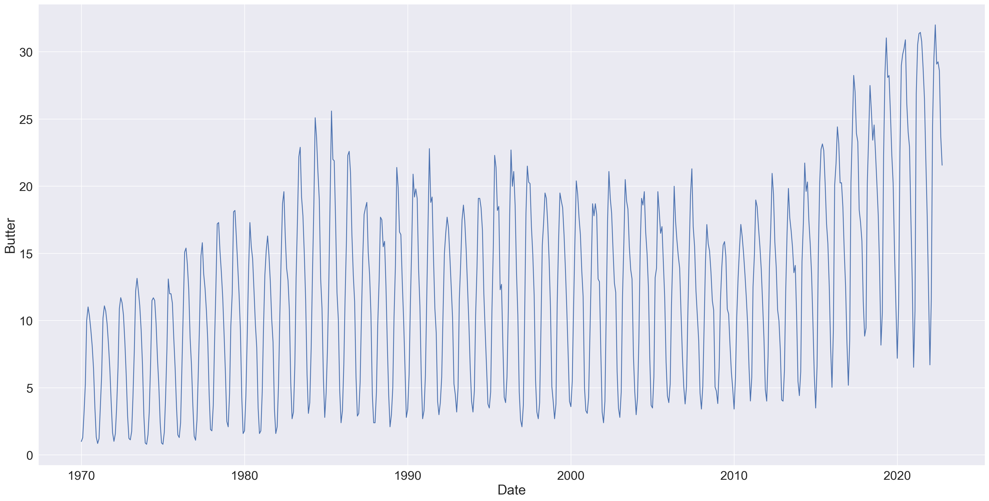Figure 1: Monthly Butter Production Ireland (in Thousand Tonnes)

For Machine Learning I will do a linear regression using the Month to forecast Butter production and Milk collected going forward into 2023. All other columns are will be dropped they are not able to help us predict. I added rows at the end of the dataframe for the 12 months in the future with null values for Butter production.
The numbers for the Month (1-12) represent a description for the Month and are not something you can math on for Machine Learning. Therefore I need to create dummy variables for the Month column.
Looking at the graph above it is clear that the relationship between time and Butter produced is not a linear one. I will add time*2 and time*3 to the dataframe and then experiment to find the best combination of values.

Table 1: First 5 Rows of prepared dataframe
Butter | time | time2 | time3 | m12_10 | m12_11 | m12_12 | m12_2 | m12_3 | m12_4 | m12_5 | m12_6 | m12_7 | m12_8 | m12_9
1.1 | 1 | 1 | 1 | 0 | 0 | 0 | 0 | 0 | 0 | 0 | 0 | 0 | 0 | 0
2.6 | 2 | 4 | 8 | 0 | 0 | 0 | 1 | 0 | 0 | 0 | 0 | 0 | 0 | 0
5.9 | 3 | 9 | 27 | 0 | 0 | 0 | 0 | 1 | 0 | 0 | 0 | 0 | 0 | 0
10 | 4 | 16 | 64 | 0 | 0 | 0 | 0 | 0 | 1 | 0 | 0 | 0 | 0 | 0
14.8 | 5 | 25 | 125 | 0 | 0 | 0 | 0 | 0 | 0 | 1 | 0 | 0 | 0 | 0

I also plan to use an Autoregressive method to forecast Butter and Raw Milk for the next 12 months, then compare and pick the best the best approach. The Autoregressive method needs little engineering all that is required is to extract the relevant column from the dataframe (eg Butter) and input this to the algorithm.
Once I am finished with ML the foretasted values will be added to the dataframe. This will allow graphing of the foretasted values.

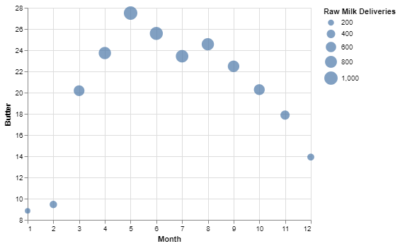
Interactive Dashboard
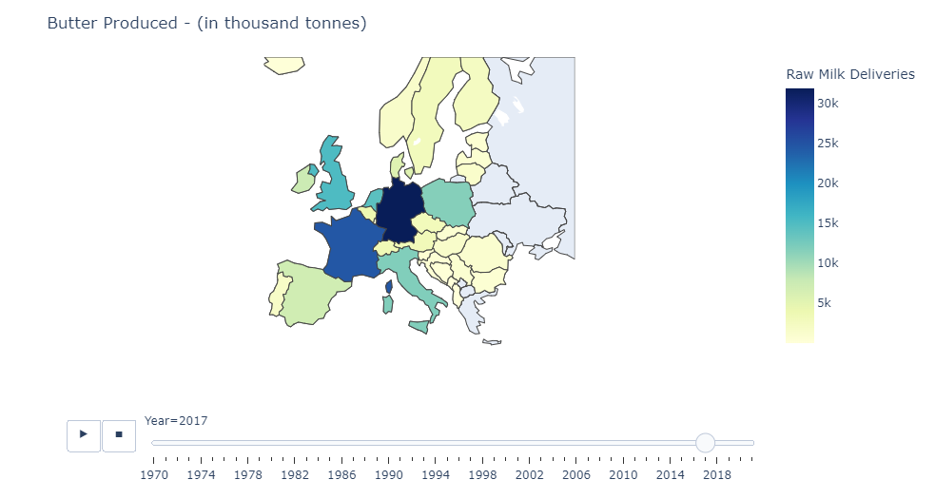Figure 2: Map of Butter production
For my first interactive dashboard I wanted to use he country information and produce a choropleth map to visualize Butter production in Europe over time. Giving each country a shade color for the amount of Butter production is a quick way to visualize Butter production in relation to country and country size.

As part of Machine Learning I forecast Raw Milk collected and Butter produced for the next 12 months. To be able to predict these values will help farmers to plan ahead. I developed an interactive plot to show Butter production per month from 1977 for Raw Milk deliveries going forward into 2023.

I wanted to produce a chart that shows a couple of pieces of information clearly. Not to add so much that there is too much going on in the graph. I want as little clutter as possible. I want to allow the user to browse the data and have them understand the narrative of Butter production over time for Raw Milk deliveries. The chart also makes viewing a large dataset comprehensible.
It is tempering to add more to the dashboard but I want to tell the simple story of Butter production.

Descriptive Statistics

Here is a table showing the measures of Central Tenancy for Ireland from 1970 to 2022 (in thousand tonnes)
Table 2: Measures of Central Tendency
 | Mode | Mean | Median | Standard Deviation | Maximum | Minimum
Raw Milk Collected | 5224  5271 | 5246 | 5254 | 1307 | 9018 | 2790
Butter Produced | 139  143 | 144 | 141 | 44 | 275 | 70
Cream Produced | 9.9 | 7 | 9.3 | 4.3 | 25.9 | 3.8

The skewness score is .67 for Raw Milk deliveries showing that the distribution is moderately skewed. The skewness score is 1.03 for Butter production and 1.69 for Cream production show those distributions are highly skewed which is not obvious from the table above as Mode, Mean and Median are close in value.
Here is a histogram for Cream production showing the skewness.

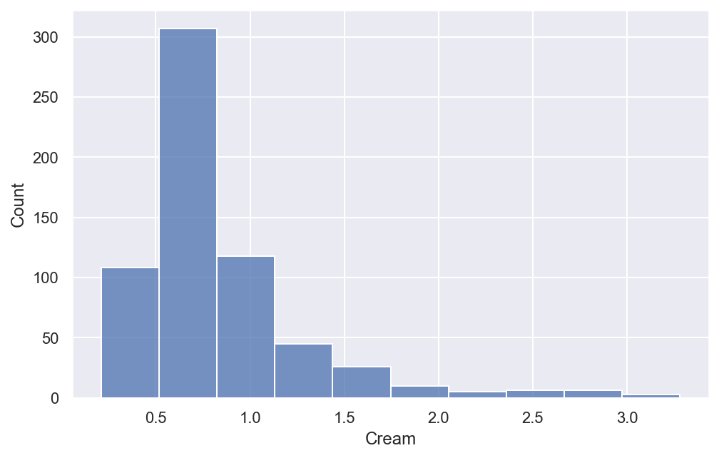Figure 3: Histogram for Irish Cream production

When I plot the monthly data for Ireland the graphs show a clear seasonal time series pattern. Here is the plot for Cream production and the trend is clearly upwards.
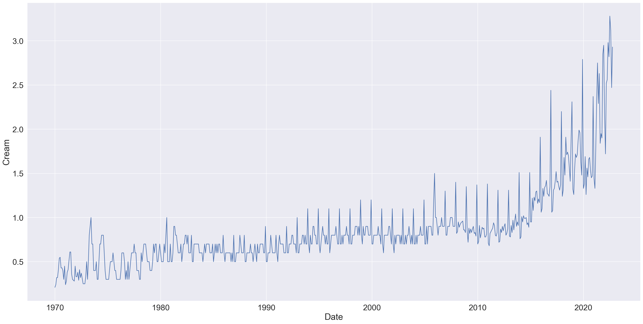Figure 4: Monthly Cream production Ireland

and the plot for Raw Milk deliveries also with an upward trend from about 2010.

The time series nature of the data leads we to explore 2 different Machine Learning models.
1. A autoregressive model which will look at which observations at previous time values are directly influencing the values at future time values.
2. A forecasting model using Linear Regression to predict the values going forward into 2023.

Inferential Statistics

I wanted to do look at the relationship between the amount of Raw Milk collected at Irish creameries and the selling price of Milk. This looked to be a standard economic relationship.
I developed a simple Linear Regression model to examine this. The independent variable Milk selling price made almost no contribution to the amount of Raw Milk produced. The one variable that made a difference to the amount of Raw Milk collected was month with a training score of 0.85.
I then used the model to examine the amount of Cream, Drinking Milk and Butter produced using Milk Collected as the independent variable. The results for Cream and Drinking Milk were both under a training score of 0.10. However, Milk Collected made a significant contribution to the amount of Butter produced with a training score of 0.95.
The model shows that excess Raw Milk collected is turned into Butter.

Hypothesis Testing

I will compare Ireland, Belgium and French monthly data for the year 2000.

Raw Milk Deliveries
A Shapiro-Wilk test was performed on the Irish and Belgium data. The Irish data had a test result of 0.11 and he Belgium data a test result of 0.83. In both cases the p value is greater than 0.05 and the null hypothesis is not rejected, and the data is normal.
A t-test with a significance level of 0.05 was performed and the test statistic T equaled 2.5 which was just inside the rejection zone (t > 2.07 or t <-2.07).
The p-value = 0.017 which is less than 0.05.
I conclude that there is enough evidence to say that there are significant differences between the Raw Milk collections between Ireland and Belgium.

Butter Produced
The Shapiro-Wilk test results were a p-value of 0.19 for Ireland and 0.15 for Belgium and I conclude that the data is normal.
A t-test with a significance level of 0.05 was performed and the test statistic T equaled 0.889 which is outside the rejection zone (t > 4.37 or t <-4.37) and the p-value is 0.38.
I can conclude that the difference between the two samples is not big enough to be statistically significant.

Milk Produced
The Shapiro-Wilk test results were 0.75 for Ireland and 0.67 for Belgium and I conclude that the data is normal.
A t-test with a significance level of 0.05 was performed and the test statistic T equaled –7.42 which is well within the rejection zone (t > 2.73 or t <-2.73) and the p-value is 1.98e-07
I conclude that there is enough evidence to conclude that there are significant differences between the Raw Milk produced between Ireland and Belgium.

Butter Produced 3 Countries
The Shapiro-Wilk test results were 0.19 for Ireland, 0.15 for Belgium and 0.16 for France. I conclude that the data is normally distributed. The three groups have the same sample size of 12 samples. The samples are independent. I calculated a p-value of 0.12 for the Levene Test. The p-value is greater than 0.5 so I fail to reject the null hypothesis and conclude the variance between the countries is the same. Therefore I can use an Anova test in this case.

Using Python I calculated the p-value to be 6.6e-15. This is less than 0.05 therefore we reject the null hypothesis and conclude there is significant difference between butter production for the 3 countries.

Raw Milk Collected 3 Countries
The Shapiro-Wilk test results were 0.12 for Ireland, 0.83 for Belgium and 0.39 for France. I conclude that the data is normally distributed. The three groups have the same sample size of 12 samples. The samples are independent.
I calculated a p-value of 1.9e-06 for the Levene Test. The p-value is less than 0.5 so I reject the null hypothesis and conclude the variance between the countries is the not the same. Therefore I can not use a Anova test in this case.
In this case I will use a Kruskal-Wallis test. Using Python I calculate the p-value to be 5.5e-06 which is less than 0.05. I reject the null hypothesis and conclude there significant difference between Raw Milk collected production for the 3 countries.

Butter Supermarket Sample t-test

As part of the inferential statistics section, I was interested in the shelf life of butter. I took samples of butter and cream-based spreads in Tesco and Aldi.

Table 3: Shelf life of Butter products in days
Sample | 1 | 2 | 3 | 4 | 5 | 6
Tesco | 149 | 116 | 70 | 89 | 138 | 95
Aldi | 109 | 88 | 92 | 116 | 75 | 113

The Shapiro-Wilk test results were 0.79 for Tesco and 0.46 for Aldi.

H0 is that the self life of the two supermarkets is the same
H1 is that the self life of the two supermarkets is different

I will reject H0 if t > 2.22 or if t < -2.22
Using a calculator, I find that t = 0.75 which is not in the rejection zone and the p-value is 0.46 greater than 0.05 therefore we can conclude that the average shelf life of the butter products in the two supermarkets is the same.

Research

There is a huge amount of agricultural data out there. The main challenge was working out what data to work on and it was difficult to get focused and not over whelmed with the amount of data.
Linear Regression model showed that excess Raw Milk was converted into Butter not into Cream or Drinking Milk.
The main reasons for this are Irish butter is a valuable export and it has a long shelf life lasting up to 9 months or longer when frozen.
A trip to my local Tesco has Butter with a best before of almost 5 months in the future. This means it is an easy product to store and export on ships. Each kilo of Butter uses up the 25 liters of milk, so it uses up the excess Raw milk collected.
Up to 2017 the EU supplemented the price of Butter leading to an over supply and Butter mountains. After 2017 the subside was cut and Butter production stabilized. After 2017 the price of Butter increased leading to an increase of Butter production in Ireland (clal.it/, 2022).

Machine Learning

Project Management Framework

For this project I used the CRISP-DM framework which is an industry standard. The CRISP-DM methodology has the following phases:
- Business Understanding
- Data Understanding
- Data Preparation
- Modeling
- Evaluation
- Deployment

CRISP-DM can be used as Agile methodology where different stages can happen at the same time and it is required to move back and forth between the stages. I found that that was defintially the case for this project.
The following diagram shows the basic flow of CRISP-DM and the iterative nature of the framework (datascience-pm.com, 2020).

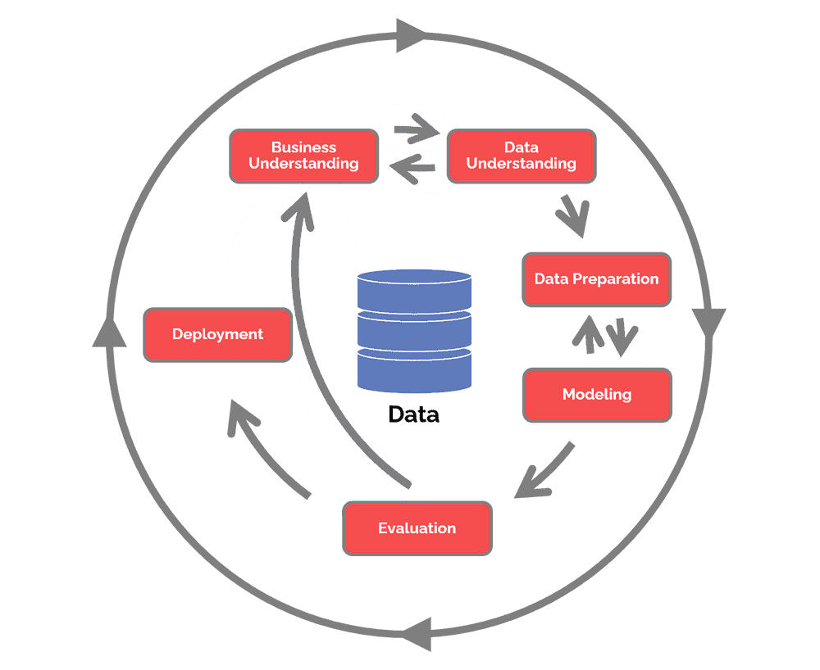Figure 5: CRISP-DM Model

Machine Learning Models
After examining the monthly Irish data for Raw Milk production and the associated products I discovered that the data is seasonal time series data. There are 3 main approaches I want to take:
1. Linear Regression model taking Time and other independent variables such as Milk selling price to predict Butter production.
2. Autoregressive Model which looks to predict the future values of the Butter production and Raw Milk production based on previous values. We are using the idea that past events can help us predict future events with Time Series data.
3. A forecasting model to use linear regression to predict the values going forward into 2023.
Both of these models are supervised learning as we will compare with test data with the correct values.
I will also use a Ridge Regression and Polynomial Regression models as an experiment to improve on the basic Linear Regression model along with GridsearchCV to find the best hyperparameters.

Linear Regression
I prepared the data by inserting dummy values for Month. I set the seed value to 42.
For the linear Regression model I will first predict the Butter based on Month and Raw Milk collected. I did some experimentation and Milk Selling price did not increase the score.
I got a respectable score of .96 for the Training and Test scores.

Cross Validation
To Access to accuracy of the Linear Regression model I used a resampling methodology, K-fold Cross Validation. The data will be split into a number of bins. It is recommended to take between 5 and 10 bins so I will pick 6 about (about10 years per bucket). Each bin contains an equal number of values. The algorithm will be run K times each time taking a different bin as the test set.
Table 4: Cross Validation results
0.967 | 0.957 | 0.967 | 0.949 | 0.953 | 0.966

With a mean of 0.96

Ridge Regression and GridSearchCV
For the next step in the process I used a Ridge Regression model using GridSearchCV to find the optiomal hyperparameters. This gave a very slight increase in the test score to .97.

Polynomial Regression
Next I tried a Polynomial Regression model. It does look like there is a non-linear relationship between Month and Butter production. The Polynomial Regression increased the training score slightly to .97. I conclude that the relationship between Raw Milk collected and Butter production is linear essentially making no difference here. I will explore this relationship more in the forecasting section.

Autoregressive Model
Partial Autocorrelation is the measure of the direct correlation from one time period to another. The Partial Autocorrelation graph with 48 lags shows major spikes that the Butter produced this month is affected directly by the Butter produced 1, 2, 7, 8, 9, 10, and 13 months ago.

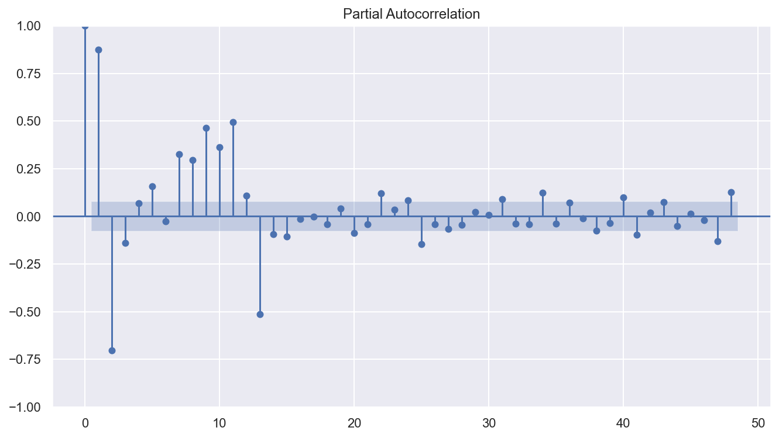Figure 6: Partial Autocorrelation Butter at 48 lags

For the Autoregressive Model, I created a set of test data containing the year 1977 to 1984 and test data for 1985 and 1986. I experimented a little and found that an autoregressive lag value of 16 worked best.
I called the Predict method to predict for the test period. I calculated the residuals (testdata – predictions). I calculated the Root Mean Squared Error (np.sqrt(np.mean(residuals**2)) to be 2.17.
The plot of the residuals shows how much our predictions are off compared to the test data.

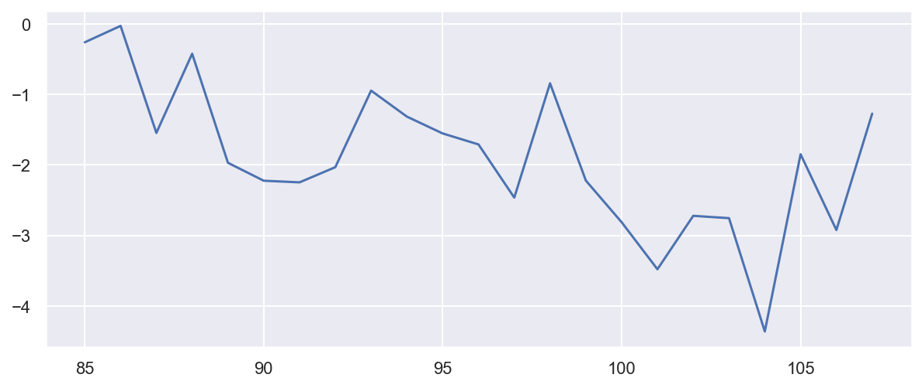Figure 7: Residuals at 16 lags

The graph below shows the model gets the shape of the predictions in relation to the actual data pretty good.

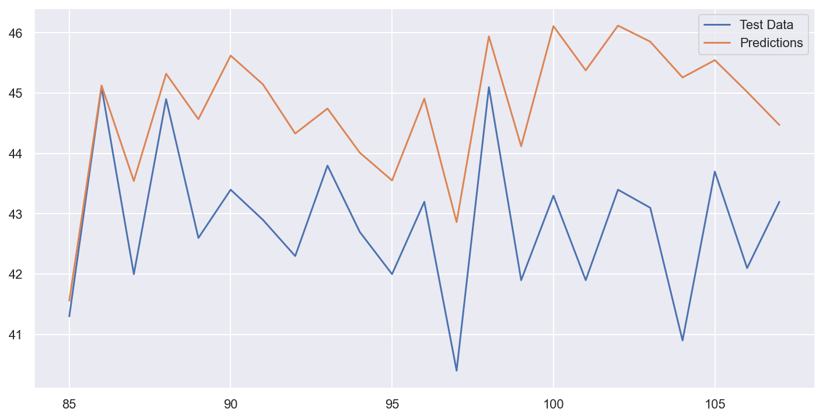Figure 8: Test Data vs Predictions

Split Cross-Validation
I performed Split Cross-Validation on my Autoregressive Model. Below is a visualization of this algorithm (datascience-pm.com, 2020)
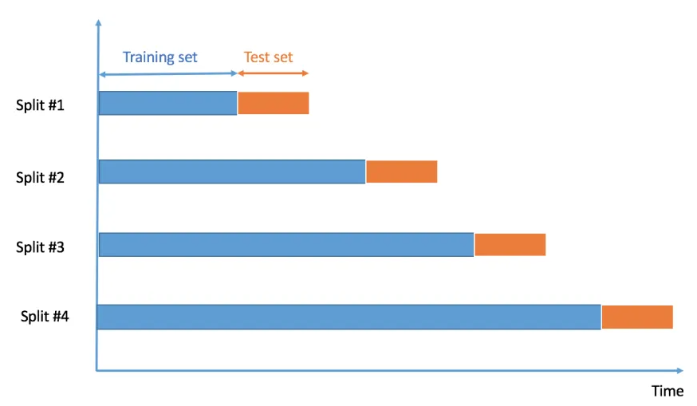Figure 9: Split-Cross Validation

I set this algorithm to do 10 splits and the results are as follows. With a mean of 1.71
Table 5: Root Mean Squared Error
1.3 | 0.76 | 1.39 | 4.08 | 1.66 | 1.8 | 0.76 | 2.6 | 1.31 | 1.43

Forcasting
For the Autoregressive model I set the prediction start and end dates to be for the next 12 months into the future. I ran the model getting predicted values for the future.

I added to the Linear Regression model dataframe the Year and Month dates for the values I am looking to predict (eg Year 2023, Month 5). The Butter values for the future dates are set to null.
To the dataframe I added time*2 and time *3 as the plots show the model is not linear.
Then I added dummy variables for the Month.
I ran the model 3 times with actual training and test data sets. First was time + time*2 + time*3. There was some possible over fitting so I ran the model with time + time*2 and time + time*3 both which gave better results. The difference between time*2 and time*3 was tiny.
I then ran the model to predict the future values.

Forecast Results
I will compare the results of the two models on predicting Butter production.

Table 6: Forcasted Butter production (thousand tonnes)
Date | Autoregressive Model | Linear Regression Model
Nov 2022 | 20.57 | 18.29
Dec 2022 | 14.01 | 13.75
Jan 2023 | 9.37 | 9.09
Feb 2023 | 16.1 | 12.24
March 2023 | 26.94 | 24.55
April 2023 | 32.37 | 29.27
May 2023 | 34.76 | 31.59
June 2023 | 33.58 | 30.08
July 2023 | 32.73 | 29.16
August 2023 | 31.72 | 27.46
Sept 2023 | 28.99 | 24.08
Oct 2023 | 26.29 | 21.84

The root mean squared error for the Autoregressive model was 1.77 and for the Linear Regression model was 2.3. I conclude in this case the Autoregressive model is the more accurate one.

Both models produced good results. Here is a plot showing Actual vs Predicted for November 2021 to October 2022 for both models.

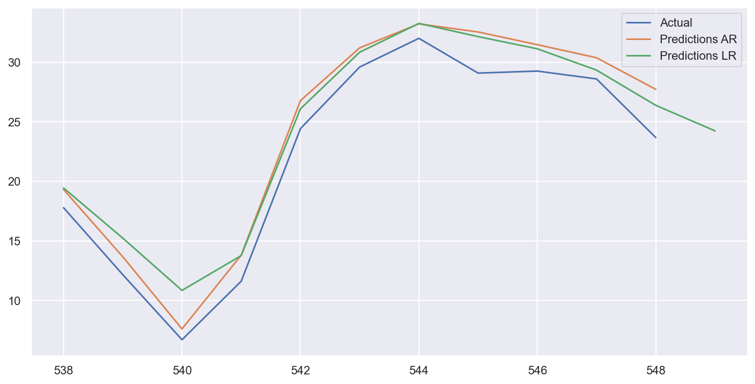Figure 10: Actual vs Predicted for AutoReg and LinearReg

Note: I have been unable to find the values for November/December 2022.

References

(2022) EU: Butter - Stocks, market prices and intervention prices. Available at: https://www.clal.it/en/?section=magazzino_burro_confronto
(Accessed 22nd December 2022)

Hotz N. (2020) CRISP-DM. Available at: https://www.datascience-pm.com/crisp-dm-2/
(Accessed: 29th December 2022)

Moudiki T. (2020) Cross Validation on time series data. Available at: https://www.r-bloggers.com/2020/03/time-series-cross-validation-using-crossval/
(Accessed: 29th December 2022)

Appendix A Hypothesis testing calculations

Raw Milk Deliveries Ireland vs Belgium for Year 2000

#Perform Shapiro-Wilk test
shapiro(df_Milk_2020_I['Raw Milk Deliveries'])

ShapiroResult(statistic=0.8884272575378418, pvalue=0.11246637254953384)

#Perform Shapiro-Wilk test
shapiro(df_Milk_2020_B['Raw Milk Deliveries'])

ShapiroResult(statistic=0.9636621475219727, pvalue=0.8345453143119812)

#Perform t-test
stats.ttest_ind(df_Milk_2020_I['Raw Milk Deliveries'],df_Milk_2020_B['Raw Milk Deliveries'])

Ttest_indResult(statistic=2.557186763492045, pvalue=0.017966561865284413)

Butter Produced Ireland vs Belgium for Year 2000

#Perform Shapiro-Wilk test
shapiro(df_Milk_2020_I['Butter'])

ShapiroResult(statistic=0.9066749215126038, pvalue=0.1933693140745163)

#Perform Shapiro-Wilk test
shapiro(df_Milk_2020_B['Butter'])

ShapiroResult(statistic=0.8989026546478271, pvalue=0.15352949500083923)

#Perform t-test
stats.ttest_ind(df_Milk_2020_I['Butter'],df_Milk_2020_B['Butter'])

Ttest_indResult(statistic=0.8898611722103216, pvalue=0.3831682731711141)

Milk Produced Ireland vs Belgium for Year 2000

#Perform Shapiro-Wilk test
shapiro(df_Milk_2020_I['Milk'])

ShapiroResult(statistic=0.9581571817398071, pvalue=0.7572346925735474)

#Perform Shapiro-Wilk test
shapiro(df_Milk_2020_B['Milk'])

ShapiroResult(statistic=0.9530268907546997, pvalue=0.6815672516822815)

#Perform t-test
stats.ttest_ind(df_Milk_2020_I['Milk'],df_Milk_2020_B['Milk'])

Ttest_indResult(statistic=-7.426824012787325, pvalue=1.982420533041643e-07)

Butter Produced 3 Countries (Ireland, Belgium, France)

#Perform Shapiro-Wilk test
shapiro(df_Milk_2020_I['Butter'])

ShapiroResult(statistic=0.9066749215126038, pvalue=0.1933693140745163)

#Perform Shapiro-Wilk test
shapiro(df_Milk_2020_B['Butter'])

ShapiroResult(statistic=0.8989026546478271, pvalue=0.15352949500083923)

#Perform Shapiro-Wilk test
shapiro(df_Milk_2020_F['Butter'])

ShapiroResult(statistic=0.9012460112571716, pvalue=0.1646021008491516)

#Levene's test centered at the mean
stats.levene(df_Milk_2020_I['Butter'], df_Milk_2020_B['Butter'], df_Milk_2020_F['Butter'], center='mean')

LeveneResult(statistic=2.3315902875587047, pvalue=0.11294048079527529)

# Conduct the one-way ANOVA
f_oneway(df_Milk_2020_I['Butter'], df_Milk_2020_B['Butter'], df_Milk_2020_F['Butter'])

F_onewayResult(statistic=102.79514626010791, pvalue=6.6712821543493e-15)

Raw Milk Collected 3 Countries (Ireland, Belgium, France)

#Perform Shapiro-Wilk test
shapiro(df_Milk_2020_I['Raw Milk Deliveries'])

ShapiroResult(statistic=0.8884272575378418, pvalue=0.11246637254953384)

#Perform Shapiro-Wilk test
shapiro(df_Milk_2020_B['Raw Milk Deliveries'])

ShapiroResult(statistic=0.9636621475219727, pvalue=0.8345453143119812)

#Perform Shapiro-Wilk test
shapiro(df_Milk_2020_F['Raw Milk Deliveries'])

ShapiroResult(statistic=0.931726336479187, pvalue=0.3987703323364258)

#Levene's test centered at the mean
stats.levene(df_Milk_2020_I['Raw Milk Deliveries'], df_Milk_2020_B['Raw Milk Deliveries'], df_Milk_2020_F['Raw Milk Deliveries'], center='mean')

LeveneResult(statistic=20.15780950065625, pvalue=1.9043100729445404e-06)

#perform Kruskal-Wallis Test
stats.kruskal(df_Milk_2020_I['Raw Milk Deliveries'], df_Milk_2020_B['Raw Milk Deliveries'], df_Milk_2020_F['Raw Milk Deliveries'])

KruskalResult(statistic=24.216216216216225, pvalue=5.514618359491551e-06)

Supermarket Sample Hypothesis testing.

tesco = [149,116,70,89,138,95]
aldi = [109,88,92,116,75,113]

#Perform Shapiro-Wilk test
shapiro(tesco)

ShapiroResult(statistic=0.9574099779129028, pvalue=0.7995737791061401)

#Perform Shapiro-Wilk test
shapiro(aldi)

ShapiroResult(statistic=0.9141708016395569, pvalue=0.464398592710495)

#Perform t-test
stats.ttest_ind(tesco,aldi)

Ttest_indResult(statistic=0.7582810649803788, pvalue=0.4657779706516897)

