Software Quality Engineering
Test Report

Project Name | Conduit RealWorld Blog App
Group Number | Group 3
Project Path | Path A — The Integrator
Tech Stack | React.js, Node.js, Express.js, MongoDB
Submission Date | ( fill in date )

Member 1 (Lead) | ( your name )
Member 2 | ( name )
Member 3 | Than Soryapongs
Member 4 | ( name )
Member 5 | ( name )

Phase 1A — Black-Box Test Cases
Each member tests their assigned cases, fills in the Actual Result, Status, and pastes their screenshot.

TC-001 — Register with valid data
Test Case ID | TC-001
Test Title | Register with valid data
Tester Name | ( Member 1 name )
Technique | Equivalence Partitioning
Pre-conditions | User is on the register page at localhost:4100/#/register
Test Steps | 1. Go to localhost:4100/#/register 2. Enter Username: testuser1 3. Enter Email: testuser1@test.com 4. Enter Password: Test1234 5. Click Sign Up
Test Data | Username: testuser1 | Email: testuser1@test.com | Password: Test1234
Expected Result | Account is created. User is redirected to home feed. Username appears in the navbar.
Actual Result | ( fill after testing )
Status | ( Pass / Fail / Blocked )
Post-conditions | ( fill after testing )
Screenshot | ( paste screenshot here )

TC-002 — Register with duplicate email
Test Case ID | TC-002
Test Title | Register with duplicate email
Tester Name | ( Member 1 name )
Technique | Equivalence Partitioning — Sad Path
Pre-conditions | An account with email testuser1@test.com already exists in the system
Test Steps | 1. Go to localhost:4100/#/register 2. Enter Username: testuser2 3. Enter Email: testuser1@test.com 4. Enter Password: Test1234 5. Click Sign Up
Test Data | Username: testuser2 | Email: testuser1@test.com (already used) | Password: Test1234
Expected Result | An error message appears saying the email is already taken. Account is not created.
Actual Result | ( fill after testing )
Status | ( Pass / Fail / Blocked )
Post-conditions | ( fill after testing )
Screenshot | ( paste screenshot here )

TC-003 — Login with correct credentials
Test Case ID | TC-003
Test Title | Login with correct credentials
Tester Name | ( Member 2 name )
Technique | Equivalence Partitioning — Happy Path
Pre-conditions | A registered account exists. User is on the login page at localhost:4100/#/login
Test Steps | 1. Go to localhost:4100/#/login 2. Enter Email: testuser1@test.com 3. Enter Password: Test1234 4. Click Sign In
Test Data | Email: testuser1@test.com | Password: Test1234
Expected Result | User is logged in. Home feed is displayed. Username shows in the top navbar.
Actual Result | ( fill after testing )
Status | ( Pass / Fail / Blocked )
Post-conditions | ( fill after testing )
Screenshot | ( paste screenshot here )

TC-004 — Login with wrong password
Test Case ID | TC-004
Test Title | Login with wrong password
Tester Name | ( Member 2 name )
Technique | Equivalence Partitioning — Sad Path
Pre-conditions | A registered account exists. User is on the login page
Test Steps | 1. Go to localhost:4100/#/login 2. Enter Email: testuser1@test.com 3. Enter Password: wrongpassword 4. Click Sign In
Test Data | Email: testuser1@test.com | Password: wrongpassword
Expected Result | An error message appears. User stays on the login page and is not logged in.
Actual Result | ( fill after testing )
Status | ( Pass / Fail / Blocked )
Post-conditions | ( fill after testing )
Screenshot | ( paste screenshot here )

TC-005 — Create article with all fields filled
Test Case ID | TC-005
Test Title | Create article with all fields filled
Tester Name | Than Soryapongs
Technique | Equivalence Partitioning — Happy Path
Pre-conditions | User is logged in and on the new article page at localhost:4100/#/editor
Test Steps | 1. Login to the app 2. Click New Article in the navbar 3. Fill Title: My First Article 4. Fill Description: This is a test article 5. Fill Body: Article body content here 6. Fill Tags: testing 7. Click Publish Article
Test Data | Title: My First Article | Description: This is a test article | Tag: testing
Expected Result | Article is published. User is redirected to the article page. Article appears on their profile.
Actual Result | The same as Expected Result
Status | Pass
Post-conditions | New article exists in the database and is visible on the profile page.
Screenshot | 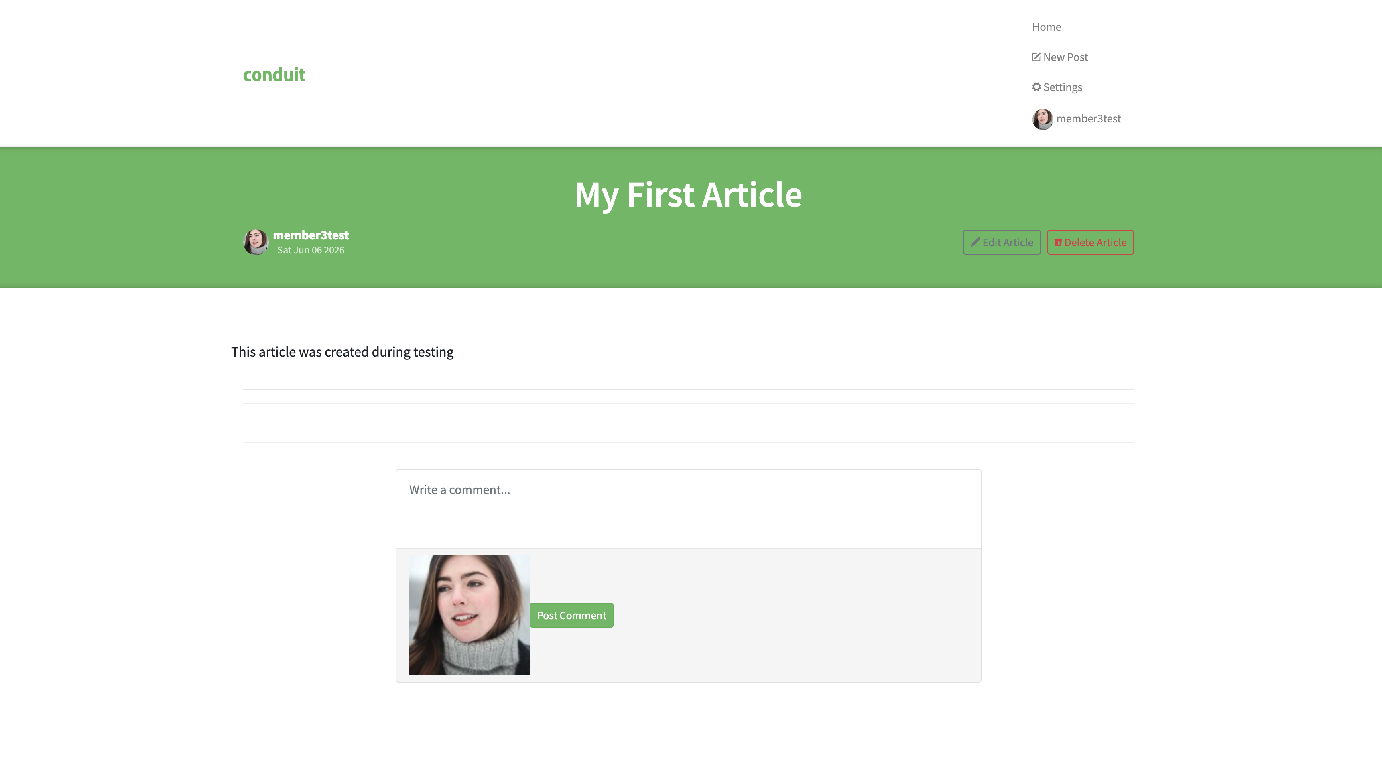  Did the article appear? Yes

TC-006 — Create article with missing title
Test Case ID | TC-006
Test Title | Create article with missing title
Tester Name | Than Soryapongs
Technique | Boundary Value Analysis — Sad Path
Pre-conditions | User is logged in and on the new article page
Test Steps | 1. Login to the app 2. Click New Article 3. Leave Title field empty 4. Fill Description: No title test 5. Fill Body: Testing missing title 6. Click Publish Article
Test Data | Title: (empty) | Description: No title test | Body: Testing missing title
Expected Result | An error message appears. Article is not published. User stays on the editor page.
Actual Result | As Expected
Status | Failed
Post-conditions | No article was created. Editor page remains open.
Screenshot | 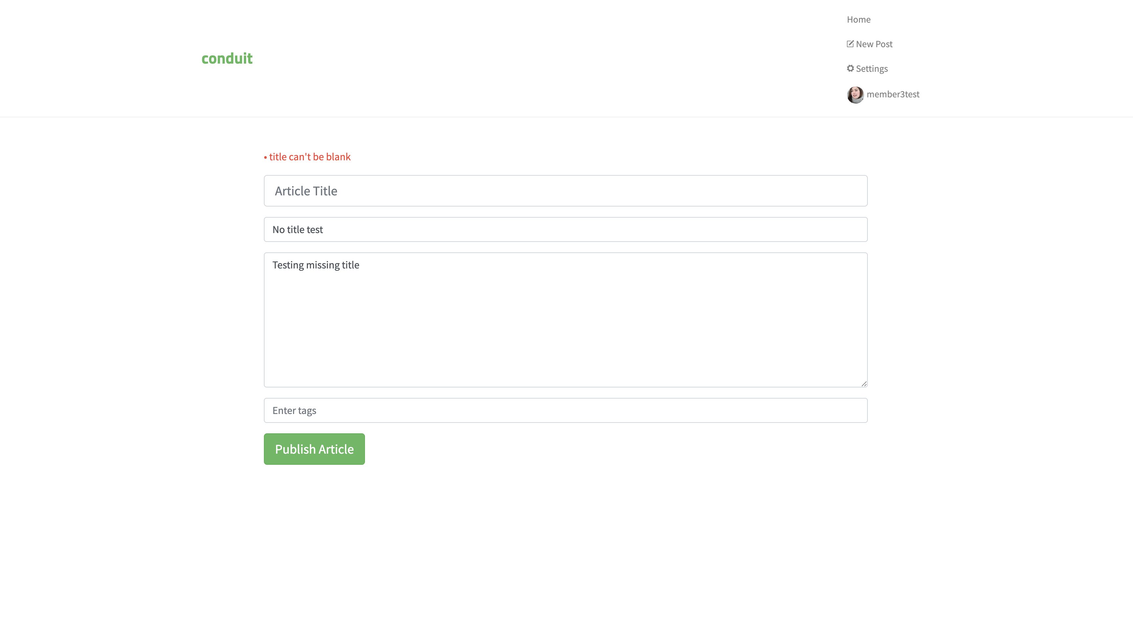  Did an error appear? Yes

TC-007 — Edit own article
Test Case ID | TC-007
Test Title | Edit own article
Tester Name | ( Member 4 name )
Technique | Equivalence Partitioning — Happy Path
Pre-conditions | User is logged in and has at least one published article
Test Steps | 1. Login to the app 2. Go to your profile and open your article 3. Click Edit Article 4. Change title to: My Edited Article 5. Click Publish Article
Test Data | New Title: My Edited Article
Expected Result | Article is updated with the new title. Changes appear immediately on the article page.
Actual Result | ( fill after testing )
Status | ( Pass / Fail / Blocked )
Post-conditions | ( fill after testing )
Screenshot | ( paste screenshot here )

TC-008 — Delete own article
Test Case ID | TC-008
Test Title | Delete own article
Tester Name | ( Member 4 name )
Technique | Equivalence Partitioning — Happy Path
Pre-conditions | User is logged in and has at least one published article
Test Steps | 1. Login to the app 2. Go to your profile and open your article 3. Click Delete Article
Test Data | Any article created by the logged-in user
Expected Result | Article is deleted. User is redirected. The article no longer appears on the profile page.
Actual Result | ( fill after testing )
Status | ( Pass / Fail / Blocked )
Post-conditions | ( fill after testing )
Screenshot | ( paste screenshot here )

TC-009 — Follow another user
Test Case ID | TC-009
Test Title | Follow another user
Tester Name | ( Member 5 name )
Technique | Equivalence Partitioning — Happy Path
Pre-conditions | User is logged in. At least one other user account exists in the system
Test Steps | 1. Login to the app 2. Click on any article on the home page 3. Click on the author name 4. Click the Follow button on their profile
Test Data | Any existing author profile in the app
Expected Result | Follow button changes to Unfollow. The author is added to the following list.
Actual Result | ( fill after testing )
Status | ( Pass / Fail / Blocked )
Post-conditions | ( fill after testing )
Screenshot | ( paste screenshot here )

TC-010 — Add comment to an article
Test Case ID | TC-010
Test Title | Add comment to an article
Tester Name | ( Member 5 name )
Technique | Equivalence Partitioning — Happy Path
Pre-conditions | User is logged in. At least one article exists in the system
Test Steps | 1. Login to the app 2. Click on any article on the home page 3. Scroll to the bottom 4. Type in the comment box: This is my test comment 5. Click Post Comment
Test Data | Comment text: This is my test comment
Expected Result | Comment appears below the article with the logged-in user's username and timestamp.
Actual Result | ( fill after testing )
Status | ( Pass / Fail / Blocked )
Post-conditions | ( fill after testing )
Screenshot | ( paste screenshot here )

Phase 1B — Investigative Testing (Charter Logs)
Each charter is a free 20-30 minute exploration session. Document everything you tried and found.

CH-001 — ( Member 2 name )
Charter ID | CH-001
Tester Name | ( Member 2 name )
Mission | Explore login and registration to find broken validation or security issues
Areas to Explore | Register page, login page, form validation, error messages, special characters in fields, empty fields
Start Time | ( e.g. 10:00 AM )
End Time | ( e.g. 10:30 AM )
Duration | ( e.g. 30 minutes )
What I Tried | ( describe your actions step by step )
Findings / Bugs | ( describe what you found, or write NONE )
Observations | ( anything unexpected or worth noting )
Screenshots | ( list screenshot filenames )

CH-002 — Than Soryapongs
Charter ID | CH-002
Tester Name | Than Soryapongs
Mission | Hunt for bugs in article creation and editing — look for missing validation and data issues
Areas to Explore | New article editor, publish flow, edit article, tag system, markdown rendering, very long text inputs
Start Time | 1:40 PM
End Time | 2:04 PM
Duration | 24 minutes
What I Tried | - Paste 10,000 characters into the title  - Add multiple tags at once  - Publish, then immediately edit and publish again
Findings / Bugs | - Tag is not storing into DB after published  - Title only exceeded 100 characters error but not display error message to interface
Observations | Inspect error in Browser DevTools
Screenshots | Tag is not storing into DB after published  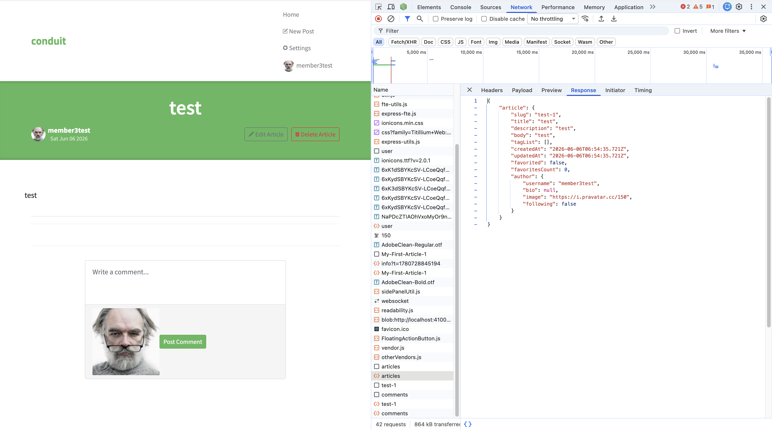  Title only exceeded 100 characters error but not display error message to interface  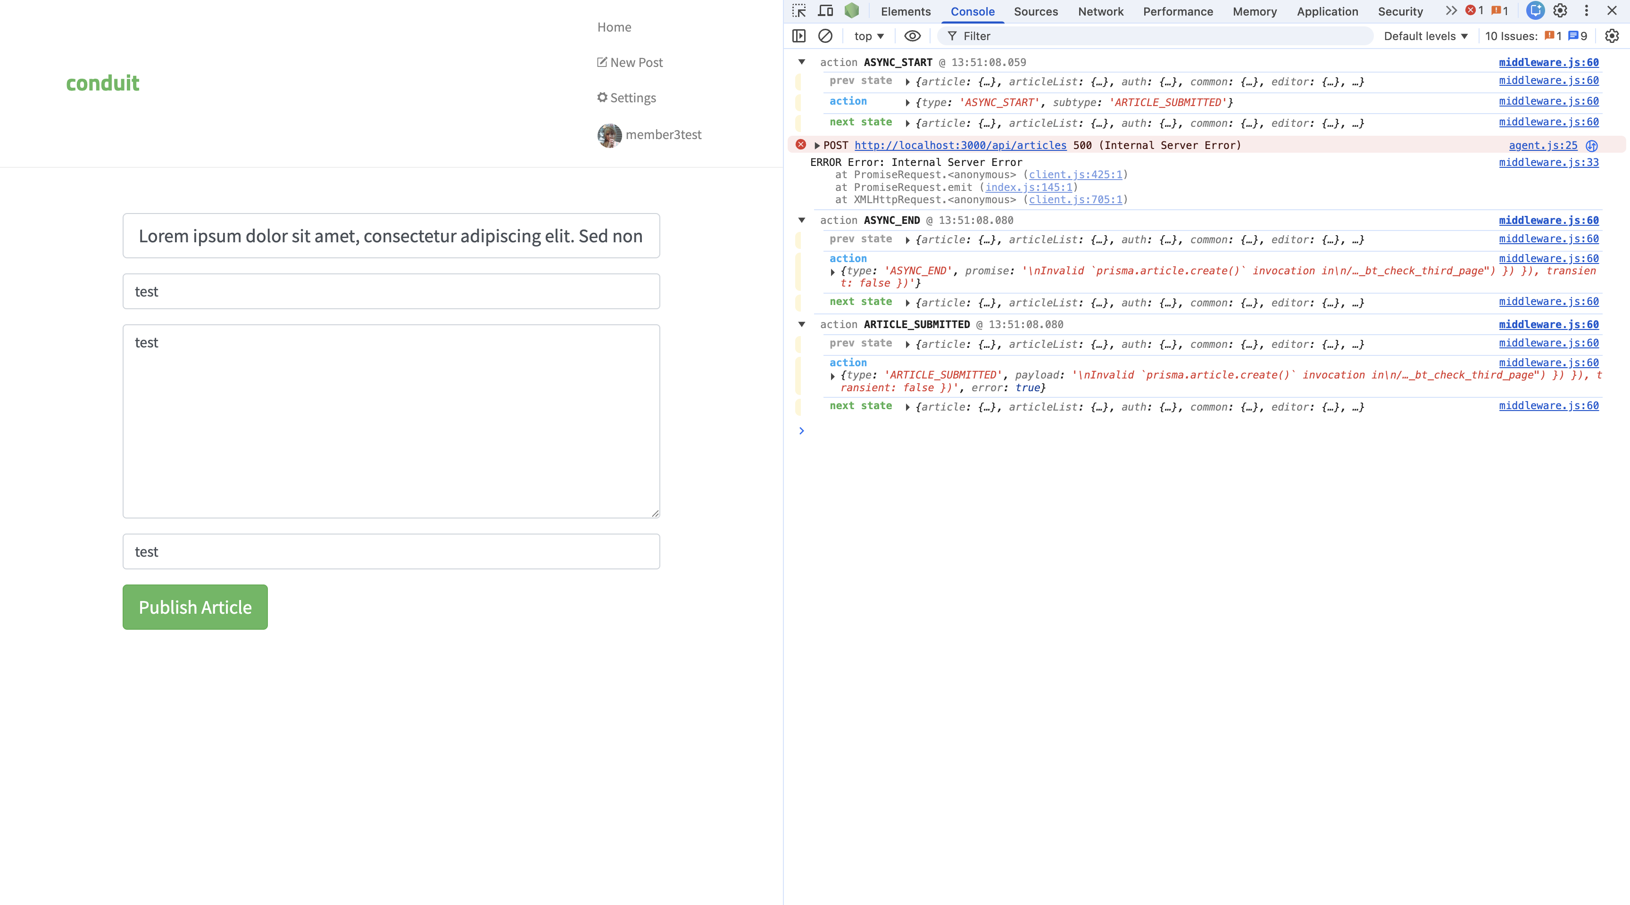

CH-003 — ( Member 4 name )
Charter ID | CH-003
Tester Name | ( Member 4 name )
Mission | Test concurrent and boundary behaviors using two browsers logged in to the same account
Areas to Explore | Two browsers same account, rapid clicking, follow and unfollow quickly, edit same article in two tabs
Start Time | ( e.g. 10:00 AM )
End Time | ( e.g. 10:30 AM )
Duration | ( e.g. 30 minutes )
What I Tried | ( describe your actions step by step )
Findings / Bugs | ( describe what you found, or write NONE )
Observations | ( anything unexpected or worth noting )
Screenshots | ( list screenshot filenames )

Phase 1C — Bug Reports
Fill one table per bug found during testing. Add more tables if needed.

BUG-001
Bug ID | BUG-001
Bug Title | ( short summary of the issue )
Reported By | ( your name )
Severity | ( Critical / Major / Minor )
Priority | ( P1 / P2 / P3 )
Environment | Browser: Chrome | OS: Windows | App: localhost:4100
Steps to Reproduce | ( 1. step one 2. step two 3. step three )
Expected Result | ( what should have happened )
Actual Result | ( what actually happened )
Evidence | ( paste screenshot here )
Status | New

BUG-002
Bug ID | BUG-002
Bug Title | ( short summary of the issue )
Reported By | ( your name )
Severity | ( Critical / Major / Minor )
Priority | ( P1 / P2 / P3 )
Environment | Browser: Chrome | OS: Windows | App: localhost:4100
Steps to Reproduce | ( 1. step one 2. step two 3. step three )
Expected Result | ( what should have happened )
Actual Result | ( what actually happened )
Evidence | ( paste screenshot here )
Status | New

BUG-003
Bug ID | BUG-003
Bug Title | ( short summary of the issue )
Reported By | ( your name )
Severity | ( Critical / Major / Minor )
Priority | ( P1 / P2 / P3 )
Environment | Browser: Chrome | OS: Windows | App: localhost:4100
Steps to Reproduce | ( 1. step one 2. step two 3. step three )
Expected Result | ( what should have happened )
Actual Result | ( what actually happened )
Evidence | ( paste screenshot here )
Status | New

Phase 2 — Engineering

2A — Unit Tests
Developer: Than Soryapongs
File: /unit-tests/users.test.js
Framework: Jest + Supertest
Total: 10 test cases — 6 happy path, 4 sad path

macbookpro@Kettos-MacBook-Pro backend % npx jest --runTestsByPath src/tests/users.test.ts
PASS api src/tests/users.test.ts
Users and Articles API checklist tests
✓ UT-001 Register with valid data (Happy Path) (16 ms)
✓ UT-002 Register with duplicate email (Sad Path) (4 ms)
✓ UT-003 Login with correct credentials (Happy Path) (2 ms)
✓ UT-004 Login with wrong password (Sad Path) (2 ms)
✓ UT-005 Login with missing email (Sad Path) (2 ms)
✓ UT-006 Create article with valid data (Happy Path) (2 ms)
✓ UT-007 Create article without title (Sad Path) (2 ms)
✓ UT-008 Create article without auth token (Sad Path) (2 ms)
✓ UT-009 Get all articles (Happy Path) (2 ms)
✓ UT-010 Delete article with valid auth (Happy Path) (2 ms)

Test Suites: 1 passed, 1 total
Tests: 10 passed, 10 total
Snapshots: 0 total
Time: 0.578 s, estimated 1 s
Ran all test suites within paths "src/tests/users.test.ts".

Test ID | Test Name | Type | Result
UT-001 | Register with valid data | Happy Path | Pass
UT-002 | Register with duplicate email | Sad Path | Pass
UT-003 | Login with correct credentials | Happy Path | Pass
UT-004 | Login with wrong password | Sad Path | Pass
UT-005 | Login with missing email | Sad Path | Pass
UT-006 | Create article with valid data | Happy Path | Pass
UT-007 | Create article without title | Sad Path | Pass
UT-008 | Create article without auth token | Sad Path | Pass
UT-009 | Get all articles | Happy Path | Pass
UT-010 | Delete article with valid auth | Happy Path | Pass

2B — Postman API Collection
Developer: Than Soryapongs
File: /postman/Group3_Conduit.postman_collection.json
Base URL: http://localhost:3000/api
Total requests: 10 | Each request has minimum 2 assertions

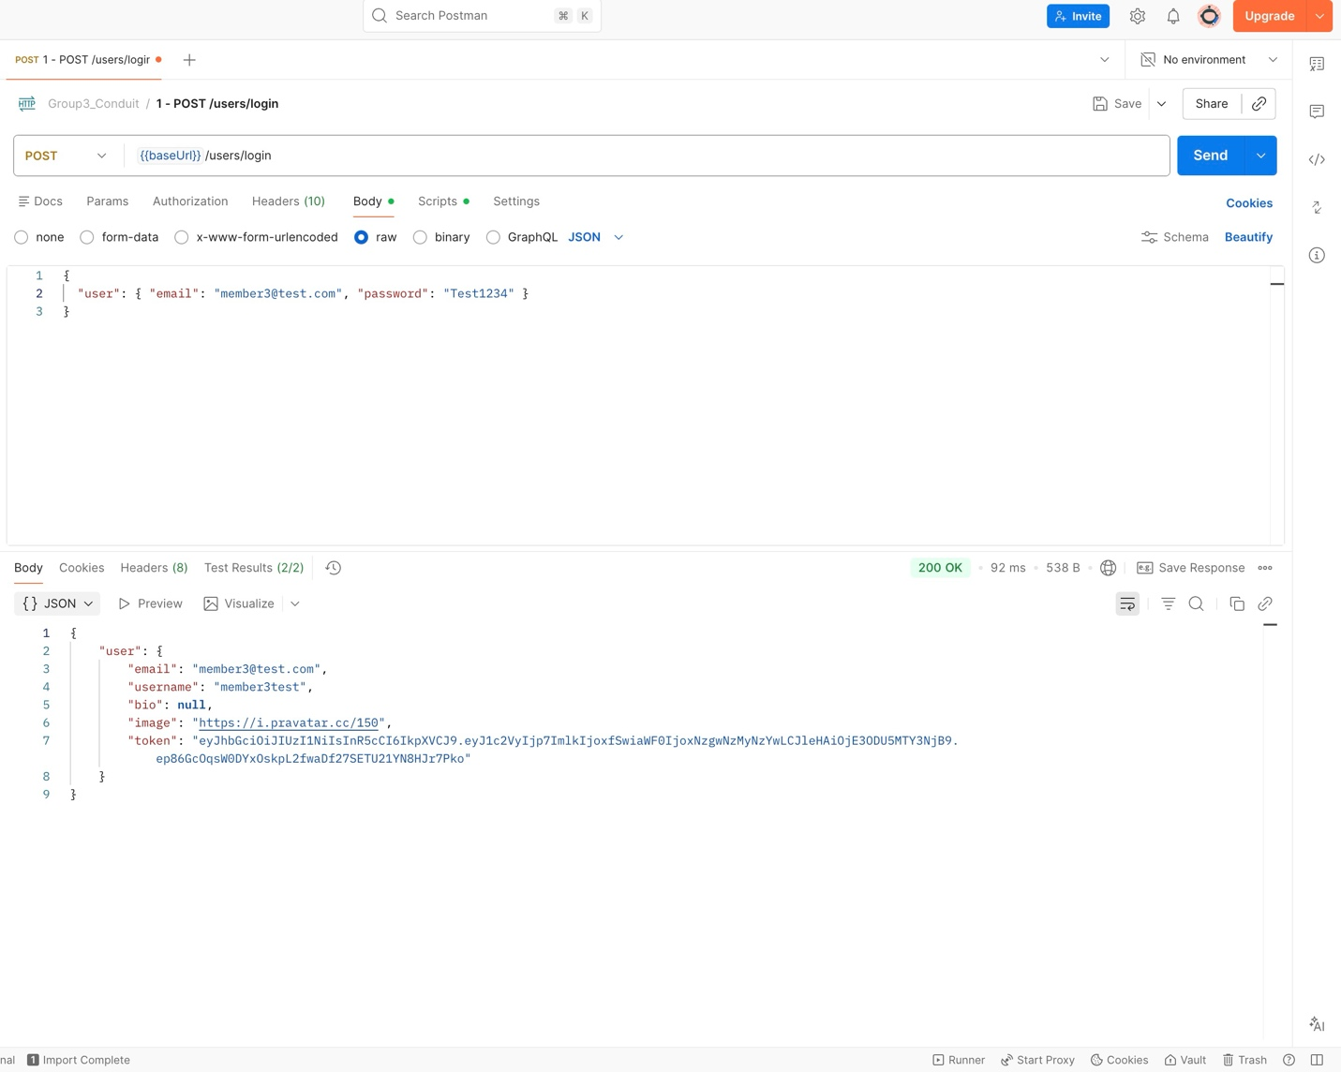
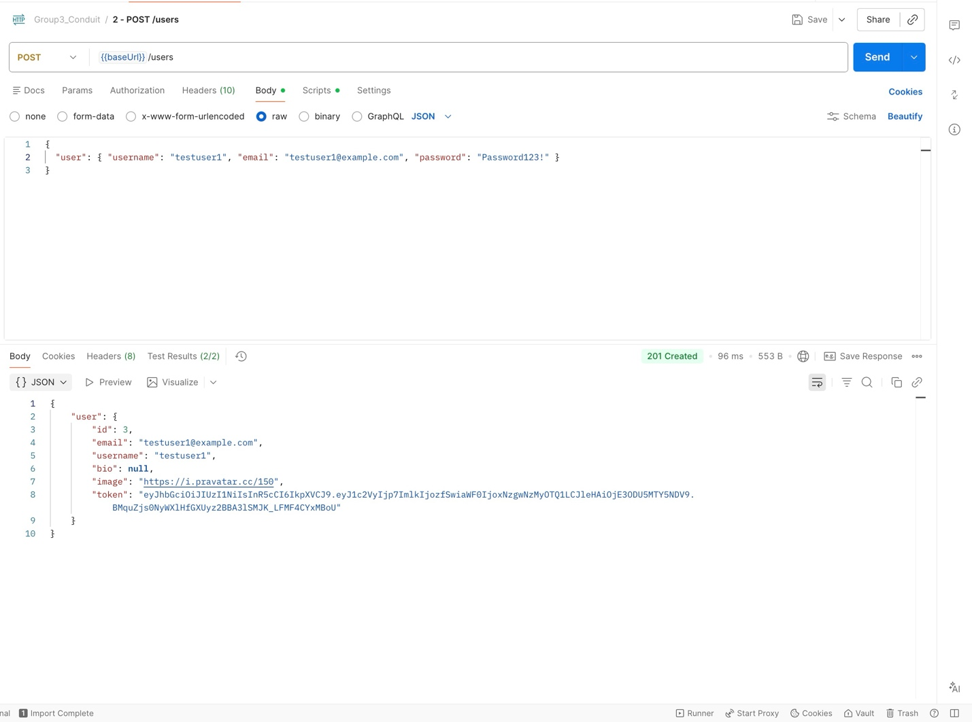
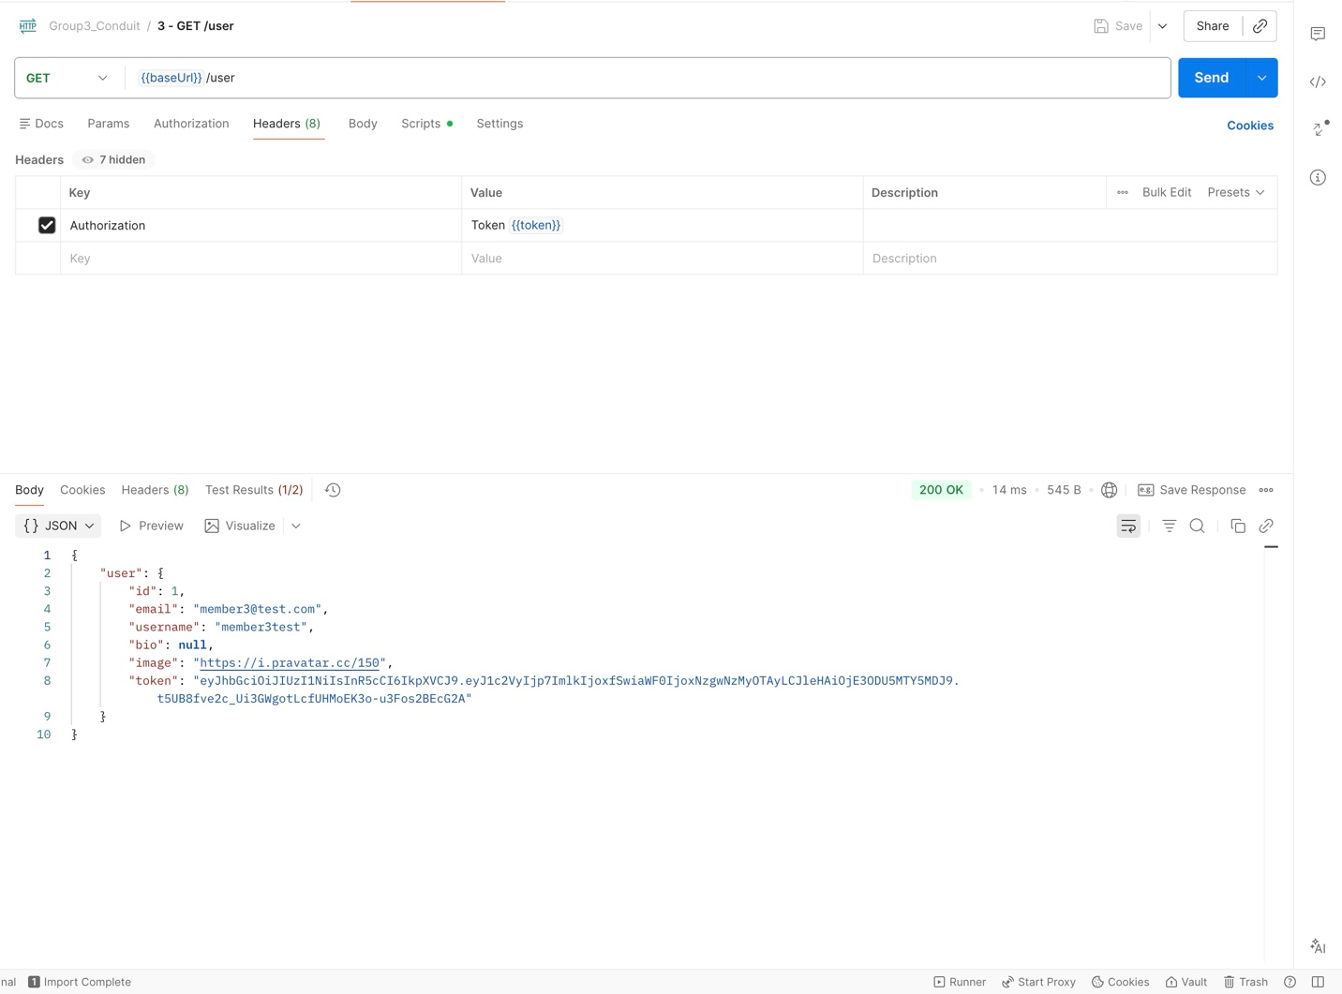
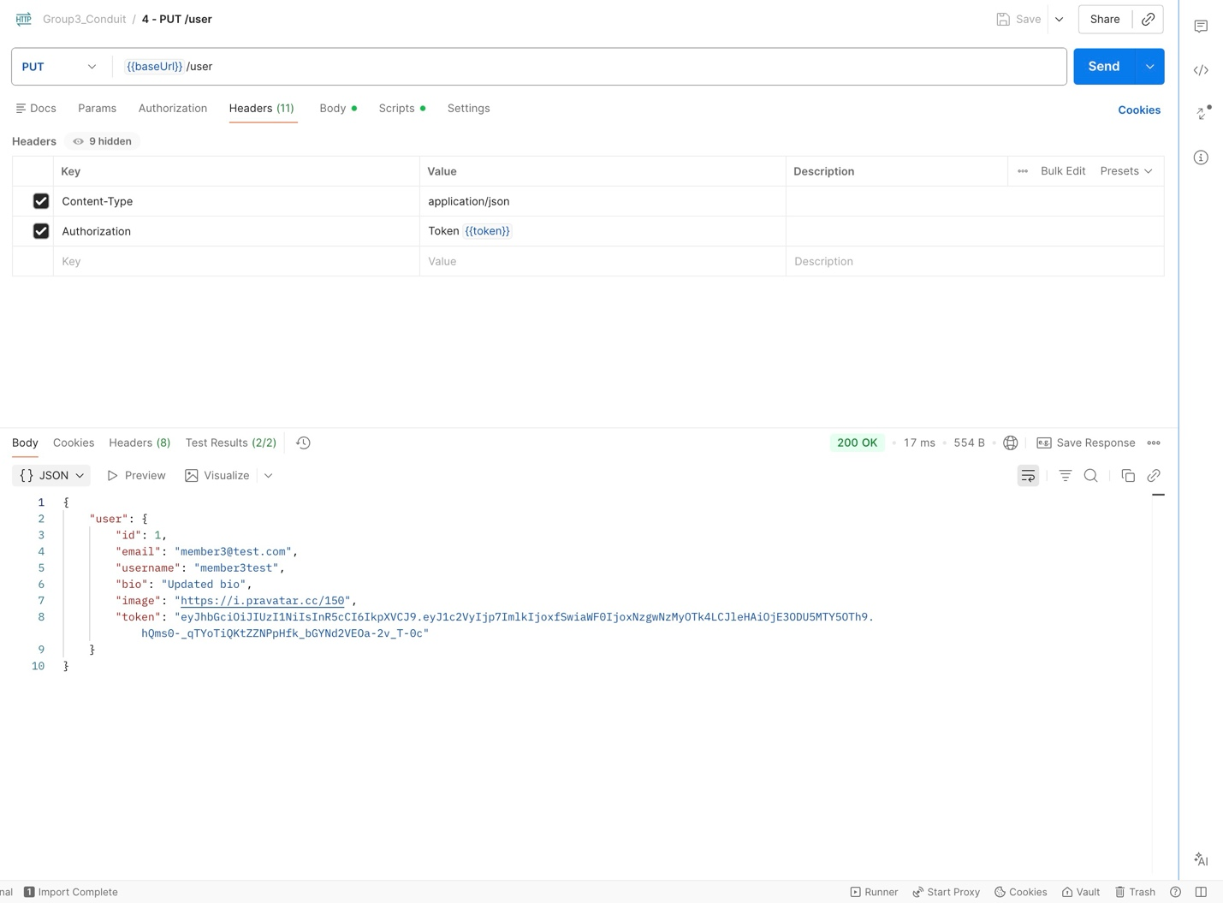
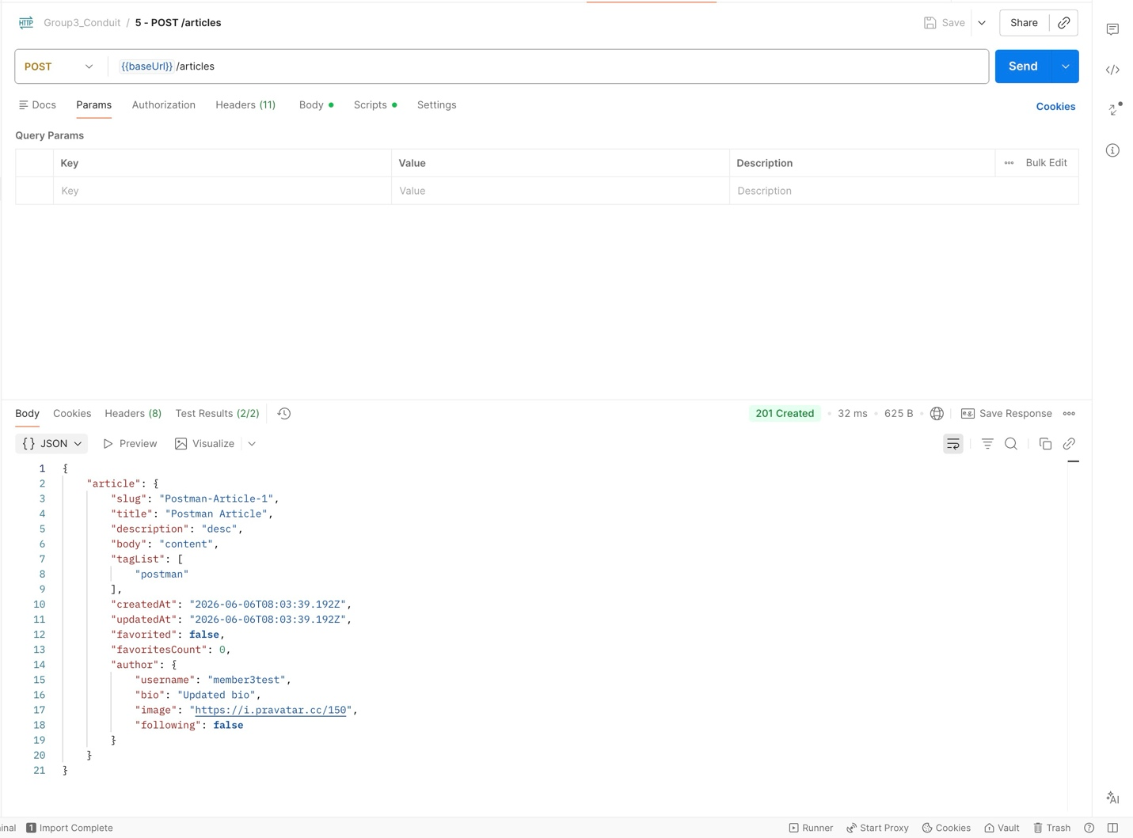
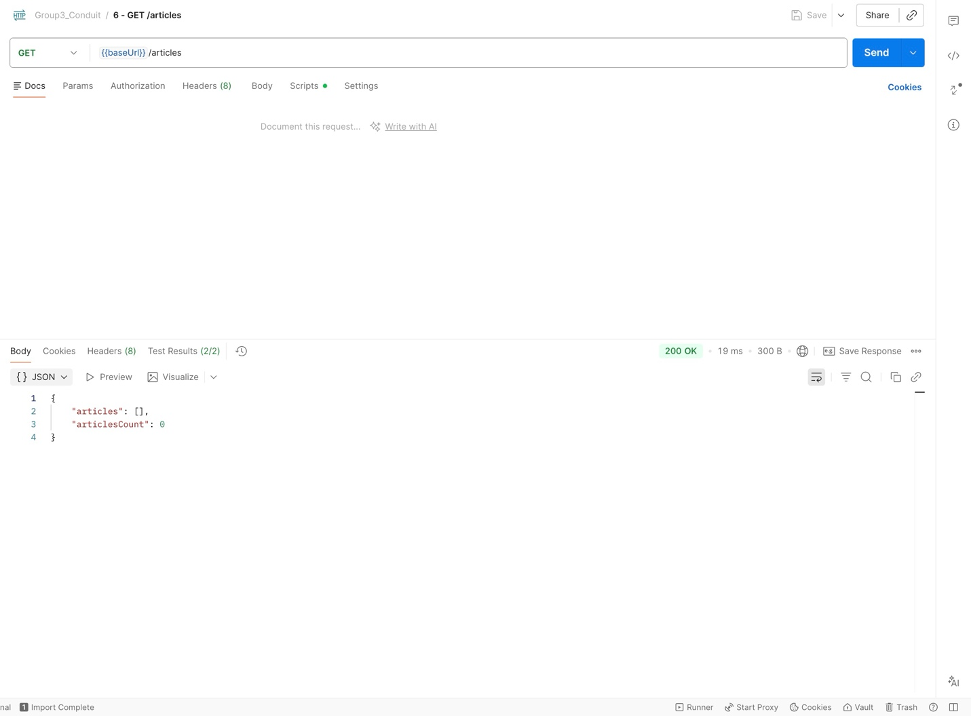
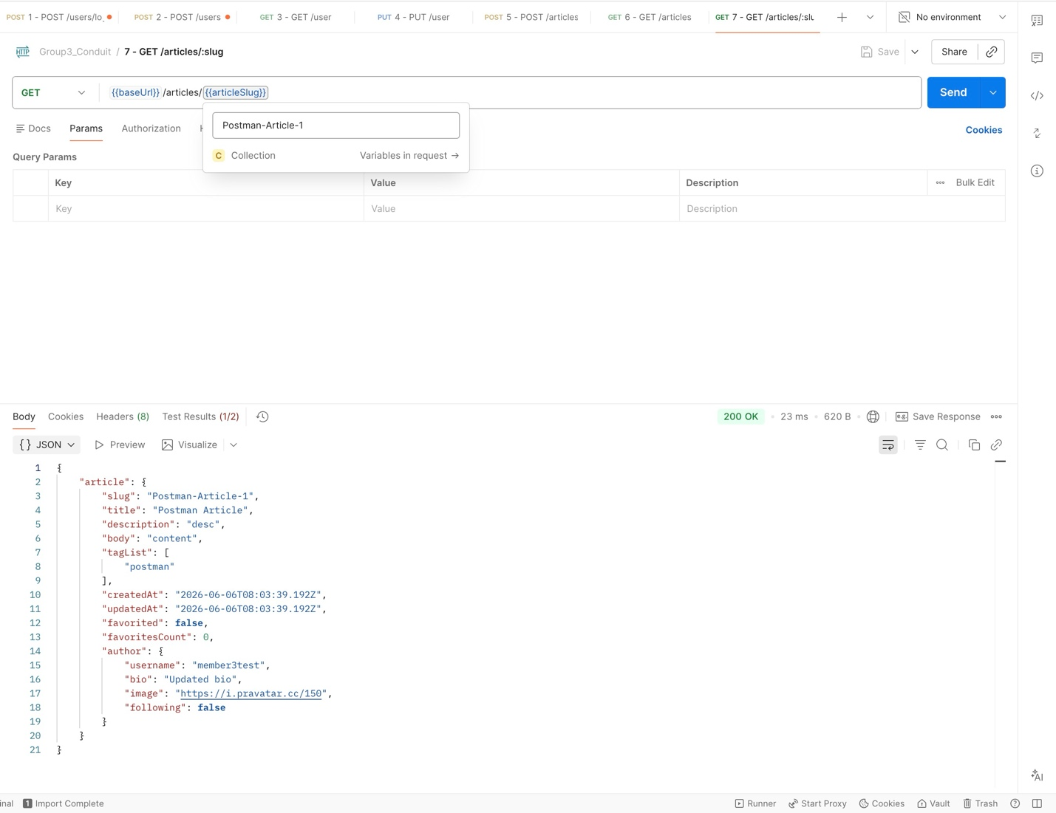
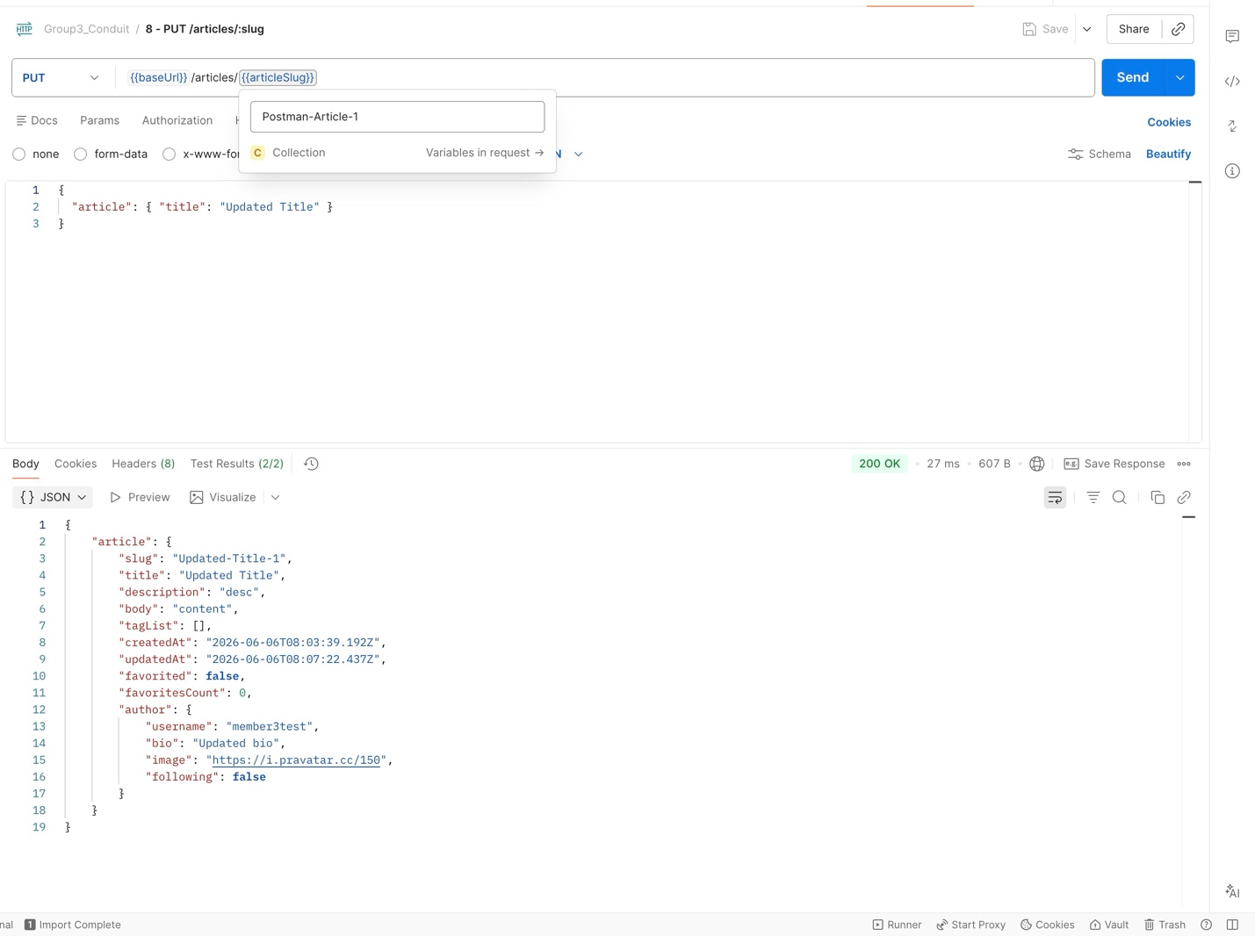
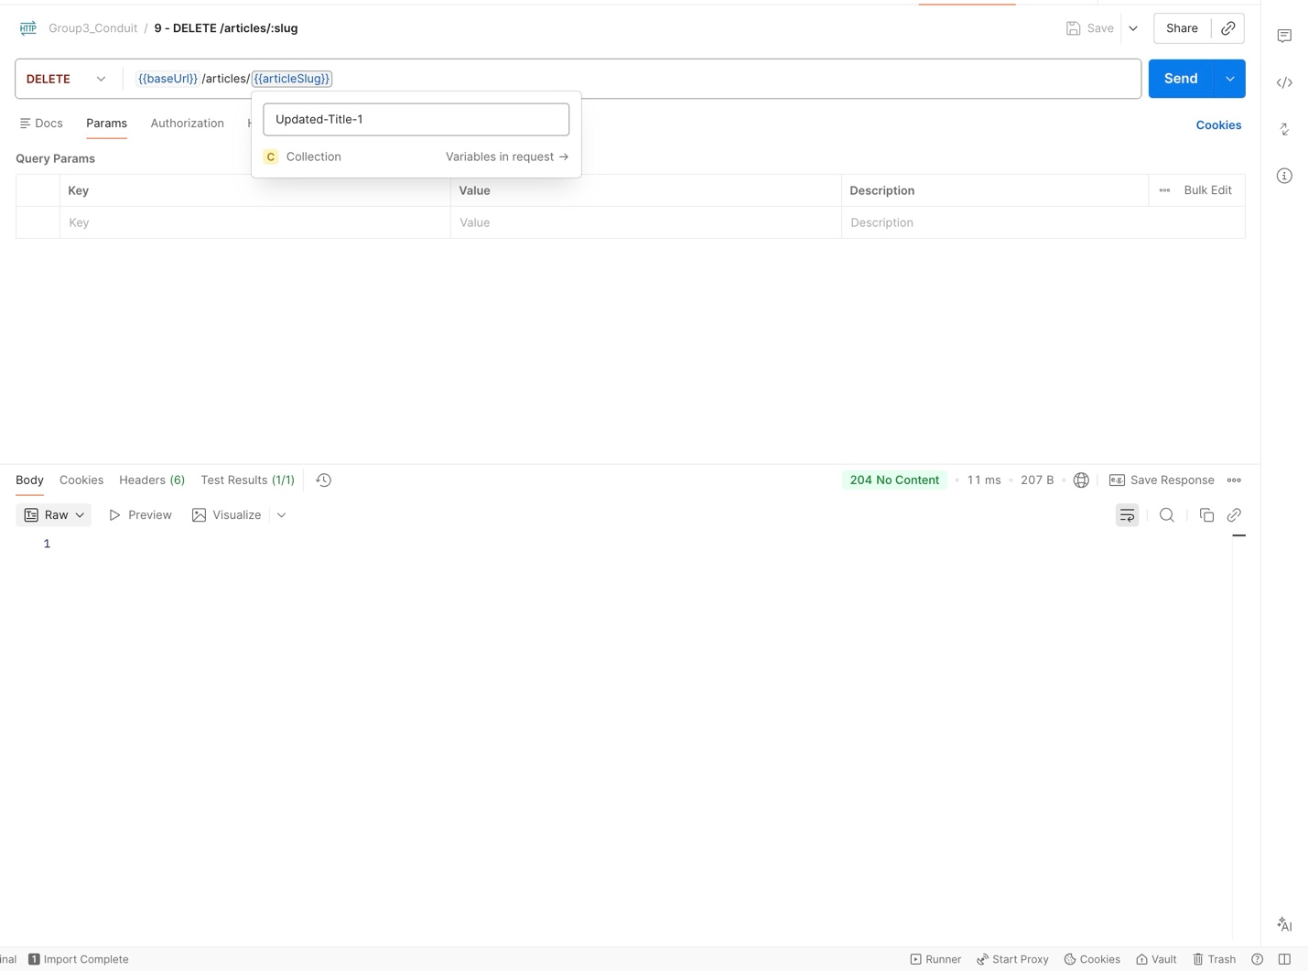
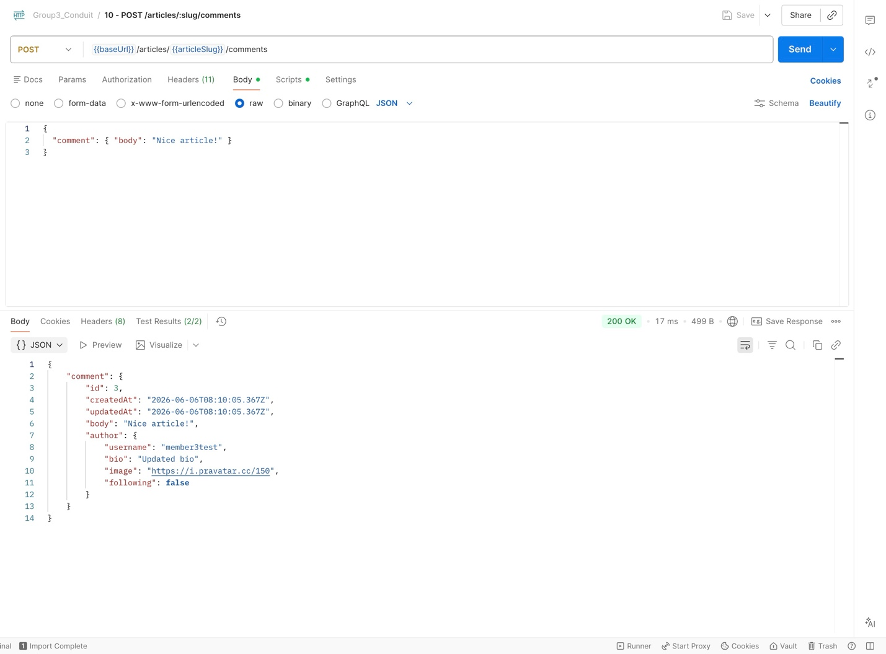

# | Method | Endpoint | Assertions | Result
1 | POST | /users/login | Status 200, token exists | Pass
2 | POST | /users | Status 201, user object | Pass
3 | GET | /user | Status 200, email matches | Pass
4 | PUT | /user | Status 200, updated field | Pass
5 | POST | /articles | Status 201, slug exists | Pass
6 | GET | /articles | Status 200, articles array | Pass
7 | GET | /articles/:slug | Status 200, correct slug | Pass
8 | PUT | /articles/:slug | Status 200, updated title | Pass
9 | DELETE | /articles/:slug | Status 204, No Content | Pass
10 | POST | /articles/:slug/comments | Status 200, comment body | Pass

2C — Playwright E2E Automation
Developer: ( Member 4 name )
File: /playwright/e2e.spec.js
Framework: Playwright

( Paste Playwright test results screenshot below this line )

Flow ID | Description | Result
E2E-001 | User registers and logs in — verify username appears in navbar | ( Pass / Fail )
E2E-002 | User logs in, creates article — verify article appears on profile page | ( Pass / Fail )

Phase 3 — Performance Analysis
Tester: ( Member 5 name )
Tool: JMeter
Target: GET http://localhost:3000/api/articles

Test Round | Concurrent Users | Avg Response Time | Error Rate
Baseline | 1 user | ( fill after test ) | ( fill after test )
Load Test 1 | 10 users | ( fill after test ) | ( fill after test )
Load Test 2 | 25 users | ( fill after test ) | ( fill after test )
Load Test 3 | 50 users | ( fill after test ) | ( fill after test )
Stress Test | ( max users ) | ( fill after test ) | ( fill after test )

Response Time vs Load Graph
( Paste JMeter graph screenshot here )

Bottleneck Analysis
Breaking point (number of users): ( fill after test )
Primary bottleneck: ( e.g. database connection timeout / CPU spike / memory limit )

Summary:
( Write 3 to 5 sentences here. Describe what happened during the stress test. At what user count did response time spike? What caused the failure? Example: The system handled up to X concurrent users with response times under 500ms. Beyond that point, response times increased sharply. The primary bottleneck was the MongoDB connection pool being exhausted, causing requests to queue and time out. )

GitHub Repository
Repository link: ( paste link here )

Folder / File | Description
/backend/ | Conduit Node.js + Express source code — committed by Member 1
/frontend/ | Conduit React.js source code — committed by Member 1
/unit-tests/users.test.js | Jest unit tests — committed by Member 3
/postman/*.json | Postman collection export — committed by Member 3
/playwright/e2e.spec.js | Playwright E2E scripts — committed by Member 4
/performance/*.jmx | JMeter test plan — committed by Member 5
/report/*.docx | This report — each member commits their section

