Software Quality Engineering
Test Report

Project Name | Conduit RealWorld Blog App
Group Number | Group 3
Project Path | Path A — The Integrator
Tech Stack | React.js, Node.js, Express.js, MongoDB
Submission Date | 6/6/24

Member 1 (Lead) | Gnan Antopou
Member 2 | Chron Rachana
Member 3 | Than Soryapongs
Member 4 | Nai Panhavorn
Member 5 | Hor Bunnareth

Phase 1A — Black-Box Test Cases
Each member tests their assigned cases, fills in the Actual Result, Status, and pastes their screenshot.

TC-001 — Register with valid data
Test Case ID | TC-001
Test Title | Register with valid data
Tester Name | ( Member 1 name )
Technique | Equivalence Partitioning
Pre-conditions | User is on the register page at localhost:4100/#/register
Test Steps | 1. Go to localhost:4100/#/register 2. Enter Username: testuser1 3. Enter Email: testuser1@test.com 4. Enter Password: Test1234 5. Click Sign Up
Test Data | Username: testuser1 | Email: testuser1@test.com | Password: Test1234
Expected Result | Account is created. User is redirected to home feed. Username appears in the navbar.
Actual Result | ( fill after testing )
Status | ( Pass / Fail / Blocked )
Post-conditions | ( fill after testing )
Screenshot | ( paste screenshot here )

TC-002 — Register with duplicate email
Test Case ID | TC-002
Test Title | Register with duplicate email
Tester Name | ( Member 1 name )
Technique | Equivalence Partitioning — Sad Path
Pre-conditions | An account with email testuser1@test.com already exists in the system
Test Steps | 1. Go to localhost:4100/#/register 2. Enter Username: testuser2 3. Enter Email: testuser1@test.com 4. Enter Password: Test1234 5. Click Sign Up
Test Data | Username: testuser2 | Email: testuser1@test.com (already used) | Password: Test1234
Expected Result | An error message appears saying the email is already taken. Account is not created.
Actual Result | ( fill after testing )
Status | ( Pass / Fail / Blocked )
Post-conditions | ( fill after testing )
Screenshot | ( paste screenshot here )

TC-003 — Login with correct credentials
Test Case ID | TC-003
Test Title | Login with correct credentials
Tester Name | ( Member 2 name )
Technique | Equivalence Partitioning — Happy Path
Pre-conditions | A registered account exists. User is on the login page at localhost:4100/#/login
Test Steps | 1. Go to localhost:4100/#/login 2. Enter Email: testuser1@test.com 3. Enter Password: Test1234 4. Click Sign In
Test Data | Email: testuser1@test.com | Password: Test1234
Expected Result | User is logged in. Home feed is displayed. Username shows in the top navbar.
Actual Result | ( fill after testing )
Status | ( Pass / Fail / Blocked )
Post-conditions | ( fill after testing )
Screenshot | ( paste screenshot here )

TC-004 — Login with wrong password
Test Case ID | TC-004
Test Title | Login with wrong password
Tester Name | ( Member 2 name )
Technique | Equivalence Partitioning — Sad Path
Pre-conditions | A registered account exists. User is on the login page
Test Steps | 1. Go to localhost:4100/#/login 2. Enter Email: testuser1@test.com 3. Enter Password: wrongpassword 4. Click Sign In
Test Data | Email: testuser1@test.com | Password: wrongpassword
Expected Result | An error message appears. User stays on the login page and is not logged in.
Actual Result | ( fill after testing )
Status | ( Pass / Fail / Blocked )
Post-conditions | ( fill after testing )
Screenshot | ( paste screenshot here )

TC-005 — Create article with all fields filled
Test Case ID | TC-005
Test Title | Create article with all fields filled
Tester Name | ( Member 3 name )
Technique | Equivalence Partitioning — Happy Path
Pre-conditions | User is logged in and on the new article page at localhost:4100/#/editor
Test Steps | 1. Login to the app 2. Click New Article in the navbar 3. Fill Title: My First Article 4. Fill Description: This is a test article 5. Fill Body: Article body content here 6. Fill Tags: testing 7. Click Publish Article
Test Data | Title: My First Article | Description: This is a test article | Tag: testing
Expected Result | Article is published. User is redirected to the article page. Article appears on their profile.
Actual Result | ( fill after testing )
Status | ( Pass / Fail / Blocked )
Post-conditions | ( fill after testing )
Screenshot | ( paste screenshot here )

TC-006 — Create article with missing title
Test Case ID | TC-006
Test Title | Create article with missing title
Tester Name | ( Member 3 name )
Technique | Boundary Value Analysis — Sad Path
Pre-conditions | User is logged in and on the new article page
Test Steps | 1. Login to the app 2. Click New Article 3. Leave Title field empty 4. Fill Description: No title test 5. Fill Body: Testing missing title 6. Click Publish Article
Test Data | Title: (empty) | Description: No title test | Body: Testing missing title
Expected Result | An error message appears. Article is not published. User stays on the editor page.
Actual Result | ( fill after testing )
Status | ( Pass / Fail / Blocked )
Post-conditions | ( fill after testing )
Screenshot | ( paste screenshot here )

TC-007 — Edit own article
Test Case ID | TC-007
Test Title | Edit own article
Tester Name | ( Member 4 name )
Technique | Equivalence Partitioning — Happy Path
Pre-conditions | User is logged in and has at least one published article
Test Steps | 1. Login to the app 2. Go to your profile and open your article 3. Click Edit Article 4. Change title to: My Edited Article 5. Click Publish Article
Test Data | New Title: My Edited Article
Expected Result | Article is updated with the new title. Changes appear immediately on the article page.
Actual Result | ( fill after testing )
Status | ( Pass / Fail / Blocked )
Post-conditions | ( fill after testing )
Screenshot | ( paste screenshot here )

TC-008 — Delete own article
Test Case ID | TC-008
Test Title | Delete own article
Tester Name | ( Member 4 name )
Technique | Equivalence Partitioning — Happy Path
Pre-conditions | User is logged in and has at least one published article
Test Steps | 1. Login to the app 2. Go to your profile and open your article 3. Click Delete Article
Test Data | Any article created by the logged-in user
Expected Result | Article is deleted. User is redirected. The article no longer appears on the profile page.
Actual Result | ( fill after testing )
Status | ( Pass / Fail / Blocked )
Post-conditions | ( fill after testing )
Screenshot | ( paste screenshot here )

TC-009 — Follow another user
Test Case ID | TC-009
Test Title | Follow another user
Tester Name | Hor Bunnareth
Technique | Equivalence Partitioning — Happy Path
Pre-conditions | User is logged in. At least one other user account exists in the system
Test Steps | 1. Login to the app  2. Click on any article on the home page  3. Click on the author name  4. Click the Follow button on their profile
Test Data | Any existing author profile in the app
Expected Result | Follow button changes to Unfollow. The author is added to the following list.
Actual Result | The Follow button changed to "Unfollow Jakub Kamau" after clicking the Follow button.
Status | Pass
Post-conditions | The logged-in user member5test is following Jakub Kamau.
Screenshot | Insert TC-009 screenshot showing the "Unfollow Jakub Kamau" button.
 | 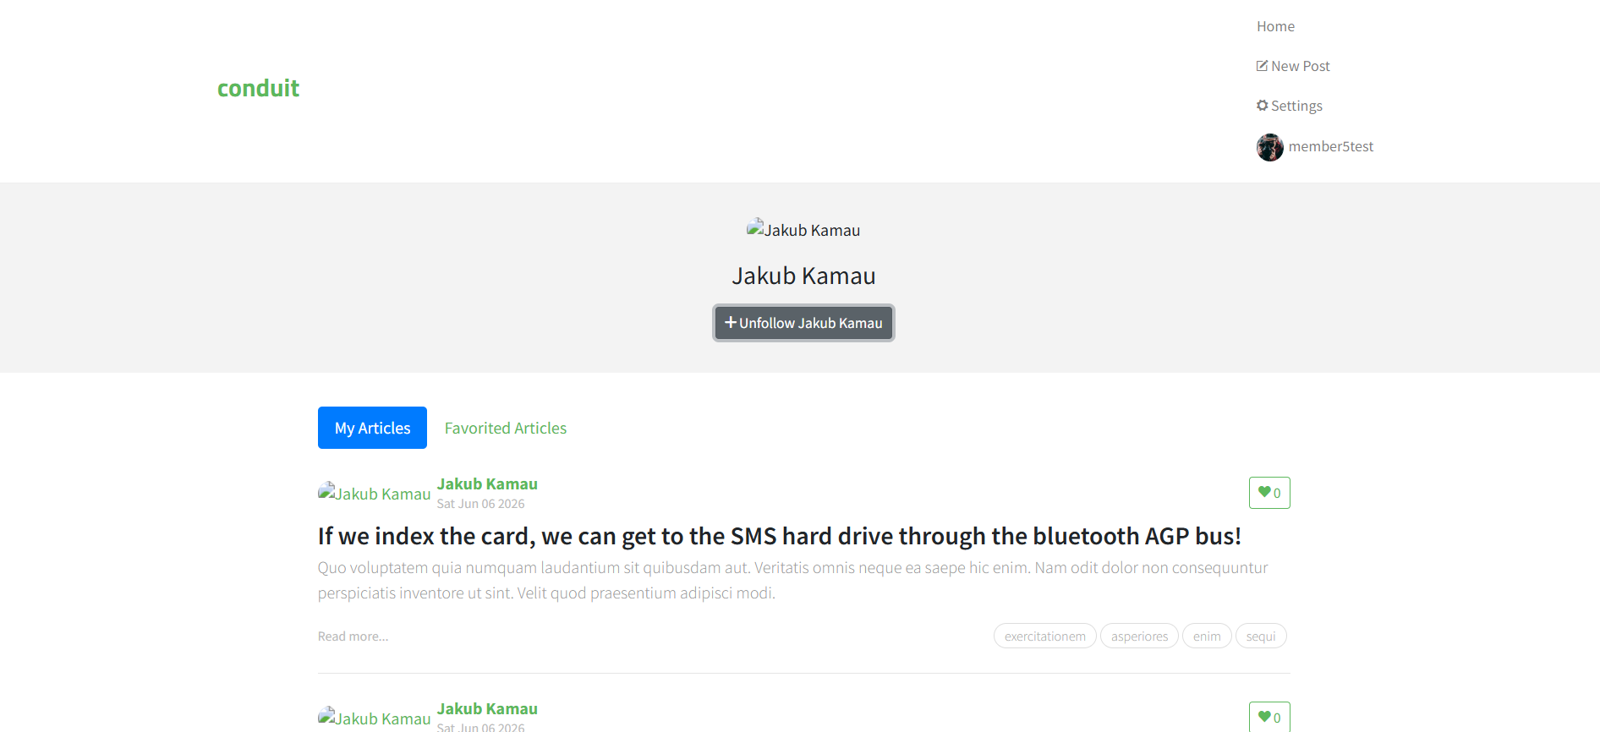

TC-010 — Add comment to an article
Test Case ID | TC-010
Test Title | Add comment to an article
Tester Name | Hor Bunnareth
Technique | Equivalence Partitioning — Happy Path
Pre-conditions | User is logged in. At least one article exists in the system
Test Steps | 1. Login to the app  2. Click on any article on the home page  3. Scroll to the bottom  4. Type in the comment box: This is my test comment  5. Click Post Comment
Test Data | Comment text: This is my test comment
Expected Result | Comment appears below the article with the logged-in user's username and timestamp.
Actual Result | The comment "This is my test comment" appeared under the article with the logged-in username member5test and timestamp.
Status | Pass
Post-conditions | The new comment remains visible under the selected article.
Screenshot | Insert TC-010 screenshot showing the posted comment: "This is my test comment".
 | 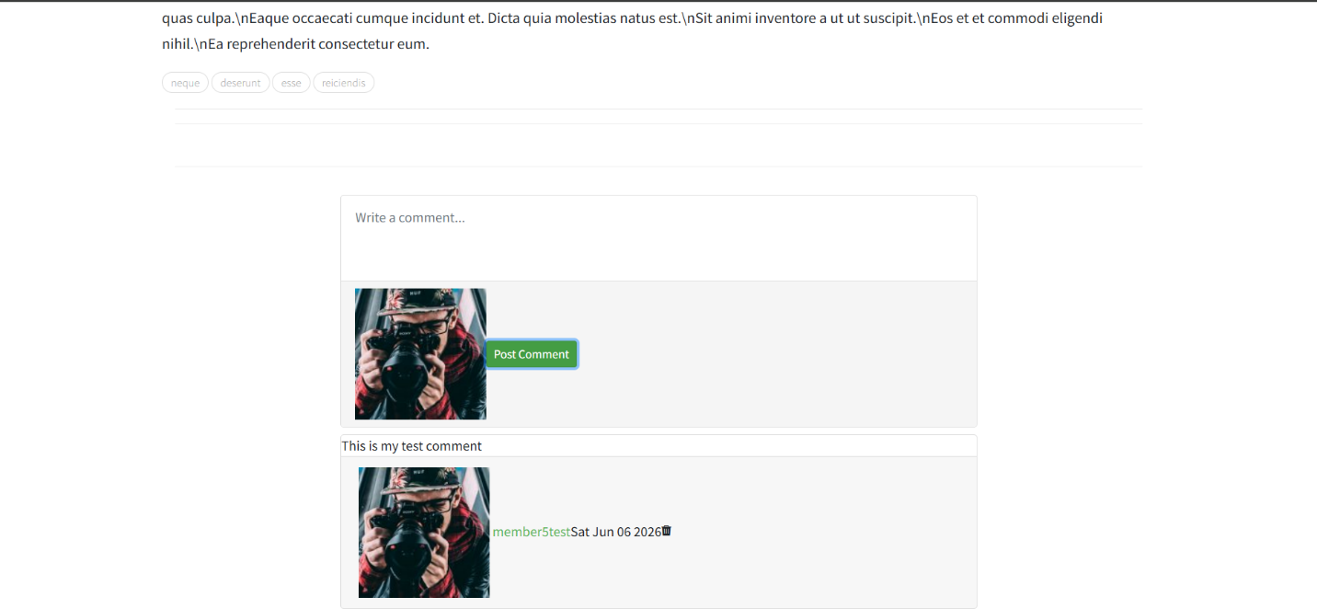

Phase 1B — Investigative Testing (Charter Logs)
Each charter is a free 20-30 minute exploration session. Document everything you tried and found.

CH-001 — ( Member 2 name )
Charter ID | CH-001
Tester Name | ( Member 2 name )
Mission | Explore login and registration to find broken validation or security issues
Areas to Explore | Register page, login page, form validation, error messages, special characters in fields, empty fields
Start Time | ( e.g. 10:00 AM )
End Time | ( e.g. 10:30 AM )
Duration | ( e.g. 30 minutes )
What I Tried | ( describe your actions step by step )
Findings / Bugs | ( describe what you found, or write NONE )
Observations | ( anything unexpected or worth noting )
Screenshots | ( list screenshot filenames )

CH-002 — ( Member 3 name )
Charter ID | CH-002
Tester Name | ( Member 3 name )
Mission | Hunt for bugs in article creation and editing — look for missing validation and data issues
Areas to Explore | New article editor, publish flow, edit article, tag system, markdown rendering, very long text inputs
Start Time | ( e.g. 10:00 AM )
End Time | ( e.g. 10:30 AM )
Duration | ( e.g. 30 minutes )
What I Tried | ( describe your actions step by step )
Findings / Bugs | ( describe what you found, or write NONE )
Observations | ( anything unexpected or worth noting )
Screenshots | ( list screenshot filenames )

CH-003 — ( Member 4 name )
Charter ID | CH-003
Tester Name | ( Member 4 name )
Mission | Test concurrent and boundary behaviors using two browsers logged in to the same account
Areas to Explore | Two browsers same account, rapid clicking, follow and unfollow quickly, edit same article in two tabs
Start Time | ( e.g. 10:00 AM )
End Time | ( e.g. 10:30 AM )
Duration | ( e.g. 30 minutes )
What I Tried | ( describe your actions step by step )
Findings / Bugs | ( describe what you found, or write NONE )
Observations | ( anything unexpected or worth noting )
Screenshots | ( list screenshot filenames )

Phase 1C — Bug Reports
Fill one table per bug found during testing. Add more tables if needed.

BUG-001
Bug ID | BUG-001
Bug Title | ( short summary of the issue )
Reported By | ( your name )
Severity | ( Critical / Major / Minor )
Priority | ( P1 / P2 / P3 )
Environment | Browser: Chrome | OS: Windows | App: localhost:4100
Steps to Reproduce | ( 1. step one 2. step two 3. step three )
Expected Result | ( what should have happened )
Actual Result | ( what actually happened )
Evidence | ( paste screenshot here )
Status | New

BUG-002
Bug ID | BUG-002
Bug Title | ( short summary of the issue )
Reported By | ( your name )
Severity | ( Critical / Major / Minor )
Priority | ( P1 / P2 / P3 )
Environment | Browser: Chrome | OS: Windows | App: localhost:4100
Steps to Reproduce | ( 1. step one 2. step two 3. step three )
Expected Result | ( what should have happened )
Actual Result | ( what actually happened )
Evidence | ( paste screenshot here )
Status | New

BUG-003
Bug ID | BUG-003
Bug Title | ( short summary of the issue )
Reported By | ( your name )
Severity | ( Critical / Major / Minor )
Priority | ( P1 / P2 / P3 )
Environment | Browser: Chrome | OS: Windows | App: localhost:4100
Steps to Reproduce | ( 1. step one 2. step two 3. step three )
Expected Result | ( what should have happened )
Actual Result | ( what actually happened )
Evidence | ( paste screenshot here )
Status | New

Phase 2 — Engineering

2A — Unit Tests
Developer: ( Member 3 name )
File: /unit-tests/users.test.js
Framework: Jest + Supertest
Total: 10 test cases — 6 happy path, 4 sad path

( Paste Jest test run screenshot below this line )

Test ID | Test Name | Type | Result
UT-001 | Register with valid data | Happy Path | ( Pass / Fail )
UT-002 | Register with duplicate email | Sad Path | ( Pass / Fail )
UT-003 | Login with correct credentials | Happy Path | ( Pass / Fail )
UT-004 | Login with wrong password | Sad Path | ( Pass / Fail )
UT-005 | Login with missing email | Sad Path | ( Pass / Fail )
UT-006 | Create article with valid data | Happy Path | ( Pass / Fail )
UT-007 | Create article without title | Sad Path | ( Pass / Fail )
UT-008 | Create article without auth token | Sad Path | ( Pass / Fail )
UT-009 | Get all articles | Happy Path | ( Pass / Fail )
UT-010 | Delete article with valid auth | Happy Path | ( Pass / Fail )

2B — Postman API Collection
Developer: ( Member 3 name )
File: /postman/Group3_Conduit.postman_collection.json
Base URL: http://localhost:3000/api
Total requests: 10 | Each request has minimum 2 assertions

( Paste Postman collection run screenshot below this line )

# | Method | Endpoint | Assertions | Result
1 | POST | /users/login | Status 200, token exists | ( Pass / Fail )
2 | POST | /users | Status 201, user object | ( Pass / Fail )
3 | GET | /user | Status 200, email matches | ( Pass / Fail )
4 | PUT | /user | Status 200, updated field | ( Pass / Fail )
5 | POST | /articles | Status 201, slug exists | ( Pass / Fail )
6 | GET | /articles | Status 200, articles array | ( Pass / Fail )
7 | GET | /articles/:slug | Status 200, correct slug | ( Pass / Fail )
8 | PUT | /articles/:slug | Status 200, updated title | ( Pass / Fail )
9 | DELETE | /articles/:slug | Status 200 | ( Pass / Fail )
10 | POST | /articles/:slug/comments | Status 200, comment body | ( Pass / Fail )

2C — Playwright E2E Automation
Developer: ( Member 4 name )
File: /playwright/e2e.spec.js
Framework: Playwright

( Paste Playwright test results screenshot below this line )

Flow ID | Description | Result
E2E-001 | User registers and logs in — verify username appears in navbar | ( Pass / Fail )
E2E-002 | User logs in, creates article — verify article appears on profile page | ( Pass / Fail )

Phase 3 — Performance Analysis
Tester: Hor Bunnareth
Tool: JMeter
Target: GET http://localhost:3000/api/articles

Test Round | Concurrent Users | Avg Response Time | Error Rate
Baseline | 1 user | ( 13 ms ) | (0.00%)
Load Test 1 | 10 users | ( 6ms ) | (0.00% )
Load Test 2 | 25 users | ( 6 ms ) | (0.00% )
Load Test 3 | 50 users | ( 6 ms ) | (0.00% )
Stress Test | Not performed |  | (0.00% )

Response Time vs Load Graph

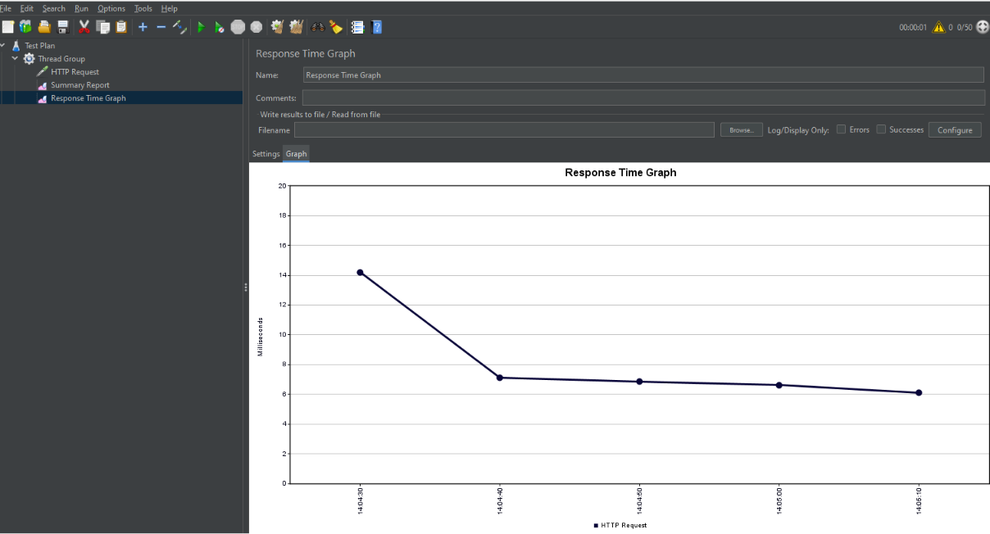
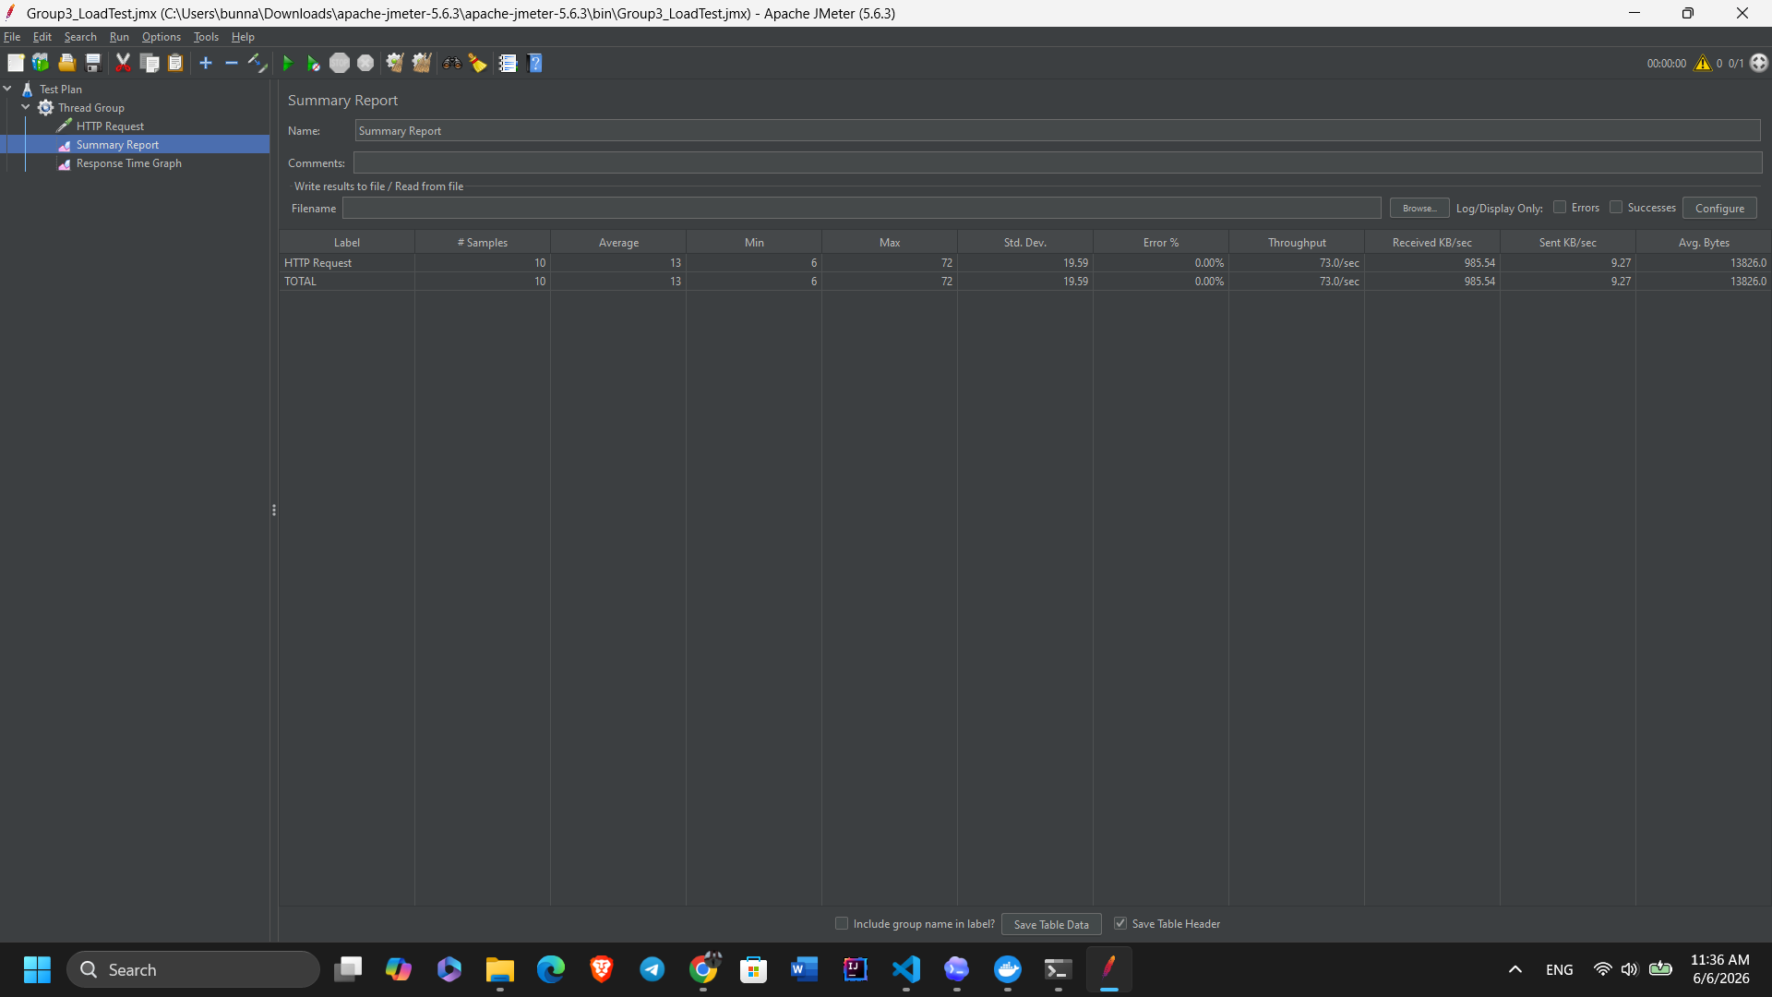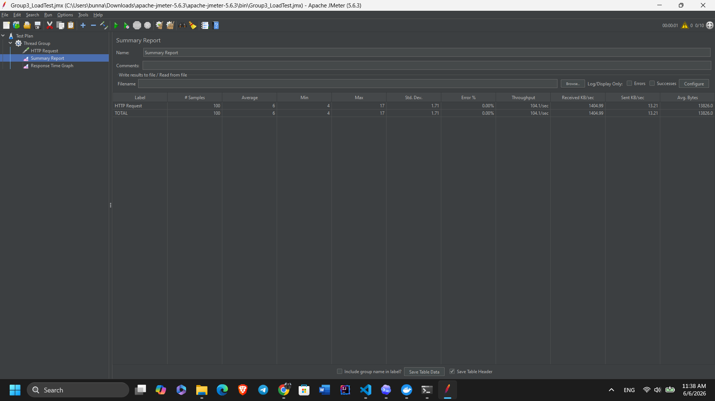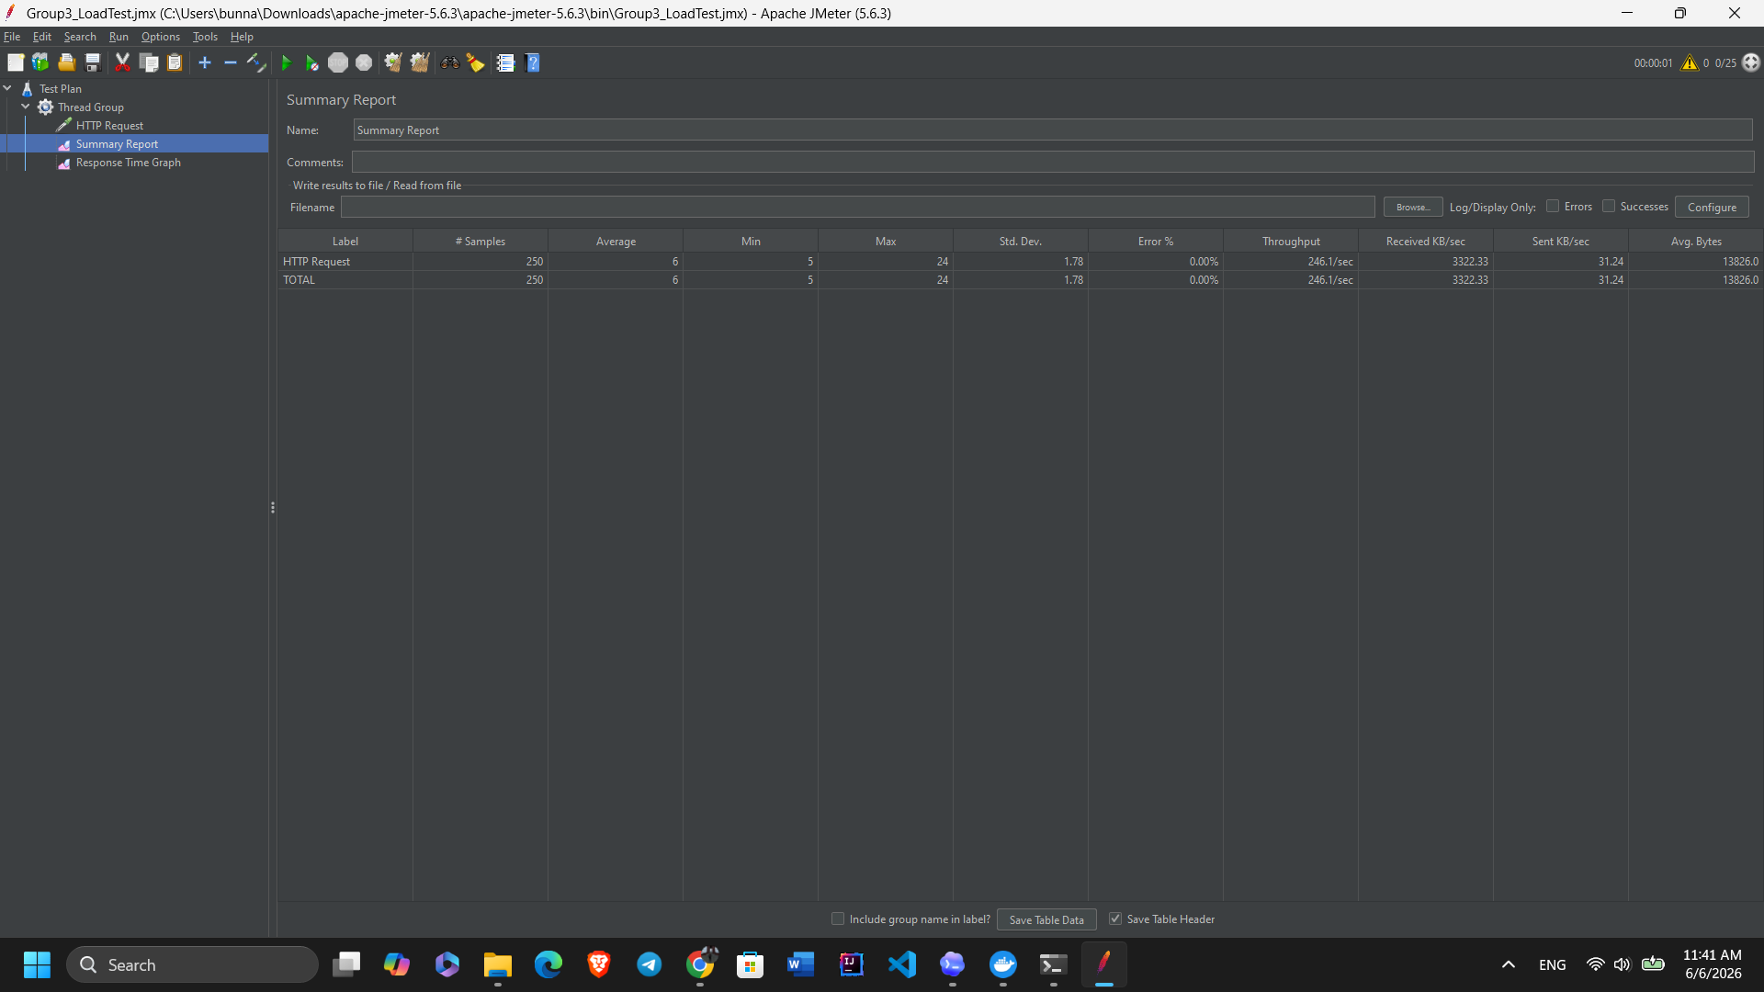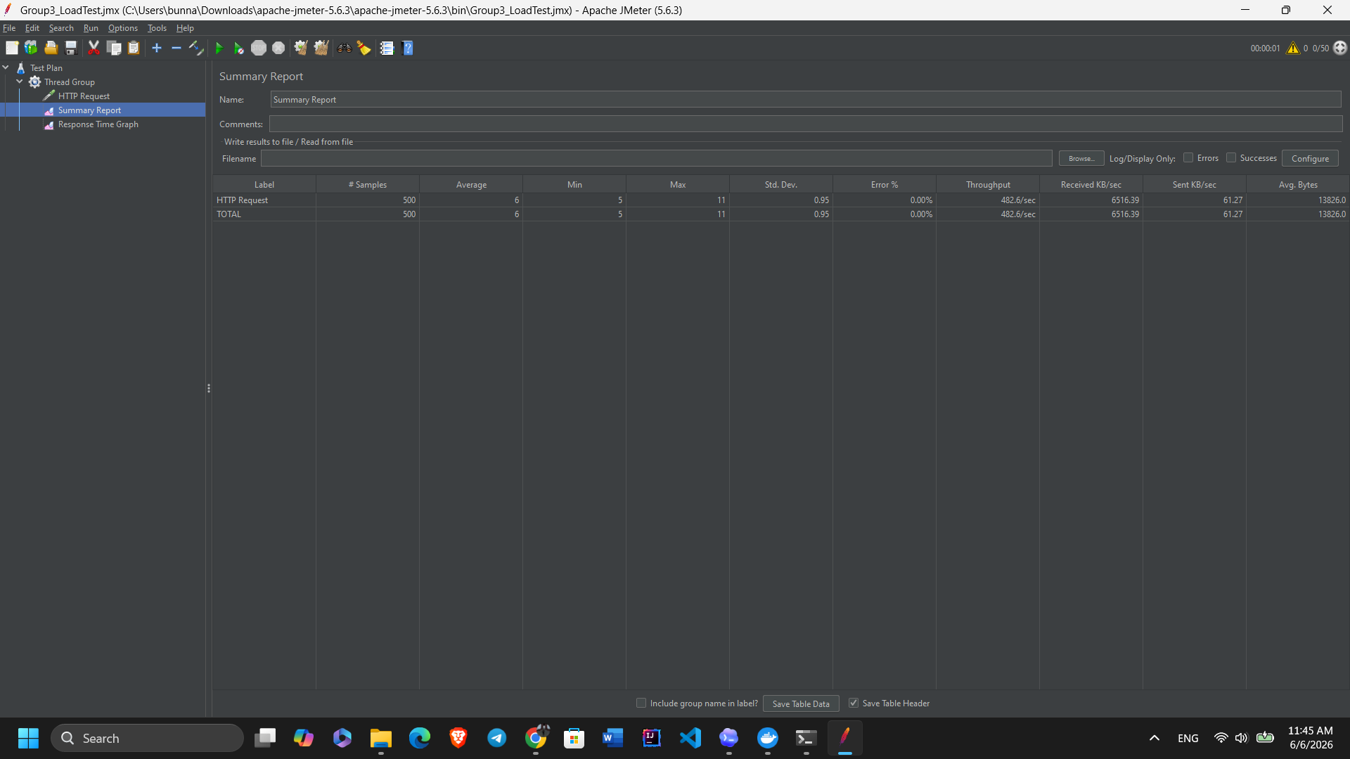

Bottleneck Analysis
Breaking point (number of users): (Not reached during the test, up to 50 concurrent users.)
Primary bottleneck: (No bottleneck was observed during the tested load range.)

Summary:
The application did not show a slowdown during the tested load range from 1 to 50 concurrent users. The average response time stayed low, around 6-13 ms, and the error rate remained 0.00% for all rounds. Based on these results, the system did not reach its breaking point during this JMeter test. A higher number of users or a longer test duration would be needed to identify the actual bottleneck.

GitHub Repository
Repository link: https://github.com/Antopou/group3-conduit-qe

Folder / File | Description
/backend/ | Conduit Node.js + Express source code — committed by Member 1
/frontend/ | Conduit React.js source code — committed by Member 1
/unit-tests/users.test.js | Jest unit tests — committed by Member 3
/postman/*.json | Postman collection export — committed by Member 3
/playwright/e2e.spec.js | Playwright E2E scripts — committed by Member 4
/performance/*.jmx | JMeter test plan — committed by Member 5
/report/*.docx | This report — each member commits their section

