



**COURSE TITLE:** Database System Lab

**COURSE CODE:** CSE 210

## EXPERIMENT NO.: 01

**EXPERIMENT NAME: All the Queries** *(Create to Delete)*

**DATE OF PERFORMANCE:** 18/06/2021 & 25/06/2021

**DATE OF SUBMISSION:** 07/07/2021

|  |  |
| --- | --- |
| SUBMITTED TO:  **Name: Umme Habiba Designation: Lecturer Department of CSE**  **Green University of Bangladesh** | SUBMITTED BY:  **Name: Mst.Bithy Khatun ID: 193015065**  **Batch No.: 193 EC Department of CSE**  **Green University of Bangladesh** |

**REMARKS**

**Made in Corona Situation**

# Create DataBase:

----Create the Database---

CREATE DATABASE University;

# Screenshot:

# 

# Use DataBase:

---- Use the Databse ----

USE University;

# Screenshot:

# 

# Create Table:

----- Create the table ----

CREATE TABLE Student (

ID INT NOT NULL Primary Key,

Name VARCHAR(30) NOT NULL,

Email VARCHAR(30) NOT NULL,

Batch VARCHAR(20),

Section VARCHAR(30),

Department VARCHAR(30),

);

CREATE TABLE Teacher (

ID INT NOT NULL Primary Key,

Name VARCHAR(30) NOT NULL,

Email VARCHAR(30) NOT NULL,

Department VARCHAR(30),

# );

# Screenshot:

# 

# Insert Data:

---- Data insert ----

INSERT INTO Student VALUES

(101, 'Trisha', 'trishaakter@gmail.com', '191', 'EB', 'CSE'),

(102, 'Shammi', 'shammiahmed@gmail.com', '192', 'EA', 'EEE'),

(103, 'Radee', 'radee0255@gmail.com', '193', 'EC', 'English'),

(104, 'Shuvo', 'shuvo303030@gmail.com', '182', 'EA', 'EEE'),

(105, 'Bithy', 'bithyakter@gmail.com', '201', 'EB', 'CSE');

INSERT INTO Teacher VALUES

(011, 'Aimunnesa Nodi', 'aimunnesanodi@gmail.com', 'CSE'),

(012, 'Shamima Ahmed', 'shamimaahmed@gmail.com', 'EEE'),

(013, 'Rahatul Rahat', 'rahatulrahat@gmail.com', 'English'),

# (014, 'Abdur Rashid', 'abdurrashid@gmail.com', 'CSE');

# Screenshot:

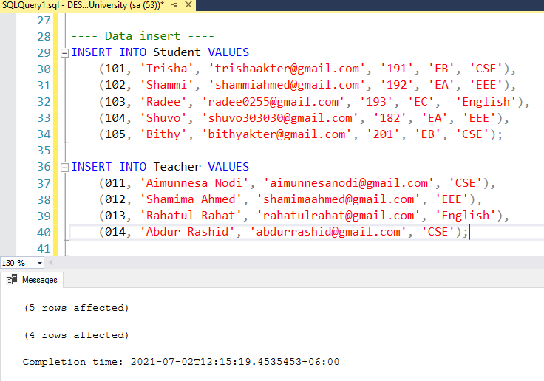

# Describe Table:

---- Show table info ---

SELECT * FROM Student;

SELECT * FROM Teacher;

# Screenshot:

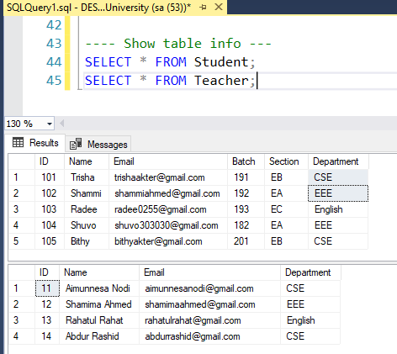

# Drop Query:

----Drop Query----

-- DROP Database

DROP Database University;

-- DROP Table

DROP table Student;

DROP table Teacher;

# Screenshot:

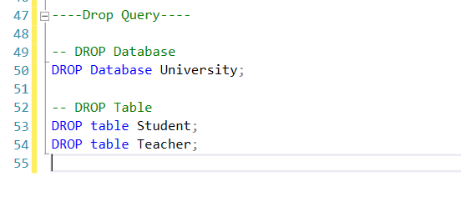

# Select & Where Query:

---- SELECT & WHERE QUERY ---

SELECT * FROM Student WHERE ID=102;

SELECT * FROM Teacher WHERE Name='Shamima Ahmed';

# SELECT * FROM Teacher WHERE Department='CSE';

# Screenshot:

# 

# Where Condition:

--Between

SELECT * FROM Student

WHERE ID BETWEEN 101 AND 104;

--Like Search

SELECT * FROM Student

# WHERE Name LIKE 's%';

# Screenshot:

# 

# Primary key & Foreign key:

----- Primary key and Foreign key ----

CREATE TABLE StudentInfo (

StudentID INT NOT NULL Primary Key,

Name VARCHAR(30) NOT NULL,

Email VARCHAR(30) NOT NULL,

Batch VARCHAR(20),

Section VARCHAR(30),

Department VARCHAR(30),

ID int FOREIGN KEY REFERENCES Teacher(ID)

# );

# Screenshot:

# 

# Update Query:

--- Update Query----

update Student

set ID = 2

where ID=102;

# SELECT * FROM Student

# Screenshot:

# 

# Delete Query:

--- Delete Query----

delete from Teacher

where Department='English'

# Screenshot:

