**SSD: Single Shot Multibox Detector**

Antu, Asif Ikbal

*Department of Computer Sciences, American International University-Bangladesh*

# Abstract

This report presents an implementation of Single Shot Multibox Detector (SSD) model. Deep learning is emerging as a powerful tool and has become a leading machine learning tool in computer vision and image analysis. SSD is designed for object detection in real-time. Faster R-CNN uses a region proposal network to create boundary boxes and utilizes those boxes to classify objects. The implementation and working principle have discussed in this report.

*Keywords:* Deep learning, Computer Vision, Object detection, SSD

# Introduction

SSD is designed for object detection in real-time. Faster R-CNN uses a region proposal network to create boundary boxes and utilizes those boxes to classify objects. While it is considered the start-of-the-art in accuracy, the whole process runs at 7 frames per second. Far below what real-time processing needs. SSD speeds up the process by eliminating the need for the region proposal network. To recover the drop in accuracy, SSD applies a few improvements including multi-scale features and default boxes. These improvements allow SSD to match the Faster R-CNN’s accuracy using **lower resolution images**, which further pushes the speed higher. According to the following comparison, it achieves the real-time processing speed and even beats the accuracy of the Faster R-CNN. (Accuracy is measured as the mean average precision mAP: the precision of the predictions.)

# Literature Review

1. Single Shot Detector is a name like YOLO providing results through a single shot.Proposed regions are not choosen in the CNN.A countable number of features extraction is processed in the way and a particular area is obtained in some feaure layers.In the next step,CNN layer is applied in the extracted feature layer.
2. At first our image processes through some convolutions to feature extraction.Through this step,we get a feature layer which is m*n*p (channels)Our Image will be divided into different size scaled boxes with different aspect ratio.
3. And then each of the bounding boxes are computed c class scores and offset relative with the original default bounding box shapes.And then we get output.
4. Now every training image is sampled randomly with original input image and Randomly sample a patch.Now each patch is of [0,1,1] or original size.
5. Now SSD may not be an effiecnt model but it sure gives us more accuracy and truth.If we compare with yolo,it gives us efficiency but fails to be more accurate.
6. 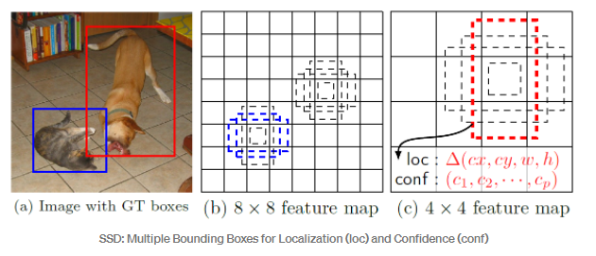
7. 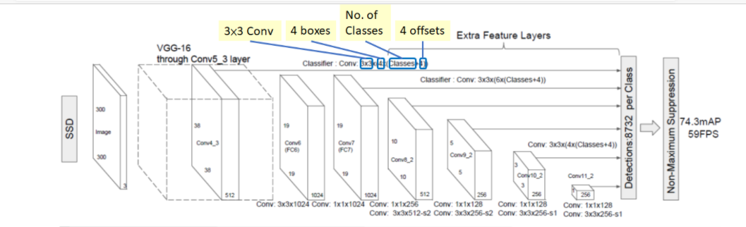

# Proposed Method

# Discussion

# Conclusion

This research shows an implementation of current develop of image processing and deep learning i.e.

Single Shot Multibox Detector (SSD).

4.1. Conclussion

We successfully utilize SSD to give an assist for quadcopter (The copter) to find and approach to an

object (target). The assistance of SSD was as feedback of copter control system. A closed loop control

system i.e. PID was used to control the copter to approach and also to find the target. Our PID

characteristics has rise time 7.467 ms, and settling time 12s by calculate using the PID response chart.

In other hand, measured rise time and settling time under live measurement are 9.542s and 14.24s. This

shifting is caused by difference process load condition of the SBC.

4.2. Future works

Our works only test one object detection technique, hence, there is no comparison of this result to another

works with another object detection e.g. [1, 2]. Another object detection would has different computation

requirements which also has different aptitude in terms of detection time, accuracy, and precission.

Furthermore, there is no comparison of this object detection in other implementation under another

circumstance, such as under steady condition, implemented in land vehicles, other autonomous

application, etc. All of those application certainly would have different physics factor which also has

different role to the system.

This research shows an implementation of current develop of image processing and deep learning i.e.

Single Shot Multibox Detector (SSD).

4.1. Conclussion

We successfully utilize SSD to give an assist for quadcopter (The copter) to find and approach to an

object (target). The assistance of SSD was as feedback of copter control system. A closed loop control

system i.e. PID was used to control the copter to approach and also to find the target. Our PID

characteristics has rise time 7.467 ms, and settling time 12s by calculate using the PID response chart.

In other hand, measured rise time and settling time under live measurement are 9.542s and 14.24s. This

shifting is caused by difference process load condition of the SBC.

4.2. Future works

Our works only test one object detection technique, hence, there is no comparison of this result to another

works with another object detection e.g. [1, 2]. Another object detection would has different computation

requirements which also has different aptitude in terms of detection time, accuracy, and precission.

Furthermore, there is no comparison of this object detection in other implementation under another

circumstance, such as under steady condition, implemented in land vehicles, other autonomous

application, etc. All of those application certainly would have different physics factor which also has

different role to the system.

This research shows an implementation of current develop of image processing and deep learning i.e.

Single Shot Multibox Detector (SSD).

4.1. Conclussion

We successfully utilize SSD to give an assist for quadcopter (The copter) to find and approach to an

object (target). The assistance of SSD was as feedback of copter control system. A closed loop control

system i.e. PID was used to control the copter to approach and also to find the target. Our PID

characteristics has rise time 7.467 ms, and settling time 12s by calculate using the PID response chart.

In other hand, measured rise time and settling time under live measurement are 9.542s and 14.24s. This

shifting is caused by difference process load condition of the SBC.

4.2. Future works

Our works only test one object detection technique, hence, there is no comparison of this result to another

works with another object detection e.g. [1, 2]. Another object detection would has different computation

requirements which also has different aptitude in terms of detection time, accuracy, and precission.

Furthermore, there is no comparison of this object detection in other implementation under another

circumstance, such as under steady condition, implemented in land vehicles, other autonomous

application, etc. All of those application certainly would have different physics factor which also has

different role to the system.

This research shows an implementation of current develop of image processing and deep learning i.e. Single Shot Multibox Detector (SSD).

**5.1 Conclusion**

We successfully utilize SSD to give an assist for quadcopter (The copter) to find and approach to an object (target). The assistance of SSD was as feedback of copter control system. A closed loop control system i.e. PID was used to control the copter to approach and also to find the target. Our PID characteristics has risen time 7.467 ms, and settling time 12s by calculate using the PID response chart. In other hand, measured rise time and settling time under live measurement are 9.542s and 14.24s. This shifting is caused by difference process load condition of the SBC.

**5.2. Future works**

Our works only test one object detection technique, hence, there is no comparison of this result to another works with another object detection. Another object detection would have different computation requirements which also has different aptitude in terms of detection time, accuracy, and precision. Furthermore, there is no comparison of this object detection in other implementation under another circumstance, such as under steady condition, implemented in land vehicles, other autonomous application, etc. All of those application certainly would have different physics factor which also has different role to the system.

# References