|  |  |  |  |  |  |  |  |
| --- | --- | --- | --- | --- | --- | --- | --- |
| **Course Name** | **Engineering Shop** | **Course Code** | **EEE 3110** | **Semester** | **Summer 21-22** | **Section** | **I** |
| **Faculty** | **Nuzat Nuary Alam** | | | | | | |
| **Assignment** | **Project Proposal** | | | | **Group No** | **01** | |

|  |  |  |  |
| --- | --- | --- | --- |
| **SL.** | **Student Name** | **ID** | **Dept.** |
| **1** | **HASAN, MD. MAHMUDUL** | **17-35195-2** | **CSE** |
| **2** | **Antu Asif Ikbal** | **17-34554-2** | **CSE** |
| **3** | **ASHRAF, MOHAMMED** | **17-34496-2** | **CSE** |
| **4** | **FATEMA JAHAN LUBNA** | **17-35255-2** | **EEE** |
| **5** | **Md.Farhan Islam** | **17-34787-2** | **EEE** |

**Following sections must be present in your project proposal:**

* **Title of the project**
* **Introduction of the system you want to design**
* **Literature review (If possible)**
* **Design methodology**
* **Timeline.**

## **Title: Working of Self Resetting Alarm using Timer IC 555 and PCB design**

**Introduction:**

One of the most common projects made in electronics is burglar alarm or security alarm. If your search over the internet there are dozen of burglar or [security alarms](https://bestengineeringprojects.com/automatic-fence-lighting-with-alarm/) but the problem with this circuit is, it does not have a self-resetting option i.e. continuously sounds till someone switches off the system. Thus, in order to solve this type of problem (self-resetting) we have come with the project Self Resetting LDR Alarm using Timer IC 555.

This circuit detects the interruption of light and produces sound for a definite interval of time. By using the circuit configuration and electronics component shown in figure 1, the time interval is of 10 seconds which can be adjusted (increased or decreased) by adjusting the value of resistor and capacitor used in this circuit.

**Literature Review:**

The circuit diagram of Self Resetting Alarm using Timer IC 555 is shown in figure 1. The construction of this project is very simple and is built using the most commonly used IC in the history of electronics i.e. Timer IC 555.

The circuit uses two ICs, namely 555 timers. The first one is used in [monostable mode](https://bestengineeringprojects.com/monostable-multivibrator/) while the second IC is used as an audio oscillator, i.e. in [astable mode](https://bestengineeringprojects.com/astable-multivibrator/). The [monostable mode](https://bestengineeringprojects.com/monostable-multivibrator/) is also called timer mode because it produces one-shot output for a definite interval of time i.e. produce output high for a fixed interval of time. The [astable mode](https://bestengineeringprojects.com/astable-multivibrator/) is also called [frequency oscillator](https://bestengineeringprojects.com/audio-oscillators/) mode because it produces frequency.

**Design Methodology and Working Process:**

When the beam of light is focused on LDR, its resistance remains low and the trigger terminal (pin 2) of IC1 (IC 555) is held at positive potential and its output is zero. Whenever the beam is interrupted, the resistance of LDR goes high. During that moment a negative pulse is applied to the trigger terminal and IC1 (IC 555) performs a 10-second [monostable](https://bestengineeringprojects.com/audio-oscillators/) operation. The output of IC1 gets applied to the audio oscillator consisting of IC2 which gives an alarm for ten to eleven seconds.

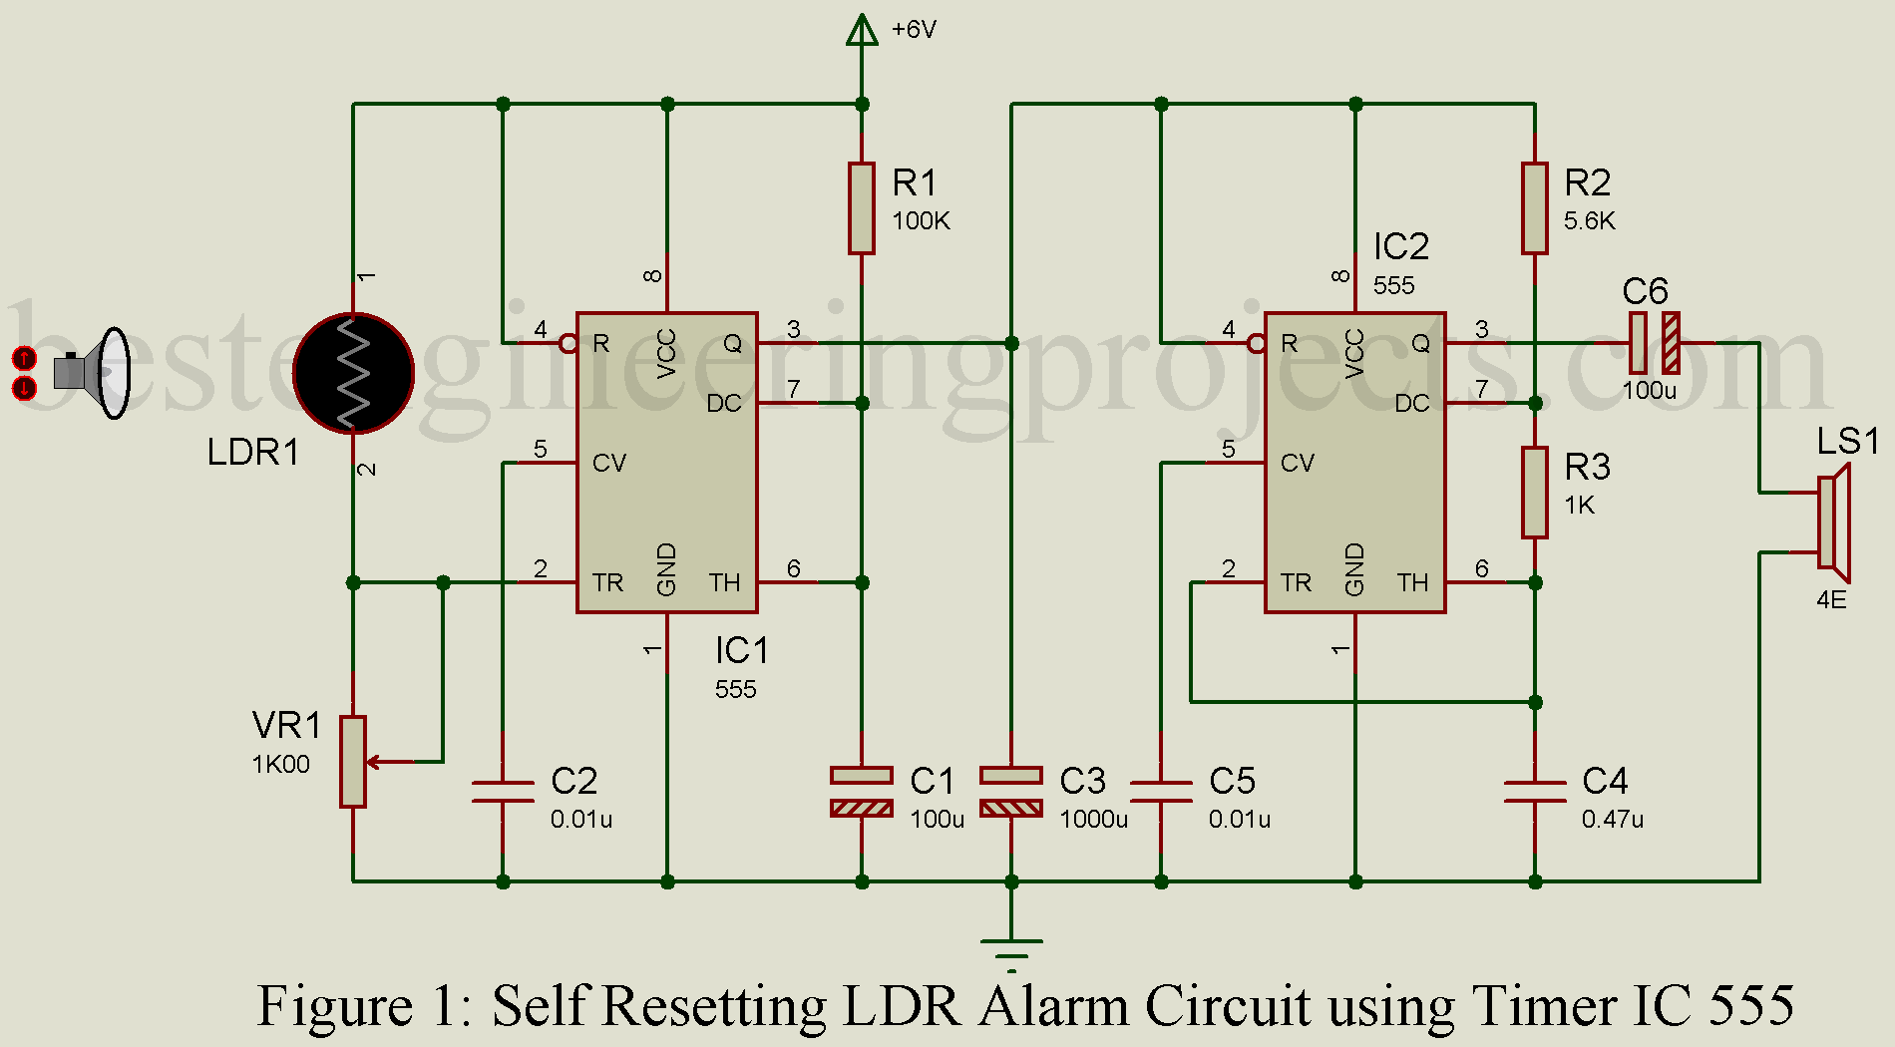

**Fig1: Circuit diagram**

**Timeline:**

|  |  |  |  |  |  |  |
| --- | --- | --- | --- | --- | --- | --- |
| **Date**  **Task** | **March 03-10** | **March 10-17** | **March 17-31** | **March 31-April 07** | **April 07-14** | **April 14-21** |
| **Topic Selection** |  |  |  |  |  |  |
| **Preparing Proposal Reports And Submit** |  |  |  |  |  |  |
| **Optimizing Circuits And Software work** |  |  |  |  |  |  |
| **Project Report Writing** |  |  |  |  |  |  |
| **Submission Of Project And Report** |  |  |  |  |  |  |
| **Attending Final And Presenting the Project** |  |  |  |  |  |  |

Under the supervision of

**UZAT NUARY ALAM**

Faculty of Engineering.

According to the Engineering Shop laboratory class and AIUB academic calendar.