# Homework: Introduction to AngularJS

This document defines the homework assignments from the ["JavaScript SPA with AngularJS" Course @ Software University](https://softuni.bg/trainings/coursesinstances/details/1075). Please submit as homework a single zip / rar / 7z archive holding the solutions (source code) of all below described problems.

## Student Page

Using AngularJS, perform the following operations:

* Display student information in a page
* Try to display picture using <span class="important">**ngSrc</span>** directive (look in Angular documentation how to use it)

|  |
| --- |
| **Student Object** |
| {  "name": “Pesho”,  "photo": "http://www.nakov.com/wp-content/uploads/2014/05/SoftUni-Logo.png"  "grade": 5,  "school": "High School of Mathematics",  "teacher": "Gichka Pesheva",  } |

## Bind Image Source to Text Box

Try to bind text input to source attribute of image tag. When input valid picture <span class="important">**url</span>**, picture should show on the page.

|  |
| --- |
| **Example** |
|  |

## 3. Tiger

You are given an object like this:   
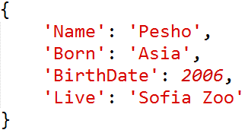

You need to extract information with Angular and add it to your HTML file in the same way as the picture below:

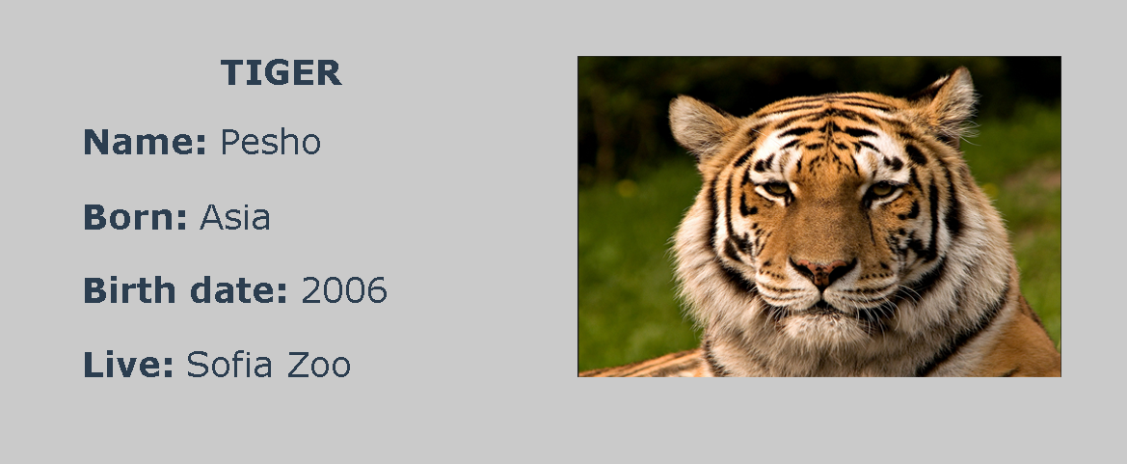

Add image in the object from this URL: <http://tigerday.org/wp-content/uploads/2013/04/tiger.jpg>

Note: Use only Angular JS styles for text values.