Name: Antarin Ghosal

Ha5.1:

*/*Author : Antarin Ghosal*

*Program : WAP to swap first element with last, second element with second last and*

*so on, stored in an array.*/*

#include<stdio.h>

int main(){

    int s[]={1,2,3,4,5},temp,i,n=5;

    for(i=0;i<5/2;i++){

        temp=s[i];

        s[i]=s[n-i-1];

        s[n-i-1]=temp;

    }

    for(i=0;i<5;i++){

        printf("%d ",s[i]);

    }

    return 0;

}



Ha5.2

*/*Author : Antarin Ghosal*

*Program : WAP to find out the second largest element stored in an array of 20*

*integers.*/*

#include<stdio.h>

int main(){

    int s[]={1,2,3,4,5,6,7,8,9,10,11,12,13,14,15,16,18,19,20};

    int i,max,max2,n=20;

    for(i=0;i<20;i++){

        if(s[i]>s[i+1]){

            max=i-1;

        }

        else if (s[i+1]>s[i]){

            max=i;

        }

    }

    s[max]=0;

    for(i=0;i<20;i++){

        if(s[i]>s[i+1]){

            max2=i-1;

        }

        else if (s[i+1]>s[i]){

            max2=i;

        }

    }

    printf("The second largest element : %d",s[max2-2]);

    return 0;

}



Ha 5.3

*/*Author : Antarin Ghosal*

*Program : WAP to find the median of a list of numbers.*/*

#include<stdio.h>

int main(){

    int a[]={1,2,3,4,5,6,7},n=6,median;

    if ( n % 2 == 0)

        median = (a[n/2] + a[n/2+1])/2.0 ;

    else

    median = a[n/2 + 1];

    printf("%d ",median);

    return 0;

}



Ha5.4

*/*Author : Antarin Ghosal*

*Program : WAP to find the standard deviation of a list of numbers.*/*

#include<stdio.h>

#include<math.h>

int main(){

int i;

    float data[10];

    printf("Enter 10 elements: ");

    for (i = 0; i < 10; ++i)

        scanf("%f", &data[i]);

    float sum = 0.0, mean, SD = 0.0;

    for (i = 0; i < 10; ++i) {

        sum += data[i];

    }

    mean = sum / 10;

    for (i = 0; i < 10; ++i) {

        SD += pow(data[i] - mean, 2);

    }

    printf("\nStandard Deviation = %.6f", sqrt(SD / 10));

    return 0;

}

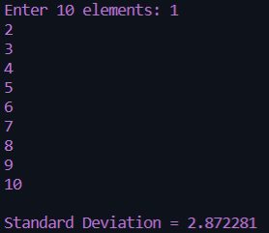

La5.1

*/*Author : Antarin Ghosal*

*Program : WAP to input 10 integers into an array of size 10. Print all elements.*/*

#include<stdio.h>

int main(){

    int i,arr[10];

    for(i=0;i<10;i++){

        printf("Enter the %d number : ",i+1);

        scanf("%d",&arr[i]);

    }

    printf("\n");

    for(i=0;i<10;i++){

        printf("The Entered number is %d \n",arr[i]);

    }

    return 0;

}

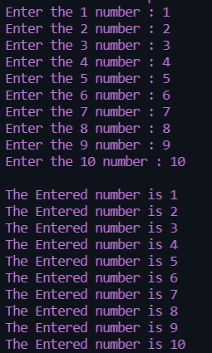 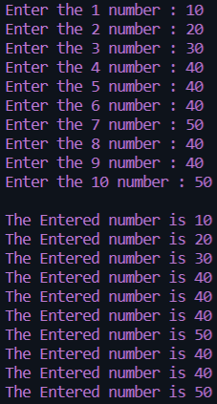

La 5.2

*/*Author : Antarin Ghosal*

*Program : WAP to store max. 100 numbers into an array. Print all the elements*

*that are three digit even integers..*/*

#include<stdio.h>

int main(){

    int arr[100],n,i;

    printf("Enter the amount of numbers we want to input : ");

    scanf("%d",&n);

    for(i=0;i<n;i++){

        printf("Enter a number : ");

        scanf("%d",&arr[i]);

    }

    printf("\n");

    for(i=0;i<n;i++){

        printf("The Entered value was : %d \n",arr[i]);

    }

    printf("\n");

    printf("The EVEN integers are as follows : \n");

    for(i=0;i<=n;i++){

        if ((arr[i]<=999 && arr[i]>=100) && arr[i]%2==0){

            printf("%d\n",arr[i]);

        }

    }

    return 0;

}

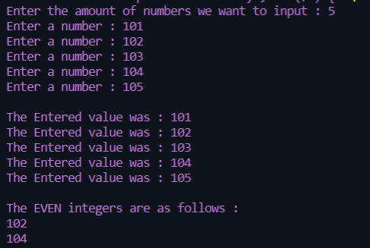

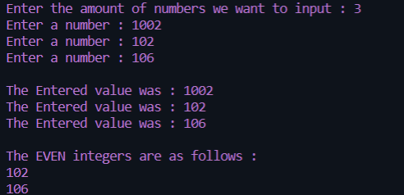

La 5.3

*/*Author : Antarin Ghosal*

*Program : WAP to find out the largest even integer stored in the array of n*

*integers. n is the user input.*/*

#include<stdio.h>

int main(){

    int n[100],i,num,j,largest;

    printf("Enter the amount of numbers we want to input : ");

    scanf("%d",&num);

    for(i=0;i<num;i++){

        printf("Enter a number : ");

        scanf("%d",&n[i]);

    }

    largest = n[0];

    for(i=0;i<num;i++){

        if (n[i]%2==0 && n[i]>largest){

                    largest=n[i];

            }

    }

    printf("The largest number is : %d",largest);

    return 0;

}

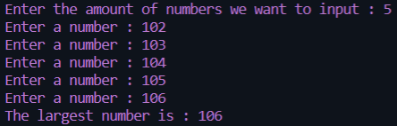 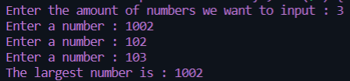

La 5.4

*/*Author : Antarin Ghosal*

*Program : WAP to swap the pair of elements starting from beginning.*/*

#include<stdio.h>

int main()

{

    int arr[100],n,i;

    int temp;

    printf("Enter total number of elements: ");

    scanf("%d",&n);

*//value of n must be even*

    if(n%2 !=0)

    {

        printf("Total number of elements should be EVEN.");

        return 1;

    }

*//read array elements*

    printf("Enter array elements:\n");

    for(i=0;i < n;i++)

    {

        printf("Enter element %d:",i+1);

        scanf("%d",&arr[i]);

    }

*//swap adjacent elements*

    for(i=0;i < n;i+=2)

    {

        temp    = arr[i];

        arr[i]  = arr[i+1];

        arr[i+1]= temp;

    }

    printf("\nArray elements after swapping adjacent elements:\n");

    for(i=0;i < n;i++)

    {

        printf("%d\n",arr[i]);

    }

    return 0;

}



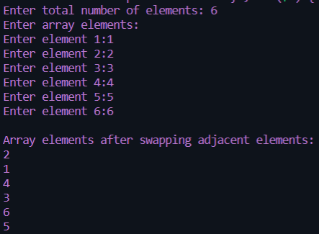

La 5.5

*/*Author : Antarin Ghosal*

*Program : WAP to arrange the numbers stored in the array so that it will display*

*first all odd numbers,then even numbers.*/*

#include<stdio.h>

int main(){

    int i,n,s[]={1,2,3,4,5,6,7,8,9,10};

    for(i=0;i<10;i++){

        if (s[i]%2==0)

            printf(" Even %d \n",s[i]);

    }

    for(i=0;i<10;i++){

        if (s[i]%2==1)

            printf(" Odd %d \n",s[i]);

    }

    return 0;

}

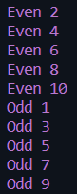

La 5.6

*/*Author : Antarin Ghosal*

*Program : WAP to display the array elements in reverse order.*/*

#include<stdio.h>

int main(){

    int s[]={1,2,3,4,5};

    for(int i=4;i>=0;i--){

        printf("%d ",s[i]);

    }

    return 0;

}



La52.1

*/*Author : Antarin Ghosal*

*Program : WAP to print fibonacci series using arrays.*/*

#include<stdio.h>

int main(){

    int arr[30],n,i;

    printf("Enter the number of elements we want to print : ");

    scanf("%d",&n);

    if (n>30){

        printf("Too many numbers !!");

        return 0;

    }

    printf("The Requested Elements are : \n0 \n1 \n");

    arr[0]=0;

    arr[1]=1;

    for(i=2;i<n;i++){

        arr[i]=arr[i-1]+arr[i-2];

        printf("%d\n",arr[i]);

    }

    return 0;

}

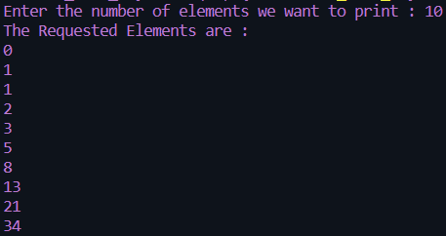 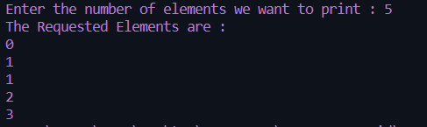

La52.2

*/*Author : Antarin Ghosal*

*Program : WAP to find first and second largest in an array.*/*

#include<stdio.h>

int main(){

    int i,j,arr[30],n,large1,large2;

    printf("Enter the amount of numbers we want to enter : ");

    scanf("%d",&n);

    if (n>30){

        printf("Too many numbers !!");

        return 0;

    }

    printf("Enter the numbers : \n");

    for(i=0;i<n;i++){

        scanf("%d",&arr[i]);

    }

    large1=arr[0];

    for(i=1;i<n;i++){

        if(arr[i]>large1)

        {

            large1=arr[i];

            j=i;

        }

    }

    arr[j]=0;

    large2=arr[0];

    for(i=1;i<n;i++){

        if(arr[i]>large2)

            large2=arr[i];

    }

    printf("The first largest value is : %d\n",large1);

    printf("The second largest value is : %d\n",large2);

    return 0;

}

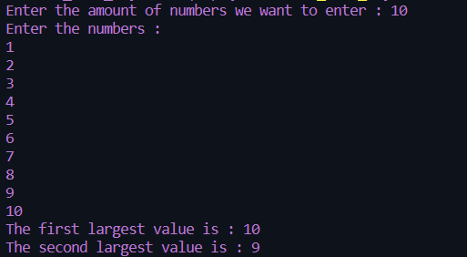

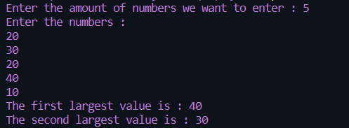

La 52.3

*/*Author : Antarin Ghosal*

*Program : WAP to perform linear search on a array for a search key.*/*

#include<stdio.h>

int main(){

    int i,j,arr[30],n,key;

    printf("Enter the amount of numbers we want to enter : ");

    scanf("%d",&n);

    printf("Enter the numbers : \n");

    for(i=0;i<n;i++){

        scanf("%d",&arr[i]);

    }

    printf("\nEnter the number you want to find : ");

    scanf("%d",&key);

    for(i=0;i<n;i++){

        if(arr[i]==key){

            printf("The number %d is found at index %d",key,i);

        }

    }

    return 0;

}

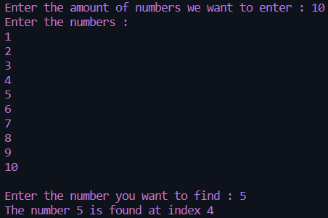

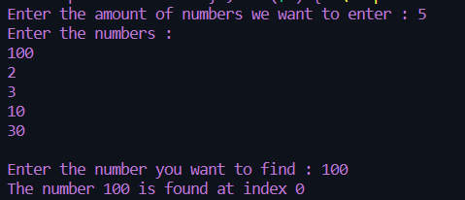

La 52.4

*/*Author : Antarin Ghosal*

*Program : WAP to perform binary search on a array for a search key.*/*

#include<stdio.h>

int main(){

    int i,j,arr[30],n,key,temp;

    printf("Enter the amount of numbers we want to enter : ");

    scanf("%d",&n);

    printf("Enter the numbers : \n");

    for(i=0;i<n;i++){

        scanf("%d",&arr[i]);

    }

    printf("\nEnter the number you want to find : ");

    scanf("%d",&key);

    temp=n/2;

    if (key <= arr[temp]){

        for(i=temp;i>=0;i--){

            if(key==arr[i])

            printf("The number %d is found at index %d\n",key,i);

        }

    }

    else if (key > arr[temp]) {

        for (i=temp;i<n;i++){

            if(key==arr[i])

            printf("The number %d is found at index %d\n",key,i);

        }

    }

    return 0;

}





La 52.5

*/*Author : Antarin Ghosal*

*Program : WAP to print odd and even numbers in a array.*/*

#include<stdio.h>

int main(){

    int n,arr[30],i,j;

    printf("Enter the amount of numbers we want to enter : ");

    scanf("%d",&n);

    printf("Enter the numbers : \n");

    for(i=0;i<n;i++){

        scanf("%d",&arr[i]);

    }

    printf("\nAll EVEN numbers are as follows : \n");

    for(i=0;i<n;i++){

        if(arr[i]%2==0){

            printf("\n%d",arr[i]);

        }

    }

    printf("\n\nAll ODD numbers are as follows : \n");

    for(i=0;i<n;i++){

        if(arr[i]%2==1){

            printf("\n%d",arr[i]);

        }

    }

    return 0;

}

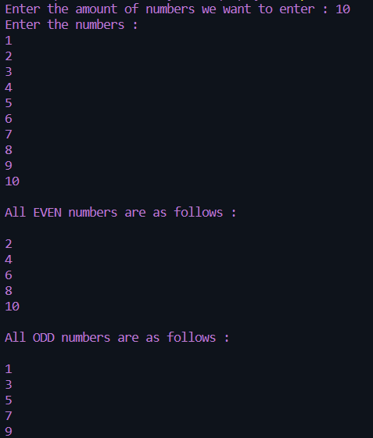

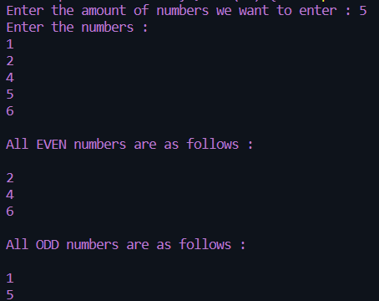

Ha 5.6

*/*Author : Antarin Ghosal*

*Program :WAP to find out the sum of the secondary diagonal elements of a matrix.*/*

#include<stdio.h>

int main(){

    int arr1[3][3]={{1,2,3},{4,5,6},{7,8,9}},i,j,sum=0;

    for(i=0;i<3;i++){

            sum+=arr1[i][3-i-1];

    }

    printf("%d",sum);

    return 0;

}



Ha 5.7

*/*Author : Antarin Ghosal*

*Program : WAP to check whether a given matrix is symmetric or not.*/*

#include<stdio.h>

int main(){

    int arr1[10][10],i,j,m,n,arr2[10][10],flag;

    printf("Enter the number of rows : ");

    scanf("%d",&m);

    printf("Enter the number of coloumns : ");

    scanf("%d",&n);

*//takes input*

    for(i=0;i<m;i++){

        for(j=0;j<n;j++){

            printf("Enter the [%d][%d] element : ",i,j);

            scanf("%d",&arr1[i][j]);

        }

    }

*//finds transpose*

    for(i=0;i<3;i++){

        for(j=0;j<3;j++){

            arr2[j][i]=arr1[i][j];

        }

    }

*//checks for symmetric*

    for(i=0;i<3;i++){

        for(j=0;j<3;j++){

            if(arr1[i][j]==arr2[i][j])

                flag=1;

            else flag=0;

        }

    }

    if(flag==1){

        printf("The given matrix is Symmetric !!");

    }

    else{

        printf("The given matrix is NOT symmetric.");

    }

    return 0;

}

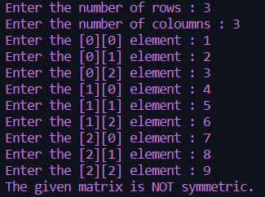 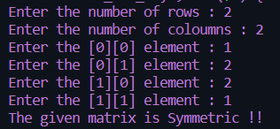

Ha 5.8

*/*Author : Antarin Ghosal*

*Program : WAP to check whether a given matrix is orthogonal or not.*/*

#include<stdio.h>

int main(){

    int arr1[10][10],i,j,m,n,arr2[10][10],mularr[10][10],iarr[10][10],flag;

    printf("Enter the number of rows : ");

    scanf("%d",&m);

    printf("Enter the number of coloumns : ");

    scanf("%d",&n);

*//creating identity matrix*

    for(i=0;i<m;i++){

        for(j=0;j<n;j++){

            if(i==j)

                iarr[i][i]=1;

            else iarr[i][j]=0;

        }

    }

*//takes input*

    for(i=0;i<m;i++){

        for(j=0;j<n;j++){

            printf("Enter the [%d][%d] element : ",i,j);

            scanf("%d",&arr1[i][j]);

        }

    }

*//finds transpose*

    for(i=0;i<3;i++){

        for(j=0;j<3;j++){

            arr2[i][j]=arr1[j][i];

        }

    }

*//multiplying A and At.*

    for(i=0;i<3;i++){

        for(j=0;j<3;j++){

            mularr[i][j]=arr1[j][i]*arr2[i][j];

        }

    }

*//checking if A*At=I or not*

    for(i=0;i<3;i++){

        for(j=0;j<3;j++){

            if(mularr[i][j]==iarr[i][j])

                flag=0;

            else flag=1;

        }

    }

    if(flag==1){

        printf("The given matrix is Orthogonal !!");

    }

    else{

        printf("The given matrix is NOT orthogonal.");

    }

    return 0;

}

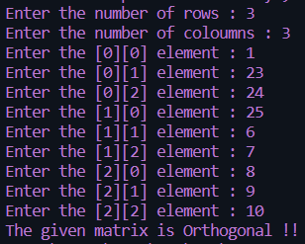 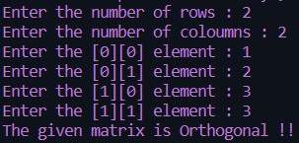

La 5.7

*/*Author : Antarin Ghosal*

*Program : WAP to find out the sum of the elements stored in a matrix.*/*

#include<stdio.h>

int main(){

    int i,j,arr[3][3]={1,2,3,4,5,6,7,8,9},sum=0;

    for (i=0;i<3;i++){

        for (j=0;j<3;j++){

            sum+=arr[i][j];

        }

    }

    printf("%d",sum);

    return 0;

}



La 5.8

*/*Author : Antarin Ghosal*

*Program : WAP to find out the transpose of a given matrix.*/*

#include<stdio.h>

int main(){

    int i,j,arr2[3][3];

    int arr1[3][3]={{1,2,3},{4,5,6},{7,8,9}};

    for(i=0;i<3;i++){

        for(j=0;j<3;j++){

            arr2[i][j]=arr1[j][i];

        }

    }

    for(i=0;i<3;i++){

        for(j=0;j<3;j++){

            printf("%d ",arr2[i][j]);

        }

        printf("\n");

    }

    return 0;

}



Sa 6.5

*/*Author : Antarin Ghosal*

*Program : WAP to add two matrices and display it.*/*

#include<stdio.h>

int main(){

    int arr1[3][3]={{1,2,3},{4,5,6},{7,8,9}};

    int arr2[3][3]={{9,8,7},{6,5,4},{3,2,1}};

    int sumarr[3][3],i,j;

    for(i=0;i<3;i++){

        for(j=0;j<3;j++){

            sumarr[i][j]=arr1[i][j]+arr2[i][j];

        }

    }

    for(i=0;i<3;i++){

        for(j=0;j<3;j++){

            printf("%d ",sumarr[i][j]);

        }

    printf("\n");

    }

    return 0;

}

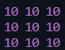

Sa 6.6

*/*Author: Antarin Ghosal*

*Program: WAP to multiply two matrices and display it.*/*

#include<stdio.h>

int main()

{

    int r,c,a[100][100],b[100][100],d[100][100];

    int i,j,k,sum,e;

    printf("Enter the number of rows:");

    scanf("%d",&r);

    printf("\nEnter the number of columns:");

    scanf("%d",&c);

    for(i=0;i<r;i++){

        for(j=0;j<c;j++){

            printf("\nEnter a[%d][%d]:",i,j);

            scanf("%d",&a[i][j]);

        }

    }

    for(i=0;i<r;i++){

        for(j=0;j<c;j++){

            printf("\nEnter b[%d][%d]:",i,j);

            scanf("%d",&b[i][j]);

        }

    }

    for(i=0;i<r;i++){

        for(j=0;j<c;j++)

        {

            sum=0;

            e=1;

            for(k=0;k<c;k++)

            {

                e=a[i][k]*b[k][j];

                printf("%d",e);

                sum+=e;

            }

            d[i][j]=sum;

            sum=0;

        }

    }

    printf("\nThe multiplication of the two matrix is:\n");

    for(i=0;i<r;i++){

        for(j=0;j<c;j++){

            printf("%d  ",d[i][j]);

        }

        printf("\n");

    }

    return 0;

}

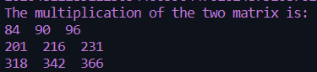

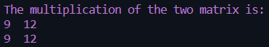

Sa 6.7

*/*Author : Antarin Ghosal*

*Program : WAP to find the Trace(sum of the diagonal element) of a given mxn matrix.*/*

#include<stdio.h>

int main(){

int arr1[3][3]={{1,2,3},{4,5,6},{7,8,9}},i,j,sum=0;

    for(i=0;i<3;i++){

            sum+=arr1[i][i];

    }

    printf("%d",sum);

    return 0;

}



Ha 7.1

*/\**

*Name : Antarin ghosal*

*program : HA7.1 WAP to capitalize first character of each word of a string entered through keyboard.*

*\*/*

#include <stdio.h>

#include<string.h>

#include<ctype.h>

int main()

    {

    char str[30];int len=0,i;

    printf("Enter the string: ");

    scanf("%[^\n]s",str);

    len=strlen(str);

    char str2[len];

    str2[0]=toupper(str[0]);

    for(i=1;i<len;i++)

        if(str[i-1]==' ')

            str2[i]=toupper(str[i]);

        else

            str2[i]=str[i];

    printf("%s",str2);

        return 0;

    }

 

Ha 7.2

*/\**

*Name : Antarin ghosal*

*HA7.2 WAP to take a sentence as input and reverse every word of the sentence.*

*\*/*

#include<stdio.h>

#include<string.h>

#include<ctype.h>

int main()

{

int i,j=0;

char str[100];

*//input*

    printf("Enter the sstring: ");

    scanf("%[^\n]s",str);

    sprintf(str,"%s ",str);

    int k=0,len=strlen(str);

while(str[i]!='\0')

{

    if(str[i]==32)

    {

        for(j=i-1;j>=k;j--)

            printf("%c",str[j]);

            printf(" ");

            k=i+1;

    }

    i++;

}

return 0;

}

 

Ha 7.3

*/\**

*Name : Antarin ghosal*

*HA7.3 WAP to print a given string in an alphabetical order*

*\*/*

#include<stdio.h>

#include<string.h>

#include<ctype.h>

int main()

{

int i,j;

char str[10];

*//input*

    printf("Enter the sstring: ");

    scanf("%[^\n]s",str);

    int len=strlen(str);

*//cal and out*

    for(i=65;i<=90;i++)

    for(j=0;j<len;j++)

        if(toupper(str[j])==(char)i)

            printf("%c",(char)i);

return 0;

}

 

La 7.1

*/\**

*Name : Antarin ghosal*

*LA7.1 WAP to extract the last character of each word of a given string.*

*\*/*

#include <stdio.h>

#include<string.h>

#include<ctype.h>

int main()

    {

    char str[100],str2[100];int len=0,i;

    printf("Enter the sstring: ");

    scanf("%[^\n]s",str);

    sprintf(str,"%s ",str);

    len=strlen(str);

    for(i=0;i<len;i++)

        if(str[i]==' ')

            printf("%c ",str[i-1]);

    return 0;

    }

 

La 7.2

*/\**

*Name : Antarin ghosal*

*LA7.2 Write a program to concatenate two strings without using any library function.*

*\*/*

#include <stdio.h>

#include<string.h>

#include<ctype.h>

int main()

    {

    char str[100];

    char str2[100];

    char buffer[200];

    printf("Enter 1st string: ");

    gets(str);

    printf("Enter 2nd string: ");

    gets(str2);

    sprintf(buffer,"%s %s",str,str2);

    printf("CONCATENATED STRING: %s",buffer);

    return 0;

    }

 

La 7.3

*/\**

*Name : Antarin ghosal*

*LA7.3 WAP to check whether a string entered through keyboard is palindrome or not.*

*\*/*

#include <stdio.h>

#include<string.h>

#include<ctype.h>

int main()

    {

    char str[100],str2[100];int len=0,i;

    printf("Enter the sstring: ");

    scanf("%[^\n]s",str);

    len=strlen(str);

    int r=len-1;

    for(i=0;i<len;i++)

        str2[i]=str[r--];

    short int flag=0;

    for(i=0;i<len;i++)

        if(str[i]!=str2[i])

            flag=1;

    if(flag==1)

        printf("%s is not palindrome",str);

    else

        printf("%s is palindrome",str);

    return 0;

    }

 

La 7.4

*/\**

*Name : Antarin ghosal*

*LA7.4 Write a program to count the number of characters, alphabets, tabs, newlines, words, vowels, consonants present in a in a string.*

*\*/*

#include <stdio.h>

#include<string.h>

#include<ctype.h>

int main()

{

  char str[150];

  int vowels=0, consonant=0, digit=0, space=0,i;

  vowels = consonant = digit = space = 0;

  printf("Enter a str of string: ");

  fgets(str, sizeof(str), stdin);

  for (i=0;str[i]!='\0';i++)

  {

    str[i]=tolower(str[i]);

    if(str[i]=='a'||str[i]=='e'||str[i]=='i'||str[i]=='o'||str[i]=='u')

        vowels++;

    else if((str[i]>='a'&&str[i]<='z'))

        consonant++;

    else if(str[i]>='0'&&str[i]<='9')

        digit++;

    else if(str[i]==' ')

        space++;

  }

  printf("Vowels: %d", vowels);

  printf("\nConsonants: %d", consonant);

  printf("\nDigits: %d", digit);

  printf("\nWhite spaces: %d", space);

  return 0;

}

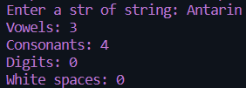 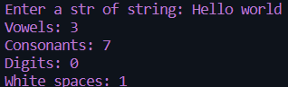

Sa 7.1

*/\**

*Name : Antarin ghosal*

*SA7.1 WAP to find the length of a string with/without using library function for getting length of the string.*

*\*/*

#include <stdio.h>

#include<string.h>

#include<ctype.h>

int main()

    {

    char str[100];

    int len=0,i,sp=0;

    scanf("%[^\n]s",str);

    for(i=0;i<100;i++)

        if(str[i]!='\0')

        {

            if(str[i]!=' ')

            len+=1;

            if(str[i]==' ')

            sp+=1;

        }

        else

            break;

    printf("String: %s\n",str);

    printf("Lenght without white space: %d\n",len);

    printf("Lenght with white space: %d",(len+sp));

    return 0;

    }

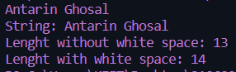 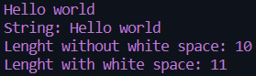

Sa 7.2

*/\**

*Name : Antarin ghosal*

*SA7.2 WAP to copy one string into other with/without using a library function for copy operation.*

*\*/*

#include <stdio.h>

#include<string.h>

#include<ctype.h>

int main()

    {

    char str[100];

    char str2[100];

    printf("Enter THE string: ");

    scanf("%[^\n]s",str);

    int i;

*//  sprintf(str2,"%s",str);*

*//  strcpy(str2,str)*

    for(i=0;i<strlen(str);i++)

        str2[i]=str[i];

        str2[strlen(str)]='\0';

    printf("COPIED STRING:    %s",str2);

    return 0;

    }

 

Sa 7.3

*/\**

*Name : Antarin ghosal*

*SA7.3 WAP to compare two strings without using library function for comparison operation.*

*\*/*

#include <stdio.h>

#include<string.h>

#include<ctype.h>

int main()

    {

    int i=0;

    char str1[100];

    char str2[100];

    printf("Enter 1st string: ");

    gets(str1);

    printf("Enter 2nd string: ");

    gets(str2);

    while(str1[i]!='\0'&&str2[i]!='\0')

        {

            if(str1[i]==str2[i])

            {

                i++;

                continue;

            }

            else

                break;

        }

    printf("%d",str1[i]-str2[i]);

    return 0;

    }

 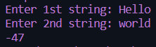

Sa 7.4

*/\**

*Name : Antarin ghosal*

*SA7.4 WAP to find the reverse of a string with/without using library function.*

*\*/*

#include <stdio.h>

#include<string.h>

#include<ctype.h>

int main()

    {

    char str[100];int len=0,i;

    printf("Enter the sstring: ");

    scanf("%[^\n]s",str);

    len=strlen(str);

    int r=len-1;

    char str2[len];

    for(i=0;i<len,r>=0;i++)

        str2[i]=str[r--];

    printf("STRING: %s",str);

    printf("\nREVERSE: %s",str2);

    return 0;

    }

 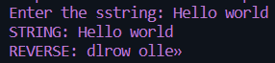

Ha 7.5

*/\**

*Name : Antarin ghosal*

*HA7.5 WAP to replace all occurrences of a substring in a given string with a new one.*

*\*/*

#include<stdio.h>

#include<string.h>

int main()

{

    char str[100],str1[100],str2[100];

    int k,ch,b,j;

    printf("ENTER THE STRING:");

    scanf("%[^\n]s",str);

    printf("ENTER THE SUBSTRING TO REPLACE:");

    scanf(" %[^\n]s",str1);

    printf("ENTER THE SUBSTRING TO REPLACE WITH:");

    scanf(" %[^\n]s",str2);

    int len=strlen(str),len1=strlen(str1),len2=strlen(str2),i=0;

    while(str[i]!='\0')

    {

        b=0;

        if(str[i]==str1[0])

            {

                k=0,ch=0,b=0;

                for(j=i;j<i+len1;j++)

                    if(str1[k++]==str[j])

                        ch++;

                if(ch==len1)

                    b=1;

            }

        if(b==1)

            {

                printf("%s",str2);

                i=i+(len1-1);

            }

        else

            printf("%c",str[i]);

            i=i+1;

    }

    return 0;

}

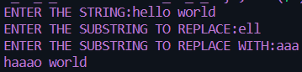 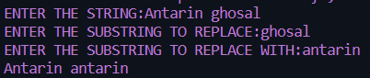

Ha 7.4

*/\**

*Name : Antarin ghosal*

*HA7.4 WAP to sort a list of names/strings alphabetically.*

*\*/*

#include<stdio.h>

#include<string.h>

int main()

{

   int i,j,n;

   char str[100][100],temp[100];

   printf("Enter number of names :\n");

   scanf("%d",&n);

   printf("Enter names in any order:\n");

   for(i=0;i<n;i++)

   {

      scanf("%s",str[i]);

   }

   for(i=0;i<n;i++)

   {

      for(j=i+1;j<n;j++)

     {

         if(strcmp(str[i],str[j])>0)

       {

            strcpy(temp,str[i]);

            strcpy(str[i],str[j]);

            strcpy(str[j],temp);

         }

      }

   }

   printf("\nThe sorted order of names are:\n");

   for(i=0;i<n;i++)

   {

      printf("%s\n",str[i]);

   }

   return 0;

}

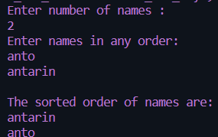 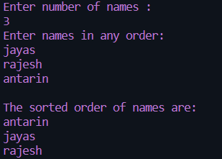

La 7.5

*/\**

*Name : Antarin ghosal*

*LA7.5 WAP to reads a sentence and prints frequency of each of the vowels and total count of Consonants.*

*\*/*

#include<stdio.h>

#include<string.h>

#include<ctype.h>

int main()

{

int i,vc=0,c=0;char ch;

char str[100];

    printf("Enter the sstring: ");

    scanf("%[^\n]s",str);

    int len=strlen(str);

    for(i=0;i<len;i++)

    {

        if(str[i]=='a'||str[i]=='e'||str[i]=='i'||str[i]=='o'||str[i]=='u'||str[i]=='A'||str[i]=='E'||str[i]=='I'||str[i]=='O'||str[i]=='U')

            vc++;

        else if(isalpha(str[i]))

            c+=1;

        else

            continue;

    }

    printf("NUMBER OF VOWEL: %d\n",vc);

    printf("NUMBER OF CONSUNENT: %d",c);

return 0;

}

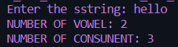 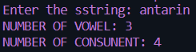

La 7.6

*/\**

*Name : Antarin ghosal*

*LA7.6 WAP to replace all occurrences of a character in a string with the previous 3rd character if any of the character.*

*\*/*

#include<stdio.h>

#include<string.h>

int main()

{

char ch;

char str[10];

int i;

    printf("Enter the sstring: ");

    scanf("%[^\n]s",str);

    int len=strlen(str);

    printf("%s",str);

    for(i=0;i<len;i++)

    {

        ch=tolower(str[i])-3;

        if(ch<97)

            ch=ch+26;

        if(isalpha(str[i]))

            str[i]=ch;

    }

    printf("\n%s",str);

return 0;

}

*//reverse is on the string*

 

La 7.7

*/\**

*Name : Antarin ghosal*

*LA7.7 Develop a user defined function and test them in the main program for the following standard function:*

*int MatchAny(char s1[], char s2[]) :It takes two string arguments and it returns  1 if s2 is substring of s1, returns 0 if both s1 and s2 are equal strings,*

*otherwise, returns -1. Do not use the standard library functions.*

*\*/*

#include<stdio.h>

#include<string.h>

int main()

{

    char str[100],str1[100],str2[100];

    int k,ch,b=0,j;

    printf("ENTER THE STRING(s1):");

    scanf("%[^\n]s",str);

    printf("ENTER THE SUBSTRING:(s2):");

    scanf(" %[^\n]s",str1);

    int len=strlen(str),len1=strlen(str1),i=0;

    if(len!=len1)

    {

        while(str[i]!='\0')

        {

        b=0;

        if(str[i]==str1[0])

                {

                    k=0,ch=0,b=0;

                    for(j=i;j<i+len1;j++)

                        if(str1[k++]==str[j])

                            ch++;

                    if(ch==len1)

                        b=1;

                }

            i=i+1;

        }

    if(b==1)

        printf("1");

    else

        printf("-1");

    }

    else if(len==len1)

    {

        for(i=0;i<len;i++)

            if(str[i]!=str1[i])

                b=1;

        if(b=1)

            printf("0");

        else

            printf("-1");

    }

    else

        printf("-1");

    return 0;

}

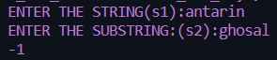 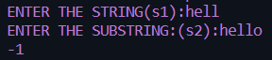

Sa 7.5

*/\**

*Name : Antarin ghosal*

*SA7.5 WAP to extract the first character of each word of a given string  (Achromatic string).*

*\*/*

#include<stdio.h>

#include<string.h>

int main()

{

    char ch;

    char str[10];

    int i;

    printf("Enter the string: ");

    scanf("%[^\n]s",str);

    int len=strlen(str);

    printf("%c ",str[0]);

    for(i=1;i<len;i++)

        if(str[i]==' ')

            printf("%c ",str[i+1]);

return 0;

}

 

Sa 7.6

*/\**

*Name : Antarin ghosal*

*SA7.6 WAP to extract a substring of a given string.*

*\*/*

#include<stdio.h>

#include<string.h>

int main()

{

    char ch;

    char str[10];

    int i,p1,s;

    printf("Enter the string: ");

    scanf("%[^\n]s",str);

    int len=strlen(str);

    printf("enter the staring postion: ");

    scanf("%d",&p1);

    printf("enter the size of the substring:");

    scanf("%d",&s);

    printf("subString: ");

    for(i=p1-1;i<(p1+s)-1;i++)

        printf("%c",str[i]);

return 0;

}

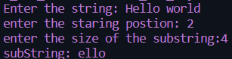 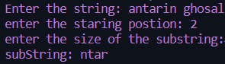

Sa 7.8

*/\**

*Name : Antarin ghosal*

*SA7.8 WAP to replace all occurrences of a character in a given string with a new character.*

*\*/*

#include<stdio.h>

#include<string.h>

int main()

{

    char ch,ch2;

    char str[10];

    int i,p1,s;

    printf("Enter the string: ");

    scanf("%[^\n]s",str);

    int len=strlen(str);

    printf("CHAR TO REPLACE:");

    scanf(" %c",&ch);

    printf("REPLACE WITH: ");

    scanf(" %c",&ch2);

    printf("NEW STRING:  ");

    for(i=0;i<len;i++)

        if(str[i]==ch)

            str[i]=ch2;

    printf("%s",str);

return 0;

}

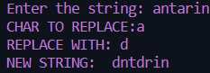 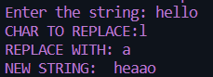

Ha 7.1

*/\**

*Antarin Ghosal*

*HA7.1 WAP to test whether a number num (num is entered through keyboard) is a number in*

*the Fibonacci sequence or not.*

*\*/*

int fibo(int x)

{

    int a=-1,b=1,c=a+b,flag=0;

    while(c<=x)

    {

        if(c==x)

            flag=1;

        a=b;

        b=c;

        c=a+b;

    }

    return flag;

}

int main()

{

    int num;

    printf("Enter a number: ");

    scanf(" %d",&num);

    if(fibo(num))

        printf("%d comes in fibonaci series",num);

    else

        printf("IT DOES NOT COMES IN FIBONACCI SERIES");

    return 0;

}

 

Ha 7.2

*/\**

*Antarin Ghosal*

*HA7.2 WAP to compute the power series (e to the power x).*

*ex=1+x+x^2/2!+x^3/3!+x^4/4!+���..*

*\*/*

#include<stdio.h>

int POWER(int x,int y)

{

    int pow=1,i;

    for(i=1;i<=y;i++)

        pow*=x;

    return pow;

}

int fact(int x)

{

    int i,fact=1;

    for(i=1;i<=x;i++)

        fact*=i;

        return fact;

}

int main()

{

    int x,term=1;

    float sum=1.0;

    printf("ENTER THE VALUE OF X: ");

    scanf("%d",&x);

    while(term<x)

    {

        sum+=(float)POWER(x,term)/fact(term);

        term++;

    }

    printf("sum of the series: %0.2f",sum);

}

 

Ha 7.3

*/\**

*Antarin Ghosal*

*HA7.3 WAP to find the LCM of two numbers a and b by using a suitable function (say LCM) for this.*

*\*/*

#include<stdio.h>

int LCM(int a,int b)

{

    int i,lcm;

        for(i=1;i<=(a<b?a:b);i++)

            if(a%i==0&&b%i==0)

                lcm=i;

    return lcm;

}

int main()

{

    int x,y;

    printf("ENTER the value of A and B : ");

        scanf("%d %d",&x,&y);

    printf("LCM of %d and %d is %d",x,y,LCM(x,y));

    return 0;

}

 

Ha 7.4

*/\**

*Antarin Ghosal*

*HA7.4 WAP to find out the sum of n elements of an integer array a[] by using recursion.*

*\*/*

#include<stdio.h>

void sumOfArray(int a[],int n,int sum)

{

    if(n>=0)

    {

        sum+=(a[n]);

    sumOfArray(a,n-1,sum);

    }

    else

    printf("Sum:%d",sum);

}

int main()

{

    int i,n,sum=0;

    printf("ENTER NUMBER OF ARRay elements: ");

    scanf("%d",&n);

    int a[n];

    printf("Enter array elements:\n");

    for(i=0;i<n;i++)

        scanf("%d",&a[i]);

        sumOfArray(a,n-1,sum);

    return 0;

}

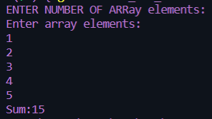 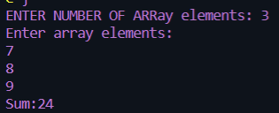

Ha 7.5

*/\**

*Antarin Ghosal*

*HA7.5 WAP by designing a recursive function to calculate the sum of all even digits of*

*any given integer.*

*\*/*

#include<stdio.h>

void sumEd(int num,int sum)

{

    if(num!=0)

    {

        if((num%10)%2==0)

            sum+=num%10;

        sumEd(num/10,sum);

    }

    else

    printf("SUM OF EVEN DIGIT:%d ",sum);

    return;

}

int main()

{

    int n,sum=0;

    printf("ENter the number: ");

    scanf("%d",&n);

    sumEd(n,sum);

    return 0;

}

 

La 7.1

*/\**

*Antarin Ghosal*

*LA7.1 WAP to swap the values of two variables by using a suitable user defined function*

*(say SWAP) for it.*

*\*/*

#include<stdio.h>

void SWAP(int x,int y)

{

    x=x+y;

    y=x-y;

    x=x-y;

    printf("value of a:%d b:%d After swap\n ",x,y);

}

int main()

{

    int a,b;

    printf("Enter the value of a and b: ");

    scanf("%d %d",&a,&b);

    printf("Value of a:%d b:%d before swap\n",a,b);

    SWAP(a,b);

    return 0;

}

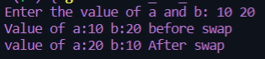 

La 7.2

*/\**

*Antarin Ghosal*

*LA7.2 WAP to find out ncr factor by using a user defined function for factorial (say fact).*

*\*/*

#include<stdio.h>

int fact(int x)

{

    int i,fact=1;

    for(i=1;i<=x;i++)

        fact*=i;

        return fact;

}

int main()

{

    int n,r;

    printf("Enter the value of n and r: ");

    scanf("%d %d",&n,&r);

    int nCr=fact(n)/(fact(r)*fact(n-r));

    printf("\nnCr:%d",nCr);

    return 0;

}

 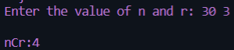

La 7.3

*/\**

*Antarin Ghosal*

*LA7.3 WAP to test whether a number n is palindrome number or not.*

*\*/*

#include<stdio.h>

int pali(int x)

{

    int rem,rev,temp;

    temp=x;

    while(x!=0)

    {

        rem=x%10;

        rev=rev*10+rem;

        x=x/10;

    }

    if(rev==temp)

        return 1;

    else

        return 0;

}

int main()

{

    int n;

    printf("Enter a number: ");

    scanf("%d",&n);

    if(pali(n))

        printf("%d is palindrome",n);

    else

        printf("%d is not palndrome",n);

    return 0;

}

 

La 7.4

*/\**

*Antarin Ghosal*

*LA7.4 WAP to calculate x^y by writing a function(say POWER) for it.*

*\*/*

#include<stdio.h>

int POWER(int x,int y)

{

    int pow=1,i;

    for(i=1;i<=y;i++)

        pow*=x;

    return pow;

}

int main()

{

    int n,m;

    printf("Enter a number: ");

    scanf("%d",&n);

    printf("enter power:");

    scanf("%d",&m);

    printf("%d power %d: %d",n,m,POWER(n,m));

    return 0;

}

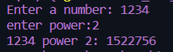 

La 7.5

*/\**

*Antarin Ghosal*

*LA7.5 WAP to generate all the prime numbers between 1 and n by using a user defined*

*function (say isPRIME) to be used for prime number testing, where n is a value supplied by the user.*

*\*/*

#include<stdio.h>

int isPrime(int x)

{

    int flag=0,i;

    for(i=2;i<x;i++)

        if(x%i==0)

            flag=1;

    if(flag==1)

        return 0;

    else

        return 1;

}

int main()

{

    int n,i;

    printf("Enter the value of n: ");

    scanf("%d",&n);

    for(i=1;i<=n;i++)

        if(isPrime(i))

            printf("%d  ",i);

    return 0;

}

 

La 7.6

*/\**

*Antarin Ghosal*

*LA7.6 A Fibonacci sequence is defined as follows: the first and second terms in the*

*sequence are 0 and 1. Subsequent terms are found by adding the preceding two terms in the*

*sequence (Fi=Fi-1+Fi-2). WAP to generate the first n terms of the sequence by writing a*

*suitable user defined function (say fib) to be used to get nth term Fibonacci value.*

*\*/*

#include<stdio.h>

int fib(int x)

{

    int a=-1,b=1,c=a+b,i;

    for(i=1;i<=x;i++)

        {

            a=b;

            b=c;

            c=a+b;

        }

    return c;

}

int main()

{

    int n,i;

    printf("Enter the value of n: ");

    scanf("%d",&n);

    for(i=1;i<=n;i++)

        printf("%d ",fib(i));

    return 0;

}

 

La 7.7

*/\**

*Antarin Ghosal*

*LA7.7 WAP to compute the cosine series using function.*

*cos(x)=1-x^2/2!+x^4/4!-x^6/6!+ �*

*\*/*

#include<stdio.h>

int POWER(int x,int y)

{

    int pow=1,i;

    for(i=1;i<=y;i++)

        pow*=x;

    return pow;

}

int fact(int x)

{

    int i,fact=1;

    for(i=1;i<=x;i++)

        fact*=i;

        return fact;

}

int main()

{

    float sum=1.0;

    int term=1,y=2,n,x;

    printf("Enter the value of N: ");

    scanf("%d",&n);

    printf("enter the value of x: ");

    scanf("%d",&x);

    while(term<n)

    {

        if(term%2!=0)

            sum-=(float)POWER(x,y)/fact(y);

        else

            sum+=(float)POWER(x,y)/fact(y);

        y=y+2;

        term=term+1;

    }

    printf("SUM OF THE SERIES: %0.2f",sum);

    return 0;

}

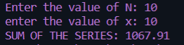 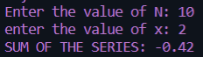

La 7.8

*/\**

*Antarin Ghosal*

*LA7.8 WAP to count number of digits of a positive integer n by using recursion.*

*\*/*

#include<stdio.h>

void COUNT(int num,int count)

{

    if(num<0)

    {

        printf("the number is not postive");

        return;

    }

    if(num!=0)

    {

            count+=1;

        COUNT(num/10,count);

    }

    else

    printf("NUMBER OF DIGIT: :%d ",count);

    return;

}

int main()

{

    int n,count=0;

    printf("ENter the number: ");

    scanf("%d",&n);

    COUNT(n,count);

    return 0;

}

 

La 8.1

*/\**

*Antarin Ghosal*

*LA8.1 WAP to add two numbers using call by reference.*

*\*/*

#include <stdio.h>

int add(int *a,int *b,int *c){

    *c=*a+*b;}

int main ()

    {

    int x,y,s=0;

    printf("ENter the Value of x and y: ");

    scanf("%d %d",&x,&y);

    add(&x,&y,&s);

    printf("SUM:%d",s);

   return 0;

}

 

La 8.2

*/\**

*Antarin Ghosal*

*LA8.2 WAP to compute the sum of all elements in an array using pointer.*

*\*/*

#include <stdio.h>

int main ()

    {

    int N,i,sum=0;

    printf("Enter number of element in the array:");

    scanf("%d",&N);

    int arr[N];

    for(i=0;i<N;i++)

    {

        printf("ENter arr element [%d]: ",i);

        scanf("%d",&arr[i]);

    }

    int *p=&arr[0];

    for(i=0;i<N;i++)

    {

        sum+=*p;

        p=p+1;

    }

    printf("sum of the array: %d",sum);

   return 0;

}

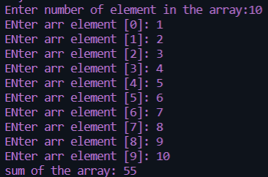

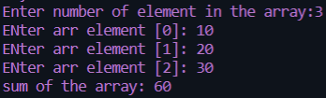

La 8.3

*/\**

*Antarin Ghosal*

*LA8.3 WAP to display values in reverse order from an integer array using pointer.*

*\*/*

#include <stdio.h>

int main ()

    {

    int N,i,sum=0;

    printf("Enter number of element in the array:");

    scanf("%d",&N);

    int arr[N];

    for(i=0;i<N;i++)

    {

        printf("ENter arr element [%d]: ",i);

        scanf("%d",&arr[i]);

    }

    int *p=&arr[N-1];

    for(i=N-1;i>=0;i--)

    {

        printf("%d\t",*p);

        p=p-1;

    }

   return 0;

}

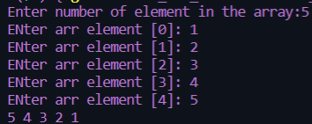

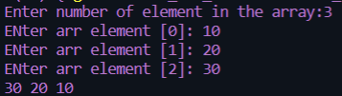

La 8.4

*/\**

*Antarin Ghosal*

*LA8.4 WAP to swap three numbers in cyclic order using Call by Reference. In other words, WAP that*

*takes three variable (a, b, c) in as separate parameters and rotates the values stored so that*

*value a goes to be, b, to c and c to a.*

*\*/*

#include <stdio.h>

cyclic(int *i,int *j,int *k)

{

        int temp=*j;

        *j=*i;

        *i=*k;

        *k=temp;

}

int main ()

    {

    int a,b,c;

    printf("Enter the value of a b and c: ");

    scanf("%d %d %d",&a,&b,&c);

    printf("VAlue before cyclic swap A:%d\tB:%d\tC:%d\n",a,b,c);

    cyclic(&a,&b,&c);

    printf("VAlue after cyclic swap A:%d\tB:%d\tC:%d",a,b,c);

   return 0;

}





Sa 8.1

*/\**

*Antarin Ghosal*

*SA8.1 WAP to create, initialize, assign and access a pointer variable.*

*\*/*

#include <stdio.h>

int main ()

    {

    int a=5;

    int *p1;

    p1=&a;

    printf("%d ",*p1);

   return 0;

}

Sa 8.2

*/\**

*Antarin Ghosal*

*SA8.2 WAP to print size of different types of pointer variables.*

*\*/*

#include <stdio.h>

int main ()

    {

        printf("\nsize of int pointer: %d",sizeof(int*));

        printf("\nsize of char pointer: %d",sizeof(char*));

        printf("\nsize of float pointer: %d",sizeof(float*));

        printf("\nsize of double pointer: %d",sizeof(double*));

   return 0;

}

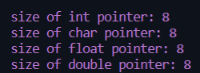

Sa 8.3

*/\**

*Antarin Ghosal*

*SA8.3 WAP to add two numbers using pointers.*

*\*/*

#include <stdio.h>

int main ()

    {

    int a=5,*p1=&a;

    int b=6,*p2=&b;

    int c= *p1+*p2;

    printf("SUM: %d",c);

   return 0;

}



Sa 8.4

*/\**

*Antarin Ghosal*

*SA8.4 WAP to swap two numbers using call by reference.*

*\*/*

#include <stdio.h>

int swap(int *a,int *b)

{

    int temp=*b;

    *b=*a;

    *a=temp;

}

int main ()

    {

    int x,y;

    printf("ENter the Value of x and y: ");

    scanf("%d %d",&x,&y);

    printf("Before swaping :\na:%d\tb:%d\n",x,y);

    swap(&x,&y);

    printf("After swaping :\na:%d\tb:%d\n",x,y);

   return 0;

}

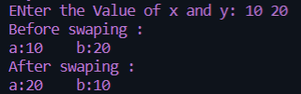 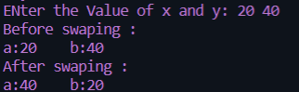

La 9.5

*/*Author : Antarin Ghosal*

*Program : WAP to sort an array using Pointer.*/*

#include<stdio.h>

void bubblesort();

int main(){

    int arr[6]={6,3,7,1,9,2};

    bubblesort(arr,6);

    return 0;

}

void bubblesort(int *p,int n){

    int i,j,temp;

    for(i=1;i<n;i++){

        for(j=0;j<n-i;j++){

            if(*(p+j)<*(p+j+1)){

                temp=*(p+j);

                *(p+j)=*(p+j+1);

                *(p+j+1)=temp;

            }

        }

    }

    printf("The sorted array is : ");

    for(i=0;i<6;i++){

        printf("%d,",p[i]);

    }

}



La 9.6

*/*Author : Antarin Ghosal*

*Program : WAP to count vowels and consonants in a string using pointer.*/*

#include<stdio.h>

#include<string.h>

int main(){

    char s[100];

    char *p;

    int vow=0,consts=0;

    printf("\nEnter a string : ");

    gets(s);

    p=s;

    while(*p!='\0'){

        if(*p=='A'||*p=='E'||*p=='I'||*p=='O'||*p=='U'||*p=='a'||*p=='e'||*p=='i'||*p=='o'||*p=='u'){

            vow++;

        }

        else{

            if(*p!=' '){

                consts++;

            }

        }

    p++;

    }

    printf("The number of vowels Present are : %d",vow);

    printf(" And consonants are : %d",consts);

    return 0;

}





La 9.7

*/*Author : Antarin Ghosal*

*Program : WAP to print a string in reverse using a pointer.*/*

#include<stdio.h>

#include<string.h>

int main(){

    char s[]="Hello world";

    int i,l;

    l=strlen(s);

    printf("The reversed string is : ");

    for(i=l;i>=0;i--){

        printf("%c",*(s+i));

    }

    return 0;

}



La 9.8

*/*Author : Antarin Ghosal*

*Program : WAP to find the largest element stored in an array of n elements by using dynamic memory*

*allocation*/*

#include<stdio.h>

#include<stdlib.h>

int main(){

    int n,*a,i,s=0,max;

    printf("Enter the number of elements : ");

    scanf("%d",&n);

    a=(int *)malloc(n*sizeof(int));

    if(a==NULL){

        printf("Unsuccessful !!");

        exit(0);

    }

    printf("Enter the array Elements : ");

    for(i=0;i<n;i++){

        scanf("%d",&a[i]);

    }

    for(i=0;i<n;i++){

        if(a[i]>a[i-1]){

            max=a[i];

        }

        else max=a[i-1];

    }

    printf("The largest element is : %d",max);

    return 0;

}

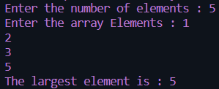 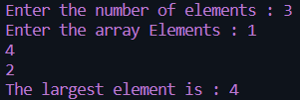

La 9.9

*/*Author : Antarin Ghosal*

*Program : WAP to bubble sort array elements declared dynamically using call by reference.*/*

#include<stdio.h>

void bubblesort();

int main(){

    int arr[6]={6,3,7,1,9,2};

    bubblesort(arr,6);

    return 0;

}

void bubblesort(int *p,int n){

    int i,j,temp;

    for(i=1;i<n;i++){

        for(j=0;j<n-i;j++){

            if(*(p+j)<*(p+j+1)){

                temp=*(p+j);

                *(p+j)=*(p+j+1);

                *(p+j+1)=temp;

            }

        }

    }

    printf("The sorted array is : ");

    for(i=0;i<6;i++){

        printf("%d,",p[i]);

    }

}



Sa 9.5

*/*Author : Antarin Ghosal*

*Program : WAP to print a string using pointer.*/*

#include<stdio.h>

int main(){

    char str[100];

    char *p;

    printf("\nEnter a string : ");

    gets(str);

    p = str;

    printf("\nEntered string is : ");

    while(*p!='\0')

        printf("%c",*p++);

    return 0;

}

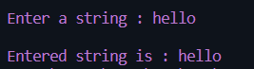 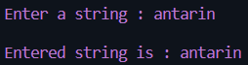

Sa 9.6

*/*Author : Antarin Ghosal*

*Program : WAP to count vowels in a string using pointer.*/*

#include<stdio.h>

#include<string.h>

int main(){

    char s[100];

    char *p;

    int vow=0;

    printf("\nEnter a string : ");

    gets(s);

    p=s;

    while(*p!='\0'){

        if(*p=='A'||*p=='E'||*p=='I'||*p=='O'||*p=='U'||*p=='a'||*p=='e'||*p=='i'||*p=='o'||*p=='u'){

            vow++;

        }

    p++;

    }

    printf("The number of vowels Present are : %d",vow);

    return 0;

}





Sa 9.7

*/*Author : Antarin Ghosal*

*Program : WAP to store n elements in an array using dynamic memory allocation and print the elements*

*using pointer.*/*

#include<stdio.h>

#include<stdlib.h>

int main(){

    int n,*a,i,s=0;

    printf("Enter the number of elements : ");

    scanf("%d",&n);

    a=(int *)malloc(n*sizeof(int));

    if(a==NULL){

        printf("Unsuccessful !!");

        exit(0);

    }

    printf("Enter the array Elements : ");

    for(i=0;i<n;i++){

        scanf("%d",&a[i]);

    }

    return 0;

}

int bubble

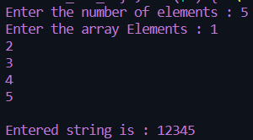 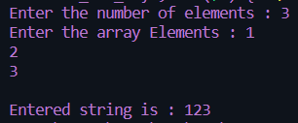

Ha 9.2

#include<stdio.h>

#include<stdlib.h>

int main()

{

    int n,*a,i,max,*b,N;

    int k=0;

    printf("enter number of elment of the array: ");

    scanf("%d",&n);

    a=(int*)malloc(n*sizeof(int));

    b=(int*)malloc(n*sizeof(int));

    printf("Enter the cyclic switch: ");

    scanf("%d",&N);

    if(a==NULL)

    {

        printf("MEMORY ALLOCATION UNSUCCESFULL");

        exit(0);

    }

    else

    {

        printf("\ENTER THE ARRAY ELEMENT ONE by one\n:");

        for(i=0;i<n;i++)

        {

            printf("Enter element number [%d]: ",i+1);

            scanf("%d",(a+i));

        }

    k=N;

    for(i=0;i<n-N;i++)

        *(b+i)=*(a+k++);

    k=0;

    for(i=n-N;i<n;i++)

        *(b+i)=*(a+k++);

    printf("AFTER LEFT CYCLIC SWITCH OF VALUE %d\n",N);

    for(i=0;i<n;i++)

        printf("%d\t",*(b+i));

    }

    return 0;

}

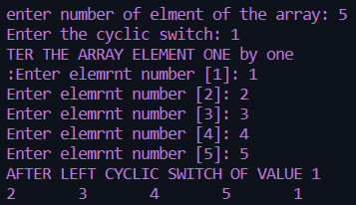

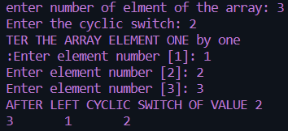

Ha 9.3

#include<stdio.h>

#include<string.h>

#include <ctype.h>

int main()

{

    int n;char ch[100],*str=ch;

    int vc=0,c=0,i;

    printf("Enter the string:");

    scanf("%[^\n]s",ch);

    for(i=0;i<strlen(ch);i++)

    {

        if(*(str+i)=='A'||*(str+i)=='E'||*(str+i)=='I'||*(str+i)=='O'||*(str+i)=='U'||*(str+i)=='a'||*(str+i)=='e'||*(str+i)=='i'||*(str+i)=='o'||*(str+i)=='u')

            vc++;

        else if(isalpha(*(str+i)))

                c++;

    }

    printf("VOWEL: %d\n",vc);

    printf("CONSONANT: %d\n",c);

return 0;

}

 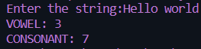

Ha 9.4

#include <stdio.h>

#include <string.h>

void swap(char *x, char *y)

{

    char temp;

    temp = *x;

    *x = *y;

    *y = temp;

}

void permute(char *a, int l, int r)

{

int i;

if (l==r)

    printf("%s\n",a);

else

{

    for(i=l;i<=r;i++)

    {

        swap((a+l),(a+i));

        permute(a,l+1, r);

        swap((a+l),(a+i));

    }

}

}

int main()

{

    char str[100];

    printf("Enter the string:");

    scanf("%[^\n]s",str);

    int n = strlen(str);

    permute(str, 0, n-1);

    return 0;

}

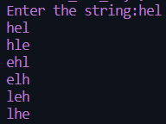 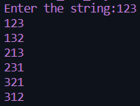

Ha 9.5

#include <stdio.h>

#include <string.h>

void swap(char* str)

{

    char c=0;

    int length=0,i=0;

    length = strlen(str);

    if (length % 2 == 0)

    {

        for(i=0;i<length;i+=2)

        {

            c=str[i];

            str[i]=str[i+1];

            str[i+1] =c;

        }

        printf("%s\n", str);

    }

    else {

        printf("NA\n");

    }

}

int main()

{

    char str[100];

    printf("Enter the string:");

    scanf("%[^\n]s",str);

    swap(str);

    return 0;

}





Ha 9.6

#include <stdio.h>

#include <string.h>

void main()

{

    char str[100], sub[100];

    int count=0,count1=0;

    int i,j,l,l1,l2;

    printf("Enter a string : ");

    scanf("%[^\n]s", str);

    l1=strlen(str);

    printf("\nEnter a substring : ");

    scanf(" %[^\n]s", sub);

    l2=strlen(sub);

    for(i=0;i<l1;)

    {

        j=0;

        count=0;

        while((str[i]==sub[j]))

        {

            count++;

            i++;

            j++;

        }

        if(count==l2)

        {

            count1++;

            count=0;

        }

        else

            i++;

    }

    printf("%s occurs %d times in %s", sub, count1, str);

}

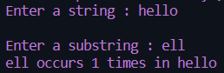 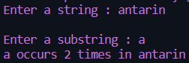

Ha 10.1

*/\**

*Name: Antarin ghosal*

*WAP to create a new data type DATE with the help of structure and typedef. Write the*

*following user defined functions for the date manipulations.*

*a) To return next date*

*b) To return next month.*

*c) To return next year.*

*d) to add few days in a date.*

*e) To add few months in a date.*

*f) To add few years in a date.*

*g) To return month name from a date.*

*h) To display date in various format such as DD-MM-YYYY, DD.MM.YY etc.*/*

#include<stdio.h>

typedef struct date

{

    int day;

    int month;

    int year;

}d;

int main()

{

    d date;

    int n,x;

    printf("Enter Date :~");

    scanf("%i %i %i",&date.day,&date.month,&date.year);

    printf("Enter Command Number For Function:~\n");

    printf("1 for Next Day\n");

    printf("2 for Next Month\n");

    printf("3 for Next Year\n");

    printf("4 for Add Date\n");

    printf("5 for Add Month\n");

    printf("6 for Add Year\n");

    printf("7 for Different Styles\n");

    printf("Enetr Function key:~");

    scanf("%i",&n);

    switch (n)

    {

    case 1:

        printf("Next Date Is %i/%i/%i",date.day+1,date.month,date.year);

        break;

    case 2:

        printf("Next Month Is %i",date.month+1);

        break;

    case 3:

        printf("Next Year Is %i",date.year+1);

        break;

    case 4:

        printf("Enter Date To Add:~");

        scanf("%i",&x);

        printf("Resultant Date Is %i",date.year+x);

        break;

    case 5:

        printf("Enter Month To Add:~");

        scanf("%i",&x);

        printf("Resultant Month Is %i",date.month+x);

        break;

    case 6:

        printf("Enter Year To Add:~");

        scanf("%i",&x);

        printf("Resultant Year Is %i",date.year+x);

        break;

    case 7:

        printf("Date Is %i/%i/%i\n",date.day+1,date.month,date.year);

        printf("Date Is %i.%i.%i\n",date.day+1,date.month,date.year);

        printf("Date Is %i-%i-%i\n",date.day+1,date.month,date.year);

        break;

    default:

        printf("Please Enter Valid Number");

        break;

    }

}

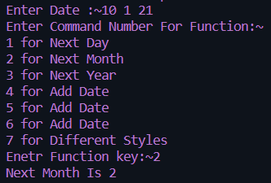

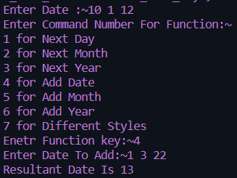

Ha 10.2

*/\**

*Name: Antarin ghosal*

*HA10.2 WAP to calulate the difference between two time periods. Times are given in hr, min and sec.*

*\*/*

#include<stdio.h>

struct time{

    int second,min,hr;

}t1,t2,D;

int main()

{

    printf("Time1:\n");

    printf("ENTER TIME:hr:");

    scanf("%d",&t1.hr);

    printf("min:");

    scanf("%d",&t1.min);

    printf("Sec:");

    scanf("%d",&t1.second);

    printf("Time2:\n");

    printf("ENTER TIME:hr:");

    scanf("%d",&t2.hr);

    printf("min:");

    scanf("%d",&t2.min);

    printf("Sec:");

    scanf("%d",&t2.second);

*//DIFRENCE*

    D.hr=t1.hr-t2.hr;

    D.min=t1.min-t2.min;

    D.second=t1.second-t2.second;

    while(D.second<0)

    {

        D.second=60+D.second;

        D.min=D.min-1;

    }

    while(D.min<0)

    {

        D.min+=60;

        D.hr=-1;

    }

    printf("TIME DIFFRENCE:%d:%d:%d",D.hr,D.min,D.second);

    return 0;

}

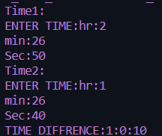 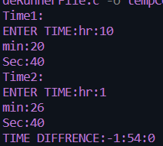

Ha 10.3

*/\**

*Name: Antarin ghosal*

*HA10.3 WAP to extract individual bytes from an unsigned int using union.*

*\*/*

#include<stdio.h>

union tagname

{

    unsigned int a;

    unsigned char s[4];

}object;

int main()

{

    char i; *//for loop counter*

    printf("ENter an integer number: ");

    scanf("%d",&object.a);

    printf("Integer number: %ld, hex: %X\n",object.a,object.a);

    printf("Indivisual bytes: ");

    for(i=3;i>=0;i--)

        printf("%02X ",object.s[i]);

    printf("\n");

    return 0;

}

 

La 10.1

*/*Author : Antarin Ghosal*

*Program : WAP to store n student’s information (i.e. student’s roll no, name, gender, marks in 5 subjects*

*etc) of an educational institute and display all the data with total marks of each student, using*

*array of structure. If full mark of each subject is considered as 100 and pass mark as 40, then*

*display the list of students failed in a particular subject.*

*\*/*

#include<stdio.h>

struct student

{

    int roll;

    char name[30];

    char gender;

    int marks1;

    int marks2;

    int marks3;

    int marks4;

    int marks5;

}

stu[5]={

    {1,"Ramesh",'M',74,68,70,76,80},

    {2,"Suresh",'M',89,90,86,74,83},

    {3,"Kamli",'F',78,36,78,80,62},

    {4,"Ananya",'F',58,93,32,78,80},

    {5,"Kamlesh",'M',89,64,80,28,90},

};

int main(){

    printf("The Student details of individual student are : \n");

    for(int i=0;i<5;i++){

        printf("\t  %d  \t  %s  \t  %c  \t  %d  \t  %d  \t  %d  \t  %d  \t  %d  \t\n",stu[i].roll,stu[i].name,stu[i].gender,stu[i].marks1,stu[i].marks2,stu[i].marks3,stu[i].marks4,stu[i].marks5);

    }

    return 0;

}

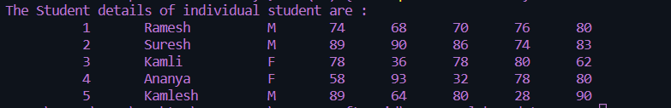

La 10.2

*/\**

*Name: Antarin ghosal*

*LA10.2 WAP to add two distances (in km-meter) using structures.*

*\*/*

#include<stdio.h>

struct dis

{

    int km;

    int m;

};

int main()

{

    struct dis d1,d2,sum;

    printf("Enter distance1:KM:");

    scanf("%d",&d1.km);

    printf("M:");

    scanf("%d",&d1.m);

    printf("Enter distance2:KM:");

    scanf("%d",&d2.km);

    printf("M:");

    scanf("%d",&d2.m);

    sum.km=d1.km+d2.km;

    sum.m=d1.m+d2.m;

    if(sum.m>1000)

        {

            int temp=sum.m/1000;

            sum.km=sum.km+temp;

            sum.m=sum.m%1000;

        }

    printf("Total distance: %dkm %dm",sum.km,sum.m);

    return 0;

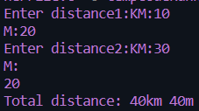 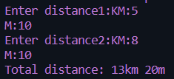

La 10.3

#include<stdio.h>

struct Time

{

    int h;

    int m;

    int s;

};

int main()

{

    struct Time T1,T2,S;

    printf("\nEnter time 1\n");

    printf("Hour:");

    scanf("%d",&T1.h);

    printf("MINUTE:");

    scanf("%d",&T1.m);

    printf("SECOUND:");

    scanf("%d",&T1.s);

    printf("\nEnter time 2\n");

    printf("Hour:");

    scanf("%d",&T2.h);

    printf("MINUTE:");

    scanf("%d",&T2.m);

    printf("SECOUND:");

    scanf("%d",&T2.s);

    S.h=T1.h+T2.h;

    S.m=T1.m+T2.m;

    S.s=T1.s+T2.s;

    while(S.s>60)

    {

        S.s-=60;

        S.m+=1;

    }

    while(S.m>60)

    {

        S.m-=60;

        S.h+=1;

    }

printf("\nT1 : %d:%d:%d",T1.h,T1.m,T1.s);

printf("\nT2 : %d:%d:%d",T2.h,T2.m,T2.s);

printf("\nADDED TIME: %d:%d:%d",S.h,S.m,S.s);

    return 0;

}

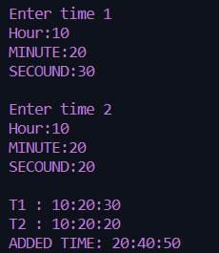 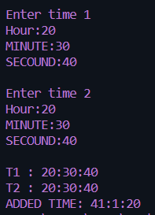

La 10.4

#include<stdio.h>

struct info

{

    char name[20];

    char Gender;

    char designaton[25];

    char depatment[25];

    float BP;

    float GP;

};

int main()

{

    printf("Enter number of employee: ");

    int n,i;

    scanf("%d",&n);

    struct info employe[n];

    printf("\n\t\tEnter information of the employee\n");

    float HR,DA;

    for(i=0;i<n;i++)

        {

            printf("\t\t\t\tEMPLOYE %d\n\n",i+1);

            printf("ENter name: ");

            scanf(" %[^\n]s",&employe[i].name);

            printf("Enter Gender: ");

            scanf(" %c",&employe[i].Gender);

            printf("Enter DEGIGNATION: ");

            scanf(" %[^\n]s",&employe[i].designaton);

            printf("Enter DEPARTMENT: ");

            scanf(" %[^\n]s",&employe[i].depatment);

            printf("ENTER BP(basic pay): ");

            scanf("%f",&employe[i].BP);

            HR=(float)25*employe[i].BP/100;

            DA=(float)75*employe[i].BP/100;

            employe[i].GP=employe[i].BP+HR+DA;

        }

*//DISPLAY*

        printf("\n %10s\t %10s\t %10s\t %10s\t %10s\t %10s\n","NAME","GENDER","DESIGNATION","DEPARTMANT","BP","GP");

        for(i=0;i<n;i++)

        printf("\n %10s\t %10c\t %10s\t %10s\t %10.2f\t %10.2f\n",employe[i].name,employe[i].Gender,employe[i].designaton,employe[i].depatment,employe[i].BP,employe[i].GP);

    return 0;

}

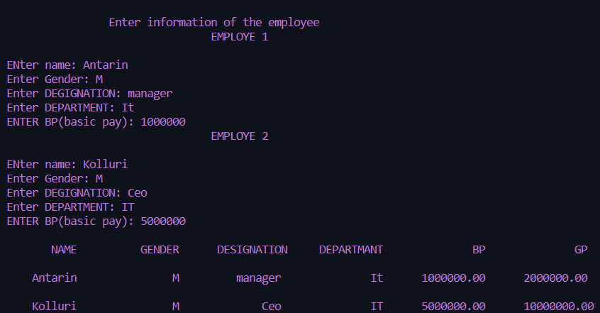

La 10.5

*/\**

*Name: Antarin ghosal*

*WAP to declare an union named as ABC having three members a, b and c as character, integer*

*and double respectively. Assign user entered values to these members respectively one by one*

*and display these values immediately. Again assign these user entered values to a, b, c one by*

*one all together and display these values at last. Find the difference.*/*

#include<stdio.h>

union ABC

{

    char a;

    int b;

    double c;

}ob;

int main()

{

    int n;

    char s;

    double x;

    printf("Enter Value Of int:~");

    scanf("%i",&n);

    printf("Enter Charater Value:~\n");

    scanf("\n%c",&s);

    printf("Enter Double Value:~\n");

    scanf("%ld",&x);

    ob.a = s;

    printf("Current Value In %u Is %c After Adding a Value\n",&ob,ob.a);

    ob.b = n;

    printf("Current Value In %u Is %i After Adding b Value\n",&ob,ob.b);

    ob.c = x;

    printf("Current Value In %u Is %i After Adding b Value\n",&ob,ob.c);

    ob.a = s;

    ob.b = n;

    ob.c = x;

    printf("Current Value In %u Is %c After Adding All Values\n",&ob,ob.a);

    printf("Current Value In %u Is %i After Adding All Values\n",&ob,ob.b);

    printf("Current Value In %u Is %ld After Adding All Values",&ob,ob.c);

}

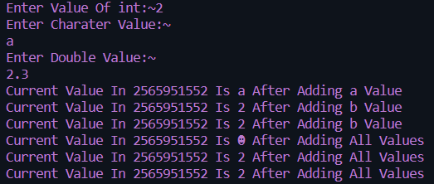

Sa 10.1

*/\**

*Name: Antarin ghosal*

*SA10.1 WAP to store one student�s information (i.e. student�s roll no, name, gender, marks etc) of an*

*educational institute and display all the data, using structure.*

*24/05/2022*

*\*/*

#include<stdio.h>

#include<string.h>

struct stdinf

{

    char name[20];

    int roll;

    char gender;

    int marks;

};

int main()

{

    struct stdinf std1={"Antarin",2106096,'M',100};

    printf("Name:%s\nRoll:%d\nGender:%c\nMarks:%d",std1.name,std1.roll,std1.gender,std1.marks);

    return 0;

}

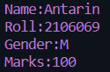

Sa 10.2

*/\**

*Name: Antarin ghosal*

*SA10.2 WAP to store n student�s information (i.e. student�s roll no, name, gender, marks etc) of an*

*educational institute and display all the data, using array of structure.*

*24/05/2022*

*\*/*

#include<stdio.h>

#include<string.h>

struct stdinf

{

    char name[20];

    int roll;

    char gender;

    int marks;

};

int main()

{

    int n,i;

    printf("Enter the value of n:(total number of student)");

    scanf("%d",&n);

    struct stdinf std[n];

*//input*

    for(i=0;i<n;i++)

        {

            printf("\n-------for student %d---------",i+1);

            printf("\nEnter name: ");

            scanf("%s",&std[i].name);

            printf("\nEnter roll: ");

            scanf("%d",&std[i].roll);

            printf("\nEnter gender: ");

            scanf(" %c",&std[i].gender);

            printf("\nEnter marks: ");

            scanf("%d",&std[i].marks);

        }

*//display*

    printf("\n\nSno.\tName\tRoll\tGender\tmarks\n");

    for(i=0;i<n;i++)

        printf("%d\t%s\t%d\t%c\t%d\n",i+1,std[i].name,std[i].roll,std[i].gender,std[i].marks);

    return 0;

}

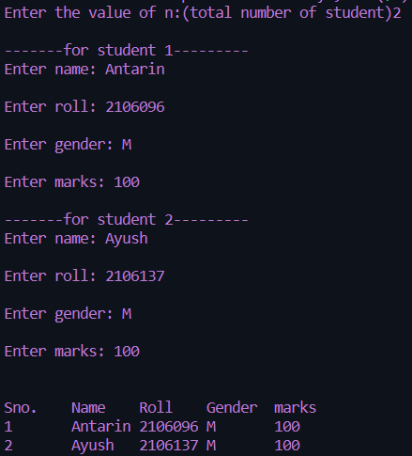

Sa 10.4

*/\**

*Name: Antarin ghosal*

*WAP to add two complex numbers by passing structure to a function*

*24/05/2022*

*\*/*

#include <stdio.h>

typedef struct complex

{

    float real;

    float imag;

} complex;

complex add(complex n1, complex n2)

{

    complex temp;

    temp.real = n1.real + n2.real;

    temp.imag = n1.imag + n2.imag;

    return (temp);

}

int main() {

    complex n1, n2, result;

    printf("For 1st complex number \n");

    printf("Enter the real then imaginary parts: ");

    scanf("%f %f", &n1.real, &n1.imag);

    printf("\nFor 2nd complex number \n");

    printf("Enter the real then imaginary parts: ");

    scanf("%f %f", &n2.real, &n2.imag);

    result = add(n1, n2);

    printf("Sum = %.1f + %.1fi", result.real, result.imag);

    return 0;

}

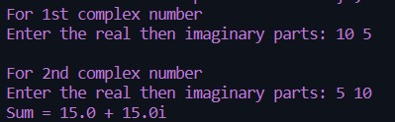

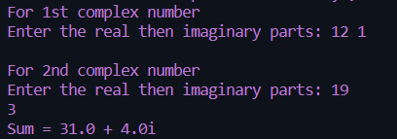

Sa 10.5

*/\**

*Name: Antarin ghosal*

*WAP to store n books data such as title, author, pulication, price etc using structures with*

*dynamically memory allocation. Display all the books information of a particular author.*/*

#include<stdio.h>

#include<string.h>

#define SIZE 20

struct bookdetail

{

    char name[20];

    char author[20];

    int pages;

    float price;

};

void output(struct bookdetail v[],int n)

{

    int i,t=1;

    for(i=0;i<n;i++,t++)

    {

        printf("\n");

        printf("Book No.%d\n",t);

        printf("\t\tBook %d Name is=%s \n",t,v[i].name);

        printf("\t\tBook %d Author is=%s \n",t,v[i].author);

        printf("\t\tBook %d Pages is=%d \n",t,v[i].pages);

        printf("\t\tBook %d Price is=%f \n",t,v[i].price);

        printf("\n");

    }

}

void main()

{

    struct bookdetail b[SIZE];

    int num,i;

    printf("Enter the Numbers of Books:");

    scanf("%d",&num);

    printf("\n");

    for(i=0;i<num;i++)

    {

        printf("\t=:Book %d Detail:=\n",i+1);

        printf("\nEnter the Book Name:\n");

        scanf("%s",b[i].name);

        printf("Enter the Author of Book:\n");

        scanf("%s",b[i].author);

        printf("Enter the Pages of Book:\n");

        scanf("%d",&b[i].pages);

        printf("Enter the Price of Book:\n");

        scanf("%f",&b[i].price);

    }

    output(b,num);

}

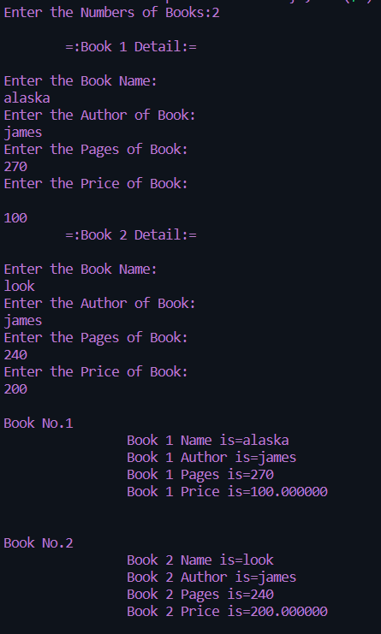

Sa 10.6

*/\**

*Name: Antarin ghosal*

*WAP to read item details used in party and calculate all expenses, divide expenses in all*

*friends equally.*/*

#include <stdio.h>

#define MAX 50

*//structure definition*

typedef struct item_details

{

    char itemName[30];

    int quantity;

    float price;

    float totalAmount;

}item;

int main()

{

    item thing[MAX];

    int i,choice;

    int count=0;

    float expenses=0.0f;

    i=0;

*//infinite loop*

    do{

        printf("Enter item details [%2d]:\n",i+1);

        printf("Item:  ");

        fgets(thing[i].itemName,30,stdin);

        printf("Price? ");

        scanf("%f",&thing[i].price);

        printf("Quantity:  ");

        scanf("%d",&thing[i].quantity);

        thing[i].totalAmount=(float)thing[i].quantity*thing[i].price;

        expenses += thing[i].totalAmount;

        i++;

        count++;

        printf("\nWant to more items (press 1): ");

        scanf("%d",&choice);

        getchar();

    }while(choice==1);

*//print all items*

    printf("All details are:\n");

    for(i=0; i<count; i++)

    {

        printf("%-30s\t %.2f \t %3d \n %.2f\n",thing[i].itemName, thing[i].price, thing[i].quantity, thing[i].totalAmount);

    }

    printf("#### Total expense: %.2f\n",expenses);

    printf("Want to divide in friends (press 1 for yes): ");

    scanf("%d",&choice);

    if(choice==1)

    {

        printf("How many friends? ");

        scanf("%d",&i);

        printf("Each friend will have to pay: %.2f\n",(expenses/(float)i));

    }

    printf("~Thanks for using me... Enjoy your party!!!~\n");

    return 0;

}

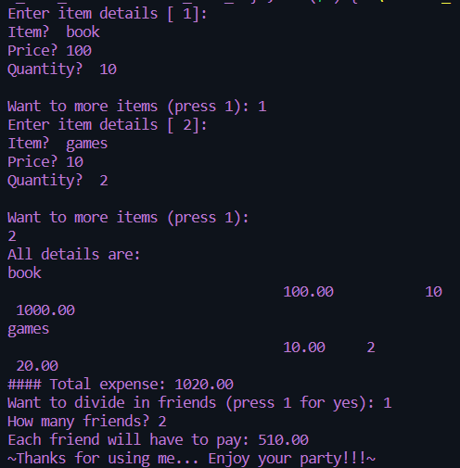

Sa 10.7

*/\**

*Name: Antarin ghosal*

*WAP to declare an union named as ABC having two members a as character and b as*

*integer . Assign ‘A’ to a, 1088 to b respectively through an union variable ob one by one and*

*display these these values immediately. Now assign these values to a, b through ob all*

*together and display these values at last. Find the difference.*/*

#include<stdio.h>

union Ob

{

    char a;

    int b;

}ob;

int main()

{

    int n;

    char s;

    printf("Enter Value Of int:~");

    scanf("%i",&n);

    printf("Enter Charater Value:~");

    scanf("%c",&s);

    ob.a = s;

    printf("Current Value In %u Is %c After Adding a Value\n",&ob,ob.a);

    ob.b = n;

    printf("Current Value In %u Is %i After Adding b Value\n",&ob,ob.b);

    ob.a = s;

    ob.b = n;

    printf("Current Value In %u Is %c After Adding Both Values\n",&ob,ob.a);

    printf("Current Value In %u Is %i After Adding Both Value",&ob,ob.b);

}

