Name: Antarin Ghosal

Ha 10.1

*/\**

*Name: Antarin ghosal*

*WAP to create a new data type DATE with the help of structure and typedef. Write the*

*following user defined functions for the date manipulations.*

*a) To return next date*

*b) To return next month.*

*c) To return next year.*

*d) to add few days in a date.*

*e) To add few months in a date.*

*f) To add few years in a date.*

*g) To return month name from a date.*

*h) To display date in various format such as DD-MM-YYYY, DD.MM.YY etc.*/*

#include<stdio.h>

typedef struct date

{

    int day;

    int month;

    int year;

}d;

int main()

{

    d date;

    int n,x;

    printf("Enter Date :~");

    scanf("%i %i %i",&date.day,&date.month,&date.year);

    printf("Enter Command Number For Function:~\n");

    printf("1 for Next Day\n");

    printf("2 for Next Month\n");

    printf("3 for Next Year\n");

    printf("4 for Add Date\n");

    printf("5 for Add Month\n");

    printf("6 for Add Year\n");

    printf("7 for Different Styles\n");

    printf("Enetr Function key:~");

    scanf("%i",&n);

    switch (n)

    {

    case 1:

        printf("Next Date Is %i/%i/%i",date.day+1,date.month,date.year);

        break;

    case 2:

        printf("Next Month Is %i",date.month+1);

        break;

    case 3:

        printf("Next Year Is %i",date.year+1);

        break;

    case 4:

        printf("Enter Date To Add:~");

        scanf("%i",&x);

        printf("Resultant Date Is %i",date.year+x);

        break;

    case 5:

        printf("Enter Month To Add:~");

        scanf("%i",&x);

        printf("Resultant Month Is %i",date.month+x);

        break;

    case 6:

        printf("Enter Year To Add:~");

        scanf("%i",&x);

        printf("Resultant Year Is %i",date.year+x);

        break;

    case 7:

        printf("Date Is %i/%i/%i\n",date.day+1,date.month,date.year);

        printf("Date Is %i.%i.%i\n",date.day+1,date.month,date.year);

        printf("Date Is %i-%i-%i\n",date.day+1,date.month,date.year);

        break;

    default:

        printf("Please Enter Valid Number");

        break;

    }

}

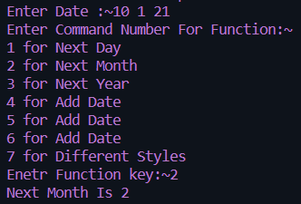

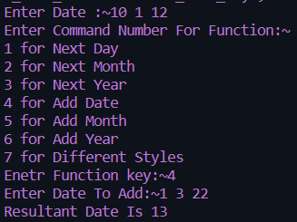

Ha 10.2

*/\**

*Name: Antarin ghosal*

*HA10.2 WAP to calulate the difference between two time periods. Times are given in hr, min and sec.*

*\*/*

#include<stdio.h>

struct time{

    int second,min,hr;

}t1,t2,D;

int main()

{

    printf("Time1:\n");

    printf("ENTER TIME:hr:");

    scanf("%d",&t1.hr);

    printf("min:");

    scanf("%d",&t1.min);

    printf("Sec:");

    scanf("%d",&t1.second);

    printf("Time2:\n");

    printf("ENTER TIME:hr:");

    scanf("%d",&t2.hr);

    printf("min:");

    scanf("%d",&t2.min);

    printf("Sec:");

    scanf("%d",&t2.second);

*//DIFRENCE*

    D.hr=t1.hr-t2.hr;

    D.min=t1.min-t2.min;

    D.second=t1.second-t2.second;

    while(D.second<0)

    {

        D.second=60+D.second;

        D.min=D.min-1;

    }

    while(D.min<0)

    {

        D.min+=60;

        D.hr=-1;

    }

    printf("TIME DIFFRENCE:%d:%d:%d",D.hr,D.min,D.second);

    return 0;

}

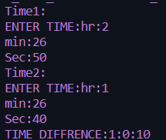 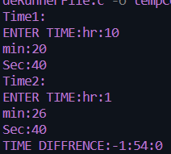

Ha 10.3

*/\**

*Name: Antarin ghosal*

*HA10.3 WAP to extract individual bytes from an unsigned int using union.*

*\*/*

#include<stdio.h>

union tagname

{

    unsigned int a;

    unsigned char s[4];

}object;

int main()

{

    char i; *//for loop counter*

    printf("ENter an integer number: ");

    scanf("%d",&object.a);

    printf("Integer number: %ld, hex: %X\n",object.a,object.a);

    printf("Indivisual bytes: ");

    for(i=3;i>=0;i--)

        printf("%02X ",object.s[i]);

    printf("\n");

    return 0;

}

 

La 10.1

*/*Author : Antarin Ghosal*

*Program : WAP to store n student’s information (i.e. student’s roll no, name, gender, marks in 5 subjects*

*etc) of an educational institute and display all the data with total marks of each student, using*

*array of structure. If full mark of each subject is considered as 100 and pass mark as 40, then*

*display the list of students failed in a particular subject.*

*\*/*

#include<stdio.h>

struct student

{

    int roll;

    char name[30];

    char gender;

    int marks1;

    int marks2;

    int marks3;

    int marks4;

    int marks5;

}

stu[5]={

    {1,"Ramesh",'M',74,68,70,76,80},

    {2,"Suresh",'M',89,90,86,74,83},

    {3,"Kamli",'F',78,36,78,80,62},

    {4,"Ananya",'F',58,93,32,78,80},

    {5,"Kamlesh",'M',89,64,80,28,90},

};

int main(){

    printf("The Student details of individual student are : \n");

    for(int i=0;i<5;i++){

        printf("\t  %d  \t  %s  \t  %c  \t  %d  \t  %d  \t  %d  \t  %d  \t  %d  \t\n",stu[i].roll,stu[i].name,stu[i].gender,stu[i].marks1,stu[i].marks2,stu[i].marks3,stu[i].marks4,stu[i].marks5);

    }

    return 0;

}

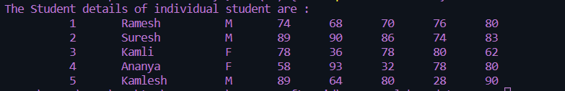

La 10.2

*/\**

*Name: Antarin ghosal*

*LA10.2 WAP to add two distances (in km-meter) using structures.*

*\*/*

#include<stdio.h>

struct dis

{

    int km;

    int m;

};

int main()

{

    struct dis d1,d2,sum;

    printf("Enter distance1:KM:");

    scanf("%d",&d1.km);

    printf("M:");

    scanf("%d",&d1.m);

    printf("Enter distance2:KM:");

    scanf("%d",&d2.km);

    printf("M:");

    scanf("%d",&d2.m);

    sum.km=d1.km+d2.km;

    sum.m=d1.m+d2.m;

    if(sum.m>1000)

        {

            int temp=sum.m/1000;

            sum.km=sum.km+temp;

            sum.m=sum.m%1000;

        }

    printf("Total distance: %dkm %dm",sum.km,sum.m);

    return 0;

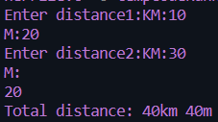 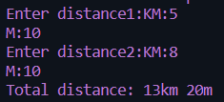

La 10.3

#include<stdio.h>

struct Time

{

    int h;

    int m;

    int s;

};

int main()

{

    struct Time T1,T2,S;

    printf("\nEnter time 1\n");

    printf("Hour:");

    scanf("%d",&T1.h);

    printf("MINUTE:");

    scanf("%d",&T1.m);

    printf("SECOUND:");

    scanf("%d",&T1.s);

    printf("\nEnter time 2\n");

    printf("Hour:");

    scanf("%d",&T2.h);

    printf("MINUTE:");

    scanf("%d",&T2.m);

    printf("SECOUND:");

    scanf("%d",&T2.s);

    S.h=T1.h+T2.h;

    S.m=T1.m+T2.m;

    S.s=T1.s+T2.s;

    while(S.s>60)

    {

        S.s-=60;

        S.m+=1;

    }

    while(S.m>60)

    {

        S.m-=60;

        S.h+=1;

    }

printf("\nT1 : %d:%d:%d",T1.h,T1.m,T1.s);

printf("\nT2 : %d:%d:%d",T2.h,T2.m,T2.s);

printf("\nADDED TIME: %d:%d:%d",S.h,S.m,S.s);

    return 0;

}

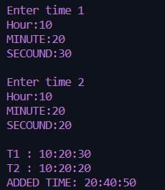 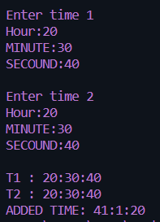

La 10.4

#include<stdio.h>

struct info

{

    char name[20];

    char Gender;

    char designaton[25];

    char depatment[25];

    float BP;

    float GP;

};

int main()

{

    printf("Enter number of employee: ");

    int n,i;

    scanf("%d",&n);

    struct info employe[n];

    printf("\n\t\tEnter information of the employee\n");

    float HR,DA;

    for(i=0;i<n;i++)

        {

            printf("\t\t\t\tEMPLOYE %d\n\n",i+1);

            printf("ENter name: ");

            scanf(" %[^\n]s",&employe[i].name);

            printf("Enter Gender: ");

            scanf(" %c",&employe[i].Gender);

            printf("Enter DEGIGNATION: ");

            scanf(" %[^\n]s",&employe[i].designaton);

            printf("Enter DEPARTMENT: ");

            scanf(" %[^\n]s",&employe[i].depatment);

            printf("ENTER BP(basic pay): ");

            scanf("%f",&employe[i].BP);

            HR=(float)25*employe[i].BP/100;

            DA=(float)75*employe[i].BP/100;

            employe[i].GP=employe[i].BP+HR+DA;

        }

*//DISPLAY*

        printf("\n %10s\t %10s\t %10s\t %10s\t %10s\t %10s\n","NAME","GENDER","DESIGNATION","DEPARTMANT","BP","GP");

        for(i=0;i<n;i++)

        printf("\n %10s\t %10c\t %10s\t %10s\t %10.2f\t %10.2f\n",employe[i].name,employe[i].Gender,employe[i].designaton,employe[i].depatment,employe[i].BP,employe[i].GP);

    return 0;

}

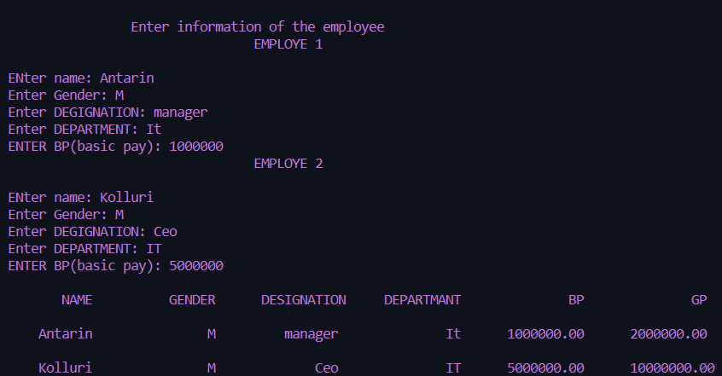

La 10.5

*/\**

*Name: Antarin ghosal*

*WAP to declare an union named as ABC having three members a, b and c as character, integer*

*and double respectively. Assign user entered values to these members respectively one by one*

*and display these values immediately. Again assign these user entered values to a, b, c one by*

*one all together and display these values at last. Find the difference.*/*

#include<stdio.h>

union ABC

{

    char a;

    int b;

    double c;

}ob;

int main()

{

    int n;

    char s;

    double x;

    printf("Enter Value Of int:~");

    scanf("%i",&n);

    printf("Enter Charater Value:~\n");

    scanf("\n%c",&s);

    printf("Enter Double Value:~\n");

    scanf("%ld",&x);

    ob.a = s;

    printf("Current Value In %u Is %c After Adding a Value\n",&ob,ob.a);

    ob.b = n;

    printf("Current Value In %u Is %i After Adding b Value\n",&ob,ob.b);

    ob.c = x;

    printf("Current Value In %u Is %i After Adding b Value\n",&ob,ob.c);

    ob.a = s;

    ob.b = n;

    ob.c = x;

    printf("Current Value In %u Is %c After Adding All Values\n",&ob,ob.a);

    printf("Current Value In %u Is %i After Adding All Values\n",&ob,ob.b);

    printf("Current Value In %u Is %ld After Adding All Values",&ob,ob.c);

}

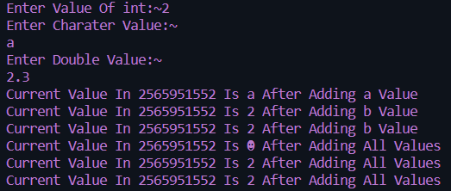

Sa 10.1

*/\**

*Name: Antarin ghosal*

*SA10.1 WAP to store one student�s information (i.e. student�s roll no, name, gender, marks etc) of an*

*educational institute and display all the data, using structure.*

*24/05/2022*

*\*/*

#include<stdio.h>

#include<string.h>

struct stdinf

{

    char name[20];

    int roll;

    char gender;

    int marks;

};

int main()

{

    struct stdinf std1={"Antarin",2106096,'M',100};

    printf("Name:%s\nRoll:%d\nGender:%c\nMarks:%d",std1.name,std1.roll,std1.gender,std1.marks);

    return 0;

}

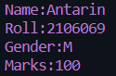

Sa 10.2

*/\**

*Name: Antarin ghosal*

*SA10.2 WAP to store n student�s information (i.e. student�s roll no, name, gender, marks etc) of an*

*educational institute and display all the data, using array of structure.*

*24/05/2022*

*\*/*

#include<stdio.h>

#include<string.h>

struct stdinf

{

    char name[20];

    int roll;

    char gender;

    int marks;

};

int main()

{

    int n,i;

    printf("Enter the value of n:(total number of student)");

    scanf("%d",&n);

    struct stdinf std[n];

*//input*

    for(i=0;i<n;i++)

        {

            printf("\n-------for student %d---------",i+1);

            printf("\nEnter name: ");

            scanf("%s",&std[i].name);

            printf("\nEnter roll: ");

            scanf("%d",&std[i].roll);

            printf("\nEnter gender: ");

            scanf(" %c",&std[i].gender);

            printf("\nEnter marks: ");

            scanf("%d",&std[i].marks);

        }

*//display*

    printf("\n\nSno.\tName\tRoll\tGender\tmarks\n");

    for(i=0;i<n;i++)

        printf("%d\t%s\t%d\t%c\t%d\n",i+1,std[i].name,std[i].roll,std[i].gender,std[i].marks);

    return 0;

}

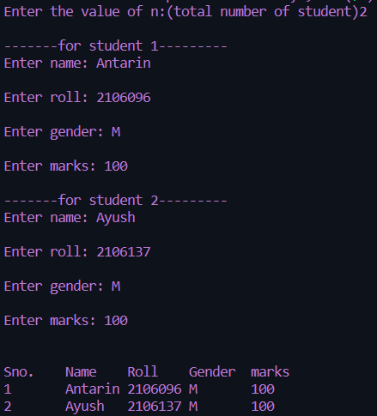

Sa 10.4

*/\**

*Name: Antarin ghosal*

*WAP to add two complex numbers by passing structure to a function*

*24/05/2022*

*\*/*

#include <stdio.h>

typedef struct complex

{

    float real;

    float imag;

} complex;

complex add(complex n1, complex n2)

{

    complex temp;

    temp.real = n1.real + n2.real;

    temp.imag = n1.imag + n2.imag;

    return (temp);

}

int main() {

    complex n1, n2, result;

    printf("For 1st complex number \n");

    printf("Enter the real then imaginary parts: ");

    scanf("%f %f", &n1.real, &n1.imag);

    printf("\nFor 2nd complex number \n");

    printf("Enter the real then imaginary parts: ");

    scanf("%f %f", &n2.real, &n2.imag);

    result = add(n1, n2);

    printf("Sum = %.1f + %.1fi", result.real, result.imag);

    return 0;

}

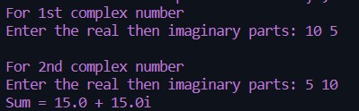

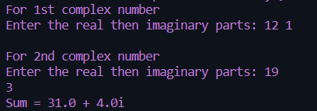

Sa 10.5

*/\**

*Name: Antarin ghosal*

*WAP to store n books data such as title, author, pulication, price etc using structures with*

*dynamically memory allocation. Display all the books information of a particular author.*/*

#include<stdio.h>

#include<string.h>

#define SIZE 20

struct bookdetail

{

    char name[20];

    char author[20];

    int pages;

    float price;

};

void output(struct bookdetail v[],int n)

{

    int i,t=1;

    for(i=0;i<n;i++,t++)

    {

        printf("\n");

        printf("Book No.%d\n",t);

        printf("\t\tBook %d Name is=%s \n",t,v[i].name);

        printf("\t\tBook %d Author is=%s \n",t,v[i].author);

        printf("\t\tBook %d Pages is=%d \n",t,v[i].pages);

        printf("\t\tBook %d Price is=%f \n",t,v[i].price);

        printf("\n");

    }

}

void main()

{

    struct bookdetail b[SIZE];

    int num,i;

    printf("Enter the Numbers of Books:");

    scanf("%d",&num);

    printf("\n");

    for(i=0;i<num;i++)

    {

        printf("\t=:Book %d Detail:=\n",i+1);

        printf("\nEnter the Book Name:\n");

        scanf("%s",b[i].name);

        printf("Enter the Author of Book:\n");

        scanf("%s",b[i].author);

        printf("Enter the Pages of Book:\n");

        scanf("%d",&b[i].pages);

        printf("Enter the Price of Book:\n");

        scanf("%f",&b[i].price);

    }

    output(b,num);

}

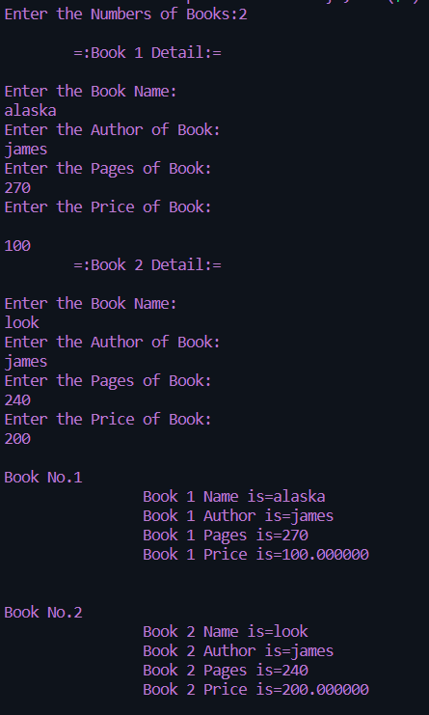

Sa 10.6

*/\**

*Name: Antarin ghosal*

*WAP to read item details used in party and calculate all expenses, divide expenses in all*

*friends equally.*/*

#include <stdio.h>

#define MAX 50

*//structure definition*

typedef struct item_details

{

    char itemName[30];

    int quantity;

    float price;

    float totalAmount;

}item;

int main()

{

    item thing[MAX];

    int i,choice;

    int count=0;

    float expenses=0.0f;

    i=0;

*//infinite loop*

    do{

        printf("Enter item details [%2d]:\n",i+1);

        printf("Item:  ");

        fgets(thing[i].itemName,30,stdin);

        printf("Price? ");

        scanf("%f",&thing[i].price);

        printf("Quantity:  ");

        scanf("%d",&thing[i].quantity);

        thing[i].totalAmount=(float)thing[i].quantity*thing[i].price;

        expenses += thing[i].totalAmount;

        i++;

        count++;

        printf("\nWant to more items (press 1): ");

        scanf("%d",&choice);

        getchar();

    }while(choice==1);

*//print all items*

    printf("All details are:\n");

    for(i=0; i<count; i++)

    {

        printf("%-30s\t %.2f \t %3d \n %.2f\n",thing[i].itemName, thing[i].price, thing[i].quantity, thing[i].totalAmount);

    }

    printf("#### Total expense: %.2f\n",expenses);

    printf("Want to divide in friends (press 1 for yes): ");

    scanf("%d",&choice);

    if(choice==1)

    {

        printf("How many friends? ");

        scanf("%d",&i);

        printf("Each friend will have to pay: %.2f\n",(expenses/(float)i));

    }

    printf("~Thanks for using me... Enjoy your party!!!~\n");

    return 0;

}

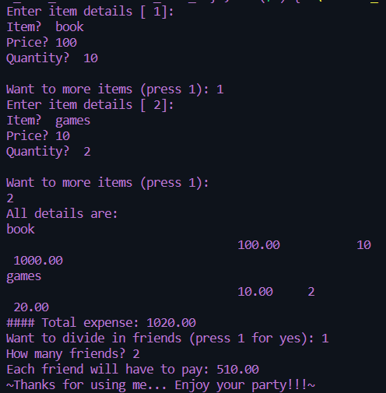

Sa 10.7

*/\**

*Name: Antarin ghosal*

*WAP to declare an union named as ABC having two members a as character and b as*

*integer . Assign ‘A’ to a, 1088 to b respectively through an union variable ob one by one and*

*display these these values immediately. Now assign these values to a, b through ob all*

*together and display these values at last. Find the difference.*/*

#include<stdio.h>

union Ob

{

    char a;

    int b;

}ob;

int main()

{

    int n;

    char s;

    printf("Enter Value Of int:~");

    scanf("%i",&n);

    printf("Enter Charater Value:~");

    scanf("%c",&s);

    ob.a = s;

    printf("Current Value In %u Is %c After Adding a Value\n",&ob,ob.a);

    ob.b = n;

    printf("Current Value In %u Is %i After Adding b Value\n",&ob,ob.b);

    ob.a = s;

    ob.b = n;

    printf("Current Value In %u Is %c After Adding Both Values\n",&ob,ob.a);

    printf("Current Value In %u Is %i After Adding Both Value",&ob,ob.b);

}

