Name : Antarin Ghosal

La 8.1

*/\**

*Antarin Ghosal*

*LA8.1 WAP to add two numbers using call by reference.*

*\*/*

#include <stdio.h>

int add(int \*a,int \*b,int \*c){

    \*c=\*a+\*b;}

int main ()

    {

    int x,y,s=0;

    printf("ENter the Value of x and y: ");

    scanf("%d %d",&x,&y);

    add(&x,&y,&s);

    printf("SUM:%d",s);

   return 0;

}

 

La 8.2

*/\**

*Antarin Ghosal*

*LA8.2 WAP to compute the sum of all elements in an array using pointer.*

*\*/*

#include <stdio.h>

int main ()

    {

    int N,i,sum=0;

    printf("Enter number of element in the array:");

    scanf("%d",&N);

    int arr[N];

    for(i=0;i<N;i++)

    {

        printf("ENter arr element [%d]: ",i);

        scanf("%d",&arr[i]);

    }

    int \*p=&arr[0];

    for(i=0;i<N;i++)

    {

        sum+=\*p;

        p=p+1;

    }

    printf("sum of the array: %d",sum);

   return 0;

}

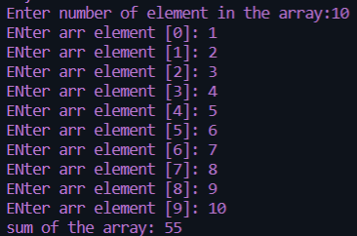

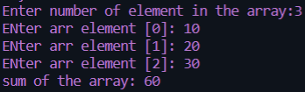

La 8.3

*/\**

*Antarin Ghosal*

*LA8.3 WAP to display values in reverse order from an integer array using pointer.*

*\*/*

#include <stdio.h>

int main ()

    {

    int N,i,sum=0;

    printf("Enter number of element in the array:");

    scanf("%d",&N);

    int arr[N];

    for(i=0;i<N;i++)

    {

        printf("ENter arr element [%d]: ",i);

        scanf("%d",&arr[i]);

    }

    int \*p=&arr[N-1];

    for(i=N-1;i>=0;i--)

    {

        printf("%d\t",\*p);

        p=p-1;

    }

   return 0;

}

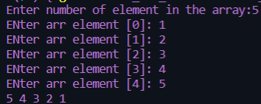

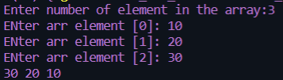

La 8.4

*/\**

*Antarin Ghosal*

*LA8.4 WAP to swap three numbers in cyclic order using Call by Reference. In other words, WAP that*

*takes three variable (a, b, c) in as separate parameters and rotates the values stored so that*

*value a goes to be, b, to c and c to a.*

*\*/*

#include <stdio.h>

cyclic(int \*i,int \*j,int \*k)

{

        int temp=\*j;

        \*j=\*i;

        \*i=\*k;

        \*k=temp;

}

int main ()

    {

    int a,b,c;

    printf("Enter the value of a b and c: ");

    scanf("%d %d %d",&a,&b,&c);

    printf("VAlue before cyclic swap A:%d\tB:%d\tC:%d\n",a,b,c);

    cyclic(&a,&b,&c);

    printf("VAlue after cyclic swap A:%d\tB:%d\tC:%d",a,b,c);

   return 0;

}





Sa 8.1

*/\**

*Antarin Ghosal*

*SA8.1 WAP to create, initialize, assign and access a pointer variable.*

*\*/*

#include <stdio.h>

int main ()

    {

    int a=5;

    int \*p1;

    p1=&a;

    printf("%d ",\*p1);

   return 0;

}

Sa 8.2

*/\**

*Antarin Ghosal*

*SA8.2 WAP to print size of different types of pointer variables.*

*\*/*

#include <stdio.h>

int main ()

    {

        printf("\nsize of int pointer: %d",sizeof(int\*));

        printf("\nsize of char pointer: %d",sizeof(char\*));

        printf("\nsize of float pointer: %d",sizeof(float\*));

        printf("\nsize of double pointer: %d",sizeof(double\*));

   return 0;

}

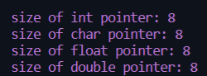

Sa 8.3

*/\**

*Antarin Ghosal*

*SA8.3 WAP to add two numbers using pointers.*

*\*/*

#include <stdio.h>

int main ()

    {

    int a=5,\*p1=&a;

    int b=6,\*p2=&b;

    int c= \*p1+\*p2;

    printf("SUM: %d",c);

   return 0;

}



Sa 8.4

*/\**

*Antarin Ghosal*

*SA8.4 WAP to swap two numbers using call by reference.*

*\*/*

#include <stdio.h>

int swap(int \*a,int \*b)

{

    int temp=\*b;

    \*b=\*a;

    \*a=temp;

}

int main ()

    {

    int x,y;

    printf("ENter the Value of x and y: ");

    scanf("%d %d",&x,&y);

    printf("Before swaping :\na:%d\tb:%d\n",x,y);

    swap(&x,&y);

    printf("After swaping :\na:%d\tb:%d\n",x,y);

   return 0;

}

