Name: Antarin Ghosal

Ha5.1:

*/\*Author : Antarin Ghosal*

*Program : WAP to swap first element with last, second element with second last and*

*so on, stored in an array.\*/*

#include<stdio.h>

int main(){

    int s[]={1,2,3,4,5},temp,i,n=5;

    for(i=0;i<5/2;i++){

        temp=s[i];

        s[i]=s[n-i-1];

        s[n-i-1]=temp;

    }

    for(i=0;i<5;i++){

        printf("%d ",s[i]);

    }

    return 0;

}



Ha5.2

*/\*Author : Antarin Ghosal*

*Program : WAP to find out the second largest element stored in an array of 20*

*integers.\*/*

#include<stdio.h>

int main(){

    int s[]={1,2,3,4,5,6,7,8,9,10,11,12,13,14,15,16,18,19,20};

    int i,max,max2,n=20;

    for(i=0;i<20;i++){

        if(s[i]>s[i+1]){

            max=i-1;

        }

        else if (s[i+1]>s[i]){

            max=i;

        }

    }

    s[max]=0;

    for(i=0;i<20;i++){

        if(s[i]>s[i+1]){

            max2=i-1;

        }

        else if (s[i+1]>s[i]){

            max2=i;

        }

    }

    printf("The second largest element : %d",s[max2-2]);

    return 0;

}



Ha 5.3

*/\*Author : Antarin Ghosal*

*Program : WAP to find the median of a list of numbers.\*/*

#include<stdio.h>

int main(){

    int a[]={1,2,3,4,5,6,7},n=6,median;

    if ( n % 2 == 0)

        median = (a[n/2] + a[n/2+1])/2.0 ;

    else

    median = a[n/2 + 1];

    printf("%d ",median);

    return 0;

}



Ha5.4

*/\*Author : Antarin Ghosal*

*Program : WAP to find the standard deviation of a list of numbers.\*/*

#include<stdio.h>

#include<math.h>

int main(){

int i;

    float data[10];

    printf("Enter 10 elements: ");

    for (i = 0; i < 10; ++i)

        scanf("%f", &data[i]);

    float sum = 0.0, mean, SD = 0.0;

    for (i = 0; i < 10; ++i) {

        sum += data[i];

    }

    mean = sum / 10;

    for (i = 0; i < 10; ++i) {

        SD += pow(data[i] - mean, 2);

    }

    printf("\nStandard Deviation = %.6f", sqrt(SD / 10));

    return 0;

}

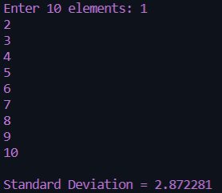

La5.1

*/\*Author : Antarin Ghosal*

*Program : WAP to input 10 integers into an array of size 10. Print all elements.\*/*

#include<stdio.h>

int main(){

    int i,arr[10];

    for(i=0;i<10;i++){

        printf("Enter the %d number : ",i+1);

        scanf("%d",&arr[i]);

    }

    printf("\n");

    for(i=0;i<10;i++){

        printf("The Entered number is %d \n",arr[i]);

    }

    return 0;

}

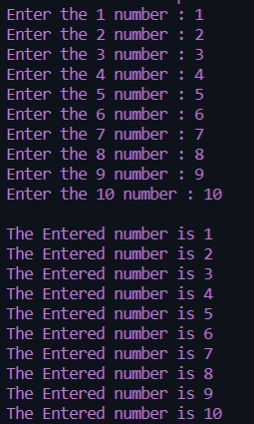 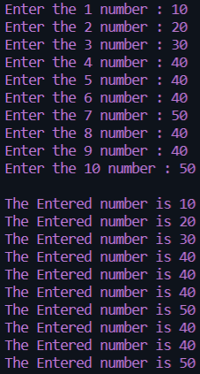

La 5.2

*/\*Author : Antarin Ghosal*

*Program : WAP to store max. 100 numbers into an array. Print all the elements*

*that are three digit even integers..\*/*

#include<stdio.h>

int main(){

    int arr[100],n,i;

    printf("Enter the amount of numbers we want to input : ");

    scanf("%d",&n);

    for(i=0;i<n;i++){

        printf("Enter a number : ");

        scanf("%d",&arr[i]);

    }

    printf("\n");

    for(i=0;i<n;i++){

        printf("The Entered value was : %d \n",arr[i]);

    }

    printf("\n");

    printf("The EVEN integers are as follows : \n");

    for(i=0;i<=n;i++){

        if ((arr[i]<=999 && arr[i]>=100) && arr[i]%2==0){

            printf("%d\n",arr[i]);

        }

    }

    return 0;

}

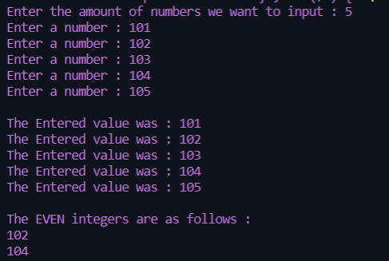

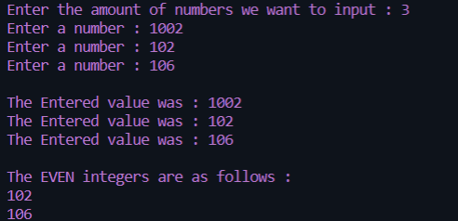

La 5.3

*/\*Author : Antarin Ghosal*

*Program : WAP to find out the largest even integer stored in the array of n*

*integers. n is the user input.\*/*

#include<stdio.h>

int main(){

    int n[100],i,num,j,largest;

    printf("Enter the amount of numbers we want to input : ");

    scanf("%d",&num);

    for(i=0;i<num;i++){

        printf("Enter a number : ");

        scanf("%d",&n[i]);

    }

    largest = n[0];

    for(i=0;i<num;i++){

        if (n[i]%2==0 && n[i]>largest){

                    largest=n[i];

            }

    }

    printf("The largest number is : %d",largest);

    return 0;

}

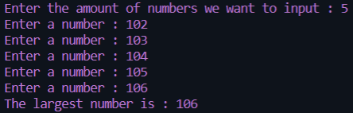 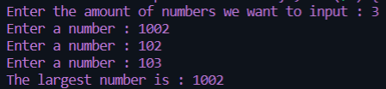

La 5.4

*/\*Author : Antarin Ghosal*

*Program : WAP to swap the pair of elements starting from beginning.\*/*

#include<stdio.h>

int main()

{

    int arr[100],n,i;

    int temp;

    printf("Enter total number of elements: ");

    scanf("%d",&n);

*//value of n must be even*

    if(n%2 !=0)

    {

        printf("Total number of elements should be EVEN.");

        return 1;

    }

*//read array elements*

    printf("Enter array elements:\n");

    for(i=0;i < n;i++)

    {

        printf("Enter element %d:",i+1);

        scanf("%d",&arr[i]);

    }

*//swap adjacent elements*

    for(i=0;i < n;i+=2)

    {

        temp    = arr[i];

        arr[i]  = arr[i+1];

        arr[i+1]= temp;

    }

    printf("\nArray elements after swapping adjacent elements:\n");

    for(i=0;i < n;i++)

    {

        printf("%d\n",arr[i]);

    }

    return 0;

}



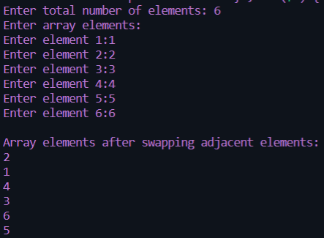

La 5.5

*/\*Author : Antarin Ghosal*

*Program : WAP to arrange the numbers stored in the array so that it will display*

*first all odd numbers,then even numbers.\*/*

#include<stdio.h>

int main(){

    int i,n,s[]={1,2,3,4,5,6,7,8,9,10};

    for(i=0;i<10;i++){

        if (s[i]%2==0)

            printf(" Even %d \n",s[i]);

    }

    for(i=0;i<10;i++){

        if (s[i]%2==1)

            printf(" Odd %d \n",s[i]);

    }

    return 0;

}

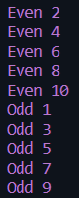

La 5.6

*/\*Author : Antarin Ghosal*

*Program : WAP to display the array elements in reverse order.\*/*

#include<stdio.h>

int main(){

    int s[]={1,2,3,4,5};

    for(int i=4;i>=0;i--){

        printf("%d ",s[i]);

    }

    return 0;

}

