Name: Antarin Ghosal

La52.1

*/\*Author : Antarin Ghosal*

*Program : WAP to print fibonacci series using arrays.\*/*

#include<stdio.h>

int main(){

    int arr[30],n,i;

    printf("Enter the number of elements we want to print : ");

    scanf("%d",&n);

    if (n>30){

        printf("Too many numbers !!");

        return 0;

    }

    printf("The Requested Elements are : \n0 \n1 \n");

    arr[0]=0;

    arr[1]=1;

    for(i=2;i<n;i++){

        arr[i]=arr[i-1]+arr[i-2];

        printf("%d\n",arr[i]);

    }

    return 0;

}

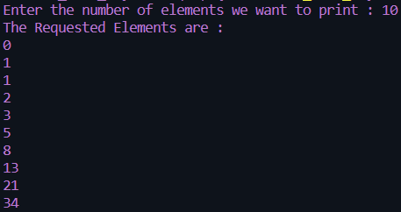 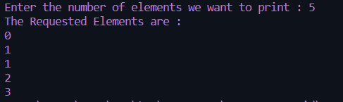

La52.2

*/\*Author : Antarin Ghosal*

*Program : WAP to find first and second largest in an array.\*/*

#include<stdio.h>

int main(){

    int i,j,arr[30],n,large1,large2;

    printf("Enter the amount of numbers we want to enter : ");

    scanf("%d",&n);

    if (n>30){

        printf("Too many numbers !!");

        return 0;

    }

    printf("Enter the numbers : \n");

    for(i=0;i<n;i++){

        scanf("%d",&arr[i]);

    }

    large1=arr[0];

    for(i=1;i<n;i++){

        if(arr[i]>large1)

        {

            large1=arr[i];

            j=i;

        }

    }

    arr[j]=0;

    large2=arr[0];

    for(i=1;i<n;i++){

        if(arr[i]>large2)

            large2=arr[i];

    }

    printf("The first largest value is : %d\n",large1);

    printf("The second largest value is : %d\n",large2);

    return 0;

}

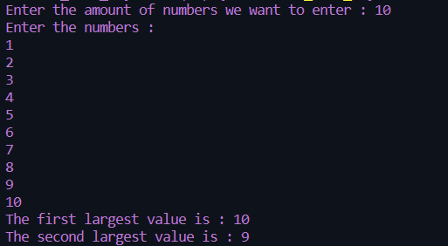

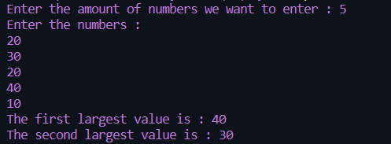

La 52.3

*/\*Author : Antarin Ghosal*

*Program : WAP to perform linear search on a array for a search key.\*/*

#include<stdio.h>

int main(){

    int i,j,arr[30],n,key;

    printf("Enter the amount of numbers we want to enter : ");

    scanf("%d",&n);

    printf("Enter the numbers : \n");

    for(i=0;i<n;i++){

        scanf("%d",&arr[i]);

    }

    printf("\nEnter the number you want to find : ");

    scanf("%d",&key);

    for(i=0;i<n;i++){

        if(arr[i]==key){

            printf("The number %d is found at index %d",key,i);

        }

    }

    return 0;

}

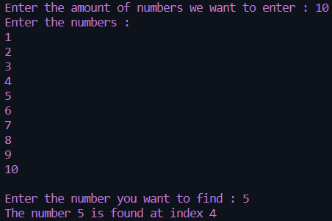

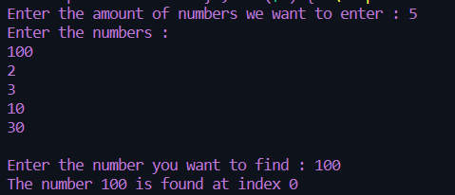

La 52.4

*/\*Author : Antarin Ghosal*

*Program : WAP to perform binary search on a array for a search key.\*/*

#include<stdio.h>

int main(){

    int i,j,arr[30],n,key,temp;

    printf("Enter the amount of numbers we want to enter : ");

    scanf("%d",&n);

    printf("Enter the numbers : \n");

    for(i=0;i<n;i++){

        scanf("%d",&arr[i]);

    }

    printf("\nEnter the number you want to find : ");

    scanf("%d",&key);

    temp=n/2;

    if (key <= arr[temp]){

        for(i=temp;i>=0;i--){

            if(key==arr[i])

            printf("The number %d is found at index %d\n",key,i);

        }

    }

    else if (key > arr[temp]) {

        for (i=temp;i<n;i++){

            if(key==arr[i])

            printf("The number %d is found at index %d\n",key,i);

        }

    }

    return 0;

}





La 52.5

*/\*Author : Antarin Ghosal*

*Program : WAP to print odd and even numbers in a array.\*/*

#include<stdio.h>

int main(){

    int n,arr[30],i,j;

    printf("Enter the amount of numbers we want to enter : ");

    scanf("%d",&n);

    printf("Enter the numbers : \n");

    for(i=0;i<n;i++){

        scanf("%d",&arr[i]);

    }

    printf("\nAll EVEN numbers are as follows : \n");

    for(i=0;i<n;i++){

        if(arr[i]%2==0){

            printf("\n%d",arr[i]);

        }

    }

    printf("\n\nAll ODD numbers are as follows : \n");

    for(i=0;i<n;i++){

        if(arr[i]%2==1){

            printf("\n%d",arr[i]);

        }

    }

    return 0;

}

