**CC LAB 02** | Lex Program

**Aim:** Count the number of comments, keywords, identifiers, words, lines and spaces from input file.

**Implementation:**

%option noyywrap

%{

*#include* <stdio.h>

int comments = 0;

int keywords = 0;

int identifiers = 0;

int words = 0;

int lines = 0;

int spaces = 0;

%}

%%

"//"(.*[ \t]*.*)* { comments = comments + 1; }

"if" |

"else" |

"int" |

"class" { keywords = keywords + 1; }

*^*[a-zA-Z][a-zA-Z]* {words = words + 1;}

*^*[a-zA-Z][a-zA-Z0-9_]* {identifiers = identifiers + 1; }

[\n] { lines = lines +1; }

[ \t] { spaces = spaces + 1;}

%%

int main(int *argc*, char \**argv*[])

{

*if* (argc==2) {

yyin=fopen(argv[1],"r");

}

*else* {

printf("\nEnter the input:\n");

yyin=stdin;

}

yylex();

printf("\n\nComments Encountered: %d", comments);

printf("\nKeywords Encountered: %d", keywords);

printf("\nIdentifiers Encountered: %d", identifiers);

printf("\nWords Encountered: %d", words);

printf("\nSpaces Encountered: %d", spaces);

printf("\nLines Encountered: %d", lines);

printf("\n");

*return* 0;

}

**Input File**

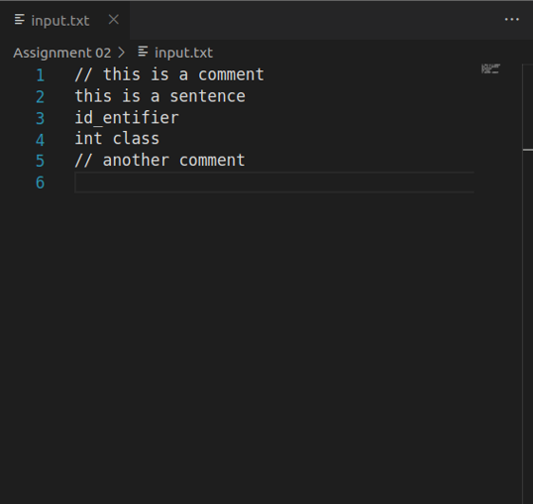

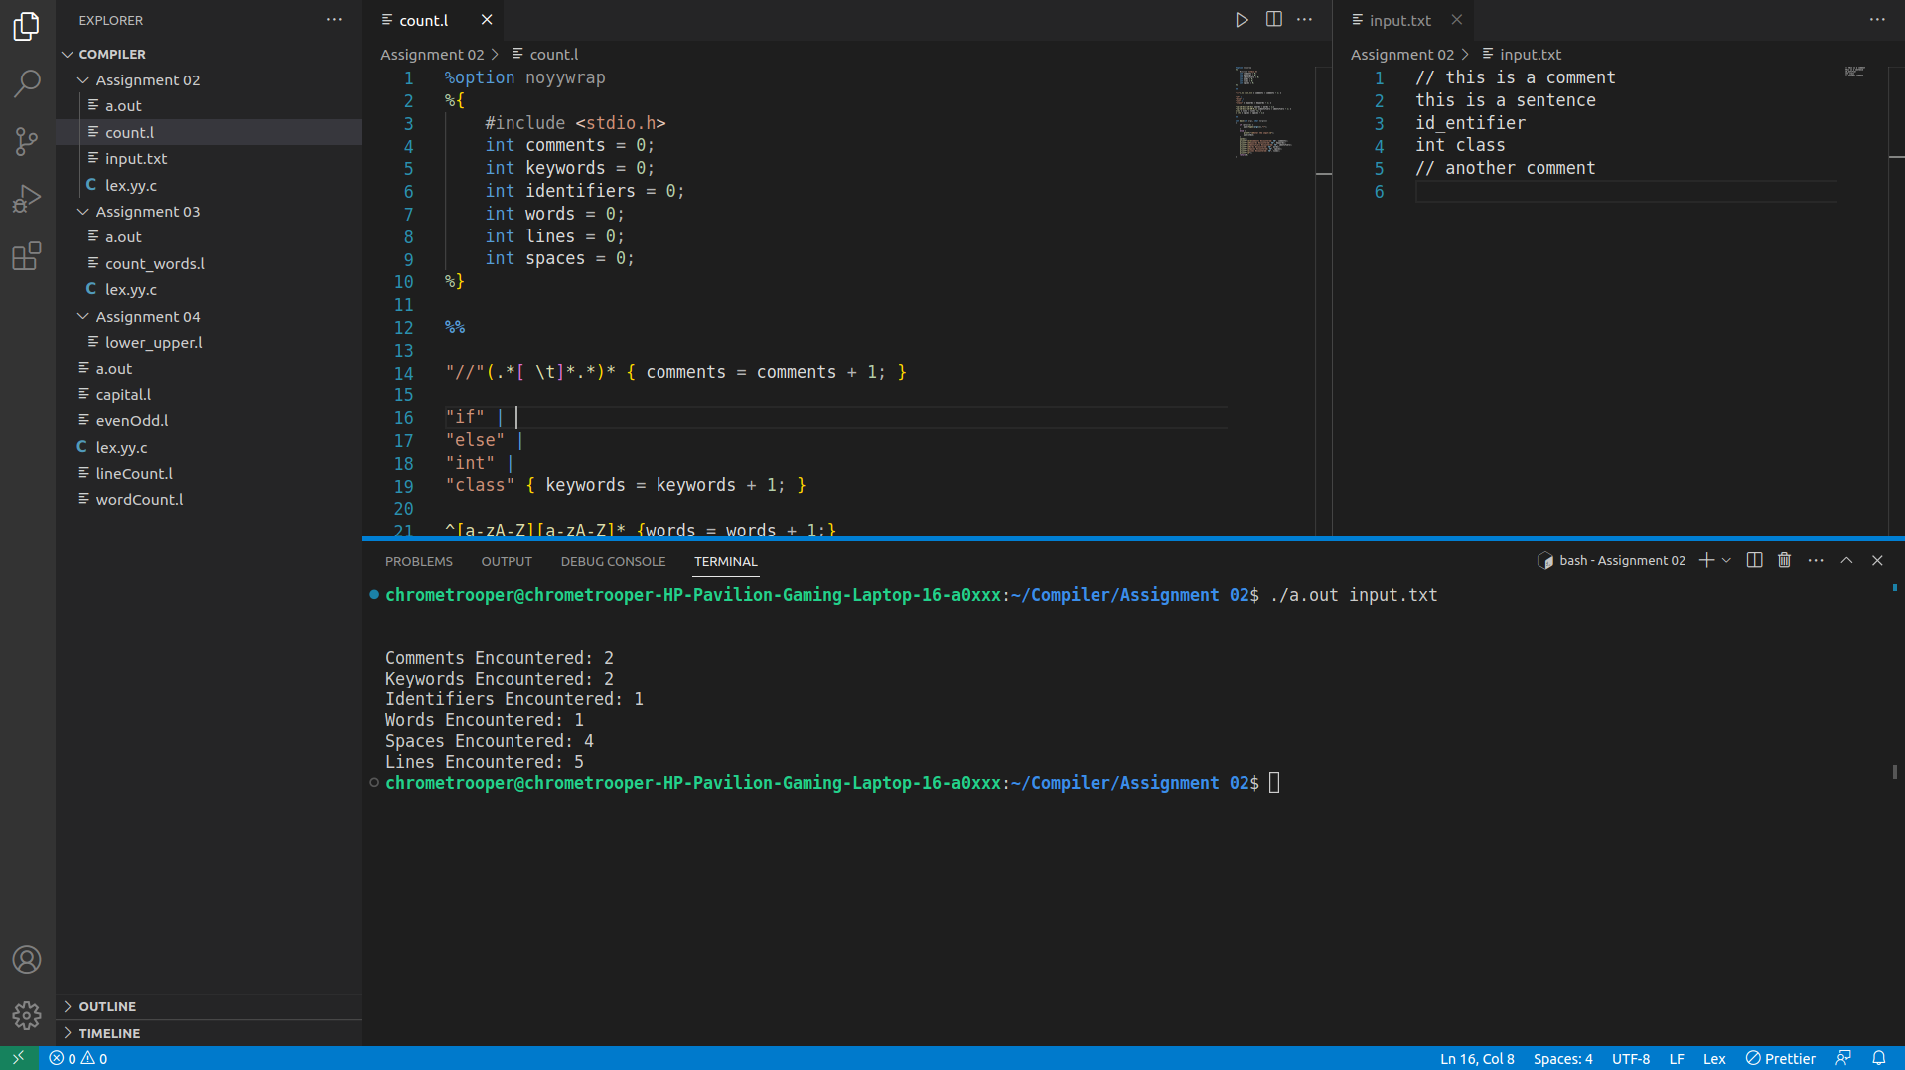**Output:**