**CC LAB 03** | Lex Program

**Aim:** Count number of words starting with ‘A’

**Implementation:**

%option noyywrap

%{

*#include* <stdio.h>

    int a_count =0;

%}

alpha    [a-zA-Z]

digit      [0-9]

space    [ \t\n]

start      ^a

%%

{start} {a_count++;}

{space}[a|A][{alpha}|{digit}]* {a_count++;}

end *return* 0;

%%

int main(int *argc*, char \**argv*[])

{

*if* (argc==2) {

        yyin=fopen(argv[1],"r");

    }

*else* {

        printf("\nEnter the input:\n");

        yyin=stdin;

    }

    yylex();

    printf("\nWords Starting with A: %d\n", a_count);

*return* 0;

}

**Input File:**

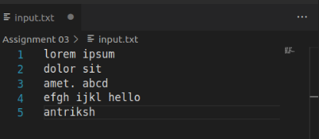

**Output:**

