**CC LAB 04** | Lowercase to Uppercase

**Aim:** LEX program for conversion of lower case to upper case and vice versa.

**Implementation:**

%option noyywrap

%{

*#include* <stdio.h>

%}

lower [a-z]

upper [A-Z]

%%

{lower} { printf("%c", yytext[0]- 32);}

{upper} { printf("%c", yytext[0] + 32);}

[ \t\n] { printf("%c", yytext[0]); }

. ECHO;

%%

int main(int *argc*, char \**argv*[])

{

*if* (argc==2) {

        yyin=fopen(argv[1],"r");

    }

*else* {

        printf("\nEnter the input:\n");

        yyin=stdin;

    }

    yylex();

    printf("\n");

*return* 0;

}

**Input File:**

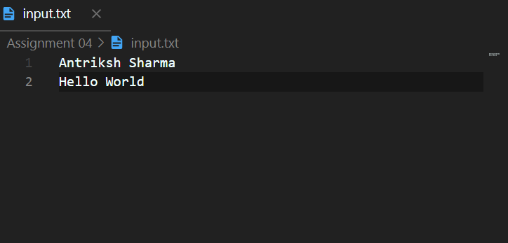

**Output:**

