**CC LAB 05** | Decimal to Hexadecimal

**Aim:** LEX program for conversion of decimal number to hexadecimal number in a file.

**Implementation:**

%option noyywrap

%{

*#include* <stdio.h>

    int num =0, digit=0, count=0, pcount=0, rem, i;

    char hexAr[] = {'A', 'B', 'C', 'D', 'E', 'F'};

    char result[100];

%}

number [0-9]+

%%

{number} {

    num = atoi(yytext);

    count = 0;

*while* (num > 0) {

        rem = num%16;

*if* (rem>9) {

            result[count] = hexAr[rem%10];

        }

*else* {

            result[count] = '0'+rem;

        }

        count += 1;

        num=num/16;

    }

*for* (i=count-1; i>=0; --i) {

        printf("%c", result[i]);

    }

    printf("\n");

}

[.\n] {printf("%c", yytext[0]);}

%%

int main(int *argc*, char* *argv*[])

{

*if* (argc==2) {

        yyin=fopen(argv[1],"r");

    }

*else* {

        printf("\nEnter the input:\n");

        yyin=stdin;

    }

    yylex();

*return* 0;

}

**Input File:**

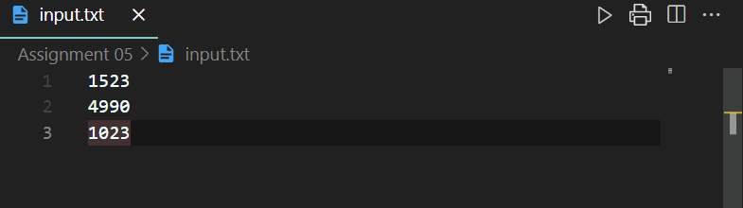

**Output:**

