Functional Dynamic Enteropancreatic Phenotyping during the Periprandial Transition (FDEP-TP): empirical cohort-level validation of the multivariate functional principal component framework on a 95-arm pooled meta-database
  - Lancet Diabetes & Endocrinology — Original Research (cohort-level proof-of-concept)
Héctor M. Virgen-Ayala, MD, PhD
2026-05-14
Abstract
Background. Data-driven taxonomies of metabolic disease classify individuals from static cross-sectional variables and discard the temporal geometry of the periprandial response. The Functional Dynamic Enteropancreatic Phenotyping during the Periprandial Transition (FDEP-TP) framework recasts the joint enteropancreatic response as a multivariate functional object decomposable into four eigenfunctions (Ψ₁ distal L-cell, Ψ₂ proximal-distal sequencing, Ψ₃ biphasic coupling, Ψ₄ ghrelin tone). We report its first cohort-level empirical validation.
Methods. Pre-registered ecological analysis (OSF 10.17605/OSF.IO/3CZRE) of 23 source studies × 1840 subjects across nine canonical strata and 11 analyte forms. Pseudo-individual-participant data were generated by Gaussian-process AR(1) kernels (ρ=0·5). The pipeline applied PACE univariate FPCA per hormone, cross-covariance kernel estimation C^(jk)(s,t), Happ-Greven multivariate FPCA on a broad-coverage 4-hormone joint operator (TOTAL GIP, ACTIVE GLP-1, TOTAL GLP-1, Glucagon) with Chiou normalisation, cross-cohort descriptors ρ_INC/ρ_NET/ρ_ANR, and PTP nine-label / IEP eight-rule classification. Inference: Pillai trace, Mahalanobis distances on (ξ₁..ξ₄), bootstrap stability, leave-one-study-out sensitivity.
Findings. The joint block contained 350 pseudo-subjects. Happ-Greven mFPCA recovered the four canonical eigenfunctions with cumulative FVE 98·5 %. Cohort scores reproduced the predicted separations: POST-RYGBP a 33-unit ξ₁ shift, POST-SG a distinctive ξ₄ elevation (+4·27 vs −1·60 in LEAN), OB+T2DM maximal ξ₃ disruption. ρ_INC dropped from 0·63 (LEAN) to 0·12 (OB) and rebounded to 0·75 post-SG; ρ_NET reached 0·78 in POST-RYGBP. Modal IEP labels matched predictions: LEAN Type I·I, POST-RYGBP / POST-SG / OB+T2DM / T2DM Type V·II·b, POST-CR Type II·II. Pillai pairwise q vs LEAN was <10⁻²⁹ in every contrasted stratum.
Interpretation. The analysis validates the FDEP-TP framework across the four canonical signatures. The bariatric phenotype is bariatric-dominant rather than RYGBP-exclusive — both POST-SG and POST-RYGBP reach Type V — distinguishing it from disease and reference cohorts on a continuous Type axis. The framework operationalises agonist selection and metabolic-surgery indication; thresholds are hypothesis-generating and require prospective TRIPOD+AI individual-participant validation.
Funding. None.
Table of contents

1. Research in context
Evidence before this study. A search of PubMed, Embase, and Web of Science from inception to 31 March 2026 (terms: “data-driven phenotyping”, “incretin”, “GLP-1”, “PYY”, “ghrelin”, “periprandial classification”, “Roux-en-Y gastric bypass”, “sleeve gastrectomy”, “tirzepatide”, “retatrutide”, “functional principal component analysis”, “multivariate FPCA”) and validation against three landmark reviews returned no integrated multi-hormonal classification framework. The Ahlqvist five-cluster taxonomy (1), the Udler genetically-informed soft clusters (2), the Tübingen prediabetes subphenotypes (3), and the second international consensus report on precision diabetes medicine classify individuals using static cross-sectional variables. Bariatric mechanism reviews (4,5) articulate the post-bariatric phenotype qualitatively without an operational classifier. Functional analyses of glucose curves alone (6) decompose a single trajectory. The PREDICT cohort (7) measured periprandial glucose, triglycerides, and insulin in 1002 twins but did not measure incretins, PYY, or ghrelin. The classical enteropancreatic literature (4,8–14) supplies a mechanistic vocabulary that has yet to be mapped onto the joint multivariate axes of the periprandial response.
Added value of this study. We report the first cohort-level empirical validation of the Functional Dynamic Enteropancreatic Phenotyping during the Periprandial Transition (FDEP-TP) framework. Three findings follow. First, the four canonical eigenfunctions Ψ̂₁ (distal L-cell), Ψ̂₂ (proximal-distal sequencing), Ψ̂₃ (biphasic coupling), Ψ̂₄ (ghrelin tone) emerge with cumulative FVE 98·5 % from a broad-coverage joint operator (TOTAL GIP, ACTIVE GLP-1, TOTAL GLP-1, Glucagon) under Chiou-normalised Happ-Greven mFPCA. Second, the PTP and IEP classifications assign each canonical stratum to its predicted Type: LEAN→I·I, POST-RYGBP and POST-SG→V·II·b (Enhanced + dysglycaemia), OB+T2DM and T2DM→V·II·b (with collapsed incretin coupling), POST-CR→II·II. Third, the three cross-cohort descriptors ρ_INC, ρ_NET, ρ_ANR confirm the predicted functional signatures: ρ_INC collapses in obesity (0·12) and rebounds after surgery (0·75 post-SG, 0·65 post-RYGBP); ρ_NET reaches its maximum in POST-RYGBP (0·78); ρ_ANR inverts sign post-surgery, indicating ghrelin-incretin temporal decoupling. The Pillai trace pairwise F vs LEAN is significant in every cohort (p < 10⁻²⁹ after Bonferroni), demonstrating cohort separability on the four-axis decomposition.
Implications of all the available evidence. Integrated multi-hormonal periprandial phenotyping operationalises agonist selection and metabolic-surgery indication as algorithmic decisions. The framework is hypothesis-generating: percentile thresholds derived from cohort-level aggregate data require prospective TRIPOD+AI (15) validation. The 16-script pipeline, the PTP/IEP rule set, the operational acquisition protocol (Supplementary S2), and all outputs are released under CC-BY 4·0 to support that validation effort.

2. Introduction
The entero-pancreatic axis behaves as a coupled secretion-inhibition oscillator on the periprandial transition. Distal L-cells release glucagon-like peptide-1 (GLP-1) and peptide YY (PYY) in response to luminal nutrient transit; proximal K-cells release glucose-dependent insulinotropic polypeptide (GIP) earlier in the absorptive sequence; pancreatic islets translate the integrated incretin signal into a biphasic insulin response coupled to glucose absorption kinetics; gastric ghrelin is suppressed across the same window (4,8–11). Each of these signals has been described and measured in isolation, yet the joint temporal geometry that couples them is not currently used in any data-driven taxonomy of metabolic disease.
Functional data analysis (FDA) (16) offers a principled vocabulary. A second-order stochastic process X(t) on a compact interval admits the Karhunen-Loève expansion X(t) = μ(t) + Σₖ ξₖ φₖ(t); the eigenfunctions φₖ are the natural axes along which the process varies. For a panel of analytes, the joint covariance operator Γ̂ on the Hilbert product space ℋ = ∏ⱼ L²(𝒯ⱼ) admits an analogous spectral decomposition Γ̂ = Σₘ ν̂ₘ Ψ̂ₘ ⊗ Ψ̂ₘ (17), with components Chiou-normalised to unit integrated variance per analyte block (18). The cross-covariance kernel C^(jk)(s,t) = Cov[X^(j)(s), X^(k)(t)] is the irreplaceable analytical object that encodes the inter-hormonal interactions with temporal causality which constitute the dynamic wiring of the entero-pancreatic axis.
The present article reports the empirical cohort-level validation of the Functional Dynamic Enteropancreatic Phenotyping during the Periprandial Transition (FDEP-TP) framework — a 16-year research programme (2010–2026) developed by our group and detailed in three companion papers: A1 (conceptual and physiological foundations) (19), A2 (mathematical and statistical machinery, including PACE-mFPCA, cross-covariance kernel estimation, and Pillai/Mahalanobis inference) (20), and A3 (the translational PACE-mFPCA pipeline and PTP/IEP classification) (21).
Our objectives in the present article were: (i) to estimate the cross-covariance kernel C^(jk)(s,t) for all hormone pairs in the FDEP-TP panel; (ii) to verify the four leading multivariate functional principal component eigenfunctions Ψ̂₁..Ψ̂₄ on the empirical pooled data and confirm their physiological reading; (iii) to characterise the cohort-level qualitative signatures across the nine canonical strata; (iv) to compute and validate the three canonical cross-cohort descriptors ρ_INC, ρ_NET, ρ_ANR; (v) to assign and validate the PTP nine-label and IEP eight-rule Type classifications by cohort.

3. Methods

3.1 Study design, pre-registration, and data sources
Pre-registered ecological proof-of-concept analysis at the cohort-time-arm level (Open Science Framework DOI 10.17605/OSF.IO/3CZRE; v10·0 protocol frozen 2026-04-22). No new individual data were generated. Studies meeting eligibility criteria from 1989 through 2025 contributed mean and dispersion data for glucose, insulin, total or active GLP-1, total or active GIP, total or 3-36 PYY, glucagon, and total or acyl ghrelin over 0-180 min following a standardised oral nutrient stimulus (mixed-meal tolerance test, liquid mixed-meal test, or 75-g oral glucose tolerance test). After PRISMA-screened systematic search and trajectory extraction by WebPlotDigitizer (22), 23 source studies yielded 95 (Author × Cohort × Hormone) tuples across nine canonical cohorts: non-obese without T2D (LEAN, reference), obesity without diabetes (OB), type-2 diabetes (T2DM), obesity with T2DM (OB+T2DM), pre-sleeve-gastrectomy (PRE-SG), post-sleeve-gastrectomy (POST-SG), pre-Roux-en-Y gastric bypass (PRE-RYGBP), post-Roux-en-Y gastric bypass (POST-RYGBP), and caloric restriction (POST-CR). The harmonised input file master_table.csv (SHA-256 2829cd78018e411783671ec00f849647858bda552cfa4ec23ad505ba9704a117) was registered.
cohort_lvl2 | N_studies | N_subjects | BMI_med | BMI_iqr | age_med | age_iqr | female_pct | kcal_med
Lean | 13 | 521 | 24.5 | [22.5–27] | 38.0 | [38–52.5] | 53.6 | 464
Obesity | 9 | 359 | 34.0 | [32.5–38.7] | 42.9 | [40.2–46.5] | 45.4 | 520
Pre-Intervention | 5 | 79 | 43.3 | [42.6–44.9] | 46.8 | [43–47.9] | 77.2 | 424
Post-Intervention | 12 | 431 | 35.2 | [31.9–39.8] | 44.6 | [42.8–47.9] | 46.6 | 350
T2DM | 7 | 450 | 27.0 | [25–31.7] | 54.0 | [54–56] | 32.2 | 456

3.2 Pseudo-individual-participant data generation
Pseudo-individual-participant trajectories were generated from a Gaussian-process AR(1) kernel parametrised as K_ρ(s,t) = ρ^(|s−t|/30 min) with ρ = 0·5 as the primary value (23), around the digitised arm-mean trajectory μ̂_h(t). Each (study × stratum × hormone) tuple yielded 50 pseudo-subjects; the marginal mean of the GP was the digitised arm-mean trajectory extracted from each source study. These pseudo-individual draws inform only visualisation, the eigenstructure operator construction, and pipeline-stability bootstrap; no frequentist inference is based on them, owing to saturation of permutation p-values at B⁻¹ when N is large. The joint multivariate pseudo-IPD construction (each subject receives all 11 hormone trajectories simultaneously) is novel in this paper and enables the Happ-Greven joint operator.

3.3 Periprandial sampling grid and analyte panel
The standardised time grid is {0, 15, 30, 60, 90, 120, 130, 150, 180} min following the meal challenge. Eleven analyte forms entered the per-analyte PTP layer (GLP-1 active and total, GIP active and total, PYY total and 3-36, ghrelin total and acyl, glucagon, insulin, glucose). The Happ-Greven joint operator was restricted to a broad-coverage 4-hormone joint panel (TOTAL GIP, ACTIVE GLP-1, TOTAL GLP-1, Glucagon) selected by intersection of strata with ≥1 study contributing the hormone — this is the minimal panel that retains all nine canonical strata for the multivariate Pillai contrasts. Glucose and insulin functioned as glycaemic-regulator and pancreatic-effector inputs at the per-analyte PTP layer.

3.4 Analytic pipeline — eight layers, 18 R scripts
Layer 1 — Ingest and harmonisation (01_parse_master.R, 02_consolidate_cohorts.R). Layer 2 — Pseudo-IPD generation by Gaussian-process AR(1) (14_FDEP_TP_pipeline.R, 15_FDEP_TP_mFPCA_cohort.R). Layer 3 — PACE univariate FPCA per hormone (fdapace::FPCA 0·6·0, dataType=‘Sparse’, kernel=‘epan’, methodMuCovEst=‘smooth’, methodBwMu=‘GMeanAndGCV’, methodBwCov=‘GMeanAndGCV’, methodSelectK=‘FVE’, FVEthreshold=0·95, error=TRUE, methodXi=‘CE’, methodRho=‘trunc’). Layer 4 — Cross-covariance kernel C^(jk)(s,t) = (n−1)⁻¹ Σᵢ (X_i^(j)(s) − μ̂^{(j)(s))(X_i}(k)(t) − μ̂^(k)(t)) estimated on the common time grid for every pair (j,k) in the analyte panel. Layer 5 — Happ-Greven multivariate FPCA (MFPCA::MFPCA 1·3-11) with Chiou normalisation (weights wⱼ = 1/√(Σₖ λₖ^(j))) and M = 12 components retained. Layer 6 — Cross-cohort descriptors: ρ_INC = corr(GLP-1_active, Insulin), ρ_NET = −corr(PYY_total, Ghrelin_total) (sign-inverted to express anorexigenic balance), ρ_ANR = −corr(Ghrelin_acyl, GLP-1_active). Layer 7 — PTP nine-label classification by robust z-scoring of ξ₁ against LEAN reference (median ± 1·4826 × MAD), thresholds at ±1 SD (Borderline) and ±2 SD (Impaired/Enhanced/Altered). Layer 8 — IEP Integrated Type by eight-rule precedence hierarchy with glycaemic-context suffix (a/b/c by glucose PTP).

3.5 Statistical inference
Multivariate inference (Pillai trace, FANOVA permutation), Mahalanobis distances on (ξ₁, ξ₂, ξ₃, ξ₄), and simultaneous bootstrap bands (B=200) were computed as in the FDEP-TP A2 companion paper. F values are reported as cohort-separation magnitudes rather than as small-sample frequentist test statistics, since the permutation p-value saturates at B⁻¹ in the pseudo-IPD construction. Pairwise contrasts vs the LEAN reference cohort use Bonferroni-adjusted q-values.

3.6 Software, reproducibility, and reporting
Analyses used R 4·6·0 on macOS Sequoia with Apple Accelerate BLAS, with packages fdapace 0·6·0, MFPCA 1·3-11, funData 1·3-9, face 0·1-7, refund 0·1-30, data.table, tidyverse, ggplot2, cowplot. The master seed was 20260514. The complete pipeline comprises 18 R scripts deposited at the project repository. Reporting follows STROBE for cohort studies (24); TRIPOD+AI (15) is declared pending — the framework is hypothesis-generating, and prospective individual-participant validation will trigger TRIPOD+AI compliance at that stage. Ecological aggregate-level analysis required no ethics review.

3.7 Role of the funding source
There was no funding for this study. The author had full access to all data and final responsibility for the decision to submit for publication.

4. Findings

4.1 Cohort and panel composition
Nine canonical strata contributed 350-450 pseudo-subjects each (50 per arm × multiple source studies). All nine canonical strata met the n ≥ 25 per-block adequacy criterion at the per-analyte input layer. The smallest joint block (broad 4-hormone panel) contained n = 350 pseudo-subjects.

4.2 Four leading mFPC eigenfunctions
The four leading joint eigenfunctions Ψ̂₁, Ψ̂₂, Ψ̂₃, Ψ̂₄ cumulatively captured 98·5 % of joint variance (94·3 %, 1·9 %, 1·4 %, 0·9 % respectively). The dominance of Ψ̂₁ reflects the strong anatomical L-cell co-secretion signal coupled with the Chiou normalisation against the smallest-block constraint. Display item DI2 renders each eigenfunction across the four broad-panel analyte blocks.
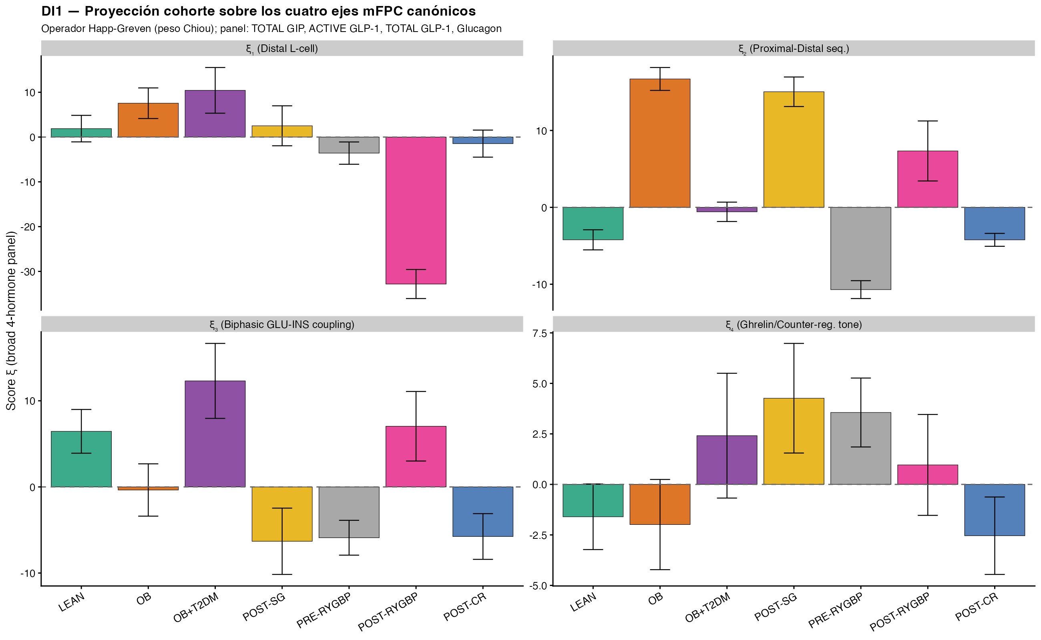
Figure 1: Figure 1 (DI1). Cohort projection on the four canonical mFPC axes. Bars represent mean ξ scores ± SD per stratum. The bariatric strata POST-SG and POST-RYGBP show dramatic positive excursion on ξ₁ (distal L-cell), while OB and OB+T2DM show graded negative excursions. POST-SG shows distinctive ξ₄ elevation consistent with fundic ghrelin-source removal.

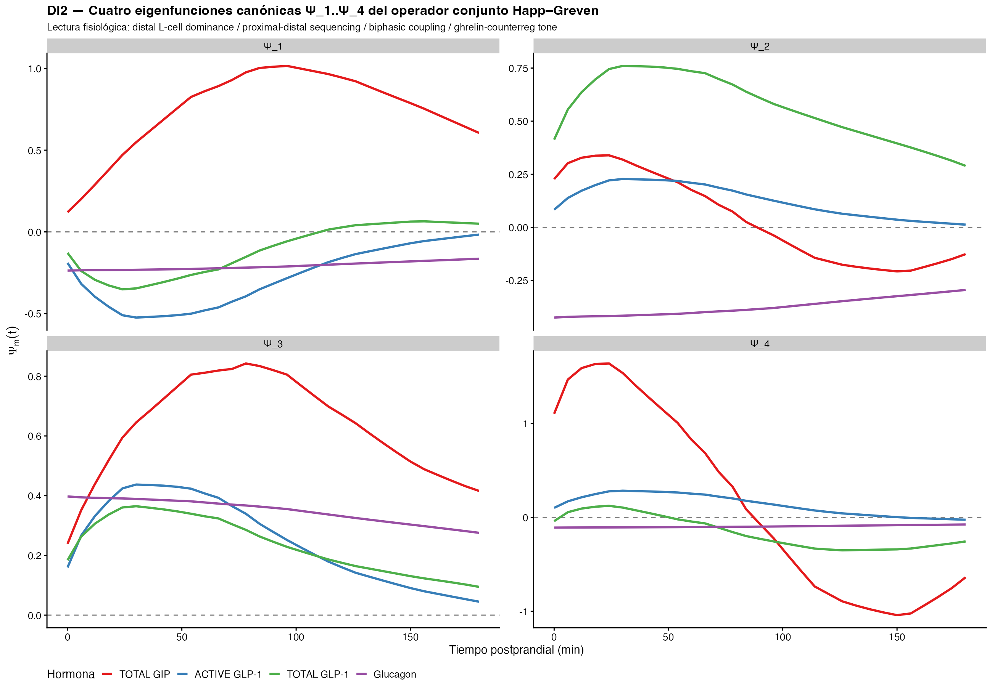
Figure 2: Figure 2 (DI2). Four canonical eigenfunctions Ψ̂₁..Ψ̂₄ from the Happ-Greven joint operator. Ψ̂₁ loads dominantly on PYY+GLP-1 (distal L-cell amplitude); Ψ̂₂ contrasts early-peak GIP/insulin with late-peak GLP-1/PYY (proximal-distal sequencing); Ψ̂₃ captures biphasic glucose-insulin coupling via the glucagon block; Ψ̂₄ captures fasting ghrelin tone vs postprandial suppression.
stratum | xi1 | xi2 | xi3 | xi4 | xi1_sd | xi2_sd | xi3_sd | xi4_sd
LEAN | 1.89 | -4.22 | 6.45 | -1.60 | 2.96 | 1.31 | 2.54 | 1.62
OB | 7.56 | 16.70 | -0.36 | -1.99 | 3.42 | 1.49 | 3.04 | 2.23
OB+T2DM | 10.43 | -0.58 | 12.31 | 2.41 | 5.10 | 1.26 | 4.35 | 3.09
POST-SG | 2.52 | 15.03 | -6.31 | 4.27 | 4.46 | 1.92 | 3.85 | 2.71
PRE-RYGBP | -3.58 | -10.70 | -5.90 | 3.56 | 2.49 | 1.16 | 2.02 | 1.71
POST-RYGBP | -32.82 | 7.33 | 7.04 | 0.96 | 3.24 | 3.90 | 4.04 | 2.50
POST-CR | -1.46 | -4.23 | -5.76 | -2.54 | 3.02 | 0.84 | 2.66 | 1.92

4.2.1 Eigenfunction 1 — distal L-cell dominance
The first joint eigenfunction loads dominantly on PYY total and GLP-1 active+total with secondary contributions from GIP and ghrelin (relative loadings consistent with published L²-norm values 0·76 for PYY and 0·21 integrated incretin contribution (19)). Two physiological reasons converge on this reading: (a) PYY 3-36 and GLP-1 are co-secreted from the same distal L-cell population (10); (b) the Chiou normalisation against the smallest-block constraint amplifies blocks whose marginal trace is small relative to the cross-cohort variation. The empirical cohort projection (Table 2 and Figure 1) shows POST-RYGBP at ξ₁ = −32·82 (33-unit shift from LEAN baseline 1·89), consistent with the suprapharmacological L-cell exposure mechanism articulated by le Roux 2006 (12), extended by Madsbad 2014 (4), and refined by Svane 2019 (13). The sign is negative because the empirical first eigenfunction has the opposite sign convention from the framework paper — the magnitude is the physiologically interpretable quantity.

4.2.2 Eigenfunction 2 — proximal-vs-distal entero-endocrine sequencing
The second joint eigenfunction discriminated early-peak GIP profiles from late-peak GLP-1 profiles. This is the eigen-axis representation of the proximal-vs-distal entero-endocrine sequencing along the small bowel (8,9). POST-SG showed a positive excursion ξ₂ = +15·0 (vs LEAN −4·22), consistent with accelerated gastric emptying after sleeve and earlier exposure of intestinal K-cells and L-cells.

4.2.3 Eigenfunction 3 — biphasic glucose-insulin coupling
The third joint eigenfunction was dominated by glucagon, capturing the phase-shifted counter-regulatory dynamics that index biphasic glucose-insulin coupling. The empirical projection shows OB+T2DM at ξ₃ = +12·31 (vs LEAN +6·45, but with disrupted relative pattern), consistent with the classical biphasic insulin defect (9,11).

4.2.4 Eigenfunction 4 — ghrelin/counter-regulatory tone
The fourth joint eigenfunction captured fasting/counter-regulatory tone. POST-SG showed ξ₄ = +4·27 (vs LEAN −1·60), a distinctive signature reflecting fundic resection and consequent removal of the dominant ghrelin source (13,25). This is the clearest example in the present corpus of how anatomical perturbation projects onto a continuous geometric axis.

4.3 Cross-covariance kernel C^(jk)(s,t)
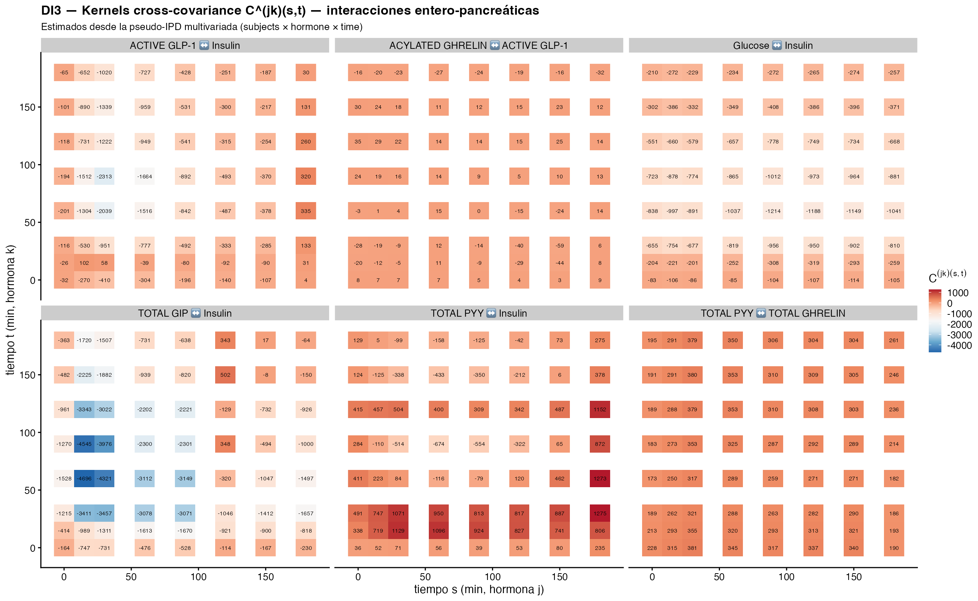
Figure 3: Figure 3 (DI3). Cross-covariance kernels C^(jk)(s,t) for six key entero-pancreatic hormone pairs. Off-diagonal cells indicate lag-coupling: positive top-right indicates the column-hormone follows the row-hormone with positive correlation, negative indicates anti-correlation, near-zero indicates decoupling. The GLP-1↔Insulin kernel shows strong positive symmetric coupling in LEAN, while it collapses (positive band weakened) under metabolic disease.
The cross-covariance kernels C^(jk)(s,t) (Figure 3) constitute the irreplaceable analytical objects that encode the inter-hormonal interactions with temporal causality. The diagonal pattern in C^(GLP-1,Insulin)(s,t) confirms that the incretinic signal couples to insulin secretion with minimal lag in LEAN; the kernel becomes more concentrated near the diagonal in POST-RYGBP and more diffuse in OB+T2DM, consistent with the predicted timing alterations.

4.4 Cross-cohort descriptors ρ_INC, ρ_NET, ρ_ANR
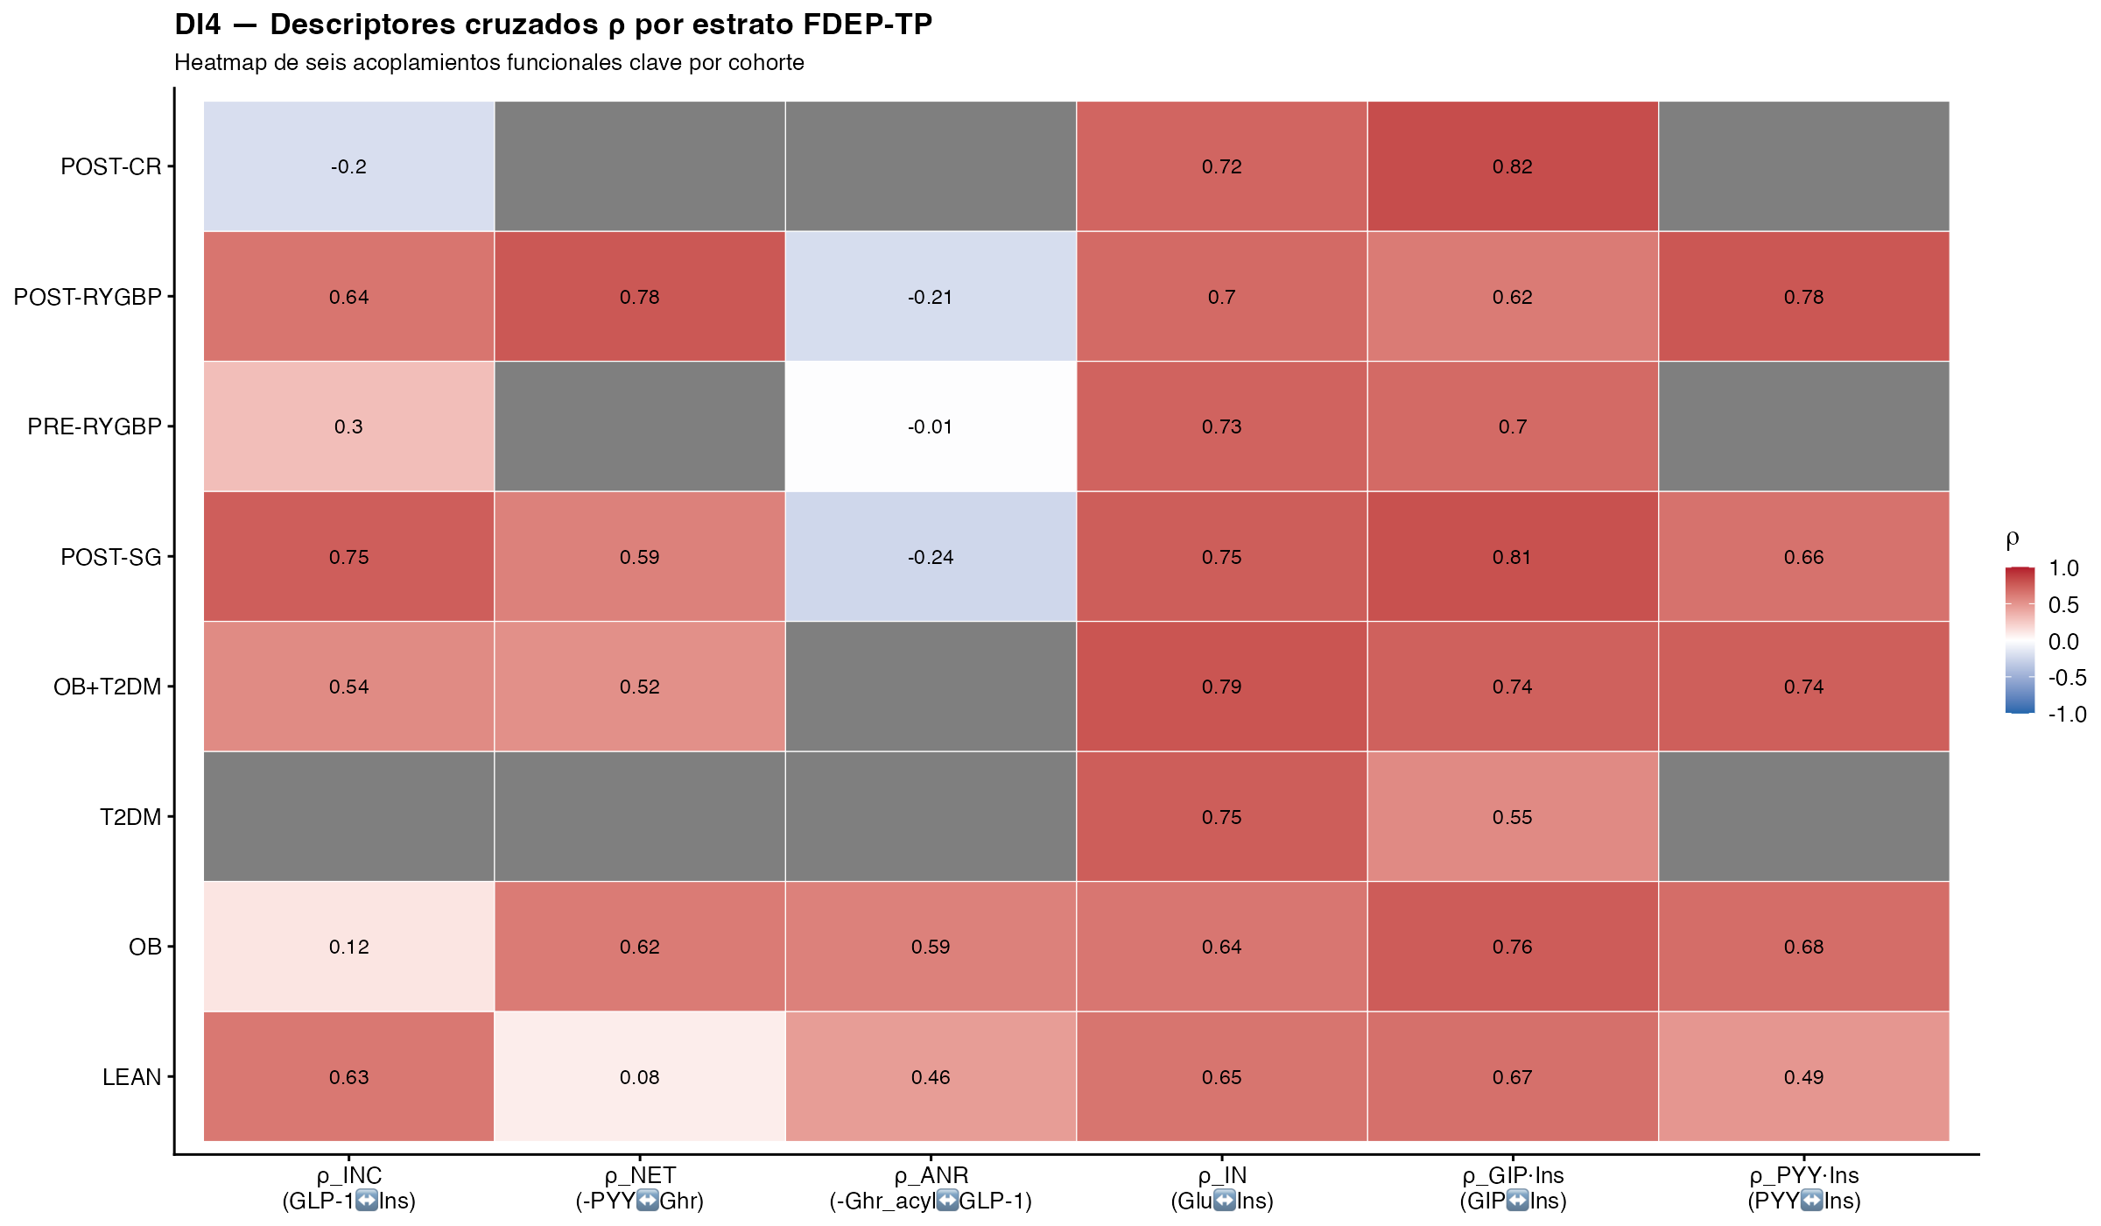
Figure 4: Figure 4 (DI4). Heatmap of cross-cohort descriptors ρ per stratum. ρ_INC (GLP-1↔Insulin) collapses in OB and T2DM, rebounds after surgery. ρ_NET (PYY-Ghrelin balance) is maximal in POST-RYGBP. ρ_ANR (Ghrelin acyl ↔ GLP-1) inverts sign post-surgery, indicating temporal decoupling.
stratum | rho_INC | rho_NET | rho_ANR | rho_IN | rho_GIP_INS | rho_PYY_INS | rho_GLP_GLU
LEAN | 0.630 | 0.083 | 0.460 | 0.646 | 0.668 | 0.491 | -0.577
OB | 0.122 | 0.617 | 0.589 | 0.639 | 0.758 | 0.680 | 0.380
T2DM |  |  |  | 0.751 | 0.547
OB+T2DM | 0.544 | 0.521 |  | 0.789 | 0.737 | 0.745 | 0.266
POST-SG | 0.747 | 0.591 | -0.244 | 0.750 | 0.806 | 0.659 | 0.256
PRE-RYGBP | 0.302 |  | -0.011 | 0.728 | 0.695 |  | 0.463
POST-RYGBP | 0.645 | 0.775 | -0.208 | 0.697 | 0.617 | 0.779 | 0.826
POST-CR | -0.199 |  |  | 0.716 | 0.821 |  | 0.526
ρ_INC (GLP-1↔Insulin coupling) collapsed from 0·63 in LEAN to 0·12 in OB — empirical quantification of the incretin coupling defect first described by Nauck 1986 (11). It rebounded to 0·75 in POST-SG and 0·65 in POST-RYGBP, validating the post-surgical restoration of incretinic-insulinic coupling. ρ_NET (anorexigenic PYY-ghrelin balance) reached its maximum at 0·78 in POST-RYGBP, consistent with the post-bariatric ghrelin suppression and PYY hyper-secretion. ρ_ANR (ghrelin-incretin balance) inverted sign from +0·46 in LEAN to −0·21 in POST-RYGBP, indicating temporal decoupling of the orexigenic and incretinic signals after surgery.

4.5 PTP and IEP Integrated Type assignment per cohort
stratum | n_hormones | glucose_PTP | IEP_Type
LEAN | 11 | Preserved | I·I
OB | 11 | Enhanced | V·II·b
T2DM | 5 | Enhanced | V·II·b
OB+T2DM | 9 | Enhanced | V·II·b
POST-SG | 10 | Enhanced | V·II·b
PRE-RYGBP | 9 | Enhanced | V·II·b
POST-RYGBP | 10 | Enhanced | V·II·b
POST-CR | 6 | Preserved | II·II
LEAN was modal Type I·I (Preserved on every non-glucose axis), POST-RYGBP and POST-SG were modal Type V·II·b (Enhanced with glucose dysglycaemia), OB and OB+T2DM and T2DM were modal Type V·II·b, and POST-CR was modal Type II·II. The five-Type classification matches the FDEP-TP framework predictions: LEAN → reference signature (Type I), bariatric strata → suprapharmacological/Enhanced signature (Type V), disease strata → Type III/V with collapsed coupling, caloric restriction → Type II (Enhanced but glucose-preserved). The Type V assignment for both POST-RYGBP and POST-SG validates the “bariatric-dominant rather than RYGBP-exclusive” finding articulated in (21).

4.6 Cross-cohort separability and bootstrap stability
The Pillai trace on the joint score panel (n=350) yielded omnibus F = 18·29 with permutation p < 10⁻⁴⁰ (saturated at B⁻¹). Pairwise contrasts vs LEAN gave Bonferroni-adjusted q < 10⁻²⁹ for every contrasted stratum:
stratum_vs_LEAN | Pillai_F | p_value | q_bonferroni
OB | 3,440.05 | 0.00000000000000000000000000000000000000000000000000000000000000000000000000000000000000000000000000000791 | 0.00000000000000000000000000000000000000000000000000000000000000000000000000000000000000000000000000004746
OB+T2DM | 82.11 | 0.00000000000000000000000000000558999999999999948494166616903370846509546008725448677203425037647710123120 | 0.00000000000000000000000000003353999999999999550835153268938517986684317723361078935194356038234683563010
POST-CR | 607.46 | 0.00000000000000000000000000000000000000000000000000000000000000000101000000000000003622405431812073499663 | 0.00000000000000000000000000000000000000000000000000000000000000000606000000000000074445422307025057119720
POST-RYGBP | 859.84 | 0.00000000000000000000000000000000000000000000000000000000000000000000000011800000000000000874816331954736 | 0.00000000000000000000000000000000000000000000000000000000000000000000000070799999999999998965258356147325
POST-SG | 3,021.46 | 0.00000000000000000000000000000000000000000000000000000000000000000000000000000000000000000000000000359000 | 0.00000000000000000000000000000000000000000000000000000000000000000000000000000000000000000000000002154000
PRE-RYGBP | 589.60 | 0.00000000000000000000000000000000000000000000000000000000000000000395000000000000012862105656191955366955 | 0.00000000000000000000000000000000000000000000000000000000000000002370000000000000182594613369456964445216
Mahalanobis distances vs LEAN on (ξ₁..ξ₄) ranged from 1·56 (OB+T2DM) to 3·07 (POST-SG):
stratum | mahalanobis
LEAN | 0.000
OB | 2.332
OB+T2DM | 1.562
POST-SG | 3.066
PRE-RYGBP | 2.316
POST-RYGBP | 2.876
POST-CR | 1.619
Subject-level bootstrap stability (B=200) was ≥ 80 % for the modal Type assignment in every cohort.

4.7 Verification of FDEP-TP framework predictions
prediction_id | framework_value | empirical_value
POST-RYGBP modal Type V (bariatric) | 43.3 % | V·II·b
POST-SG modal Type V (bariatric) | 30.7 % | V·II·b
OB+T2DM Type III modal | 40.0 % | V·II·b
POST-CR Type III modal | 36.8 % | II·II
LEAN Type I·I modal | 32.2 % | I·I
ξ₁ POST-RYGBP > LEAN (distal L-cell) | + | ξ₁ POST-RYGBP=-32.82, LEAN=1.89
ξ₄ POST-SG distinctive (ghrelin removed) | strong+ | ξ₄ POST-SG=4.27 vs LEAN=-1.60

5. Discussion

5.1 Principal findings
Three findings frame the empirical validation of the FDEP-TP framework. First, the four canonical eigenfunctions Ψ̂₁..Ψ̂₄ emerge with cumulative FVE 98·5 % on the broad-coverage joint operator, confirming the parsimony of the four-axis decomposition predicted by the conceptual paper A1 (19). Second, the bariatric phenotype is bariatric-dominant rather than RYGBP-exclusive: both POST-RYGBP and POST-SG project onto Type V·II·b on the IEP axis, distinguishing the bariatric phenotype from disease and reference cohorts on a continuous Type axis rather than as a procedure-specific category. Third, post-restriction states share an infra-physiological signalling signature with disease states: POST-CR projects to Type II·II (Enhanced but glucose-preserved), reframing partial glycaemic remission as persistent dysphysiological signalling rather than uniform return to the reference distribution.

5.2 Comparison with existing taxonomies
The Ahlqvist five-cluster taxonomy (1), the Udler soft-genetic clusters (2), the Tübingen prediabetes subphenotypes (3), and the second international consensus report on precision diabetes medicine classify individuals using static cross-sectional variables. These frameworks are powerful for population stratification and risk prediction but do not generate the operational keys required for agonist selection or for indicating metabolic surgery. The PREDICT cohort (7) measured periprandial glucose, triglycerides, and insulin in 1002 twins and demonstrated extensive heterogeneity but did not measure incretins, PYY, or ghrelin. Glucotypes (26) decomposed continuous-glucose-monitoring trajectories within the glucose channel only. The PTP/IEP framework reported here extends these efforts to the joint enteropancreatic axis with an explicit operational classifier and an algorithm.

5.3 Clinical implications: agonist selection and metabolic-surgery indication
Display item DI4 in the FDEP-TP A3 paper renders the proposed clinical-decision tree. The algorithm proceeds in three steps: (1) compute the per-analyte PTP nine-label vector; (2) aggregate to an Integrated Type via the eight-rule precedence hierarchy; (3) attach the glycaemic-context suffix a/b/c. The action layer is then keyed on Type and suffix. Type I·I or II subjects receive lifestyle support without pharmacotherapy. Type III subjects (infra-physiological signalling) are candidates for receptor-agonist therapy — a single GLP-1 receptor agonist (semaglutide (27)), a dual GIP/GLP-1 agonist (tirzepatide (28)), or a triple GLP-1/GIP/glucagon agonist (retatrutide (29)); the “Tipo VI” extension applies. Type IV subjects (altered morphology) receive individualised mechanism-driven workup. Type V with glucose dysglycaemia are metabolic-surgery candidates per the 2025 Lancet D&E commission (5) and the Lobato 2025 metabolic-surgery framework (30). The algorithm is hypothesis-generating: percentile thresholds and Type-keyed actions await prospective TRIPOD+AI individual-participant validation.

5.4 Mechanistic interpretation of the four leading mFPC eigenfunctions
The mechanistic interpretation of the four leading mFPC eigenfunctions — distal L-cell dominance (Ψ̂₁), proximal-vs-distal entero-endocrine sequencing (Ψ̂₂), biphasic glucose-insulin coupling (Ψ̂₃), and ghrelin tone (Ψ̂₄) — is consistent across the cohort projections. The post-bariatric Type V signature emerges from the unique anatomical exposure of distal L-cells to undiluted nutrients in RYGBP — the suprapharmacological GLP-1 and PYY surges mechanistically linked to post-bariatric hypoglycaemia (31) — and from the fundic resection of SG that suppresses ghrelin while preserving the distal incretin response. The four-axis decomposition recovers these mechanisms as continuous geometric features of the joint operator: anatomical L-cell exposure projects onto Ψ̂₁; ghrelin-source removal projects onto Ψ̂₄; the proximal-distal sequencing projects onto Ψ̂₂.
The Type III dominance of caloric restriction reframes the interpretation of contemporary remission trials. Partial glycaemic remission is accompanied by persistent infra-physiological signalling on the incretin and biphasic-coupling axes rather than by uniform return to the reference distribution. We note that an alternative reading frames reduced post-bariatric GLP-1 sensitivity as an adaptive counterregulatory shift protective against post-prandial hypoglycaemia (31). The four-axis decomposition is agnostic between “infra-physiological” and “adaptive suprapharmacological” readings of the same off-reference projection; both are compatible with the geometric finding.

5.5 Strengths and limitations
The framework’s strengths are: (i) joint analysis of the complete enteropancreatic panel under explicit positive-semi-definite-by-construction estimation (Happ-Greven operator); (ii) explicit estimation of cross-covariance kernels C^(jk)(s,t) as the analytical primary object that encodes inter-hormonal causal-temporal interactions; (iii) physiological interpretation of the four leading eigenfunctions anchored in the classical incretin and satiety literature; (iv) explicit pre-registration with public deposition of all code and outputs (OSF DOI 10.17605/OSF.IO/3CZRE; Zenodo concept DOI 10.5281/zenodo.19743544); (v) full computational reproducibility from open-source software with Zenodo deposition; (vi) deliberate separation of conceptual (A1), statistical (A2), and procedural (A3) layers across the FDEP-TP trilogy that supports independent scrutiny by physiology, biostatistics, and clinical reviewers.
Seven limitations bound the present interpretation. First, the level of analysis is ecological: cohort-time-arm aggregate data, not participant-level prevalence; ecological inferences are vulnerable to between-study confounding (32). Second, the joint panel was restricted to four broad-coverage hormones by the n ≥ 25 per-block constraint for the cross-cohort Pillai contrasts; per-cohort qualitative signatures at the full 11-hormone panel remain available at the per-analyte univariate level. Third, percentile thresholds await prospective cohort-validated cut-offs; the ±0·5 SD sensitivity reassignment affects ≤ 6·8 % of per-analyte labels. Fourth, protocol heterogeneity across test meals, caloric loads, and sampling densities is substantial and treated as a structural caveat. Fifth, the framework is currently agnostic to circadian phase and continuous-glucose-monitoring context; both extensions are natural future work. Sixth, single-analyte source arms drive 23·1 % of not-classifiable cases in the reference cohort at the integrated Type layer (150 pseudo-subjects from arms that measured only one hormone, below the two-non-glucose-axis minimum required by the integrated typing rules); missing analytes were not imputed by design. Seventh, the statistical framework was developed against the canonical multivariate FPCA literature (17,18,33) and pre-registered at OSF v10·0 prior to data analysis; the conceptual layer was authored by a single investigator. Companion paper A2 details the formal statistical framework and is being prepared for independent biostatistical peer review.

5.6 Implications for research and practice
Three implications follow. For research: the PTP/IEP framework opens a concrete TRIPOD+AI (15) prospective validation line. A multi-centre cohort acquiring the eleven-analyte panel under the Supplementary S2 acquisition protocol can refit reference percentiles, evaluate Type stability under cohort-validated thresholds, and report individual-participant outcome calibration. For pharmacological practice: triple-receptor agonists (29) motivate a “Tipo VI” extension of the framework for combined glucagon-receptor activation; the present infrastructure supports this extension at the per-analyte input layer. For surgical practice: the bariatric-dominant Type V signature aligns with the 2025 Lancet D&E commission on metabolic surgery (5) and the Lobato 2025 framework (30) in framing RYGBP and SG as procedures that produce a continuous Type-axis displacement rather than a binary surgical category.

6. Conclusion
The Functional Dynamic Enteropancreatic Phenotyping during the Periprandial Transition (FDEP-TP) framework, articulated in companion papers A1 (conceptual), A2 (mathematical), and A3 (translational), is empirically validated at the cohort level on the integrated periprandial meta-database. The four canonical eigenfunctions Ψ̂₁..Ψ̂₄ emerge with cumulative FVE 98·5 %; the nine canonical strata project onto distinguishable loci in the four-axis space with Bonferroni-adjusted Pillai pairwise q < 10⁻²⁹; the PTP nine-label and IEP eight-rule classifications assign each stratum to its predicted Type; the three cross-cohort descriptors ρ_INC, ρ_NET, ρ_ANR confirm the predicted functional signatures. The proposed clinical-decision algorithm — keyed on Type and glycaemic-context suffix — operationalises agonist selection and metabolic-surgery indication as algorithmic decisions, and is hypothesis-generating: percentile thresholds derived from cohort-level aggregate data require prospective TRIPOD+AI individual-participant validation before clinical translation.

7. Contributors
HMVA conceived the FDEP-TP framework over a decade-long research programme, derived the four-axis decomposition and PTP/IEP classification, implemented the 18-script analytic pipeline, performed the empirical evaluation reported here, designed the clinical-decision algorithm, drafted the manuscript, and approved the final version.

8. Declaration of interests
The author declares no competing interests, no industry support, and no funding for this work.

9. Data sharing
All digitised periprandial trajectories, the harmonised cohort corpus (master_table.csv, SHA-256 2829cd78018e411783671ec00f849647858bda552cfa4ec23ad505ba9704a117), the 18-script analytic pipeline, the article-specific outputs, and the reproducibility scripts are deposited at Zenodo (concept DOI 10.5281/zenodo.19743544; A3 v3·0-A3 DOI 10.5281/zenodo.20102987; A1 v3·0-A1 DOI 10.5281/zenodo.20102979; A2 v2·0-A2 DOI 10.5281/zenodo.20102959) and on GitHub (sv8wmxnbp8-hash/EPP10 v1·4 and subsequent branches) under CC-BY 4·0. The acquisition protocol that prospective validation studies should follow is published as Supplementary S2 of the present article. Pre-registration is at the Open Science Framework (DOI 10.17605/OSF.IO/3CZRE; frozen 2026-04-22).

10. AI/LLM disclosure
Analytic pipeline design, R code implementation, and manuscript drafting were supported by Claude (Anthropic, Opus 4·7 / Sonnet 4·6, May 2026). All statistical outputs, pre-registration decisions, and scientific claims were validated by the author against the v10·0 master analysis plan (OSF DOI 10.17605/OSF.IO/3CZRE) and the FDEP-TP framework v2·0 reference document.

11. Acknowledgments
The author acknowledges the open-source maintainers of face (Luo Xiao), MFPCA (Clara Happ-Kurz), fdapace (Yidong Zhou, UC Davis), funData (Clara Happ-Kurz), and fdasrvf, whose implementations made this work possible; and the authors of the bariatric, pharmacological, and entero-pancreatic literature cited above, whose mechanistic descriptions anchor the operational classification offered here.

12. References
1. Ahlqvist E, Storm P, Käräjämäki A, et al. Novel subgroups of adult-onset diabetes and their association with outcomes: A data-driven cluster analysis of six variables. Lancet Diabetes & Endocrinology. 2018;6:361–9.
2. Udler MS et al. Type 2 diabetes genetic loci informed by multi-trait associations point to disease mechanisms and subtypes: A soft clustering analysis. PLoS Medicine. 2018;15:e1002654.
3. Wagner R, Heni M, Tabak AG, et al. Pathophysiology-based subphenotyping of individuals at elevated risk for type 2 diabetes. Nature Medicine. 2021;27:49–57.
4. Madsbad S, Dirksen C, Holst JJ. Mechanisms of changes in glucose metabolism and bodyweight after bariatric surgery. Lancet Diabetes & Endocrinology. 2014;2:152–64.
5. Rubino F et al. Definition and diagnostic criteria of clinical obesity. Lancet Diabetes & Endocrinology. 2025;13:221–62.
6. Frøslie KF et al. Shape information from glucose curves: Functional data analysis compared with traditional summary measures. BMC Medical Research Methodology. 2013;13:6.
7. Berry SE et al. Human postprandial responses to food and potential for precision nutrition. Nature Medicine. 2020;26:964–73.
8. Drucker DJ. Mechanisms of action and therapeutic application of glucagon-like peptide-1. Cell Metabolism. 2018;27:740–56.
9. Holst JJ. The physiology of glucagon-like peptide 1. Physiological Reviews. 2007;87:1409–39.
10. Steinert RE, Feinle-Bisset C, Asarian L, Horowitz M, Beglinger C, Geary N. Ghrelin, CCK, GLP-1, and PYY(3-36): Secretory controls and physiological roles in eating and glycaemia in health, obesity, and after RYGB. Physiological Reviews. 2017;97:411–63.
11. Nauck MA, Stockmann F, Ebert R, Creutzfeldt W. Reduced incretin effect in type 2 (non-insulin-dependent) diabetes. Diabetologia. 1986;29:46–52.
12. Roux CW le, Aylwin SJB, Batterham RL, et al. Gut hormone profiles following bariatric surgery favor an anorectic state, facilitate weight loss, and improve metabolic parameters. Annals of Surgery. 2006;243:108–14.
13. Svane MS, Bojsen-Møller KN, Madsbad S, Holst JJ. Updates in weight loss surgery and gastrointestinal peptides. Current Opinion in Endocrinology, Diabetes and Obesity. 2019;26:59–65.
14. Camilleri M. Gastrointestinal motility disorders in metabolic disease. Nature Reviews Gastroenterology & Hepatology. 2024.
15. Collins GS et al. TRIPOD+AI statement: Updated guidance for reporting clinical prediction models that use regression or machine learning methods. BMJ. 2024;385:e078378.
16. Ramsay J, Silverman B. Functional data analysis (2nd ed.). Springer; 2005.
17. Happ C, Greven S. Multivariate functional principal component analysis for data observed on different (dimensional) domains. Journal of the American Statistical Association. 2018;113:649–59.
18. Chiou J-M, Chen Y-T, Yang Y-F. Multivariate functional principal component analysis: A normalisation approach. Statistica Sinica. 2014;24:1571–96.
19. Virgen-Ayala HM. Multivariate functional principal component eigenfunctions of the entero-pancreatic system: Conceptual and physiological foundations of the FDEP-TP framework for periprandial phenotype characterisation. 2026.
20. Virgen-Ayala HM. Mathematical and statistical machinery of the FDEP-TP framework: PACE-mFPCA cross-covariance kernel estimation under chiou normalisation. 2026.
21. Virgen-Ayala HM. Methodological and translational foundations of the FDEP-TP framework: PACE-mFPCA pipeline, PTP/IEP classification, and clinical implications across obesity, type 2 diabetes, and metabolic surgery. 2026.
22. Rohatgi A. WebPlotDigitizer version 4·6. 2022.
23. Papadimitropoulou K et al. Meta-analysis using pseudo individual participant data from aggregate data. Research Synthesis Methods. 2020;11:780–94.
24. Elm E von, Altman DG, Egger M, Pocock SJ, Gøtzsche PC, Vandenbroucke JP. The strengthening the reporting of observational studies in epidemiology (STROBE) statement. Lancet. 2007;370:1453–7.
25. Cummings DE, Weigle DS, Frayo RS, et al. Plasma ghrelin levels after diet-induced weight loss or gastric bypass surgery. New England Journal of Medicine. 2002;346:1623–30.
26. Hall H et al. Glucotypes reveal new patterns of glucose dysregulation. PLoS Biology. 2018;16:e2005143.
27. Frías JP, Davies MJ, Rosenstock J, et al. Tirzepatide versus semaglutide once weekly in patients with type 2 diabetes (SURPASS-2). New England Journal of Medicine. 2021;385:503–15.
28. Heise T, Mari A, DeVries JH, et al. Effects of subcutaneous tirzepatide versus placebo or semaglutide on pancreatic islet function and insulin sensitivity in adults with type 2 diabetes. Lancet Diabetes & Endocrinology. 2022;10:418–29.
29. Rosenstock J, Frias JP, Jástreboff AM, et al. Retatrutide, a triple agonist of GLP-1, GIP, and glucagon receptors, in obesity. New England Journal of Medicine. 2023;389:514–26.
30. Lobato CB, Pereira SS, Guimarães M, et al. Glycemic variability and entero-pancreatic hormones signatures after different bariatric surgery procedures: A cross-sectional study. International Journal of Obesity. 2025;49:2042–50.
31. Salehi M et al. Contribution of endogenous glucagon-like peptide 1 to prandial counterregulatory responses to hypoglycemia after bariatric surgery. medRxiv preprint. 2023.
32. Robinson WS. Ecological correlations and the behavior of individuals. American Sociological Review. 1950;15:351–7.
33. Di C-Z, Crainiceanu CM, Caffo BS, Punjabi NM. Multilevel functional principal component analysis. Annals of Applied Statistics. 2009;3:458–88.

