Üldandmed
Projekti nimi: Veebipõhine foorum
Kuupäev: 30.04
Autorid: Ants Aas, Rainer Tahker
Staatus: Lõpetamatta

Eesmärk
Teha foorumi andmebaas,kus saab luua teemad, mille alla saab lisada postitusi, saad kommentaare panna positustele ja hääletada, andes kas upvote või downvote

Definitsioonid ja lühendid

Kasutatav tarkvara
Operatsioonisüsteem | Linux (Arch), Windows
Andmebaasid | Mariadb, Mongodb

Funktsionaalsed nõuded
Nõue | Priotiteet | Märkused
Teemade tabel | 1.
Postituste tabel | 2.
Hääletused postituste jaoks | 3.
Kommentaarid postituste jaoks | 4.

Andmemudel

MongoDB:
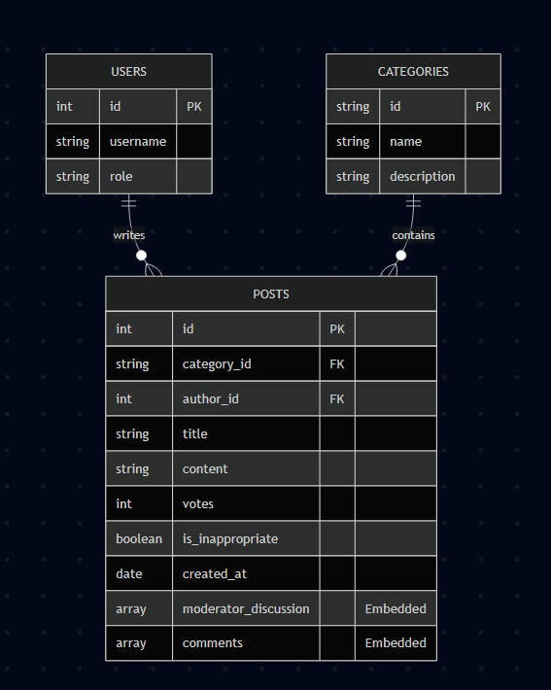

Posts: {
"_id": 101,
"category_id": "games",
"author_id": 1,
"title": "Dark Souls is hard",
"content": "Why on gods green earth is this game so hard? Any tips for the first boss?",
"votes": 69,
"is_inappropriate": false,
"created_at": {
"$date": "2026-05-20T10:03:06.212Z"
},
"moderator_discussion": [],
"comments": [
{
"comment_id": 1,
"author_id": 2,
"parent_comment_id": 0,
"content": "This game is not that hard, you just need to roll at the right time.",
"votes": 12,
"created_at": {
"$date": "2026-05-20T10:03:06.212Z"
}
},
{
"comment_id": 2,
"author_id": 1,
"parent_comment_id": 1,
"content": "Easy for you to say, my timing is terrible!",
"votes": -5,
"created_at": {
"$date": "2026-05-20T10:03:06.212Z"
}
}
]
},

Categories:
{
"_id": "games",
"name": "Gaming and eSports",
"description": "All things video games"
},

Users:
{
"_id": 1,
"username": "gamer_pro",
"role": "user"
},

Mariadb:
CREATE TABLE users (
id INT AUTO_INCREMENT PRIMARY KEY,
username VARCHAR(100) NOT NULL UNIQUE,
admin BOOLEAN DEFAULT FALSE
);

CREATE TABLE subjects (
id INT AUTO_INCREMENT PRIMARY KEY,
name VARCHAR(100) NOT NULL UNIQUE
);

CREATE TABLE posts (
id INT AUTO_INCREMENT PRIMARY KEY,
subject_id INT NOT NULL,
user_id INT NOT NULL,

title VARCHAR(255) NOT NULL,
content TEXT NOT NULL,

votes INT DEFAULT 0,

create_date DATETIME NOT NULL DEFAULT CURRENT_TIMESTAMP,

visible BOOLEAN DEFAULT TRUE,

FOREIGN KEY (subject_id) REFERENCES subjects(id),
FOREIGN KEY (user_id) REFERENCES users(id)
);

-- Replies are just comments with a parent_comment_id
CREATE TABLE comments (
id INT AUTO_INCREMENT PRIMARY KEY,

post_id INT NOT NULL,
user_id INT NOT NULL,

parent_comment_id INT NULL,

content TEXT NOT NULL,

votes INT DEFAULT 0,

create_date DATETIME NOT NULL DEFAULT CURRENT_TIMESTAMP,

mod_post BOOLEAN DEFAULT FALSE,

FOREIGN KEY (post_id) REFERENCES posts(id),
FOREIGN KEY (user_id) REFERENCES users(id),

FOREIGN KEY (parent_comment_id)
REFERENCES comments(id)
ON DELETE CASCADE
);

