Jommi Koljonen, Maximilian Kolomainen, Antti Kukkonen, Peppi Mäkinen

Heartbeat Monitor

**Project Report**

First-year Hardware Project

School of ICT

Metropolia University of Applied Sciences

29 March 2023

Abstract

The report describes a project that aimed to develop a monitor capable of measuring heart rate and analyzing heart rate variability, with the data displayed on an OLED screen. Divided into several sections, including an introduction, theoretical background, methods and materials, implementation, and conclusion, the report provides a comprehensive overview of the project. The introduction briefly summarizes the project's objectives, while the theoretical background section explains heart rate and HRV, their relationship to physiological phenomena, and the use of a PPG sensor in calculating HRV. In addition, the section discusses time-domain and nonlinear HRV parameters. The methods and materials section provides details on the hardware and software used in the project, including the Raspberry Pi Pico board, OLED screen, Crowtail-Pulse Sensor, and Micropython. The implementation section provides a detailed breakdown of the algorithm used to extract the heart rate from the PPG signal. Lastly, the conclusion discusses the project's success and suggests future development ideas.

Contents

Abstract 2

1 Introduction 1

2 Theoretical Background 1

2.1 Heart Rate Variable (HRV) Parameters 3

2.1.1 Time-domain HRV parameters 3

2.1.2 Nonlinear HRV parameters 5

2.2 HRV in Evaluating Autonomic Nervous System (ANS) Function 6

2.2.1 Parasympathetic nervous system (PNS) index 6

2.2.2 Sympathetic nervous system (SNS) index 7

3 Methods and Material 8

4 Implementation 10

5 Conclusions 11

References 13

# Introduction

This project aimed to develop a heart rate monitor that is accurate and reliable. The device was to be capable of measuring and analysing heart rate, displaying the data on an OLED screen, and transmitting the information to a remote device. The project was completed during the Hardware 2 course, which covers topics such as electronics and the collection of health data. During the previous Hardware 1 course, topics such as networks and digital circuits were covered. All these topics are integral to our understanding and the completion of the project. The team working on this project consists of Jommi Koljonen, Max Kolomainen, Antti Kukkonen, and Peppi Mäkinen.

A problem we were aiming to solve with this project was the reliable measuring and calculation of heart rate, heart rate variability and other physiological phenomena relating to heart rate. The project provided an excellent opportunity to develop our skills in embedded systems, electronics, and networks, and to put them into practice. The project deepened understanding in the concepts relating to hardware and real-world applications in the field.

# Theoretical Background

Heart rate is the number of heartbeats per minute. The amount of time between heartbeats fluctuates slightly. Heart rate variability (HRV) is the measurement of said fluctuation. The fluctuation is controlled by a primitive part of the nervous system called the autonomic nervous system (ANS). It operates automatically without the need for conscious thinking. The operations of ANS include regulating heart rate, blood pressure, breathing, digestion, etc. ANS is subdivided into two main parts: sympathetic nervous system (SNS) and parasympathetic nervous system (PNS). SNS is responsible for the “fight-or-flight” response which increases heart rate and blood pressure. PNS stabilizes SNS and controls the natural relaxation response.

HRV and heart rate are related to several physiological phenomena, including:

* Thermoregulation, Body temperature can affect and be affected by heart rate and HRV. When body temperature increases, heart rate increases and vice versa.
* Exercise, heart rate increases to supply the body with oxygen and nutrients.
* Emotional states, for example stress and anxiety increase heart rate.

Heart rate and HRV vary greatly from person to person. A typical heart rate is 60-100 beats per minute. Higher HRV is associated with better health and fitness. A resting HRV value of 50-100 milliseconds is considered normal for healthy individuals. (1-3.)

The photoplethysmogram (PPG) sensor produces a signal that is reflective of the amount of light absorbed by the tissue. This signal can be used to calculate heart rate and HRV, as it reflects the changes in blood volume due to the heart's pumping.

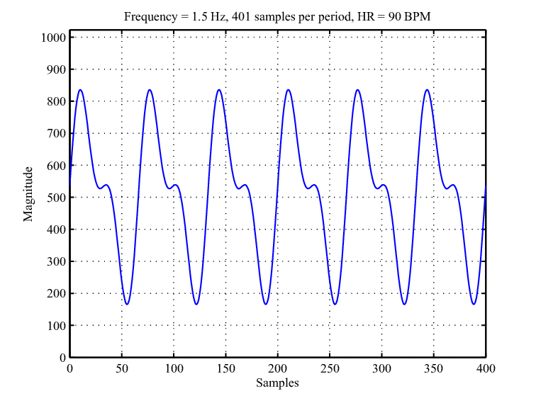Figure 1 shows an example of a PPG signal.

**Figure 1:** Mathematical model of a pure PPG signal with a calculated heart rate of 90 BPM.

The graph in Figure 1 is an example of a PPG signal with heartbeat time intervals also known as Peak-to-Peak or P-P intervals. HRV can be calculated by measuring the P-P intervals of the PPG signal. (4.)

## **Heart Rate Variable (HRV) Parameters**

The HRV analysis parameters can be divided into three main categories: time-domain, frequency-domain, and nonlinear HRV analysis methods. In this project emphasis is given to time-domain and nonlinear parameters. (5-8.)

### Time-domain HRV parameters

Time-domain HRV parameters are calculated from the aforementioned P-P intervals.

The mean RR interval (i.e., P-P interval) and the mean heart rate are calculated with the following formula:

,

where ‘N’ is the amount of intervals.

The standard deviation of RR (P-P) intervals (SDNN) is defined as follows:

‘NN’ in SDNN means ‘normal’ heartbeats which excludes abnormal and false beats. SDNN reflects the overall (both short-term and long-term) variation within the P-P interval time series.

The standard deviation of successive RR (P-P) interval differences (SDSD) is defined as follows:

But since in this project the stationary RR (P-P) series is used, SDSD equals the root mean square of successive differences (RMSSD) which is defined as follows:

RMSSD is a measuring form that is most commonly used in HRV because it characterizes short-term rapid changes in heart rate. Such quick changes can only occur under the influence of the PNS.

Baevsky’d stress index (SI) is defined as follows:

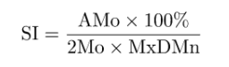

Baevsky’s stress index is a geometric HRV analysis method that is calculated from the RR (P-P) interval histogram. It is a method used to evaluate an individual’s stress level based on changes in HRV.

AMo is the mode amplitude presented as a percentage, Mo is the mode (the most frequent RR interval) and MxDMn is the variation scope reflecting degree of RR (P-P) interval variability. The AMo represents the height of the normalised RR (P-P) interval histogram, the Mo is the median of the RR (P-P) intervals and MxDMn is the difference between longest and shortest RR (P-P) interval values. (5-8.)

### Nonlinear HRV parameters

Nonlinear HRV parameters are used to evaluate nonlinear mechanisms, complexity, or chaotic behaviour of HRV. One commonly used nonlinear HRV analysis method is the Poincaré plot. It is a graphical representation of the correlation between successive RR (P-P) intervals. The shape of the plot is essential and a common approach to parameterize the shape is to fit an ellipse to the plot as shown in figure 2. (5-8.)

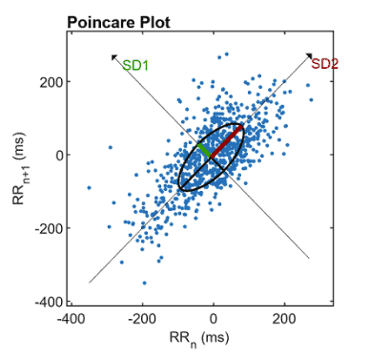**Figure 2:** Poincaré plot analysis with the ellipse fitting procedure.

As seen in figure 2, SD1 and SD2 are the standard deviations perpendicular to and along the line-of-identity *RRn = Rrn+1*, respectively.

SD1 is related to the time-domain measure SDSD (i.e., RMSSD) according to:

.

SD2 is related to time-domain measure SDNN and SDSD (RMMSD) by:

.

## **HRV in Evaluating Autonomic Nervous System (ANS) Function**

PNS activity is known to decrease heart rate (HR) and increase HRV, but SNS activity has more or less the opposite effect on HR and HRV, i.e., it increases HR and decreases HRV. In layman’s terms, HR is lowest and HRV is highest when person is at rest and fully recovered. During stressful situations when SNS activity is increased, HR is elevated and HRV is decreased.

### Parasympathetic nervous system (PNS) index

PNS index is based on the following three parameters:

1. Mean RR (P-P) interval. Longer mean RR (P-P) interval means lower HR and higher parasympathetic cardiac activation.
2. RMSSD. High values of RMMSD indicate high parasympathetic cardiac activation.
3. Poincaré plot index SD1 in normalized units, since SD1 is known to be linked to RMSSD.

The utilization of these values can be seen in the following figure 3.

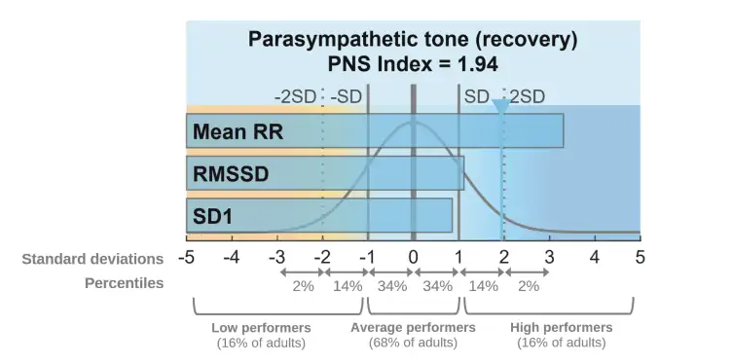**Figure 3:** An example of parasympathetic nervous system (PNS) index.

Each parameter value is first compared to their normal population values which can be seen in figure 3. The parameter values are then scaled with the standard deviations (SD) of normal population and finally proprietary weighting is applied to obtain robust and reliable PNS index value. (9.)

The interpretation of the PNS index is as follows:

* A PNS index value of zero means that the three parameters are on average equal to the normal population average.
* A positive and negative index value tells how many SDs above or below the normal population average the parameter values are.
* In rest, PNS index is typically between -2 and +2.
* During stress or during high intensity exercise much lower PNS index values can be expected

### Sympathetic nervous system (SNS) index

SNS index is based on the following three parameters:

1. Mean HR interval. A higher heart rate is linked to higher sympathetic cardiac activation.
2. Baevsky’s stress index (SI). High values of SI indicate reduced variability and high sympathetic cardiac activation.
3. Poincaré plot index SD2 in normalized units, since SD2 is known to be linked to SDNN.

The utilization of these values can be seen in the following figure 4

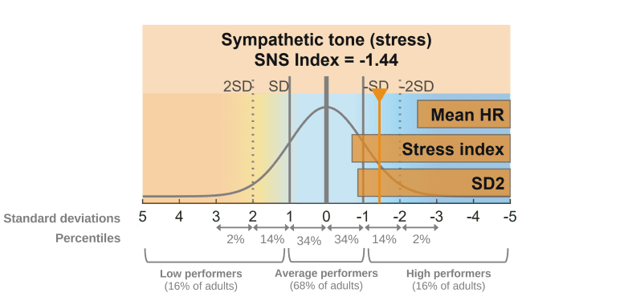**Figure 4:** An example of sympathetic nervous system (SNS) index.

Each parameter value is first compared to their normal population values as can be seen in figure 4. The parameter values are then scaled with the standard deviations (SD) of normal population and finally proprietary weighting is applied to obtain robust and reliable SNS index value. (9.)

The interpretation of SNS index is similar to PNS index:

* A SNS index value of zero means that the three parameters are on average equal to the normal population average.
* A positive and negative index value tells how many SDs above or below the normal population average the parameter values are.
* During stress or high intensity exercise SNS index can have values as high as 5-35

# Methods and Material

The heart rate monitor project was carried out using a Raspberry Pi Pico board, programmed with MicroPython. The Pico board was chosen for its low cost and compatibility with MicroPython, which allowed for easy implementation of the heart rate monitor system.

The project used an optical Crowtail-Pulse Sensor as the heart rate sensor. This sensor measures heart rate by detecting changes in blood volume using photoplethysmography (PPG) technology. The sensor consists of an infrared LED and a photodetector, which are placed on the skin to detect the blood volume changes.

The sensor was connected to the Pico board through its analog input pins. The analog signal from the sensor was then converted to a digital signal using an Analog-to-Digital Converter (ADC) on the Pico board.

The heart-rate data was displayed on a small OLED display. The display had a resolution of 128x64 pixels and was connected to the Pico board through its I2C interface. The display was used in conjunction with a rotary encoder to build a user interface to show the heart rate data, various values relating to physiological phenomena, and allow recording of new data.

Accurate readings were ensured with a hardware timer, callback functions, and a ring buffer for the samples. A heart-rate monitor requires precise timing to accurately measure the intervals between heartbeats. The use of a hardware timer is necessary to ensure that readings are taken at precise intervals and that the timing is not impacted by other processes running on the system.

Without a hardware timer, the heart-rate monitor may rely on software timing, which is not as accurate or reliable as hardware timing. This could result in inaccurate readings or missed heartbeats, which could be potentially dangerous for the user and is considered a catastrophic failure of the system. Therefore, the use of a hardware timer is essential for ensuring the accuracy and safety of a heart-rate monitor.

The algorithm used for detecting PPI was tested against a set of PPG signal values with known peak-to-peak intervals and verified to be accurate. Values such as the SDNN and RMSSD were also calculated using verified algorithms that have been tested on data sets with expected results.

# Implementation

The project is a standalone system, with only the need for power and a Wi-Fi connection for the Kubios HRV analysis. The system is described in figure 5.

**Figure 5:** A system diagram showing the parts of the system and the flow of data between them.

The system diagram gives an overview of the system. The data flowing from the optical sensor and the Pico board, and from the Pico board to the OLED screen is flowing through physical copper wires. Communications between the Pico board and Kubios is done over Wi-Fi using HTTP requests.

The algorithm for extracting the PPI from the PPG signal uses the following logic:

1. Read a sample.
2. Calculate the average of the samples from the last 3 seconds.
3. Calculate a high and a low threshold, that are the average multiplied by 1.08 and 1.02 respectively.
4. While the sample is above the high threshold:
   1. Check if the sample is larger than the max and update the max if necessary.
   2. Set peak number as the sample’s number.
5. When the sample crosses the lower threshold:
   1. Calculate the distance of the peaks and multiply it by the sample rate to get the time between peaks.
   2. Check whether the time between peaks falls into a ‘normal’ range of PPIs to determine whether the measurement was true.
   3. Set the peak number as the last peak and reset the max to 0.
6. Store true PPI values and repeat.

The project was set to collect 15 seconds of data, and then send it to Kubios for some of the HRV analysis. The SDNN and RMSSD are calculated on the board without the need for Kubios. The analysed data is stored in the random-access memory (RAM) of the Pico board, which is lost whenever the system gets turned off. Long-term storage of the data is possible with the hardware but would come with the challenge of dealing with the very limited flash memory on the Pico board.

# Conclusions

In conclusion, the heartbeat monitor project went well. The goals set at the beginning of the project were achieved and the project itself was completed within the allotted time frame. As stated earlier, the project aimed to design and develop a proof of concept of a heartbeat monitor that is both reliable and accurate. While we did encounter some problems during the project, based on test results and feedback from the project teacher, the prototype was successful in meeting these objectives.

The measurement system succeeded in demonstrating the desired level of accuracy in detecting the heartbeat of its user, and in displaying the information required. While the project performs all desired features well, the system still has some limitations. The device's accuracy drops if the user is moving relative to the sensor introducing artifacts to the PPG signal. The device also cannot measure a heartbeat from parts of the body with lower amounts of blood flow or where the blood flow is blocked by a large amount of tissue.

To improve the work in the future, some bits of the programming could be developed further. An example being that the threshold could be calculated dynamically based on the strength of the signal, which might enable the measurement of heartbeats from lower blood flow areas as well. Also, a more extensive user testing phase would be beneficial to identify and address any issues that may arise during usage.

References

1. Shaffer F, Ginsberg JP. An Overview of heart rate variability metrics and norms. Fr Pub Heal. 2017 Sep 28; 5: 258. Available from: https://www.ncbi.nlm.nih.gov/pmc/articles/PMC5624990/ doi: 10.3389/fpubh.2017.00258
2. Harvard Health Publishing, Heart rate variability: how it might indicate well-being [Internet], 2021 [cited 2023 Mar 29]. Available from: https://www.health.harvard.edu/blog/heart-rate-variability-new-way-track-well-2017112212789
3. Cleveland Clinic, Heart rate variability (hrv) [Internet], 2021 [cited 2023 Mar 29]. Available from: https://my.clevelandclinic.org/health/symptoms/21773-heart-rate-variability-hrv
4. Castaneda D, Esparza A, Ghamari M, Soltanpur C, Nazeran H. A review on wearable photoplethysmography sensors and their potential future applications in health care. Int J Bios Bio. 2018 Aug 6; 4(4): 195-202. Available from: https://www.ncbi.nlm.nih.gov/pmc/articles/PMC6426305/ doi: [10.15406/ijbsbe.2018.04.00125](https://doi.org/10.15406%2Fijbsbe.2018.04.00125)
5. kubios, HRV Analysis Methods [Internet], [cited 2023 May 5]. Available from: https://www.kubios.com/hrv-analysis-methods/
6. Welltory Team, RMSSD and other HRV measurements [Internet], 2022 [cited 2023 May 5]. Available from: https://welltory.com/rmssd-and-other-hrv-measurements/
7. Ernest, HRV metrics: SDNN and RMSSD [Internet], 2022 [cited 2023 May 5]. Available from: https://blog.tryterra.co/measuring-hrv-sdnn-and-rmssd-3a9b962f7314
8. Altini M. Heart Rate Variability (HRV) Features: can we use SDNN instead of rMMSD? A data-driven perspective on short term variability analysis [Internet], 2018 [cited 2023 May 5]. Available from: https://www.hrv4training.com/blog/heart-rate-variability-hrv-features-can-we-use-sdnn-instead-of-rmssd-a-data-driven-perspective-on-short-term-variability-analysis
9. kubios, HRV in Evaluating Autonomic Nervous System Function [Internet], [cited 2023 May 5]. Available from: https://www.kubios.com/hrv-ans-function/