Memoryz database-practical work
Antti Kotiranta, June/July 2015.

1. Jump into the world of Memoryz

What is Memoryz?
As now days people have so many things to remember, Memoryz website is here to help working class Joe, business manager Bill, stay-a-home mother Martha, student Sandy, stock-market Stud, homeless Hank, Jeff and everyone to help them remember their important matters. The idea behind Memoryz is that users can create their own table of things needed to be done, class them, rate their priority, rank them in different order and of course mark them as done. Memoryz will provide full chore controlling system to you anywhere and anytime ;) ;) ;).
Memoryz is a web-site where users create their account. After logging in, users can create new chores, set their priority, create labels and add them to chores. Every user has their own private chores and labels. Chores can be marked as done and they can be edited and deleted if necessary. Also labels can be edited and deleted.

Implementation
The practical work is a web-site based interface what uses database. This practical work does not use any ORM libraries. The database used in this practical work is PostgreSql and the functionality between the interface and database is written with PHP.
The works environment will be implemented with Heroku (www.heroku.com), but if other environment is used the platform/environment will need to support at least PostgreSql and PHP. At least JavaScript support is needed from the browser.
More specific info will be added later.

2. Use case

Use case diagram
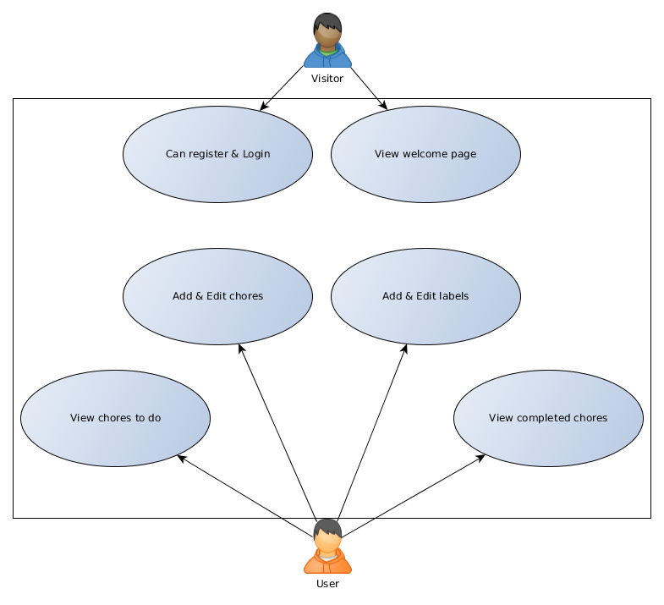
Visitor
Visitors is anyone who visits the site. Everyone is a visitor before logging in.
User
User is a registered and logged in visitor.

Use case descriptions
A visitor may:
-See a welcome page which contains basic information of the site
-Register as user
-Log in
User:
Preconditions: The user is registered and logged in.
-View chores to do: The user can browse their own chores they haven't completed in a list, which includes the chores priority and labels.
-View completed chores: The user can see chores they have marked as done, it's priority and labels listed as well.
-Add & Edit chore: The user can add a new chore by giving it a name, description, priority and labels. He/She can also edit a chore and delete it if necessary.
-Add & Edit label: The user can add a new label by giving it a name and description. He/She can also edit a label and delete it if necessary.
-Log out.

