DAQ System with modular concept

# Introduction

The modular concept allows complex analog and digital designs to be partitioned into “functional blocks” implemented as SMTA compatible modules that can be used in standard assembly process as regular components.

Modules are sized 23.5 x 23.5 mm: this size is sufficient to hold at least one special IC (ADC, DAC, DDS, Filter, etc) and all components that are needed for the special IC to function properly. The concept has been tested out with several digital modules based on Microcontrollers and FPGA devices.

For analog functions the pin mapping has been carefully selected to allow sensitive signals to have very short connection between modules for best signal integrity.

# PCIe DAQ Board

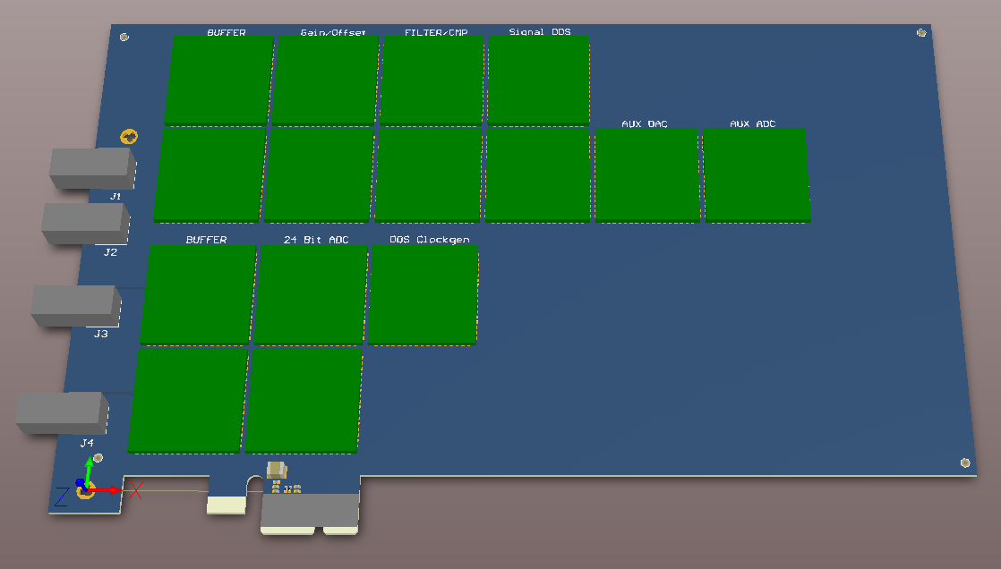

PCIe board with 2 ADC and 2 DDS signal generator channels, LEMO connectors for signals.

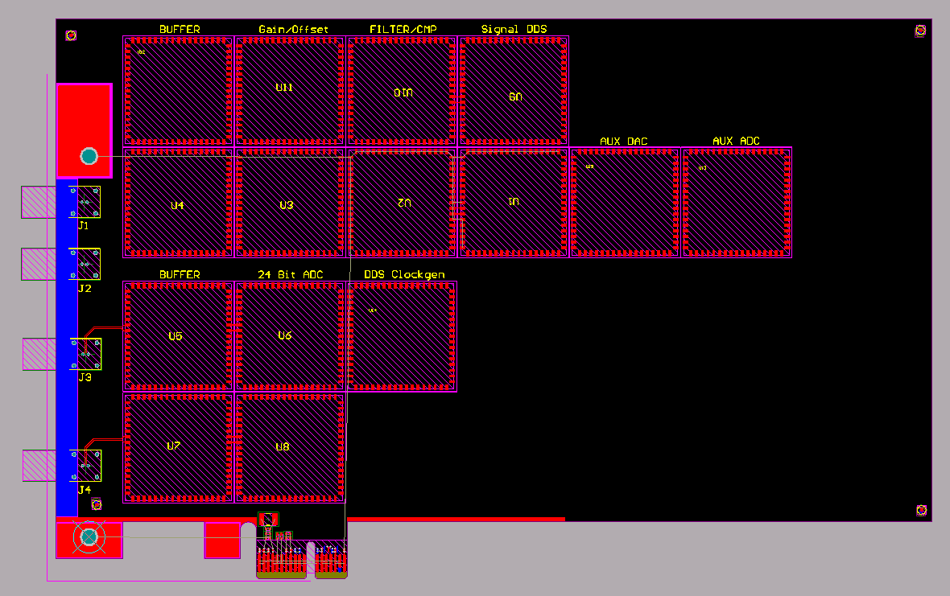

# Clock Generation

Clock generation using DDS based direct synthesis.

## Module: DDS based Clock

This module is based on AD9912 14-bit 1GS/s DDS. DDS differential outputs are filtered and connected to the on-chip comparator.

Fixed settings for AD9912

* Powerdown: disabled (that is DDS is always in operational mode)
* Clock mode: Internal oscillator enabled (25 MHz on-board crystal)
* Startup mode S1=S2=S3=S4=0 – output disabled
* CMOS output: 1.8V level

Power supplies needed

* +3.3V Digital supply, on-board LC filter: ?
* +5V Analog Supply
  + +3.3V LDO for DAC
* +2.5V Supply
  + +1.8V LDO for system domain, extra filters
  + +1.8V LDO for AVDD pin 53
  + +1.8V LDO for main AVDD

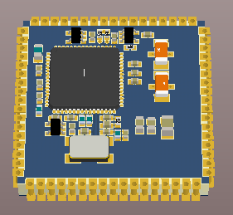

## Clock DDS Evaluation

This is a USB controller evaluation and measurement board for the DDS based clock generation module. DDS outputs are available on SMA connector. This evaluation board was designed to accept AD9912 based DDS clock generation module, however other compatible modules can be evaluated as well.

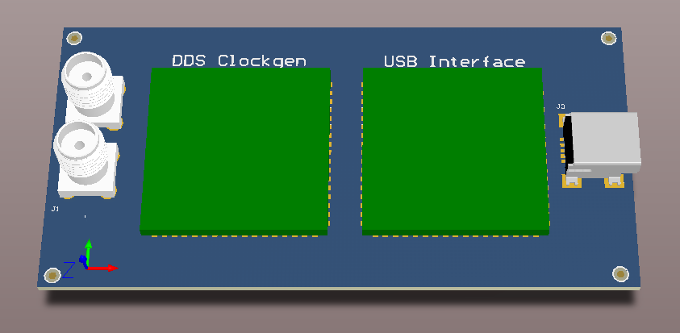

USB interface for this evaluation board is implemented using existing STM32F4 (ARM Cortex M4) based module.

Optionally the DDS I/O interface pins are available on pin header as well for control by external circuitry.

# Main ADC Path

Two modules are used ADC module itself and second module that implement input buffering and extra signal processing before ADC.

## Module: 24Bit ADC

This module is based on AD7760 ADC, 24Bit. ADC differential inputs are directly available on module terminals. ADC clock is scaled to 5V range using NC7S08P5X single AND gate driver. ADC input circuit is done by the reference schematic suggestions using top layer only routing and symmetrical layout of the tracks.

Fixed settings for AD7760

* Input range: +/- 3.25V

Power supplies needed

* +2.5V Digital supply, on-board LC filter
* +7.5V Analog supply, on-board LC filters
  + On-board +2.5V low noise LDO ADP7104
  + On-board +5V low noise LDO ADP7104
  + On-board high precision 4.096V reference ADR434B

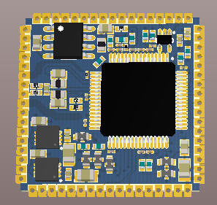

## 24 Bit ADC Evaluation

Evaluation and test board for the 24 Bit ADC and input buffer modules.

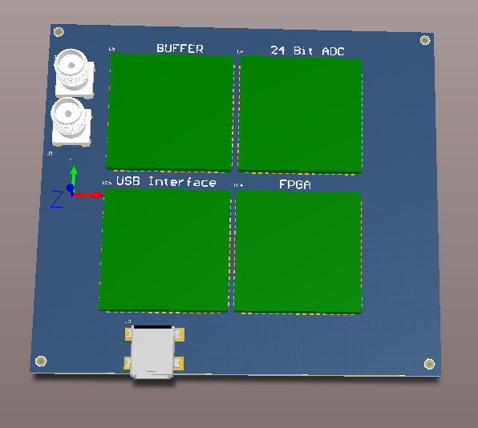

The ADC can be accessed either by USB interface or by direct connection (pins are available in EXT header). Existing USB and FPGA modules can be used.

# DDS Signal Generator

The signal generation path includes 4 modules per channel:

* DDS with differential analog outputs
* Filter module with differential to single conversion and programmable gain
* Gain and offset module
* Output buffer driver module

## Module: DDS Signal synthesis

Based on AD9952 14-bit DDS. Differential DDS outputs are connected to module terminals. On-chip comparator inputs are in parallel to DDS outputs, comparator output is available on the module terminals, this signal can be used to synchronize the DDS FTW updates to be done at the zero crossing point of the of the output signal.

Fixed settings for AD9952

* Powerdown: disabled (always in powered operational mode)
* Clock mode: external
* OOK: disabled
* Comparator inputs connected directly to DDS outputs

Power supplies needed

* +3.3V Digital supply, on-board LC filter: I/O Voltage
* +2.5V Supply
  + +1.8V LDO for Analog power
  + +1.8V LDO for Digital power

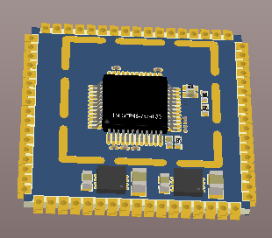

## Module: DDS Filter

Two differentially implemented active low pass filters cascaded, based on AD8132 differential amplifiers. AD8132 also removes the DC offset and aligns the signal around 0V. Output of the filter is available on module terminals directly (differential outputs). Single ended signal is also available, conversion is made using AD8251 instrumental amplifier, and fixed gain of 1,2,4,8 can be selected. Signal path is DC coupled; there is no lower frequency limit. Differential signal from the filter is also connected to ADCMP604 comparator with LVDS outputs. This comparator does perform zero crossing detection.

This filter is designed to be connected directly to DDS differential outputs.

Power supplies needed

* +3.3V Digital supply, on-board LC filter: ADCM604
* +15V Analog supply, on-board LC filter: AD8251
* -15V Analog supply, on-board LC filter: AD8251
* +5V Analog supply, on-board LC filter: AD8132
* -5V Analog supply, on-board LC filter: AD8132

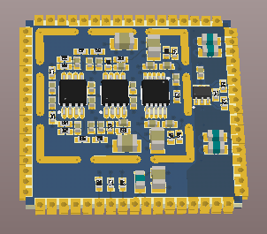

## Module: Gain/Offset adjustment

This module takes singled ended bipolar voltage as input, applies gain (using AD5543, 16 bit resolution) then offset (using AD5422, 16 bit resolution) and outputs voltage (ADA4004-1 used to convert AD5543 output to voltage).

Fixed settings for AD5422

* Internal LDO: disabled
* Clear select: midscale (0V output)
* Reference: internal
* Current output: not used

Power supplies needed

* +3.3V Digital supply, on-board LC filter: AD5422
* +15V Analog supply, on-board LC filter: AD5422, ADA4004
* -15V Analog supply, on-board LC filter: AD5422, ADA4004
* +5V Supply, on-board LC filter: AD5543

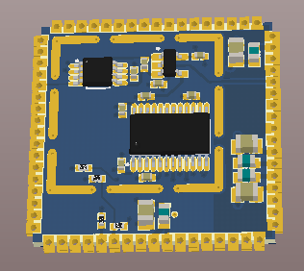

# AUX ADC and DAC

Slow ADC and DAC channels are implemented on separate modules:

* 4 channel DAC
* 8 channel ADC

## Module: 4 Channel DAC

This module is based on AD5764R DAC, 16Bit, 4 channels. All channel outputs are routed to module terminals, including channel reference grounds (they are not connected on module to common ground).

Fixed settings for AD5764R

* Reference: Internal for both AB and CD channels
* Bin/2sComp mode: 2’s complement

Power supplies needed

* +3.3V Digital supply, on-board LC filter
* +15V Analog supply, on-board LC filter
* -15V Analog supply, on-board LC filter

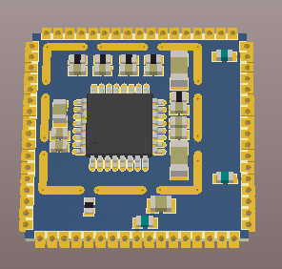

## Module: 8 Channel ADC

This module is based on AD7606 ADC, 16Bit, 8 channels. All channel inputs are routed to module terminals, including channel reference grounds (they are not connected on module to common ground).

Fixed settings for AD7606

* Reference: Internal
* Input range: +/- 10V
* Powerdown: disabled (that is ADC is always in operational mode)
* Conversion start: A and B are started at same time (signals tied together)

Power supplies needed

* +3.3V Digital supply, on-board LC filter
* +5V Analog supply, on-board LC filter

