iFI SPDIF iPurifier Technical Review

by Antti Lukats

SPDIF-iPurifier Claims:

* Femto second master clock, jitter < 300 femto Seconds
* Global Master Timing®
* Ultra clean iPower 5V Power supply (“Quieter than Battery”)

# First Jitter measurement

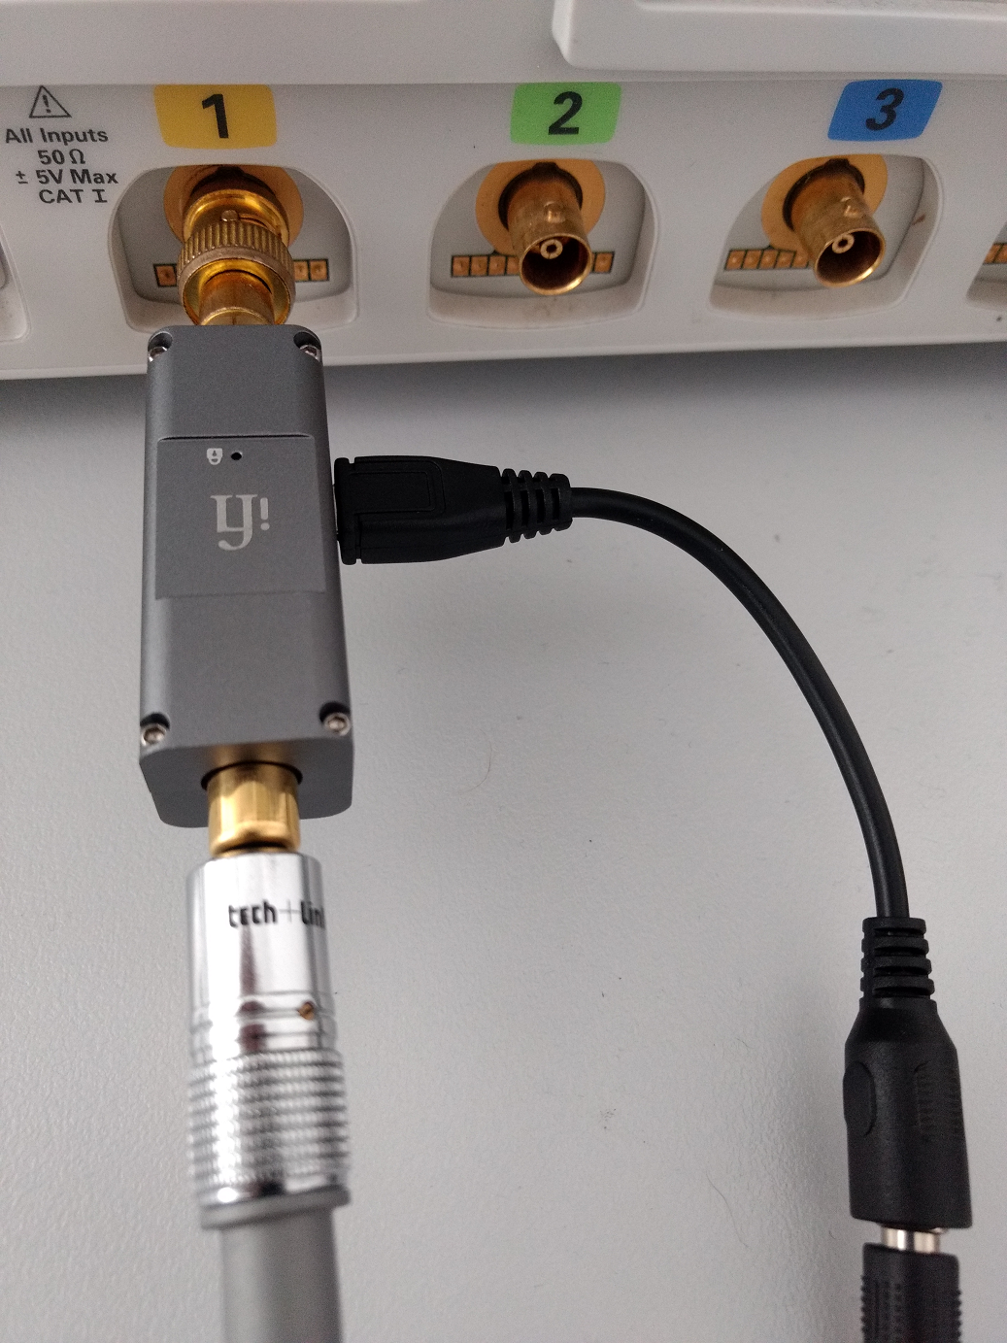

Measurement setup: using optical SPDIF input to remove any possible galvanic connection noise from signal source, iPurifier powered from supplied iPower low noise power supply, SPDIF output directly to DSO, no cables - using direct connection using supplied RCA to BNC adapter.

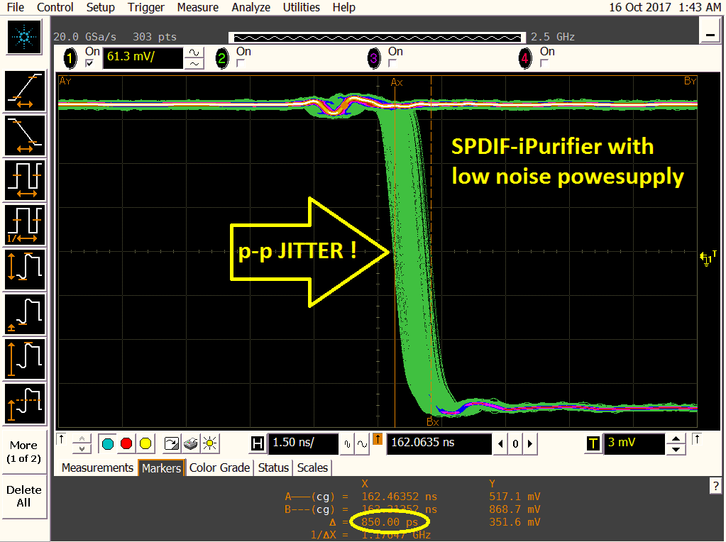

iPurifier output Peak to Peak jitter measured at least 850 pS!

Note when using 5V power from Notebook USB port with exactly the same setup p-p Jitter was about 700pS, less than with the low noise supply!