Word Automation

Business Science

2023-02-07

## Executive Summary

This document tracks the economics data of US population and unemployment.

## Table of Contents

## Table of Figures

## Figures

This is a linked reference to a figure , its number is computed by Word and it’s linked to the corresponding graphic when clicking on it.

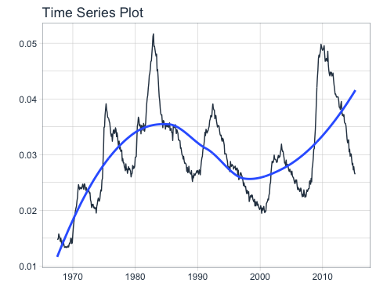

**Figure** **:** economics plot

## Tables

* This is a linked reference to a table , its number is computed by Word and it’s linked to the corresponding table when clicking on it.

**Table** **:** economics table

| date | pce | pop | psavert | uempmed | unemploy |
| --- | --- | --- | --- | --- | --- |
| 1967-07-01 | 506.7 | 198712 | 12.6 | 4.5 | 2944 |
| 1967-08-01 | 509.8 | 198911 | 12.6 | 4.7 | 2945 |
| 1967-09-01 | 515.6 | 199113 | 11.9 | 4.6 | 2958 |
| 1967-10-01 | 512.2 | 199311 | 12.9 | 4.9 | 3143 |
| 1967-11-01 | 517.4 | 199498 | 12.8 | 4.7 | 3066 |
| 1967-12-01 | 525.1 | 199657 | 11.8 | 4.8 | 3018 |