
Antti Yli-Kujala
Structure from motion using OpenCV
Bachelor’s thesis

Technology and Innovation
Bachelor’s thesis
Technology
Vaasa 2022

UNIVERSITY OF VAASA
School of …
Author: First name Last name
Title of the Thesis: Title : subtitle if needed
Degree: Esimerkkitieteiden maisteri
Programme: Oma koulutusohjelmasi
Supervisor: Etunimi Sukunimi
Year: 20XX Sivumäärä: 44
ABSTRACT:
Lorem ipsum dolor sit amet, consectetur adipiscing elit….

KEYWORDS: Finto: http:/finto.fi/yso/en/?clang=fi&anylang=on

Contents
1 Introduction 6
2 Tools and frameworks 7
2.1 Python 7
2.2 OpenCV 7
2.3 Hardware 7
2.4 Image set 7
3 Computer vision 8
3.1 Image geometry 9
3.2 Digital images 14
3.3 3D reconstruction 17
4 Structure from motion pipeline 21
4.1 Phases of sfm pipeline 22
4.2 Pipeline comparison 23
5 Camera calibration 26
5.1 Camera calibration implementation 29
6 Feature detection and matching 31
6.1 Feature detection and matching 31
6.2 Feature detection and matching implementation 31
7 Epipolar geometry and pose estimation 32
7.1 Epipolar geometry and pose estimation 32
7.2 Epipolar geometry and pose estimation implementation 32
8 3D point triangulation and 3D view 33
8.1 3D point triangulation and view 33
8.2 Implementation 33
9 Fine tuning and results 34
10 Conclusions 35
References 36
Appendices 39
Appendix 1. Name of appendix 39

Pictures

Picture 1: Point in 3D and 2D space 9
Picture 2: Point P in world coordinates 10
Picture 3: Point P in world and image coordinates 12
Picture 4: Point P projected to image plane 13
Picture 5: Greyscale image I 15
Picture 6: Subarray of I and it's color map representation. 16
Picture 7: Binocular disparity 19

Figures

Figure 1. Caption (Source). 6

Tables

Table 1: Features of binocular disparity (Aharchi & Air Kbit, 2020). 20
Table 2: Features of motion parallax (Aharchi & Air Kbit, 2020). 21

Abbreviations

2D Two dimensional
3D Three dimensional
BF Brute Force
DLT Direct Linear Transformation
FED Fast Explicit Diffusion
FLANN Fast Library for Approximate Nearest Neighbors
M-LDB Modified-Local Difference Binary
ms millisecond
MVS Multi-view Stereo
SFM Structure From Motion

Introduction
Thesis will go through photogrammetric range imaging technique called structure from motion. Sfm is used to recover 3D structure from multiple images taken of same view. Thesis will first go over tools and frameworks used for the implementation of sfm and why they were chosen.

Secondly thesis will cover the fundamental needed to understand the future parts of sfm. It will also take look at different 3D structuring methods and have some comparison between them and lastly in this chapter thesis will have look at sfm applications and research.

After these mandatory parts are covered thesis will start to go along pipeline of the sfm implementation which is following:
camera intrinsics → Feature detection → Feature matching → Epipolar geometry → Pose estimation → 3D point triangulation → 3D view from 2D → Adding more images and fine tuning results
Each step of the pipeline will have it’s own chapter that first discusses the topic itself and looks at some research about it. Then at the end of the chapter there will be explanation of how it was implemented for this thesis using OpenCV.

Implementation is going to be python program build with OpenCV that can construct 3D structure from set of images. Structure to be constructed will be 3D printer benchmark 3DBenchy https://www.3dbenchy.com/. Image set will consist of X amount of images taken of this model.

Aikataulutus
Alkuraportti | 09.12.2022
Väliraportti | 31.01.2023
Loppuraportti | 01.03.2023

Tools and frameworks
This chapter describes the tools and frameworks used in thesis. This chapter will discuss reasoning behind choosing these tools. This reasoning will be based on research topics concerning the subject but also on practical application of building sfm software. This chapter will also document the used hardware and images.

Python
Python is an programming language created in early 1990’s by Guido van Rossum.

OpenCV

Hardware
Cameras, 3D printers etc used hardware
50mm focal length

Image set

Computer vision
Humans have natural ability to perceive world around them in three dimension. We can easily determine where every object is in relation to our position and in addition we can also easily deduct all kinds of information from that object without any effort. Person can glance around them and easily identify and memorize objects in their vicinity. For example with quick view at vase full of flowers a person can tell what shape the vase it, what colors the flowers are and with some knowledge even tell species of flowers. Same person can have look at cars and extract all the same information from them and again have guess at what manufacturer made the car just from it’s features. These kind of decutions use so called top-down method where humans make guesses based on the features of perceived object that then guide the process of making decision of for example cars manufacturer based on it’s features (Carbon, 2008).

These fixations when humans perceive information from object usually last only about 200-250 ms (Rayner et al., 2001), and during that fixation it only takes few milliseconds for our semantic networks to regocnise familiar objects (Locher et al., 1993). In addition to all of that people can even perceive very abstract concepts such as other peoples feelings just from their faces within 100 ms (Willis & Todorov, 2006). These features that humans either posess naturaly or learn during their lifespan make human eyesight and mind very generalized and sophisticated tool for problem solving.

For computers though such features don’t come naturaly. To begin with computers don’t have any natural way to observe their surroundings and even with that ability they still need human made algorithms in order to learn to make some form of deductions from images. For this reason mathematical algorithms have been developed to allow computers to generate 3D models from input images and thus being able to perceive their surroundings.

Image geometry
In order to digitaly process images we need to be able to process them mathematicaly in a way that we can extract information from them. Mathematical formulas used in this subchapter come from Richard Szeliski’s (2022) book’s chapter 2.1. « Geometric primitives and transformations ». Firstly let’s declare 2D space as two dimensional space that has cordinates in X and Y direction. Likewise 3D space is three dimensional space that has cordinates in X, Y and Z directions. We can represent point P in 2D and 3D space using cartesian coordinates as follows :

(1)

Picture 1: Point in 3D and 2D space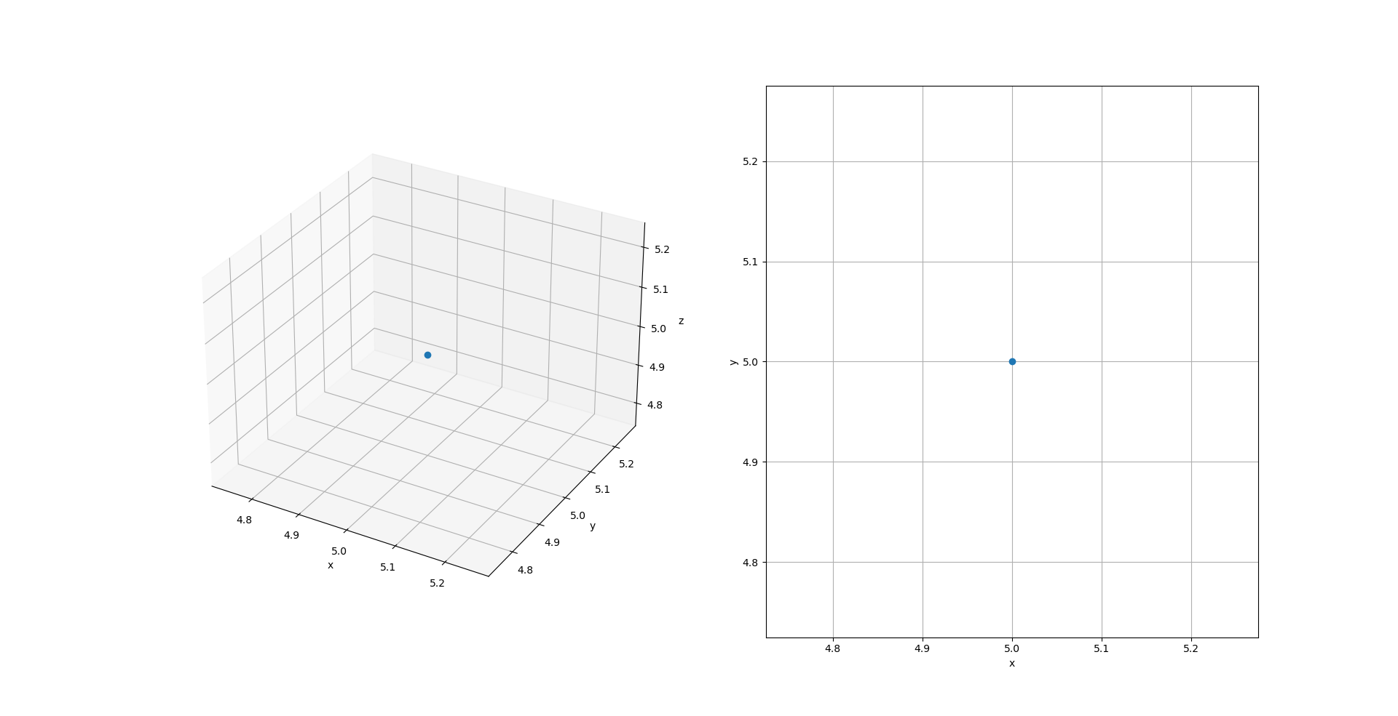
Picture 1 shows point P in 3D and 2D space in cordinates (5, 5) and (5, 5, 5) and illustrates the difference between the spaces.

There are three different coordinate systems that are needed for image formation. First let’s declare that there is point P that exists in some room in real world. In this three dimensional room this point lies in the first coordinate system, world coordinates (X, Y, Z). This world coordinate system depends on some origin (0, 0, 0) that has been chosen, for example middle of room or some corner of room and it displays the point P’s location in relation to origin.

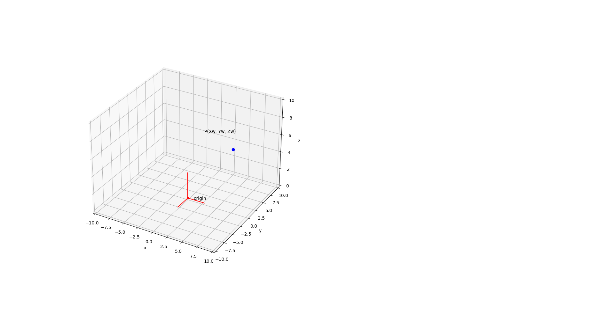Picture 2: Point P in world coordinates
Picture 2 shows point P in a room where origin is set in middle of room and P in origin related world coordinate point (5, 5, 5). From this it is clear that world coordinates dictate points distance from origin.

Next coordinate system needed is camera coordinates. Let’s declare that there exists camera C in the room that is used to capture images. In case that camera is located at exactly same point as origin these two systems would be the same. However this is rarely the case as camera might need to move between pictures and it needs to be able to point into any direction. For this reason camera coordinates are needed.

Moving point in space while maintaining it’s orientation is called translation. We can use following equation to find new cordinate point X’ from original coordinate point x and translation t :

(2)

Camera is located in arbituary point in room at coordinates (X_{c}, Y_{c}, Z_{c}). These coordinates dictate that camera location is translated by (X_{c}, Y_{c}, Z_{c}) respectively to origin point of world coordinates. In addition to translation camera coordinates also need to take in note the rotation of camera. Because camera can exists in any point in room it can also point into any direction in the room so it is essential to know these directions in order to calculate the point P’s location in camera coordinates. 3D rotations can be expressed as 3 x 3 rotation matrix R. The combination of these matrixes is called camera extrinsics matrix E and is displayed with following equation :

(3)

By using this E matrix, camera coordinates of point P’ (X’, Y’, Z’) can be calculated from P’s world coordinates (X, Y, Z) using following equation :

(4)
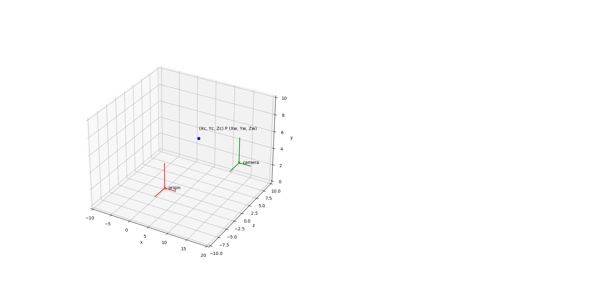Picture 3: Point P in world and image coordinates
Picture 3 illustrates origin and point P in same places as in picture 2 but also adds camera to world coordinates (15, 6, 3). This point acts as camera coordinate’s origin.

Now the point P can be be projected from world coordinates to camera coordinates using rotation and translation matrixes. Lastly one more projection is needed from camera coordinates to final coordinate system, image coordinates. These coordinates are used to project a point in real world via camera coordinates to image plane that will then form the image.

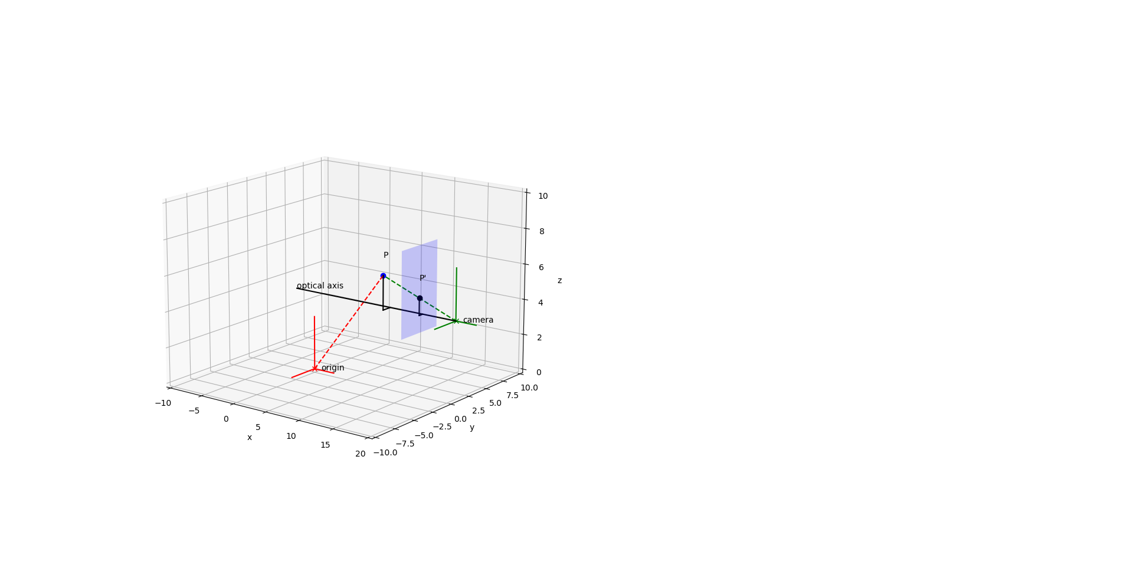Picture 4: Point P projected to image plane
Picture 4 shows how point P gets projected to point P’’ on image plane (blue transparent rectangle) in a pinhole camera. In actual image this point would be projected upside down but in this example image has already been rotated to right orientation to simplify maths needed. Camera center acts as origin for camera coordinates. Distance between camera origin and image plane is called focal length f. Using focal length it is possible to calculate X’’ and Y’’ coordinates of P’’ on 2D image plane from camera coordinates of P’ using similiar triangle geometry.

(5)

This equation however only works if all the pixels in camera’s censor are square and for this reason two different focal lengthts are needed f_{x} and f_{y}. In addition to that the optical center of camera and the image coordinates might not align and to account for that we need possible offsets c_{x} and c_{y}. From these camera intrinsics matrix I can be former. This intrinsics matrix is used to transform camera coordinates to image coordinates with following equation.

(6)

Now with use of equation 4 these values can be transformed to image coordinates. As mentioned before image plane only has two dimensions but equation 5 gives three coordinates. This is because it uses homogenous coordinates. Homogenous coordinates are system used to represent points anywhere, even in infinity, with finite number of coordinates and are that why used to project points into coordinate systems with different dimensions. Cartesian coordinates can be transformed into homogenous coordinates simply by adding one more dimension w, in this 2D case :

(7)

Conversion from homogenous coordinates back to cartesian coordinates works by dividing u and c coordinates with the new dimension w :

(8)

Digital images
Images begin as rays of light reflected from surface. These rays then need to be transformed into some kind of format usable for computers. This subchapter looks at how camera transforms light into matrixes that can be used for different machine vision applications. Thesis doesn’t cover more indepth physics of light and reflectivity as they are not necessary to understand subject. For more indepth look at subject refer to Szelinski’s book’s chapter 2.2 on photometric image formation. This chapter uses Solomon’s & Breckon’s (2011) book as reference.
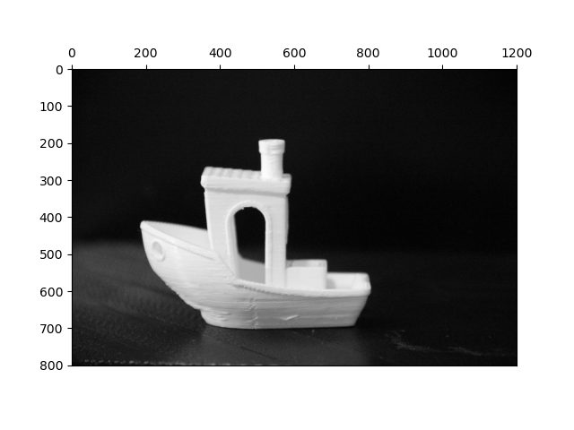Picture 5: Grey scale image I
Digital images are discrete representations of data containing two kinds of information, spatial information for layout and intensity information for colors. Digital images are represented as matrixes with rows and columns where values coordinates contain spatial information and value itself contain intensity information. Consider image I of size M x N where any pixel can be represented as image coordinate of I(m, n). For example picture 5 shows greyscale image of size 1200 x 800. Thesis uses coordinate system so that I(0, 0) is located in top left corner of the image and I(M, N) at the bottom right corner. This size of image is also called image resolution and it determines how many pixels the image contains. Native resolution is used to describe the resolution that image was taken in. This native resolution can then be scaled to different resolutions according to needs. Bigger resolution images contain more information wich in some cases is useful but it also makes processing them slower wich on other hand can be disadvantageous in some applications.
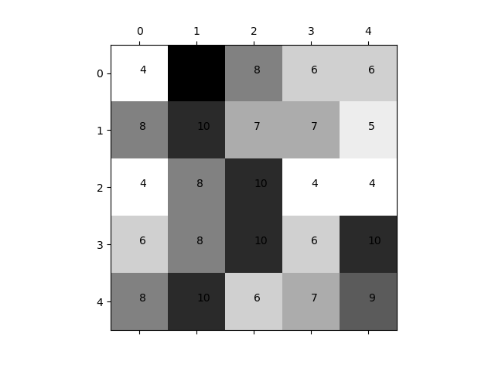Picture 6: Sub array of I and it's color map representation.
Images are formed of one or more channels that each contain information about certain colour. Picture 5 represents grayscale image that only contains one channel. This channel contains numerical value corresponding to signal level at that pixel in cameras sensor. This signal level then gets converted to color using colour maps. Colour maps are technique that contains specific colour information for specific numerical value of each channel. Picture 6 shows 4 x 4 caption of image I with it’s numerical values and corresponding color map values of OpenCV’s colormap ‘Greys’, picture shows that pixels with matching numerical values also get assigned matching color values. In addition to greyscale images another common color format is ‘RGB’. This format contains three different channels each containing values such as represented in picture 6 but for green, blue and red colors respectively. This way images with colors can be shown by merging these three different channels to represent one image.

3D reconstruction
3D reconstruction refers to techniques for constructing a 3D structure from 2D images. Constructing realistic 3D structures from images is one of the core aspects of image based modeling and computer vision and it has applications in variety of fields. Some of these include medicine, where it is used for example in non-stereo corresponding points stereography that helps to reduce the radiation dose needed for imaging by using multiple x-ray images to create 3D model instead of CT or MRI scan (Mitulescy, et al. 2001).Autonomous vechiles can use 3D reconstruction for pathfinding and obstacle detection (Fazakas & Fekete 2010). In addition to these two many other fields such as geology, urban planning and archeology use these techniques (Moncef & M’hammed, 2020). The challenge of 3D reconstruction using 2D images is that these images alone don’t contain any information about depth. Multiple algorithms exist for this purpose each having their own pros and cons. This chapter looks at some of the most common algorithms used for 3D reconstruction as discussed in review by Aharchi and Ait Kbir (2020).

Main problems in 3D reconstruction involve the following : Calibration, matching, reconstruction and density. For calibration it is necessary to know how point in world has been projected to the image as discussed in chapter 3.1.1.. For this reason algorithms need to be able to calculate parameters needed for different coordinate conversions. Matching involves identifying identical points from separate images wich are then used for reconstruction. Reconstruction works by calculating necessary parameters using these identical points in separate images. Lastly density involves finding corresponding surfaces to match to these points in order to create solid model. (Aharchi & Ait Kbir, 2020.)

In their paper Aharchi and Ait Kbir look at different 3D reconstruction methods and review their features. In their research they divide these methods into two categories : active and passive methods. Active methods interfere with the object in some way, for example by using different rangefinding techniques such as lasers or depth cauges to measure distance to object. The benefit is that these methods usualy have better results with less computational expense, drawback being that they need specialised imagining hardware that can perform these kind of rangefinding tasks. Passive methods on the other hand don’t need any kind of excess sensors of accessories other than camera to capture image. Depth values are then calculated from these images using different algorithms. Main benefit of passive methods is that they don’t need any kind of specialised hardware for imaging but drawback being that they need more computational resources to get accurate results. These two categories are then divided into two more subcategories : methods that use only one image and methods that use two or more images.

In their paper Aharchi and Ait Kbir compare 3D reconstruction methods in variety of features. Method can recover relative or absolute depth. Absolute depth being the real distance from camera to object in image measured in some actual unit while relative distances dont give any kind of actual distance in some unit for example meters but it shows that some part of image are at different depths. Next feature is depth range, meaning the range of depth where these algorithms work. Methods also have different real time processing features, some methods requiring so much computational expense that they aren’t suitable for real time applications. Methods can require different image acquisition techniques as discussed in active and passive methods and they can also require different kind of image contents, meaning that some methods depends on shadows or blurs in images for example. In addition to image content some methods also require motion presence so that depth can be calculated from movement of the camera. Lastly methods can output either sparse or dense depth maps. This means that some methods provide more depth information than others with dense depth maps being more accurate but also more computationaly expensive.

Table 1: Features of different 3D structuring methods (Aharchi & Air Kbir, 2020).
Method | Depth | Range | Real time  processing | Image  acquisition | Image  content | Motion  presence | Density | No. of input images
Binocular disparity | Absolute | < 30m | Yes | Active | All | Yes | Dense/sparse | 2 or more
Motion parallax | Absolute | < 30m | Yes | Active/passive | All | Yes | Dense/sparse | 2 or more
Image blur | Absolute | N/A | Yes | Active | Objects with complex surfaces | No | Dense | 2 or more
Shape from silhouette | Absolute | Indoor size | Yes | Active | Object must be distinguishable from background | Yes | Sparse | 2 or more
Shape from shading | Relative | All ranges | No | Passive | Image must contain shades | No | Dense on surface | 1
Structure from motion | Relative | All ranges | No | Passive | Image must contain shades | No | Dense on surface | 1

Structure from motion method, published by Snavely, Seitz and Szeliski (2006), uses series of 2D images to construct 3D structure. Structure from motion relies on same principles as binocular disparity but instead of requiring sprecialised stereo camera, sfm only needs a regular camera for taking images. Where binocular disparity relies on knowing the distance between two cameras sfm uses identical points in images taken from different perspectives to calculate the distances in image. This thesis will discuss sfm more thoroughly in following chapters, introducing pipeline for this method and introducing research and applications of each step.

Structure from motion pipeline
This chapter discusses the benefits and downsides of structure from motion. It will also discuss why it was chosen for this thesis and introduce a pipeline used for sfm application in this thesis. Table 1 displays the features of sfm methods. According to Aharchi and Air Kbit (2020), these features involve many positive features such as absolute dept acquisition, real time processing and ability to form 3D structures with dense point clouds without specialised equipment while not requiring any specific features from input images. Downsides being that sfm requires movement of camera and multiple images of same object to work. In addition to these features, Shalaby, Elmogy and El-Fetouh (2017), discuss that sfm method involves multiple principal features of computer vision such as feature detection, feature matching and image geometry making it good choice for learning more about computer vision applications. Using these feature sfm methods are able

Even with all of it’s good features Oliensis (2000) discusses some critique of structure from motion algorithms. In his article Oliensis states that even if sfm is heavily researched area of computer vision, these research usualy neglect to adress the theory behind them and only display that algorithm works on some small select set of images, Without proper context and comparisions between algorithms it is impossible to tell how theyd actually perform in applications other than the selected test set. Oliensis argues that two image algorithms perform nearly as well as multi image algorithms if analysed with proper theorems. In the article Oliensis comes to conclusion that algorithms are robust only in limited domains and in order to determine whether algorithm will work reliable or not it is necessary to determine circumstances in which these algorithms need to work in real world applications and then test algorithms under these varying conditions during research. Then comparing these algorithms workings to other less phenomenal algorithms one must determine whether these algorithms actually perform adequatly.

Phases of sfm pipeline
Bianco, Ciocca and Marelli (2018) review and compare differen sfm pipelines. First one being incremental sfm pipeline. Incremental sfm pipeline works by incrementing more pictures to algorithm in order to form 3D structure from them. First phase of this pipeline is called correspondence search phase that is further divided into three sub phases : feature extraction, feature matching and geometric verification. Feature matching uses some algorithm to identify and collect local features from images. The choice of this algorithm has big affect on robustness of whole pipeline. These feature points are then used during feature matching to identify matching points of same scene from different images. Lastly geometric verification is used to make sure that these matched points indeed do match. Feature matching only compares the likeness of these feature point of interests but geometric verification checks if there exists geometric translation between the matching points. Only if such translation exists are these images for sure from same scene. For accurate results of geometric verification camera needs to be calibrated. For this reason camera calibration is sometimes needed. After these steps corrsepondence search phase outpus a scene graph.

Second phase is called iterative reconstruction phase. This phase begins with initialization step that is then followed by three reconstruction steps called image registration, triangulation and bundle adjustment. During initialization a pair of images with most geometricaly verified points is chosen as starting point for reconstruction. After initialization the actual iterative reconstruction phase begins. As name mentions it is iterative phase meaning that it is repeated for every new image added to structure. Firstly these newly added images go through image registration during which image is compared to the formed structure and using this 2D to 3D correspondences a camera pose of this image is estimated using some algorithm. With camera pose known it is now possible to calculate 3D coordinates of points in images during triangulation phase. These two phases are prone to generate inaccuracies to 3D structure bundle adjustment is needed in order to prevent these inaccuracies from cumulating and invalidating the formed structure. Different bundle adjustment implementations can be used but in general they are very computationaly heavy. This phase estimates camera pose and reconstructs sparse 3D point cloud from scene graph.

Pipeline comparison
Bianco, Ciocca and Marelli (2018) compare seven different sfm pipelines in their article. These seven pipelines include COLMAP, Theia, OpenMVG and VisualSFM. These pipelines are evaluated in four different phases : Alignment and registration, evaluation of sparse point cloud, evaluation of camera pose and evaluation of dense point cloud.

For this comparison Bianco, Ciocca and Marelli created a Blender plug-in that allowed creation of synthetic datasets. By using synthetic datasets it was easy to extract exact ground truths for comparing and analyzing the performances of different pipelines. For this comparison, five different 3D models with highly detailed geometry and textures was created in Blender and then placed in scene inside Blender. These models were statue of a person, empire vase, bicycle, fire hydrant and jeep. Virtual cameras were used to take pictures of this model from different positions and these pictures were then used to compare performances of different sfm pipelins. In addition each pipeline was further paired with multi-view stereo software to improve the density of outputted point clouds.

Table 2: Summary of pipeline performances (Bianco, Ciocca & Marelli 2018).
Pipeline | Cloud evaluation |  |  | Camera pose evaluation |  |  |  | Execution
 | avg dist | std dev | no. | mean dist | pos std dev | mean rot | rot std dev | time (s) | RAM (mb)
COLMAP | 0.06 | 0.35 | 8k | 0.56 | 0.43 | 14.67 | 13.05 | 248 | 1051
OpenMVG | 0.06 | 0.48 | 6k | 0.47* | 1.01* | 10.87* | 26.00* | 102 | 1351
Theia | 0.02 | 0.05 | 7k | 1.30 | 0.23 | 35.61 | 1.77 | 268 | 2068
VisualSFM | 0.06 | 0.22 | 6k | 1.06 | 1.14 | 14.95 | 18.10 | 332 | 1440

Table 2 shows results of each pipeline in different evaluation tests. These values are averages including pipeline’s performance on all six models. Note that OpenMVG failed to produce dense enough point clouds of fire hydrant for the MVS software so it failed each test for fire hydrant making it not really comparable with other pipelines. Abbreviations in table 8 mean following measured values. Cloud evaluation phase included average distance of point cloud from the ground truth (avg std), standard deviation of avg std (std dev) and number of reconstructed points (no.). Camera pose evaluation included mean distance from ground truth of reconstructed camera position (mean dist), mean dist’s standard deviation (pos std dev), mean rotation difference of camera from ground truth (mean rot) and standard deviation of mean rot (rot std dev). Lastly execution phase evaluated pipelines in run times (time) and ram usage (RAM).

In their article Bianco, Ciocca and Marelli come to conclusion that COLMAP has best average performance of all the pipelines compared. Some of the pipelines do outperform COLMAP in some cases but in general it shows best results in average. COLMAP (Schönberger & Frahm, 2016 ; Schönberger, Zheng, Pollefeys & Frahm, 2016.) is an open source implementation fro incremental SfM and MVS pipeline. It is designed for general use so that it performs accuratetly on any kind of scene.

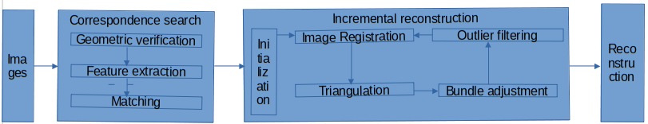Picture 7: COLMAP pipeline (Schönberger & Frahm, 2016.; Schönberger, Zheng, Pollefeys & Frahm, 2016. ).
Picture 7 displays COLMAP pipeline as introduced by Schönberger and Frahm (2016) and Schönberger et al (2016). Pipeline includes same phases as discussed in chapter 4.1. This pipeline will also be used as basis of this thesis due to it’s good performance in comparision to other pipelines. To be noted that COLMAP pipeline does not include camera calibration phase even though it will be included in the pipeline used for this thesis. Each phase will be further discussed in their respective chapter later in this thesis.

Camera calibration
This chapter looks at camera calibration and different methods used for it. Chapter will also include implementation of camera calibration. Chapter uses terms camera intrinsic matrix I and camera extrinsic matrix E introduced in chapter 3.1. As discussed in chapter 3.1. camera intrinsics have different parameters affected by physical attributes of camera. These parameters will then cause distortions in images that will later decrease the accuracy of 3D structure formed from these images. To prevent this camera calibration is needed.

Qi, Li and Zhenzhong (2010) did a review on camera calibration where they discussed different camera calibration methods. In their article they review traditional calibration methods, self calibrating technologies, active vision based calibration techniques and other calibration methods. Because of the camera used in this thesis self calibration and active vision based calibration techniques are not possible due to them requiring special features from used hardware and because sfm pipeline created in this thesis is meant to work with non specialized hardware. Because of this focus will be on traditional calibration methods.

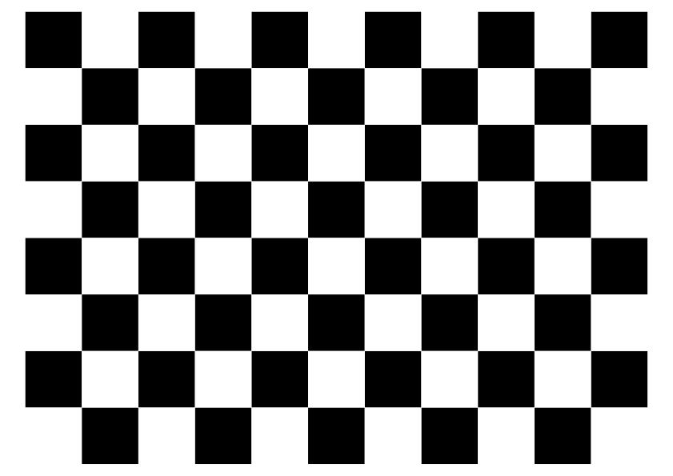Picture 8: Calibration checkerboard generated with https://markhedleyjones.com/projects/calibration-checkerboard-collection
Traditional calibration methods reviewed by Qi, Lin and Zhenzhong (2010) use calibration pieces with known high precision structures. By using such object with known exact dimensions it is possible to calculate different distortions caused by camera from the image taken. Because these methods only require some kind of calibration piece such as checkerboard image like in picture 13, no specialized hardware is needed. In addition traditional methods give very accurate results given that the calibration object is accurate.

First traditional method reviewed is direct linear transformation method (DLT). First introduced by Karara and Abdel-Aziz (1974) works by defining set of intermediate parameters wich are then used to determine intrinsic and extrinsic parameters of camera. Main benefit of DLT being that it can solve these parameters using linear equations without a need for iterative calculations. Because of this DLT is fast and relatively easy to implement. However due to it’s linear nature it can’t handle non linear problems. Second reviewed method introduces solution to this limitation of DLT. Non linear optimization technique uses distortion of camera to calculate the calibration. Traditionaly these algorithms offer very high precision but they are complex to implement and are very computationaly heavy due to their iterative nature. Unal, Yezzi and Soatto (2007) however introduced simplified and rapid lenst distortion based calibration method. This method easies the implementation and improves robustness of camera calibration compared to traditional non linear optimization techniques.

Qi, Lin and Zhenzhong (2010) reviewed two more traditional calibration methods. Two-step method combines features from both DLT and non linear optimization techniques. It first uses DLT to obtain linear parameters needed for calibration as this is faster and works in more generalized solutions. These parameters are then used as initial values for non linear optimization technique to further enhance the accuracy. Because of this two step approach the iterations required by non linear optimization technique can be reduced making algorithm perform faster while producing more accurate results than simple DLT method. Last traditional method reviewed is biplane method. This method does not rely on pinhole camera physics as the other traditional methods. Instead it works by having two target planes in the scene being captured. By knowing distances to these planes and distances between the planes it is possible to use insertion methods to calculate calibration matrixes. This technique however needs additional work on the scene and because of all the values required it needs a lot of parameters in order to achieve accurate results.

For this thesis two step method was chosen. This choice was made because of it’s good performance and fast performance combining best features from both DLT and non linear optimization technique. Next chapter will discuss the inner workings of chosen method as well as how it is implemented in code.

Camera calibration implementation
This chapter discusses the two step calibration method used this thesis as well as how it’s implemented. This thesis uses OpenCV’s build in camera calibration function cv.calibrateCamera(). This function uses the two step method described in previous chapter with some useful additions, main one being that it accepts calibration objects with uneven surfaces and still produces accurate calibration matrixes. This feature is based on Strobl and Hirzinger’s (2011) article and is very useful in this thesis as calibration objects are images printed on paper and thats why it is hard to get perfectly even surfaces on them. C

To calculate intrinsics matrix I introduced in formula 6 some math needs to be understood. For starters chapter 3.1. introduced pinhole camera model and those same principles will be used in this chapter too. Camera calibration only changes when camera’s focal length is changed. This is why all the images in this thesis are taken with 50mm focal length. Following equations are from Zhang’s (1998) article on camera calibration and Frank et al. (2010) Presentation on camera calibration that OpenCV’s camera calibration methods also use as main basis with some additions from Strobl and Hirzinger.

Picture 4 shows point P that exists in some world coordinates, projected to image plane as point P’’ that exists in some image coordinates. All the steps will be using homogenous coordinates. By applying camera extrinsics matrix E to point P’s coordinates we can turn it into point P’ in camera coordinates as follows :

(9)

Now by also including intrinsics matrix into the equation we can get coordinates for point P’’ on image plane with following equation :

(10)

Equation 10 displays the situation in ideal world. However in real world camera lenses cause distortion to images. To counter this effect it is necessary to calculate these distortions as part of the equation making it somewhat more complex :

(11)

Equation 11 displays bunch of new parameters that are used to calculate different distortions. Radial distortion is measured with k_{1,}, k₂, k₃, k₄, k₅ and k₆. Tangential distortion is measured with p₁ and p₂ and lastly thin prism coefficent is measured with s₁, s₂, s₃, and s₄. Most notable distortion being radial distortion causing either pincushion distortion with positive values and barrel distortion with negative values. OpenCV also calculates possible image sensor tilting but as used camera doesn’t support such feature it is not included in this thesis.

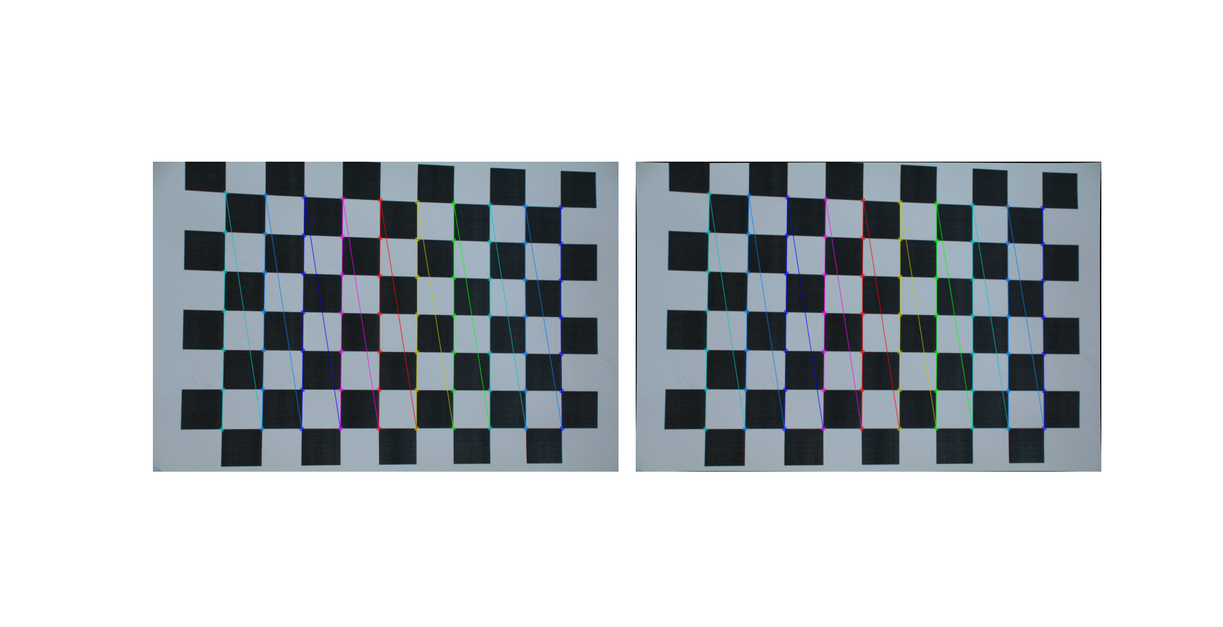Picture 9: Calibration image before and after undistort with detected corners visualized
For the actual calibration a set of 6 images of a checkerboard were taken. This checkerboard was same as in picture 8 printed on A4 paper with 25mm x 25mm grid size. These images were then passed to sfm pipeline’s camera_calibration.py. Calibration uses following simplified pipeline :

for i in imgs :
ret, corners = cv2.findChessBoardCorners(…)
if ret == TRUE :
corners2 = cv2.cornerSubPix(…)
imgpoints.append(corners2)
ret, mtx, dist, rvecs, tvec = cv2.calibrateCamera(...)

For whole code and parameters refer to thesis github page and section camera_calibration.py. First program loops through all the calibration images and tries to find predetermined amount of corners from checkerboard with cv2.findChessboardCorners(). If this function returns true value it means all the corners were found and these corners are then passed further to cv2.cornerSubPix() function to pinpoint their locations even more accuratetly, this is to increase calibration accuracy. Lastly these corner locations are passed to cv2.calibrateCamera() function along with the checkerboard dimensions to calculate camera calibration matrixes. This function returns boolean value ret indicating whether operation was succesfull or not, camera intrinsics matrix mtx and lens distortion coefficients dist. In addition it also returns rotation and translation vectors rvecs and tvecs for each image but these are further discussed in later chapters. With this pipeline following matrixes were obtained :

(12)

(13)

With these matrixes it is now possible to fix distortions in images taken with same camera and lens while focal length remains unchanged. This camera is now called calibrated camera and it’s usage improves the accuracy of sfm pipeline. Picture 9 shows calibration image before and after cv2.undistort(…), which is used to fix distortions in images using equation 11, was applied. As image shows the difference is very minimal as it should be given good quality camera used to capture image. However parameters received from calibration show that there is indeed slight distortions and since cv2.undistort(…) only takes around 7,5ms to execute for one image it doesn’t threaten the real time application capabilities of program. Aharchi and Air Kbit (2020) state in their review that all the slight improvements in early parts of pipelines help to improve accuracy of final 3D structure so even slight distortion fixes should help the accuracy of pipeline with minimal performance costs.

Feature detection and matching
This chapter looks at feature detection and matching, reviews different methods for them and lastly shows implementation of chosen method. Feature detection and matching is used in 3D structuring to first find local features from images that are both localizable and distinguishable. These features then need to be matched between different images in order to find out corresponding points of object that are needed for 3D structuring. Both of these steps come with their own challenges and methods that are discussed next starting with feature detection.

Feature detection begins with detecting local features from images. These local features are points at the image that are easily distinguishable for computer algorithms. One of the big challenges being that images can be taken from different angles or in different rotations and can have different kind of distortions yet these features must be represented in a way that matching features remain identical in all the images. For this purpose descriptor information is extracted from these points once regocnised. Chien et al. (2016) review different mainstream methods used for these two tasks : SIFT, SURF, ORB and A-KAZE. These algorithms work in different ways and are rather complex so this chapter will only focus on pros and cons of each ones while the chosen method will be further explained in implementation chapter.

Table 3: Feature detection performance comparison (Chien et al. 2016)
Method | SIFT | SURF | ORB | AKAZE
no. of features | 765 436 | 1 140 410 | 1 017 350 | 603 246
Time spent | 98s | 50s | 10s | 43s
Disk storage | 391mb | 305mb | 54mb | 49mb

Table 3 shows the performance comparison between different algorithms as compared by Chien et al.. Table shows that SIFT and SURF are heaviest algorithms on memory and computation usage and ORB being the fastest while AKAZE stands somewhere between taking almost same run time as SURF but requiring noticeable less memory. However when comparing the actual descriptor accuracy of these algorithms the performance order is reversed with SURF and SIFT achieving best results with very close comparison between the two. ORB on the other hand performs the worst and A-KAZE again landing between these two ends. Last notable features of these algorithms being that SURF and SIFT are patented while A-KAZE and ORB are open-source. For this thesis A-KAZE was chosen as the feature detection algorithm. Even though SURF did give more accurate results with almost same run time AKAZE’s open source availability was the deciding factor. ORB was not chosen because of it’s worts performance in accuracy as this project favors accuracy over runtime performances. Disk storage was not deciding factor as it is not limitation in this project.

After these local features have been described they also need to be matched between the images. Golovnin and Rybnikov (2021) reviewed two commonly used mathcing algorithms BF (Brute Force) and FLANN (Fast Library for Nearest Neighbor). These algorithms work in different ways so again only the chosen one will be explained further in the implementation chapter. In their review Golovnin and Rybnikov compared these algorithms with different feature detection systems but only AKAZE performance will be analyzed in this chapter due to it being the chosen algorithm.

Table 4: Feature matching algorithm comparison (Golovnin & Rybnikov, 2021).
Method | Average matching time (ms) | Average features matched
BF | 97.44 | 1526.43
FLANN | 384.52 | 1080.55

Table 4 shows average performance results as reviewed by Golovnin and Rybnikov. In their review they came to conclusion that BF matching outperforms FLANN in both run times and in the accuracy of features matched which also shows in the table 4. Due to these clear results BF matching was chosen as matching algorithm for thesis.

Feature detection and matching implementation
AKAZE, published by Alcantarilla, Nuevo and Bartoli (2013) is improved version of KAZE. Where as SIFT and SURF use Guassian derivates, KAZE relies on nonlinear diffusion filtering. This design choice improves the repeatability and distinctiveness of feature detection at the cost of computational expense. To counter this computational cost Alcantrilla, Nuevo and Bartoli introduced Accelerated-KAZE that relies on FED (Fast Explicit Diffusion). In addition to FED AKAZE also improves from KAZE by using M-LDB (Modified-Local Difference Binary) descriptors to minimize computational and storage requirements.

(14)

(15)

KAZE relies on nonlinear diffusion filtering to find candidates for local features. Nonlinear diffusion equation (14) is used to describe the change of lumination L of image based on gradient G and divergence D operators. What this equation does is that it displays the change in luminance over time t of a local area described by c(x, y, t) as a vector. Conductivity function c (15) allows the diffusion to be adaptive to local point in image. DL_{o} represent the gradient of a gaussian smoothed version of the original image. Because nonlinear diffusion equations can’t be solved analyticaly they have to be instead solved partially, this can require multiple iterations to to achieve desired accuracy causing the big computational expense. FED is used to calculate the needed amount of iterations, explicit diffusion steps and step sizes needed good quality results. By doing this it is possible to reduce the needed iterations and diffusion steps to minimum, improving the overall performance of the alogrithm.

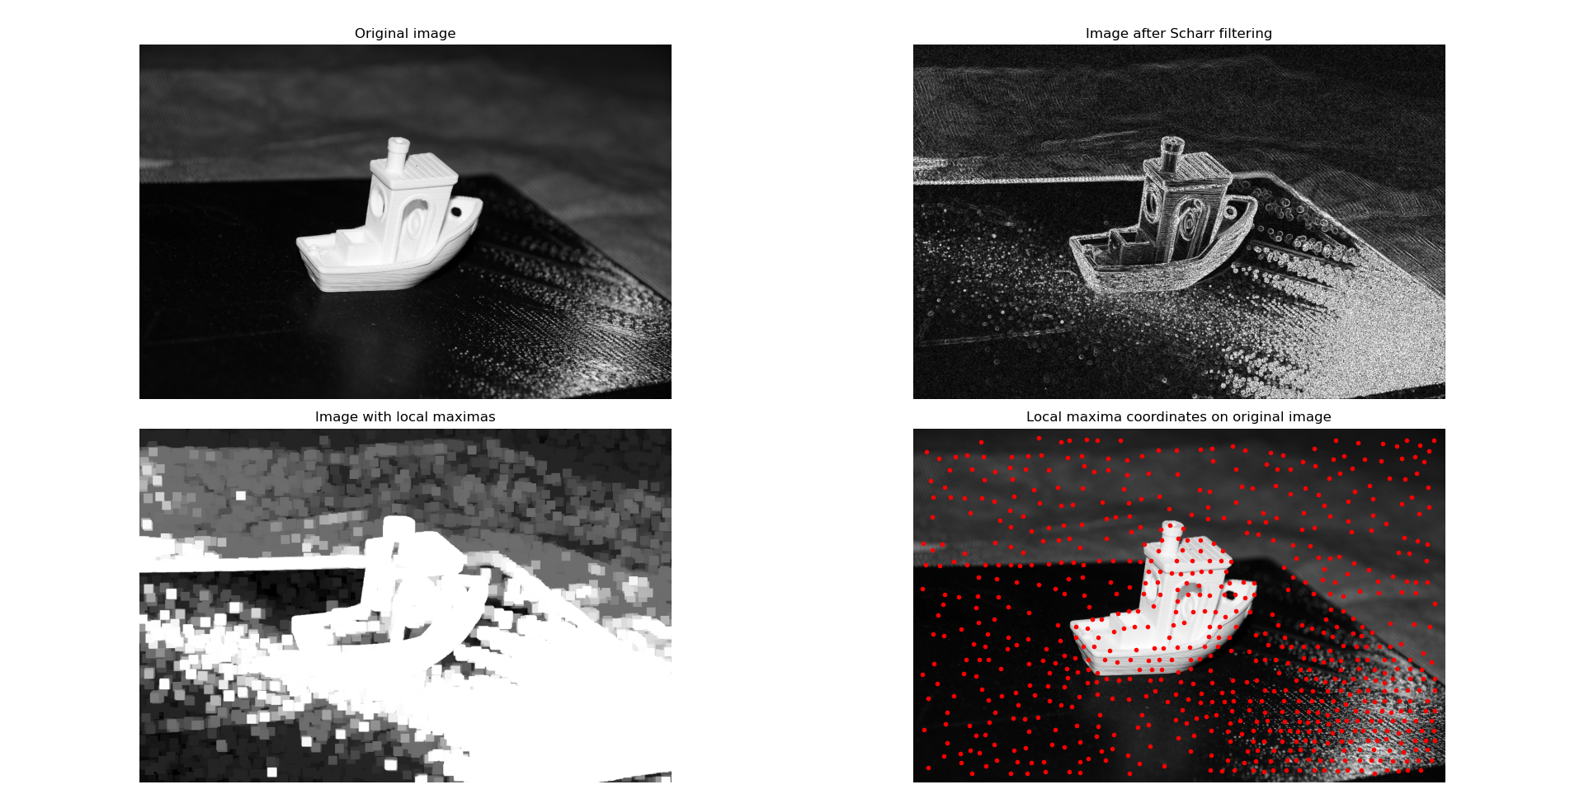Picture 10: Different stages of feature detection
Picture 10 illustrates different stages of feature detection. First picture shows the original image that is then processed with Scharr filter (equation 14) to highlight gradient edges of image. After highlighting gradients local maximas are searched. Note that for picture 10 kernel size of 20 is used for illustration purposes, when actual implementation uses kernel of size 3. Local maximas are found by running kernel over filtered image and finding potential maxima for every kernel. These potential maximas are then compared to every other potential maximas directly above and below them then biggest potential maxima of them is chosen as the local maxima. Last picture is only visualizing the local maxima coordinates in original image. These local maximas are then turned into feature descriptors. Feature descriptors are mathematical values used to describe local features in a way that makes them identifiable in different rotations, lightning etc. AKAZE uses M-LDB descriptors for this.

A

Epipolar geometry and pose estimation

Epipolar geometry and pose estimation
This chapter introduces epipolar geometry pose estimation

Epipolar geometry and pose estimation implementation
Implementation in epipolar geometry and pose estimation

3D point triangulation and 3D view

3D point triangulation and view

Implementation

Fine tuning and results

Conclusions

References

Aharchi, M., & Ait Kbir, M. (2020). A Review on 3D Reconstruction Techniques from 2D Images. 10.1007/978-3-030-37629-1_37.

Alcantarilla, P., Nuevo, J. & Bartoli, A. (2013). Proceedings of the British Machine Vision Conference. doi : http://dx.doi.org/10.5244/C.27.13.

Bianco, S., Ciocca, G., & Marelli, D. (2018). Evaluating the Performance of Structure from Motion Pipelines. Journal of Imaging, 4(8), 98. MDPI AG. Retrieved from http://dx.doi.org/10.3390/jimaging4080098

Carbon, C. (2008). Famous faces as icons. The illusion of being an expert in the recognition of famous faces. Perception 37, 801–806. doi: 10.1068/p5789

Chien, H., Chuang, C., Chen, C. & Klette, R.(2016). When to use what feature? SIFT, SURF, ORB, or A-KAZE features for monocular visual odometry. International Conference on Image and Vision Computing New Zealand (IVCNZ). doi: 10.1109/IVCNZ.2016.7804434.

Fazakas, T. & Fekete, R. (2010). 3D reconstruction system for autonomous robot navigation. 11th International Symposium on Computational Intelligence and Informatics (CINTI), Budapest, Hungary, 2010, pp. 267-270, doi: 10.1109/CINTI.2010.5672236.

Frank, B., Stachniss, C., Grisetti, G., Arras, K. & Burgard, W. (2009). Camera Calibration. Albert-Ludwigs-Universität Freiburg, Autonome Intelligente Systeme, Robotics 2, Wintersemester 09/10.

Golovnin, O. & Rybnikov, D. (2021). Benchmarking of Feature Detectors and Matchers using OpenCV-Python Wrapper, International Conference on Information Technology and Nanotechnology (ITNT). doi: 10.1109/ITNT52450.2021.9649278.

Karara, H. & Abdel-Aziz, Y. (1974). Accuracy aspects of non- mehic imageries. Photogrammetric Engineering & Rehote en sing, 40(9), 1107-1117.

Locher, P., Unger, R., Sociedade, P., & Wahl, J. (1993). At 1st glance: accessibility of the physical attractiveness stereotype. Sex Roles 28, 729–743. doi: 10.1007/bf00289990

Mitulescu, A., Semaan, I., De Guise, J., Leborgne, P., Adamsbaum, C. & Skalli, W. (2001). Validation of the non-stereo corresponding points stereoradiographic 3D reconstruction technique. Med. Biol. Eng. Comput. 39, 152–158 (2001). https://doi.org/10.1007/BF02344797

Oliensis, J. (2002). A Critique of Structure-from-Motion Algorithms. Computer Vision and Image Understanding, Volume 80, Issue 2, Pages 172-214, https://doi.org/10.1006/cviu.2000.0869.

Qi, W., Li, F. & Zhenzhong, L. (2010). Review on Camera Calibration. Chinese Control and Decision Conference (CCDC). p. 3354 – 3358. DOI:10.1109/CCDC.2010.5498574.

Rayner, K., Foorman, B. R., Perfetti, C. A., Pesetsky, D. & Seidenberg, M. S. (2001). How psychological science informs the teaching of reading. Psychol. Sci. 2, 31–74. doi: 10.1111/1529-1006.00004

Schönberger, J. & Fragm, J. (2016). Sctructure-from-Motion Revisited. Conference on Computer Vision and Pattern Regocnition (CVPR).

Schönberger, J., Zheng, E., Pollefeys, M. & Frahm, J. (2016). Pixelwise View Selection for Unstructured Multi-View Stereo. European Conference on Computer Vision (ECCV).

Shalaby, A., Elmogy, M. & El-Fetouh, A. (2017). Algorithms and Applications of Structure from Motion (SFM): A Survey. International Journal of Computer and Information Technology. 6. 358-365.

Snavely, N., Seitz, S. & Szeliski, R. (2006). Photo Tourism: Exploring Photo Collections in 3D

Solomon, C. & Breckon, T. (2011) Fundamentals of Digital Image Processing. John Wiley & Sons ltd.

Strobl, K. & Hirzinger, G. (2011). More accurate pinhole camera calibration with imperfect planar target. IEEE International Conference on Computer Vision (ICCV), pages 1068–1075, Barcelona.

Szeliski, R. (2022). Computer Vision: Algorithms and Applications, 2nd ed. The University of Washington.

Unal, G., Yezzi, A. & Soatto., S. (2007). A variational approach to problems in calibration of multiple cameras finder from natural scenes. IEEE Transactions on Pattern Analysis and Machine Intelligence, Vol.29, No.8, 1322-1338.

Willis, J. & Todorov, A. (2006). First impressions: making up your mind after a 100-ms exposure to a face. Psychol. Sci. 17, 592–598. doi: 10.1111/j.1467-9280.2006.01750.x

Zhengyou, Z. (1998). A Flexible New Technique for Camera Calibration. Technical Report MSR-TR-98-71. Microsoft Research, Microsoft Corporation.

Appendices

Appendix 1. Name of appendix
References and Appendices heading style is ”Ref+Append heading”. Style on names of appendices ”Append name”.

