# Natural Language Processing using BioBERT for COVID-19 related terms

**Abstract**

The COVID-19 pandemic has resulted in an unprecedented amount of scientific publications related to its biological mechanisms, spread of the virus and potential treatment of the disease being published. Almost every field of science has produced new research in an attempt to minimize the impact of the epidemic. The amount of publications itself is also a problem, however, as it makes identifying relevant findings and promising research lines more difficult. To avoid missing potentially interesting publications, a specialised text-mining tool could “process” the articles that are being continuously released to extract the most relevant information. This way, it would effectively remove a bottleneck in the research process. While text-mining approaches have been proposed before to deal with the high output of new research, tools specialised in finding information specifically related to COVID-19 have become a necessity with the coming of the pandemic. In this project, the BioBERT language-representation model was applied to perform Name Entity Recognition on a corpus of COVID-19-related scientific publications. Three new models were created by fine-tuning the base BioBERT model with a datasets built from that corpus. The resulting models perform better than the default BioBERT models when detecting mentions of diseases, proteins and chemicals related to the SARS-CoV-2 virus.

**Introduction**

The global pandemic of COVID-19 has resulted in an unprecedented volume of scientific publications related to the disease and the SARS-CoV-2 virus that causes it. According to *Nature* *Biotechnology*, 7,136 COVID-19-related papers had already been uploaded to PubMed in 2020 by the 5th of May [1]. The COVID-19 literature database managed by the World Health Organization currently contains almost 20.000 scientific articles on the topic, and the amount of papers being published on the topic will most likely keep increasing exponentially.

Keeping up with the constant output of relevant papers has been an issue for researchers even before the pandemic caused an explosion on the amount of publications. One of the solutions proposed to solve this problem has been the development of effective text mining tools that will be able to extract information from an otherwise overwhelming amount of research articles. Such a model would be built following principles of Natural Language Processing (NLP).

**NLP and its uses**

Natural Language Processing is a field within Computer Science and Artificial Intelligence focused on the computer-based processing and analysis of human languages. NLP-based technology has been applied to develop things such as machine translations, automatic audio-to-text processing and the construction of knowledge-graphs. It can also be a valuable tool in biomedical research and healthcare, assisting in diagnostics or information extraction (extracting information from literature, medical or not). [2]

Historically, NLP and text mining have been “rule-based”. A number of handcrafted rules were used to create NLP systems such as chatbots. However, most modern approaches to NLP rely heavily on Neural Network-based methods.

One of such modern NLP systems is the language representation model BERT [3]. Developed by Google, BERT has become popular in the NLP community for allowing for the creation of state-of-the-art models with minimal fine-tuning of a pre-trained BERT model. On top of that, several projects have attempted to increase the effectiveness of BERT on specific fields by creating domain-specific variants of the original BERT such as SciBERT, ClinicalBERT or BioBERT **[CITE]**.

**Common NLP tasks**

Natural Language Processing is a broad field that deals with several challenges. Within NLP, there are some common tasks that models attempt to carry out. A distinction can be made between sentence-level tasks, which focus on whole sentences, and token-level tasks. In NLP, a token is a string of characters between spaces or punctuation marks. Common token-level tasks include Relationship Extraction (RE), Question-answering (QA) and Named Entity Recognition (NER).

*(Note to self: maybe mention Sentiment Analysis, Topic Modelling and Automatic Summarization/Information Extraction too???)*

In Named Entity Recognition (NER), an NLP model is used to recognize and classify “Named Entities” into different categories. NER is a crucial sub-task for information extraction, as it allows for automatic identification of key terms in the text.

**BioBERT**

BioBERT is the medical/biological variant of BERT, first introduced by Lee et *al*. [4]. While BERT is a general-purpose tool trained on English Wikipedia and BookCorpus, BioBERT is designed specifically to deal with biomedical text. It builds on top of BERT by using PubMed abstracts and full-text articles from PMC. This makes it more appropriate to handle words that are specific to the field. BioBERT is able to perform three of the aforementioned text mining tasks: Named Entity Recognition (NER), Relationship Extraction (RE) and Question Answering (QA).

In this project, BioBERT was used exclusively for NER. The goal of the project was to generate new BioBERT models that would be better than those presented in the original BioBERT paper at detecting mentions of COVID-19, the SARS-CoV-2 virus, and drugs that could potentially be used in the treatment of patients suffering from the disease.

**Methods**

**The Colab environment**

*Google Colaboratory*, also known as just *Colab*, is a cloud-based environment for Jupyter Notebook developed by Google. It allows its users to run python code through the browser, without the need any setup process. Users can also get access to limited GPU resources for free, which makes it ideal for machine learning related tasks.

This project was carried out almost exclusively in Colab, with data being loaded from and stored in Google Drive.

**Fine-tuned Models**

The GitHub repository for the BioBERT project (<https://github.com/dmis-lab/biobert>) provides a number of different versions of the base BioBERT model. In this project, I used the **BioBERT-Base v1.1 (+ PubMed 1M)** model.

Apart from this, the repository also includes 8 datasets used by the developers of BioBERT to fine-tune the base BioBERT model with in order to perform NER. These datasets include the NCBI-disease dataset [5], the JNLPBA dataset [6] and the BC5CDR dataset [7]. This last one divided into two separate datasets: one focused on drugs and chemicals, and the second one focused on diseases.

*(Note to self: I might as well include every dataset for NER in BioBERT)*

The base BioBERT model and the datasets were loaded into a notebook in Colab, where the datasets were used to perform fine-tuning on top of the base model.

Following the steps of Lee et *al.* [4], fine-tuning was performed for three of the datasets: NCBI-disease, JNLPBA and BC5CDR-Chem. This resulted in three separate models specialised in looking for mentions of diseases, proteins/genes and chemicals/drugs respectively. In each case, training was carried out for 10 epochs, using the default BioBERT parameters.

**The CORD19 research challenge**

In March of 2020, the Allen Institute For AI issued a challenge through the Kaggle platform **[CITE?]** that included several machine-learning and text-mining tasks aimed at advancing research regarding COVID-19. The page also gave access to the CORD-19 dataset [8], a dataset of more than 44,000 articles in JSON format, all related to the COVID-19 disease or different types of coronaviruses. CORD-19 was specifically designed to be used by the global community in machine-learning projects. In this project, a 100-paper subset of the dataset was isolated and extensively used in several tests, with the idea of making every step scalable for the full database.

**Prediction**

While BioBERT claims to have a separate “prediction mode” for performing NER with fine-tuned models, this functionality appears to not have been fully implemented yet. Instead, prediction can be done by repeating the steps of the fine-tuning process for a model that has already being fine-tuned.

Introducing data into the BioBERT model for prediction, as well as extracting the results from the output file proved challenging, and extensive pre and post-formatting was required.

The prediction itself was performed with a learning rate of 5e-05 and a maximum sentence length of 512 tokens.

**Text Processing**

In order to introduce data into BioBERT, both for fine-tuning and prediction, the data needs to be stored in a tsv file structured in a particular format. While the exact data-formatting steps used in creating this file have not been made available by the developers of BioBERT, citing issues related to copyright and the PubMed API. An approximation was implemented through a collection of custom-made python scripts. This pipeline was later used to generate the necessary tsv file form the data provided in the CORD19 challenge. The final version of the pre-processing pipeline was able to extract information from either files of the CORD19 database or JSON files in the standard PubAnnotation format.

Performing prediction with BioBERT produces a single output file in a format similar to the input that was re-converted to more readable JSON files in the standard PubAnnotation format.

*(A figure detailing the text-processing pipeline goes here. Hand drawn for now.)*

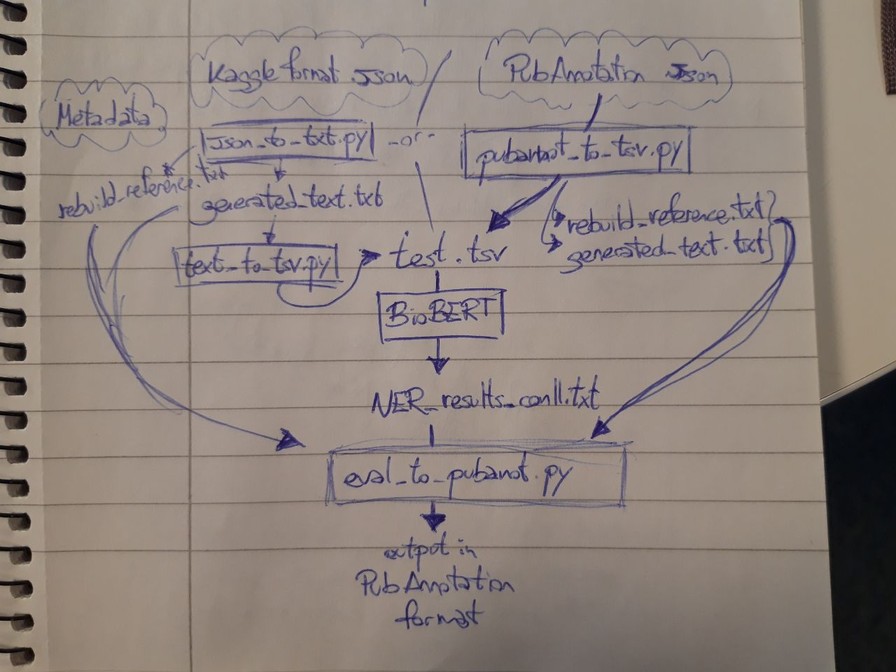

**Models built with expanded training data**

In order to be able to fine-tune models with data specific to COVID-19 related articles, new datasets were generated from the results of dictionary-based taggers on the CORD19 data. Models were also built by fusing these databases with the original BioBERT databases.

In total, 4 models were fine-tuned with datasets containing CORD19 data: dictionary-only disease, dictionary-Disease and NCBI-Disease combined, dictionary-only protein and dictionary-Protein and JNLPBA combined.

**Evaluation of results**

Two different evaluation scripts were used when comparing the results of different models. When attempting to reproduce the steps of the BioBERT paper by Lee et *al.*, the models fine-tuned with the datasets of the original BioBERT publication were evaluated using the native BioBERT evaluator script written in perl.

The evaluation of the results of those same models for the CORD19 data, however, was done with the help of a python script provided by the Aits Lab in Lund University (<https://github.com/Aitslab/corona/tree/master/prototypes>). The same is true for the evaluations of the models fine-tuned from the new datasets.

**Results**

The results depicted in Table 1 represent the evaluations obtained for the BioBERT models when tested using the test files used in the original BioBERT publication. The results of the article were reproduced for three of the models, and a second evaluation was performed with the test file of another dataset with the same tag type for the NCBI-Disease and JNLPBA models.

Table 1:

|  |  |  |  |  |  |
| --- | --- | --- | --- | --- | --- |
| Model | Test Data | Precision  (Reproduced) | Precision  (BioBERT) | Recall  (Reproduced) | Recall  (BioBERT) |
| NCBI-Disease | NCBI-Disease | 93.64% | 88.22% | 93.76% | 91.25% |
|  | BC5CDR-Disease | 68.94% | - | 67.59% | - |
| JNLPBA | JNLPBA | 70.81% | 72.24% | 83.03% | 83.56% |
|  | BC2GM | 51.01% | - | 65.71% | - |
| BC5CDR-Chem | BC5CDR-Chem | 86.58% | 93.68% | 89.38% | 93.26% |

The same models were later used on the Gold Standard Dataset. The newly fine-tuned models using the dictionary data were also used to perform prediction in the same data. The results were then evaluated using

Table 2:

|  |  |  |  |  |
| --- | --- | --- | --- | --- |
| Type | Model | Test Data | Precision | Precision |
| *Disease* | **NCBI-Disease** | Gold Standard | 31% | 35% |
|  | **Dict-Disease** |  | 26% | 30% |
|  | **NCBI-Disease + Dict-Disease** |  | 33% | 28% |
| *Protein* | **JNLPBA** |  | 17% | 18% |
|  | **Dict-Protein** |  | 0% | 0% |
|  | **JNLPBA + Dict-Protein** |  | 0% | 0% |

**Discussion**

**Reproduction**

The results obtained when reproducing the steps presented in the BioBERT article by Lee et *al*. are close to the ones reported in the paper. The slight difference in the values could be explained by the parameters used when performing the testing, as values such as the number of epochs were not reported and therefore a mismatch in the parameters is possible.

It is interesting to note that the values for the model fine-tuned with the NCBI-Disease model are slightly higher than those in the original publication. This, again, was most likely caused by small discrepancies in the training parameters of the models.

**New models**

Neither the base model fine-tuned with the NCBI-Disease dataset nor the models fine-tuned from the results of dictionary-based tagger on the 100-paper subset are very good. One of the causes for this is the high amount of false positives, as all of the models include disease-symptoms in their predictions.

In the protein related models, the base JNLPBA model does a really poor job in the Gold Standard dataset. The model fine-tuned with dictionary data, however, performs even worse, not getting a single true positive.

**Limitations and future work**

The models used in this project can be considerably improved upon. One of the unresolved issues encountered with working with BioBERT was its limitation when dealing with long sentences. If a sentence is longer than 512 tokens long, every token coming after that threshold gets ignored by the model and is not considered for prediction. Circumventing this issue would probably be possible with appropriate additional pre and post-processing of the data.

As shown by this project, the precision and recall of a fine-tuned BioBERT model depend considerably on the data used in training. As such, having access to more, higher quality data would benefit the effectiveness of the model as well.

Furthermore, the evaluation results were influenced by the limitations of the Gold Standard Corpus, which unfortunately included only a limited amount of tags of each of the types.

That being said, the best possible results for Covid-19-related NER would most probably come from a combination of different approaches, not just the BioBERT model. Dictionary-based taggers, in particular, seem to be a powerful tool to combine with neural networks.

**Acknowledgements**

My thanks to professor Sonja Aits for her advice and guideance during the development of this project. Thanks to professor Marcus Klang and to Salma Kazemi Rashed for their time and help. Finally, thanks to Emil, Peter, William, Annie, Sofi, Viktor and Rasmus, as well as to everyone else whose code or data I used during this project.

**References**

[1] All that’s fit to preprint. *Nat Biotechnol* **38,** 507 (2020). <https://doi.org/10.1038/s41587-020-0536-x>

[2] Huang, C. C., & Lu, Z. (2016). Community challenges in biomedical text mining over 10 years: success, failure and the future. *Briefings in bioinformatics*, *17*(1), 132-144.

[3] Devlin, J., Chang, M. W., Lee, K., & Toutanova, K. (2018). Bert: Pre-training of deep bidirectional transformers for language understanding. *arXiv preprint arXiv:1810.04805*.

[4] Lee, J., Yoon, W., Kim, S., Kim, D., Kim, S., So, C. H., & Kang, J. (2020). BioBERT: a pre-trained biomedical language representation model for biomedical text mining. *Bioinformatics*, *36*(4), 1234-1240.

[5] Doğan, R. I., Leaman, R., & Lu, Z. (2014). NCBI disease corpus: a resource for disease name recognition and concept normalization. *Journal of biomedical informatics*, *47*, 1-10.

[6] Li, J., Sun, Y., Johnson, R. J., Sciaky, D., Wei, C. H., Leaman, R., ... & Lu, Z. (2016). BioCreative V CDR task corpus: a resource for chemical disease relation extraction. *Database*, *2016*.

[7] Kim, J. D., Ohta, T., Tsuruoka, Y., Tateisi, Y., & Collier, N. (2004, August). Introduction to the bio-entity recognition task at JNLPBA. In *Proceedings of the international joint workshop on natural language processing in biomedicine and its applications* (pp. 70-75).

[8] Wang, L.L., Lo, K., Chandrasekhar, Y., Reas, R., Yang, J., Eide, D., Funk, K., Kinney, R.M., Liu, Z., Merrill, W., Mooney, P., Murdick, D.A., Rishi, D., Sheehan, J., Shen, Z., Stilson, B., Wade, A.D., Wang, K., Wilhelm, C., Xie, B., Raymond, D.M., Weld, D.S., Etzioni, O., & Kohlmeier, S. (2020). CORD-19: The Covid-19 Open Research Dataset. *ArXiv, abs/2004.10706*.

Other useful links for Antton:

**JOURNALS, PREPRINTS, AND SPEED OF PUBLISHING section in** <http://www.wame.org/page2.php?id=76>

(<https://elpais.com/sociedad/2020/05/05/conduce_como_piensas/1588675204_485005.html>)

Formatting for BioBERT. Special characters not disclosed but should look like: <https://github.com/dmis-lab/biobert/issues/12>

Cite CORD-19:

<https://www.semanticscholar.org/paper/CORD-19%3A-The-Covid-19-Open-Research-Dataset-Wang-Lo/bc411487f305e451d7485e53202ec241fcc97d3b>