COMPUTER SECURITY DEEPA M
MODULE I
INTRODUCTION
The requirements of information security within an organization have undergone two major changes in the last several decades. Before the widespread use of data processing equipment,the security of information felt to be valuable to an organization was provided primarily by physical (eg. rugged filing cabinets with locks) and administrative mechanisms (eg. Personnel screening procedures during hiring process).
Growing computer use implies a need for automated tools for protecting files and other information stored on it. This is especially the case for a shared system, such as a time-sharing system, and even more so for systems that can be accessed over a public telephone network, data network, or the Internet.
The second major change that affected security is the introduction of distributed systems and the use of networks and communications facilities for carrying data between terminal user and computer and between computer and computer. Network security measures are needed to protect data during their transmission.
Definitions
- Computer Security - generic name for the collection of tools designed to protect data and to thwart hackers
- Network Security - measures to protect data during their transmission
- Internet Security - measures to protect data during their transmission over a collection of interconnected networks. Internet Security consists of measures to deter, prevent, detect, and correct security violations that involve the transmission & storage of information
Computer Security
The NIST Computer Security Handbook [NIST95] defines the term computer security as
“ The protection afforded to an automated information system in order to attain the applicable objectives of preserving the integrity, availability and confidentiality of information system resources (includes hardware, software, firmware, information/data, and telecommunications”. This definition introduces three key objectives that are at the heart of computer security:
• Confidentiality: This term covers two related concepts:
- Data confidentiality: Assures that private or confidential information is not made available or disclosed to unauthorized individuals.
- Privacy: Assures that individuals control or influence what information related to them may be collected and stored and by whom and to whom that information may be disclosed.
• Integrity: This term covers two related concepts:
- Data integrity: Assures that information and programs are changed only in a specified and authorized manner.
- System integrity: Assures that a system performs its intended function in an unimpaired manner, free from deliberate or inadvertent unauthorized manipulation of the system.
• Availability: Assures that systems work promptly and service is not denied to authorized users.
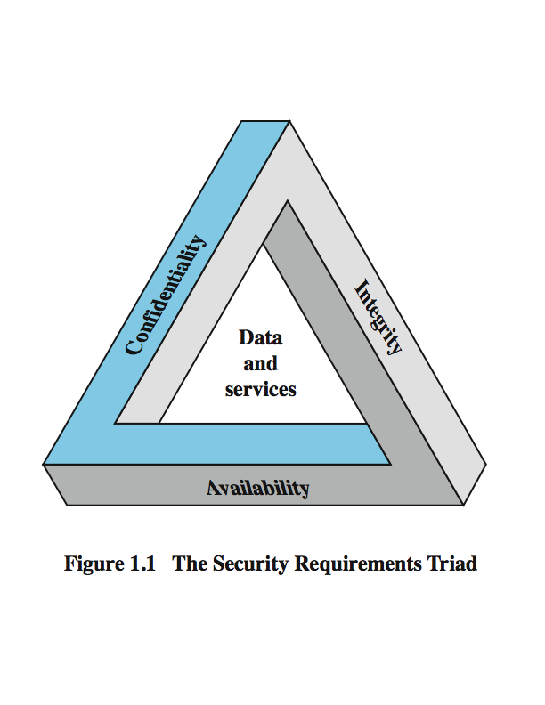
The Security Requirements Triad
Figure 1.1
These three concepts form what is often referred to as the CIA triad (Figure 1.1). The three concepts embody the fundamental security objectives for both data and for information and computing services.
Although the use of the CIA triad to define security objectives is well established, some in the security field feel that additional concepts are needed to present a complete picture. Two of the most commonly mentioned are:
• Authenticity: The property of being genuine and being able to be verified and trusted; confidence in the validity of a transmission, a message, or message originator.
• Accountability: The security goal that generates the requirement for actions of an entity to be traced uniquely to that entity.
Computer Security Challenges
- not simple
- must consider potential attacks
- procedures used counter-intuitive
- involve algorithms and secret info
- must decide where to deploy mechanisms
- battle of wits between attacker / admin
- not perceived on benefit until fails
- requires regular monitoring
- too often an after-thought
- regarded as impediment to using system

OSI SECURITY ARCHITECTURE
To assess effectively the security needs of an organization and to evaluate and choose various security products and policies, the manager responsible for security needs some systematic way of defining the requirements for security and characterizing the approaches to satisfying those requirements. This is difficult enough in a centralized data processing environment; with the use of local and wide area networks the problems are compounded.
ITU-T Recommendation X.800, Security Architecture for OSI, defines such a systematic approach. The OSI security architecture is useful to managers as a way of organizing the task of providing security.
Furthermore, because this architecture was developed as an international standard, computer and communications vendors have developed security features for their products and services that relate to this structured definition of services and mechanisms.
The OSI security architecture focuses on security attacks, mechanisms and services. These can be defined briefly as follows:
• Security attack: Any action that compromises the security of information owned by an organization.
• Security mechanism: A process (or a device incorporating such a process) that is designed to detect, prevent,or recover from a security attack.
• Security service: A processing or communication service that enhances the security of the data processing systems and the information transfers of an organization.The services are intended to counter security attacks, and they make use of one or more security mechanisms to provide the service.
Threat - A potential for violation of security, which exists when there is a circumstance, capability, action, or event that could breach security and cause harm. That is, a threat is a possible danger that might exploit a vulnerability.
Attack - An assault on system security that derives from an intelligent threat; that is, an intelligent act that is a deliberate attempt (especially in the sense of a method or technique) to evade security services and violate the security policy of a system.

SECURITY ATTACKS
A useful means of classifying security attacks, used both in X.800 and RFC 2828, is in terms of passive attacks and active attacks. A passive attack attempts to learn or make use of information from the system but does not affect system resources.An active attack attempts to alter system resources or affect their operation.

Passive Attacks
Passive attacks are in the nature of eavesdropping on, or monitoring of, transmissions. The goal of the opponent is to obtain information that is being transmitted. Two types of passive attacks are the release of message contents and traffic analysis.
The release of message contents is easily understood (Figure 1.2a).A telephone conversation, an electronic mail message, and a transferred file may contain sensitive or confidential information. We would like to prevent an opponent from learning the contents of these transmissions.
A second type of passive attack, traffic analysis, is subtler (Figure 1.2b). Suppose that we had a way of masking the contents of messages or other information traffic so that opponents, even if they captured the message, could not extract the information from the message. The common technique for masking contents is encryption. If we had encryption protection in place, an opponent might still be able to observe the pattern of these messages. The opponent could determine the location and identity of communicating hosts and could observe the frequency and length of messages being exchanged. This information might be useful in guessing the nature of the communication that was taking place.
Passive attacks are very difficult to detect, because they do not involve any alteration of the data. Typically, the message traffic is sent and received in an apparently normal fashion, and neither the sender nor receiver is aware that a third party has read the messages or observed the traffic pattern.Thus, the emphasis in dealing with passive attacks is on prevention rather than detection.
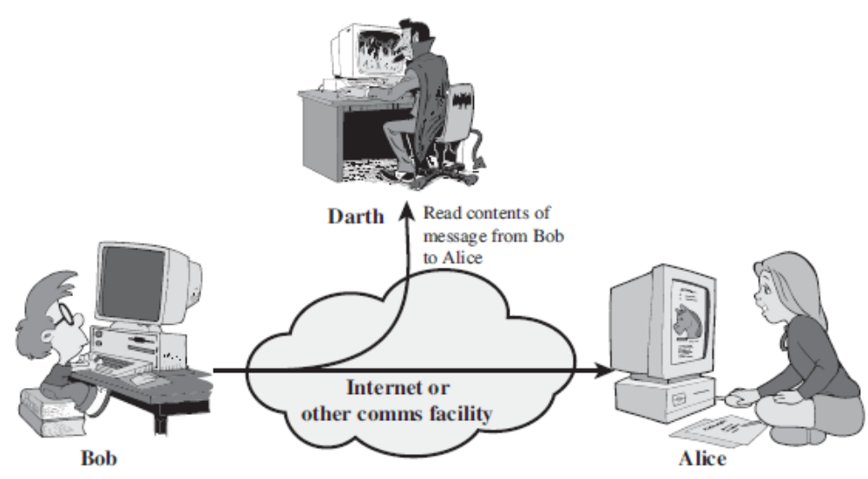

Figure 1.2a Release of message contents
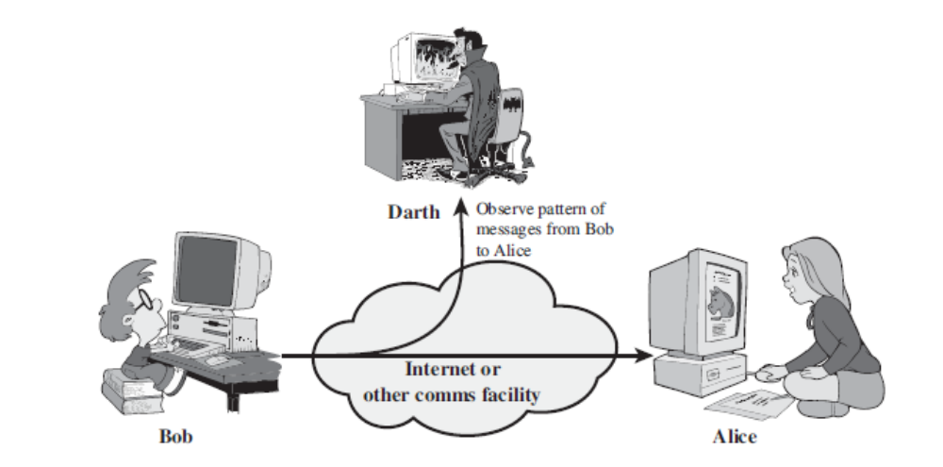
Figure 1.2b Traffic analysis
Active Attacks
Active attacks involve some modification of the data stream or the creation of a false stream and can be subdivided into four categories: masquerade, replay, modification of messages, and denial of service.
A masquerade takes place when one entity pretends to be a different entity (Figure 1.3a). A masquerade attack usually includes one of the other forms of active attack. For example, authentication sequences can be captured and replayed after a valid authentication sequence has taken place, thus enabling an authorized entity with few privileges to obtain extra privileges by impersonating an entity that has those privileges.
Replay involves the passive capture of a data unit and its subsequent retransmission to produce an unauthorized effect (Figure 1.3b).
Modification of messages simply means that some portion of a legitimate message is altered, or that messages are delayed or reordered, to produce an unauthorized effect (Figure 1.3c). For example, a message meaning “Allow John Smith to read confidential file accounts” is modified to mean “Allow Fred Brown to read confidential file accounts.”
The denial of service prevents or inhibits the normal use or management of communications facilities (Figure 1.3d). This attack may have a specific target; for example, an entity may suppress all messages directed to a particular destination(e.g., the security audit service).Another form of service denial is the disruption of an entire network, either by disabling the network or by overloading it with messages so as to degrade performance.
Active attacks present the opposite characteristics of passive attacks.Passive attacks are difficult to detect,.Hence measures are available to prevent their success. On the other hand, it is quite difficult to prevent active attacks absolutely because of the wide variety of potential physical, software, and network vulnerabilities. Instead, the goal is to detect active attacks and to recover from any disruption or delays caused by them.

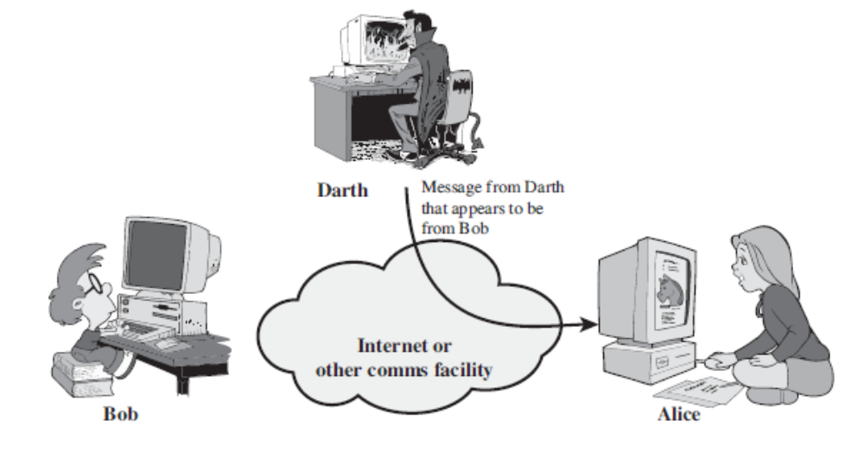
(1.3.a) Masquerade
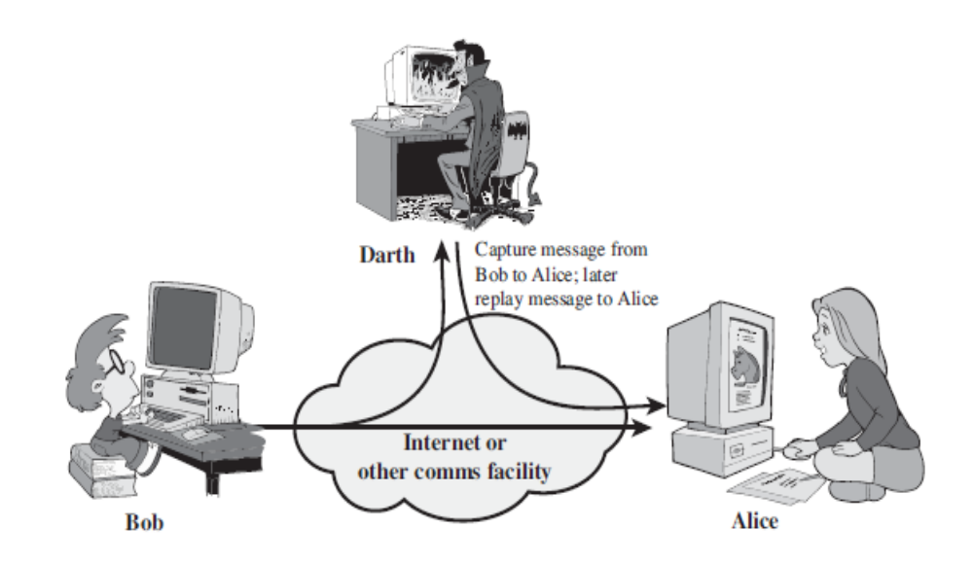
(1.3.b) Replay

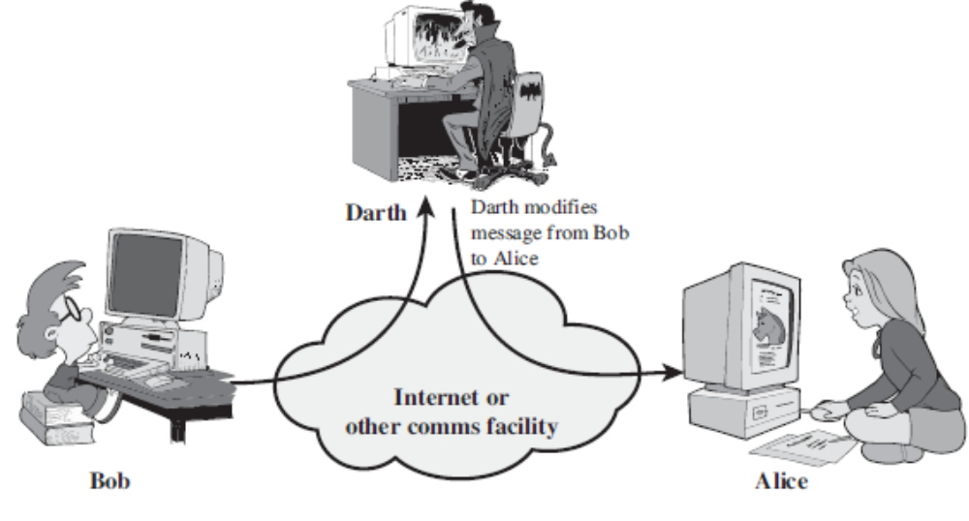
(1.3.c) Modification of messages

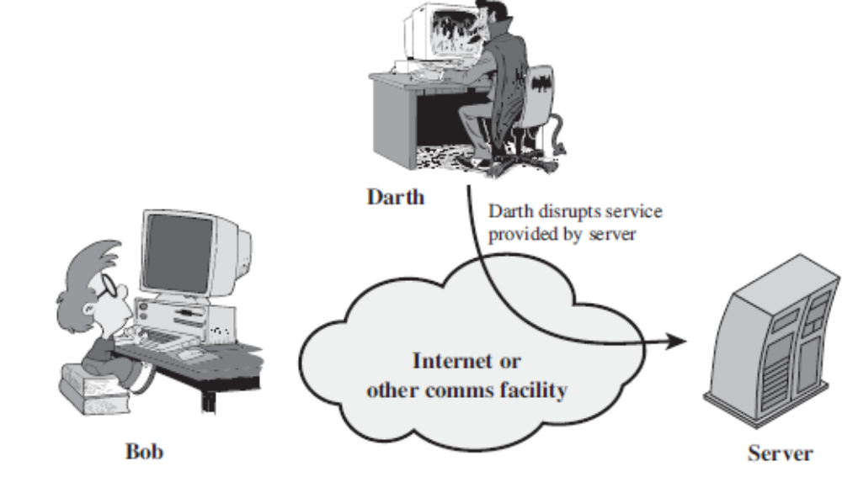
(1.3.d) Denial of service

SECURITY SERVICES
X.800 defines a security service as a service that is provided by a protocol layer of communicating open systems and that ensures adequate security of the systems or of data transfers. RFC 2828 provides the following definition: a processing or communication service that is provided by a system to give a specific kind of protection to system resources; security services implement security policies and are implemented by security mechanisms.
X.800 divides these services into five categories and fourteen specific services (Table 1.1)
Authentication
The authentication service is concerned with assuring that a communication is authentic. In the case of a single message, such as a warning or alarm signal, the function of the authentication service is to assure the recipient that the message is from the source that it claims to be from. In the case of an ongoing interaction, such as the connection of a terminal to a host, two aspects are involved. First, at the time of connection initiation, the service assures that the two entities are authentic, that is, that each is the entity that it claims to be. Second, the service must assure that the connection is not interfered with in such a way that a third party can masquerade as one of the two legitimate parties for the purposes of unauthorized transmission or reception.
Two specific authentication services are defined in X.800:
• Peer entity authentication: Provides for the corroboration of the identity of a peer entity in an association. Two entities are considered peers if they implement to same protocol in different systems; e.g., two TCP modules in two communicating systems. Peer entity authentication is provided for use at the establishment of, or at times during the data transfer phase of, a connection.
• Data origin authentication: Provides for the corroboration of the source of a data unit. It does not provide protection against the duplication or modification of data units. This type of service supports applications like electronic mail, where there are no prior interactions between the communicating entities.

Table 1.1 Security Services (X.800)
AUTHENTICATION  The assurance that the communicating entity is the one that it claims to be.  Peer Entity Authentication  Used in association with a logical connection to provide confidence in the identity of the entities connected.  Data-Origin Authentication  In a connectionless transfer, provides assurance that the source of received data is as claimed.  ACCESS CONTROL  The prevention of unauthorized use of a resource (i.e., this service controls who can have access to a resource, under what conditions access can occur, and what those accessing the resource are allowed to do).  DATA CONFIDENTIALITY  The protection of data from unauthorized  disclosure.  Connection Confidentiality  The protection of all user data on a connection.  Connectionless Confidentiality  The protection of all user data in a single data block  Selective-Field Confidentiality  The confidentiality of selected fields within the user data on a connection or in a single data block.  Traffic-Flow Confidentiality  The protection of the information that might be derived from observation of traffic flows. | DATA INTEGRITY  The assurance that data received are exactly as sent by an authorized entity (i.e., contain no modification, insertion, deletion, or replay).  Connection Integrity with Recovery  Provides for the integrity of all user data on a  connection and detects any modification, insertion, deletion, or replay of any data within an entire data sequence, with recovery attempted.  Connection Integrity without Recovery  As above, but provides only detection without recovery.  Selective-Field Connection Integrity  Provides for the integrity of selected fields within the user data of a data block transferred over a connection and takes the form of determination of whether the selected fields have been modified, inserted,  deleted, or replayed.  Connectionless Integrity  Provides for the integrity of a single connectionless data block and may take the form of detection of data modification. Additionally, a limited form of replay detection may be provided.  Selective-Field Connectionless Integrity  Provides for the integrity of selected fields within a single connectionless data block; takes the form of determination of whether the selected fields have been modified.  NONREPUDIATION  Provides protection against denial by one of the entities involved in a communication of having participated in all or part of the communication.  Nonrepudiation, Origin  Proof that the message was sent by the specified party.  Nonrepudiation, Destination  Proof that the message was received by the specified  party.

Access Control
In the context of network security, access control is the ability to limit and control the access to host systems and applications via communications links. To achieve this, each entity trying to gain access must first be identified, or authenticated, so that access rights can be tailored to the individual.
Data Confidentiality
Confidentiality is the protection of transmitted data from passive attacks.With respect to the content of a data transmission, several levels of protection can be identified.The broadest service protects all user data transmitted between two users over a period of time. Narrower forms of this service can also be defined, including the protection of a single message or even specific fields within a message.
The other aspect of confidentiality is the protection of traffic flow from analysis. This requires that an attacker not be able to observe the source and destination, frequency, length, or other characteristics of the traffic on a communications facility.
Data Integrity
As with confidentiality, integrity can apply to a stream of messages, a single message, or selected fields within a message. Again, the most useful and straightforward approach is total stream protection.
A connection-oriented integrity service, one that deals with a stream of messages, assures that messages are received as sent with no duplication, insertion, modification, reordering, or replays. The destruction of data is also covered under this service. Thus, the connection-oriented integrity service addresses both message stream modification and denial of service. On the other hand, a connectionless integrity service, one that deals with individual messages without regard to any larger context, generally provides protection against message modification only.
We can make a distinction between service with and without recovery. There are mechanisms available to recover from the loss of integrity of data. The incorporation of automated recovery mechanisms is, in general, the more attractive alternative.
Nonrepudiation
Nonrepudiation prevents either sender or receiver from denying a transmitted message. Thus, when a message is sent, the receiver can prove that the alleged sender in fact sent the message. Similarly,when a message is received, the sender can prove that the alleged receiver in fact received the message.
Availability Service
Both X.800 and RFC 2828 define availability to be the property of a system or a system resource being accessible and usable upon demand by an authorized system entity, according to performance specifications for the system (i.e., a system is available if it provides services according to the system design whenever users request them). An availability service is one that protects a system to ensure its availability.This service addresses the security concerns raised by denial-of-service attacks.
SECURITY MECHANISMS
Table 1.2 lists the security mechanisms defined in X.800. The mechanisms are divided into those that are implemented in a specific protocol layer, such as TCP or an application-layer protocol, and those that are not specific to any particular protocol layer or security service.
X.800 distinguishes between reversible encipherment mechanisms and irreversible encipherment mechanisms.A reversible encipherment mechanism is simply an encryption algorithm that allows data to be encrypted and subsequently decrypted. Irreversible encipherment mechanisms include hash algorithms and message authentication codes, which are used in digital signature and message authentication applications.
Table 1.3, based on one in X.800, indicates the relationship between security services and security mechanisms.

Table 1.2 Security Mechanisms (X.800)
SPECIFIC SECURITY MECHANISMS  May be incorporated into the appropriate protocol  layer in order to provide some of the OSI security  services.  Encipherment  The use of mathematical algorithms to transform data into a form that is not readily intelligible.The transformation and subsequent recovery of the data depend on an algorithm and zero or more encryption keys.  Digital Signature  Data appended to, or a cryptographic transformation of, a data unit that allows a recipient of the data unit to prove the source and integrity of the data unit and protect against forgery (e.g., by the recipient).  Access Control  A variety of mechanisms that enforce access rights to  resources.  Data Integrity  A variety of mechanisms used to assure the integrity of a data unit or stream of data units.  Authentication Exchange  A mechanism intended to ensure the identity of an entity by means of information exchange.  Traffic Padding  The insertion of bits into gaps in a data stream to frustrate traffic analysis attempts.  Routing Control  Enables selection of particular physically secure routes for certain data and allows routing changes, especially when a breach of security is suspected.  Notarization  The use of a trusted third party to assure certain | PERVASIVE SECURITY MECHANISMS  Mechanisms that are not specific to any particular OSI security service or protocol layer.  Trusted Functionality  That which is perceived to be correct with respect to  some criteria (e.g., as established by a security policy).  Security Label  The marking bound to a resource (which may be a data unit) that names or designates the security attributes of that resource.  Event Detection  Detection of security-relevant events.  Security Audit Trail  Data collected and potentially used to facilitate a security audit, which is an independent review and  examination of system records and activities.  Security Recovery  Deals with requests from mechanisms, such as event  handling and management functions, and takes recovery actions.

Table 1.3 Relationship Between Security Services and Mechanisms
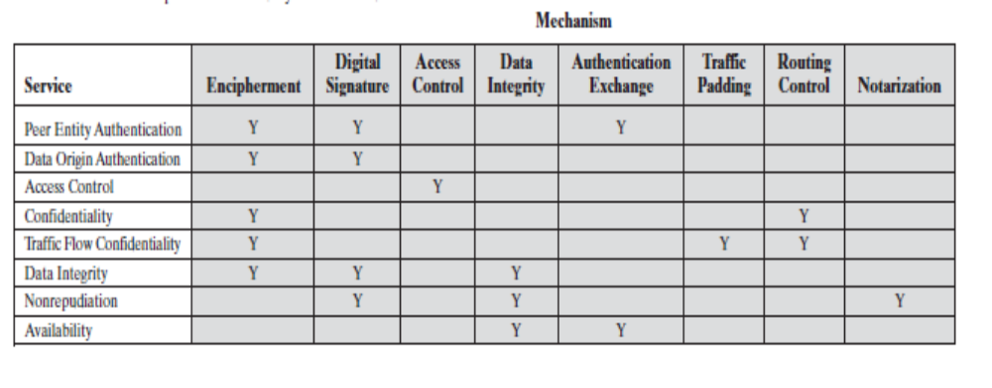

A MODEL FOR NETWORK SECURITY
A model for much of what we will be discussing is captured, in very general terms, in Figure 1.4.
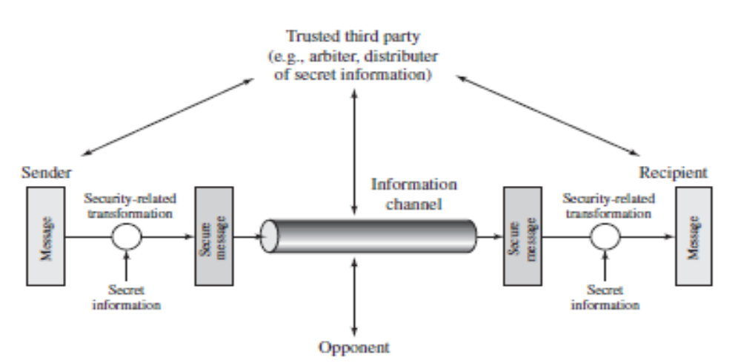
A message is to be transferred from one party to another across some sort of Internet service. The two parties, who are the principals in this transaction, must cooperate for the exchange to take place. A logical information channel is established by defining a route through the Internet from source to destination and by the cooperative use of communication protocols (e.g., TCP/IP) by the two principals.
All the techniques for providing security have two components:
• A security-related transformation on the information to be sent. Examples include the encryption of the message, which scrambles the message so that it is unreadable by the opponent, and the addition of a code based on the contents of the message, which can be used to verify the identity of the sender.
• Some secret information shared by the two principals and, it is hoped, unknown to the opponent. An example is an encryption key used in conjunction with the transformation to scramble the message before transmission and unscramble it on reception.
A trusted third party may be needed to achieve secure transmission. For example, a third party may be responsible for distributing the secret information to the two principals while keeping it from any opponent. Or a third party may be needed to arbitrate disputes between the two principals concerning the authenticity of a message transmission. This general model shows that there are four basic tasks in designing a particular security service:
1. Design an algorithm for performing the security-related transformation. The algorithm should be such that an opponent cannot defeat its purpose.
2. Generate the secret information to be used with the algorithm.
3. Develop methods for the distribution and sharing of the secret information.
4. Specify a protocol to be used by the two principals that makes use of the security algorithm and the secret information to achieve a particular security service.
Programs can present two kinds of threats:
• Information access threats: Intercept or modify data on behalf of users who should not have access to that data.
• Service threats: Exploit service flaws in computers to inhibit use by legitimate users.
CLASSICAL ENCRYPTION TECHNIQUES
Symmetric encryption, also referred to as conventional encryption or single-key encryption, was the only type of encryption in use prior to the development of publickey encryption in the 1970s. It remains by far the most widely used of the two types of encryption.
Symmetric encryption is a form of cryptosystem in which encryption and decryption are performed using the same key. Symmetric encryption transforms plaintext into ciphertext using a secret key and an encryption algorithm. Using the same key and a decryption algorithm, the plaintext is recovered from the ciphertext.
Some Basic Terminology
An original message is known as the plaintext, while the coded message is called the ciphertext.The process of converting from plaintext to ciphertext is known as enciphering or encryption; restoring the plaintext from the ciphertext is deciphering or decryption. The many schemes used for encryption constitute the area of study known as cryptography. Such a scheme is known as a cryptographic system or a cipher. Techniques used for deciphering a message without any knowledge of the enciphering details fall into the area of cryptanalysis. Cryptanalysis is what the layperson calls “breaking the code.”The areas of cryptography and cryptanalysis together are called cryptology.
SYMMETRIC CIPHER MODEL
A symmetric encryption scheme has five ingredients (Figure 1.5):
• Plaintext: This is the original intelligible message or data that is fed into the algorithm as input.
• Encryption algorithm: The encryption algorithm performs various substitutions and transformations on the plaintext.
• Secret key: The secret key is also input to the encryption algorithm. The key is a value independent of the plaintext and of the algorithm. The algorithm will produce a different output depending on the specific key being used at the time.The exact substitutions and transformations performed by the algorithm depend on the key.
• Ciphertext: This is the scrambled message produced as output. It depends on the plaintext and the secret key. For a given message, two different keys will produce two different ciphertexts. The ciphertext is an apparently random stream of data and, as it stands, is unintelligible.
• Decryption algorithm: This is essentially the encryption algorithm run in reverse. It takes the ciphertext and the secret key and produces the original plaintext.
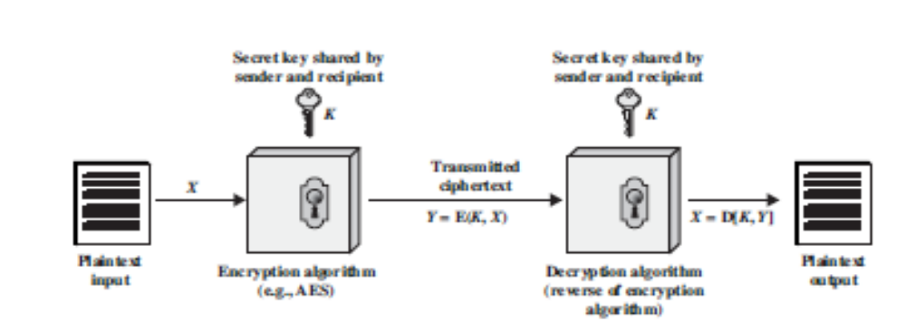
Figure 1.5
There are two requirements for secure use of conventional encryption:
1. We need a strong encryption algorithm. At a minimum, we would like the algorithm to be such that an opponent who knows the algorithm and has access to one or more ciphertexts would be unable to decipher the ciphertext or figure out the key.This requirement is usually stated in a stronger form:Theopponent should be unable to decrypt ciphertext or discover the key even if he or she is in possession of a number of ciphertexts together with the plaintext that produced each ciphertext.
2. Sender and receiver must have obtained copies of the secret key in a secure fashion and must keep the key secure. If someone can discover the key and knows the algorithm, all communication using this key is readable
We do not need to keep the algorithm secret; we need to keep only the key secret. This feature of symmetric encryption is what makes it feasible for widespread use.
Essential elements of a symmetric encryption scheme is given in Figure 1.6. A source produces a message in plaintext, X = [X₁, X₂, … , X_{M}]. The M elements of X are letters in some finite alphabet. Traditionally, the alphabet usually consisted of the 26 capital letters. Nowadays, the binary alphabet {0, 1} is typically used. For encryption, a key of the form K = [K₁, K₂, … , K_{M}]. is generated. If the key is generated at the message source. Then it must also be provided to the destination by means of some secure channel. Alternatively, a third party could generate the key and securely deliver it to both source and destination.
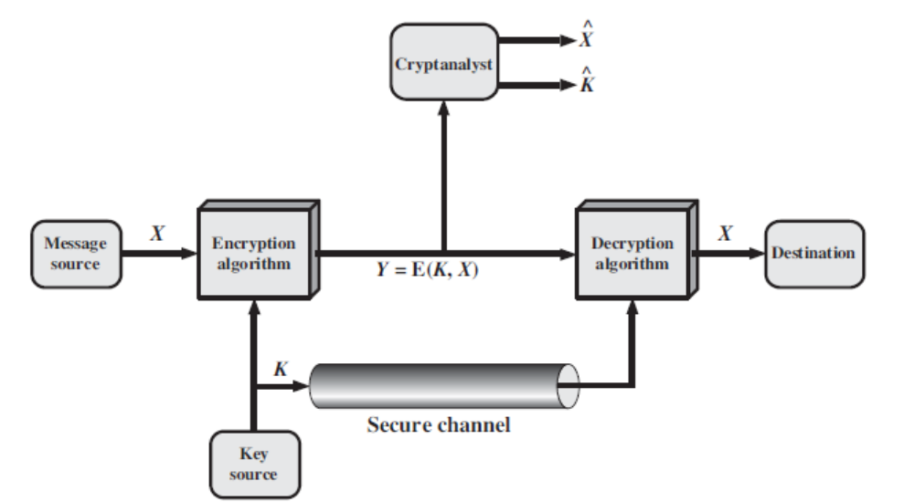
Figure 1.6
With the message X and the encryption key K as input, the encryption algorithm forms the ciphertext Y = [Y₁, Y₂, … , Y_{N}] .We can write this as
Y = E(K, X)
This notation indicates that is produced by using encryption algorithm E as a function of the plaintext , with the specific function determined by the value of the key .
The intended receiver, in possession of the key, is able to invert the transformation:X = D(K, Y)
Cryptography
Cryptographic systems are characterized along three independent dimensions: The type of operations used for transforming plaintext to ciphertext. All encryption algorithms are based on two general principles: substitution, in which each element in the plaintext (bit, letter, group of bits or letters) is mapped into another element, and transposition, in which elements in the plaintext are rearranged. The fundamental requirement is that no information be lost (that is, that all operations are reversible). Most systems, referred to as product systems, involve multiple stages of substitutions and transpositions.
2. The number of keys used. If both sender and receiver use the same key, the system is referred to as symmetric, single-key, secret-key, or conventional encryption. If the sender and receiver use different keys, the system is referred to as asymmetric, two-key, or public-key encryption.
3. The way in which the plaintext is processed. A block cipher processes the input one block of elements at a time, producing an output block for each input block. A stream cipher processes the input elements continuously, producing output one element at a time, as it goes along.
Cryptanalysis and Brute-Force Attack
Typically, the objective of attacking an encryption system is to recover the key in use rather than simply to recover the plaintext of a single ciphertext.There are two general approaches to attacking a conventional encryption scheme:
• Cryptanalysis: Cryptanalytic attacks rely on the nature of the algorithm plus perhaps some knowledge of the general characteristics of the plaintext or even some sample plaintext–ciphertext pairs. This type of attack exploits the characteristics of the algorithm to attempt to deduce a specific plaintext or to deduce the key being used.
• Brute-force attack: The attacker tries every possible key on a piece of ciphertext until an intelligible translation into plaintext is obtained. On average, half of all possible keys must be tried to achieve success.

Table 1.4 summarizes the various types of cryptanalytic attacks based on the amount of information known to the cryptanalyst.
Table 1.4
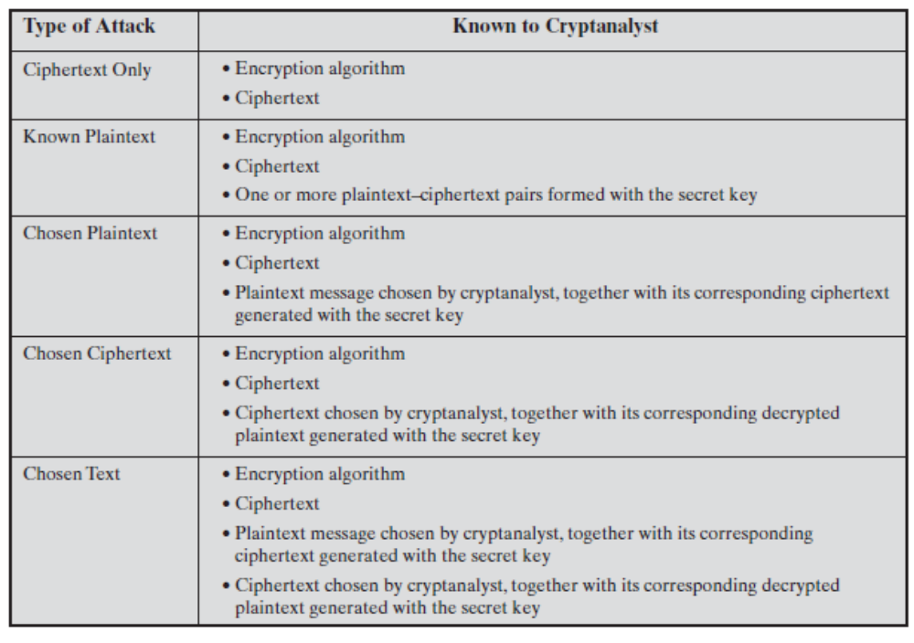
All the users of an encryption algorithm can strive for is an algorithm that meets one or both of the following criteria:
An encryption scheme is unconditionally secure if the ciphertext generated by the scheme does not contain enough information to determine uniquely the corresponding plaintext, no matter how much ciphertext is available.
• The cost of breaking the cipher exceeds the value of the encrypted information.
• The time required to break the cipher exceeds the useful lifetime of the information.
An encryption scheme is said to be computationally secure if either of the foregoing two criteria are met.
SUBSTITUTION TECHNIQUES
The two basic building blocks of all encryption techniques are substitution and transposition.A substitution technique is one in which the letters of plaintext are replaced by other letters or by numbers or symbols.1 If the plaintext is viewed as a sequence of bits, then substitution involves replacing plaintext bit patterns with ciphertext bit patterns.
Caesar Cipher
The earliest known, and the simplest, use of a substitution cipher was by Julius Caesar.The Caesar cipher involves replacing each letter of the alphabet with the letter standing three places further down the alphabet.
For example,
plain: meet me after the toga party
cipher: PHHW PH DIWHU WKH WRJD SDUWB
The alphabet is wrapped around, so that the letter following Z is A. We can define the transformation by listing all possibilities, as follows:
plain: a b c d e f g h i j k l m n o p q r s t u v w x y z
cipher: D E F G H I J K L M N O P Q R S T U V W X Y Z A B C
Let us assign a numerical equivalent to each letter:
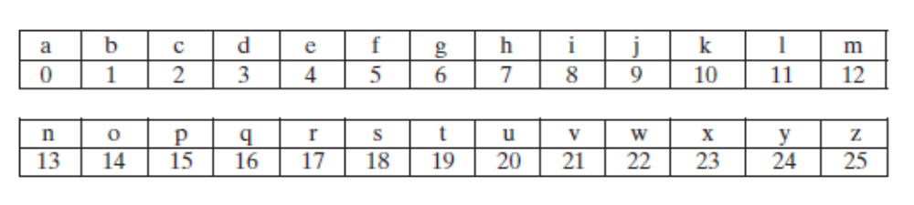
Then the algorithm can be expressed as follows. For each plaintext letter , substitute the ciphertext letter
C = E(3, p) = (p + 3) mod 26
A shift may be of any amount, so that the general Caesar algorithm is
C = E(k, p) = (p + k) mod 26
where takes on a value in the range 1 to 25.The decryption algorithm is simply
p = D(k, C) = (C - k) mod 26
If it is known that a given ciphertext is a Caesar cipher, then a brute-force cryptanalysis is easily performed:
Three important characteristics of this problem enabled us to use a bruteforce cryptanalysis:
1. The encryption and decryption algorithms are known.
2. There are only 25 keys to try.
3. The language of the plaintext is known and easily recognizable
Monoalphabetic Ciphers
With only 25 possible keys, the Caesar cipher is far from secure.A dramatic increase in the key space can be achieved by allowing an arbitrary substitution. Before proceeding, we define the term permutation.A permutation of a finite set of elements S is an ordered sequence of all the elements of S , with each element appearing exactly once. In general, there are n! permutations of a set of elements. If, instead, the “cipher” line can be any permutation of the 26 alphabetic characters, then there are 26! or greater than possible keys.This is 10 orders of magnitude greater than the key space for DES and would seem to eliminate brute-force techniques for cryptanalysis. Such an approach is referred to as a monoalphabetic substitution cipher, because a single cipher alphabet (mapping from plain alphabet to cipher alphabet) is used per message.
In monoalphabetic cipher
- Rather than just shifting the alphabet could shuffle (jumble) the letters arbitrarily
- each plaintext letter maps to a different random ciphertext letter
- hence key is 26 letters long
For Example,
Plain: abcdefghijklmnopqrstuvwxyz
Key : DKVQFIBJWPESCXHTMYAUOLRGZN
Plaintext: ifwewishtoreplaceletters
Ciphertext: WIRFRWAJUHYFTSDVFSFUUFYA
Monoalphabetic ciphers are easy to break because they reflect the frequency data of the original alphabet. A countermeasure is to provide multiple substitutes, known as homophones, for a single letter
Playfair Cipher
The best-known multiple-letter encryption cipher is the Playfair, which treats digrams in the plaintext as single units and translates these units into ciphertext digrams. The Playfair algorithm is based on the use of a 5 × 5 matrix of letters constructed using a keyword. Here is an example,
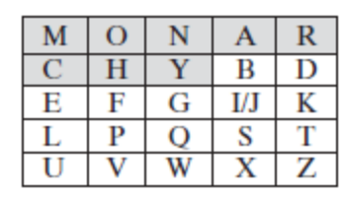

In this case, the keyword is monarchy. The matrix is constructed by filling in the letters of the keyword (minus duplicates) from left to right and from top to bottom, and then filling in the remainder of the matrix with the remaining letters in alphabetic order. The letters I and J count as one letter. Plaintext is encrypted two letters at a time, according to the following rules:
1. Repeating plaintext letters that are in the same pair are separated with a filler letter, such as x, so that balloon would be treated as ba lx lo on.
2. Two plaintext letters that fall in the same row of the matrix are each replaced by the letter to the right, with the first element of the row circularly following the last. For example, ar is encrypted as RM.
3. Two plaintext letters that fall in the same column are each replaced by the letter beneath, with the top element of the column circularly following the last. For example, mu is encrypted as CM.
4. Otherwise, each plaintext letter in a pair is replaced by the letter that lies in its own row and the column occupied by the other plaintext letter. Thus, hs becomes BP and ea becomes IM (or JM, as the encipherer wishes).
The Playfair cipher is a great advance over simple monoalphabetic ciphers. For one thing, whereas there are only 26 letters, there are 26 × 26 = 676 digrams, so that identification of individual digrams is more difficult. the Playfair cipher is relatively easy to break, because it still leaves much of the structure of the plaintext language intact.
Hill Cipher
Another interesting multiletter cipher is the Hill cipher, developed by the mathematician Lester Hill in 1929.
This encryption algorithm takes successive m plaintext letters and substitutes for them m ciphertext letters. The substitution is determined by m linear equations in which each character is assigned a numerical value (a = 0, b = 1,…, z = 25) . For , the system can be described as
c1 = (k₁₁p₁ + k₁₂p₂ + k₁₃p₃)mod 26
c2 = (k₂₁p₁ + k₂₂p₂ + k₂₃p₃)mod 26
c3 = (k₃₁p₁ + k₃₂p₂ + k₃₃p₃)mod 26

This can be expressed in terms of row vectors and matrices
C = PK mod 26
where C and P are row vectors of length 3 representing the plaintext and ciphertext, and K is a 3×3 matrix representing the encryption key. Operations are performed mod 26.
For example, consider the plaintext “paymoremoney” and use the encryption key

17 17 5
K= 21 18 21
2 2 19
The first three letters of the plaintext are represented by the vector (15 0 24). Then(15 0 24)
K = (375 819 486) mod 26 = (11 13 18) = LNS. Decryption requires using the inverse of the matrix K.
Polyalphabetic Ciphers
Another way to improve on the simple monoalphabetic technique is to use different monoalphabetic substitutions as one proceeds through the plaintext message. The general name for this approach is polyalphabetic substitution cipher. All these techniques have the following features in common:
1. A set of related monoalphabetic substitution rules is used.
2. A key determines which particular rule is chosen for a given transformation.
VIGEN`ERE CIPHER The best known, and one of the simplest, polyalphabetic ciphers is the Vigenère cipher. In this scheme, the set of related monoalphabetic substitution rules consists of the 26 Caesar ciphers with shifts of 0 through 25. Each cipher is denoted by a key letter, which is the ciphertext letter that substitutes for the plaintext letter a. Thus, a Caesar cipher with a shift of 3 is denoted by the key value .
To encrypt a message, a key is needed that is as long as the message. Usually, the key is a repeating keyword. For example, if the keyword is deceptive, the message “we are discovered save yourself” is encrypted as
key: deceptivedeceptivedeceptive
plaintext: wearediscoveredsaveyourself
ciphertext:ZICVTWQNGRZGVTWAVZHCQYGLMGJ
The periodic nature of the keyword can be eliminated by using a nonrepeating keyword that is as long as the message itself.Vigenère proposed what is referred to as an autokey system, in which a keyword is concatenated with the plaintext itself to provide a running key.
For example,
key: deceptivewearediscoveredsav
plaintext: wearediscoveredsaveyourself
ciphertext:ZICVTWQNGKZEIIGASXSTSLVVWLA
One-Time Pad
Mauborgne suggested using a random key that is as long as the message, so that the key need not be repeated. In addition, the key is to be used to encrypt and decrypt a single message, and then is discarded. Each new message requires a new key of the same length as the new message.
Such a scheme, known as a one-time pad, is unbreakable. It produces random output that bears no statistical relationship to the plaintext. Because the ciphertext contains no information whatsoever about the plaintext, there is simply no way to break the code.
Consider the ciphertext
ANKYODKYUREPFJBYOJDSPLREYIUNOFDOIUERFPLUYTS
We now show two different decryptions using two different keys:
ciphertext: ANKYODKYUREPFJBYOJDSPLREYIUNOFDOIUERFPLUYTS
key: pxlmvmsydofuyrvzwc tnlebnecvgdupahfzzlmnyih
plaintext: mr mustard with the candlestick in the hall

ciphertext: ANKYODKYUREPFJBYOJDSPLREYIUNOFDOIUERFPLUYTS
key: mfugpmiydgaxgoufhklllmhsqdqogtewbqfgyovuhwt
plaintext: miss scarlet with the knife in the library
The one-time pad offers complete security but, in practice, has two fundamental difficulties:
1. There is the practical problem of making large quantities of random keys.Any heavily used system might require millions of random characters on a regular basis. Supplying truly random characters in this volume is a significant task.
2. Even more daunting is the problem of key distribution and protection. For every message to be sent, a key of equal length is needed by both sender and receiver.Thus, a mammoth key distribution problem exists.
Because of these difficulties, the one-time pad is of limited utility and is useful primarily for low-bandwidth channels requiring very high security.The one-time pad is the only cryptosystem that exhibits what is referred to as perfect secrecy.

