Header Elements

Actor |  | Represents an external person or entity that interacts with the system
Object | 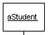 | Represents an object in the system or one of its components
Unit | 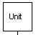 | Represents a subsystem, component, unit, or other non-object entity in the system
Separator | 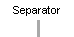 | Represents an interface or boundary between subsystems
Group | 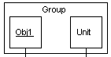 | Groups related header elements into subsystems or components

Body Elements

Action |  | Represents an action taken by a header element
Asynchronous Message |  | An asynchronous message between header elements
Block | 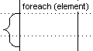 | A block representing a loop or conditional for a particular header element
Block End |  | Marks the end of a block element
Call Message | 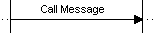 | A call (procedure) message between header elements
Create Message | 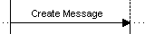 | A "create" message that creates a header element (represented by lifeline going from dashed to solid pattern)
Destroy Element | 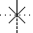 | Represents the destruction of a header element
Destroy Message | 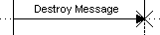 | Represents the destruction of a header element as a result of a call from another element
Diagram Link |  | Represents a section or part of a diagram being treated as a functional block. Similar to a procedure or function call that abstracts functionality or details not shown at this level. Can optionally be linked to another diagram for elaboration.
Else Block | 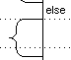 | Represents an "else" block portion of a diagram block
Flow Note |  | Documentation note that is automatically formatted to flow after previous elements
Free Note |  | Documentation note that is free-flowing and can be placed anywhere in the diagram (can also be anchored relative to a flow element)
Message |  | A simple message between header elements
Page Break |  | A page break in the diagram
Return Message | 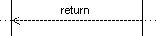 | A return message between header elements
Scenario Start |  | Start of a scenario (set of alternatives)
Scenario Case |  | Start of an alternative or case in a scenario
Scenario End |  | End of a scenario
State | 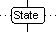 | A state change for a header element
Steady State | 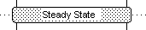 | A steady state in the system
Timer Start |  | Start of a timer for a particular header element
Timer Stop |  | Stop of a timer for a particular header element
Timer Expiration |  | Expiration of a timer for a particular header element

