**ECE1504: Assignment 2 Neural Networks**

Due: 26 Nov 2018

Tianyi Xie 1000570679

Yisi Zou 1001826321

Contribution percentage is the same for both group members

Part 1

1.2.1 Neural Network Architecture [20 pt.]

See the code in appendix 1.2.1-2

1.2.2 Training [15 pt.]

See the code in appendix 1.2.1-2

* Batch size=20
* Number of epochs=1000
* Learning rate=0.005
* Maximum number of epochs without progress=20

Here is the training and validation loss function vs. the number of epochs

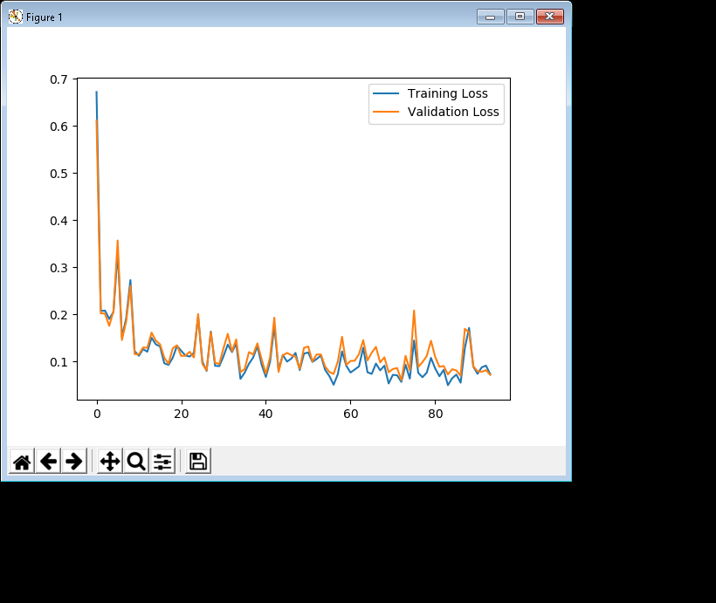

Here is the training and validation classification error vs. the number of epochs

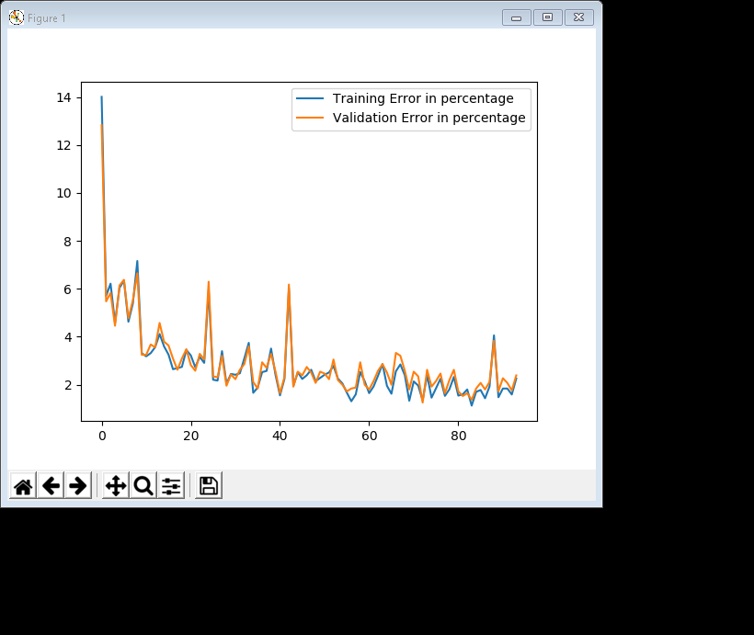

The precision we can achieve over the test set is 98.70%. It takes 73 iterations to converge.

Here is one sample from the test set for which the estimated label is not the same as its true label.

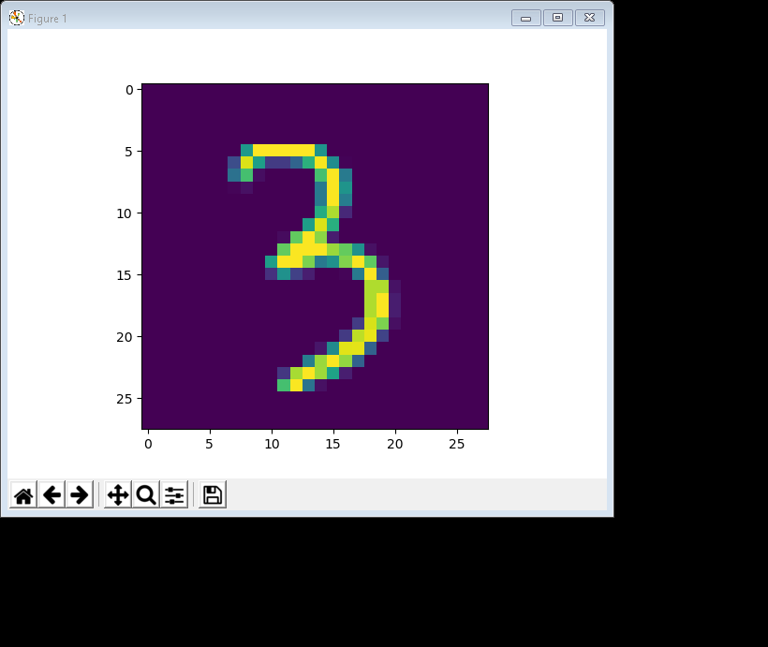

The estimated label is 4 while the true label is 3.

1.2.3 Tuning Hyperparameters [5 pt.]

1) See the code in appendix 1.2.3.1

* Batch size=20
* Number of epochs=1000
* Number of neurons per layer=50
* Learning rate=0.005
* Activation function ReLU
* Maximum number of epochs without progress=20

Here is the training and validation loss function vs. the number of epochs

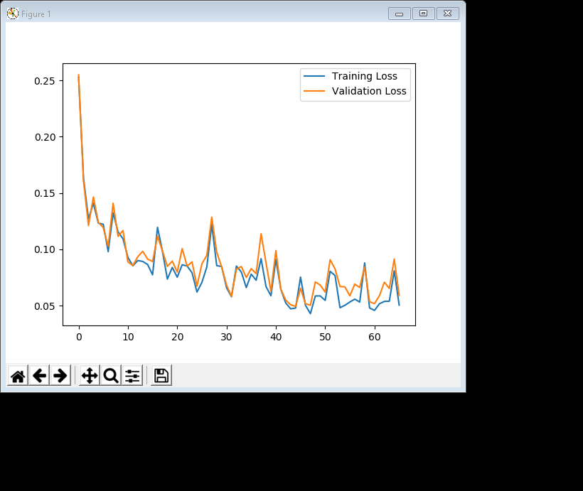

Here is the training and validation classification error vs. the number of epochs

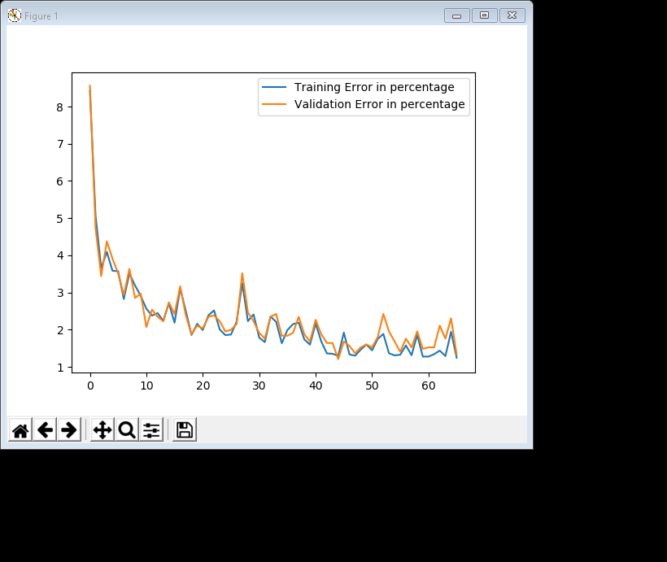

The precision we can achieve over the test set is 98.11%. It takes 68 iterations to converge.

2) See the code in appendix 1.2.3.2

* Batch size=500
* Number of epochs=1000
* Number of neurons per layer=140
* Learning rate=0.1
* Activation function Leaky ReLU with alpha=0.1
* Maximum number of epochs without progress=30

Here is the training and validation loss function vs. the number of epochs

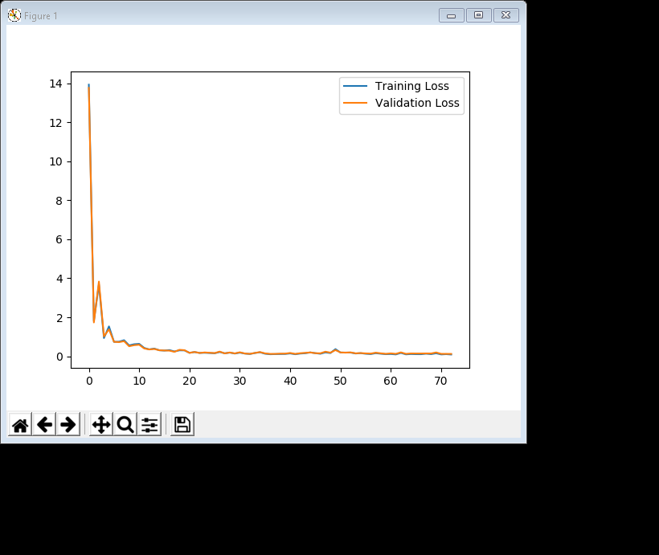

Here is the training and validation classification error vs. the number of epochs

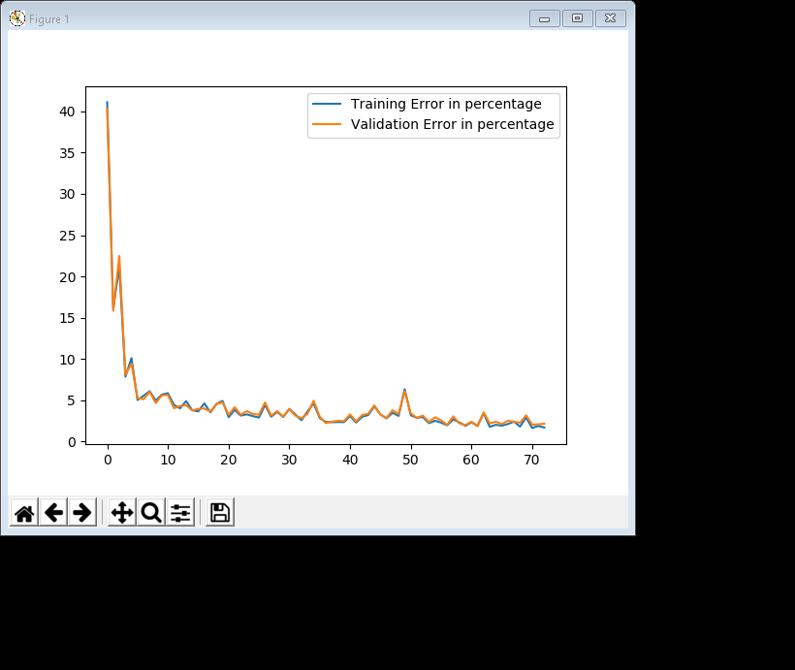

The precision we can achieve over the test set is 97.86%. It takes 72 iterations to converge.

1.2.4 Batch Normalization [10 pt.]

See the code in appendix 1.2.4

Momentum can help to reduce the noise in gradient update term and converges faster to optimal value. It helps SGD to navigate along the relevant directions and soften the oscillations in irrelevant. It adds a friction of the direction of the precious step to current step. This achieves the amplification of speed in the current direction and soften the oscillation in the run direction along the relevant directions.

The way of updating mean and variance using momentum is as follow:

running_mean = momentum * running_mean + (1 - momentum) * sample_mean  
running_var = momentum * running_var + (1 - momentum) * sample_var

Here are the comparisons of performance in terms of cross entropy and precision on the training set and validation set

|  |  |
| --- | --- |
|  |  |
|  |  |

As we can see from the plots and the table below, both training and validation precision increase as momentums increase. Similarly, the cross entropy losses of both training and validation set decrease as momentums increase. Test accuracies are also reported in the table below.

|  |  |  |  |  |  |
| --- | --- | --- | --- | --- | --- |
| Momentum | Train precision | Train loss | Valid precision | Valid loss | Test accuracy |
| 0.85 | 98.23% | 0.062747 | 98.36% | 0.055147 | 98.38% |
| 0.9 | 98.67% | 0.047420 | 98.55% | 0.041708 | 98.79% |
| 0.95 | 98.97% | 0.038702 | 99.02% | 0.039354 | 99.05% |
| 0.99 | 99.06% | 0.031642 | 98.87% | 0.030816 | 99.14% |

1.2.5 Dropout [5 pt.]

Here are the comparisons of performance in terms of cross entropy and precision on the training set and validation set, between the models in 1.2.2 and 1.2.4. For the part using the model in 1.2.4, we choose momentum = 0.99, as it has the highest test accuracy.

|  |  |
| --- | --- |
| 1.2.2 | 1.2.4 |
|  |  |
|  |  |

As we can see from the plots and the table below, both training and validation precision decrease as dropout rates increase in both models. Similarly, the cross entropy losses of both training and validation set increase as dropout rates increase in both models. Test accuracies are also reported in the table below.

|  |  |  |  |  |  |
| --- | --- | --- | --- | --- | --- |
| Model-dropout | Train precision | Train loss | Valid precision | Valid loss | Test accuracy |
| 1.2.2-0.1 | 97.79% | 0.090755 | 97.97% | 0.083478 | 98.15% |
| 1.2.2-0.3 | 97.48% | 0.091208 | 97.19% | 0.099475 | 97.80% |
| 1.2.4-0.1 | 99.11% | 0.030980 | 98.71% | 0.039979 | 99.22% |
| 1.2.4-0.3 | 98.68% | 0.046515 | 98.67% | 0.044631 | 98.60% |

1.2.6 Impact of Regularization Methods [5 pt.]

Among all three models, batch normalization + dropout has the best outcome. It seems that while training the dropout model, we add too much noise in the training parameters. Adding batch normalization on top of dropout can cancel out the noise and get better results.

Part 2 transfer Learning [40 pt.]

2.2.1 Reusing the model [10 pt.]

See the code in appendix 2.2.1-2

2.2.2 Training [10 pt.]

See the code in appendix 2.2.1-2

For the full training set:

Here is the training and validation loss function vs. the number of epochs

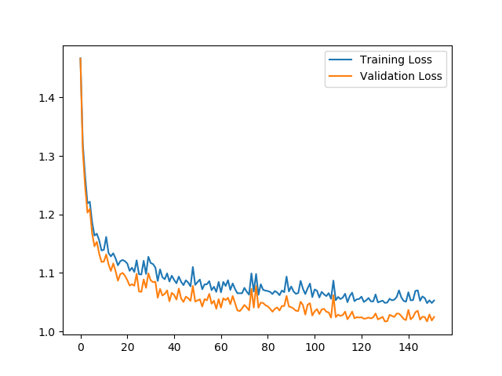

Here is the training and validation classification error vs. the number of epochs

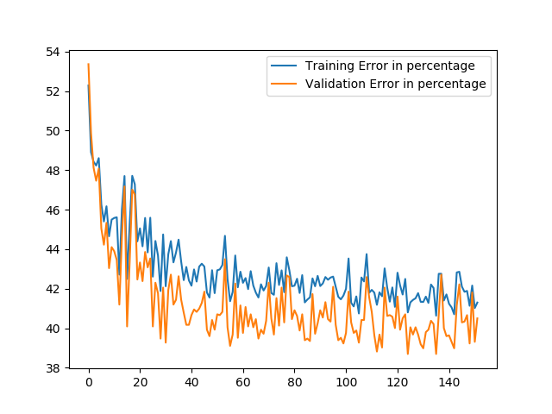

The precision we can achieve over the test set is 58.65%. It takes 151 iterations to converge.

For 100 images per digit:

Here is the training and validation classification error vs. the number of epochs

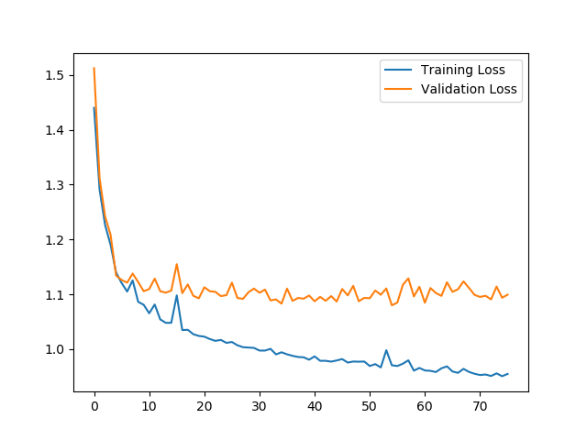

Here is the training and validation loss function vs. the number of epochs

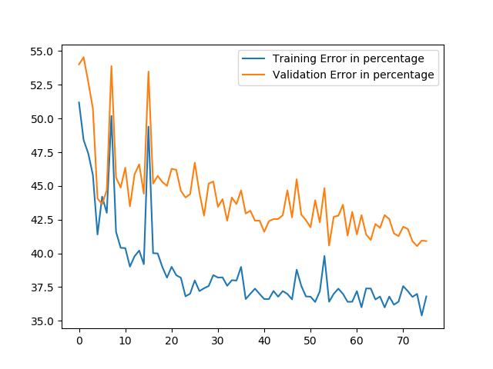

The precision we can achieve over the test set is 55.50%. It takes 75 iterations to converge.

Comparing to the case that we train on the entire training set, training using 100 images per digits converges faster, but the accuracy is lower.

2.2.3 Removing the last hidden layer [10 pt.]

See the code in appendix 2.2.3

Here is the training and validation classification error vs. the number of epochs

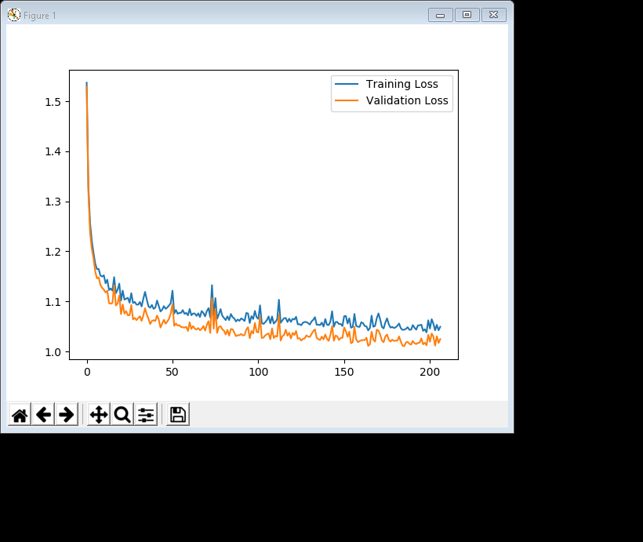

Here is the training and validation loss function vs. the number of epochs

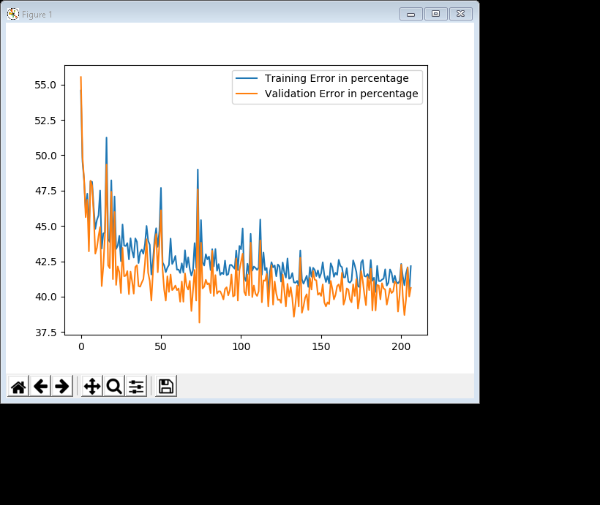

The precision we can achieve over the test set is 58.86%. It takes 206 iterations to converge.

According to our results, removing the last layer eventually resulted in better accuracy. This is because high-level features in a different model is not helpful for a new task.

2.2.4 Unfreezing hidden layers 3 and 4 [10 pt.]

See the code in appendix 2.2.4

Here is the training and validation classification error vs. the number of epochs

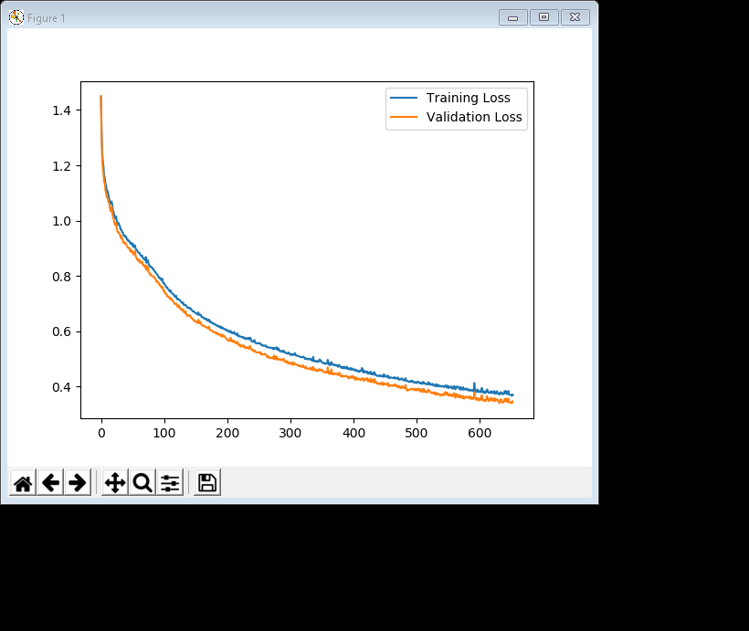

Here is the training and validation loss function vs. the number of epochs

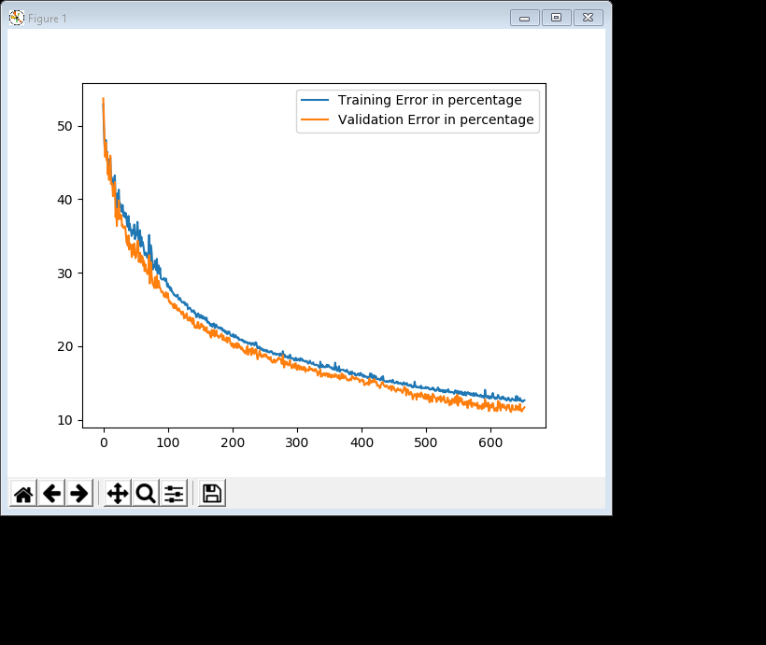

The precision we can achieve over the test set is 86.44%. It takes 652 iterations to converge

According to our results, after unfreezing the third and fourth layer, the accuracy is much higher than before. Again this is because high-level features in a different model is not helpful for a new task.

APPENDIX

PART1

1.2.1-2

import tensorflow as tf

import numpy as np

import matplotlib.pyplot as plt

He_init = tf.variance_scaling_initializer()

def reset_graph(seed=42):

tf.reset_default_graph()

tf.set_random_seed(seed)

np.random.seed(seed)

# Load data sets

(X_train, y_train), (X_test, y_test) = tf.keras.datasets.mnist.load_data()

X_train = X_train.astype(np.float32).reshape(-1,28*28)/255.0

X_test = X_test.astype(np.float32).reshape(-1,28*28)/255.0

y_train = y_train.astype(np.int32)

y_test = y_test.astype(np.int32)

X_valid, X_train = X_train[:5000], X_train[5000:]

y_valid, y_train = y_train[:5000], y_train[5000:]

# Initialize parameters

path = "./model0.ckpt"

node_num = 100

output_num = 5

learning_rate = 0.005

epoch_num = 1000

train_batch_size = 20

train_batch_num = int(epoch_num / train_batch_size)

max_check = 20

check_count = 0

best_loss = np.infty

best_error = 0

# Modify data sets

X_train1 = X_train[y_train < 5]

y_train1 = y_train[y_train < 5]

X_valid1 = X_valid[y_valid < 5]

y_valid1 = y_valid[y_valid < 5]

X_test1 = X_test[y_test < 5]

y_test1 = y_test[y_test < 5]

X_test1_pic = np.reshape(X_test1, [-1, 28, 28])

# Initialize placeholders

X = tf.placeholder(tf.float32, name="X", shape=[None,28*28])

Y = tf.placeholder(tf.int64, name="Y", shape=[None,])

batch_size = tf.placeholder(tf.int64, name="batch_size")

# Initialize the data set

dataset = tf.data.Dataset.from_tensor_slices((X, Y))

# Shuffle, repeat, and batch the examples.

dataset = dataset.shuffle(X_train.shape[0]).repeat().batch(batch_size)

# Create iterator

iter = dataset.make_initializable_iterator()

batch_X, batch_Y = iter.get_next(name="batch_xy")

# Construct a neural network

H1 = tf.layers.dense(batch_X, node_num, activation=tf.nn.elu,

kernel_initializer=He_init, name="H1")

H2 = tf.layers.dense(H1, node_num, activation=tf.nn.elu,

kernel_initializer=He_init, name="H2")

H3 = tf.layers.dense(H2, node_num, activation=tf.nn.elu,

kernel_initializer=He_init, name="H3")

H4 = tf.layers.dense(H3, node_num, activation=tf.nn.elu,

kernel_initializer=He_init, name="H4")

H5 = tf.layers.dense(H4, node_num, activation=tf.nn.elu,

kernel_initializer=He_init, name="H5")

Y_hat = tf.layers.dense(H5, output_num, name="Y_hat")

# Calculate the loss

cross_entropy = tf.nn.softmax_cross_entropy_with_logits_v2( \

labels=tf.one_hot(batch_Y, 5, dtype=tf.float32), logits=Y_hat)

loss = tf.reduce_mean(cross_entropy, name="loss")

# Calculate the accuracy

predict = tf.argmax(Y_hat, axis=1)

correct = tf.cast(tf.equal(batch_Y, predict), tf.float32)

accuracy = tf.reduce_mean(correct, name="accuracy")

optimizer = tf.train.AdamOptimizer(learning_rate).minimize(loss)

# Initialize tensorflow

init_g = tf.global_variables_initializer()

init_l = tf.local_variables_initializer()

# Initialize saver

saver = tf.train.Saver()

# Save the dataset initialization operation with name

dataset_init_op = iter.make_initializer(dataset, name='dataset_init')

# Initialize plotting coordinates

epoch_axis = []

epoch_loss_axis = []

epoch_error_axis = []

valid_loss_axis = []

valid_error_axis = []

# Start training

with tf.Session() as sess :

# Run the initializer

sess.run(init_g)

sess.run(init_l)

for epoch in range(epoch_num) :

# train for one epoch

sess.run(dataset_init_op, feed_dict={X:X_train1, Y:y_train1,

batch_size:train_batch_size})

for batch in range(train_batch_num) :

sess.run(optimizer)

# Compute current loss and error

sess.run(dataset_init_op, feed_dict={X:X_train1, Y:y_train1,

batch_size:X_train1.shape[0]})

epoch_loss, epoch_acc = sess.run([loss, accuracy])

epoch_error = (1.0 - epoch_acc) * 100

print("Epoch =", epoch, "loss =", "{:.9f}".format(epoch_loss),

"error =", "{:.2f}".format(epoch_error), "per cent")

# Calculate validation loss and error for this epoch

sess.run(dataset_init_op, feed_dict={X:X_valid1, Y:y_valid1,

batch_size:X_valid1.shape[0]})

valid_loss, valid_acc = sess.run([loss, accuracy])

valid_error = (1.0 - valid_acc) * 100

# Update the coordinates

epoch_axis.append(epoch)

epoch_loss_axis.append(epoch_loss)

epoch_error_axis.append(epoch_error)

valid_loss_axis.append(valid_loss)

valid_error_axis.append(valid_error)

if valid_loss < best_loss :

save_path = saver.save(sess, path)

best_loss = valid_loss

best_error = valid_error

check_count = 0

else :

check_count += 1

if check_count > max_check :

print("Early stopping!")

break

# Calculate test precision using the best model

saver.restore(sess, path)

sess.run(dataset_init_op, feed_dict={X:X_test1, Y:y_test1,

batch_size:X_test1.shape[0]})

test_acc, test_correct, test_predict = sess.run([accuracy, correct, predict])

precision = test_acc * 100

print("Test precision is {:.2f} per cent".format(precision))

# Show the final validation results

print("Final validation loss =", "{:.9f}".format(best_loss))

print("Final validation error =", "{:.2f}".format(best_error), "per cent")

# Plot and show the graphs

plt.plot(epoch_axis, epoch_loss_axis, label='Training Loss')

plt.plot(epoch_axis, valid_loss_axis, label='Validation Loss')

plt.legend()

plt.show()

plt.plot(epoch_axis, epoch_error_axis, label='Training Error in percentage')

plt.plot(epoch_axis, valid_error_axis, label='Validation Error in percentage')

plt.legend()

plt.show()

test_one_fail = np.argmin(test_correct)

plt.imshow(X_test1_pic[test_one_fail])

plt.show()

print("Ground truth is:", y_test1[test_one_fail])

print("Miss-predicted as:", test_predict[test_one_fail])

1.2.3.1

import tensorflow as tf

import numpy as np

import matplotlib.pyplot as plt

He_init = tf.variance_scaling_initializer()

def reset_graph(seed=42):

tf.reset_default_graph()

tf.set_random_seed(seed)

np.random.seed(seed)

# Load data sets

(X_train, y_train), (X_test, y_test) = tf.keras.datasets.mnist.load_data()

X_train = X_train.astype(np.float32).reshape(-1,28*28)/255.0

X_test = X_test.astype(np.float32).reshape(-1,28*28)/255.0

y_train = y_train.astype(np.int32)

y_test = y_test.astype(np.int32)

X_valid, X_train = X_train[:5000], X_train[5000:]

y_valid, y_train = y_train[:5000], y_train[5000:]

# Initialize parameters

path = "./model1.ckpt"

node_num = 50

output_num = 5

learning_rate = 0.005

epoch_num = 1000

train_batch_size = 20

train_batch_num = int(epoch_num / train_batch_size)

max_check = 20

check_count = 0

best_loss = np.infty

best_error = 0

# Modify data sets

X_train1 = X_train[y_train < 5]

y_train1 = y_train[y_train < 5]

X_valid1 = X_valid[y_valid < 5]

y_valid1 = y_valid[y_valid < 5]

X_test1 = X_test[y_test < 5]

y_test1 = y_test[y_test < 5]

X_test1_pic = np.reshape(X_test1, [-1, 28, 28])

# Initialize placeholders

X = tf.placeholder(tf.float32, name="X", shape=[None,28*28])

Y = tf.placeholder(tf.int64, name="Y", shape=[None,])

batch_size = tf.placeholder(tf.int64)

# Initialize the data set

dataset = tf.data.Dataset.from_tensor_slices((X, Y))

# Shuffle, repeat, and batch the examples.

dataset = dataset.shuffle(X_train1.shape[0]).repeat().batch(batch_size)

# Create iterator

iter = dataset.make_initializable_iterator()

batch_X, batch_Y = iter.get_next()

# Construct a neural network

H1 = tf.layers.dense(batch_X, node_num, activation=tf.nn.relu,

kernel_initializer=He_init, name="H1")

H2 = tf.layers.dense(H1, node_num, activation=tf.nn.relu,

kernel_initializer=He_init, name="H2")

H3 = tf.layers.dense(H2, node_num, activation=tf.nn.relu,

kernel_initializer=He_init, name="H3")

H4 = tf.layers.dense(H3, node_num, activation=tf.nn.relu,

kernel_initializer=He_init, name="H4")

H5 = tf.layers.dense(H4, node_num, activation=tf.nn.relu,

kernel_initializer=He_init, name="H5")

Y_hat = tf.layers.dense(H5, output_num, name="outputs")

# Calculate the loss

cross_entropy = tf.nn.softmax_cross_entropy_with_logits_v2( \

labels=tf.one_hot(batch_Y, 5, dtype=tf.float32), logits=Y_hat)

loss = tf.reduce_mean(cross_entropy)

# Calculate the accuracy

predict = tf.argmax(Y_hat, axis=1)

correct = tf.cast(tf.equal(batch_Y, predict), tf.float32)

accuracy = tf.reduce_mean(correct)

optimizer = tf.train.AdamOptimizer(learning_rate).minimize(loss)

# Initialize tensorflow

init_g = tf.global_variables_initializer()

init_l = tf.local_variables_initializer()

# Initialize saver

saver = tf.train.Saver()

# Initialize plotting coordinates

epoch_axis = []

epoch_loss_axis = []

epoch_error_axis = []

valid_loss_axis = []

valid_error_axis = []

# Start training

with tf.Session() as sess :

# Run the initializer

sess.run(init_g)

sess.run(init_l)

for epoch in range(epoch_num) :

# train for one epoch

sess.run(iter.initializer, feed_dict={X:X_train1, Y:y_train1,

batch_size:train_batch_size})

for batch in range(train_batch_num) :

sess.run(optimizer)

# Compute current loss and error

sess.run(iter.initializer, feed_dict={X:X_train1, Y:y_train1,

batch_size:X_train1.shape[0]})

epoch_loss, epoch_acc = sess.run([loss, accuracy])

epoch_error = (1.0 - epoch_acc) * 100

print("Epoch =", epoch, "loss =", "{:.9f}".format(epoch_loss),

"error =", "{:.2f}".format(epoch_error), "per cent")

# Calculate validation loss and error for this epoch

sess.run(iter.initializer, feed_dict={X:X_valid1, Y:y_valid1,

batch_size:X_valid1.shape[0]})

valid_loss, valid_acc = sess.run([loss, accuracy])

valid_error = (1.0 - valid_acc) * 100

# Update the coordinates

epoch_axis.append(epoch)

epoch_loss_axis.append(epoch_loss)

epoch_error_axis.append(epoch_error)

valid_loss_axis.append(valid_loss)

valid_error_axis.append(valid_error)

if valid_loss < best_loss :

save_path = saver.save(sess, path)

best_loss = valid_loss

best_error = valid_error

check_count = 0

else :

check_count += 1

if check_count > max_check :

print("Early stopping!")

break

# Calculate test precision using the best model

saver.restore(sess, path)

sess.run(iter.initializer, feed_dict={X:X_test1, Y:y_test1,

batch_size:X_test1.shape[0]})

test_acc = sess.run(accuracy)

precision = test_acc * 100

print("Test precision is {:.2f} per cent".format(precision))

# Show the final validation results

print("Final validation loss =", "{:.9f}".format(best_loss))

print("Final validation error =", "{:.2f}".format(best_error), "per cent")

# Plot and show the graphs

plt.plot(epoch_axis, epoch_loss_axis, label='Training Loss')

plt.plot(epoch_axis, valid_loss_axis, label='Validation Loss')

plt.legend()

plt.show()

plt.plot(epoch_axis, epoch_error_axis, label='Training Error in percentage')

plt.plot(epoch_axis, valid_error_axis, label='Validation Error in percentage')

plt.legend()

plt.show()

1.2.3.2

import tensorflow as tf

import numpy as np

import matplotlib.pyplot as plt

He_init = tf.variance_scaling_initializer()

def reset_graph(seed=42):

tf.reset_default_graph()

tf.set_random_seed(seed)

np.random.seed(seed)

# Load data sets

(X_train, y_train), (X_test, y_test) = tf.keras.datasets.mnist.load_data()

X_train = X_train.astype(np.float32).reshape(-1,28*28)/255.0

X_test = X_test.astype(np.float32).reshape(-1,28*28)/255.0

y_train = y_train.astype(np.int32)

y_test = y_test.astype(np.int32)

X_valid, X_train = X_train[:5000], X_train[5000:]

y_valid, y_train = y_train[:5000], y_train[5000:]

# Initialize parameters

path = "./model2.ckpt"

node_num = 140

output_num = 5

learning_rate = 0.1

epoch_num = 1000

train_batch_size = 500

train_batch_num = int(epoch_num / train_batch_size)

max_check = 30

check_count = 0

best_loss = np.infty

best_error = 0

# Modify data sets

X_train1 = X_train[y_train < 5]

y_train1 = y_train[y_train < 5]

X_valid1 = X_valid[y_valid < 5]

y_valid1 = y_valid[y_valid < 5]

X_test1 = X_test[y_test < 5]

y_test1 = y_test[y_test < 5]

X_test1_pic = np.reshape(X_test1, [-1, 28, 28])

# Initialize placeholders

X = tf.placeholder(tf.float32, name="X", shape=[None,28*28])

Y = tf.placeholder(tf.int64, name="Y", shape=[None,])

batch_size = tf.placeholder(tf.int64)

# Initialize the data set

dataset = tf.data.Dataset.from_tensor_slices((X, Y))

# Shuffle, repeat, and batch the examples.

dataset = dataset.shuffle(X_train1.shape[0]).repeat().batch(batch_size)

# Create iterator

iter = dataset.make_initializable_iterator()

batch_X, batch_Y = iter.get_next()

# Construct a neural network

H1 = tf.layers.dense(batch_X, node_num, kernel_initializer=He_init, name="H1")

H1_out = tf.nn.leaky_relu(H1, alpha=0.1)

H2 = tf.layers.dense(H1_out, node_num, kernel_initializer=He_init, name="H2")

H2_out = tf.nn.leaky_relu(H1, alpha=0.1)

H3 = tf.layers.dense(H2_out, node_num, kernel_initializer=He_init, name="H3")

H3_out = tf.nn.leaky_relu(H1, alpha=0.1)

H4 = tf.layers.dense(H3_out, node_num, kernel_initializer=He_init, name="H4")

H4_out = tf.nn.leaky_relu(H1, alpha=0.1)

H5 = tf.layers.dense(H4_out, node_num, kernel_initializer=He_init, name="H5")

H5_out = tf.nn.leaky_relu(H1, alpha=0.1)

Y_hat = tf.layers.dense(H5_out, output_num, name="outputs")

# Calculate the loss

cross_entropy = tf.nn.softmax_cross_entropy_with_logits_v2( \

labels=tf.one_hot(batch_Y, 5, dtype=tf.float32), logits=Y_hat)

loss = tf.reduce_mean(cross_entropy)

# Calculate the accuracy

predict = tf.argmax(Y_hat, axis=1)

correct = tf.cast(tf.equal(batch_Y, predict), tf.float32)

accuracy = tf.reduce_mean(correct)

optimizer = tf.train.AdamOptimizer(learning_rate).minimize(loss)

# Initialize tensorflow

init_g = tf.global_variables_initializer()

init_l = tf.local_variables_initializer()

# Initialize saver

saver = tf.train.Saver()

# Initialize plotting coordinates

epoch_axis = []

epoch_loss_axis = []

epoch_error_axis = []

valid_loss_axis = []

valid_error_axis = []

# Start training

with tf.Session() as sess :

# Run the initializer

sess.run(init_g)

sess.run(init_l)

for epoch in range(epoch_num) :

# train for one epoch

sess.run(iter.initializer, feed_dict={X:X_train1, Y:y_train1,

batch_size:train_batch_size})

for batch in range(train_batch_num) :

sess.run(optimizer)

# Compute current loss and error

sess.run(iter.initializer, feed_dict={X:X_train1, Y:y_train1,

batch_size:X_train1.shape[0]})

epoch_loss, epoch_acc = sess.run([loss, accuracy])

epoch_error = (1.0 - epoch_acc) * 100

print("Epoch =", epoch, "loss =", "{:.9f}".format(epoch_loss),

"error =", "{:.2f}".format(epoch_error), "per cent")

# Calculate validation loss and error for this epoch

sess.run(iter.initializer, feed_dict={X:X_valid1, Y:y_valid1,

batch_size:X_valid1.shape[0]})

valid_loss, valid_acc = sess.run([loss, accuracy])

valid_error = (1.0 - valid_acc) * 100

# Update the coordinates

epoch_axis.append(epoch)

epoch_loss_axis.append(epoch_loss)

epoch_error_axis.append(epoch_error)

valid_loss_axis.append(valid_loss)

valid_error_axis.append(valid_error)

if valid_loss < best_loss :

save_path = saver.save(sess, path)

best_loss = valid_loss

best_error = valid_error

check_count = 0

else :

check_count += 1

if check_count > max_check :

print("Early stopping!")

break

# Calculate test precision using the best model

saver.restore(sess, path)

sess.run(iter.initializer, feed_dict={X:X_test1, Y:y_test1,

batch_size:X_test1.shape[0]})

test_acc = sess.run(accuracy)

precision = test_acc * 100

print("Test precision is {:.2f} per cent".format(precision))

# Show the final validation results

print("Final validation loss =", "{:.9f}".format(best_loss))

print("Final validation error =", "{:.2f}".format(best_error), "per cent")

# Plot and show the graphs

plt.plot(epoch_axis, epoch_loss_axis, label='Training Loss')

plt.plot(epoch_axis, valid_loss_axis, label='Validation Loss')

plt.legend()

plt.show()

plt.plot(epoch_axis, epoch_error_axis, label='Training Error in percentage')

plt.plot(epoch_axis, valid_error_axis, label='Validation Error in percentage')

plt.legend()

plt.show()

1.2.4

import tensorflow as tf

import numpy as np

import matplotlib.pyplot as plt

He_init = tf.variance_scaling_initializer()

def reset_graph(seed=42):

tf.reset_default_graph()

tf.set_random_seed(seed)

np.random.seed(seed)

# Load data sets

(X_train, y_train), (X_test, y_test) = tf.keras.datasets.mnist.load_data()

X_train = X_train.astype(np.float32).reshape(-1,28*28)/255.0

X_test = X_test.astype(np.float32).reshape(-1,28*28)/255.0

y_train = y_train.astype(np.int32)

y_test = y_test.astype(np.int32)

X_valid, X_train = X_train[:5000], X_train[5000:]

y_valid, y_train = y_train[:5000], y_train[5000:]

# Initialize parameters

path = "./model_bn.ckpt"

node_num = 100

output_num = 5

learning_rate = 0.005

epoch_num = 1000

train_batch_size = 20

train_batch_num = int(epoch_num / train_batch_size)

max_check = 20

momentums = [0.85, 0.9, 0.95, 0.99]

# Modify data sets

X_train1 = X_train[y_train < 5]

y_train1 = y_train[y_train < 5]

X_valid1 = X_valid[y_valid < 5]

y_valid1 = y_valid[y_valid < 5]

X_test1 = X_test[y_test < 5]

y_test1 = y_test[y_test < 5]

X_test1_pic = np.reshape(X_test1, [-1, 28, 28])

# Initialize placeholders

X = tf.placeholder(tf.float32, name="X", shape=[None,28*28])

Y = tf.placeholder(tf.int64, name="Y", shape=[None,])

batch_size = tf.placeholder(tf.int64)

training = tf.placeholder_with_default(False, shape=(), name='training')

momentum = tf.placeholder(tf.float32)

# Initialize the data set

dataset = tf.data.Dataset.from_tensor_slices((X, Y))

# Shuffle, repeat, and batch the examples.

dataset = dataset.shuffle(X_train1.shape[0]).repeat().batch(batch_size)

# Create iterator

iter = dataset.make_initializable_iterator()

batch_X, batch_Y = iter.get_next()

# Construct a neural network

H1 = tf.layers.dense(batch_X, node_num, activation=tf.nn.elu,

kernel_initializer=He_init, name="H1")

BN1 = tf.layers.batch_normalization(H1, training=training, momentum=momentum)

H2 = tf.layers.dense(BN1, node_num, activation=tf.nn.elu,

kernel_initializer=He_init, name="H2")

BN2 = tf.layers.batch_normalization(H2, training=training, momentum=momentum)

H3 = tf.layers.dense(BN2, node_num, activation=tf.nn.elu,

kernel_initializer=He_init, name="H3")

BN3 = tf.layers.batch_normalization(H3, training=training, momentum=momentum)

H4 = tf.layers.dense(BN3, node_num, activation=tf.nn.elu,

kernel_initializer=He_init, name="H4")

BN4 = tf.layers.batch_normalization(H4, training=training, momentum=momentum)

H5 = tf.layers.dense(BN4, node_num, activation=tf.nn.elu,

kernel_initializer=He_init, name="H5")

BN5 = tf.layers.batch_normalization(H5, training=training, momentum=momentum)

Y_hat = tf.layers.dense(BN5, output_num, name="outputs")

# Calculate the loss

cross_entropy = tf.nn.softmax_cross_entropy_with_logits_v2( \

labels=tf.one_hot(batch_Y, 5, dtype=tf.float32), logits=Y_hat)

loss = tf.reduce_mean(cross_entropy)

# Calculate the accuracy

predict = tf.argmax(Y_hat, axis=1)

correct = tf.cast(tf.equal(batch_Y, predict), tf.float32)

accuracy = tf.reduce_mean(correct)

optimizer = tf.train.AdamOptimizer(learning_rate).minimize(loss)

# Initialize tensorflow

init_g = tf.global_variables_initializer()

init_l = tf.local_variables_initializer()

# Initialize optimizer for batch normalization

BN_optimizer = tf.get_collection(tf.GraphKeys.UPDATE_OPS)

# Initialize saver

saver = tf.train.Saver()

# Iterate for different momentums

for curr_momentum in momentums :

# Initialize parameters for early stopping

check_count = 0

best_loss = np.infty

best_acc = 0

# Initialize plotting coordinates

epoch_axis = []

epoch_loss_axis = []

epoch_acc_axis = []

valid_loss_axis = []

valid_acc_axis = []

# Start training

with tf.Session() as sess :

# Run the initializer

sess.run(init_g)

sess.run(init_l)

for epoch in range(epoch_num) :

# train for one epoch

sess.run(iter.initializer, feed_dict={X:X_train1, Y:y_train1,

batch_size:train_batch_size})

for batch in range(train_batch_num) :

sess.run([optimizer, BN_optimizer],

feed_dict={training: True, momentum:curr_momentum})

# Compute current loss and accuracy

sess.run(iter.initializer, feed_dict={X:X_train1, Y:y_train1,

batch_size:X_train1.shape[0]})

epoch_loss, epoch_acc = sess.run([loss, accuracy],

feed_dict={momentum:curr_momentum})

epoch_acc = epoch_acc * 100

print("Epoch =", epoch, "loss =", "{:.9f}".format(epoch_loss),

"precision =", "{:.2f}".format(epoch_acc), "per cent")

# Calculate validation loss and accuracy for this epoch

sess.run(iter.initializer, feed_dict={X:X_valid1, Y:y_valid1,

batch_size:X_valid1.shape[0]})

valid_loss, valid_acc = sess.run([loss, accuracy],

feed_dict={momentum:curr_momentum})

valid_acc = valid_acc * 100

# Update the coordinates

epoch_axis.append(epoch)

epoch_loss_axis.append(epoch_loss)

epoch_acc_axis.append(epoch_acc)

valid_loss_axis.append(valid_loss)

valid_acc_axis.append(valid_acc)

if valid_loss < best_loss :

save_path = saver.save(sess, path)

best_loss = valid_loss

best_acc = valid_acc

check_count = 0

else :

check_count += 1

if check_count > max_check :

print("Early stopping!")

break

# Calculate test precision using the best model

saver.restore(sess, path)

sess.run(iter.initializer, feed_dict={X:X_test1, Y:y_test1,

batch_size:X_test1.shape[0]})

test_acc, test_correct, test_predict = sess.run([accuracy, correct,

predict], feed_dict={momentum:curr_momentum})

precision = test_acc * 100

print("Test precision is {:.2f} per cent".format(precision))

# Show the final validation results

print("Final validation loss =", "{:.9f}".format(best_loss))

print("Final validation acc =", "{:.2f}".format(best_acc), "per cent")

# Plot and show the graphs

plt.plot(epoch_axis, epoch_loss_axis, label='Training Loss, momentum =' + str(curr_momentum))

plt.plot(epoch_axis, valid_loss_axis, label='Validation Loss, momentum =' + str(curr_momentum))

plt.legend()

plt.show()

plt.plot(epoch_axis, epoch_acc_axis, label='Training Precision in percentage, momentum =' + str(curr_momentum))

plt.plot(epoch_axis, valid_acc_axis, label='Validation Precision in percentage, momentum =' + str(curr_momentum))

plt.legend()

plt.show()

1.2.5.1

import tensorflow as tf

import numpy as np

import matplotlib.pyplot as plt

He_init = tf.variance_scaling_initializer()

def reset_graph(seed=42):

tf.reset_default_graph()

tf.set_random_seed(seed)

np.random.seed(seed)

# Load data sets

(X_train, y_train), (X_test, y_test) = tf.keras.datasets.mnist.load_data()

X_train = X_train.astype(np.float32).reshape(-1,28*28)/255.0

X_test = X_test.astype(np.float32).reshape(-1,28*28)/255.0

y_train = y_train.astype(np.int32)

y_test = y_test.astype(np.int32)

X_valid, X_train = X_train[:5000], X_train[5000:]

y_valid, y_train = y_train[:5000], y_train[5000:]

# Initialize parameters

path = "./model_dp.ckpt"

node_num = 100

output_num = 5

learning_rate = 0.005

epoch_num = 1000

train_batch_size = 20

train_batch_num = int(epoch_num / train_batch_size)

max_check = 20

dropout_rates = [0.1, 0.3]

# Modify data sets

X_train1 = X_train[y_train < 5]

y_train1 = y_train[y_train < 5]

X_valid1 = X_valid[y_valid < 5]

y_valid1 = y_valid[y_valid < 5]

X_test1 = X_test[y_test < 5]

y_test1 = y_test[y_test < 5]

X_test1_pic = np.reshape(X_test1, [-1, 28, 28])

# Initialize placeholders

X = tf.placeholder(tf.float32, name="X", shape=[None,28*28])

Y = tf.placeholder(tf.int64, name="Y", shape=[None,])

batch_size = tf.placeholder(tf.int64)

training=tf.placeholder_with_default(False, shape=(), name='training')

drop_rate = tf.placeholder(tf.float32)

# Initialize the data set

dataset = tf.data.Dataset.from_tensor_slices((X, Y))

# Shuffle, repeat, and batch the examples.

dataset = dataset.shuffle(X_train1.shape[0]).repeat().batch(batch_size)

# Create iterator

iter = dataset.make_initializable_iterator()

batch_X, batch_Y = iter.get_next()

# Construct a neural network

H1 = tf.layers.dense(batch_X, node_num, activation=tf.nn.elu,

kernel_initializer=He_init, name="H1")

H1_drop = tf.layers.dropout(H1, drop_rate, training=training)

H2 = tf.layers.dense(H1_drop, node_num, activation=tf.nn.elu,

kernel_initializer=He_init, name="H2")

H2_drop = tf.layers.dropout(H2, drop_rate, training=training)

H3 = tf.layers.dense(H2_drop, node_num, activation=tf.nn.elu,

kernel_initializer=He_init, name="H3")

H3_drop = tf.layers.dropout(H3, drop_rate, training=training)

H4 = tf.layers.dense(H3_drop, node_num, activation=tf.nn.elu,

kernel_initializer=He_init, name="H4")

H4_drop = tf.layers.dropout(H4, drop_rate, training=training)

H5 = tf.layers.dense(H4_drop, node_num, activation=tf.nn.elu,

kernel_initializer=He_init, name="H5")

H5_drop = tf.layers.dropout(H5, drop_rate, training=training)

Y_hat = tf.layers.dense(H5_drop, output_num, name="outputs")

# Calculate the loss

cross_entropy = tf.nn.softmax_cross_entropy_with_logits_v2( \

labels=tf.one_hot(batch_Y, 5, dtype=tf.float32), logits=Y_hat)

loss = tf.reduce_mean(cross_entropy)

# Calculate the accuracy

predict = tf.argmax(Y_hat, axis=1)

correct = tf.cast(tf.equal(batch_Y, predict), tf.float32)

accuracy = tf.reduce_mean(correct)

optimizer = tf.train.AdamOptimizer(learning_rate).minimize(loss)

# Initialize tensorflow

init_g = tf.global_variables_initializer()

init_l = tf.local_variables_initializer()

# Initialize saver

saver = tf.train.Saver()

# Iterate for different dropout rates

for dropout_rate in dropout_rates :

# Initialize parameters for early stopping

check_count = 0

best_loss = np.infty

best_acc = 0

# Initialize plotting coordinates

epoch_axis = []

epoch_loss_axis = []

epoch_acc_axis = []

valid_loss_axis = []

valid_acc_axis = []

# Start training

with tf.Session() as sess :

# Run the initializer

sess.run(init_g)

sess.run(init_l)

for epoch in range(epoch_num) :

# train for one epoch

sess.run(iter.initializer, feed_dict={X:X_train1, Y:y_train1,

batch_size:train_batch_size})

for batch in range(train_batch_num) :

sess.run(optimizer, feed_dict={training:True,

drop_rate:dropout_rate})

# Compute current loss and accuracy

sess.run(iter.initializer, feed_dict={X:X_train1, Y:y_train1,

batch_size:X_train1.shape[0]})

epoch_loss, epoch_acc = sess.run([loss, accuracy],

feed_dict={drop_rate:0.0}) # kill the dropout for testing

epoch_acc = epoch_acc * 100

print("Epoch =", epoch, "loss =", "{:.9f}".format(epoch_loss),

"accuracy =", "{:.2f}".format(epoch_acc), "per cent")

# Calculate validation loss and accuracy for this epoch

sess.run(iter.initializer, feed_dict={X:X_valid1, Y:y_valid1,

batch_size:X_valid1.shape[0]})

valid_loss, valid_acc = sess.run([loss, accuracy],

feed_dict={drop_rate:0.0}) # kill the dropout for testing

valid_acc = valid_acc * 100

# Update the coordinates

epoch_axis.append(epoch)

epoch_loss_axis.append(epoch_loss)

epoch_acc_axis.append(epoch_acc)

valid_loss_axis.append(valid_loss)

valid_acc_axis.append(valid_acc)

if valid_loss < best_loss :

save_path = saver.save(sess, path)

best_loss = valid_loss

best_acc = valid_acc

check_count = 0

else :

check_count += 1

if check_count > max_check :

print("Early stopping!")

break

# Calculate test precision using the best model

saver.restore(sess, path)

sess.run(iter.initializer, feed_dict={X:X_test1, Y:y_test1,

batch_size:X_test1.shape[0]})

test_acc, test_correct, test_predict = sess.run([accuracy, correct,

predict], feed_dict={drop_rate:0.0}) # kill the dropout for testing

precision = test_acc * 100

print("Test precision is {:.2f} per cent".format(precision))

# Show the final validation results

print("Final validation loss =", "{:.9f}".format(best_loss))

print("Final validation precision =", "{:.2f}".format(best_acc), "per cent")

# Plot and show the graphs

plt.plot(epoch_axis, epoch_loss_axis, label='Training Loss, dropout rate=' + str(dropout_rate))

plt.plot(epoch_axis, valid_loss_axis, label='Validation Loss, dropout rate=' + str(dropout_rate))

plt.legend()

plt.show()

plt.plot(epoch_axis, epoch_acc_axis,

label='Training Precision in percentage, dropout rate=' + str(dropout_rate))

plt.plot(epoch_axis, valid_acc_axis,

label='Validation Precision in percentage, dropout rate=' + str(dropout_rate))

plt.legend()

plt.show()

1.2.5.2

import tensorflow as tf

import numpy as np

import matplotlib.pyplot as plt

He_init = tf.variance_scaling_initializer()

def reset_graph(seed=42):

tf.reset_default_graph()

tf.set_random_seed(seed)

np.random.seed(seed)

# Load data sets

(X_train, y_train), (X_test, y_test) = tf.keras.datasets.mnist.load_data()

X_train = X_train.astype(np.float32).reshape(-1,28*28)/255.0

X_test = X_test.astype(np.float32).reshape(-1,28*28)/255.0

y_train = y_train.astype(np.int32)

y_test = y_test.astype(np.int32)

X_valid, X_train = X_train[:5000], X_train[5000:]

y_valid, y_train = y_train[:5000], y_train[5000:]

# Initialize parameters

path = "./model_dpbn.ckpt"

node_num = 100

output_num = 5

learning_rate = 0.005

epoch_num = 1000

train_batch_size = 20

train_batch_num = int(epoch_num / train_batch_size)

max_check = 20

best_momentum = 0.85

dropout_rates = [0.1, 0.3]

# Modify data sets

X_train1 = X_train[y_train < 5]

y_train1 = y_train[y_train < 5]

X_valid1 = X_valid[y_valid < 5]

y_valid1 = y_valid[y_valid < 5]

X_test1 = X_test[y_test < 5]

y_test1 = y_test[y_test < 5]

X_test1_pic = np.reshape(X_test1, [-1, 28, 28])

# Initialize placeholders

X = tf.placeholder(tf.float32, name="X", shape=[None,28*28])

Y = tf.placeholder(tf.int64, name="Y", shape=[None,])

batch_size = tf.placeholder(tf.int64)

training = tf.placeholder_with_default(False, shape=(), name='training')

momentum = tf.placeholder(tf.float32)

drop_rate = tf.placeholder(tf.float32)

# Initialize the data set

dataset = tf.data.Dataset.from_tensor_slices((X, Y))

# Shuffle, repeat, and batch the examples.

dataset = dataset.shuffle(X_train1.shape[0]).repeat().batch(batch_size)

# Create iterator

iter = dataset.make_initializable_iterator()

batch_X, batch_Y = iter.get_next()

# Construct a neural network

H1 = tf.layers.dense(batch_X, node_num, activation=tf.nn.elu,

kernel_initializer=He_init, name="H1")

H1_drop = tf.layers.dropout(H1, drop_rate, training=training)

BN1 = tf.layers.batch_normalization(H1_drop, training=training, momentum=momentum)

H2 = tf.layers.dense(BN1, node_num, activation=tf.nn.elu,

kernel_initializer=He_init, name="H2")

H2_drop = tf.layers.dropout(H2, drop_rate, training=training)

BN2 = tf.layers.batch_normalization(H2_drop, training=training, momentum=momentum)

H3 = tf.layers.dense(BN2, node_num, activation=tf.nn.elu,

kernel_initializer=He_init, name="H3")

H3_drop = tf.layers.dropout(H3, drop_rate, training=training)

BN3 = tf.layers.batch_normalization(H3_drop, training=training, momentum=momentum)

H4 = tf.layers.dense(BN3, node_num, activation=tf.nn.elu,

kernel_initializer=He_init, name="H4")

H4_drop = tf.layers.dropout(H4, drop_rate, training=training)

BN4 = tf.layers.batch_normalization(H4_drop, training=training, momentum=momentum)

H5 = tf.layers.dense(BN4, node_num, activation=tf.nn.elu,

kernel_initializer=He_init, name="H5")

H5_drop = tf.layers.dropout(H5, drop_rate, training=training)

BN5 = tf.layers.batch_normalization(H5_drop, training=training, momentum=momentum)

Y_hat = tf.layers.dense(BN5, output_num, name="outputs")

# Calculate the loss

cross_entropy = tf.nn.softmax_cross_entropy_with_logits_v2( \

labels=tf.one_hot(batch_Y, 5, dtype=tf.float32), logits=Y_hat)

loss = tf.reduce_mean(cross_entropy)

# Calculate the accuracy

predict = tf.argmax(Y_hat, axis=1)

correct = tf.cast(tf.equal(batch_Y, predict), tf.float32)

accuracy = tf.reduce_mean(correct)

optimizer = tf.train.AdamOptimizer(learning_rate).minimize(loss)

# Initialize tensorflow

init_g = tf.global_variables_initializer()

init_l = tf.local_variables_initializer()

# Initialize optimizer for batch normalization

BN_optimizer = tf.get_collection(tf.GraphKeys.UPDATE_OPS)

# Initialize saver

saver = tf.train.Saver()

# Iterate for different momentums

for dropout_rate in dropout_rates :

# Initialize parameters for early stopping

check_count = 0

best_loss = np.infty

best_acc = 0

# Initialize plotting coordinates

epoch_axis = []

epoch_loss_axis = []

epoch_acc_axis = []

valid_loss_axis = []

valid_acc_axis = []

# Start training

with tf.Session() as sess :

# Run the initializer

sess.run(init_g)

sess.run(init_l)

for epoch in range(epoch_num) :

# train for one epoch

sess.run(iter.initializer, feed_dict={X:X_train1, Y:y_train1,

batch_size:train_batch_size})

for batch in range(train_batch_num) :

sess.run([optimizer, BN_optimizer], feed_dict={training:True,

drop_rate:dropout_rate, momentum:best_momentum})

# Compute current loss and accuracy

sess.run(iter.initializer, feed_dict={X:X_train1, Y:y_train1,

batch_size:X_train1.shape[0]})

epoch_loss, epoch_acc = sess.run([loss, accuracy],

feed_dict={drop_rate:0.0, momentum:best_momentum}) # kill the dropout for testing

epoch_acc = epoch_acc * 100

print("Epoch =", epoch, "loss =", "{:.9f}".format(epoch_loss),

"precision =", "{:.2f}".format(epoch_acc), "per cent")

# Calculate validation loss and accuracy for this epoch

sess.run(iter.initializer, feed_dict={X:X_valid1, Y:y_valid1,

batch_size:X_valid1.shape[0]})

valid_loss, valid_acc = sess.run([loss, accuracy],

feed_dict={drop_rate:0.0, momentum:best_momentum}) # kill the dropout for testing

valid_acc = valid_acc * 100

# Update the coordinates

epoch_axis.append(epoch)

epoch_loss_axis.append(epoch_loss)

epoch_acc_axis.append(epoch_acc)

valid_loss_axis.append(valid_loss)

valid_acc_axis.append(valid_acc)

if valid_loss < best_loss :

save_path = saver.save(sess, path)

best_loss = valid_loss

best_acc = valid_acc

check_count = 0

else :

check_count += 1

if check_count > max_check :

print("Early stopping!")

break

# Calculate test precision using the best model

saver.restore(sess, path)

sess.run(iter.initializer, feed_dict={X:X_test1, Y:y_test1,

batch_size:X_test1.shape[0]})

test_acc, test_correct, test_predict = sess.run([accuracy, correct,

predict], feed_dict={drop_rate:0.0, momentum:best_momentum}) # kill the dropout for testing

precision = test_acc * 100

print("Test precision is {:.2f} per cent".format(precision))

# Show the final validation results

print("Final validation loss =", "{:.9f}".format(best_loss))

print("Final validation acc =", "{:.2f}".format(best_acc), "per cent")

# Plot and show the graphs

plt.plot(epoch_axis, epoch_loss_axis, label='Training Loss, dropout rate=' + str(dropout_rate))

plt.plot(epoch_axis, valid_loss_axis, label='Validation Loss, dropout rate=' + str(dropout_rate))

plt.legend()

plt.show()

plt.plot(epoch_axis, epoch_acc_axis,

label='Training Precision in percentage, dropout rate=' + str(dropout_rate))

plt.plot(epoch_axis, valid_acc_axis,

label='Validation Precision in percentage, dropout rate=' + str(dropout_rate))

plt.legend()

plt.show()

PART2

2.2.1-2

import tensorflow as tf

import numpy as np

import matplotlib.pyplot as plt

import time

He_init = tf.variance_scaling_initializer()

def reset_graph(seed=42):

tf.reset_default_graph()

tf.set_random_seed(seed)

np.random.seed(seed)

# Load data sets

(X_train, y_train), (X_test, y_test)=tf.keras.datasets.mnist.load_data()

X_train=X_train.astype(np.float32).reshape(-1,28*28)/255.0

X_test=X_test.astype(np.float32).reshape(-1,28*28)/255.0

y_train=y_train.astype(np.int32)

y_test=y_test.astype(np.int32)

X_valid, X_train=X_train[:5000], X_train[5000:]

y_valid, y_train=y_train[:5000], y_train[5000:]

X_train2_full=X_train[y_train>=5]

y_train2_full=y_train[y_train>=5]-5

X_valid2_full=X_valid[y_valid>=5]

y_valid2_full=y_valid[y_valid>=5]-5

X_test2=X_test[y_test>=5]

y_test2=y_test[y_test>=5]-5

# Initialize parameters

path = "./model0.ckpt"

new_path = "./transfer0.ckpt"

epoch_num = 1000

train_batch_size = 20

train_batch_num = int(epoch_num / train_batch_size)

max_check = 20

# Import graph

saver = tf.train.import_meta_graph(path+".meta")

# Initialize new saver

new_saver = tf.train.Saver()

# Restore placeholders

X = tf.get_default_graph().get_tensor_by_name("X:0")

Y = tf.get_default_graph().get_tensor_by_name("Y:0")

batch_size = tf.get_default_graph().get_tensor_by_name("batch_size:0")

learning_rate = tf.get_default_graph().get_tensor_by_name("Adam/learning_rate:0")

loss = tf.get_default_graph().get_tensor_by_name("loss:0")

accuracy = tf.get_default_graph().get_tensor_by_name("accuracy:0")

graph = tf.get_default_graph()

# Restore the dataset initialization operation

dataset_init_op = graph.get_operation_by_name('dataset_init')

# Freeze lower layers

with tf.name_scope("train"):

optimizer = tf.train.GradientDescentOptimizer(learning_rate)

train_vars=tf.get_collection(tf.GraphKeys.TRAINABLE_VARIABLES,

scope="Y_hat")

optimizer = optimizer.minimize(loss, var_list=train_vars)

# Initialize plotting coordinates

epoch_axis = []

epoch_loss_axis = []

epoch_error_axis = []

valid_loss_axis = []

valid_error_axis = []

check_count = 0

best_loss = np.infty

best_error = 0

# Start training

with tf.Session() as sess :

# Restore the session

saver.restore(sess, path)

for epoch in range(epoch_num) :

# train for one epoch

sess.run(dataset_init_op, feed_dict={X:X_train2_full, Y:y_train2_full,

batch_size:train_batch_size})

for batch in range(train_batch_num) :

sess.run(optimizer)

# Compute current loss and error

sess.run(dataset_init_op, feed_dict={X:X_train2_full, Y:y_train2_full,

batch_size:X_train2_full.shape[0]})

epoch_loss, epoch_acc = sess.run([loss, accuracy])

epoch_error = (1.0 - epoch_acc) * 100

print("Epoch =", epoch, "loss =", "{:.9f}".format(epoch_loss),

"error =", "{:.2f}".format(epoch_error), "per cent")

# Calculate validation loss and error for this epoch

sess.run(dataset_init_op, feed_dict={X:X_valid2_full, Y:y_valid2_full,

batch_size:X_valid2_full.shape[0]})

valid_loss, valid_acc = sess.run([loss, accuracy])

valid_error = (1.0 - valid_acc) * 100

# Update the coordinates

epoch_axis.append(epoch)

epoch_loss_axis.append(epoch_loss)

epoch_error_axis.append(epoch_error)

valid_loss_axis.append(valid_loss)

valid_error_axis.append(valid_error)

if valid_loss < best_loss :

save_path = new_saver.save(sess, new_path)

best_loss = valid_loss

best_error = valid_error

check_count = 0

else :

check_count += 1

if check_count > max_check :

print("Early stopping!")

break

# Calculate test precision using the best model

new_saver.restore(sess, new_path)

sess.run(dataset_init_op, feed_dict={X:X_test2, Y:y_test2,

batch_size:X_test2.shape[0]})

test_acc = sess.run(accuracy)

precision = test_acc * 100

print("Test precision is {:.2f} per cent".format(precision))

# Show the final validation results

print("Final validation loss =", "{:.9f}".format(best_loss))

print("Final validation error =", "{:.2f}".format(best_error), "per cent")

# Plot and show the graphs

plt.plot(epoch_axis, epoch_loss_axis, label='Training Loss')

plt.plot(epoch_axis, valid_loss_axis, label='Validation Loss')

plt.legend()

plt.show()

plt.plot(epoch_axis, epoch_error_axis, label='Training Error in percentage')

plt.plot(epoch_axis, valid_error_axis, label='Validation Error in percentage')

plt.legend()

plt.show()

################################################################################

# Reduce the number of samples per digits

def sample_n_instances_per_class(X, y, n) :

Xs, ys = [], []

for label in np.unique(y):

idx = (y == label)

Xc = X[idx][:n]

yc = y[idx][:n]

Xs.append(Xc)

ys.append(yc)

return np.concatenate(Xs), np.concatenate(ys)

# Initialize plotting coordinates

epoch_axis = []

epoch_loss_axis = []

epoch_error_axis = []

valid_loss_axis = []

valid_error_axis = []

check_count = 0

best_loss = np.infty

best_error = 0

new_path = "./transfer0_1.ckpt"

# Start training

with tf.Session() as sess :

# Restore the session

saver.restore(sess, path)

for epoch in range(epoch_num) :

# train for one epoch

feed_X, feed_y = sample_n_instances_per_class(X_train2_full,

y_train2_full, 100)

sess.run(dataset_init_op, feed_dict={X:feed_X, Y:feed_y,

batch_size:train_batch_size})

for batch in range(train_batch_num) :

sess.run(optimizer)

# Compute current loss and error

feed_X, feed_y = sample_n_instances_per_class(X_train2_full,

y_train2_full, 100)

sess.run(dataset_init_op, feed_dict={X:feed_X, Y:feed_y,

batch_size:X_train2_full.shape[0]})

epoch_loss, epoch_acc = sess.run([loss, accuracy])

epoch_error = (1.0 - epoch_acc) * 100

print("Epoch =", epoch, "loss =", "{:.9f}".format(epoch_loss),

"error =", "{:.2f}".format(epoch_error), "per cent")

# Calculate validation loss and error for this epoch

feed_X, feed_y = sample_n_instances_per_class(X_valid2_full,

y_valid2_full, 100)

sess.run(dataset_init_op, feed_dict={X:feed_X, Y:feed_y,

batch_size:X_valid2_full.shape[0]})

valid_loss, valid_acc = sess.run([loss, accuracy])

valid_error = (1.0 - valid_acc) * 100

# Update the coordinates

epoch_axis.append(epoch)

epoch_loss_axis.append(epoch_loss)

epoch_error_axis.append(epoch_error)

valid_loss_axis.append(valid_loss)

valid_error_axis.append(valid_error)

if valid_loss < best_loss :

save_path = new_saver.save(sess, new_path)

best_loss = valid_loss

best_error = valid_error

check_count = 0

else :

check_count += 1

if check_count > max_check :

print("Early stopping!")

break

# Calculate test precision using the best model

new_saver.restore(sess, new_path)

feed_X, feed_y = sample_n_instances_per_class(X_test2,

y_test2, 100)

sess.run(dataset_init_op, feed_dict={X:feed_X, Y:feed_y,

batch_size:X_test2.shape[0]})

test_acc = sess.run(accuracy)

precision = test_acc * 100

print("Test precision is {:.2f} per cent".format(precision))

# Show the final validation results

print("Final validation loss =", "{:.9f}".format(best_loss))

print("Final validation error =", "{:.2f}".format(best_error), "per cent")

# Plot and show the graphs

plt.plot(epoch_axis, epoch_loss_axis, label='Training Loss')

plt.plot(epoch_axis, valid_loss_axis, label='Validation Loss')

plt.legend()

plt.show()

plt.plot(epoch_axis, epoch_error_axis, label='Training Error in percentage')

plt.plot(epoch_axis, valid_error_axis, label='Validation Error in percentage')

plt.legend()

plt.show()

2.2.3

import tensorflow as tf

import numpy as np

import matplotlib.pyplot as plt

import time

He_init = tf.variance_scaling_initializer()

def reset_graph(seed=42):

tf.reset_default_graph()

tf.set_random_seed(seed)

np.random.seed(seed)

reset_graph()

# Load data sets

(X_train, y_train), (X_test, y_test)=tf.keras.datasets.mnist.load_data()

X_train=X_train.astype(np.float32).reshape(-1,28*28)/255.0

X_test=X_test.astype(np.float32).reshape(-1,28*28)/255.0

y_train=y_train.astype(np.int32)

y_test=y_test.astype(np.int32)

X_valid, X_train=X_train[:5000], X_train[5000:]

y_valid, y_train=y_train[:5000], y_train[5000:]

X_train2_full=X_train[y_train>=5]

y_train2_full=y_train[y_train>=5]-5

X_valid2_full=X_valid[y_valid>=5]

y_valid2_full=y_valid[y_valid>=5]-5

X_test2=X_test[y_test>=5]

y_test2=y_test[y_test>=5]-5

# Initialize parameters

path = "./model0.ckpt"

new_path = "./transfer1.ckpt"

epoch_num = 1000

train_batch_size = 20

train_batch_num = int(epoch_num / train_batch_size)

max_check = 20

output_num = 5

# Import graph

saver = tf.train.import_meta_graph(path+".meta")

# Initialize new saver

new_saver = tf.train.Saver()

# Restore placeholders

X = tf.get_default_graph().get_tensor_by_name("X:0")

Y = tf.get_default_graph().get_tensor_by_name("Y:0")

batch_size = tf.get_default_graph().get_tensor_by_name("batch_size:0")

learning_rate = tf.get_default_graph().get_tensor_by_name("Adam/learning_rate:0")

H4 = tf.get_default_graph().get_tensor_by_name("H4/Elu:0")

loss = tf.get_default_graph().get_tensor_by_name("loss:0")

accuracy = tf.get_default_graph().get_tensor_by_name("accuracy:0")

graph = tf.get_default_graph()

# overwrite the output layer

Y_hat = tf.layers.dense(H4, output_num, name="Y_hat")

# Restore the dataset initialization operation

dataset_init_op = graph.get_operation_by_name('dataset_init')

# Freeze lower layers

with tf.name_scope("train"):

optimizer = tf.train.GradientDescentOptimizer(learning_rate)

train_vars=tf.get_collection(tf.GraphKeys.TRAINABLE_VARIABLES,

scope="Y_hat")

optimizer = optimizer.minimize(loss, var_list=train_vars)

# Initialize plotting coordinates

epoch_axis = []

epoch_loss_axis = []

epoch_error_axis = []

valid_loss_axis = []

valid_error_axis = []

check_count = 0

best_loss = np.infty

best_error = 0

# Start training

with tf.Session() as sess :

# Restore the session

saver.restore(sess, path)

for epoch in range(epoch_num) :

# train for one epoch

sess.run(dataset_init_op, feed_dict={X:X_train2_full, Y:y_train2_full,

batch_size:train_batch_size})

for batch in range(train_batch_num) :

sess.run(optimizer)

# Compute current loss and error

sess.run(dataset_init_op, feed_dict={X:X_train2_full, Y:y_train2_full,

batch_size:X_train2_full.shape[0]})

epoch_loss, epoch_acc = sess.run([loss, accuracy])

epoch_error = (1.0 - epoch_acc) * 100

print("Epoch =", epoch, "loss =", "{:.9f}".format(epoch_loss),

"error =", "{:.2f}".format(epoch_error), "per cent")

# Calculate validation loss and error for this epoch

sess.run(dataset_init_op, feed_dict={X:X_valid2_full, Y:y_valid2_full,

batch_size:X_valid2_full.shape[0]})

valid_loss, valid_acc = sess.run([loss, accuracy])

valid_error = (1.0 - valid_acc) * 100

# Update the coordinates

epoch_axis.append(epoch)

epoch_loss_axis.append(epoch_loss)

epoch_error_axis.append(epoch_error)

valid_loss_axis.append(valid_loss)

valid_error_axis.append(valid_error)

if valid_loss < best_loss :

save_path = new_saver.save(sess, new_path)

best_loss = valid_loss

best_error = valid_error

check_count = 0

else :

check_count += 1

if check_count > max_check :

print("Early stopping!")

break

# Calculate test precision using the best model

new_saver.restore(sess, new_path)

sess.run(dataset_init_op, feed_dict={X:X_test2, Y:y_test2,

batch_size:X_test2.shape[0]})

test_acc = sess.run(accuracy)

precision = test_acc * 100

print("Test precision is {:.2f} per cent".format(precision))

# Show the final validation results

print("Final validation loss =", "{:.9f}".format(best_loss))

print("Final validation error =", "{:.2f}".format(best_error), "per cent")

# Plot and show the graphs

plt.plot(epoch_axis, epoch_loss_axis, label='Training Loss')

plt.plot(epoch_axis, valid_loss_axis, label='Validation Loss')

plt.legend()

plt.show()

plt.plot(epoch_axis, epoch_error_axis, label='Training Error in percentage')

plt.plot(epoch_axis, valid_error_axis, label='Validation Error in percentage')

plt.legend()

plt.show()

2.2.4

import tensorflow as tf

import numpy as np

import matplotlib.pyplot as plt

import time

He_init = tf.variance_scaling_initializer()

def reset_graph(seed=42):

tf.reset_default_graph()

tf.set_random_seed(seed)

np.random.seed(seed)

# Load data sets

(X_train, y_train), (X_test, y_test)=tf.keras.datasets.mnist.load_data()

X_train=X_train.astype(np.float32).reshape(-1,28*28)/255.0

X_test=X_test.astype(np.float32).reshape(-1,28*28)/255.0

y_train=y_train.astype(np.int32)

y_test=y_test.astype(np.int32)

X_valid, X_train=X_train[:5000], X_train[5000:]

y_valid, y_train=y_train[:5000], y_train[5000:]

X_train2_full=X_train[y_train>=5]

y_train2_full=y_train[y_train>=5]-5

X_valid2_full=X_valid[y_valid>=5]

y_valid2_full=y_valid[y_valid>=5]-5

X_test2=X_test[y_test>=5]

y_test2=y_test[y_test>=5]-5

# Initialize parameters

path = "./model0.ckpt"

new_path = "./transfer2.ckpt"

epoch_num = 1000

train_batch_size = 20

train_batch_num = int(epoch_num / train_batch_size)

max_check = 20

output_num = 5

# Import graph

saver = tf.train.import_meta_graph(path+".meta")

# Initialize new saver

new_saver = tf.train.Saver()

# Restore placeholders

X = tf.get_default_graph().get_tensor_by_name("X:0")

Y = tf.get_default_graph().get_tensor_by_name("Y:0")

batch_size = tf.get_default_graph().get_tensor_by_name("batch_size:0")

learning_rate = tf.get_default_graph().get_tensor_by_name("Adam/learning_rate:0")

H4 = tf.get_default_graph().get_tensor_by_name("H4/Elu:0")

loss = tf.get_default_graph().get_tensor_by_name("loss:0")

accuracy = tf.get_default_graph().get_tensor_by_name("accuracy:0")

graph = tf.get_default_graph()

# overwrite the output layer

Y_hat = tf.layers.dense(H4, output_num, name="Y_hat")

# Restore the dataset initialization operation

dataset_init_op = graph.get_operation_by_name('dataset_init')

# Freeze lower layers

with tf.name_scope("train"):

optimizer = tf.train.GradientDescentOptimizer(learning_rate)

train_vars=tf.get_collection(tf.GraphKeys.TRAINABLE_VARIABLES,

scope="H3|H4|Y_hat")

optimizer = optimizer.minimize(loss, var_list=train_vars)

# Initialize plotting coordinates

epoch_axis = []

epoch_loss_axis = []

epoch_error_axis = []

valid_loss_axis = []

valid_error_axis = []

check_count = 0

best_loss = np.infty

best_error = 0

# Start training

with tf.Session() as sess :

# Restore the session

saver.restore(sess, path)

for epoch in range(epoch_num) :

# train for one epoch

sess.run(dataset_init_op, feed_dict={X:X_train2_full, Y:y_train2_full,

batch_size:train_batch_size})

for batch in range(train_batch_num) :

sess.run(optimizer)

# Compute current loss and error

sess.run(dataset_init_op, feed_dict={X:X_train2_full, Y:y_train2_full,

batch_size:X_train2_full.shape[0]})

epoch_loss, epoch_acc = sess.run([loss, accuracy])

epoch_error = (1.0 - epoch_acc) * 100

print("Epoch =", epoch, "loss =", "{:.9f}".format(epoch_loss),

"error =", "{:.2f}".format(epoch_error), "per cent")

# Calculate validation loss and error for this epoch

sess.run(dataset_init_op, feed_dict={X:X_valid2_full, Y:y_valid2_full,

batch_size:X_valid2_full.shape[0]})

valid_loss, valid_acc = sess.run([loss, accuracy])

valid_error = (1.0 - valid_acc) * 100

# Update the coordinates

epoch_axis.append(epoch)

epoch_loss_axis.append(epoch_loss)

epoch_error_axis.append(epoch_error)

valid_loss_axis.append(valid_loss)

valid_error_axis.append(valid_error)

if valid_loss < best_loss :

save_path = new_saver.save(sess, new_path)

best_loss = valid_loss

best_error = valid_error

check_count = 0

else :

check_count += 1

if check_count > max_check :

print("Early stopping!")

break

# Calculate test precision using the best model

new_saver.restore(sess, new_path)

sess.run(dataset_init_op, feed_dict={X:X_test2, Y:y_test2,

batch_size:X_test2.shape[0]})

test_acc = sess.run(accuracy)

precision = test_acc * 100

print("Test precision is {:.2f} per cent".format(precision))

# Show the final validation results

print("Final validation loss =", "{:.9f}".format(best_loss))

print("Final validation error =", "{:.2f}".format(best_error), "per cent")

# Plot and show the graphs

plt.plot(epoch_axis, epoch_loss_axis, label='Training Loss')

plt.plot(epoch_axis, valid_loss_axis, label='Validation Loss')

plt.legend()

plt.show()

plt.plot(epoch_axis, epoch_error_axis, label='Training Error in percentage')

plt.plot(epoch_axis, valid_error_axis, label='Validation Error in percentage')

plt.legend()

plt.show()