Fall 2025
Califonia State University, Northridge
Department of Electrical & Computer Engineering

ECE 528
Robotics and Embedded Systems Lab
Final Project Report
Lethal Offensive Gear
[L.O.G]

Group 3
Performed By: Antonio Anzora Jr & Vartan Chakryan
Instructor: Aaron Nanas
Introduction:
In this project, we designed an interactive robot using the ESP32-WROOM-32E microcontroller, equipped with 4 DC motors, 4 wheels, two TB6612FNG motor drivers, and a LM2596 DC buck converter. The ESP32-WROOM-32E includes Wi-Fi capabilities, allowing us to host a local web server. Through this web interface, users can interact with the robot and send commands such as forward, backward, left, right and stop. When a command is selected, the robot immediately responds, enabling real-time control via the local server.
Background & Methodology:
The L.O.G. Project utilizes several embedded system concepts. Specifically, the ESP32-WRROM-32E microcontroller is used to host a Wi-Fi HTTP server, enabling control of the robot’s actions. This feature allows real-time user interaction through a web-based interface. By leveraging the microcontroller’s networking capabilities and integrating motor driver with DC motors, we were able to design a system that responds instantly to user commands.
Outcome:
The L.O.G. robot successfully achieves its intended functionality. The HTTP local server allows users to select commands such as forward, backward, left, right, and stop, providing real-time control of the robot. Using a touchscreen laptop makes the interaction even more intuitive compared to mouse clicks, enhancing the user experience.
Hardware Components:
Description | Quantity
ESP32-WROOM-32E | 2
TB6612FNG Motor Driver | 3
DC Gearbox Motor | 4
TT Motor Wheels | 4
LM2596 DC Buck Converter | 1
Tenergy 7.4V Battery Charger | 1

Software Components:
Description | Notes
VSCode + Platform IO Extension | Development environment for coding & uploading firmware
Autodesk Fusion 360 | CAD modeling and design of robot chassis

ESP32-WROOM-32E Peripherals Used:
GPIO (General Purpose Input/Out):
- Used for motor directions. Control H-bridge inputs (AIN1, AIN2, BIN1, BIN2, etc.).
- Also used for the motor driver STBY pins.
- These pin outputs HIGH/LO logic to set motor direction.
Wi-Fi (SoftAP Mode):
- ESP32 creates its own Wi-Fi network
- Allows phone/laptop to connect without a router
- Servers the robot control webpage
- Necessary for wireless control
SPIFFS File System:
- Stores images in webpage such as csun_logo.png and background image
- ESP32 serves these files to the web interface
- Needed for hosting User Interface (UI) assets
WebServer Library (HTTP Server):
- Handles webpage requests and motor commands
- Serves the HTML/CSS interface
- Allows real-time robot control via browser
PWM (Pulse Width Modulation):
- Used for motor speed control
- Resolution: 8-bit (0 to 255 levels of speed)
- Frequency: 20 kHz (Silent operation)
Block Diagram:
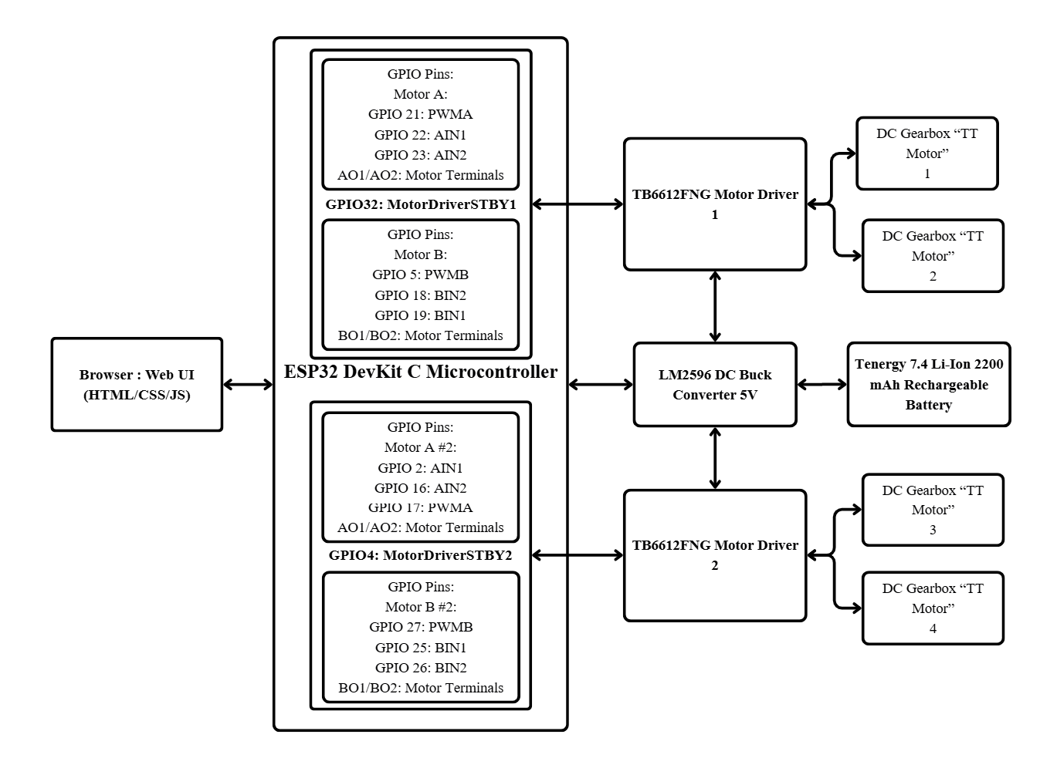
Pinout Used:
TB6612FNG Motor Driver 1 & 2 | ESP32-WROOM-32E
Motor AIN1 (Motor A) | GPIO 22
Motor AIN2 (Motor A) | GPIO 21
PWMA1 (Motor A) | GPIO 23
Motor BIN1 (Motor B) | GPIO 19
Motor BIN2 (Motor B) | GPIO 18
PWMB1 (Motor B) | GPIO 5
Motor Driver STBY 1 (Motor Driver #1) | GPIO 32
Motor AIN1 (Motor C) | GPIO 2
Motor AIN2 (Motor C) | GPIO 16
PWMA1 (Motor C) | GPIO 17
Motor BIN1 (Motor D) | GPIO 25
Motor BIN2 (Motor D) | GPIO 26
PWMB1 (Motor D) | GPIO 27
Motor Driver STBY 1 (Motor Driver #2) | GPIO 4

Analysis & Results:
We were able to create a Web Interface that allowed real-time control of the robot through the ESP32’s Wi-Fi. The robot responded correctly to all movement commands (forward, backward, left, right, and stop) and operated well during testing. One limitation observed was the wheel performance. The wheels produced noticeable noise and resistance, especially during left and right turns. Upgrading to higher-quality wheels or using a different traction material would improve movement smoothness and efficiency. Despite this, the robot performed functions effectively and provided the user with an enjoyable experience, especially when using a touchscreen device, which made the controls feel more natural and responsive.

Video Demonstrations Links:
- https://drive.google.com/drive/folders/1Z1n1CEIT03VmvK7F4xq60eIc1RUjuvVK?usp=sharing
- https://youtube.com/shorts/Mxwh_CG7am0?feature=share
Conclusion:
Overall, our project successfully produced a fully controlled robot through our customed Web Interface, using the Wi-Fi feature that the ESP32-WROOM-32E has and it demonstrates stable operation, real time commands, and it was simple yet effective for user interaction. Utilizing, a touch screen device is more intuitive compared to using mousepad to just click.
GitHub Repository Link:
https://github.com/Antwann03/LOG
References:
- Espressif Systems. ESP32-WROOM-32E / ESP32-WROOM-32UE Datasheet. Espressif Systems, 2021, documentation.espressif.com/esp32-wroom-32e_esp32-wroom-32ue_datasheet_en.pdf. PDF download.
- SparkFun. TB6612FNG Dual Motor Driver Carrier – TB6612FNG Datasheet. SparkFun Electronics, 2012, cdn.sparkfun.com/datasheets/Robotics/TB6612FNG.pdf. PDF download.
- “Instructables.” “Driving Small Motors With the TB6612FNG.” Instructables, www.instructables.com/Driving-Small-Motors-With-the-TB6612FNG/. Accessed 8 Dec. 2025.
- “Getting Started with ESP32-CAM.” Last Minute Engineers, lastminuteengineers.com/getting-started-with-esp32-cam/. Accessed 8 Dec. 2025.
- “Installing ESP32 Arduino IDE 2.0.” Random Nerd Tutorials, randomnerdtutorials.com/installing-esp32-arduino-ide-2-0/. Accessed 8 Dec. 2025.
- “PlatformIO Setup for ESP32 with ESP-IDF.” Espressif Docs, docs.espressif.com/projects/esp-idf/en/stable/esp32/third-party-tools/platformio.html. Accessed 8 Dec. 2025.
- “Getting Started with ESP32 - Step-By-Step Tutorial” - YouTube.” YouTube, uploaded by user (Tomasz Tarnowski), - (Oct 28, 2021), www.youtube.com/watch?v=tc3Qnf79Ny8&t=187s. Accessed 8 Dec. 2025.
- “Getting Started with PlatformIO - YouTube.” YouTube, uploaded by user (DroneBot Workshop), - (Jam 16, 2021), www.youtube.com/watch?v=JmvMvIphMnY&t=142s. Accessed 8 Dec. 2025.

