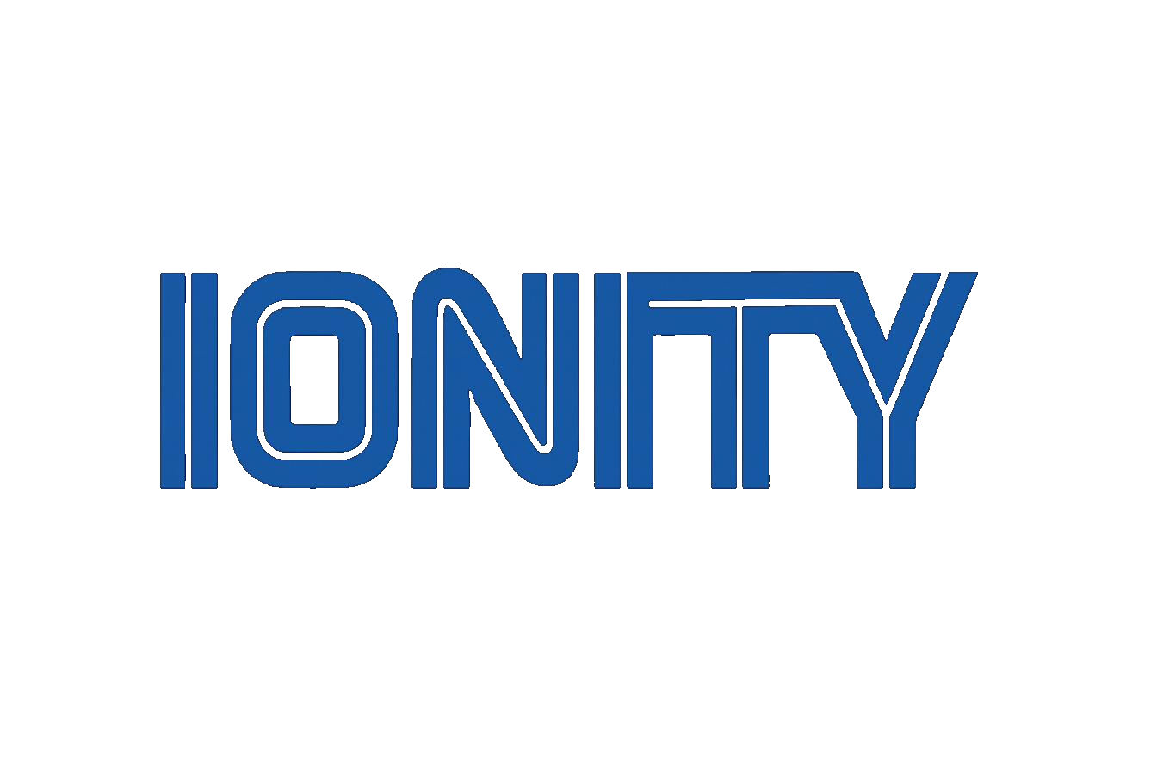

IONITY GLOBAL (Pty) Ltd
PROCESS BRIEFING NOTE
Zone → Ai-OS: The Shopping-Mall Implementation Model
Explaining the interactive diagram for the NDOH Digital Health Discovery engagement
Date | 22 August 2026
Category | Digital Health · AI Systems Architecture — NDOH IT-Discovery (Phase 1)
Attendees | Johan Wilhelm van Antwerp (Ionity Global) · NDOH HIV, TB & MCWH (Missy) · Dr Ndombe (facilitator) · Shout-It-Now
Reference | ION-NDOH-SOW-2026-001 (companion note)

Building Tomorrow, Today
www.ionity.today | ai@ionity.today | +27 64 699 9877
CONFIDENTIAL - ION-NDOH-BRIEF-2026-001 | Version 1.0 | 22 August 2026

Index - Table of Contents
Executive Summary
1. The Five Stages, Mapped
2. Where This Sits in the Engagement
3. Sources & Open Items
Action Items & Next Steps

Executive Summary
CONTEXT Companion note to the Zone → Ai-OS interactive diagram delivered alongside Phase 1 of the NDOH Digital Health Discovery engagement (ref. ION-NDOH-SOW-2026-001). The diagram shows the implementation model visually and deliberately explains nothing; this note carries the explanation.

The diagram maps five stages — Zone, Assets, Push AI, Network, Ai-OS — onto the Department's own vision for a governed digital health ‘shopping mall’, as set out in the August 2026 scoping discussions between the NDOH (HIV, TB & MCWH Branch), Dr Ndombe, Shout-It-Now and Ionity Global, and formalised in the Phase 1 Preliminary Scope of Work.
In short: the mall is the Zone; every existing patient-facing tool — B-Wise, Self-Help for Youth, MomConnect and others confirmed with the Technical Working Group — is an Asset placed inside it, audited rather than rebuilt; AI-assisted routing between life stages is the intelligence Pushed into the mall's core; tools that were never connected become one Network; and the endpoint is a single, governed, life-course Ai-OS. Phase 1 — the IT-Discovery & Status Audit now underway — exists solely to earn the evidence that makes stages two through five possible; nothing is built, hosted or connected until that audit closes.
5 | 8 | R200k–R250k
Implementation stages | Audit fields per tool | Indicative Phase 1 budget

1. The Five Stages, Mapped
Each stage of the diagram corresponds to a concrete move inside the Department's own model:
- Zone — the governed hosting platform itself: the Department owns and governs the mall; nothing is hosted inside it yet.
- Assets — every existing patient-facing tool takes its place as a shop inside the mall (B-Wise, Self-Help for Youth, MomConnect, partner tools and others confirmed with the TWG), audited in place rather than rebuilt.
- Ownership, hosting, architecture, data, security/POPIA, integration-readiness, reach and support are each scored per tool — the eight audit fields of Phase 1.
2. Where This Sits in the Engagement
- Origin: an introductory scoping meeting (August 2026) between Johan (Ionity Global), Missy (NDOH, HIV TB & MCWH), Dr Ndombe (facilitator) and a Shout-It-Now representative, aligning on the Department's life-course digital health vision.
- Guiding principle carried into every stage of the diagram: audit first — architect second — build third. Phase 1 produces evidence only (Tool Registry, Status-Audit Scorecards, Integration-Readiness Matrix, Findings & Roadmap Report, Executive Briefing — D1 to D5); it does not build, host or connect anything.
The diagram shows the destination the Department is working toward — it is not a description of Phase 1's own deliverables. Stages 3 to 5 (Push AI, Network, Ai-OS) follow from the roadmap Phase 1 produces; they are explicitly out of scope for this phase.
3. Sources & Open Items
What this note draws on
- Meeting notes: introductory NDOH / Shout-It-Now / Ionity Global scoping session, August 2026 (“Meeting one”).
- Preliminary Scope of Work — National Scale South Africa, Phase 1: IT-Discovery & Status Audit, ref. ION-NDOH-SOW-2026-001, v1.2.1, 21 August 2026.
Action Items & Next Steps
- ▢ Confirm this diagram and the mapping above with the NDOH programme lead (Missy) before it is used in any external-facing material — owner: Johan.
- ▢ Introduction to the Technical Working Group; begin Week 1 — Discover, per the Phase 1 timeline — owner: Johan / NDOH TWG.
- ▢ Open item: a second meeting-notes file supplied alongside this request was empty on upload — flagged for Johan to re-export and re-send if there is content to fold in.

Prepared by Ionity Global (Pty) Ltd - ai@ionity.today - www.ionity.today

