AIRLINE PASSENGER SATISFACTION ANALYSIS
SQL Data Analysis Documentation
Project: Data Analytics Portfolio
Database: db_airline
Table: dbo.airline_passenger_satisfaction
Total Records: 129,880 passengers
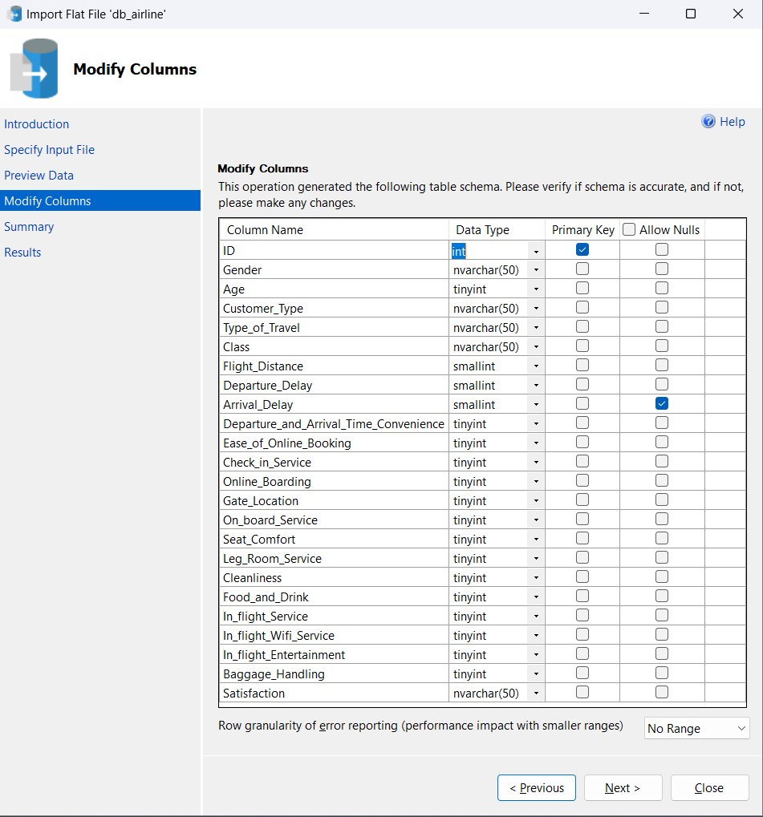
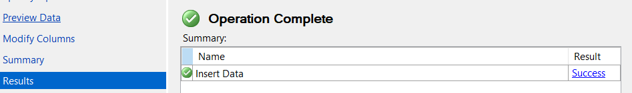
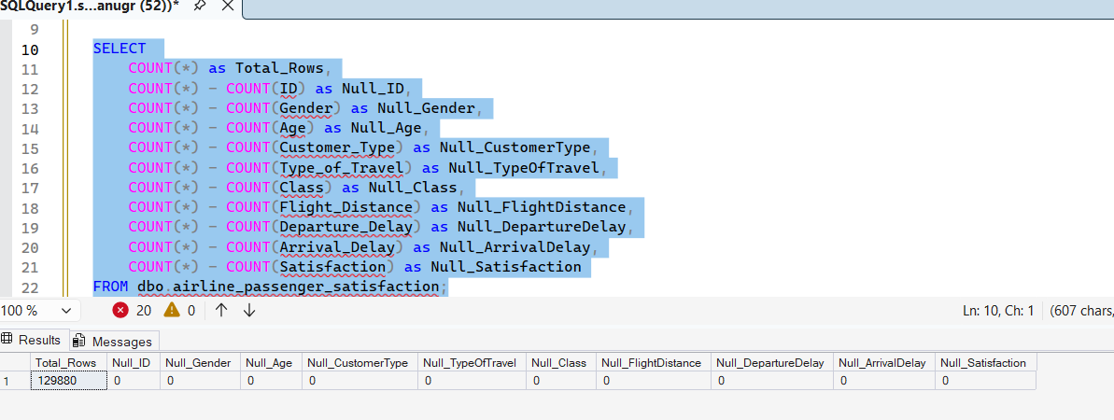
Initially there were NULL values in the delay columns. I checked the business context and treated them as zero because NULL represented flights without delay. I validated the result by rechecking the number of NULLs after the update

Total Passenger
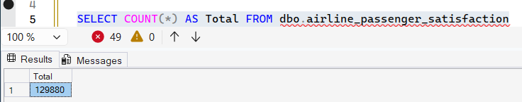
Satisfaction Distribution
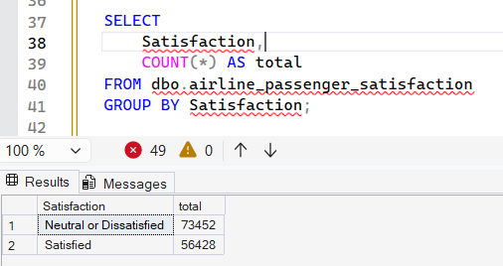
Satisfaction by Customer Type
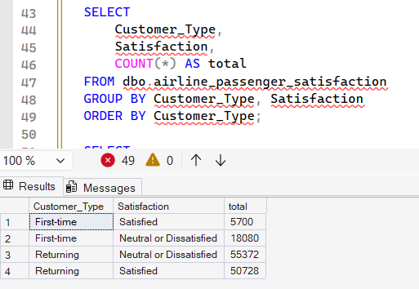
Satisfaction by Class
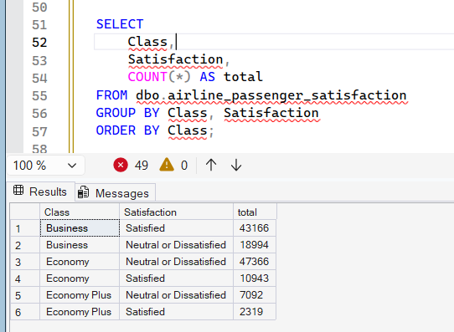

Average Service Rating
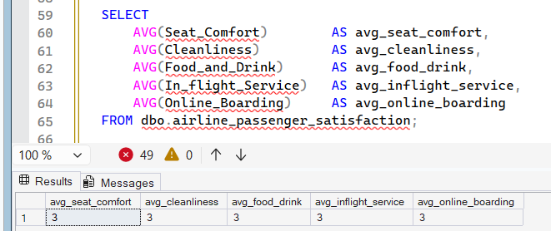
Arrival Delay vs Satisfaction
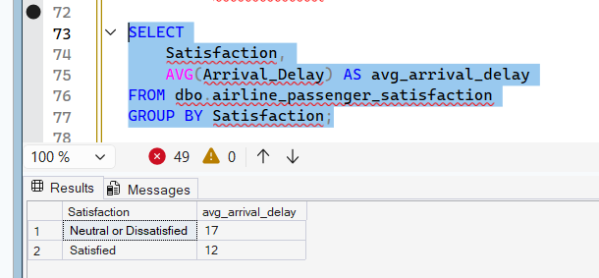
Delay by Travel Type
