**Q1) Pull any image from the docker hub, create its container, and execute it showing the output.**

docker pull is used to download the image from the docker daemon.

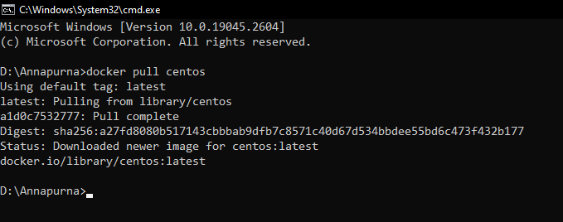

docker run command creates running containers and executes it.

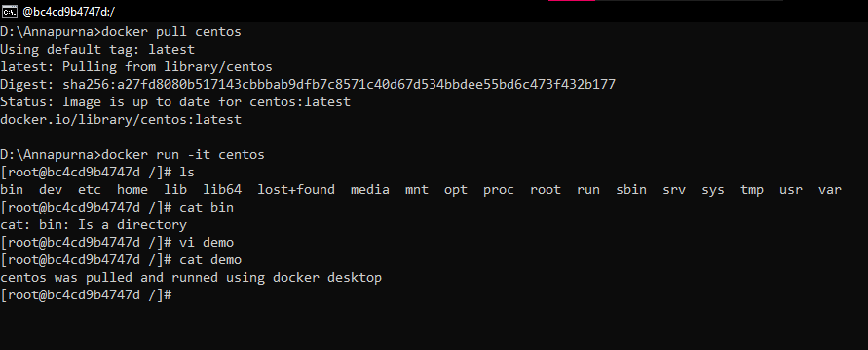

**Q2) Create the basic java application, generate its image with necessary files, and execute it with docker.**

First I have created a directory using mkdir command.



I have created a Hello.java file in the java-docker-app folder and saved it.

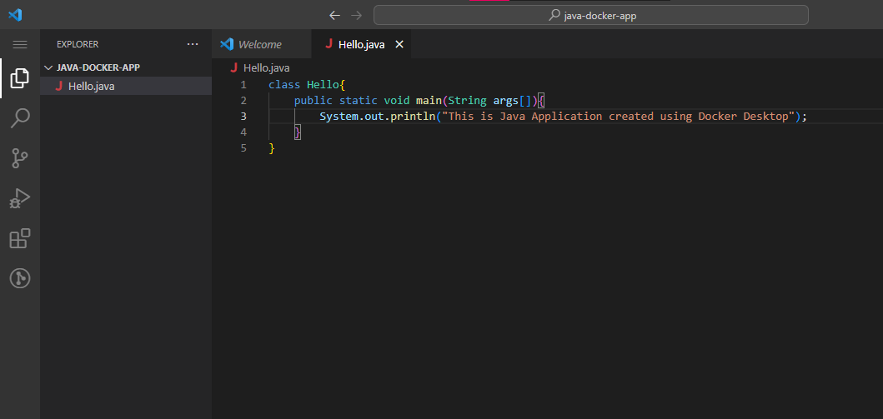

Then I have created another file named Dockerfile and added the below content in it.

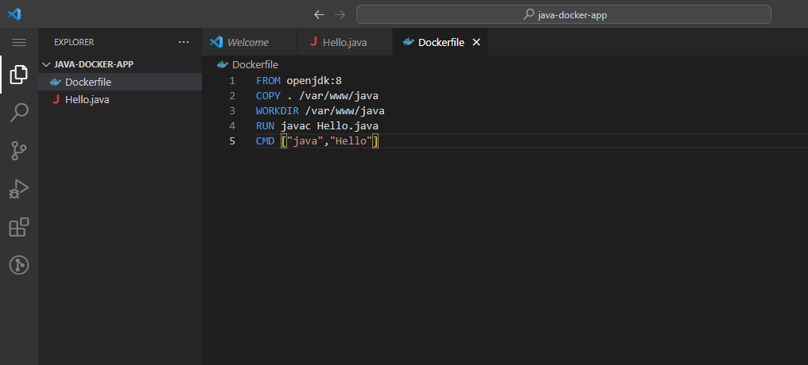

Now I have changed the directory to java-docker-app.

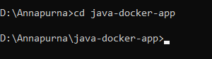

I have used the build command to create a java-app image

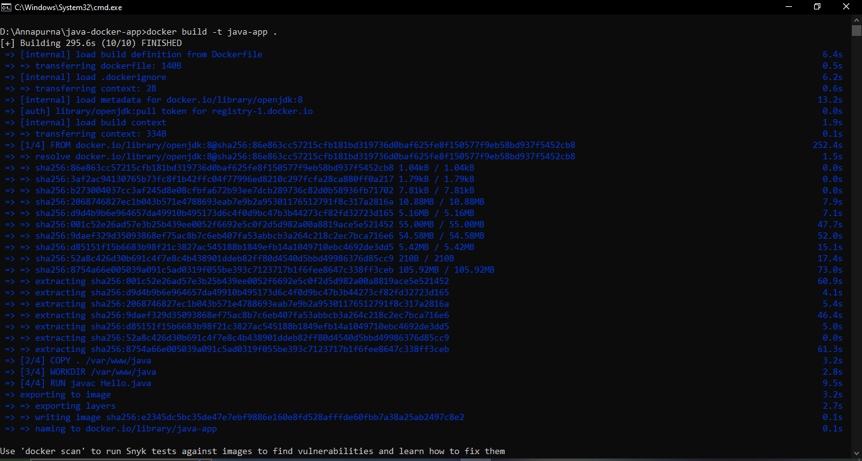**docker build –t java-app .**

To run the java-app application used the following command

docker run java-app

