**1.EC2 Instance Launch Page**

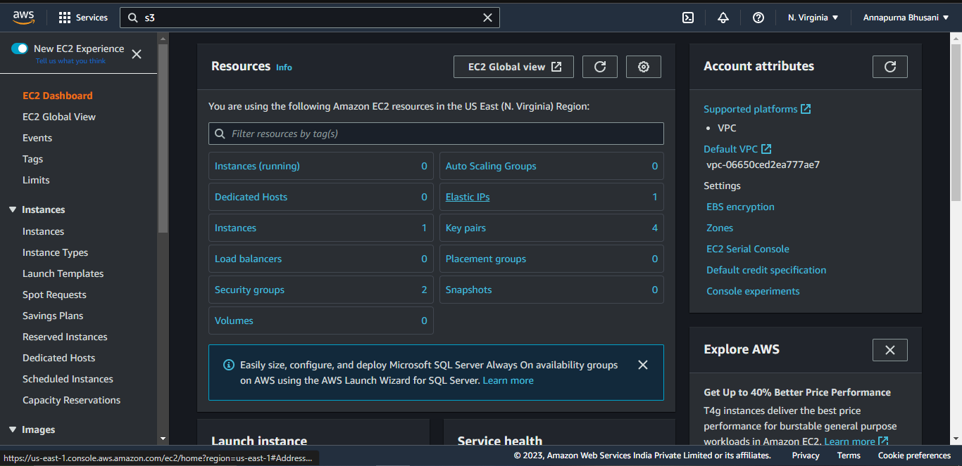

**2. EC2 Name and Tag Creation**

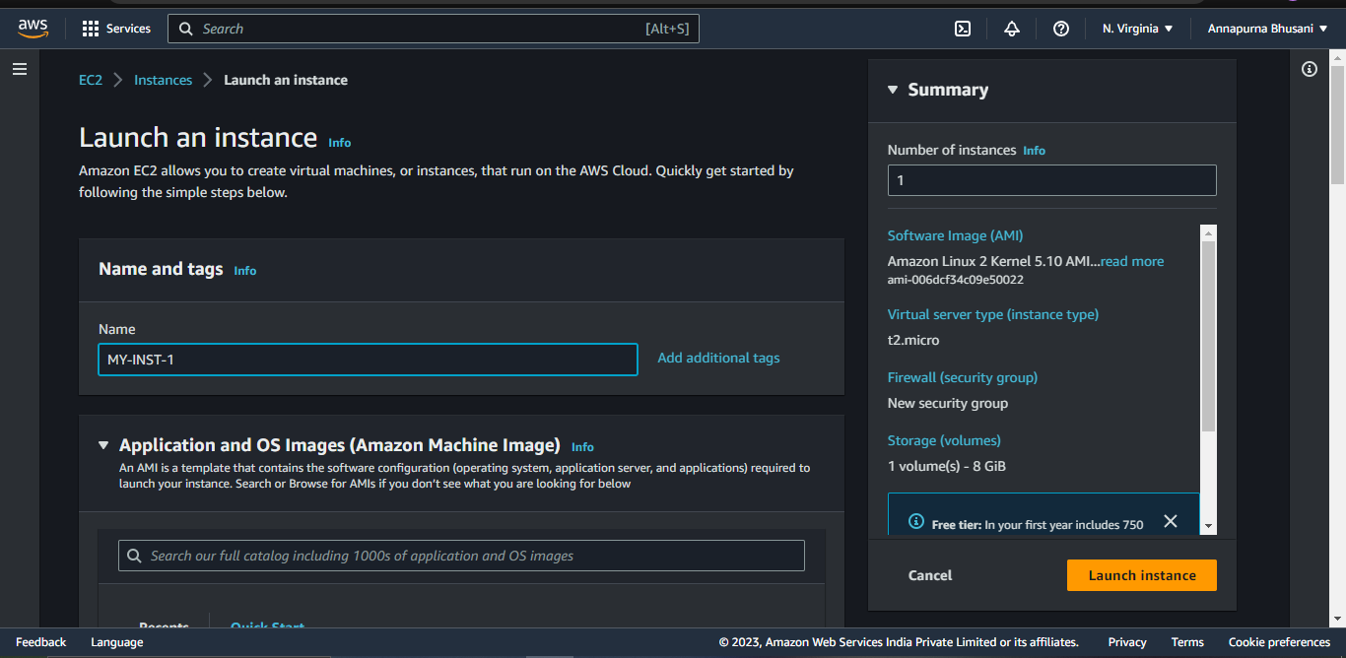

**3. EC2 AMI Selection**

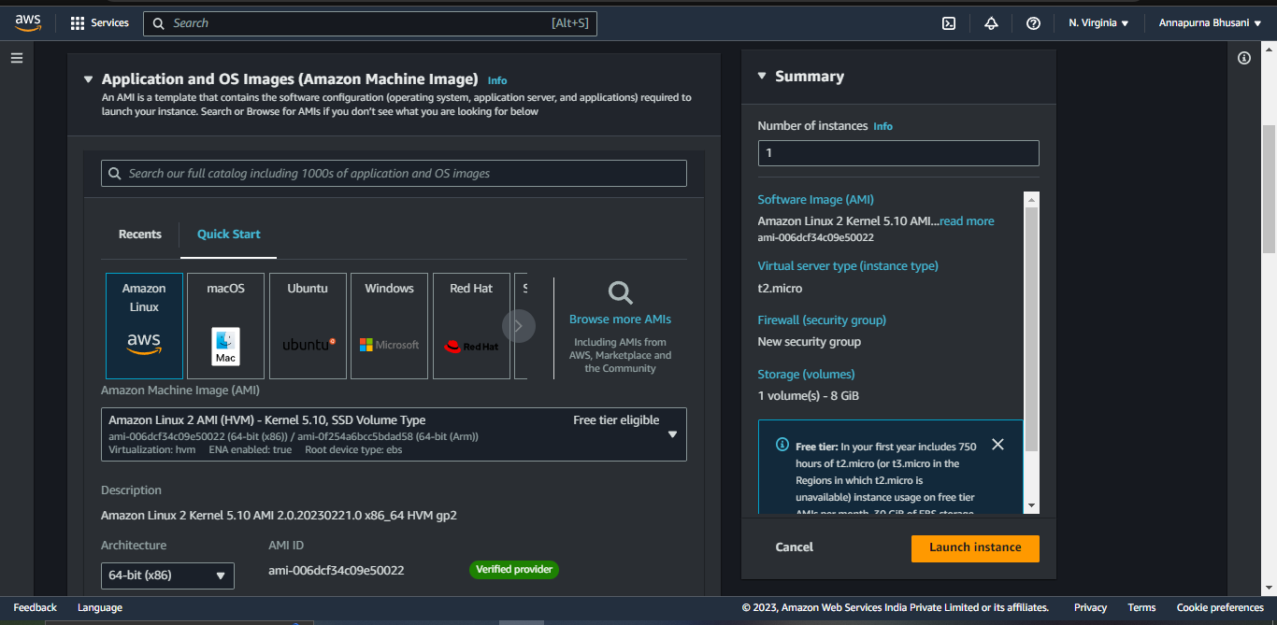

**4. EC2 Key Pair Creation**

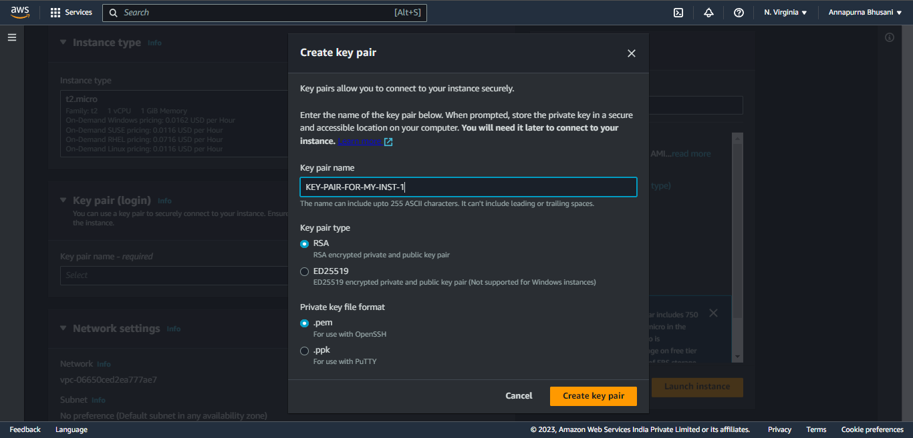

**5. EC2 Security Group Creation ( SSH,HTTP,HTTPS)**

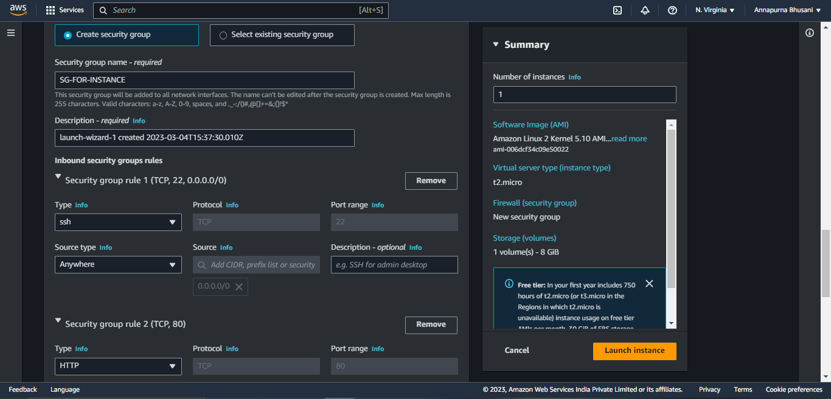

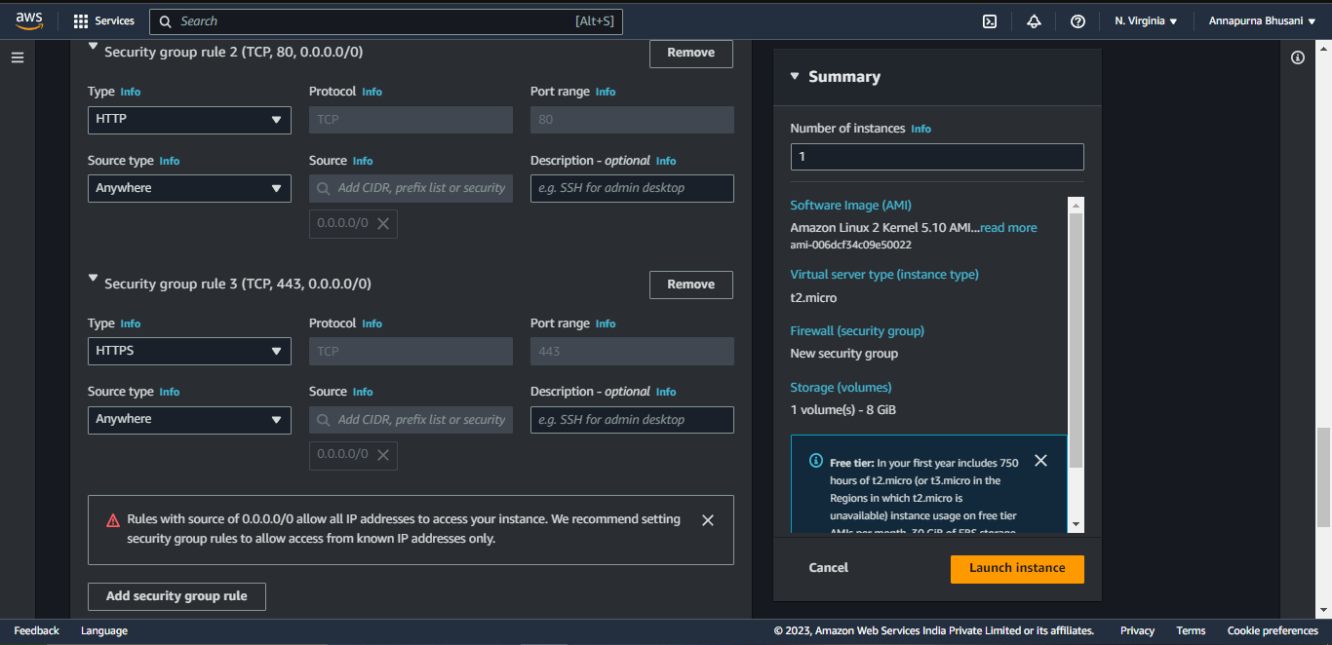

**6. EC2 VPC and Subnet Selection**

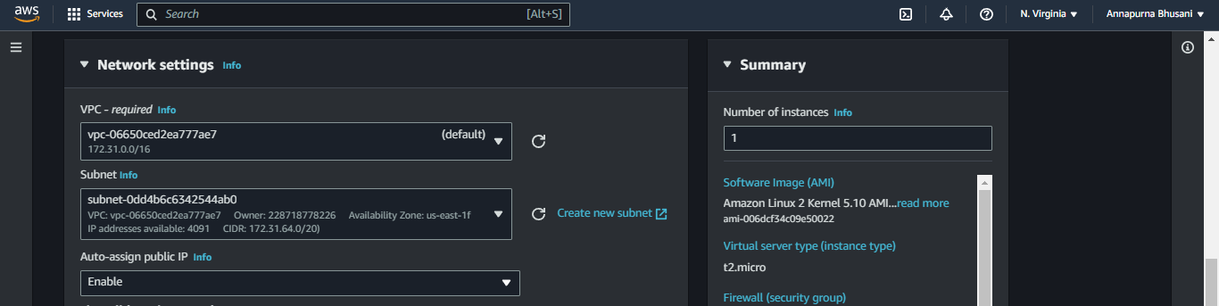

**7. EC2 EBS Volume Selection**

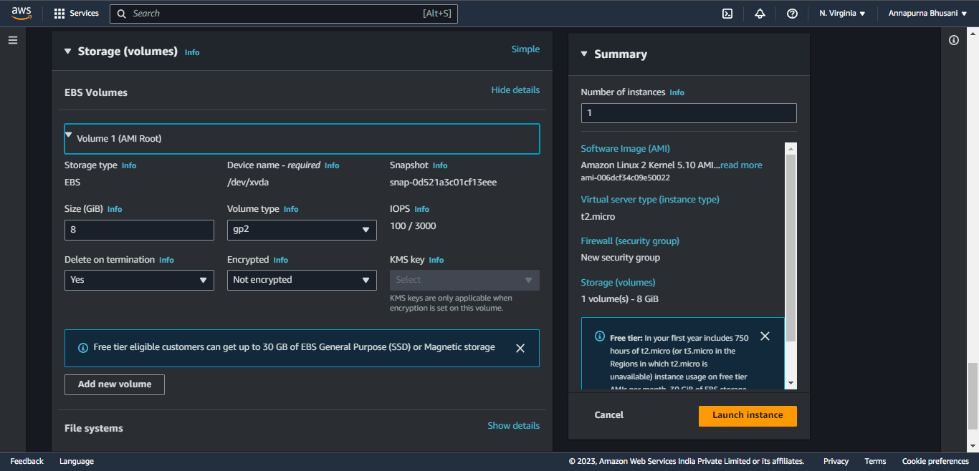

**8 . User Data Insertion Page with below command**

*#!/bin/bash*

*yum update -y*

*yum install httpd -y*

*service httpd start*

*chkconfig httpd on*

*IP_ADDR=$(curl*[*http://169.254.169.254/latest/meta-data/public-ipv4*](http://169.254.169.254/latest/meta-data/public-ipv4)*)*

*echo "Manual instance with IP $IP_ADDR" > /var/www/html/index.html*

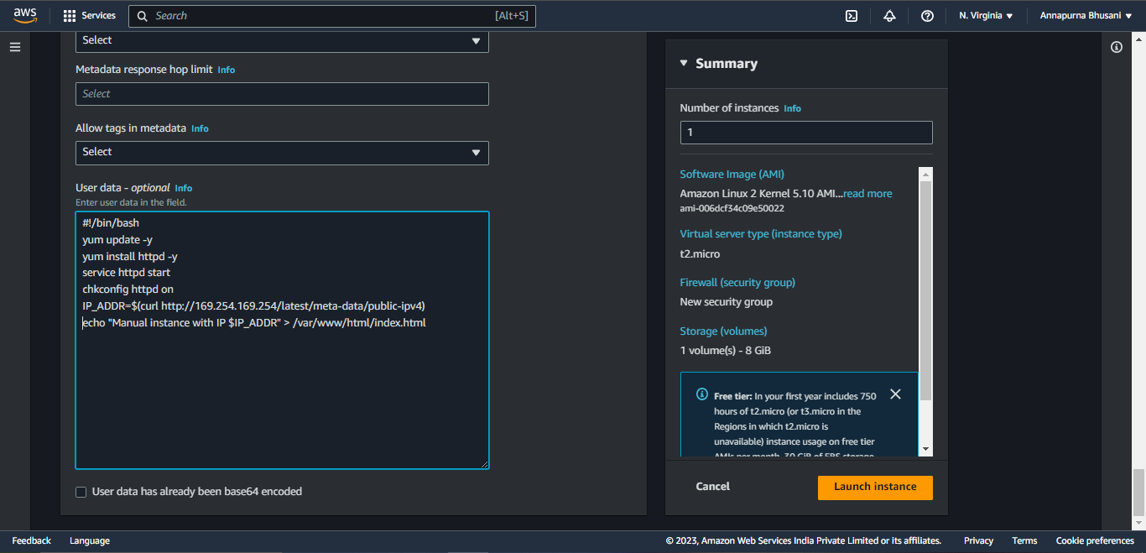

**9.  EC2 Launch Logs**

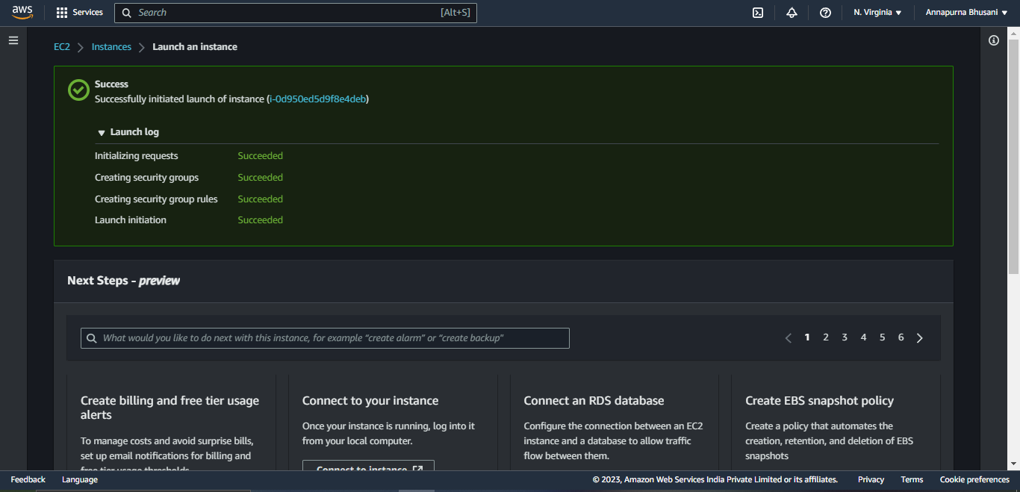

**10 . EC2 Instance Running State**

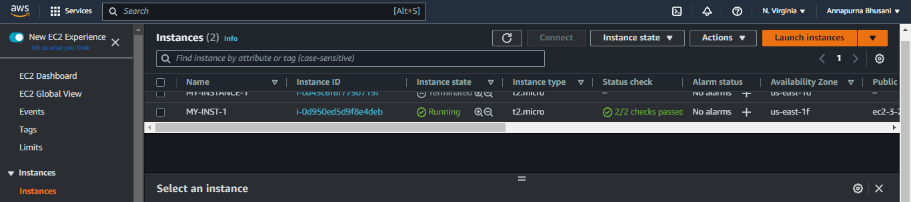

**11. EC2 Summary Page with Public and Private IP**

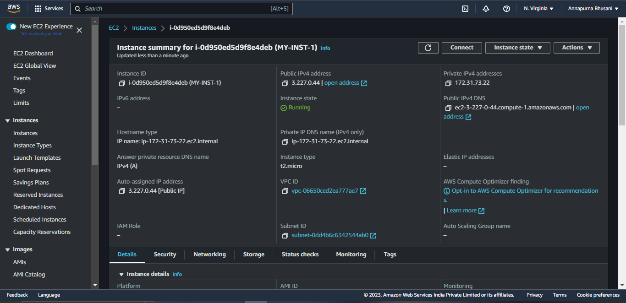

**12. EC2 Instance Monitoring Page**

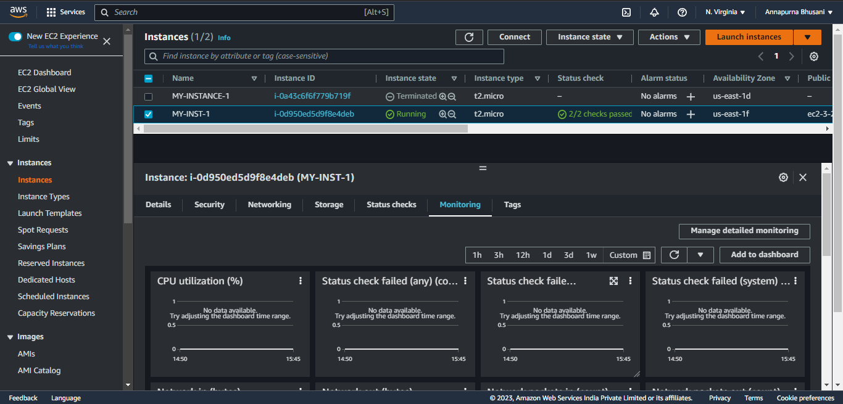

**13.  SSH Access of EC2 instance in Local Machine.**

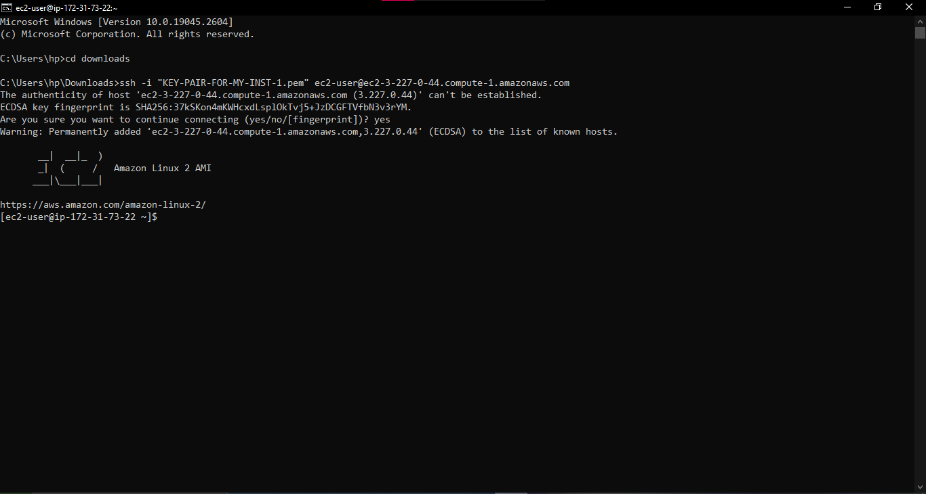

**14. Browsing  EC2 instance in the Browser Local Machine.**

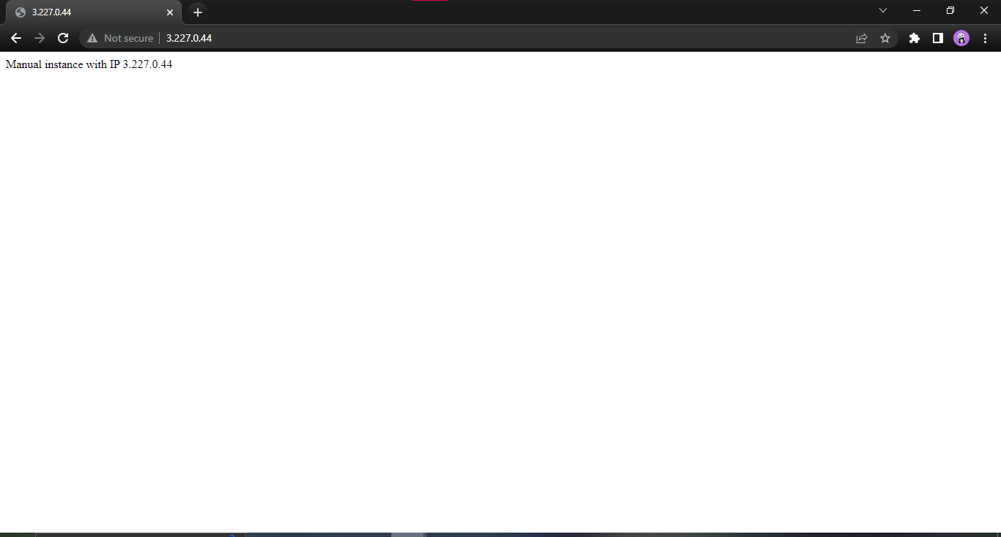

**15. Terminating the Resource.**

