Chronexa TimePro
Workforce & Attendance Management System
Admin Role — Full System Reference

Table of Contents
- System Overview ........................................ 3
- Login & Authentication .............................. 5
- Dashboard – User Insights .......................... 7
- Company Master ........................................ 8
- Organisation .......................................... 12
- Employee Master ...................................... 15
- Scheduling ............................................ 22
- Self Services ......................................... 26
- Manage Approvals ..................................... 30
- Reports .............................................. 32
- Configuration & RBAC ............................... 34
- Settings ............................................. 40
- Alerts ............................................... 41
- User Management ..................................... 42
Appendix A – Role Privilege Summary .................. 44
Appendix B – Glossary .................................. 45

1. System Overview

What is Chronexa TimePro?
Chronexa TimePro is a comprehensive web-based Workforce & Attendance Management System built for the project. It automates employee scheduling, real-time attendance tracking via biometric devices and web punch, leave and permission management, multi-level approval workflows, and rich reporting — all in a single unified platform.

Role-Based Access
The system operates on a Role-Based Access Control (RBAC) model. Three primary roles govern what each user sees and can do:

Role | Modules Accessible | Description
Admin | All modules: Dashboard, Company Master, Organisation, Employee Master, Scheduling, Self Services, Manage Approvals, Reports, Configuration, Settings, Alerts, User Management | Full system access. Configures all master data, roles, and settings.
Manager | Dashboard, Scheduling, Self Services, Manage Approvals, Reports | Manages team schedules, approves leave/punch requests, views team attendance.
Timekeeper | Self Services, Reports | Records and manages attendance punches for their assigned area. Submits missing punch corrections.

Module Access Summary
Module | Admin | Manager | Timekeeper
Dashboard — User Insights | ✔ | ✔ (limited) | —
Company Master | ✔ | — | —
Organisation | ✔ | — | —
Employee Master | ✔ | — | —
Scheduling | ✔ | ✔ | —
Self Services — Punches | ✔ | ✔ (Team) | ✔ (My & Team)
Self Services — Leaves | ✔ | ✔ (Team) | —
Self Services — Permissions | ✔ | ✔ (Team) | —
Manage Approvals | ✔ | ✔ | —
Reports | ✔ | ✔ | ✔
Configuration / Roles | ✔ | — | —
Settings | ✔ | — | —
Alerts | ✔ | — | —
User Management | ✔ | — | —

2. Login & Authentication
All users — Admin, Manager, and Timekeeper — access Chronexa TimePro through the same login screen. The system automatically loads the dashboard and sidebar modules permitted by the logged-in user's role.

Login Steps
- Open the Chronexa TimePro URL in your browser (e.g. https://timepro.chronexa.ai).
- Enter your Username in the first field.
- Enter your Password. Use the eye icon to toggle visibility.
- Optionally check Remember Me to stay logged in.
- Click the blue LOGIN button.
- Alternatively, click Sign In With Azure AD to authenticate via Microsoft Azure Active Directory.

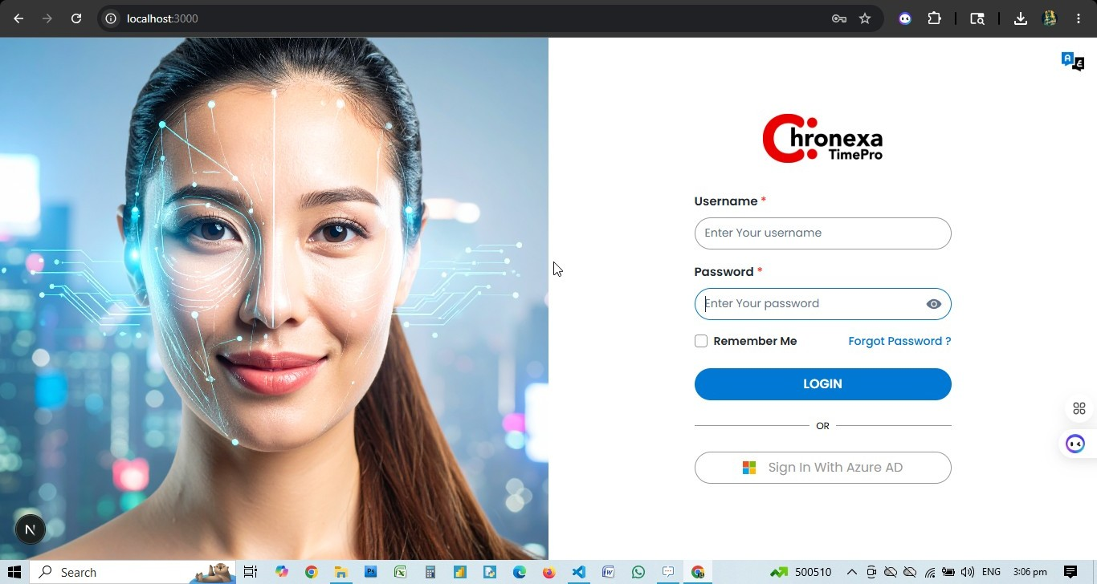

Forgot Password
Click the "Forgot Password?" link on the login screen. Enter your registered email address. The system sends a password reset link to your inbox.

💡 After login, the sidebar menu reflects only the modules your role permits. Admin users see all 12+ menu items; Managers see 4; Timekeepers see 2.

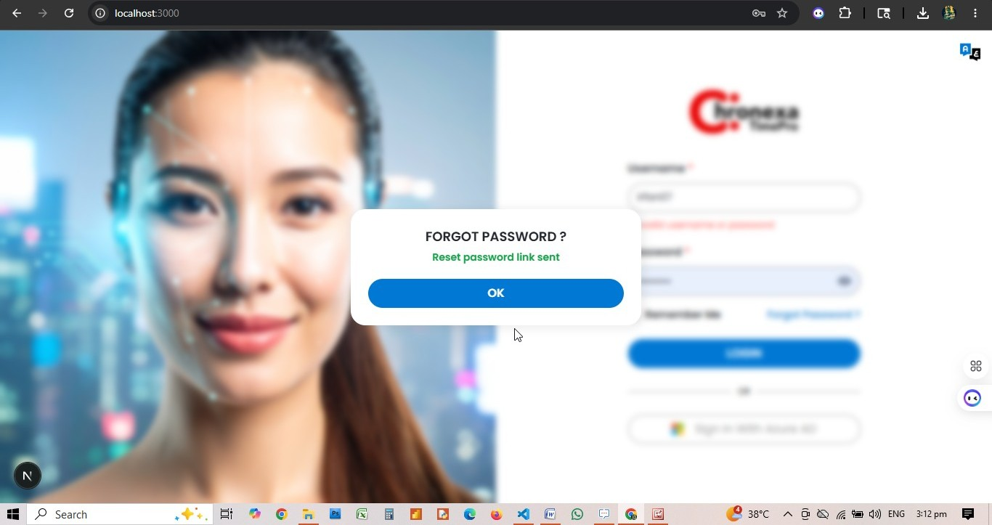

3. Dashboard — User Insights
Role: ADMIN
The Dashboard is the first screen after login. For Admin users, the User Insights tab provides organisation-wide attendance analytics in real time.

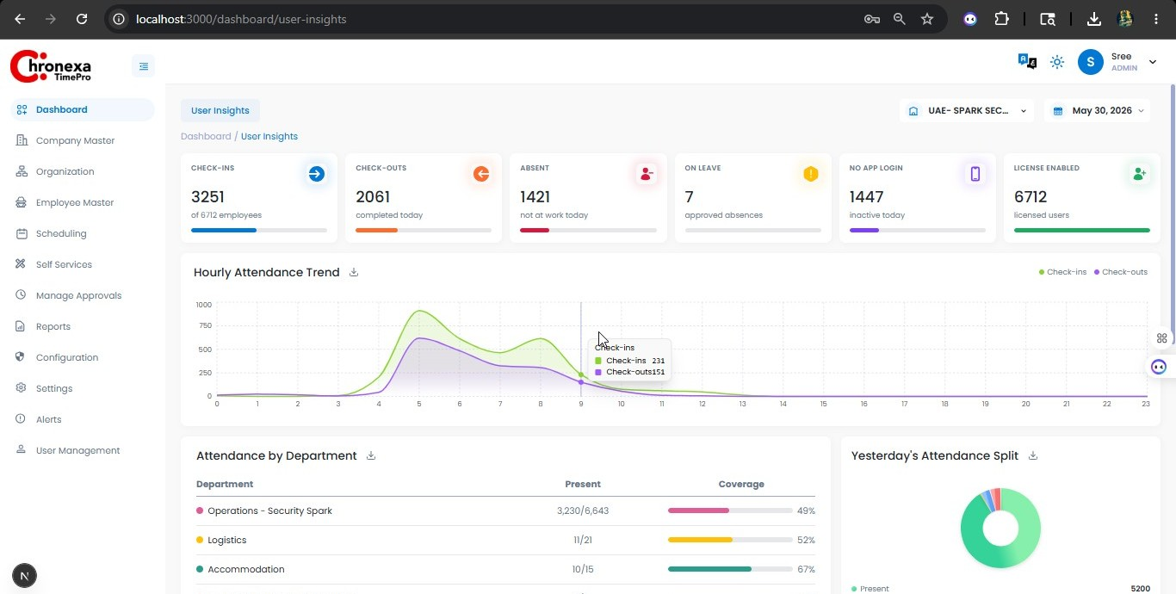
Fig 3.1 — Admin Dashboard: Locations View (Company Master)

KPI Cards (User Insights)
KPI Card | Value Example | Meaning
CHECK-INS | 3355 of 6712 | Total employees who punched in today
CHECK-OUTS | 2046 | Employees who completed their shift
ABSENT | 1322 | Employees with no punch and no approved leave
ON LEAVE | 7 | Employees on approved leave today
NO APP LOGIN | 1357 | Employees inactive (no app login today)
LICENSE ENABLED | 6712 | Total active licensed users in the system

Dashboard Charts
- Hourly Attendance Trend — line chart showing check-ins and check-outs by hour of the day.
- Attendance by Department — table showing Present count and Coverage % per department.
- Yesterday's Attendance Split — donut chart: Present, No Licensed, Missed In, Missed Out.
- Overtime & Hours Worked — avg hours, overtime users, early departures, shift coverage.
- Weekly Attendance Trend — bar chart: Present, Absent, On Leave per day of the week.

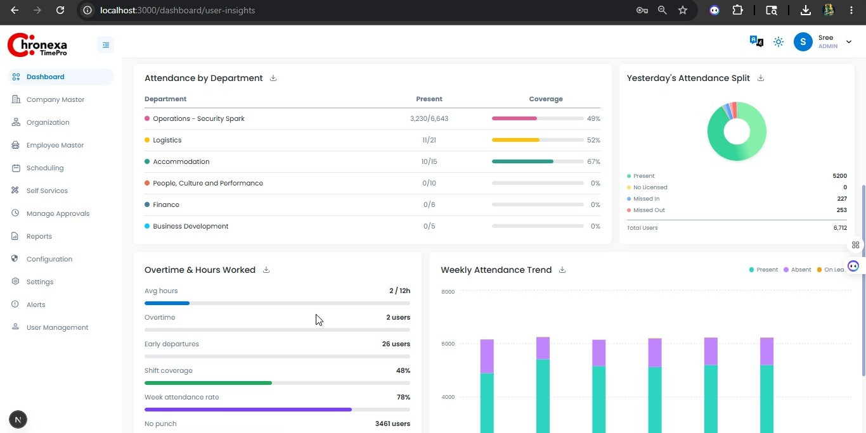
💡 Use the organisation/company filter at the top right and the date picker to scope the dashboard to a specific entity or date.
4. Company Master
Role: ADMIN
Company Master contains reference data used across employee profiles and scheduling. These must be configured before employees can be created.

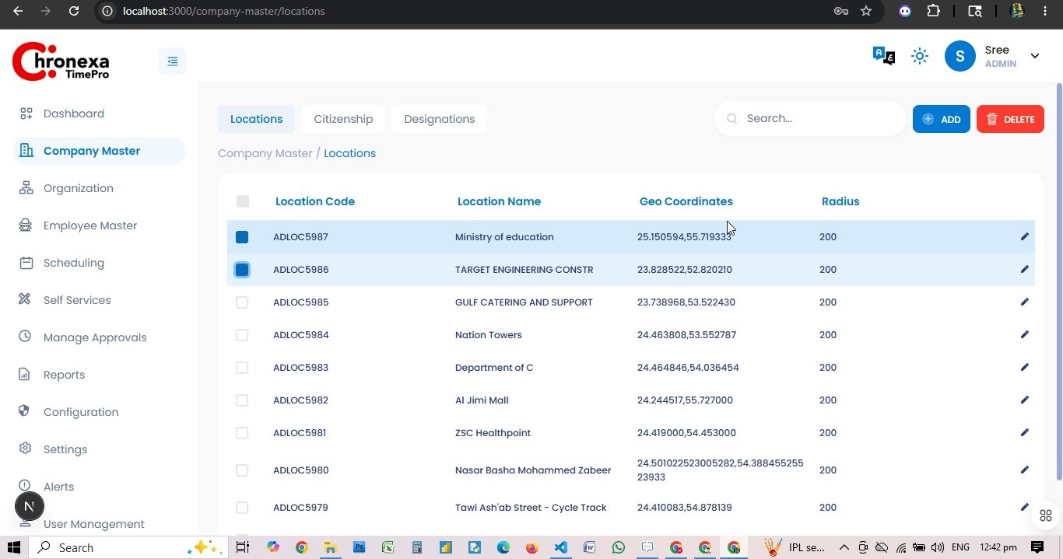
Fig 4.1 — Company Master: Locations List

Locations
Locations define physical work sites used for geofencing attendance punches. Each location has a code, name, GPS coordinates, and a radius (in metres).

Field | Description
Location Code | Unique identifier (e.g. ADLOC5987)
Location Name | Descriptive name (e.g. Ministry of Education)
Geo Coordinates | Latitude, Longitude in decimal format (e.g. 25.150594, 55.719333)
Radius | Geofence radius in metres (default: 200m)
Country Code | Country associated with the location
City | City where the location is situated

How to Add a Location
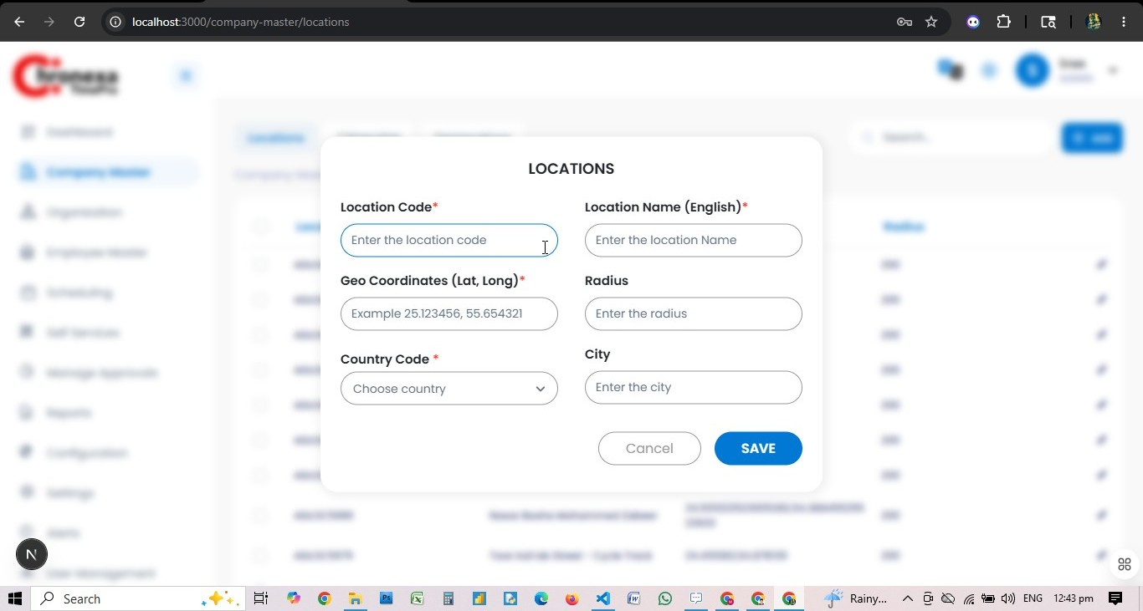
Fig 4.2 — Add Location Dialog
- Navigate to Company Master → Locations tab.
- Click the + ADD button at the top right.
- Enter the Location Code (unique identifier).
- Enter the Location Name in English.
- Enter Geo Coordinates in decimal format (Latitude, Longitude).
- Enter the geofence Radius in metres.
- Select the Country Code from the dropdown.
- Enter the City name.
- Click SAVE to create the record.

Citizenship

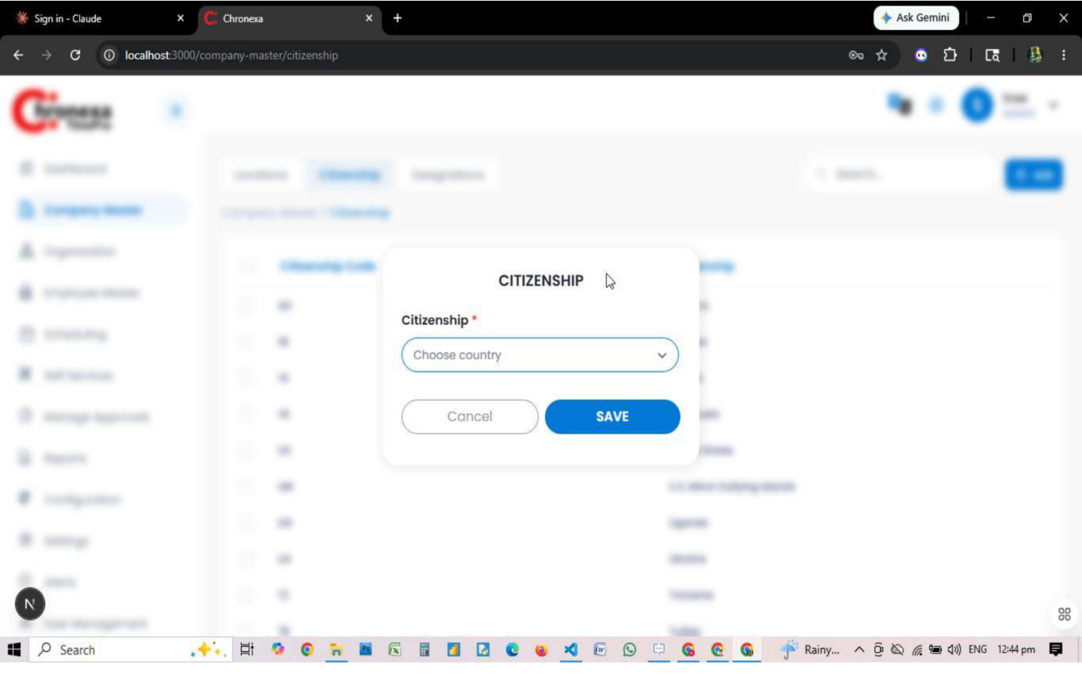
Fig 4.3 — Add Citizenship Dialog
Citizenship records define nationality options used in employee profiles.
- Navigate to Company Master → Citizenship tab.
- Click + ADD and choose a country from the dropdown.
- Click SAVE.

Designations
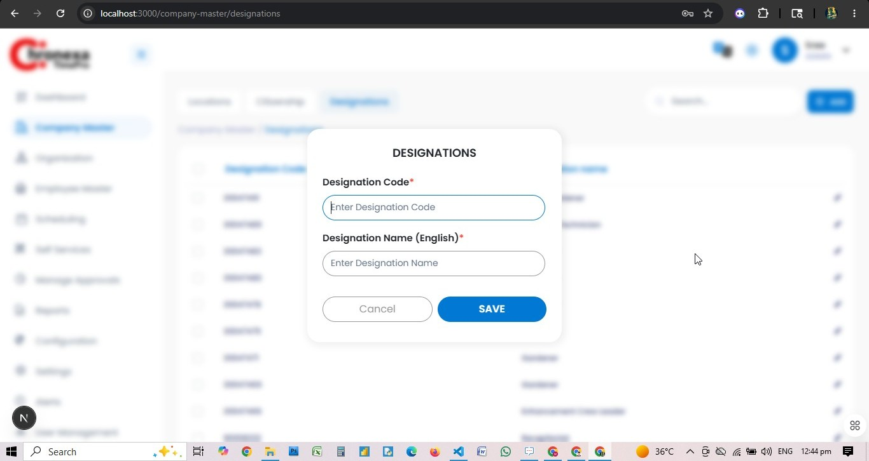
Fig 4.4 — Add Designation Dialog
Designations define job titles assigned to employees.
Field | Description
Designation Code | Unique code for the designation
Designation Name (English) | Title name in English

💡 Navigate to Company Master via the left sidebar. Use the + ADD button to create new records. Click the pencil icon to edit any existing record.

5. Organisation
Role: ADMIN
The Organisation module defines the company hierarchy. It must be configured before employees can be onboarded or schedules created.

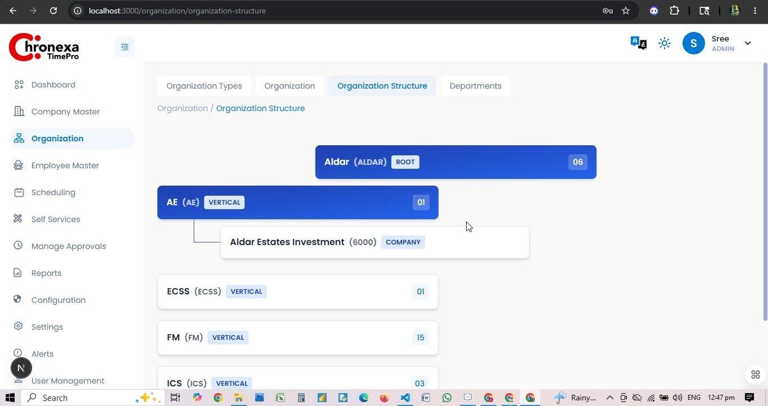
Fig 5.1 — Organisation Structure Tree

Organisation Type

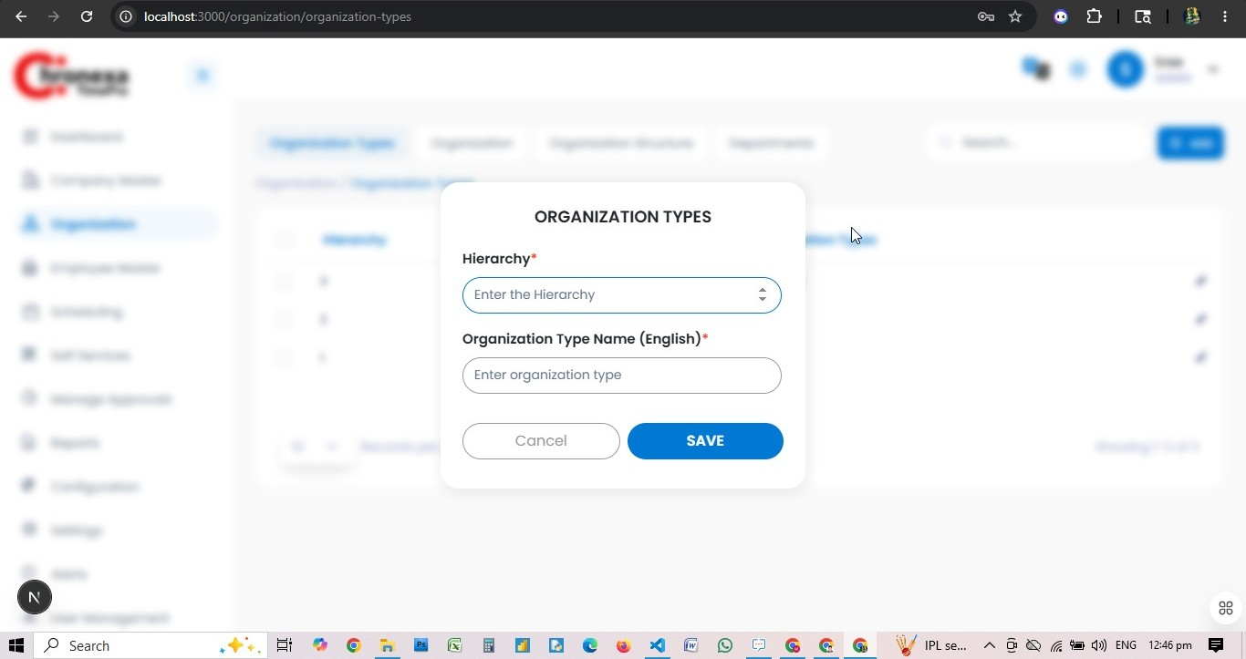
Fig 5.2 — Add Organisation Type Dialog
Organisation Types define the levels of the hierarchy. The project uses three levels:
Hierarchy Level | Type Name | Description
1 | ROOT | Top-level root organisation
2 | VERTICAL | Business vertical / division (e.g. AE, ECSS, FM)
3 | COMPANY | Individual company entity (e.g. Estates Investment)

Adding an Organisation
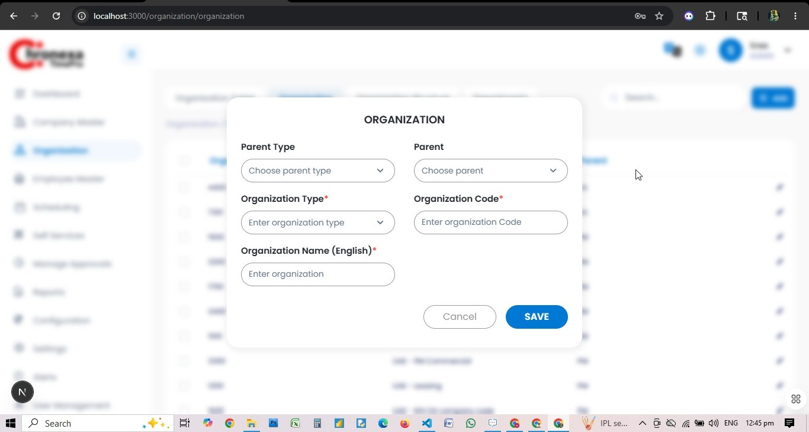
Fig 5.3 — Add Organisation Dialog
- Navigate to Organisation → Organisation tab.
- Click + ADD.
- Select Parent Type (ROOT/VERTICAL/COMPANY).
- Select the Parent organisation from the dropdown.
- Choose Organisation Type.
- Enter the Organisation Code.
- Enter the Organisation Name in English.
- Click SAVE.

Organisation Structure
The Organisation Structure tab renders a visual hierarchy tree of all organisation units, making it easy to verify parent-child relationships.

Departments
Departments belong to a specific Organisation. Each record has a Department Code and Department Name. The system holds 219 departments.

Delegation
Delegation assigns an acting manager when the primary manager is absent. Configure a delegate user, scope (team/org), and the from/to date range.
6. Employee Master
Role: ADMIN

Employee Types
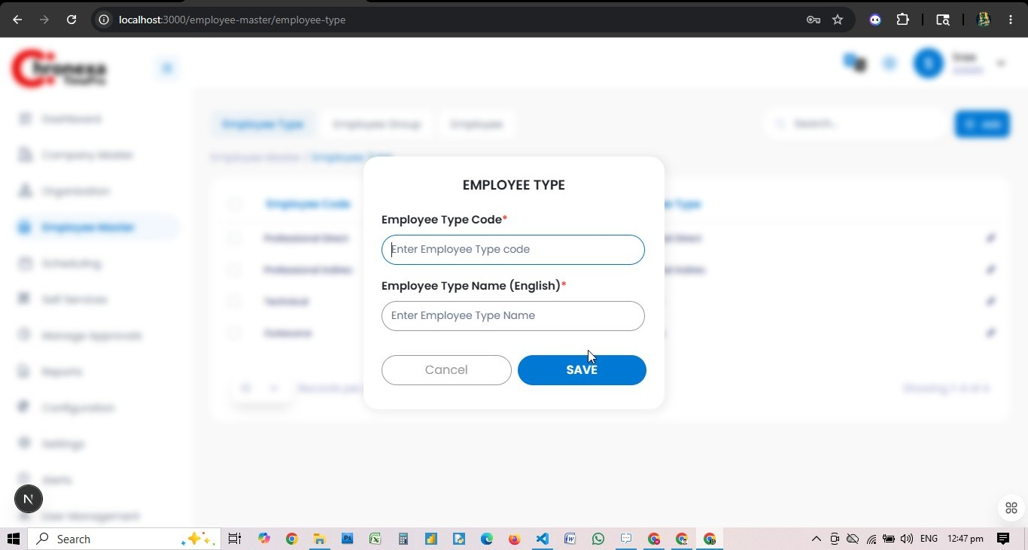
Fig 6.1 — Add Employee Type Dialog
Employee Types classify employees. The project has four types:
Employee Code | Employee Type
Professional Direct | Professional Direct
Professional Indirect | Professional Indirect
Technical | Technical
Outsource | Outsource

Employee Groups

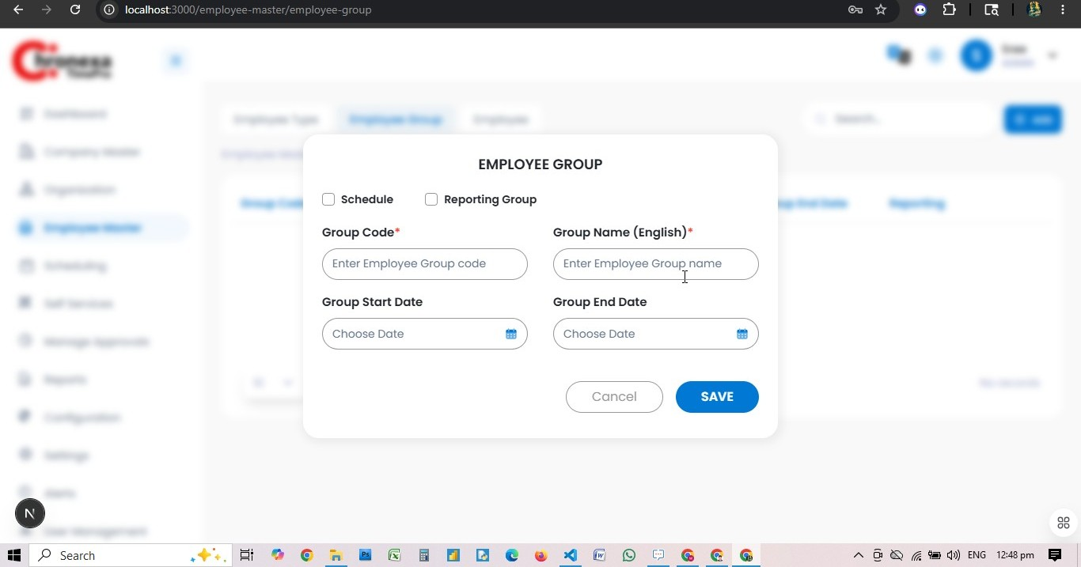
Fig 6.2 — Add Employee Group Dialog
Employee Groups bundle employees for bulk scheduling or reporting. Configure Group Code, Group Name, Start/End Dates, and whether the group is a Schedule group or Reporting group.

Adding an Employee
Employee onboarding follows a multi-step form with three sections: Personal, Credentials, Official, and Flags.
Step 1 — Personal Informatio 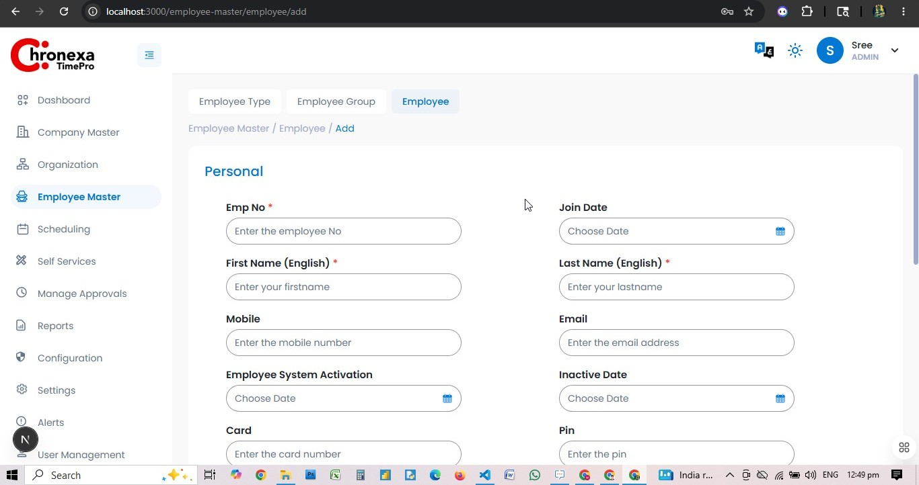
Fig 6.3 — Employee Personal Info Form
Field | Description | Required
Emp No | Unique employee number | Yes
First Name (English) | Employee's first name | Yes
Last Name (English) | Employee's last name | Yes
Join Date | Date of joining | No
Mobile | Mobile phone number | No
Email | Email for notifications and login | No
Employee System Activation | Date when system access is activated | No
Inactive Date | Date when employee becomes inactive | No
Card | Biometric card number | No
Pin | Biometric device PIN | No

Step 2 — Credentials

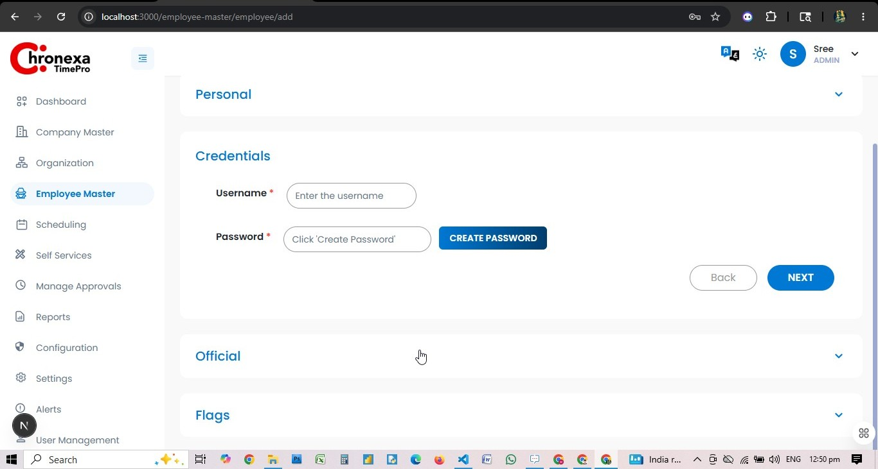
Fig 6.4 — Employee Credentials Form
Enter the Username and use the CREATE PASSWORD button to auto-generate a secure password. Click NEXT to proceed.

Step 3 — Official Information

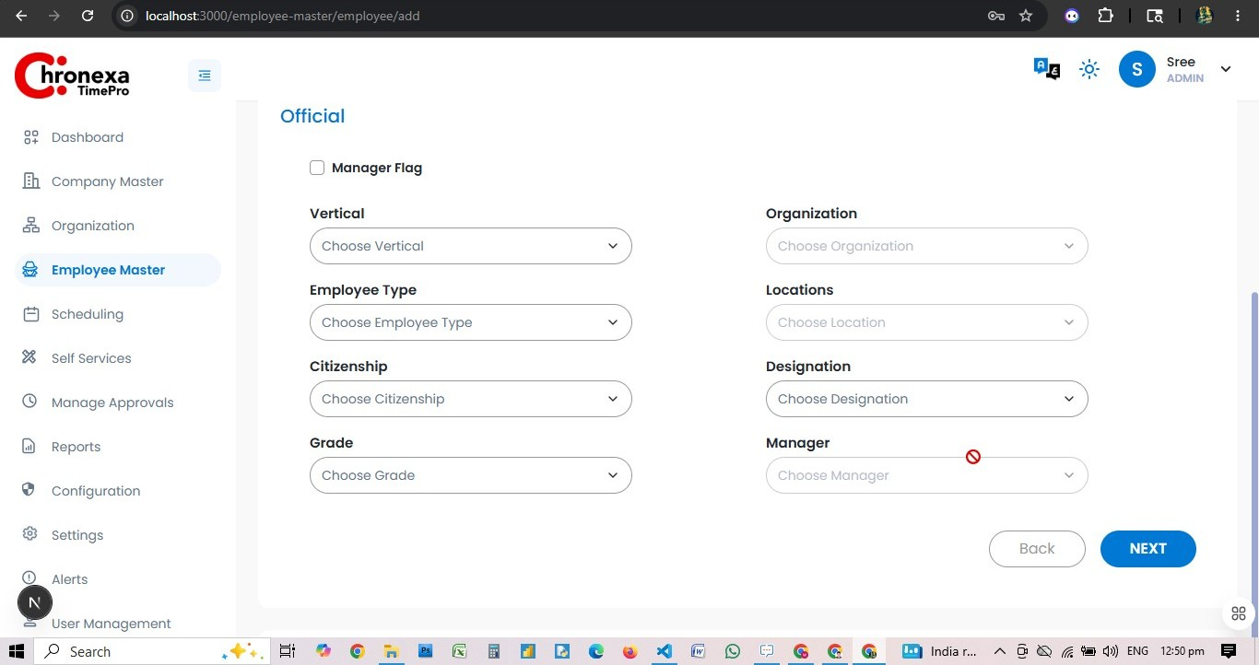
Fig 6.5 — Employee Official Info Form
Field | Description
Vertical | Business vertical assigned
Organisation | Company/org unit
Employee Type | Classification (Professional Direct, etc.)
Locations | Primary work location
Citizenship | Employee nationality
Designation | Job title
Grade | Pay grade
Manager | Reporting manager
Manager Flag | Check to designate this employee as a manager

Step 4 — Flags

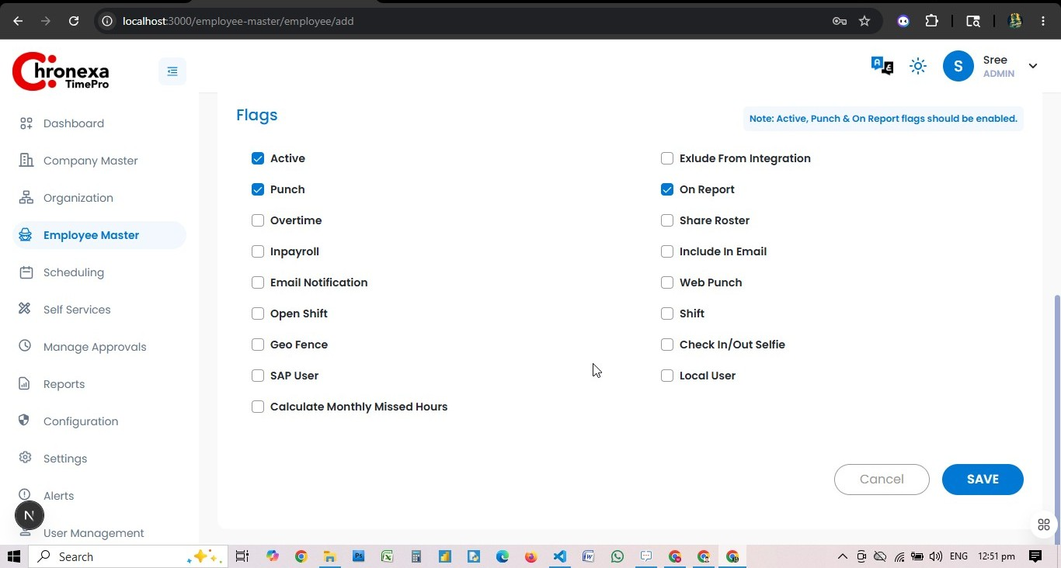
Fig 6.6 — Employee Flags
Flags control feature access for each employee. Key flags to enable:
Flag | Purpose | Default
Active | Employee is active in the system | Enabled
Punch | Employee can record attendance punches | Enabled
On Report | Employee appears in attendance reports | Enabled
Overtime | Eligible for overtime calculation | Off
Inpayroll | Included in payroll processing | Off
Email Notification | Receives system email alerts | Off
Web Punch | Can punch in/out via browser | Off
Open Shift | Can be assigned open/flexible shifts | Off
Shift | Uses fixed shift scheduling | Off
Geo Fence | Attendance restricted by geofence location | Off
Check In/Out Selfie | Must take a selfie when punching | Off
SAP User | Synced with SAP HR system | Off
Local User | Local-only account (no Azure AD sync) | Off
Calculate Monthly Missed Hours | Track missed hours on a monthly basis | Off

💡 Active, Punch, and On Report flags should always be enabled for regular employees. The note in the application confirms this requirement.

- After setting all flags, click SAVE to create the employee record.

7. Scheduling
Role: ADMIN
The Scheduling module manages shift templates, weekly patterns, public holidays, and Ramadan period dates. These must be configured before employees can be assigned to schedules.

Schedules
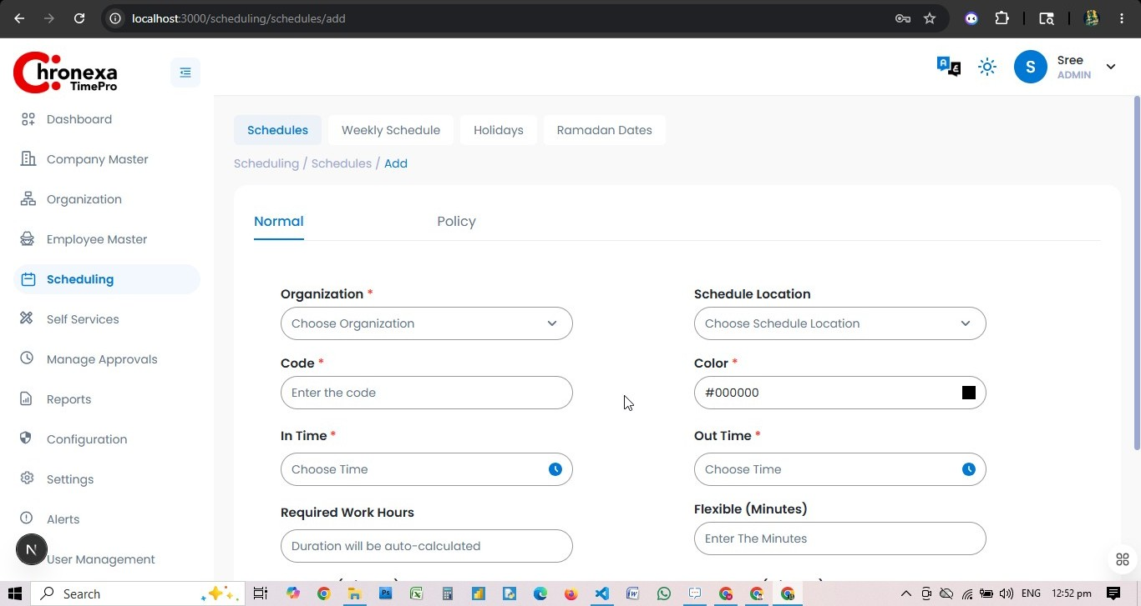
Fig 7.1 — Add Schedule (Normal Tab)
Schedules define individual shift templates. Each schedule has a unique code, colour, in/out times, and working hours.
Field | Description | Required
Organisation | The org unit this schedule belongs to | Yes
Schedule Location | Physical location associated with the schedule | No
Code | Unique short code for the schedule | Yes
Color | Visual colour shown on calendar views (hex) | Yes
In Time | Shift start time | Yes
Out Time | Shift end time | Yes
Required Work Hours | Auto-calculated from In/Out times | Auto
Flexible (Minutes) | Grace window in minutes | No

Schedule Policy Tab
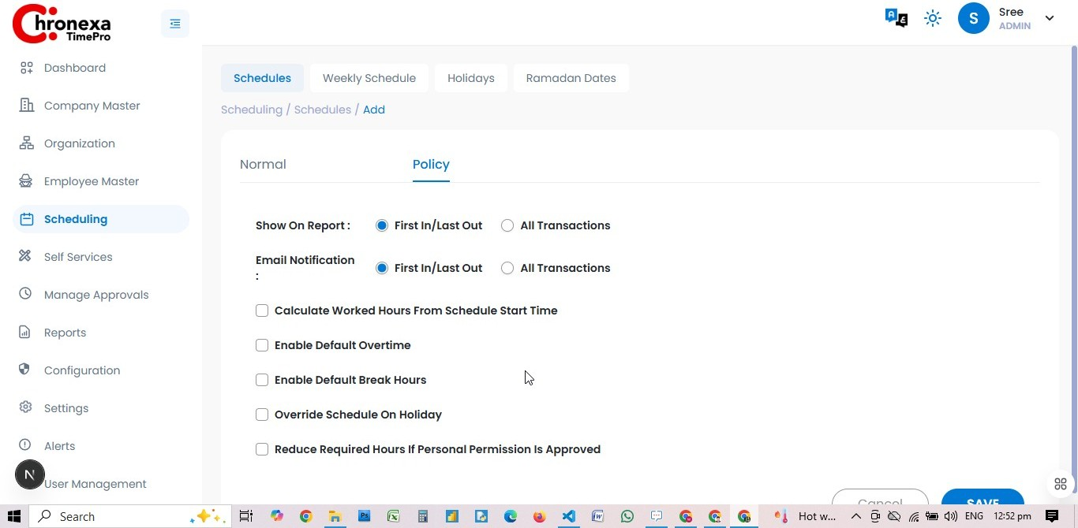
Fig 7.2 — Schedule Policy Tab
Policy Option | Description
Show On Report: First In/Last Out | Report shows only first check-in and last check-out
Show On Report: All Transactions | Report shows every punch transaction
Email Notification: First In/Last Out | Email sent for first-in and last-out only
Calculate Worked Hours From Schedule Start Time | Calculates hours from the scheduled start, not actual punch-in
Enable Default Overtime | Automatically flags hours beyond scheduled time as overtime
Enable Default Break Hours | Subtracts a fixed break period from worked hours
Override Schedule On Holiday | Schedule applies even on public holidays
Reduce Required Hours If Personal Permission Is Approved | Approved permissions reduce the required work hours for that day

Holidays
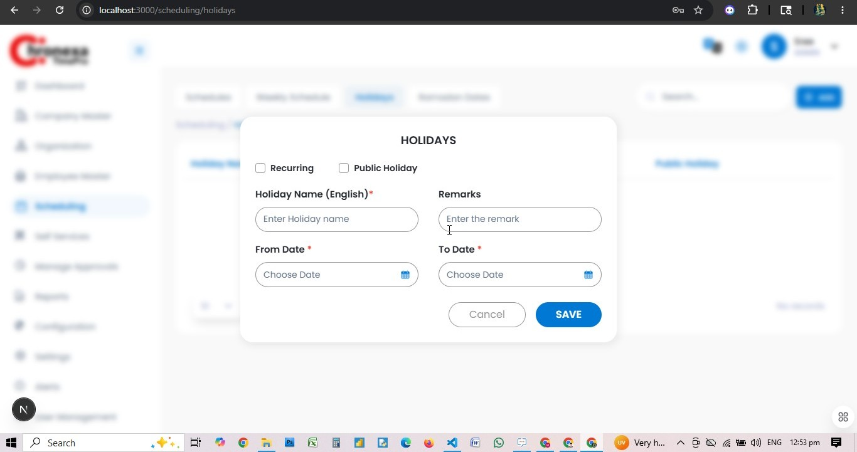
Fig 7.3 — Add Holiday Dialog
Holidays record non-working days for the organisation.
Field | Description
Holiday Name (English) | Descriptive name (e.g. National Day)
Remarks | Optional notes
From Date | Start date of the holiday
To Date | End date (same as From Date for single-day holidays)
Recurring | Check if the holiday repeats annually
Public Holiday | Check if this is a public holiday for all employees

Ramadan Dates

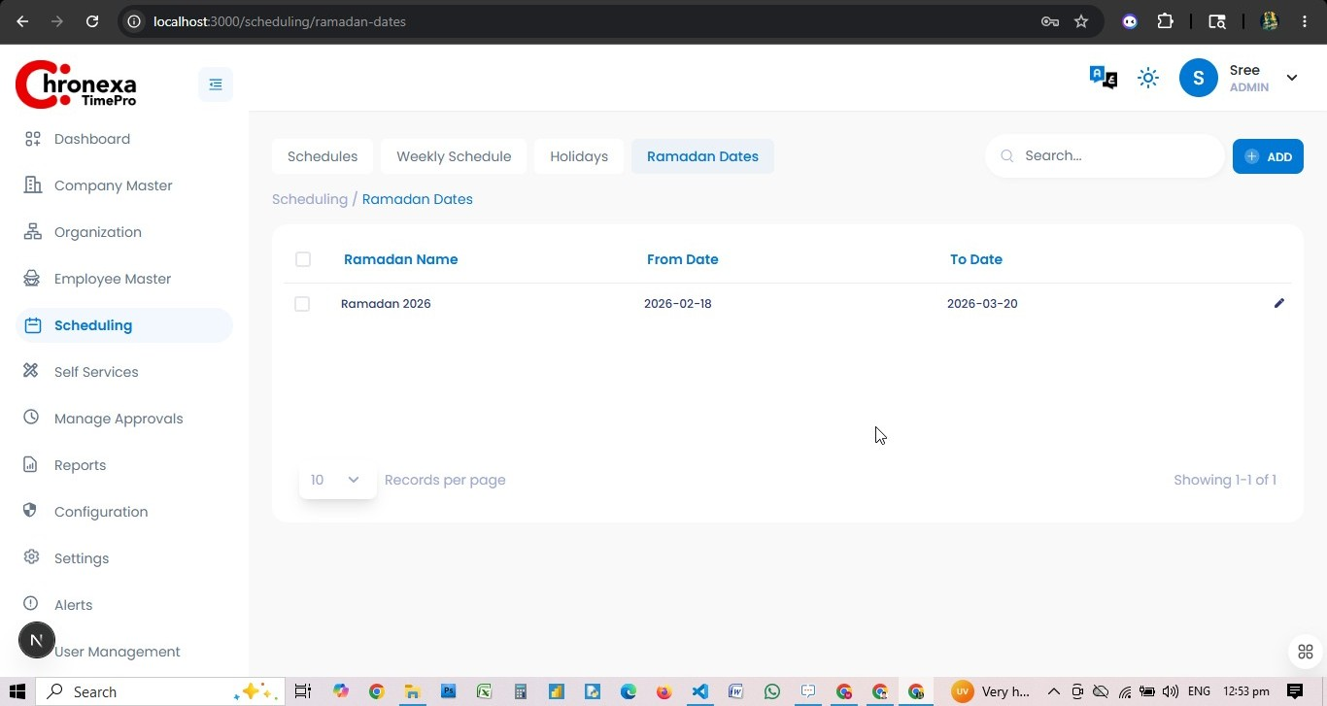
Fig 7.4 — Ramadan Dates List
Ramadan Dates define the Ramadan period so the system can apply reduced working hours automatically. Currently configured: Ramadan 2026 (18 Feb 2026 — 20 Mar 2026).
- Click + ADD to enter a new Ramadan period.
- Enter Ramadan Name, From Date, and To Date.
- Click SAVE.

8. Self Services
Role: ADMIN
Self Services is the hub for employee requests, approvals, and punch management. Admins have access to all sub-modules: Workflow, Permissions, Leaves, and Punches.

Workflow
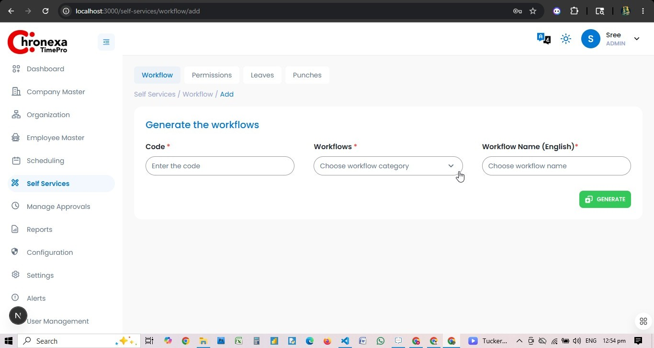
Fig 8.1 — Generate Workflow Form
Workflows define the multi-level approval chain for leaves, permissions, and punch corrections. Configure a workflow by selecting the category (Leave, Permission, Punch), assigning approvers, and generating the chain.
- Navigate to Self Services → Workflow. Click + ADD.
- Enter a Code for the workflow.
- Select the Workflow category (Leave/Permission/Missing Punch).
- Enter a Workflow Name in English.
- Click GENERATE to create the approval chain.

Permissions
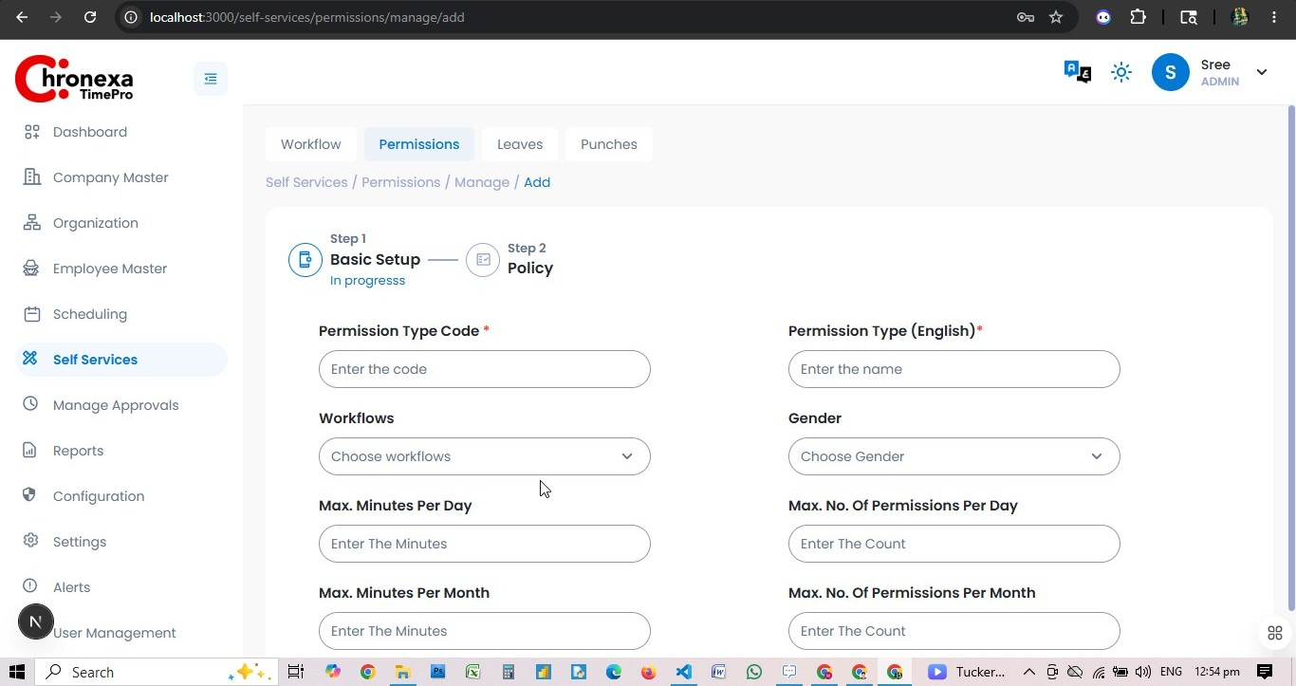
Fig 8.2 — Add Permission Type (Basic Setup)
Permissions allow employees to request early departure, late arrival, or other time exceptions. Admins configure permission types with limits and workflows.
Field | Description
Permission Type Code | Unique code for this permission type
Permission Type (English) | Name shown to employees
Workflows | Approval chain to apply
Gender | Restrict to a specific gender (or All)
Max. Minutes Per Day | Maximum minutes allowed per day
Max. No. Of Permissions Per Day | Maximum permission instances per day
Max. Minutes Per Month | Maximum minutes allowed per month
Max. No. Of Permissions Per Month | Maximum instances per month

Leaves
Leave types define the categories of leave employees can request (Annual, Sick, Emergency, etc.). Each type is linked to a workflow and has balance/entitlement rules.

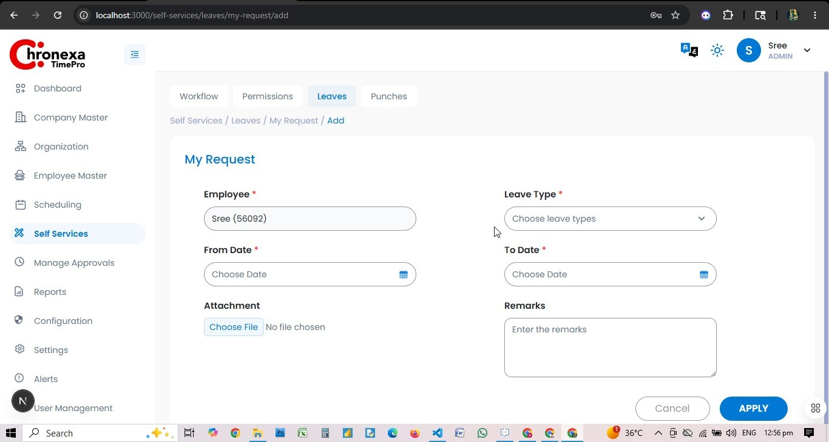
Fig 8.3 — Leaves My Request View

My Request (Leaves)
Employees (including admin users) can submit leave requests from Self Services → Leaves → My Request.
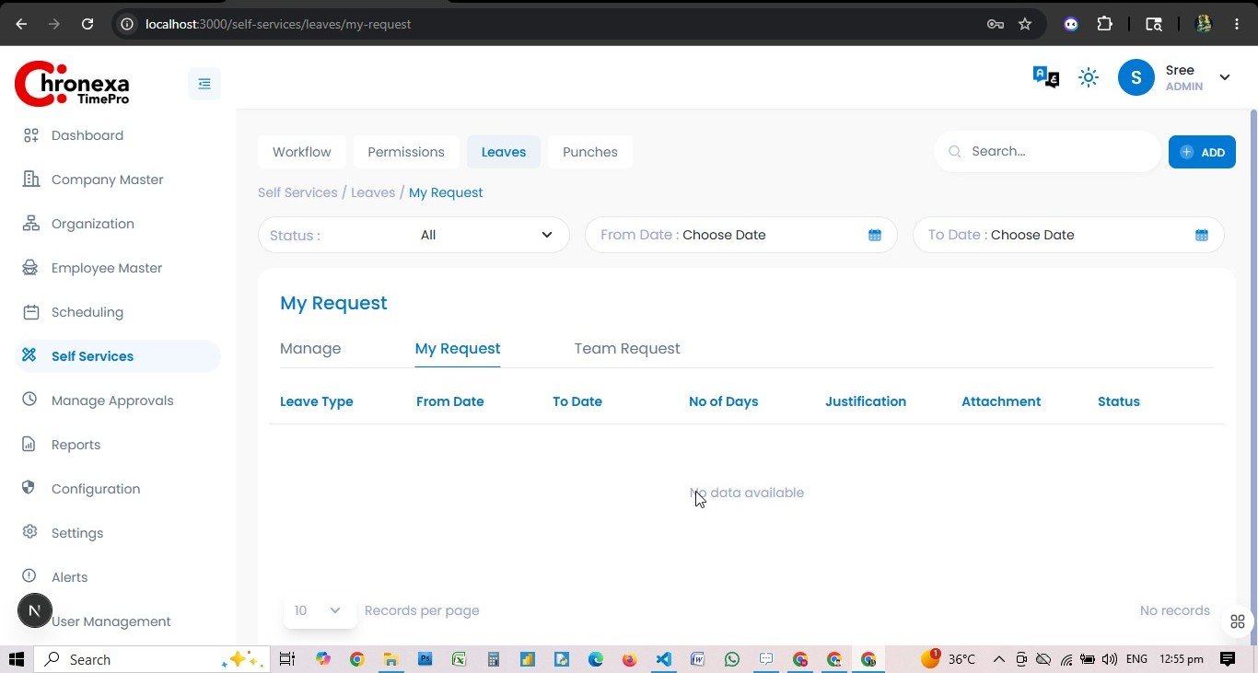
Fig 8.4 — Submit Leave Request Form
Field | Description
Employee | Auto-filled with logged-in employee
Leave Type | Select from configured leave types
From Date | First day of leave
To Date | Last day of leave
Attachment | Optional supporting document
Remarks | Reason for the leave request

💡 After submitting, the request enters the configured workflow. Status will change from Pending → Approved or Rejected.

Punches — Missing Punches
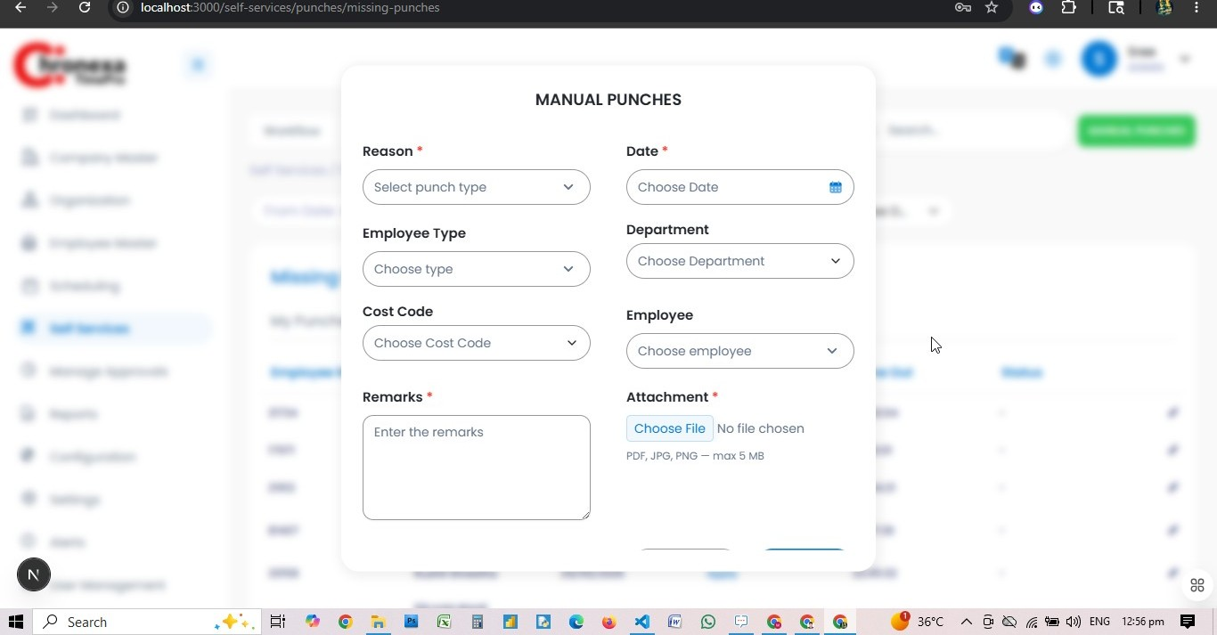
Fig 8.5 — Manual Punches Form
Admins can create manual punch records when employees have missing or incorrect punch entries.
Field | Description
Reason | Punch type (Missing In / Missing Out / Correction)
Date | Date of the missing punch
Employee Type | Filter employees by type
Department | Filter by department
Cost Code | Project/cost code association
Employee | The employee for whom the punch is being added
Remarks | Explanation for the manual entry (required)
Attachment | Supporting file (PDF, JPG, PNG — max 5MB)

9. Manage Approvals

Role: ADMIN
Manage Approvals is the centralised queue for all pending employee requests. Admins can view and action all request types across all teams.

Sub-Module | Admin Access | Description
Team Requests — Missing Punches | View | Review and approve/reject missing punch submissions from all teams
Team Requests — Permissions | View | Review employee permission requests
Team Requests — Leaves | View | Review leave requests from all employees

Approving a Missing Punch
- Navigate to Manage Approvals → Team Requests → Missing Punches.
- Filter by date range using From Date / To Date.
- Review the employee name, date, time, and remarks.
- Click Download to view any supporting attachment.
- Select the record(s) and choose Approve or Reject.
- Add an optional comment before confirming.

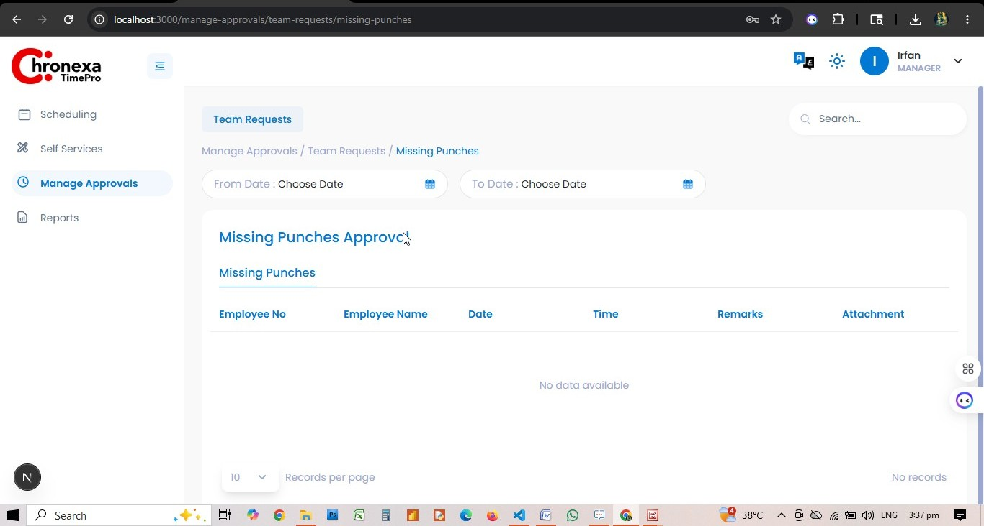

10. Reports
Role: ADMIN
The Reports module provides the Employee Time Attendance Report, allowing Admins to analyse attendance data across the entire organisation.

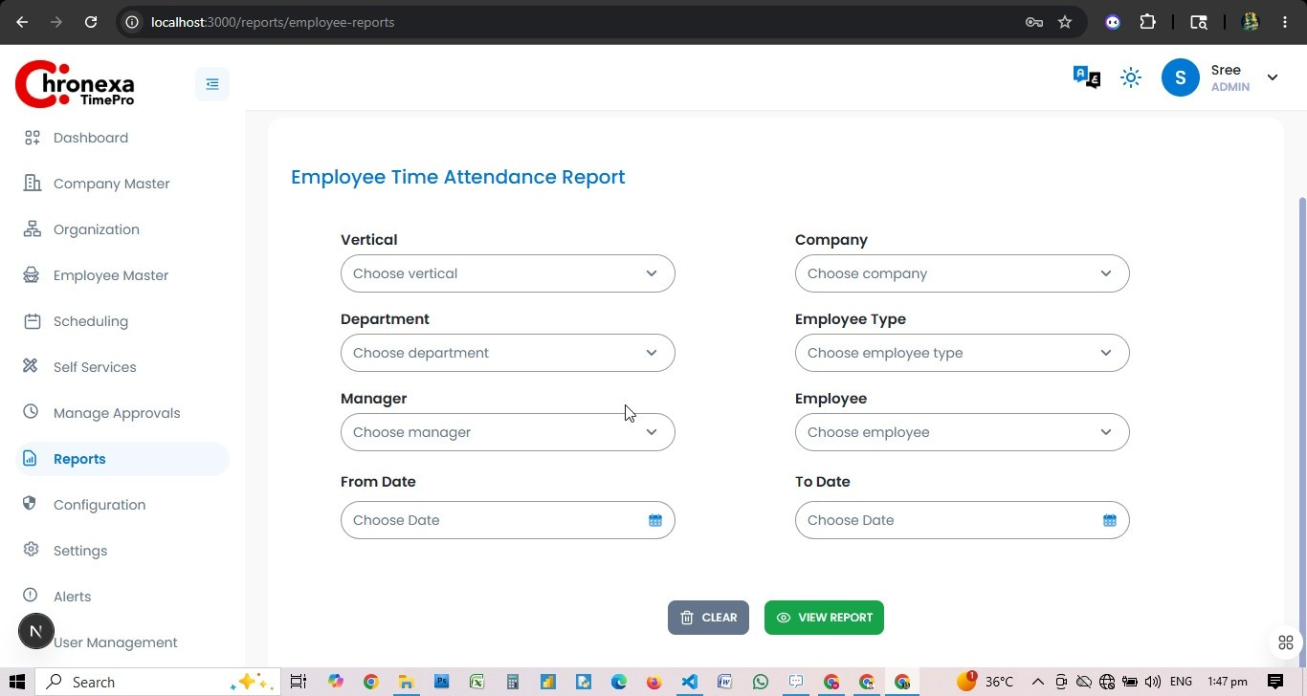
Fig 10.1 — Employee Time Attendance Report Filters

Report Filters
Filter | Description
Vertical | Filter by business vertical
Company | Filter by company/organisation
Department | Filter by specific department
Employee Type | Professional Direct, Indirect, Technical, Outsource
Manager | Filter by reporting manager
Employee | Filter for a specific individual
From Date / To Date | Custom date range for the report period

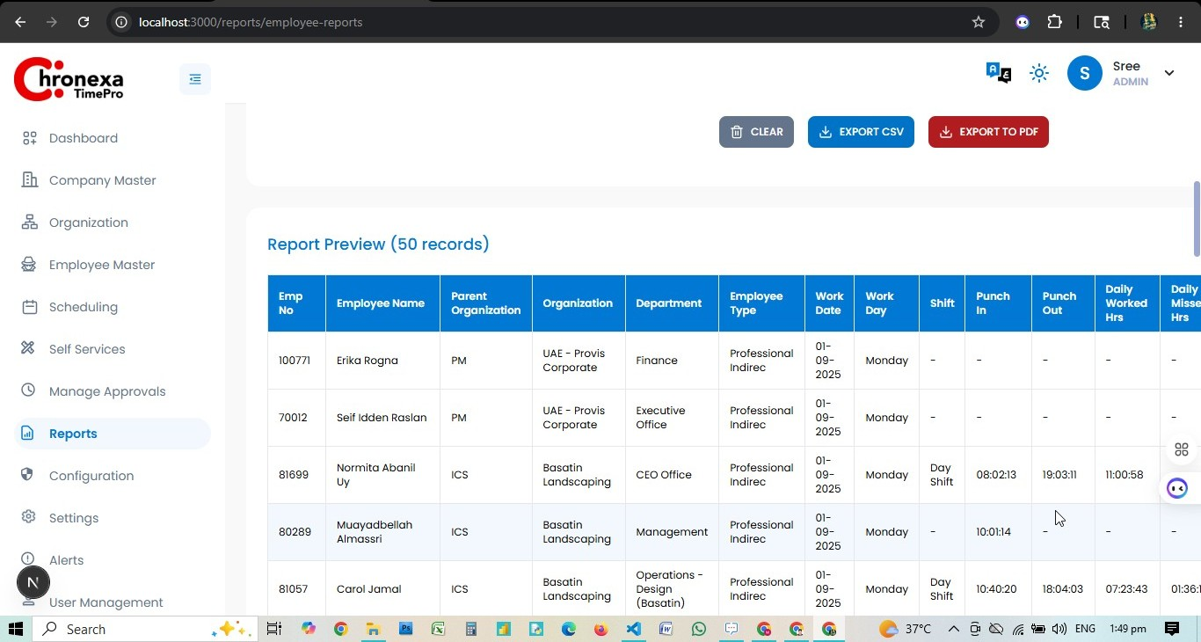
Fig 10.2 — Report Preview (Employee Attendance Data)

Report Columns
Column | Description
Emp No | Employee number
Employee Name | Full name
Parent Organisation | Top-level org unit
Organisation | Company/entity
Department | Department assigned
Employee Type | Classification
Work Date | Date of the attendance record
Work Day | Day of the week
Shift | Assigned shift code
Punch In | First check-in time
Punch Out | Last check-out time
Daily Worked Hrs | Total hours worked that day
Daily Missed Hrs | Hours below the required shift hours

Export Formats
- View the report on-screen first (recommended before exporting).
- Export to PDF — printable report with branding.
- Export to CSV / Excel (XLSX) — formatted workbook for data analysis.

11. Configuration & RBAC
Role: ADMIN
Chronexa uses a Role-Based Access Control (RBAC) model. The Configuration module is where Admins define roles and their exact privileges for every module and sub-tab.

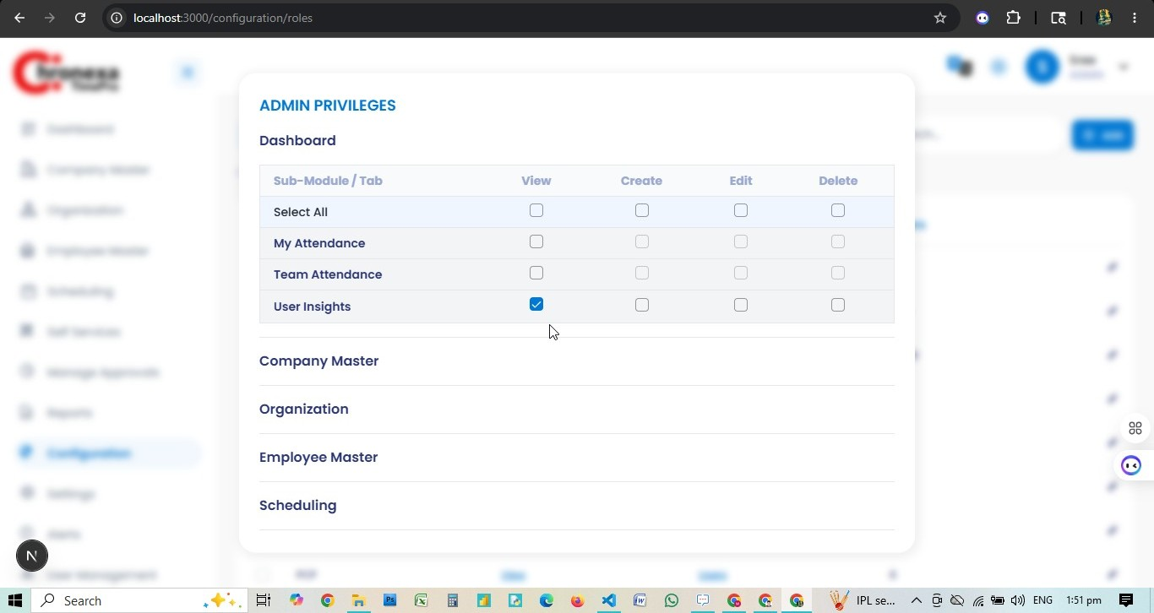
Fig 11.1 — Admin Privileges: Dashboard & Company Master
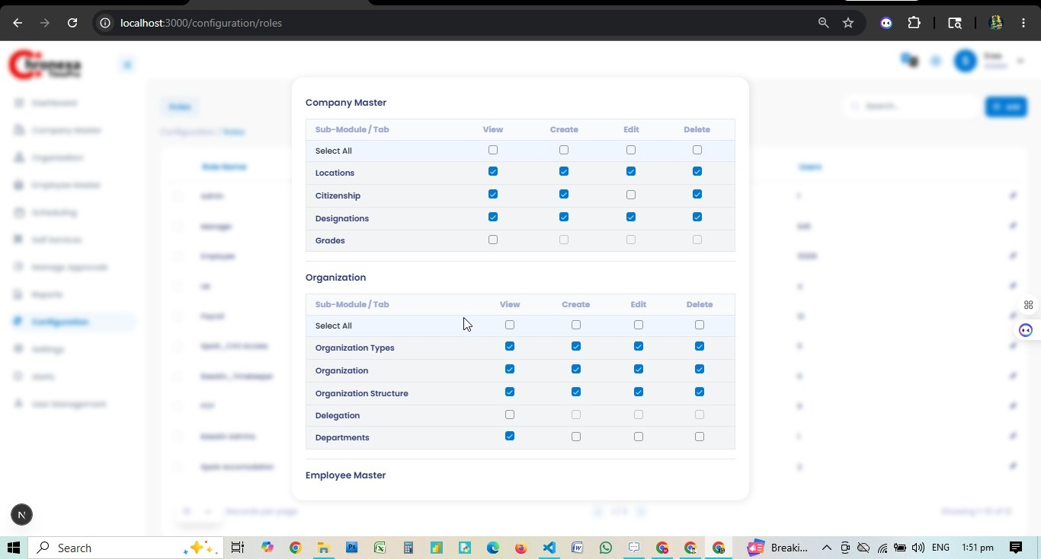
Fig 11.2 — Admin Privileges: Company Master & Organisation

How RBAC Works
Layer | What It Is | Example
Role | Named access profile assigned to users | Admin, Manager, Timekeeper
Privilege Flags | Per-module access flags | View, Create, Edit, Delete per sub-tab
Vertical / Company Scope | Which org units the role applies to | Role scoped to Operations vertical only

Creating a Role — Step by Step
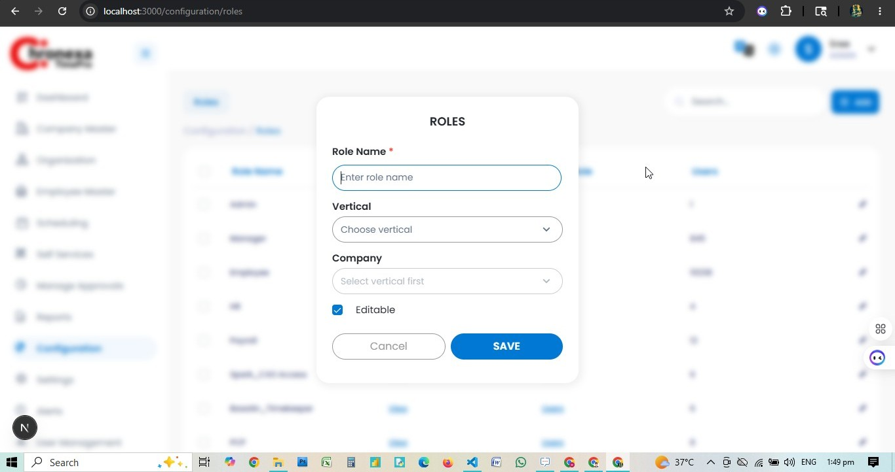
Fig 11.3 — Create New Role Dialog
- Navigate to Configuration → Roles. Click + ADD.
- Enter the Role Name (e.g. Manager, Timekeeper).
- Select Vertical scope (which business unit this role covers).
- Select Company scope (dependent on Vertical selection).
- Check Editable if the role's privileges should be adjustable.
- Click SAVE to create the role shell.
- The privilege grid appears — toggle View, Create, Edit, Delete flags per module.
- Click SAVE to finalise the privileges.

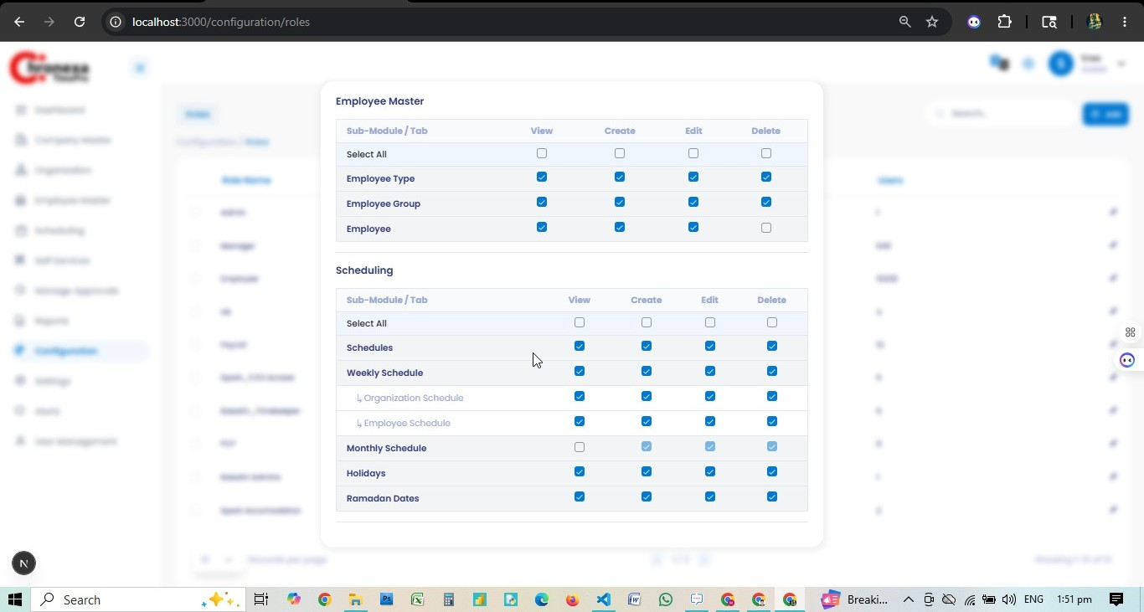
Fig 11.4 — Scheduling & Employee Master Privileges
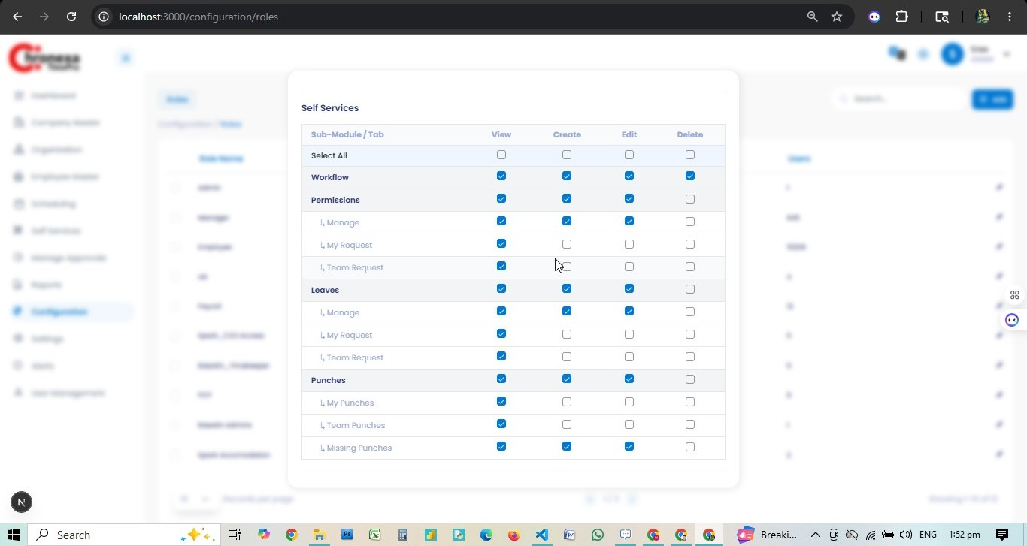
Fig 11.5 — Self Services Privileges
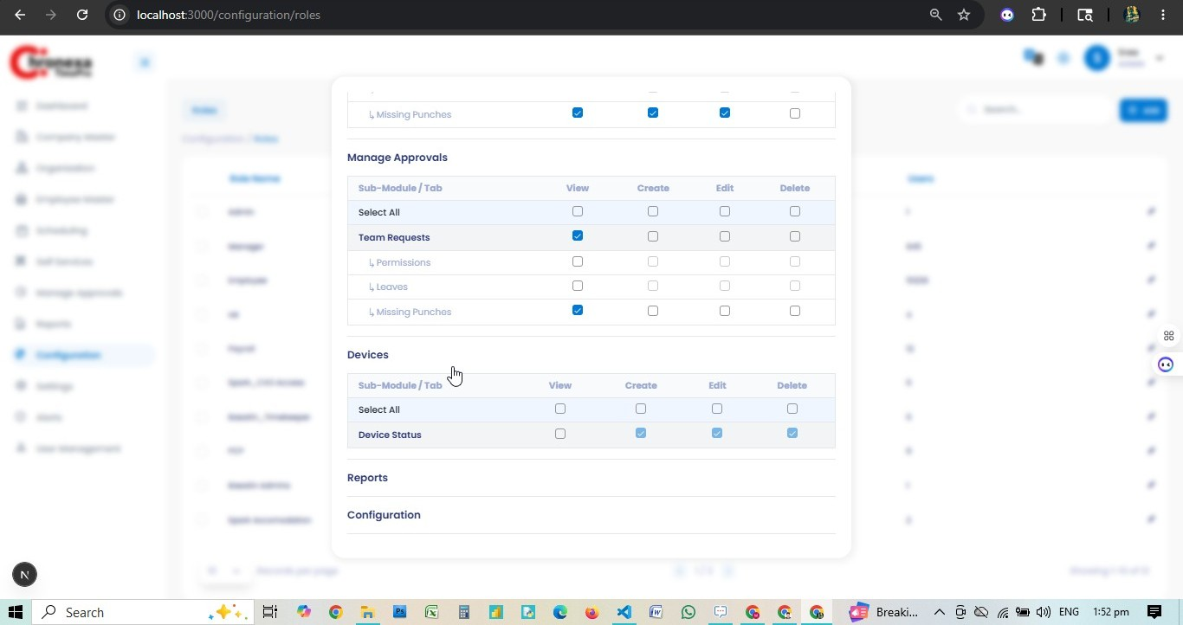
Fig 11.6 — Manage Approvals & Devices Privileges
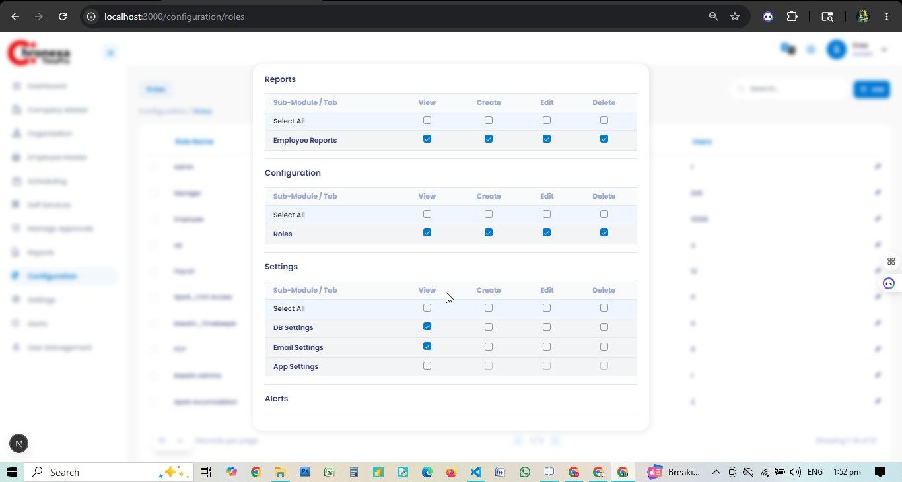
Fig 11.7 — Reports, Configuration & Settings Privileges

Assigning a Role to a User
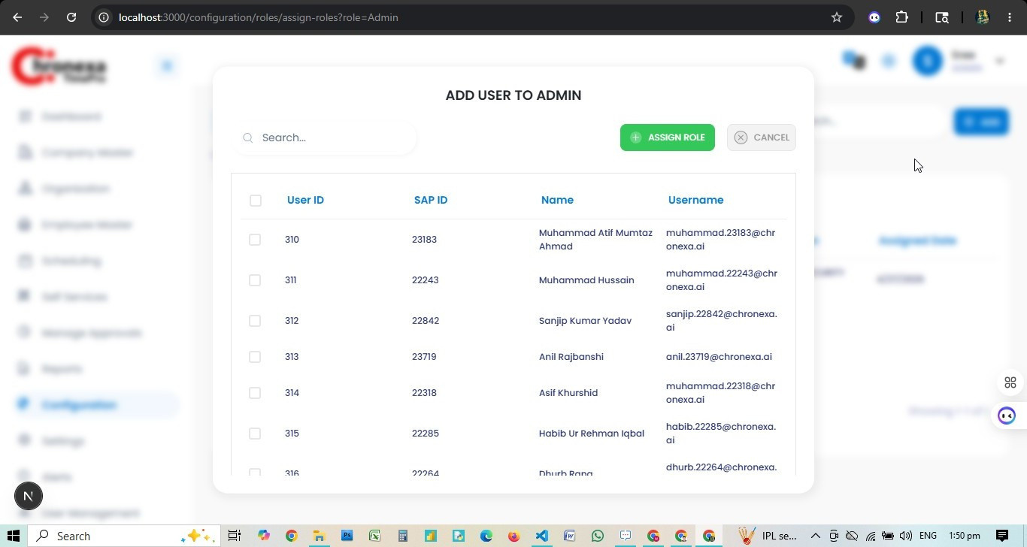
Fig 11.8 — Add User to Admin Role
- After creating the role, click on the role row in the Roles list.
- Click + ADD USER (or the assign icon) to open the user picker.
- Search for the user by name or SAP ID.
- Select the user(s) and click ASSIGN ROLE.

💡 Role assignment determines exactly what the user can see and do. Always verify the privilege flags after assigning a role to a new user.

12. Settings
Role: ADMIN

DB Settings
The DB Settings tab connects Chronexa to its backend biometric device databases. Fields include: Database, Database Name, Host, Port, and Connection status.

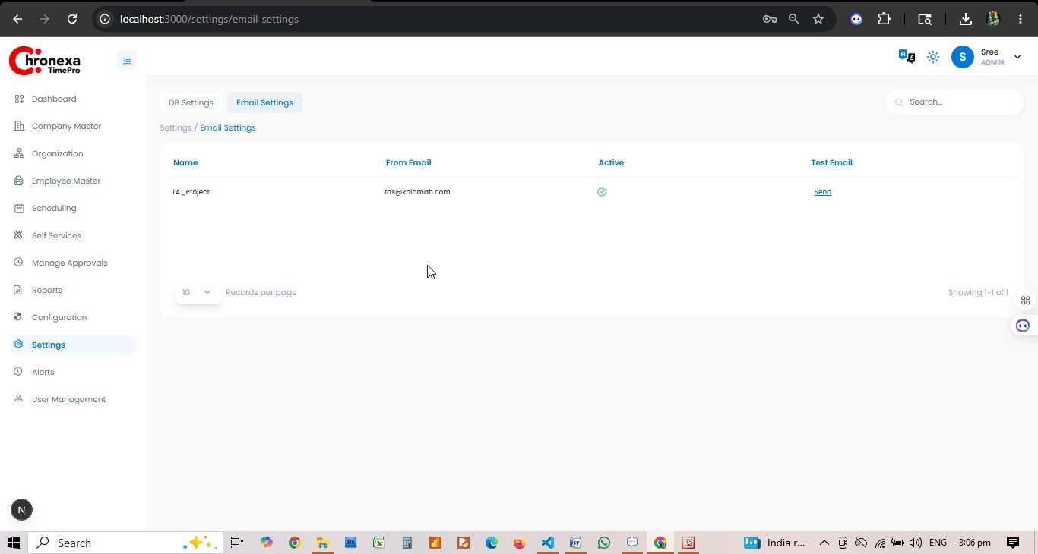

Email Settings
Email Settings configures the SMTP gateway for system notifications. The project has one active email configuration:
Field | Value
Name | TA_Project
From Email | (configured — masked for security)
Active | Yes
Test Email | Send — to verify SMTP connectivity

App Settings
App Settings controls global application parameters such as session timeout, date format, and language preferences.

13. Alerts
Role: ADMIN
The Alerts module shows all outbound email and SMS notifications generated by the system. Admins can filter by status and date range and export the log.

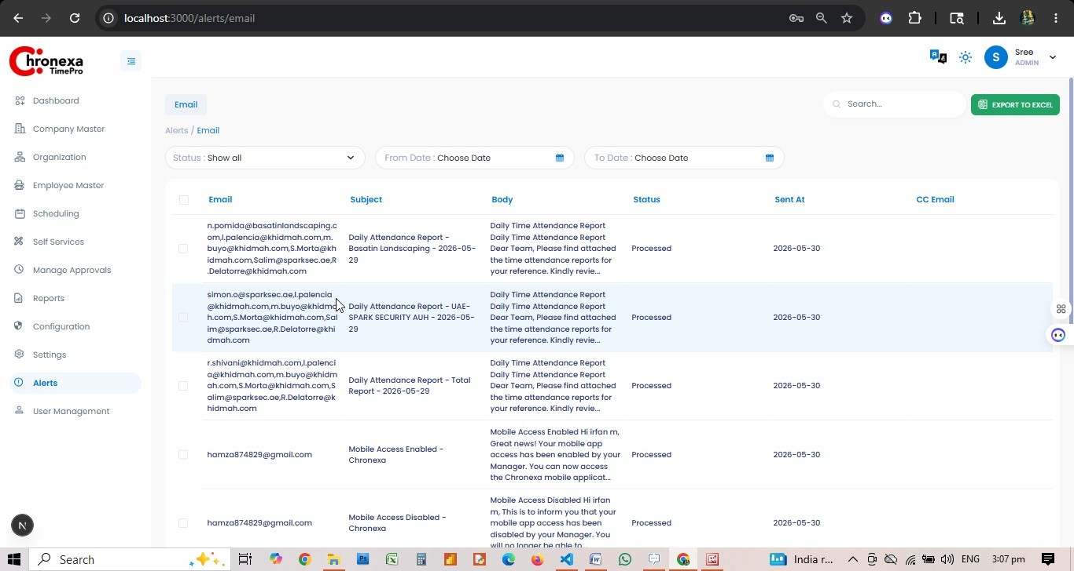

Column | Description
Email | Recipient email address(es)
Subject | Email subject line
Body | Preview of the email body
Status | Processed / Pending / Failed
Sent At | Timestamp of delivery
CC Email | Carbon copy recipient(s)

14. User Management
Role: ADMIN
User Management manages system login accounts. 10,526 users are registered. Each user record links to an employee profile and determines login credentials and license status.

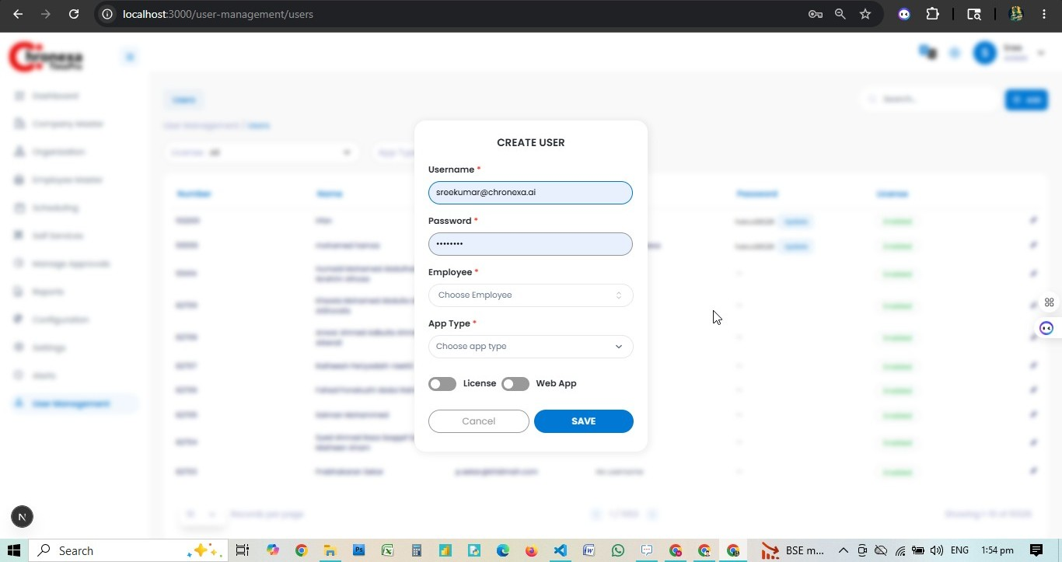
Fig 14.1 — Create User Dialog

Creating a User
- Navigate to User Management → Users. Click + ADD.
- Enter the Username (typically email format, e.g. sree@chronexa.ai).
- Set the Password.
- Select the linked Employee record.
- Choose App Type (Web / Mobile).
- Toggle License ON to grant system access.
- Toggle Web App if the user should access via browser.
- Click SAVE.

User List Columns
Column | Description
Number | Employee number
Name | Full name
Email | Login email address
Username | System username
Password | Masked — Update button to reset
License | Enabled/Disabled — controls login access

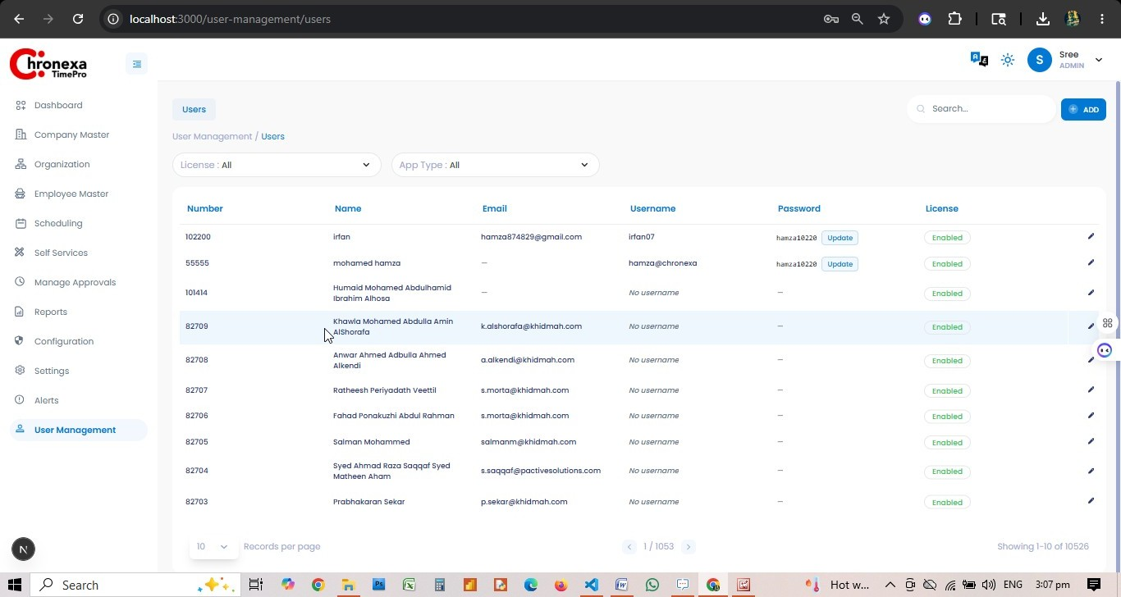
💡 Filter the user list by License (All/Enabled/Disabled) and App Type. Click the pencil icon to edit a user's role assignment or license status.

Appendix A — Role Privilege Summary
Module / Tab | Admin | Manager | Timekeeper
Dashboard — User Insights | View | View (scoped) | —
Company Master — Locations | View, Create, Edit, Delete | — | —
Company Master — Citizenship | View, Create, Edit, Delete | — | —
Company Master — Designations | View, Create, Edit, Delete | — | —
Organisation Types | View, Create, Edit, Delete | — | —
Organisation | View, Create, Edit, Delete | — | —
Organisation Structure | View, Create, Edit, Delete | — | —
Departments | View | — | —
Employee Type | View, Create, Edit, Delete | — | —
Employee Group | View, Create, Edit, Delete | — | —
Employee | View, Create, Edit | — | —
Scheduling — Schedules | View, Create, Edit, Delete | View, Create, Edit | —
Scheduling — Weekly Schedule | View, Create, Edit, Delete | View, Create, Edit | —
Scheduling — Monthly Schedule | View, Create, Edit, Delete | View, Create, Edit | —
Scheduling — Holidays | View, Create, Edit, Delete | View, Create, Edit | —
Scheduling — Ramadan Dates | View, Create, Edit, Delete | View, Create, Edit | —
Self Services — Workflow | View, Edit | — | —
Self Services — Permissions (Manage) | View, Create, Edit | View | —
Self Services — Permissions (My Req) | View | View | —
Self Services — Permissions (Team Req) | View | — | —
Self Services — Leaves (Manage) | View, Create, Edit | View | —
Self Services — Leaves (My Req) | View | View | —
Self Services — Leaves (Team Req) | View | — | —
Self Services — My Punches | View | View | View
Self Services — Team Punches | View | View | View
Self Services — Missing Punches | View, Create, Edit | View, Create | View, Create
Manage Approvals — Missing Punches | View | View | —
Manage Approvals — Permissions | View | — | —
Manage Approvals — Leaves | View | — | —
Reports — Employee Reports | View, Create, Edit, Delete | View, Create, Edit | View, Create, Edit
Configuration — Roles | View, Create, Edit, Delete | — | —
Settings — DB Settings | View | — | —
Settings — Email Settings | View | — | —
Alerts — Email | View | — | —
User Management — Users | View, Create, Edit | — | —

Appendix B — Glossary
Term | Definition
RBAC | Role-Based Access Control — the system that governs what each user can see and do
Punch | A clock-in (IN) or clock-out (OUT) transaction recorded by a device or web interface
Missing Punch | A punch record where either IN or OUT is absent for a given employee on a given date
Geofencing | Restricting web punches to a GPS radius around a registered Location
Schedule | A shift template defining In Time, Out Time, and required work hours
Weekly Schedule | A repeating 7-day pattern assigned to an org unit or individual employee
Monthly Schedule | A calendar-based roster assigning schedule codes per employee per day
Workflow | An approval chain defining who must approve a leave, permission, or punch request
Vertical | Top-level organisational unit in the hierarchy (ROOT → VERTICAL → COMPANY)
Azure AD | Microsoft Azure Active Directory — used for SSO login to Chronexa TimePro
Timekeeper | A role focused on recording and correcting attendance punches for a site/area
Coverage | Percentage of employees present vs total scheduled for a department
Delegation | Temporary assignment of manager duties to another user during absence
KPI | Key Performance Indicator — metrics shown on the dashboard
SAP ID | Employee identifier used to sync with the SAP HR system

