Chronexa TimePro
Workforce & Attendance Management System
Manager Role — Reference Guide

Table of Contents
- System Overview ........................................ 2
- Login & Authentication .............................. 4
- Manager Role – Module Reference .................. 5
- Scheduling ............................................ 6
- Self Services ......................................... 8
- Manage Approvals .................................... 10
- Reports .............................................. 11
Appendix A – Role Privilege Summary ................. 13

1. System Overview

What is Chronexa TimePro?
Chronexa TimePro is a comprehensive web-based Workforce & Attendance Management System built for the project. It automates employee scheduling, real-time attendance tracking via biometric devices and web punch, leave and permission management, multi-level approval workflows, and rich reporting — all in a single unified platform.

Role-Based Access
The system operates on a Role-Based Access Control (RBAC) model. Three primary roles govern what each user sees and can do:

Role | Modules Accessible | Description
Admin | All modules: Dashboard, Company Master, Organisation, Employee Master, Scheduling, Self Services, Manage Approvals, Reports, Configuration, Settings, Alerts, User Management | Full system access. Configures all master data, roles, and settings.
Manager | Dashboard, Scheduling, Self Services, Manage Approvals, Reports | Manages team schedules, approves leave/punch requests, views team attendance.
Timekeeper | Self Services, Reports | Records and manages attendance punches for their assigned area. Submits missing punch corrections.

Module Access Summary
Module | Admin | Manager | Timekeeper
Dashboard — User Insights | ✔ | ✔ (limited) | —
Company Master | ✔ | — | —
Organisation | ✔ | — | —
Employee Master | ✔ | — | —
Scheduling | ✔ | ✔ | —
Self Services — Punches | ✔ | ✔ (Team) | ✔ (My & Team)
Self Services — Leaves | ✔ | ✔ (Team) | —
Self Services — Permissions | ✔ | ✔ (Team) | —
Manage Approvals | ✔ | ✔ | —
Reports | ✔ | ✔ | ✔
Configuration / Roles | ✔ | — | —
Settings | ✔ | — | —
Alerts | ✔ | — | —
User Management | ✔ | — | —

2. Login & Authentication
All users — Admin, Manager, and Timekeeper — access Chronexa TimePro through the same login screen. The system automatically loads the dashboard and sidebar modules permitted by the logged-in user's role.
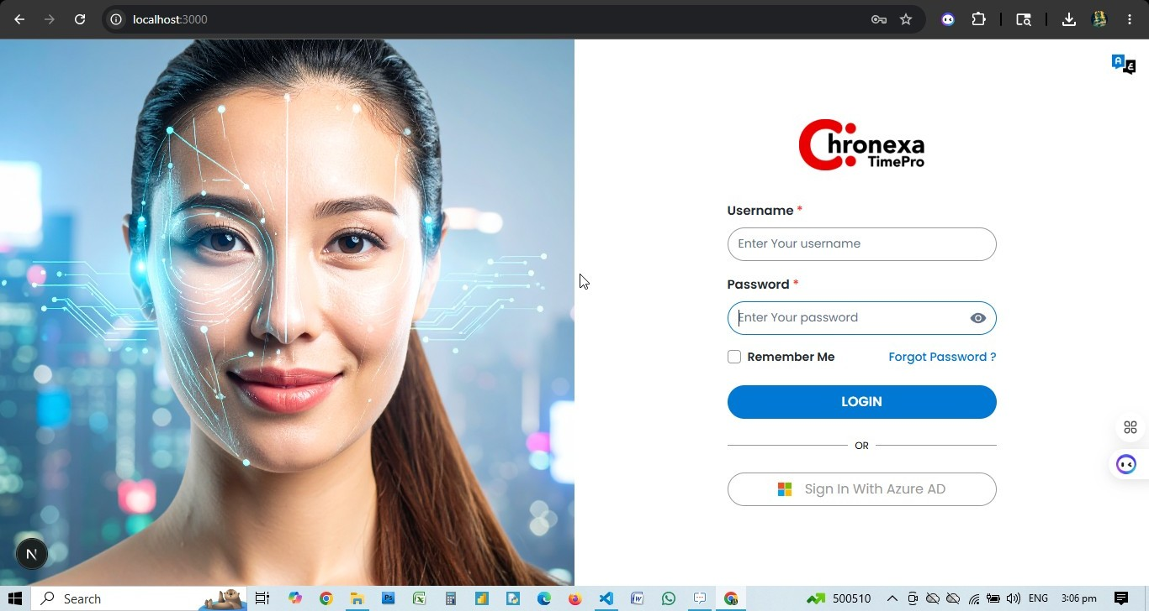

Login Steps
- Open the Chronexa TimePro URL in your browser (e.g. https://timepro.chronexa.ai).
- Enter your Username in the first field.
- Enter your Password. Use the eye icon to toggle visibility.
- Optionally check Remember Me to stay logged in.
- Click the blue LOGIN button.
- Alternatively, click Sign In With Azure AD to authenticate via Microsoft Azure Active Directory.

Forgot Password
Click the "Forgot Password?" link on the login screen. Enter your registered email address. The system sends a password reset link to your inbox.

💡 After login, the sidebar menu reflects only the modules your role permits. Admin users see all 12+ menu items; Managers see 4; Timekeepers see 2.

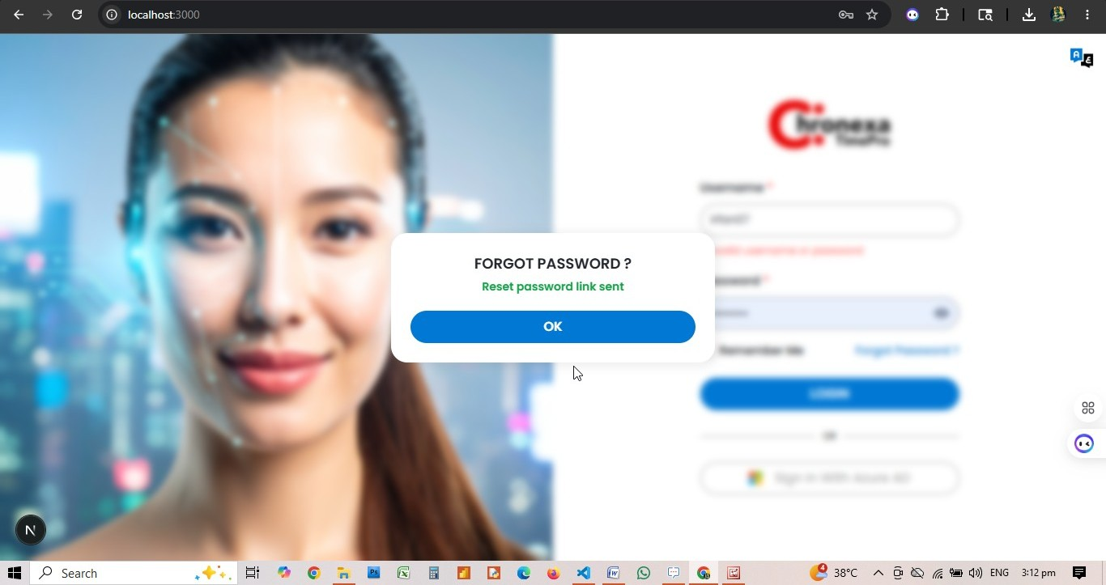

Manager Role — Module Reference
Role: MANAGER
The Manager role has access to four key areas: Scheduling, Self Services, Manage Approvals, and Reports. This guide covers each module from the manager's perspective.
💡 Manager sidebar modules: Scheduling | Self Services | Manage Approvals | Reports

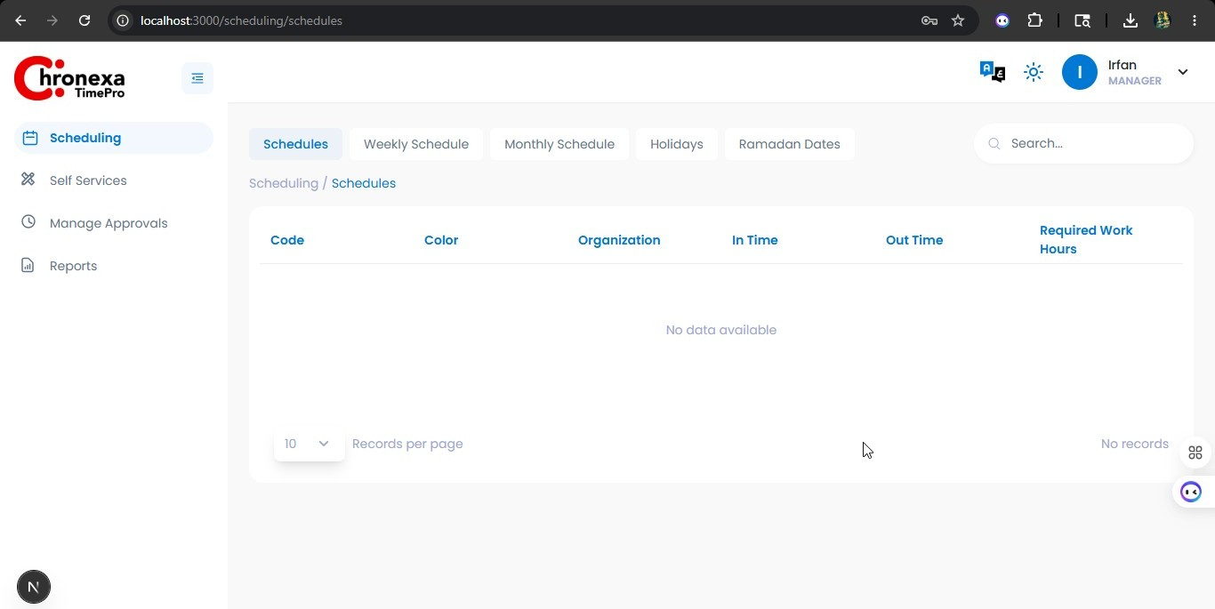

1. Scheduling
Role: MANAGER
Managers can view and manage schedules for their teams. The Scheduling module provides access to shift templates, weekly patterns, holidays, and Ramadan dates within the manager's organisation scope.

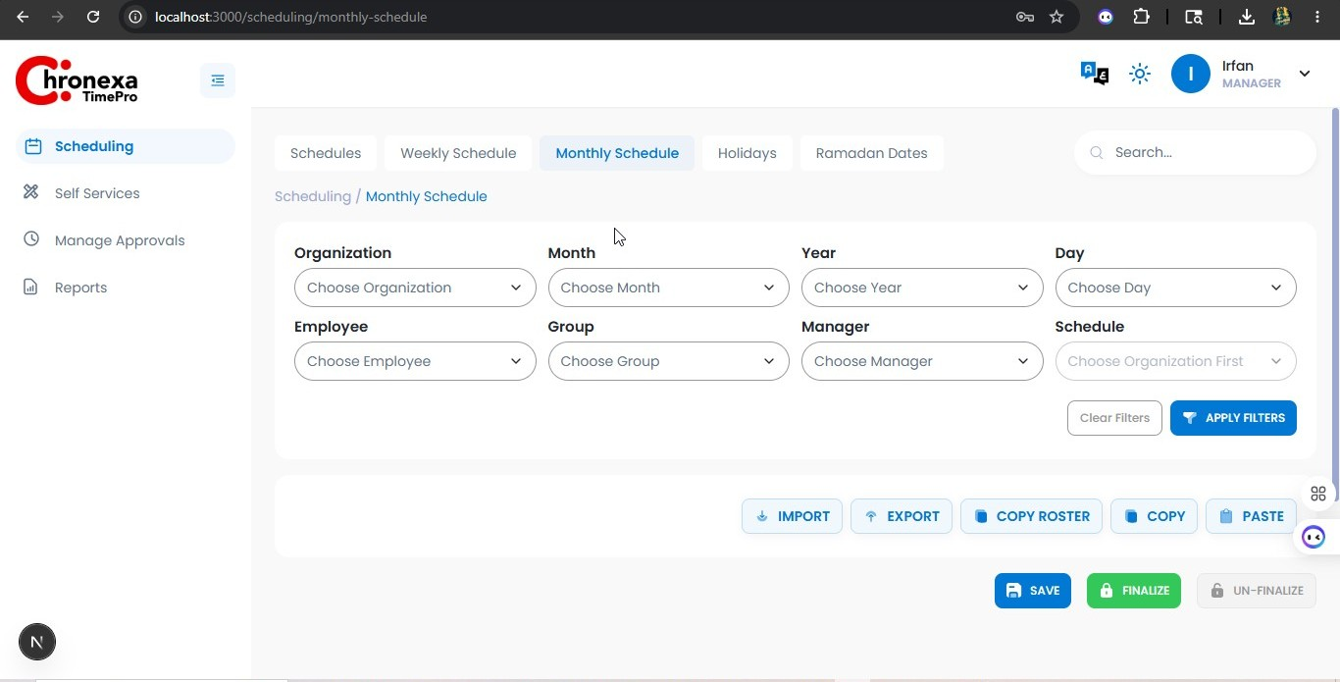

Sub-Tab | Manager Access | Description
Schedules | View | Shift templates (Code, Color, In Time, Out Time, Required Hours)
Weekly Schedule | View | 7-day repeating patterns for org or individual employee
Monthly Schedule | View, Create, Edit,apply filter | Calendar-based roster per employee per day
Holidays | View | Public holiday dates per organisation
Ramadan Dates | View | Ramadan period dates with reduced-hours schedules

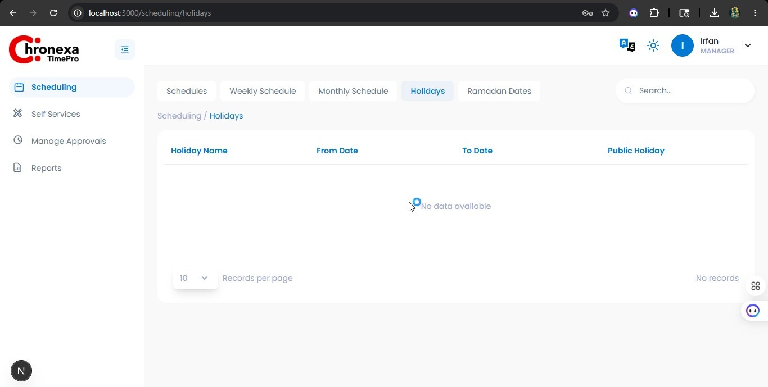

Assigning a Monthly Schedule
- Go to Scheduling → Monthly Schedule.
- Click on the Organisation Schedule or Employee Schedule tab.
- Select the organisation unit or individual employee.
- Assign a schedule code for each day of the week (or Off for rest days).
- Save the schedule.

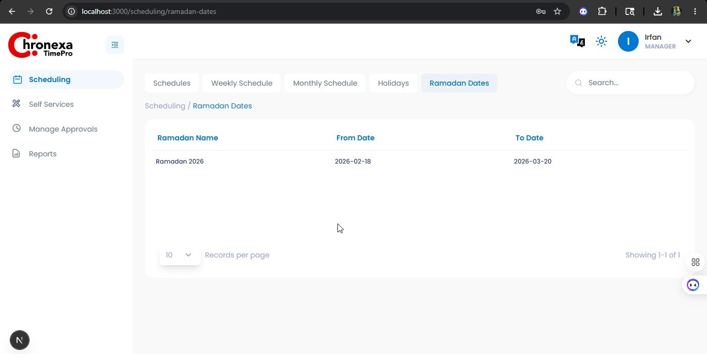

2. Self Services
Role: MANAGER
Managers use Self Services to view their own punch records and manage team requests for leaves, permissions, and punch corrections.

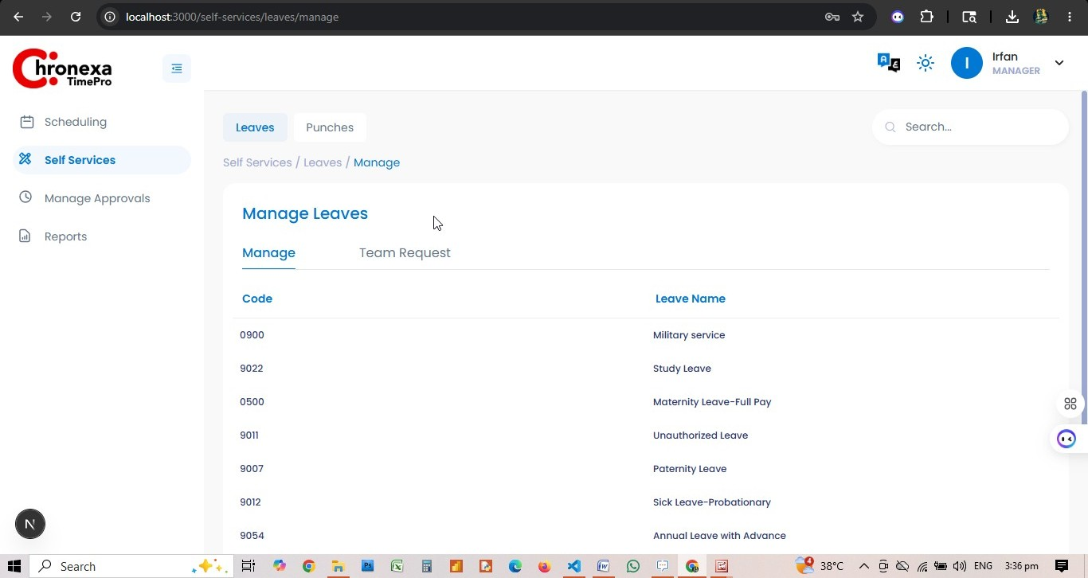

Punches
Tab | Access | Description
My Punches | View | Personal punch transaction history (IN/OUT with timestamps)
Team Punches | View | Punch records for all direct reports
Missing Punches | View | Flag and manage missing punches for team members

Leaves
Tab | Access | Description
Manage | View | Leave type reference (admin-configured types)
My Request | View | Manager's own leave requests
Team Request | View | All pending and actioned leave requests from direct reports

Permissions
Tab | Access | Description
Manage | View | Permission type reference (admin-configured)
My Request | View | Manager's own permission requests
Team Request | View | All pending permission requests from direct reports

3. Manage Approvals
Role: MANAGER
Manage Approvals is the manager's primary queue for all pending team requests. The Manager role has access to Team Requests → Missing Punches.

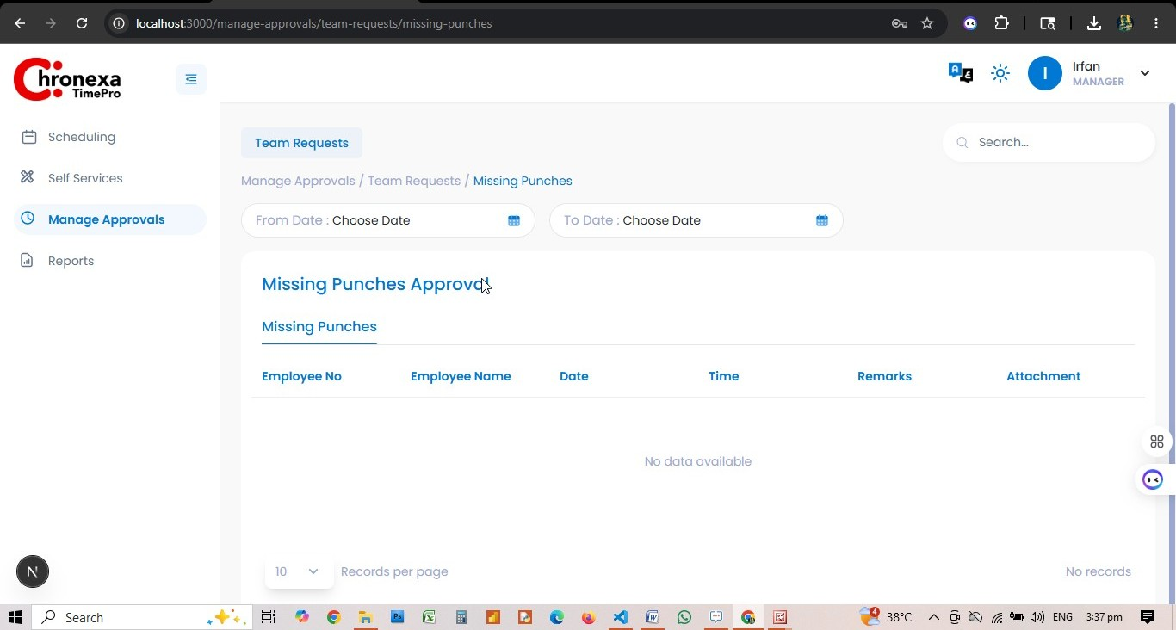

Sub-Module | Manager Access | Description
Team Requests — Missing Punches | View | Review employee missing punch submissions with remarks and attachments
Team Requests — Permissions | — | Not available for Manager role in this configuration
Team Requests — Leaves | — | Not available for Manager role in this configuration

Approving a Missing Punch
- Navigate to Manage Approvals → Team Requests → Missing Punches.
- Filter by date range using From Date / To Date.
- Review the employee's name, date, time, and remarks.
- Click Download to view any supporting attachment.
- Select the record(s) and choose Approve or Reject with an optional comment.

4. Reports
Role: MANAGER
Managers have access to Employee Reports to monitor their team's attendance over any date range.

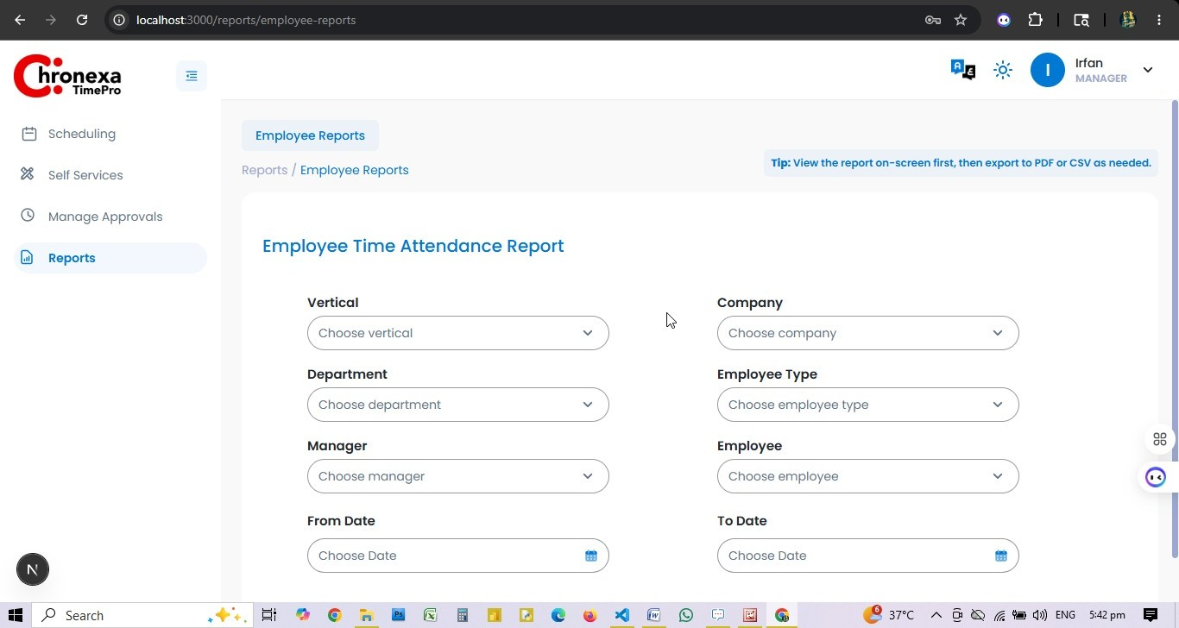
Fig 4.1 — Employee Time Attendance Report Filters

Report Filters Available to Managers
Filter | Manager Scope
Vertical | Limited to the manager's assigned vertical
Company / Organisation | Limited to the manager's company scope
Department | Any department within their scope
Employee Type | All employee types within scope
Manager | Defaults to logged-in manager; can filter sub-team
Employee | Any employee in their team
Date Range | Any custom from/to date range

Using the Report
- Navigate to Reports → Employee Reports.
- Set the desired filters (department, date range, employee).
- Click VIEW REPORT to display results on screen.
- Export to PDF or CSV/Excel as needed.
- Click CLEAR to reset all filters.

💡 View the report on screen first, then export to PDF or CSV as needed.
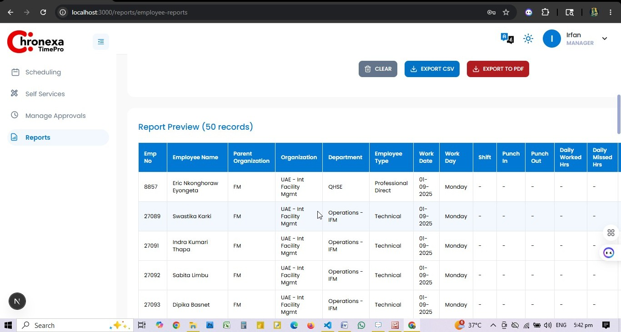

Appendix A — Role Privilege Summary
Module / Tab | Admin | Manager | Timekeeper
Dashboard — User Insights | View | View (scoped) | —
Company Master — Locations | View, Create, Edit, Delete | — | —
Company Master — Citizenship | View, Create, Edit, Delete | — | —
Company Master — Designations | View, Create, Edit, Delete | — | —
Organisation Types | View, Create, Edit, Delete | — | —
Organisation | View, Create, Edit, Delete | — | —
Organisation Structure | View, Create, Edit, Delete | — | —
Departments | View | — | —
Employee Type | View, Create, Edit, Delete | — | —
Employee Group | View, Create, Edit, Delete | — | —
Employee | View, Create, Edit | — | —
Scheduling — Schedules | View, Create, Edit, Delete | View | —
Scheduling — Weekly Schedule | View, Create, Edit, Delete | View | —
Scheduling — Monthly Schedule | View, Create, Edit, Delete | View, Create, Edit,apply filters | —
Scheduling — Holidays | View, Create, Edit, Delete | View | —
Scheduling — Ramadan Dates | View, Create, Edit, Delete | View | —
Self Services — Workflow | View, Edit | — | —
Self Services — Permissions (Manage) | View, Create, Edit | View | —
Self Services — Permissions (My Req) | View | View | —
Self Services — Permissions (Team Req) | View | — | —
Self Services — Leaves (Manage) | View, Create, Edit | View | —
Self Services — Leaves (My Req) | View | View | —
Self Services — Leaves (Team Req) | View | — | —
Self Services — My Punches | View | View | View
Self Services — Team Punches | View | View | View
Self Services — Missing Punches | View, Create, Edit | View, Create | View, Create
Manage Approvals — Missing Punches | View | View | —
Manage Approvals — Permissions | View | — | —
Manage Approvals — Leaves | View | — | —
Reports — Employee Reports | View, Create, Edit, Delete | View, Create, Edit | View, Create, Edit
Configuration — Roles | View, Create, Edit, Delete | — | —
Settings — DB Settings | View | — | —
Settings — Email Settings | View | — | —
Alerts — Email | View | — | —
User Management — Users | View, Create, Edit | — | —

