Chronexa TimePro
Workforce & Attendance Management System
Timekeeper Role — Reference Guide

Table of Contents
- System Overview ........................................ 3
- Login & Authentication .............................. 5
- Timekeeper Role – Module Reference ............... 6
- Self Services ......................................... 7
- Reports .............................................. 10
Appendix A – Role Privilege Summary ................. 12

1. System Overview

What is Chronexa TimePro?
Chronexa TimePro is a comprehensive web-based Workforce & Attendance Management System built for the project. It automates employee scheduling, real-time attendance tracking via biometric devices and web punch, leave and permission management, multi-level approval workflows, and rich reporting — all in a single unified platform.

Role-Based Access
The system operates on a Role-Based Access Control (RBAC) model. Three primary roles govern what each user sees and can do:

Role | Modules Accessible | Description
Admin | All modules: Dashboard, Company Master, Organisation, Employee Master, Scheduling, Self Services, Manage Approvals, Reports, Configuration, Settings, Alerts, User Management | Full system access. Configures all master data, roles, and settings.
Manager | Dashboard, Scheduling, Self Services, Manage Approvals, Reports | Manages team schedules, approves leave/punch requests, views team attendance.
Timekeeper | Self Services, Reports | Records and manages attendance punches for their assigned area. Submits missing punch corrections.

Module Access Summary
Module | Admin | Manager | Timekeeper
Dashboard — User Insights | ✔ | ✔ (limited) | —
Company Master | ✔ | — | —
Organisation | ✔ | — | —
Employee Master | ✔ | — | —
Scheduling | ✔ | ✔ | —
Self Services — Punches | ✔ | ✔ (Team) | ✔ (My & Team)
Self Services — Leaves | ✔ | ✔ (Team) | —
Self Services — Permissions | ✔ | ✔ (Team) | —
Manage Approvals | ✔ | ✔ | —
Reports | ✔ | ✔ | ✔
Configuration / Roles | ✔ | — | —
Settings | ✔ | — | —
Alerts | ✔ | — | —
User Management | ✔ | — | —

2. Login & Authentication
All users — Admin, Manager, and Timekeeper — access Chronexa TimePro through the same login screen. The system automatically loads the dashboard and sidebar modules permitted by the logged-in user's role.

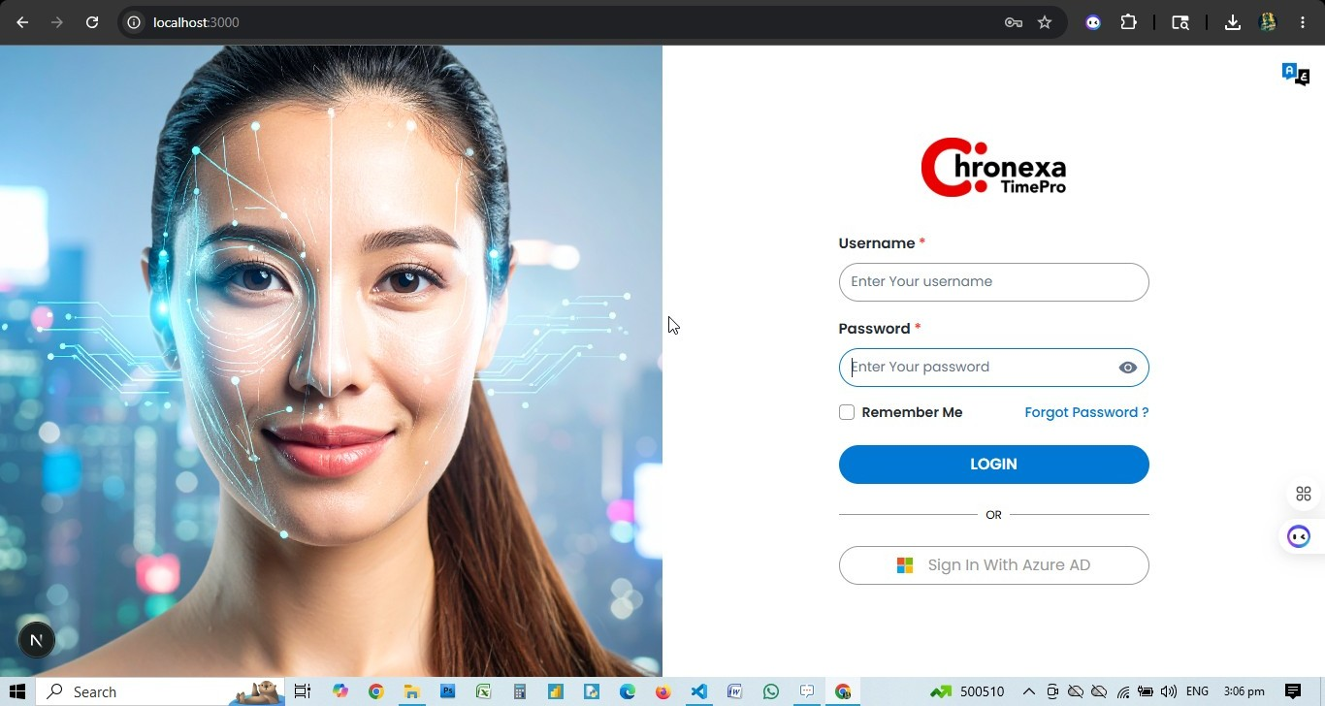

Login Steps
- Open the Chronexa TimePro URL in your browser (e.g. https://timepro.chronexa.ai).
- Enter your Username in the first field.
- Enter your Password. Use the eye icon to toggle visibility.
- Optionally check Remember Me to stay logged in.
- Click the blue LOGIN button.
- Alternatively, click Sign In With Azure AD to authenticate via Microsoft Azure Active Directory.

Forgot Password
Click the "Forgot Password?" link on the login screen. Enter your registered email address. The system sends a password reset link to your inbox.

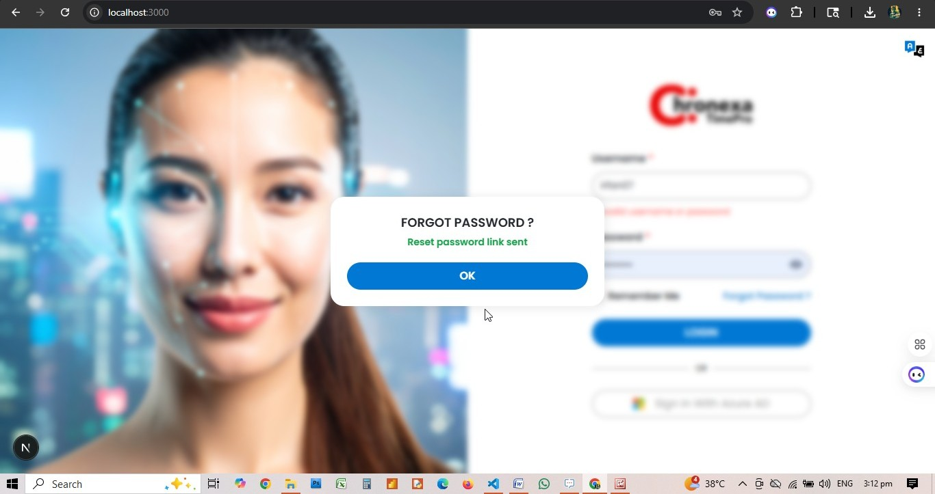

💡 After login, the sidebar menu reflects only the modules your role permits. Admin users see all 12+ menu items; Managers see 4; Timekeepers see 2.

Timekeeper Role — Module Reference

Role: TIMEKEEPER

The Timekeeper role has a focused set of two modules: Self Services and Reports. Timekeepers are responsible for recording and correcting attendance punches for their assigned area.
💡 Timekeeper sidebar modules: Self Services | Repo

1. Self Services
Role: TIMEKEEPER
The Self Services module for a Timekeeper provides access exclusively to the Punches sub-module. This allows the Timekeeper to view their own punches, manage team punches, and flag missing punches.

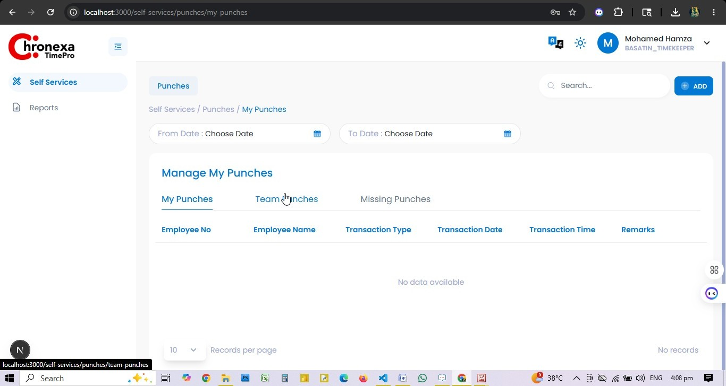

Punches Sub-Module
Tab | Access | Description
My Punches | View | Personal punch history: Transaction Type (IN/OUT), Date, Time, Remarks
Team Punches | View | Punch records for all employees in the Timekeeper's assigned area
Missing Punches | View, Create | Identify and submit missing punch records for employees

My Punches — Field Reference
Column | Description
Employee No | Timekeeper's employee number
Employee Name | Timekeeper's full name
Transaction Type | IN or OUT
Transaction Date | Date of the punch record
Transaction Time | Exact time of the punch
Remarks | System-generated note (e.g. Punch via IDS integration — ontime)

How to Add a Manual Punch
- Navigate to Self Services → Punches → My Punches or Team Punches.
- Click the + ADD button at the top right.
- Select the employee (for team punches), enter the date, time, and punch type (IN/OUT).
- Enter a remark explaining the reason for the manual entry.
- Save the record. The punch will appear in the list pending workflow approval.

Missing Punches — Timekeeper Workflow
The Missing Punches tab shows employees in the Timekeeper's scope who have an incomplete punch record for any date.
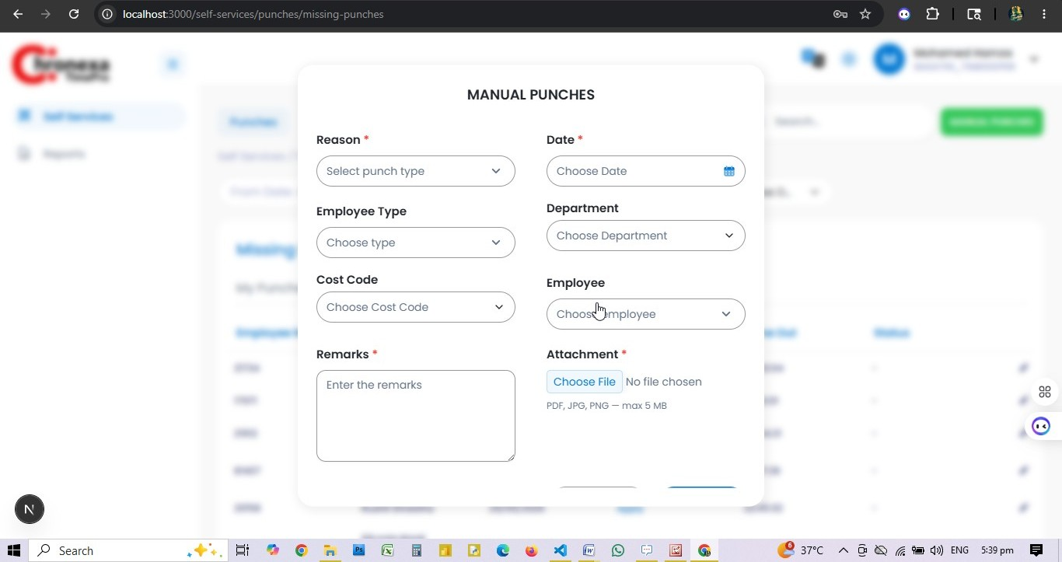
Fig 1.1 — Manual Punches Form
Column | Description
Employee No | Numeric employee ID
Employee Name | Full name of the employee
Date | Date of the missing punch
Time In | Recorded check-in time (if available)
Time Out | Apply link if check-out is missing
Status | Current status of the correction request

- Click Apply next to the Time In or Time Out column to record the missing punch.
- Use the date filters (From Date / To Date) to narrow the view to a specific period.
- Use the Department filter to scope to a specific department.
- The Manual Punches button (top right) allows batch manual entry.

💡 Timekeepers do NOT have access to Leaves or Permissions tabs. Only Punches (My Punches, Team Punches, Missing Punches) is available in Self Services.

2. Reports
Role: TIMEKEEPER
Timekeepers have access to Employee Reports to view and export attendance data for employees in their assigned area.

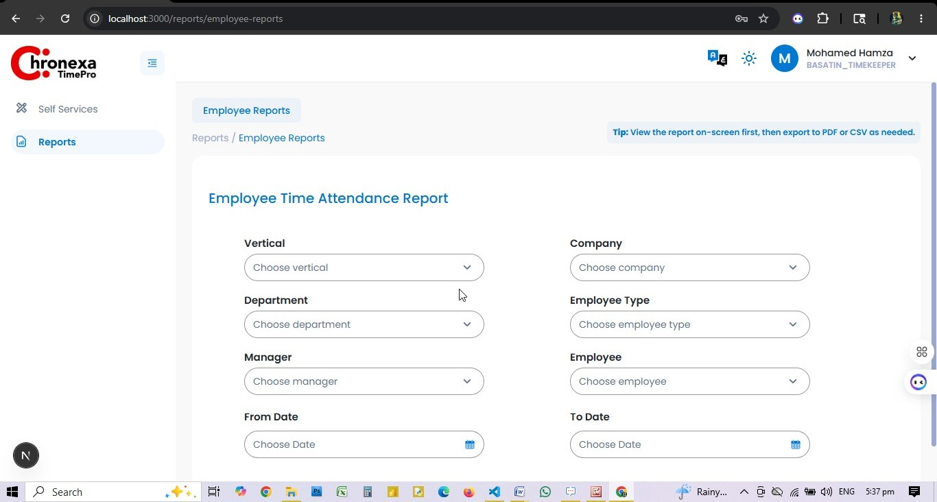
Fig 2.1 — Employee Time Attendance Report

Report Filters Available to Timekeepers
Filter | Timekeeper Scope
Vertical | Scoped to the Timekeeper's assigned vertical
Company / Organisation | Scoped to Timekeeper's assigned company
Department | Departments within their scope
Employee Type | All employee types
Employee | Any employee in their assigned area
Date Range | Any custom from/to date range

Using the Report
- Navigate to Reports → Employee Reports.
- Set filters (department, date range, employee).
- Click VIEW REPORT to display results on screen.
- Export to PDF or CSV/Excel as required.
- Click CLEAR to reset all filters.

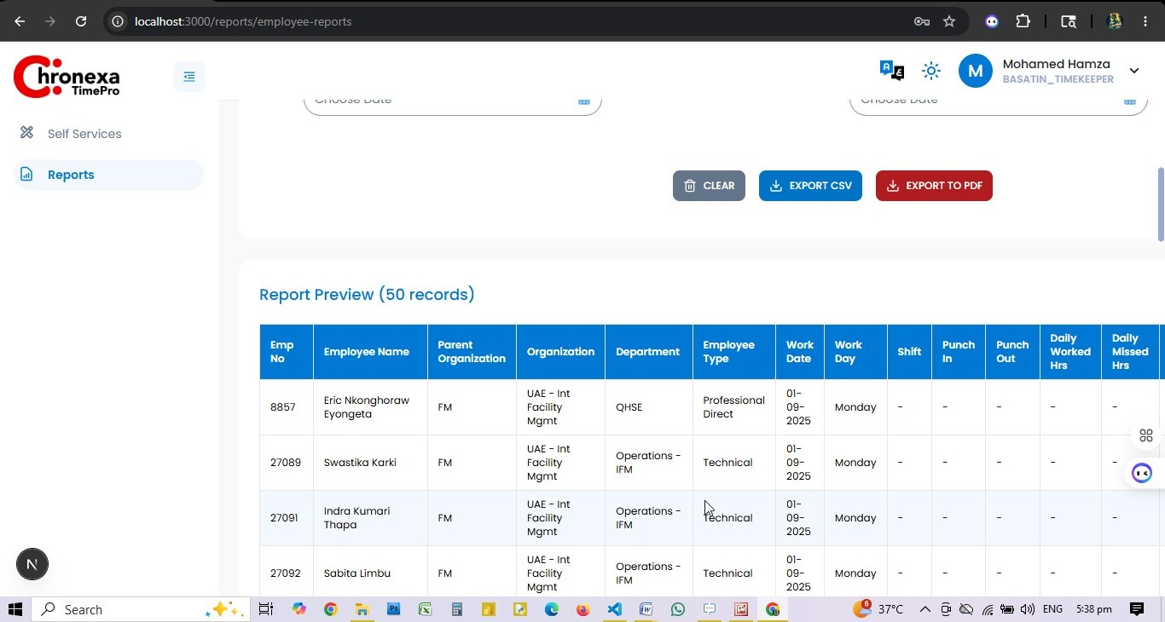

💡 View the report on screen first, then export to PDF or CSV as needed.

Appendix A — Role Privilege Summary
Module / Tab | Admin | Manager | Timekeeper
Dashboard — User Insights | View | View (scoped) | —
Company Master — Locations | View, Create, Edit, Delete | — | —
Company Master — Citizenship | View, Create, Edit, Delete | — | —
Company Master — Designations | View, Create, Edit, Delete | — | —
Organisation Types | View, Create, Edit, Delete | — | —
Organisation | View, Create, Edit, Delete | — | —
Organisation Structure | View, Create, Edit, Delete | — | —
Departments | View | — | —
Employee Type | View, Create, Edit, Delete | — | —
Employee Group | View, Create, Edit, Delete | — | —
Employee | View, Create, Edit | — | —
Scheduling — Schedules | View, Create, Edit, Delete | View, Create, Edit | —
Scheduling — Weekly Schedule | View, Create, Edit, Delete | View, Create, Edit | —
Scheduling — Monthly Schedule | View, Create, Edit, Delete | View, Create, Edit | —
Scheduling — Holidays | View, Create, Edit, Delete | View, Create, Edit | —
Scheduling — Ramadan Dates | View, Create, Edit, Delete | View, Create, Edit | —
Self Services — Workflow | View, Edit | — | —
Self Services — Permissions (Manage) | View, Create, Edit | View | —
Self Services — Permissions (My Req) | View | View | —
Self Services — Permissions (Team Req) | View | — | —
Self Services — Leaves (Manage) | View, Create, Edit | View | —
Self Services — Leaves (My Req) | View | View | —
Self Services — Leaves (Team Req) | View | — | —
Self Services — My Punches | View | View | View
Self Services — Team Punches | View | View | View
Self Services — Missing Punches | View, Create, Edit | View, Create | View, Create
Manage Approvals — Missing Punches | View | View | —
Manage Approvals — Permissions | View | — | —
Manage Approvals — Leaves | View | — | —
Reports — Employee Reports | View, Create, Edit, Delete | View, Create, Edit | View, Create, Edit
Configuration — Roles | View, Create, Edit, Delete | — | —
Settings — DB Settings | View | — | —
Settings — Email Settings | View | — | —
Alerts — Email | View | — | —
User Management — Users | View, Create, Edit | — | —

