GAME-BASED LEARNING WITH AUTOMATA THEORY

**Meghana K, M Chaithra,**

**Anu S M, N Nagamani**

**Abstract:**

***This research explores a comprehensive and interdisciplinary approach to game-based learning, leveraging the principles of Automata Theory. There are distinct papers collectively contribute to the development of an integrated educational framework. The initial paper introduces a simulator and game tailored for engineering students, emphasizing active learning in automata theory. Building upon this foundation, the second paper expands the scope, showcasing applications of Computational and Automata Theory across various domains, with a specific emphasis on arcade game design. The third paper seamlessly integrates computation, automata tools, and game theory in the development of a complex roller coaster game. This interdisciplinary approach highlights the practical application of theoretical concepts, extending implications to computer networks, law, and economics. The fourth paper introduces a finite state automata simulator and a robot-based game, incorporating Java and Lego NXT Robot set and many more. This exemplifies a hands-on, active learning pedagogy tailored for theory of computation courses. Collectively, these papers contribute to a game-based learning concept that spans multiple dimensions of Automata Theory. The provided simulator and games offer visual, interactive platforms for building, modifying, and simulating finite state machines, thereby enhancing the learning experience for engineering students. The incorporation of robots and diverse applications in arcade game design and roller coaster simulations further enriches the educational landscape. This integrated framework not only reinforces theoretical concepts but also promotes collaborative learning, active engagement, and motivation among students. The multifaceted applications showcased underscore the versatility of Automata Theory in solving real-world problems, establishing it as a pivotal component in the broader landscape of game-based learning within computer science education.***

Keywords—***: Game-Based Learning, Automata Theory, Active Learning, Finite State Machines, Computational Theory, Game Design, Educational Framework.***

# **Introduction**

This research delves into a holistic exploration of automata theory in game design, encompassing distinct papers that collectively contribute to the development of an integrated educational framework. The primary objective is to present a robust game design methodology using automata theory, specifically focusing on the development of an infinite runner game featuring dynamic objects. This involves showcasing the ease of implementation through automaton tools, emphasizing the advantages, such as fewer bugs and faster implementation. Building upon this objective, the second paper in the series focuses on addressing challenges faced by novice learners in understanding fundamental automata concepts. The aim is to enhance their motivation and active participation in the learning process by developing a visual and interactive simulator and a robot-based game for learning automata theory topics, particularly tailored for engineering students. The third paper extends the exploration into the realm of arcade game design, emphasizing computational and automata theory, and game theory's application. The objective is to create an engaging and educational arcade game that can serve as a valuable learning tool. The background emphasizes the increasing trend of using educational games, highlighting their role in accommodating different learning styles. Lastly, the fourth paper aims to leverage automata theory in multidisciplinary computing and scientific research, specifically within the context of game design. The primary objective is to demonstrate the application of non-deterministic finite state automata in designing a roller coaster game. The background provides a comprehensive overview of game theory's relevance in explaining various phenomena and its applications in computer science, telecommunication networks, law, and economics.

Collectively, these papers contribute to a game-based learning concept that spans multiple dimensions of automata theory. The provided simulators, games, and methodologies offer visual, interactive platforms for building, modifying, and simulating finite state machines, enhancing the learning experience for engineering students. The incorporation of robots, diverse applications in arcade game design, and roller coaster simulations further enrich the educational landscape. This integrated framework not only reinforces theoretical concepts but also promotes collaborative learning, active engagement, and motivation among students, establishing automata theory as a pivotal component in the broader landscape of game-based learning within computer science education.

.

# **THEORY/CALCULATIONS/ METHODOLOGY**

## An Infinite Runner Game Design

The Game Hungry bird is endless runner until player hits any hurdle, enemy or fuel runs out. This game is made using infinite loops with some condition on which it breaks the loop and exit to Game End state.

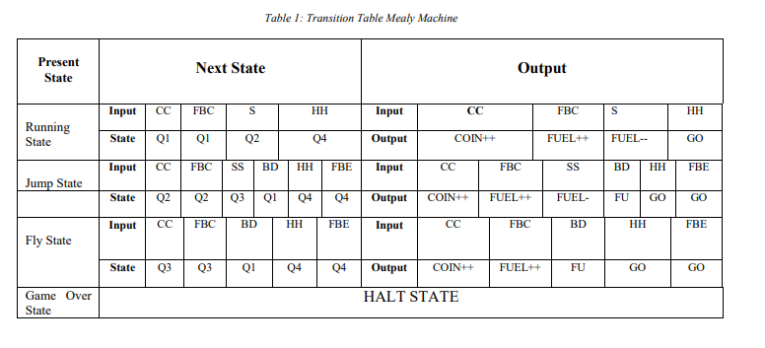

These games have Seven States.

Game Description:

1) Running State: Game will be in running state and all the game objects will performing according to job assigned.

2) Game Over State: Game will goes to game over state when player hits the enemy, hurdle or fuel barrel ends.

3) Jump State: Health bar will decrease when player is in jump state on “S” input.

4) Fly State: Player will be in fly state when “SS” input comes and it will decrease fuel.

• There will be two background images creating an impression of live/animated moving background while player will be still at its position.

• Four different types of hurdles will come from horizontal path and the player has to avoid them.

• Player can jump by input “S” and on S pressed player will be fly.

• Player will move on input “UP ARROW, DOWN ARROW, LEFT ARROW, and RIGHT ARROW.

• Fuel will be subtracted from Fuel barrel on jump and fly.

• Fuel will be added on catching fuel bonus barrel..

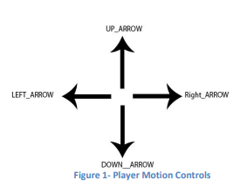

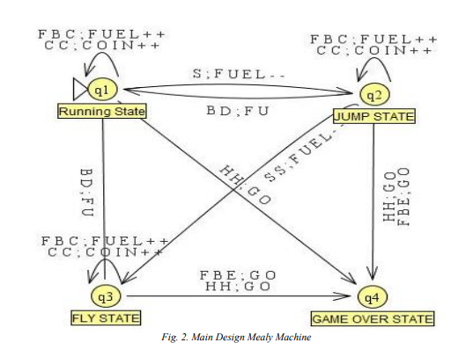

## A Game-based Learning System Using Lego NXT Robot

The methodology employed in the research involves the development and evaluation of a Finite State Machine (FSM) simulator and a robot-based game for active learning in theory of computation related courses. The initial phase of the methodology involved identifying the challenges faced by novice learners in understanding basic automata concepts and the lack of motivation to actively participate in traditional lecture-driven teaching methods. Subsequently, the research team designed and implemented a visual and interactive simulator and a robot-based game using Java language, ensuring portability, machine independence, and web-based functionality.

The development process integrated the active construction learning model, emphasizing the role of teachers as facilitators and the importance of collaborative learning environments. The simulator and game were designed to align with these principles, providing a clear workflow of learning activities and ease of use for new users. The methodology also included conducting experiments to evaluate the effectiveness of the integrated environment tools. The preliminary results of these experiments demonstrated improvements in learners' performance and motivation, validating the efficacy of the developed tools.

Furthermore, the methodology involved providing a comprehensive overview of finite state machines and their applications in software and hardware, emphasizing their relevance to various courses including theory of computations, discrete mathematics, programming languages, and compiler design. Overall, the methodology focused on addressing the limitations of existing automata learning tools and providing a model for interactive online collaborative learning tools, specifically tailored to the needs of engineering students.

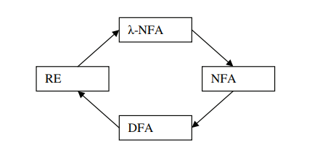

Fig 3. Transformation between finite state machine and regular expression.

## Solution of Goore game using modules of stochastic learning automata

The Goore game, also known as the Gur game, is a simple yet fascinating game with profound implications in distributed coordination and learning automata.The theory of the paper includes

1. Game Structure:

* Players: Finite and identical (symmetric) in terms of actions and rewards.
* Actions: Each player has two choices: cooperate (C) or defect (D).
* Payoffs: Cooperating with a cooperator yields the highest reward (R), while defecting against a cooperator yields the highest individual gain (T), but less than mutual cooperation. Defecting against a defector earns nothing (P).

Fig 4: Payoff Matrix

2. Equilibrium Analysis:

* Nash Equilibrium: The Goore game has two Nash equilibria: (C,C) and (D,D).
* (C,C) is Pareto Optimal: Both players maximize their joint reward in (C,C).
* Defecting Dilemma: Temptation to defect for individual gain exists, leading to the (D,D) equilibrium, even though it's worse for both players combined.

3. Distributed Coordination:

* The challenge lies in achieving (C,C) without explicit communication or centralized control.
* This is where learning automata come in.

Methodology:

1. Learning Automata:

* Finite-state machines that learn and adapt their behavior based on received rewards.
* Each player is represented by an automaton with internal states and transition rules.
* Actions (C/D) and state transitions depend on past actions and rewards received.

2. LR_1 Algorithm:

* A popular and simple learning automata algorithm for the Goore game.
* Each automaton maintains two internal states: "cooperate" and "defect".
* After each action, the state with higher reward probability is reinforced.

Over time, automata converge to playing C most of the time, leading to (C,C) coordination.

3. Convergence and Properties:

* LR_1 is guaranteed to converge to a Nash equilibrium under certain conditions.
* It is robust to noise and errors in reward signals.
* Can be extended to multi-agent systems and more complex games.

*D. LARPA: A learning automata‐based resource provisioning approach for massively multiplayer online games in cloud environments*

The paper proposes a learning-based resource provisioning approach for MMOG services that is based on the combination of the autonomic computing paradigm and learning automata (LA). The proposed approach is aimed at dealing with fluctuating demands due to variability in the arrival rate of players of the MMOG services. The authors claim that the proposed approach has a remarkable performance in terms of response time, cost, and allocated virtual machines (VMs).

1. Autonomic Computing: LARPA is said to combine utonomic computing principles with learning automata. Autonomic computing emphasizes self-management and adaptation of systems, which aligns with the use of learning automata in LARPA. Learning automata can adjust their behavior based on feedback from the environment, enabling dynamic resource allocation in response to fluctuating MMOG demands.

2. Learning Automata: The paper likely employs specific learning automata models, like the Q-learning model, to learn optimal resource allocation strategies. These models involve states, actions, transitions, and reward functions. The automata choose actions based on their current state and update their internal states based on received rewards (e.g., improved response time or reduced cost) and external observations (e.g., player arrival rate).

3. Feedback Loops: Learning automata rely on feedback loops to improve resource allocation. LARPA likely uses metrics like response time, resource utilization, and cost as feedback signals to guide the automata's learning process.

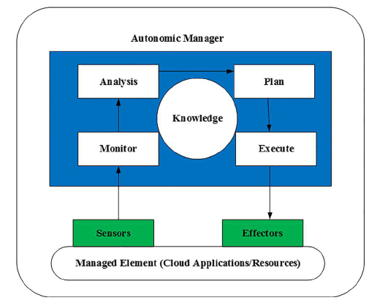

Fig 5. The MAPE-K Feedback loop

# **RESULT AND DISCUSSIONS**

## An Infinite Runner Game Design and Results.

The experimental results in the paper demonstrate the successful implementation of game design using automaton tools, particularly Mealy machines.

The results include a transition state table that illustrates the game scenario, its states, possible inputs, and corresponding outputs. This provides clear evidence of the practical application of automata theory in game design. The observed results affirm the feasibility and effectiveness of utilizing automaton tools in the development of the infinite runner game with dynamic objects. The seamless integration of theoretical concepts from automata theory into a practical and functional game design is evident. The results validate the theoretical framework presented in the paper, showcasing the successful translation of theoretical principles into a real-world application. This substantiates the practical relevance and applicability of automata theory in the context of game design, particularly in the development of dynamic and interactive gaming experiences.

*B. A Game-based Learning System Using Lego NXT Robot*

The project involved the development of a Finite State Machine Simulator and a Robot-Based Game to facilitate active learning in theory of computation related courses. Implemented in Java, the simulator features a graphical interface for building and simulating finite state machines and integrates with a Lego Mindstorm NXT robot to simulate automaton transitions. The project aimed to address the difficulties novice learners face in understanding basic concepts and to enhance their motivation to actively participate in the learning process. The simulator provides a clear workflow of learning activities and is designed to be easy-to-use and easy-to-learn for new users. It has shown to improve learners' performance and motivation, making it suitable for theory of computation, automata theory, discrete mathematics, computational models, programming languages, and compiler design courses. The integration of robots into the learning process is a novel approach, attracting less motivated students. The robot can display inputted strings, start motion according to the inputted string and automaton, and display whether the automaton accepts or rejects the input. Overall, the project has demonstrated the effectiveness of integrating interactive and online collaborative tools into the learning environment, providing a model for a wide range of topics at the undergraduate level.

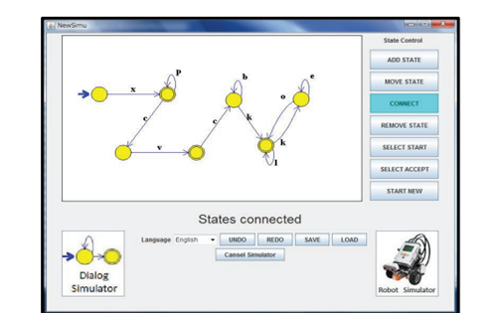*Fig 6: The simulator’s Interface*

## Solution of Goore game using modules of stochastic learning automata

1. Equilibrium Analysis: As mentioned previously, the Goore game has two Nash equilibria: (C,C) and (D,D). The (C,C) equilibrium, where all players cooperate, is Pareto optimal as it maximizes the joint reward for all players. However, the game faces the "defecting dilemma," where it's individually more tempting to defect and exploit others, leading to the less beneficial (D,D) equilibrium.

2. Learning Automata Performance: Research shows that learning automata algorithms like LR_1, Q-learning, and SARSA can successfully achieve cooperation in the Goore game. Studies have demonstrated how these algorithms converge towards the (C,C) equilibrium with high probability, particularly under conditions where cooperation offers sufficient advantages over defection.

3. Applications: The Goore game serves as a model for various real-world scenarios involving decentralized coordination and resource management. Insights gained from the game can be applied in fields like:

* Resource allocation: Coordinating agents in distributed systems to share resources efficiently.
* Sensor networks: Optimizing data collection and communication among decentralized sensors.
* Distributed optimization: Solving optimization problems involving multiple agents without a central controller.

*D. LARPA: A learning automata‐based resource provisioning approach for massively multiplayer online games in cloud environments*

1. Reduced Response Time: If the automata learn to allocate adequate resources promptly as player numbers increase, response times for players could improve.

2. Lower Cost: Efficient resource allocation based on demand might lead to cost savings by avoiding unnecessary VM provisioning.

3. Optimal VM Allocation: Learning automata, by continuously adapting to demand fluctuations, might achieve optimal VM allocation, using only the necessary resources to maintain performance.

# **CONCLUSION AND FUTURE SCOPE**

## **Conclusion**

In conclusion, the integration of automata theory in education and game design has shown promising results. The Finite State Machine Simulator and Robot-Based Game have been well-received by students, indicating interest and convenience in learning automata theory. Despite positive feedback, areas for improvement in the simulator have been identified, with plans to enhance graphical editing and eliminate command prompt usage. The benefits of using automaton and computational theory tools in game design are evident, showcasing fewer bugs, simplified design processes, and effective handling of invalid inputs. The future scope involves refining the simulator, integrating tools comprehensively, and exploring advanced artificial intelligence in game design. There's potential for broader applications in solving real-life complex problems, extending the behavioral model, and applying automata theory to diverse scenarios.

## **Future Scope**

The future direction of this research includes refining the Finite State Machine Simulator, streamlining user interfaces, and integrating the simulator and robot game into a comprehensive set of automata tools. Further enhancements aim to improve usability for both novice and advanced learners. Additionally, the exploration of advanced artificial intelligence using complexity theory in game design is proposed. Extending the application of automata theory to solve real-life complex problems and refining behavioral models for broader adaptability are avenues for future research. The potential integration of automata theory with software engineering practices and the optimization of gaming strategies opens new dimensions for multidisciplinary computing and scientific research.

# **V. APPENDIX**

*Comprehensive Methods and Development Information*

1. Finite State Machine (FSM) Simulator and Robot-Based Game Development

This section provides a comprehensive explanation of the methods used to develop the Finite State Machine (FSM) simulator and the related robot-based game. The chosen programming language, Java, is based on its suitability for portability, machine independence, and inclusion of web-based features. Architecture diagrams, code snippets, and design considerations are included to give readers an overview of the technical aspects of the development process.

1. Identifying Challenges and Learning Gaps

The initial phase of the methodology identified the challenges that novice learners face in understanding basic automata concepts. This section details methods such as surveys, interviews or focus groups to gather insights into specific student difficulties. A comprehensive overview of identified challenges and learning gaps is provided, which lays the foundation for further development of the simulator and game.

1. Integration of the Active Constructive Learning Model

This section describes the seamless integration of the Active Constructive Learning Model into the simulator and game design. It introduces the principles of active learning, collaborative environments and the role of teachers as facilitators of learning. Descriptions of aligning simulators and games with these principles are provided, emphasizing the importance of user-friendly interfaces and engaging learning activities.

1. Overview of Finite State Machines and Applications

To contextualize the importance of the tools, this section provides a comprehensive overview of Finite State Machines (FSMs) and their various applications in software and hardware. Methods for introducing the significance of FSMs to a variety of courses including theory of computation, discrete mathematics, programming languages, and compiler design are discussed

# **ACKNOWLEDGEMENT**

We would like to express our sincere gratitude to our Professor, Ms. Sini Anna Alex for her invaluable guidance throughout the course of this project and assistance on writing the Technical Report on Game Based learning with automata theory.

# **REFERENCES**

1. Norman Qureshi, “Computing Game Design with Automata Theory”, Engineering University of Engineering & Technology, Lahore 2012.

2. Zohaib Abbas, “A Roller Coaster Game Design using Automata Theory”, Engineering, University of Engineering & Technology, Lahore, 2012.

3. Visch, V. T., et al. "Persuasive Game Design: A model and its definitions." CHI 2013: Workshop Designing Gamification: Creating Gameful and Playful Experiences, Paris, France, 27 April-2 May 2013. ACM, 2013.

4. Nelson, Mark J., and Michael Mateas. "Towards automated game design." AI* IA 2007: Artificial Intelligence and Human-Oriented Computing. Springer Berlin Heidelberg, 2007. 626-637.

5. Claypool, Kaval, and Mark Claypool. "Teaching software engineering through game design." ACM SIGCSE Bulletin 37.3 (2005): 123-127.

6. Andrew Rolling and E. Adams. On Game Design. New Riders Publishing, 2003.

7. H. Bergstrom, "Applications, Minimization, and Visualization of Finite State Machines." Master Thesis. Stockholm University, 1998. Related website at: http://www.dsv.su.se/~henrikbe/petc/.

8. J. Bovet, "Visual Automata Simulator, a tool for simulating automata and Turing machines." University of San Francisco. Available at: http://www.cs.usfca.edu/~jbovet/vas.html, 2004.

9. N. Christin, "DFApplet, a deterministic finite automata simulator." Available at: http://www.sims.berkeley.edu/~christin/dfa/, 1998. 1952 Mohamed Hamada et al. / Procedia Computer Science 4 (2011) 1944–1952.

10. S. Hadjerrouit, "Toward a constructivist approach to e-learning in software engineering." Proc. E-Learn-World Conf. E-Learning Corporate, Government, Healthcare, Higher Education, Phoenix, AZ, pp. 507-514, 2003.

11. M. Hamada, "An Integrated Virtual Environment for Active and Collaborative e-Learning in Theory of Computation." IEEE Transactions on Learning Technologies, Vol. 1, No. 2, pp. 1-14, 2008.

12. E. Head, "ASSIST: A Simple Simulator for State Transitions." Master Thesis. State University of New York at Binghamton. 1998. Related website at: http://www.cs.binghamton.edu/~software/.

13. LEGO.com MINDSTORMS: "What is in the box?" [Online] Available: http://mindstorms.lego.com/en-us/history/default.aspx.

14. LEJOS Java for LEGO Mindstorms [Online] Available: http://lejos.sourceforge.net/nxt/nxj/tutorial/Preliminaries/Intro.htm.

15. LEJOS Java for LEGO Mindstorms [Online] Available: http://lejos.sourceforge.net/nxt/nxj/tutorial/Preliminaries/GettingStartedWindows.htm.

16. LEJOS java for LEGO Mindstorms [Online] Available: http://lejos.sourceforge.net/nxt/nxj/tutorial/Preliminaries/CompileAndRun.htm.

17. M. Mohri, F. Pereria, and M. Riley, "AT&T FSM Library." Software tools. 2003. Available at: http://www.research.att.com/sw/tools/fsm/.

18. S. Rodger, "Visual and Interactive tools." Website of Automata Theory tools at Duke University, http://www.cs.duke.edu/~rodger/tools/. 2006.

19. "Transforming undergraduate education in science, mathematics, engineering, and technology." In “Committee on Undergraduate Science Education”, Center for Science, Mathematics, and Engineering Education. National Research Council ed. Washington, DC: National Academy Press, 1999.

20. G. Wilson, Ed., "Constructivist Learning Environments: Case Studies in Instructional Design." Englewood Cliffs, NJ: Educational Technology, 1998.