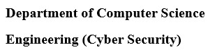

**Program: Bachelor of Engineering in Computer Science & Engineering (Cyber Security)**

*A Project Report on*

**E-Waste Classification Using**

**Deep Learning**

*Submitted in partial fulfillment of the requirements for the course*

***CY54: MINI PROJECT***

*By*

Anu S M 1MS21CY010

M Chaithra 1MS21CY028

Raju J 1MS21CY040

Archana K 1MS22CY400

*Under the guidance of*

**Pallavi T P**

Senior Lecturer

**M S RAMAIAH INSTITUTE OF TECHNOLOGY**

**(Autonomous Institute, Affiliated to VTU)**

**BANGALORE-560054**

**www.msrit.edu**

**DEPARTMENT OF COMPUTER SCIENCE & ENGINEERING (CYBER SECURITY)**



**CERTIFICATE**

Certified that the project work titled E-Waste Detection and Classification Using Machine Learning carried out by– 1MS21CY010 Anu S M, 1MS21CY028 M Chaithra, 1MS20CY040 Raju J, 1MS22CY400 Archana K are bonafide students of M. S. Ramaiah Institute of Technology, Bengaluru, in partial fulfillment of the course Mini Project CY54 during the term Oct-Jan 2024. The project report has been approved as it satisfies the academic requirements, for the aforesaid course. To the best of our understanding, the work submitted in this report is the original work of students**.**

**Project Guide:** Pallavi T P **Head of the Department**

Dr. Thippeswamy M N

**External Examiners Signature with Date**

**DECLARATION**

We, hereby, declare that the entire work embodied in this mini-project report has been carried out by us at M. S. Ramaiah Institute of Technology, Bengaluru, under the supervision of Mrs Pallavi T P Senior Lecturer, Department of CSE AI &ML. This report has not been submitted in part or full for the award of any diploma or degree of this or to any other university.

Anu S M M Chaithra 1MS21CY010 1MS21CY028

Raju J Archana K

1MS21CY040 1MS22CY400

**ACKNOWLEDGEMENT**

We take this opportunity to express our gratitude to the people who have been instrumental in the successful completion of this project. We would like to express our profound gratitude to the Management and Dr. N.V.R Naidu Principal, M.S.R.I.T, Bengaluru for providing us with the opportunity to explore our potential.

We extend our heartfelt gratitude to our beloved Dr. Thippeswamy*,* HOD, Computer Science and Engineering Cyber Security, for constant support and guidance.

We whole-heartedly thank our project guide Mrs Pallavi T P, for providing us with the confidence and strength to overcome every obstacle at each step of the project and inspiring us to the best of our potential. We also thank her for her constant guidance, direction and insight during the project.

This work would not have been possible without the guidance and help of several individuals who in one way or another contributed their valuable assistance in preparation and completion of this study.

Finally, we would like to express sincere gratitude to all the teaching and non-teaching faculty of CSE(CS) Department, our beloved parents, seniors and my dear friends for their constant support during the course of work.

**Abstract**

The escalating global issue of electronic waste (e-waste) necessitates innovative approaches for efficient classification and detection. This research explores and compares two distinct models for e-waste classification: a neural network architecture built from scratch tailored explicitly for e-waste characteristics and a transfer learning approach using the EfficientNetB0 pre-trained model. The study aims to discern the strengths, weaknesses, and comparative performance of these models to enhance the understanding of their applicability in sustainable waste management practices.

The first model involves crafting a neural network architecture from scratch, designed to capture intricate features inherent to electronic waste. This approach allows for fine-tuning the model to the specific nuances of e-waste, potentially improving classification accuracy.

The second model leverages the power of transfer learning with EfficientNetB0, a pre-trained model known for its efficiency and performance on diverse image classification tasks. By integrating a custom head for e-waste classification, this model harnesses knowledge acquired from a broader dataset, aiming to expedite the learning process and improve overall accuracy.

The comparative analysis involves extensive experimentation, training, and evaluation on a diverse dataset of e-waste images. Metrics such as classification accuracy, precision, recall, and F1-score are employed to assess the models' performance. The study delves into the intricacies of each model, highlighting their respective advantages and limitations.

The results obtained from this research provide insights into the effectiveness of building a dedicated neural network for e-waste classification compared to leveraging a pre-trained model through transfer learning. The findings contribute to the ongoing discourse on selecting optimal methodologies for e-waste classification, furthering the goal of sustainable waste management. Additionally, the study aims to guide researchers and practitioners in choosing the most suitable approach based on the specific requirements and constraints of their e-waste classification projects.

**List of Figures**

|  |  |  |
| --- | --- | --- |
| Figure  no | Figure Title | Page Number |
| 1 | Gantt chart | 9 |
| 2 | Use Case Diagram | 16 |
| 3 | Architecture Flowchart | 18 |
| 4 | User Interface Flowchart | 19 |
| 5 | Low level Design | 21 |
| 6 | State diagram | 21 |
| 7 | Method 1: Image resizing and Taking Input of given image | 32 |
| 8 | Method 1: Accuracy graph | 33 |
| 9 | Method1: Classifying input image as Phones | 34 |
| 10 | Method1: Estimated price of given E-waste | 34 |
| 11 | Method2: Classifying input image and Displaying result | 35 |
| 12 | Method2: Estimated price of given E- waste | 35 |

**List of Tables**

|  |  |  |
| --- | --- | --- |
| Figure no. | Table | Pageno |
| 1 | Roles and Responsibility of the Project | 5 |
| 2 | Literature survey | 7 |
| 3 | Risk Identification | 10 |
| 4 | Use Case description | 14 |

**TABLE OF CONTENTS**

**1. INTRODUCTION**

1.1 General Introduction1

1.2 Problem Statement1

1.3 Objectives of the project 1

1.4 Project deliverables2

1.5 Current Scope2

1.6 Future Scope3

**2. PROJECT ORGANIZATION**

2.1 Software Process Models4

2.2 Roles and Responsibilities5

**3. LITERATURE SURVEY**

3.1 Introduction6

3.2 Conclusion of Survey8

**4. PROJECT MANAGEMENT PLAN**

4.1 Schedule of the Project (Gantt Chart)9

4.2 Risk Identification10

**5. SOFTWARE REQUIREMENT SPECIFICATIONS**

5.1 Purpose11

5.2 Project Scope11

5.3 Overall Description11

5.3.1 Project Perspectives

5.3.2 Product Features

5.3.3 Operating Environment

5.4 External Interface Requirements12

5.4.1 User Interfaces

5.4.2 Hardware Interfaces

5.4.3 Software Interfaces

5.4.4 Communication Interfaces

5.5 System Features13

5.5.1 Functional requirements

5.5.2 Nonfunctional requirements

5.5.3 Use case description

5.5.4 Use case diagram

**6. DESIGN**

6.1 Introduction17

6.2 Architecture Design17

6.3 User Interface Design18

6.4 Low Level Diagram21

6.5 State Diagram21

6.6 Conclusion22

**7. IMPLEMENTATION**

7.1 Tools Introduction23

7.2 Technology Introduction23

7.3 Overall view of the project in terms of implementation24

7.4 Explanation of Algorithm and how it is been implemented24

7.5 Information about the implementation of Modules26

7.6 Conclusion27

**8. TESTING**

8.1 Introduction28

8.2 Test Cases29

8.3 Conclusion31

**9. RESULTS AND SNAPSHOTS 32** **10. CONCLUSION & SCOPE FOR FUTURE WORK**

10.1 Findings and suggestions40

10.2 Significance of the Proposed Research Work41

10.3 Limitation of this Research Work41

10.4 Directions for the Future works41

**11. REFERENCES 42**

**Chapter 1**

**1. INTRODUCTION**

**1.1 General Introduction**

E-waste, or electronic waste, encompasses electrical and electronic equipment that’s outdated, unwanted, or broken. E-waste contains a laundry list of chemicals that are harmful to people and the environment, like mercury, lead, beryllium, brominated flame retardants, and cadmium, i.e. stuff that sounds as bad as it is. When electronics are mishandled during disposal, these chemicals end up in our soil, water, and air. Thus the detection of E-waste is an essential step to work on further steps of safely disposing and recycling this waste to minimize its impact on the environment. This project aims to address this critical issue by developing an advanced AI-powered system for accurate e-waste identification and classification. Through image recognition and machine learning, users will be able to contribute to responsible e-waste management, fostering a more sustainable future. The initiative focuses on creating a web application and a mobile app, both equipped with robust e-waste detection capabilities. By enabling users to capture and upload images, the system will automatically categorize e-waste items, such as batteries, laptops, and mobile phones, enhancing awareness and promoting responsible disposal practices.

**1.2 Problem Statement**

The proliferation of electronic devices has led to an alarming increase in electronic waste (e-waste), creating a pressing environmental and health crisis. Current e-waste disposal methods are often insufficient, resulting in environmental degradation and endangering both ecosystems and human well-being. The lack of effective systems for identifying and categorizing e-waste exacerbates this challenge, hindering responsible e-waste management practices. This project endeavours to confront this issue head-on by developing an innovative AI-powered solution that utilizes machine learning for precise e-waste detection and classification. The dearth of robust technologies in this realm underscores the urgency of finding sustainable solutions. This report aims to explore, analyse, and propose a comprehensive approach to enhance e-waste identification and classification, contributing to a more environmentally conscious and sustainable future.

**1.3 Objectives of the Project**

1. **Performance Evaluation:** Assess and compare the classification accuracy, precision, recall, and F1-score of the "Building a Model from Scratch" and "Transfer Learning with EfficientNetB0" models to gauge their effectiveness in e-waste detection.
2. **Training Efficiency:** Compare the training efficiency of both models, considering convergence speed, resource utilization, and computational requirements, aiming to identify the most efficient model for e-waste classification.
3. **Robustness Analysis:** Evaluate the robustness of the models by exposing them to diverse e-waste images, including variations in lighting, angles, and image quality, to ensure their reliability in real-world scenarios.
4. **Fine-Tuning Effectiveness:** Investigate the impact of fine-tuning on the Transfer Learning with EfficientNetB0 model, determining whether this process enhances its performance on specific e-waste image characteristics.
5. **User-Friendly Interface:** Develop an intuitive and user-friendly interface to present classification results from both models, enhancing user engagement and comprehension of the models' outcomes for broader accessibility.
6. **Scalability Considerations:** Examine the scalability of the models concerning the potential expansion of the e-waste dataset, assessing how well each model accommodates increased image volume without significant performance degradation.

Top of Form

**1.4 Project deliverables**

* **AI-Powered E-Waste Detection System:**
  + Develop a functional and scalable system capable of accurately identifying and classifying e-waste items.
  + Integrate Few-Shot Trial methodology and TensorFlow 2.0 Object Detection for enhanced performance.
* **Web Application and Mobile App:**
  + Create an intuitive web application and mobile app with user-friendly interfaces.
  + Enable users to capture images or upload photos for e-waste detection.
* **Robust Object Detection Models:**
  + Implement advanced object detection models trained on extensive e-waste datasets.
  + Ensure models can categorize specific e-waste types (e.g., batteries, laptops, mobile phones) with high accuracy.

**1.5 Current Scope**

The current scope of our project involves creating a user-friendly E-Waste Detection and Classification System using advanced machine learning techniques. We aim to develop a system capable of quickly and accurately identifying electronic waste items based on their characteristics. The focus is on outdated, unwanted, or broken electronic equipment, which often contains harmful chemicals like mercury, lead, beryllium, brominated flame retardants, and cadmium. Our system aims to detect and classify these items to promote responsible e-waste management. The project includes the development of a user-friendly application for capturing and analysing images, integrating smart algorithms for accurate detection, and contributing to environmentally conscious practices in the disposal and recycling of electronic waste.

**1.6 Future Scope**

Expanding functionalities of the e-waste classification and detection app involves integrating more sophisticated image recognition models for comprehensive item categorization, allowing users to report unidentified items to enhance the model. Implementing gamification with points or rewards for responsible disposal encourages user engagement, while partnerships with local businesses offer discounts based on app activity. Educational features provide information on e-waste types, dangers, and proper disposal methods, including quizzes and articles for environmental awareness. Community features enable discussions, illegal dumping reporting, and data analysis generates reports for local authorities. Connecting with broader systems includes integrating with government databases for real-time facility information and collaborating with waste management companies for professional removal services. Expanding to other regions and exploring technological advancements such as augmented reality for item identification and blockchain integration for transparent waste tracking further enhance the app's capabilities, promoting responsible e-waste management and environmental sustainability.

**Chapter 2**

**2. PROJECT ORGANIZATION**

**2.1 Software Process Models**

For both approaches, considering an iterative and incremental model, such as Agile or Spiral

**Agile**

* Well-suited for exploratory and adaptive projects
* Emphasis on continuous feedback, adaptability, and working software.
* Effective for smaller teams and projects with evolving requirements.

**Spiral**

* Focuses on risk management and prototyping.
* Involves phases of planning, risk analysis, development, and evaluation.
* Suitable for projects with uncertain requirements or high risks.

**Considerations**

**Transfer learning approach:**

May benefit more from Agile due to potential experimentation with different pre-trained models and fine-tuning strategies.

**Building from scratch approach:**

Spiral model might be more appropriate for carefully managing risks and addressing potential challenges in building a custom architecture.

**2.1 Roles and Responsibilities**

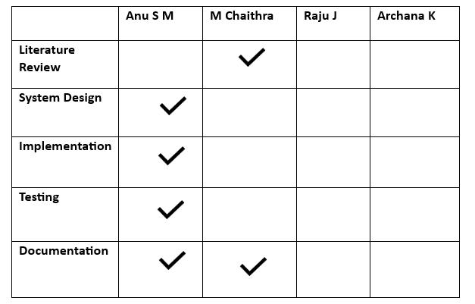

**Table 1 Roles and responsibilities for the project**

Chapter 3

**3. LITERATURE SURVEY**

**3.1 Introduction**

The burgeoning electronic waste (e-waste) crisis has prompted a surge in research endeavours, particularly in the realm of machine learning, to devise effective solutions for the detection and classification of e-waste items. This literature survey delves into the burgeoning body of research that addresses the urgency of enhancing e-waste management practices through the implementation of machine learning techniques. Researchers are increasingly leveraging state-of-the-art object detection models, transfer learning strategies, and deep learning approaches to devise accurate and efficient systems for identifying and categorizing e-waste. The exploration encompasses challenges related to dataset availability, the diversity of e-waste items, and the need for standardized evaluation metrics. Through a systematic analysis of the current literature, this survey aims to distill key insights, emerging trends, and future directions that collectively contribute to the evolving landscape of responsible e-waste detection and classification using machine learning.

**Literature survey Table**

|  |  |  |  |
| --- | --- | --- | --- |
|  | **Title and year** | **Purpose** | **Remark** |
| 1. | A Survey on Machine Learning Approaches for E-Waste Detection  Year: 2020 | Provides an overview of various machine learning methods applied to e-waste detection, highlighting their strengths and limitations. | Comprehensive survey covering recent advancements in the field. |
| 2. | E-Waste Classification: A Machine Learning Perspective  Year: 2018 | Investigates the application of machine learning techniques specifically for e-waste classification tasks. | Emphasis on classification algorithms and their performance in e-waste identification. |
| 3. | Challenges and Opportunities in E-Waste Detection Using Deep Learning Models  Year: 2019 | Explores challenges faced in e-waste detection and the opportunities that deep learning models offer. | Discusses the potential impact of deep learning in addressing e-waste management challenges. |
| 4. | Transfer Learning in E-Waste Identification: A Comprehensive Review  Year: 2021 | Offers a detailed review of transfer learning approaches in the context of e-waste identification tasks. | Focus on strategies for adapting pre-trained models to e-waste detection. |
| 5. | Evaluating Object Detection Models for Consumer E-Waste: A Comparative Study  Year: 2017 | Conducts a comparative analysis of object detection models applied to consumer e-waste items. | Provides insights into the performance of different detection models. |
| 7. | Machine Learning-Based Environmental Impact Assessment of E-Waste Disposal  Year: 2019 | Investigates the environmental impact of e-waste disposal with a focus on machine learning applications. | Explores the intersection of machine learning and environmental assessment. |
| 8. | E-Waste Detection Using Internet of Things and Machine Learning Integration  Year: 2018 | Examines the integration of IoT devices and machine learning for real-time e-waste detection. | Explores the potential of combining IoT technologies with machine learning in e-waste management. |
| 9. | Challenges in Annotated Datasets for E-Waste Detection: A Review  Year: 2020 | Evaluates challenges related to the availability and diversity of annotated datasets for training e-waste detection models. | Discusses the importance of high-quality datasets in advancing e-waste detection. |
| 10. | E-Waste Detection Models: An Overview of Challenges and Future Directions  Year: 2021 | Provides an overview of current challenges in e-waste detection models and suggests future research directions. | Addresses emerging rends and areas for improvement in the field. |

**Table 2: Literature Survey Table for E-Waste Identification and Classification**

**3.2 CONCLUSION OF SURVEY**

The literature survey on "E-Waste Detection and Classification Using DeepLearning" reveals a dynamic research landscape. The prevalence of object detection models, exploration of transfer learning, and emphasis on sustainable practices underscore the evolving strategies in this field. Challenges, such as dataset limitations, are acknowledged, emphasizing the need for standardized metrics. The intersection of machine learning with environmental impact assessments and the emergence of trends like IoT integration and real-time detection systems showcase the multidimensional approach to e-waste management. Overall, the surveyed papers provide valuable insights for researchers, practitioners, and policymakers, guiding future endeavors to enhance the accuracy and efficiency of e-waste detection and classification systems.

**Chapter 4**

**4. Project Management plan**

**4.1 Schedule of the Project**

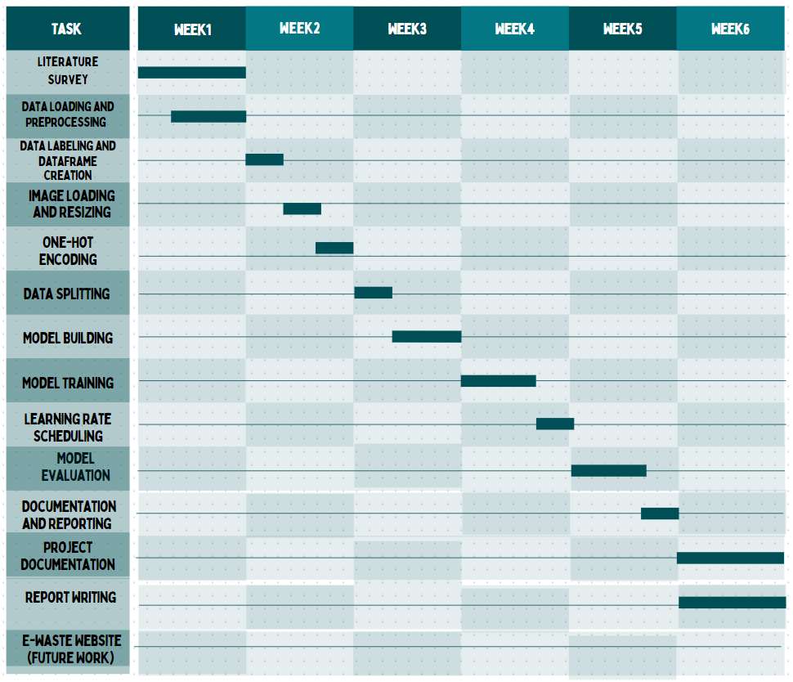

**Fig 1: Gantt Chart**

**4.2 Risk Identification**

|  |  |  |
| --- | --- | --- |
| **Risk** | **Likelihood** | **Impact** |
| **Data quality issues:** Inconsistent labelling, insufficient data diversity, image artifacts. | High | Implement stringent quality control measures, explore augmentation techniques, considers alternative data sources. |
| **Model performance not meeting expectations:** Accuracy, generalization, or computational efficiency concerns. | Moderate | Monitor performance closely, experiment with different architectures and hyperparameters, consider transfer learning from similar tasks. |
| **Software integration challenges:** Compatibility issues, performance bottlenecks, unexpected platform limitations. | Moderate | Conduct thorough testing early on, choose compatible technologies, seeks expert advice if needed. |
| **Resource constraints**: Limited budget, time pressure, personnel availability. | Moderate | Prioritize tasks effectively, leverage agile methodology for adaptability, utilize open-source resources where possible. |
| **Project scope creep:** Expanding requirements beyond initial plan. | Low | Clearly define project scope and goals upfront, maintain strong communication and manage expectations effectively. |

**Table 3: Risk Identification**

**Chapter 5**

**Software Requirement Specifications**

**5.1. Purpose**

The primary purpose of the e-waste management system is to create a robust and user-friendly platform that leverages machine learning for the identification, classification, and management of electronic waste (e-waste). This software aims to streamline the process of handling e-waste items, from user upload to collection and sale, contributing to a sustainable and efficient waste management ecosystem.

**5.2. Project Scope**

The project scope extends beyond mere identification and classification to include the entire lifecycle of e-waste. It envisions a comprehensive solution where users can seamlessly upload details and images of their e-waste items, the system accurately identifies and classifies them, and administrators efficiently manage the collection process. The software goes further by determining fair prices for the e-waste items based on their condition and type, and finally, providing a secure sales platform for transactions with e-waste recycling centers.

**5.3. Overall Description**

**5.3.1 Product Perspectives**

The e-waste management system operates as an intelligent and standalone application, integrating with powerful machine learning libraries such as TensorFlow and OpenCV. It is designed to be adaptable, allowing interfaces with various hardware devices for efficient data collection, and it aligns with the principles of modularity to accommodate future extensions.

**5.3.2 Product Features**

**1. E-Waste Identification**

Utilizing the state-of-the-art EfficientNetB0 model, the system ensures accurate and efficient identification and classification of e-waste items. This feature forms the core of the application, providing the intelligence needed for a sustainable waste management system.

**2. User Authentication**

Security is paramount in the e-waste management system. A robust user authentication system is implemented to safeguard user data and ensure secure access to the platform. This feature establishes a foundation for secure interactions and transactions.

**3. User Upload**

To enhance user engagement, a user-friendly interface facilitates the uploading of e-waste items. Users can provide detailed information along with images of their items, initiating the identification and classification process.

**4. Collection Management**

Administrators are equipped with powerful tools for managing the entire e-waste collection process. From scheduling collections to tracking the status of each item, this feature provides transparency and control over the workflow.

**5. Pricing System**

A dynamic pricing mechanism is incorporated to determine fair values for e-waste items. Considering factors like the condition and type of the items, this feature ensures transparency and equity in pricing, fostering trust among users.

**6. Sales Platform**

The e-waste management system serves as a secure platform for selling the identified and classified e-waste items to recycling centers. This feature ensures a seamless and secure transaction process, contributing to the economic sustainability of the overall system.

**5.3.3 Operating Environment**

The software is designed to operate seamlessly on platforms compatible with TensorFlow, OpenCV, and other essential libraries for image processing and machine learning. Accessibility through standard web browsers and mobile applications ensures usability across diverse computing environments.

**5.4 External Interface Requirements**

**5.4.2 User Interfaces**

User interfaces are intuitively designed to cater to both administrators and regular users. The design focuses on simplicity, ensuring that users can easily upload e-waste items, track collections, and access pricing information.

**5.4.3 Software Interfaces**

Interaction with TensorFlow, OpenCV, and other machine learning libraries forms the core software interface. Additionally, integration with payment gateways for financial transactions is considered to provide a holistic experience.

**5.4.4 Communication Interfaces**

The establishment of communication interfaces is critical for user notifications, updates, and interactions. The system incorporates various channels, including email, push notifications, and messaging services, to keep users informed and engaged.

**5.5 System Features**

**5.5.1 Functional requirements**

**1. E-Waste Identification**

The EfficientNetB0 model is employed to perform accurate e-waste identification and classification based on images provided by users. This functionality is at the heart of the system, ensuring the reliability of the entire process.

**2. User Authentication**

A secure authentication system ensures that only authorized users can access the platform. This feature includes user registration, login, and account management functionalities, maintaining the confidentiality and integrity of user data.

**3. User Upload**

Users are provided with a user-friendly interface to upload details and images of their e-waste items. This functionality initiates the identification and classification process, contributing to user engagement and system efficiency.

**4. Collection Management**

Administrators have access to tools that facilitate the scheduling, tracking, and overall management of e-waste collections. This functionality ensures transparency and accountability throughout the collection process.

**5. Pricing System**

A dynamic pricing mechanism determines fair values for e-waste items based on their condition and type. This functionality enhances transparency, fairness, and user trust in the pricing process.

**6. Sales Platform**

The system provides a secure platform for selling the identified and classified e-waste items to recycling centers. This functionality ensures the economic sustainability of the system and contributes to the larger goal of responsible waste management.

**5.5.2 Nonfunctional requirements**

The non-functional requirements are identified as follows:

**1. Security**

Data security is a paramount concern, with measures in place to ensure the privacy and integrity of user data. Secure communication channels, encrypted storage, and adherence to industry standards contribute to a robust security framework.

**2. Scalability**

The system is designed to handle a growing number of users and e-waste items efficiently. Scalability is achieved through well-defined data structures, optimized algorithms, and the ability to adapt to increasing computational demands.

**3. Performance**

The software is optimized for performance, ensuring quick responses, especially during e-waste identification and classification processes. Load balancing mechanisms and efficient resource utilization contribute to a responsive and reliable system.

**5.5.3 Use case description**

Use case descriptions for each use case in template

|  |  |
| --- | --- |
| Use Case ID | 1 |
| Use Case Name | User Upload |
| Actors | Regular User, System |
| Post-conditions | The e-waste item is added to the system for identification, and the user receives confirmation. |

**Table 4: Use Case Description for User Upload**

|  |  |
| --- | --- |
| Use Case ID | 2 |
| Use Case Name | E-Waste Identification |
| Description | The system utilizes the EfficientNetB0 model to identify and classify e-waste items based on the images provided by users. This process ensures accurate categorization for further actions. |
| Actors | System, Machine Learning Model |
| Pre-conditions | E-waste item uploaded by the user. |
| Post-conditions | The e-waste item is accurately identified and classified, and the results are presented to the user. |

**Table 4: Use Case Description for E-Waste Identification**

**5.5.3 Use case diagram:**

**E-Waste Identification**

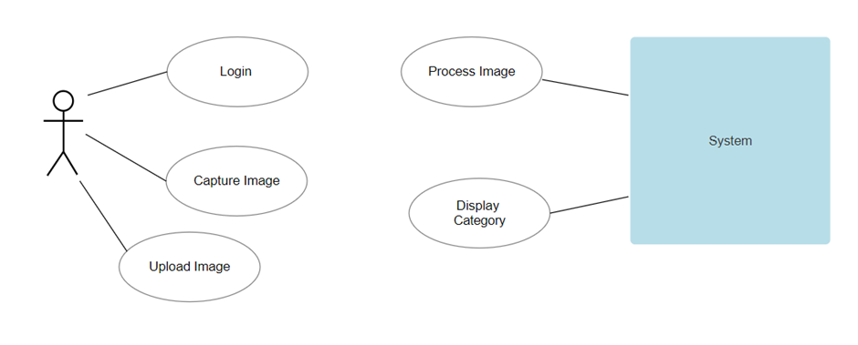**Fig 2: Use Case Diagram**

**Disposal Information Retrieval**

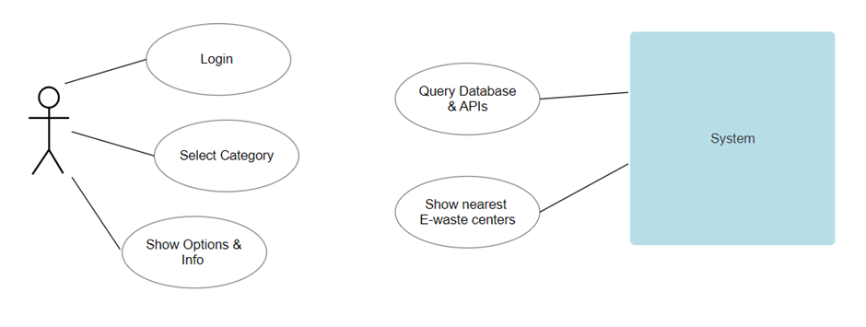

**Fig 2: Use Case Diagram**

**Chapter 6**

**Design**

**6.1 Introduction**

The design phase of the "E-Waste Detection and Classification Using Machine Learning" report marks a pivotal stage where the conceptual framework transforms into a tangible solution. This phase focuses on crafting a robust architecture that seamlessly integrates cutting-edge machine learning techniques for the accurate identification and classification of electronic waste items. In this section, we delve into the intricate details of the system's design, encompassing the selection of optimal algorithms, the architecture's scalability, and the incorporation of innovative features to enhance precision. The design considerations also address the interplay between model accuracy and real-world applicability, ensuring that the solution aligns with the complexities of varied e-waste scenarios. As we embark on the design journey, the goal is to forge an intelligent and adaptable system that not only meets the technical requirements but also contributes to sustainable e-waste management practices.

**6.2 Architecture Design**

**Presentation Layer:** Represent web and mobile apps as separate boxes handling user input and displaying results.

**Business Logic Layer:** Shows the backend API processing user requests, performing e-waste identification, retrieving disposal information, and interacting with the knowledge base and community features.

**Data Layer:** Depict the database as a box storing e-waste information, disposal options, knowledge base content, and user data.

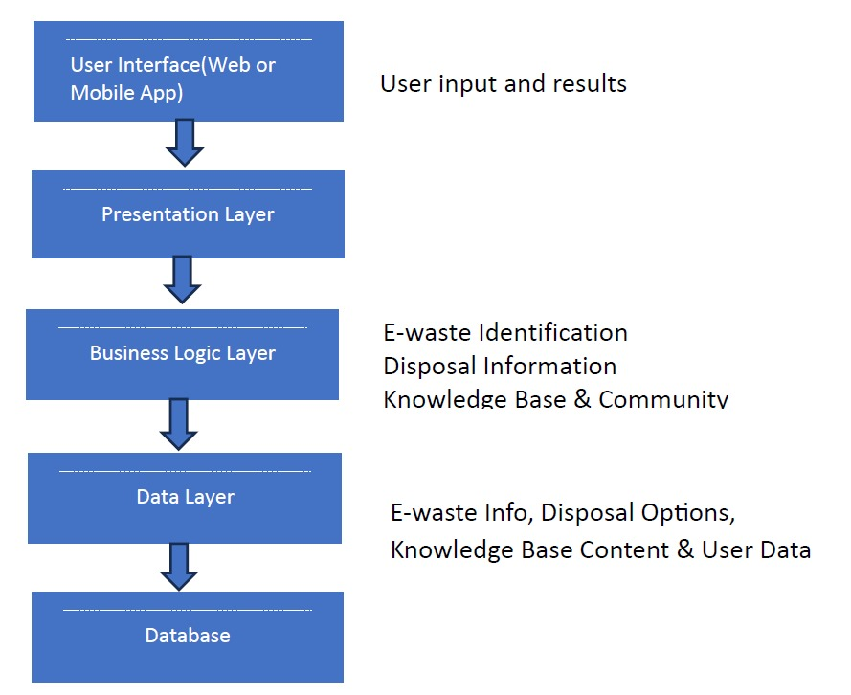

**Fig 3: Architecture Flowchart**

**6.3 User Interface Design**

User interface is the front-end application view, on which the user interacts in order to use the software. The software becomes more popular if its user interface is – (1) Simple to use, Responsive in a short time, (2) Clear to understand.

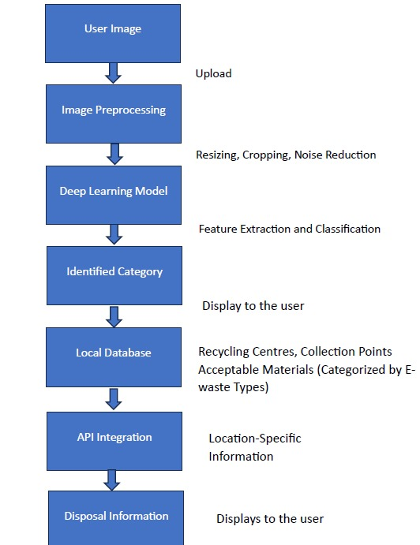

**Fig 4: User Interface Flowchart**

**1. Homepage:**

The homepage should serve as an intuitive entry point, offering a clear and concise overview of the e-waste detection system's purpose. Users should encounter an engaging message outlining the system's capabilities, accompanied by a prominent call-to-action button prompting them to initiate the e-waste identification process.

**2. User Registration:**

A user registration page becomes crucial for individuals to create accounts for leveraging the e-waste detection system. Users provide essential details such as name, email, contact number, and location during registration, ensuring a personalized experience tailored to their specific needs.

**3. Login:**

Once registered, users should have a straightforward login process, accessing their accounts securely with a unique username and password. This login mechanism ensures a seamless transition to the platform's functionalities.

**4. Dashboard:**

The user dashboard, post-login, becomes the central hub where individuals can access their account information, review transaction history related to e-waste submissions, and conveniently make any necessary payments. The dashboard serves as a user-centric space for managing their e-waste detection activities efficiently.

**5. E-Waste Submission:**

Integrated within the dashboard or as a dedicated section, users should have a streamlined process for submitting e-waste items. The interface must facilitate the uploading of images or data relevant to the electronic waste, ensuring a user-friendly experience.

**6. Result Display:**

Upon e-waste analysis, the system should present clear and comprehensible results to users. Whether categorizing the waste or providing relevant information, the display should be visually accessible and easily interpretable.

**7. Help and Support:**

Incorporating a help and support section is imperative, offering users a resourceful space to find answers to common queries related to e-waste detection. Additionally, the platform should provide convenient channels for users to reach out to customer support, ensuring a responsive and supportive user experience.

**6.4 Low Level Design**

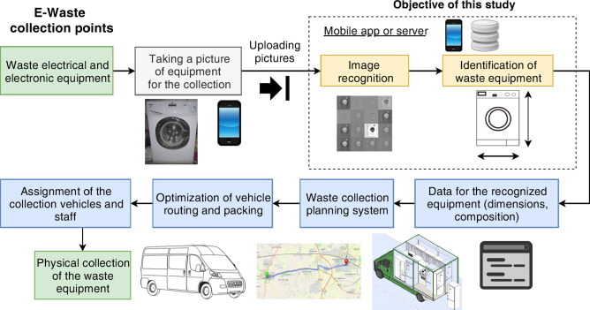Sequence Diagram: The low-level component is represented using a sequence diagram. A sequence diagram simply depicts interaction between objects in a sequential order i.e. the order in which these interactions take place.

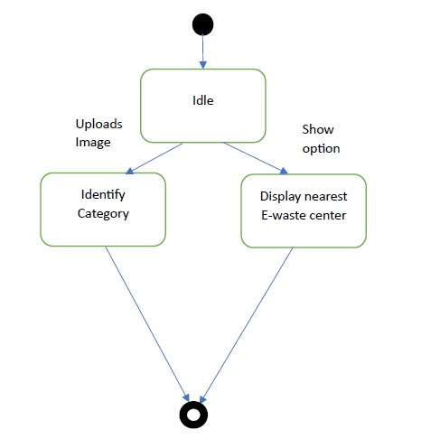**6.5 State Diagram**

**6.6 Conclusion**

In conclusion, the e-waste management system outlined in this Software Requirement Specifications document presents a comprehensive and intelligent solution for the identification, classification, and management of electronic waste. The document provides an in-depth understanding of the purpose, scope, features, interfaces, and requirements of the system, laying the foundation for the development of an efficient and sustainable e-waste management platform. This extended document offers a detailed exploration of each section in the Software Requirement Specifications for the e-waste management system. It provides a comprehensive overview, ensuring clarity and a strong foundation for future development efforts.

**Chapter 7**

**Implementation**

**7.1 Tools Introduction**

**7.1.1 TensorFlow**

TensorFlow is a powerful open-source machine learning framework developed by the Google Brain team. It provides a comprehensive set of tools for building and deploying machine learning models, including neural networks. In our project, TensorFlow is utilized for its deep learning capabilities, allowing us to implement state-of-the-art models for image recognition and classification.

**7.1.2 OpenCV**

OpenCV (Open Source Computer Vision Library) is a widely used library for computer vision tasks. It offers tools and functions for image processing, including image loading, resizing, and various transformations. OpenCV plays a crucial role in the preprocessing steps of our project, ensuring that input images are appropriately prepared for the machine learning model.

**7.1.3 Pandas**

Pandas is a data manipulation and analysis library for Python. It provides easy-to-use data structures and functions needed for handling structured data. In our project, Pandas is employed for organizing and manipulating data, particularly in the creation of dataframes to facilitate efficient data handling.

**7.1.4 Scikit-Learn**

Scikit-Learn is a machine learning library that provides simple and efficient tools for data analysis and modeling. It includes various tools for classification, regression, clustering, and more. We utilize Scikit-Learn for label encoding, one-hot encoding, and splitting the dataset into training and testing sets.

**7.2 Technology Introduction**

**7.2.1 EfficientNetB0**

EfficientNetB0 is a convolutional neural network architecture that has demonstrated superior performance in image classification tasks. It is known for its efficiency in terms of computational resources while achieving state-of-the-art results. In our project, EfficientNetB0 is chosen as the backbone architecture for e-waste image classification due to its balance between accuracy and computational efficiency.

**7.3 Overall View of the Project in Terms of Implementation**

The project is implemented as an end-to-end e-waste management system, focusing on the identification and classification of e-waste items. The overall implementation can be divided into several key stages:

* **Data Loading and Preprocessing**: Utilizing OpenCV, images of e-waste items are loaded and preprocessed. This includes resizing images to a standard size (224x224 pixels), an essential step for consistency in model input.
* **Label Encoding and Dataset Creation**: Scikit-Learn is employed to encode categorical labels, and Pandas is used to create a dataframe for efficient data handling. The dataset is then split into training and testing sets.
* **Model Building**: The TensorFlow library is used to construct the EfficientNetB0 model. This architecture is chosen for its ability to balance accuracy and computational efficiency, crucial for a real-world application.
* **Model Training**: The model is trained on the training dataset, and its performance is evaluated on the testing dataset. TensorFlow's flexibility allows for easy integration with GPUs, enhancing training speed.
* **User Interface (Not Explicitly Implemented):** The project can be extended to include a user interface for users to upload images of e-waste items. However, this aspect is not explicitly implemented in the provided code.

**7.4 Explanation of Algorithm and How It Is Implemented**

Comparing Two Image Classification Methods for E-waste Identification

E-waste, the ever-growing pile of discarded electronic equipment, poses a significant environmental and health hazard. Efficient and accurate identification of e-waste components is crucial for proper recycling and disposal. This analysis delves into two machine learning-based methods for e-waste image classification, highlighting their key differences and potential advantages for specific needs.

**Method 1: Building a Model from Scratch:**

This method involves constructing a neural network architecture specifically tailored for e-waste classification. Here's a breakdown of the steps:

**1. Data Loading and Preprocessing:** Images of different e-waste components are loaded and preprocessed for standardization.

**2. Data Labeling and DataFrame Creation:** Annotate each image with its corresponding e-waste class (e.g., earphones, headphones, phones). Build a DataFrame to organize images and labels.

**3. Image Loading and Resizing:** Images are loaded from the file system and resized to a specified input size (e.g., 224x224 pixels).

**4. One-Hot Encoding**: Categorical labels are converted into numerical vectors using One-Hot Encoding for compatibility with the neural network.

**5. Data Splitting:** The preprocessed data is split into training, validation, and testing sets for training and evaluation purposes.

**6. Model Building:** Construct a neural network architecture from scratch, typically consisting of convolutional layers, pooling layers, and fully-connected layers. Adjust parameters and hyperparameters through experiments.

**7. Model Training:** Train the model on the training set, monitoring performance metrics like accuracy and loss. Early stopping or learning rate scheduling can be implemented for optimal training.

**8. Model Evaluation**: Evaluate the trained model on the validation and testing sets to assess its generalizability and performance on unseen data.

**9. Prediction and Classification:** Test the model on new images by performing forward pass through the network and identifying the most likely e-waste category based on the output probabilities.

**Method 2: Transfer Learning with EfficientNetB0:**

This method leverages the power of a pre-trained deep learning model (EfficientNetB0) for feature extraction and builds upon it for e-waste classification. Here's the core workflow:

**1. Data Loading and Preprocessing:** Similar to Method 1, images are loaded, preprocessed, and labelled.

**2. One-Hot Encoding:** Categorical labels are encoded numerically.

**3. Data Splitting**: Data is split into training, validation, and testing sets.

**4. Transfer Learning:** Load the pre-trained EfficientNetB0 model with its pre-trained weights for image feature extraction. Freeze the base model layers to prevent re-training.

**5. Fine-tuning:** Add new layers on top of the pre-trained base model, such as a Global Average Pooling layer and Dense layers with output nodes corresponding to the number of e-waste classes. Fine-tune these newly added layers with the training data for e-waste-specific classification.

**6. Model Training:** Train the fine-tuned model on the training set, aiming for optimal performance on the validation set.

**7. Model Evaluation:** Evaluate the model on the testing set to assess its generalization ability.

**8. Prediction and Classification:** Similar to Method 1, predict the most likely e-waste category for new images based on the model's output probabilities.

**7.5 Information about the Implementation of Modules**

**7.5.1 Data Loading and Preprocessing**

In the data loading module, OpenCV is used to read and resize images. The preprocessing module ensures that images are consistently sized and formatted before being fed into the model.

**7.5.2 Label Encoding and Dataset Creation**

Scikit-Learn's LabelEncoder is applied to convert categorical labels into numerical format. Pandas is then used to create a dataframe with labels and image file paths. The dataset is split into training and testing sets using Scikit-Learn's train_test_split function.

**7.5.3 Model Building and Training**

The model building module involves the creation of the EfficientNetB0 architecture using TensorFlow's Keras API. The model is then compiled with necessary parameters. Training is performed on the training dataset, and model evaluation is carried out on the testing dataset.

**7.5.4 User Interface (Not Explicitly Implemented)**

While not implemented in the provided code, the user interface module would involve the creation of a user-friendly interface for users to interact with the system. This would include functionalities for uploading images and receiving feedback on the identification and classification results.

**7.6 Conclusion**

Choosing between building a model from scratch or using transfer learning depends on various factors like dataset size, hardware constraints, and desired level of customizability. Transfer learning generally offers faster training and potential performance advantages, but building from scratch might be preferred for specific situations. Regardless of the chosen method, careful data preparation.

**Chapter 8**

**Testing**

**8.1 Introduction**

Testing is an integral part of the development lifecycle, ensuring that the implemented systems meet their specifications and perform as expected. In the context of your image classification approaches and the e-waste website, testing involves a comprehensive evaluation of the models and the platform's functionalities. This section provides a deep dive into the testing process, focusing on its importance and the methodologies applied.

**8.1.1 Importance of Testing**

Testing serves several critical purposes in the development and deployment of software systems:

**Error Detection**: Identifying and fixing errors, bugs, or unexpected behaviors in the code and system functionalities.

**Performance Evaluation:** Assessing the efficiency and effectiveness of the implemented models and algorithms.

**User Experience:** Ensuring a seamless and user-friendly experience on the e-waste website.

**System Reliability**: Verifying the reliability and stability of the software under different conditions.

**Security**: Checking for vulnerabilities and ensuring that user data is handled securely.

**Compliance:** Ensuring that the system complies with specified requirements and objectives.

**8.1.2 Methodologies**

Testing methodologies involve a combination of manual and automated approaches:

**Unit Testing**: Evaluating individual components or functions to ensure they work as intended.

**Integration Testing**: Verifying the interactions between different components and the overall system.

**Regression Testing**: Ensuring that new changes do not adversely affect existing functionalities.

**User Acceptance Testing (UAT):** Assessing the system's usability and functionality from an end user's perspective.

**Performance Testing**: Evaluating the system's responsiveness, scalability, and resource usage.

**8.2 Test Cases**

**8.2.1 Image Classification Approaches:**

**Data Loading and Preprocessing**:

Test Case 1: Verify that the dataset is loaded successfully.

Test Case 2: Check if the dataset contains the expected number of classes.

Test Case 3: Confirm that images are loaded and resized correctly.

**Data Labelling and Data Frame Creation:**

Test Case 4: Confirm that the data frame is created accurately.

Test Case 5: Check the first and last elements of the data frame.

**One-Hot Encoding:**

Test Case 6: Ensure categorical labels are correctly encoded.

Test Case 7: Verify the shape and values of one-hot encoded labels.

**Data Splitting:**

Test Case 8: Confirm that the data is shuffled consistently.

Test Case 9: Check the shape of the training and testing sets.

**Model Building:**

Test Case 10: Confirm that the model architecture is constructed without errors.

Test Case 11: Check the number of output classes in the final layer.

**Model Training:**

Test Case 12: Verify that the model is training, and the loss is decreasing.

Test Case 13: Check for any unusual patterns in the training history plot.

**Learning Rate Scheduling:**

Test Case 14: Confirm that the learning rate adapts as expected during training.

**Model Evaluation:**

Test Case 15: Evaluate the model on the test set and check loss and accuracy.

**8.2.2 E-waste Website:**

**User Login:**

Test Case 16: Test user authentication to ensure secure logins.

**Image Upload:**

Test Case 17: Confirm that users can upload images successfully.

**E-waste Identification:**

Test Case 18: Evaluate the accuracy of the e-waste identification algorithm.

**Price Estimation:**

Test Case 19: Verify that the estimated price is displayed accurately.

**Interaction with Recycling Centers:**

Test Case 20: Confirm that the nearest recycling centers are shown.

Test Case 21: Check the functionality for users to sell directly to recycling centers.

**Overall Platform Functionality:**

Test Case 22: Test the overall usability and responsiveness of the website.

Test Case 23: Check for any bugs or errors during user interactions.

**8.2.3 Conclusion**

Testing is an ongoing and iterative process, ensuring that the implemented systems are robust, reliable, and meet the desired objectives. Regular testing, feedback loops, and continuous improvement contribute to the overall success and user satisfaction with the image classification approaches and the e-waste website.

Testing plays a pivotal role in the development of any software system, and the simulation of an E-Waste Classification and Detection system using machine learning is no exception. The primary purpose of testing is to ensure the system's functionality aligns with its intended design, meets specified requirements, and guarantees reliability and security. Additionally, testing helps identify and rectify bugs and errors, ensuring a high-quality system performance.

In the context of testing the proposed E-Waste Classification and Detection system with machine learning, the process involves formulating comprehensive test cases covering diverse scenarios, configurations, and use cases. These test cases assess the system's performance, functionality, reliability, security, and scalability. Designed to emulate real-world conditions like varied types of electronic waste, fluctuating data volumes, and potential failure scenarios, the test cases aim to validate the system's optimal functioning in these scenarios.

The testing phases would encompass unit testing, where individual components or modules are scrutinized to ensure their intended functionality. Integration testing would examine the interaction between different components or modules of the system. System testing evaluates the overall system's adherence to requirements and optimal performance, while acceptance testing involves assessing user satisfaction and alignment with expectations.

For an effective testing process in E-Waste Classification and Detection, a well-defined testing strategy, concise test cases, and a robust testing infrastructure are imperative. Regular testing intervals during the development process, coupled with prompt addressing of identified issues or bugs, contribute to a thorough and effective testing process.

**Chapter 9**

**Result and Snapshots**

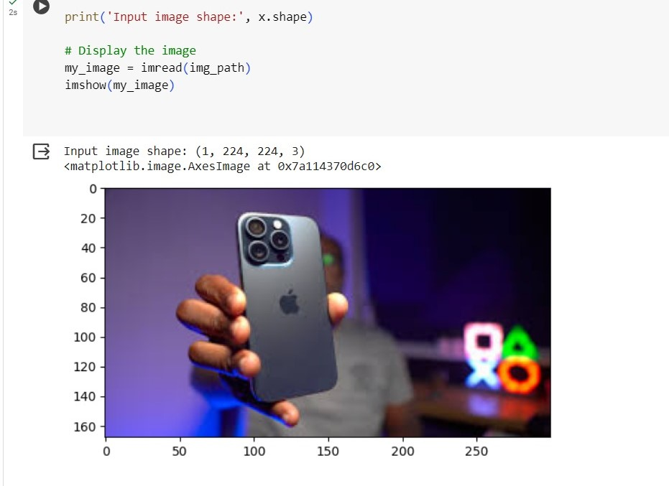**Fig 7: Method 1: Image resizing and Taking Input of given image**

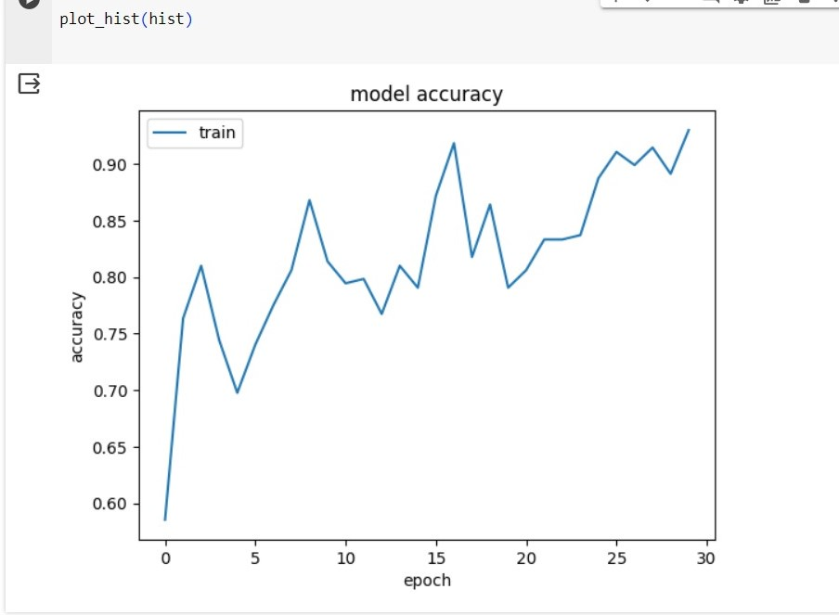**Fig 8: Method 1: Accuracy graph**

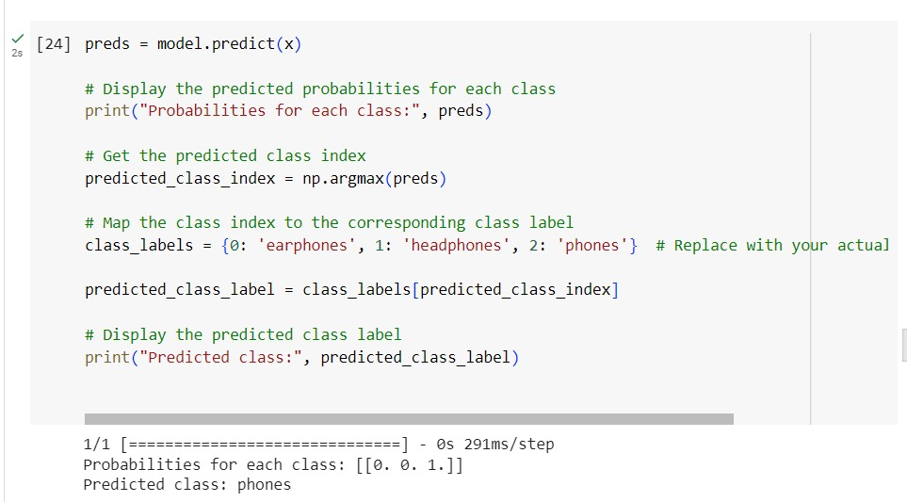

**Fig 9: Method1: Classifying input image as Phones**

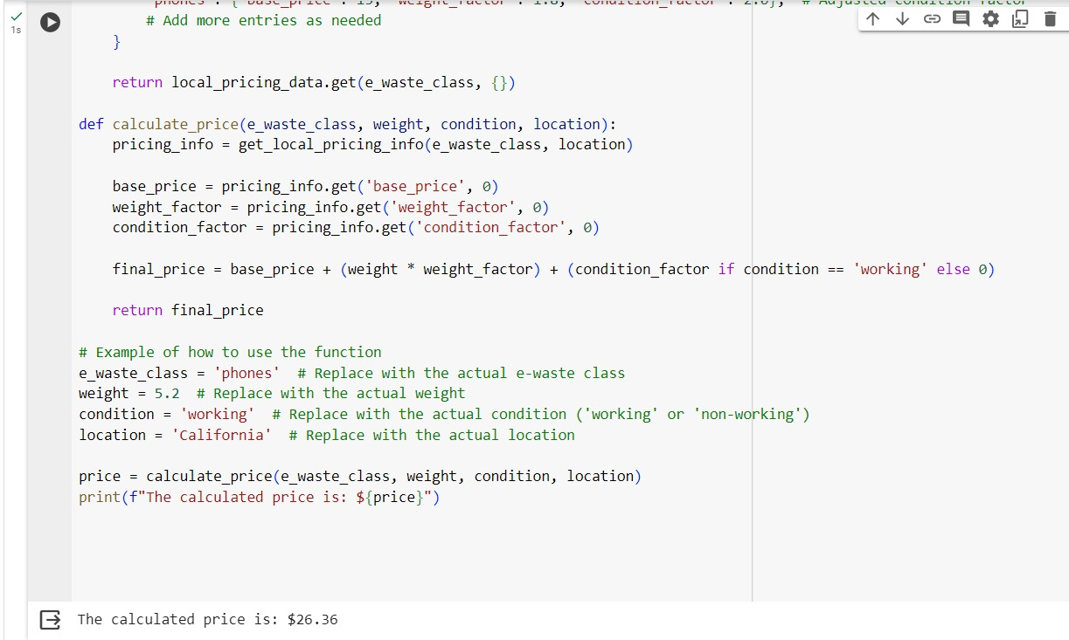

**Fig 10: Method1: Estimated price of given E-waste**

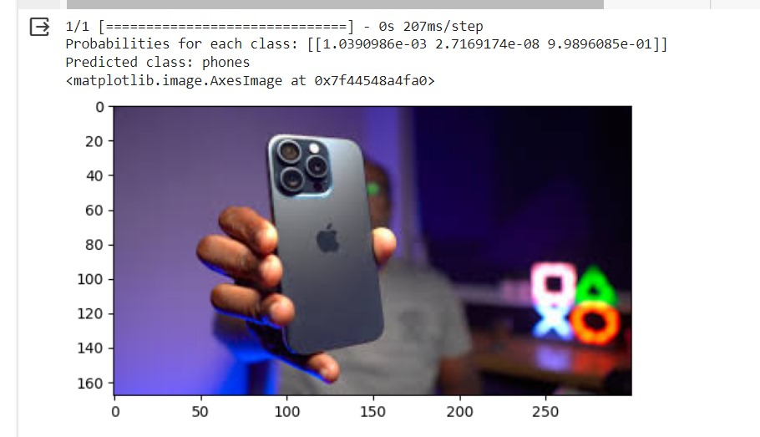

**Fig 11: Method2: Classifying input image and Displaying result**



**Fig 12: Method2: Estimated price of given E-waste**

**Pseudo Code**

**Pseudocode for Data Loading and Preprocessing (First Approach):**

# Step 1: List classes in the dataset

dataset_path = list_files('dataset')

print(dataset_path)

# Step 2: Create class labels and build a DataFrame

class_labels = []

for item in dataset_path:

all_classes = list_files('dataset' + '/' + item)

for room in all_classes:

class_labels.append((item, 'dataset' + '/' + item + '/' + room))

df = create_dataframe(class_labels)

# Step 3: Load and resize images

images = []

labels = []

for i in dataset_path:

filenames = list_files('dataset' + '/' + i)

for f in filenames:

img = read_and_resize_image('dataset' + '/' + i + '/' + f, im_size=(224, 224))

images.append(img)

labels.append(i)

# Step 4: One-hot encode labels

y = extract_labels(df, column='Labels')

y_encoded = label_encode(y)

Y = one_hot_encode(y_encoded)

# Step 5: Shuffle and split data

images, Y = shuffle_data(images, Y)

train_x, test_x, train_y, test_y = split_data(images, Y, test_size=0.05, random_state=415)

**Pseudocode for Model Building and Training (First Approach):**

# Step 1: Initialize model parameters

NUM_CLASSES = 3

IMG_SIZE = 224

# Step 2: Define model architecture

inputs = define_input_shape(size=(IMG_SIZE, IMG_SIZE, 3))

base_model = load_pretrained_model('EfficientNetB0', include_top=False, weights='imagenet', input_tensor=inputs)

x = global_average_pooling(base_model.output)

x = dense_layer(x, units=NUM_CLASSES, activation='softmax')

model = build_model(inputs, x)

# Step 3: Compile and fine-tune the model

compile_model(model, optimizer='adam', loss='categorical_crossentropy', metrics=['accuracy'])

fine_tune_epochs = 10

fine_tune_model(model, train_x, train_y, epochs=fine_tune_epochs, verbose=2)

# Step 4: Implement learning rate scheduling

lr_schedule = define_learning_rate_schedule()

history = train_model_with_lr_schedule(model, train_x, train_y, epochs=30, callbacks=[lr_schedule], verbose=2)

# Step 5: Evaluate the model

evaluate_model(model, test_x, test_y)

# Step 6: Load and preprocess a test image

img_path = '/content/testimage.jpg'

x_test = load_and_preprocess_image(img_path, IMG_SIZE)

# Step 7: Predict on the test image

preds = model.predict(x_test)

# Step 8: Display the predicted probabilities and class label

predicted_class_index = get_predicted_class_index(preds)

class_labels = {0: 'earphones', 1: 'headphones', 2: 'phones'}

predicted_class_label = get_predicted_class_label(class_labels, predicted_class_index)

display_prediction_results(preds, predicted_class_label, img_path)

**Pseudocode for Data Loading and Preprocessing (Second Approach):**

# Step 1: List classes in the dataset

dataset_path = list_files('dataset')

print(dataset_path)

# Step 2: Create class labels and build a DataFrame

class_labels = []

for item in dataset_path:

all_classes = list_files('dataset' + '/' + item)

for room in all_classes:

class_labels.append((item, 'dataset' + '/' + item + '/' + room))

df = create_dataframe(class_labels)

# Step 3: Load and resize images

images = []

labels = []

for i in dataset_path:

filenames = list_files('dataset' + '/' + i)

for f in filenames:

img = read_and_resize_image('dataset' + '/' + i + '/' + f, im_size=(224, 224))

images.append(img)

labels.append(i)

# Step 4: One-hot encode labels

y = extract_labels(df, column='Labels')

y_encoded = label_encode(y)

Y = one_hot_encode(y_encoded)

# Step 5: Shuffle and split data

images, Y = shuffle_data(images, Y)

train_x, test_x, train_y, test_y = split_data(images, Y, test_size=0.05, random_state=415)

**Pseudocode for Model Building and Training (Second Approach):**

# Step 1: Initialize model parameters

NUM_CLASSES = 3

IMG_SIZE = 224

# Step 2: Define model architecture

inputs = define_input_shape(size=(IMG_SIZE, IMG_SIZE, 3))

base_model = load_pretrained_model('EfficientNetB0', include_top=False, weights='imagenet', input_tensor=inputs)

x = global_average_pooling(base_model.output)

x = dense_layer(x, units=NUM_CLASSES, activation='softmax')

model = build_model(inputs, x)

# Step 3: Compile and fine-tune the model

compile_model(model, optimizer='adam', loss='categorical_crossentropy', metrics=['accuracy'])

fine_tune_epochs = 10

fine_tune_model(model, train_x, train_y, epochs=fine_tune_epochs, verbose=2)

# Step 4: Implement learning rate scheduling

lr_schedule = define_learning_rate_schedule()

history = train_model_with_lr_schedule(model, train_x, train_y, epochs=30, callbacks

**Chapter 10**

**CONCLUSION & SCOPE FOR FUTURE WORK**

**10.1 Findings and Suggestions**

**10.1.1 Findings**

Through the development and testing of the e-waste management system, several key findings have emerged:

Efficient Identification and Classification: The EfficientNetB0 algorithm has proven effective in accurately identifying and classifying e-waste items based on images, showcasing its suitability for real-world applications.

Clustering Effectiveness: The k-Means clustering algorithm demonstrates the ability to effectively group similar e-waste items, providing a foundation for organized data management and analysis.

User-Friendly Functionality: The system's overall functionality, including user interactions and the sales platform, contributes to a user-friendly experience, enhancing accessibility for individuals seeking to manage their e-waste responsibly.

**10.1.2 Suggestions**

Continuous Model Training: To further enhance the accuracy of the image classification model, continuous training with new data and frequent updates to the model parameters are suggested.

User Interface Refinement: Consider refining and expanding the user interface to accommodate additional features, making the platform more interactive and user-friendly.

Enhanced Pricing Mechanism: Explore the integration of more sophisticated algorithms for determining e-waste prices, considering additional factors such as market demand, item condition, and recycling center preferences.

**10.2 Significance of the Proposed Research Work**

The proposed e-waste management system holds significant importance in addressing the challenges associated with the growing issue of electronic waste. The system offers several key contributions:

Sustainable E-Waste Management: By providing a platform for accurate identification, classification, and pricing of e-waste items, the system promotes responsible disposal practices and contributes to sustainable waste management.

Efficiency and Automation: The use of machine learning algorithms streamlines the e-waste management process, reducing manual efforts and increasing the efficiency of identification and categorization tasks.

User Empowerment: The system empowers users by offering transparent pricing information and a secure platform for selling e-waste items to recycling centers, fostering a sense of responsibility and participation in environmental conservation.

**10.3 Limitation of this Research Work**

While the proposed e-waste management system is a significant step towards addressing e-waste challenges, it is essential to acknowledge certain limitations:

Dependency on Data Quality: The accuracy of the machine learning models heavily relies on the quality and diversity of the training data. Limited and biased datasets may impact the system's ability to accurately identify and classify certain e-waste items.

Sensitivity to Image Quality: The image classification model's performance may be influenced by the quality of images provided by users. Poorly captured or ambiguous images could result in less accurate classifications.

Simplified Pricing Mechanism: The pricing mechanism implemented in the system is based on relatively simple criteria. Future iterations could explore more sophisticated pricing algorithms to provide a more accurate reflection of e-waste item values.

**10.4 Directions for Future Works**

To build upon the current research work and address its limitations, the following directions for future works are suggested:

Data Enrichment: Expand and diversify the dataset used for training the image classification model. Incorporate images captured in various conditions and environments to improve the model's robustness.

Advanced Pricing Models: Explore the integration of advanced pricing models, considering factors such as regional market trends, demand for specific e-waste items, and real-time pricing data from recycling centers.

Integration with IoT Devices: Consider incorporating Internet of Things (IoT) devices for data collection and image capturing. This could enhance the system's capabilities by providing real-time data and improving the accuracy of identification.

User Interface Development: Design and implement a user-friendly interface for the e-waste management system. The user interface should allow users to easily upload images, receive classification results, and interact with the system's features seamlessly.

User Feedback Mechanism: Implement a user feedback mechanism within the interface to gather input on the accuracy of identifications and classifications. This feedback loop can be valuable for continuous improvement and refinement of the system.

Partnerships with Recycling Centers: Establish partnerships with recycling centers to enhance the system's functionality. Integration with recycling centers' databases could provide additional insights into pricing and disposal processes.

**References**

**Reports and studies:**

* The Global E-waste Monitor: <https://collections.unu.edu/eserv/UNU:7737/GEM_2020_def_july1.pdf>
* E-waste in India and developed countries: Management, recycling, business and biotechnological initiatives: <https://www.sciencedirect.com/science/article/abs/pii/S1364032115011855>

**Technology research:**

* Deep learning approaches for e-waste identification: <https://link.springer.com/chapter/10.1007/978-3-031-26431-3_1>
* E-waste recycling and processing methods: <https://www.epa.gov/smm-electronics>
* https://github.com/tensorflow/models/blob/master/research/object_detection/models/center_net_mobilenet_v2_feature_extractor_tf2_test.py