**ADABOOST**

**AdaBoost** (short for **Adaptive Boosting**) is a boosting algorithm that combines **many weak learners** (usually small decision trees called *decision stumps*) into a **strong classifier**.

**⚙️ How It Works (Simplified):**

1. Train a weak model (e.g., a small tree) on the training data.
2. Identify which samples were misclassified.
3. **Increase the weight** of those misclassified samples so the next model focuses more on them.
4. Train another weak model on the updated weights.
5. Repeat the process.
6. Combine all weak learners using a **weighted vote** based on their accuracy.

**=========================================**

**Weight = 1/(tot no of rows)**

**Decision stump (one root node, children nodes, 1level) week learner.**

**1st decision stump, the result**

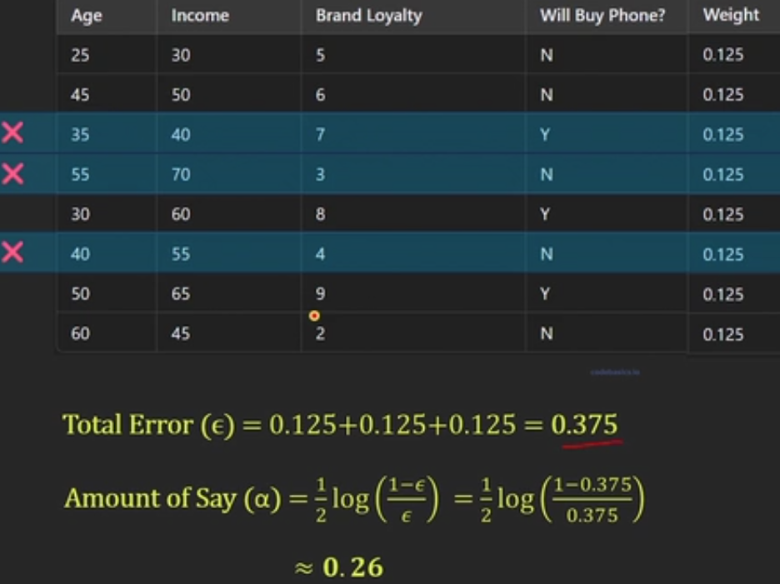

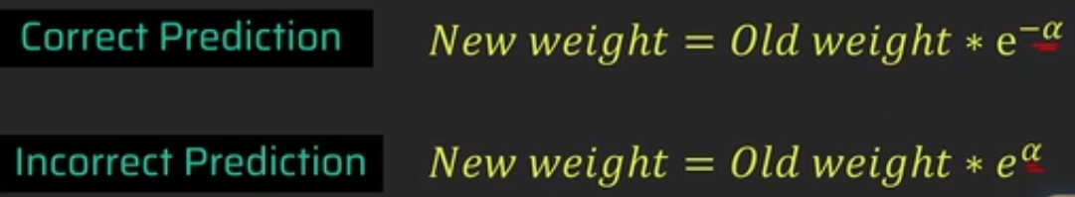

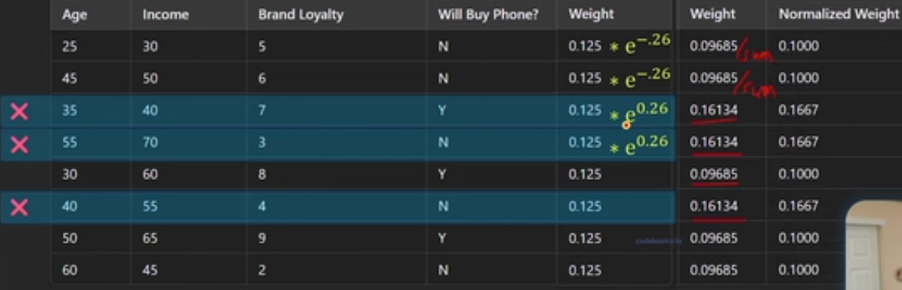

**2nd decision stump**

**In the entropy/gini calculation, normalized weights are also used.**

