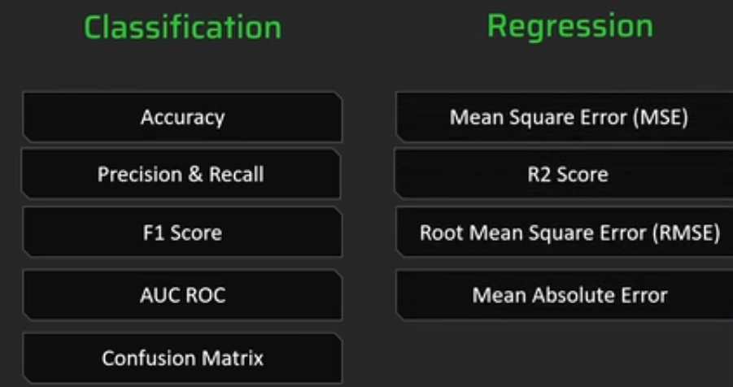

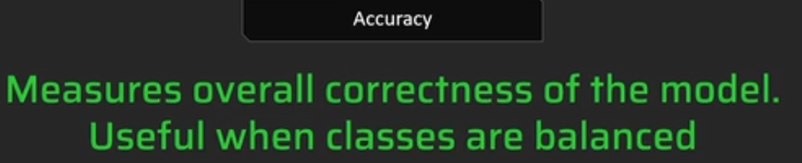

Spam, not spam -- precision

Pneumonia -- recall

AUC-ROC for cost-benefit analysis

F1 score is useful when you need to balance the precision and recall

MSE useful for highlighting large errors, sensitive to outliers.

Comparing different models

RMSE is easy to interpret

R squared value – provides an indication of goodness of fit & measures the proportion of the variance in the dependent variable that is predictable from the independent variables

