**Z-Score**

Z score tells how many standard deviations away a data point is from the mean.

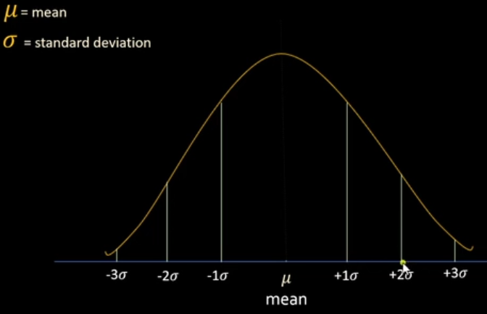

If the data point is at 2 std dev than the z-score is 2

If the data point is at -1 std dev than the z-score is -1

It is used to identify how far or close a specific value is relative to the average, and it can help in understanding the distribution of the data.

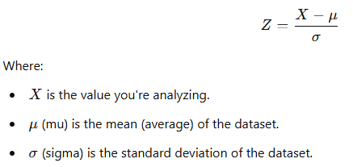

Used for

* Outlier Removal
* Comparing Different Datasets

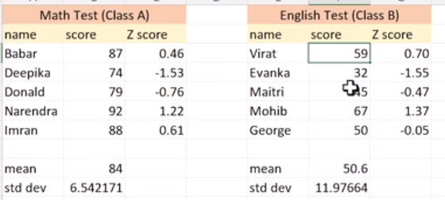

Virat with 59 score is doing better than Babar with 87 score, which is identified by the z-scores.

Comparing apple to oranges, we are standardizing the values and compaing