Collaborative Peer Review Platform
NAME: Anamika A
YEAR: 4th / IT
REG NO: 9922008189

I. ABSTRACT
The Collaborative Peer Review Platform is a web-based system designed to facilitate structured and anonymous peer evaluation of student assignments. The platform enables students to upload their assignments, after which the system automatically assigns three random peers for review based on predefined rules. Each reviewer evaluates the assignment using a rubric score and provides feedback, ensuring a fair and unbiased assessment process.
The backend of the system is developed using Node.js, Express.js, and MongoDB, ensuring scalability and efficient data handling. Mongoose is used for schema modeling and validation. The system enforces strict rules such as assigning exactly three reviewers and preventing self-review. Once all reviews are submitted, the assignment status is updated automatically.
This platform enhances collaborative learning by promoting critical thinking, accountability, and structured feedback while simulating real-world peer evaluation systems.

II. INTRODUCTION
In modern education systems, peer review has become an essential methodology for improving learning outcomes. It allows students to critically analyze others' work, receive constructive feedback, and develop a deeper understanding of the subject matter.
Traditional peer review processes are often manual, time-consuming, and prone to bias. The Collaborative Peer Review Platform addresses these challenges by automating reviewer assignment and maintaining anonymity. The system ensures that each assignment is evaluated by exactly three peers, providing balanced and reliable feedback.
The platform is designed as a RESTful API-based backend system, making it flexible for integration with any frontend interface. It emphasizes data integrity, validation, and efficient workflow management, making it suitable for academic environments.

III. OBJECTIVES
• To automate the peer review process for student assignments
• To ensure fair and anonymous evaluation
• To assign exactly three random reviewers per assignment
• To prevent self-review and duplicate evaluations
• To provide structured feedback using rubric scores
• To track assignment status (Pending, Under Review, Completed)
• To maintain scalable and modular backend architecture
• To enable efficient data retrieval and filtering

IV. SYSTEM ARCHITECTURE

The system follows a layered architecture, ensuring modularity and separation of concerns.

Architecture Flow
User (Client / Frontend)
↓
API Layer (Express.js Routes)
↓
Controller Layer (Business Logic)
↓
Service Logic (Reviewer Assignment & Validation)
↓
Database Layer (MongoDB with Mongoose)

V. LAYER-WISE EXPLANATION

Presentation Layer (Client Side)
This layer represents the frontend or client application interacting with the API. It allows users to:
- Upload assignments
- View assignments and reviews
- Submit peer reviews
Although not implemented in this backend-focused project, this layer communicates with the API using HTTP requests.

API Layer (Routing Layer)
The API layer is implemented using Express.js and defines all endpoints such as:
- POST /assignments
- GET /assignments
- POST /reviews
- GET /reviews/:assignmentId
This layer handles incoming requests and routes them to the appropriate controllers.

Controller Layer
The controller layer contains the core request-handling logic. It is responsible for:
- Processing incoming data
- Validating inputs
- Calling database operations
- Returning structured responses
Examples:
- Creating assignments
- Submitting reviews
- Fetching filtered data

Business Logic Layer
This is the most critical layer of the system. It implements:
- Random assignment of exactly three reviewers
- Prevention of self-review
- Validation of rubric scores
- Status update logic
Workflow:
- Assignment is created
- Three reviewers are randomly assigned
- Reviewers submit feedback
- Status updates to Completed after 3 reviews

Database Layer (MongoDB)
The database layer stores all persistent data using MongoDB.
Assignment Schema
- assignmentTitle
- studentName
- studentId
- fileURL
- submissionDate
- assignedReviewers (exactly 3)
- status
Review Schema
- assignmentId
- reviewerId
- rubricScore
- feedback
- reviewDate
Mongoose ensures schema validation and data consistency.
Data Flow
- User submits assignment via API
- Assignment stored in database
- System assigns three reviewers
- Reviewers submit reviews
- Reviews stored and linked to assignment
- Assignment status updated automatically

VI. RESULTS AND ANALYSIS
The system was evaluated using real-time scenarios based on two user roles: Student and Admin (Faculty). The implementation successfully demonstrates a structured workflow for assignment submission, anonymous peer review, and faculty monitoring. The results are validated through the system dashboard, assignment tracking, and review management interfaces.
Student Dashboard
The student dashboard serves as the central interface for managing assignments and review tasks.
- The dashboard displays key metrics such as:
  - My Assignments
  - Pending Reviews
  - Completed Reviews
  - In Progress Tasks
- As shown in the interface:
  - Students can instantly view their workload distribution
  - Status indicators provide quick insights into progress
  - The UI is clean, intuitive, and user-friendly
- The Recent Assignments section displays:
  - Assignment title
  - Submission date
  - Current status (e.g., Pending)
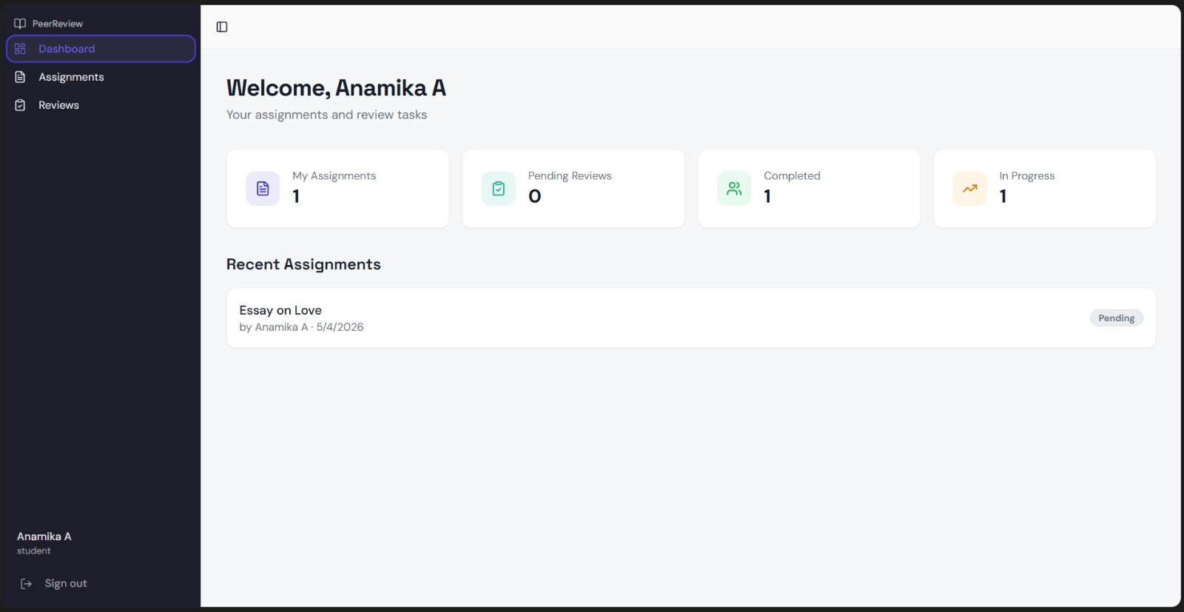
Assignment Module (Student Perspective)
- Students can upload assignments with required details such as title, file URL, and submission date
- Each assignment is automatically assigned to three anonymous reviewers
- The system ensures:
  - No self-review
  - No duplicate reviewer assignment
  - Proper validation of all input fields
- Assignment statuses dynamically update:
  - Pending → Under Review → Completed
This module ensures a smooth and automated submission workflow.
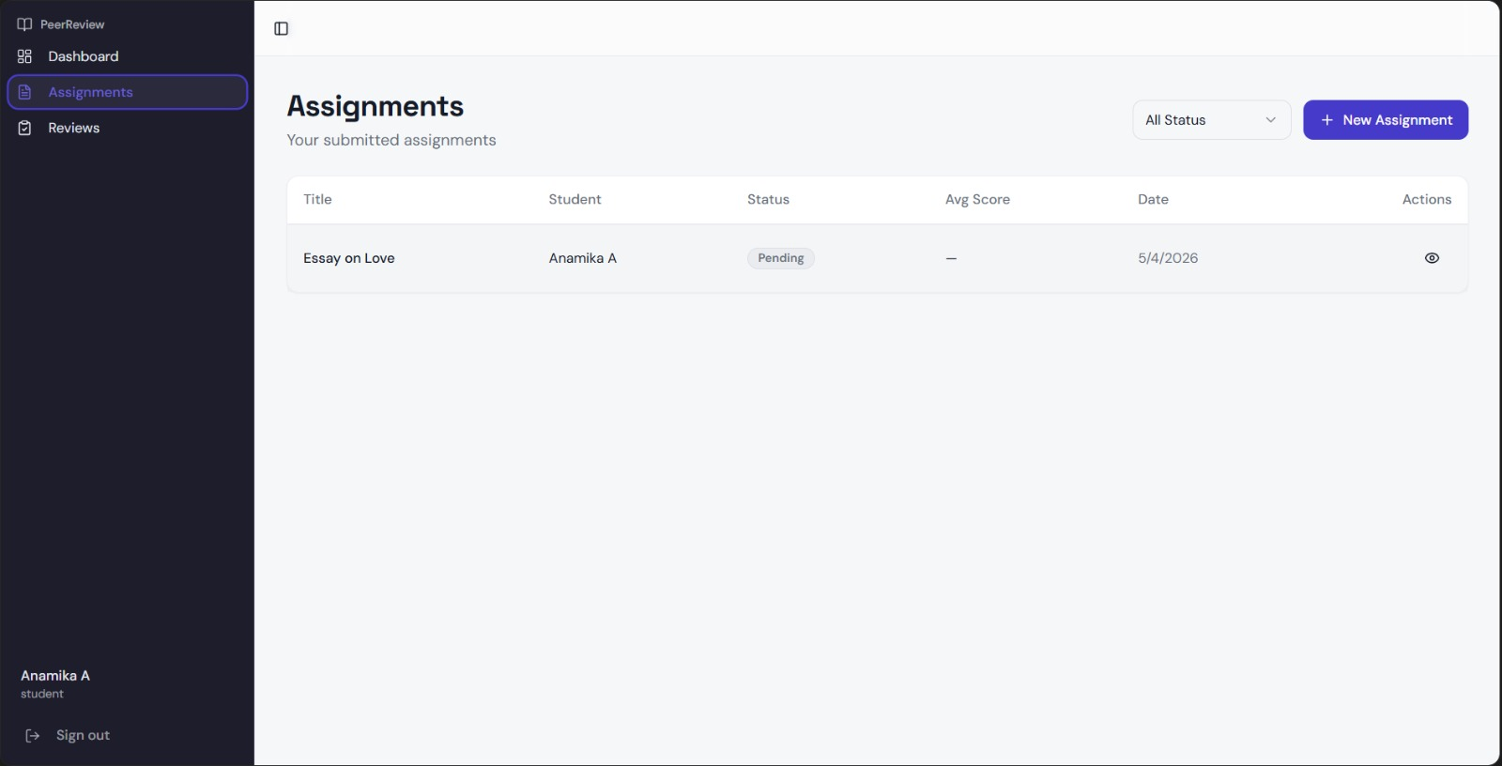
Review Module (Student Perspective)
- Students receive assigned reviews through the dashboard
- Each review includes:
  - Rubric score
  - Optional feedback
- The system enforces:
  - Score validation within allowed limits
  - One review per reviewer per assignment
  - Complete anonymity
- Students can also view feedback received after completion
This ensures fairness, accountability, and meaningful peer evaluation.
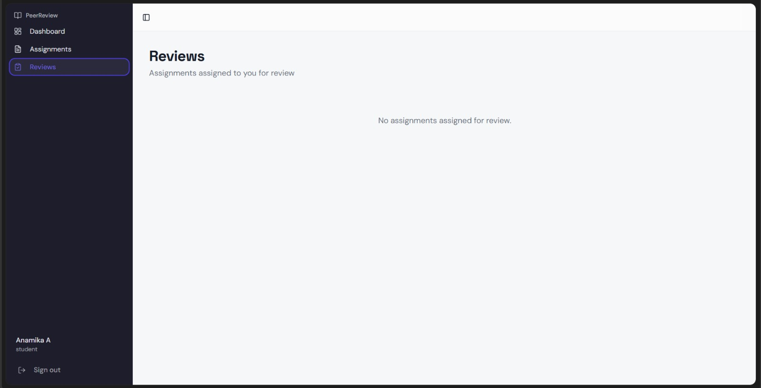
Admin Dashboard (Faculty Perspective)
The admin (faculty) dashboard provides a comprehensive overview of all system activities.
- Faculty can monitor:
  - Total assignments submitted
  - Review progress across all students
  - Completion rates
- The dashboard acts as a control panel to ensure:
  - Proper workflow execution
  - Balanced reviewer distribution
  - Timely completion of reviews
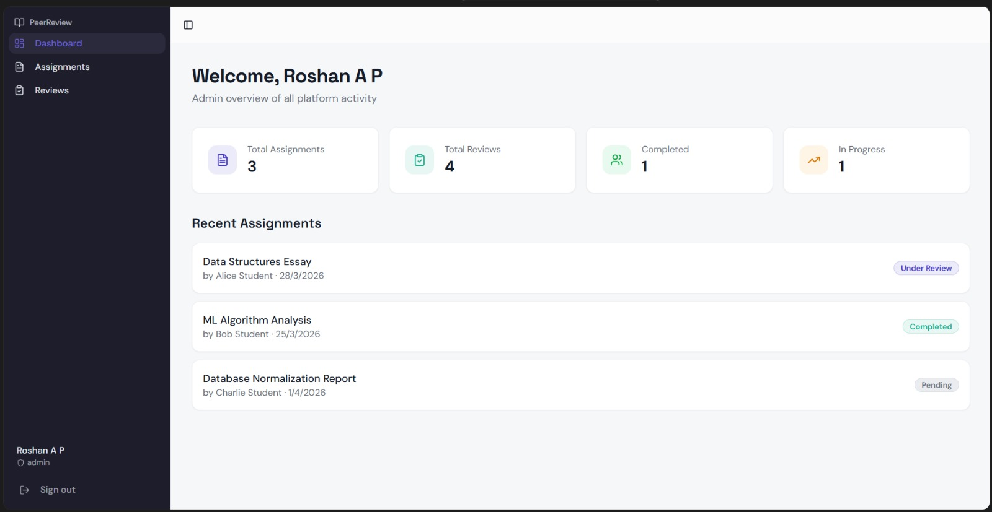
Assignment Monitoring (Admin Perspective)
- Faculty can access all assignments submitted by students
- The system ensures:
  - Each assignment has exactly three reviewers
  - Reviewer identity remains anonymous
- Admins can:
  - Track assignment status
  - Identify pending or delayed submissions
  - Ensure fairness in evaluation
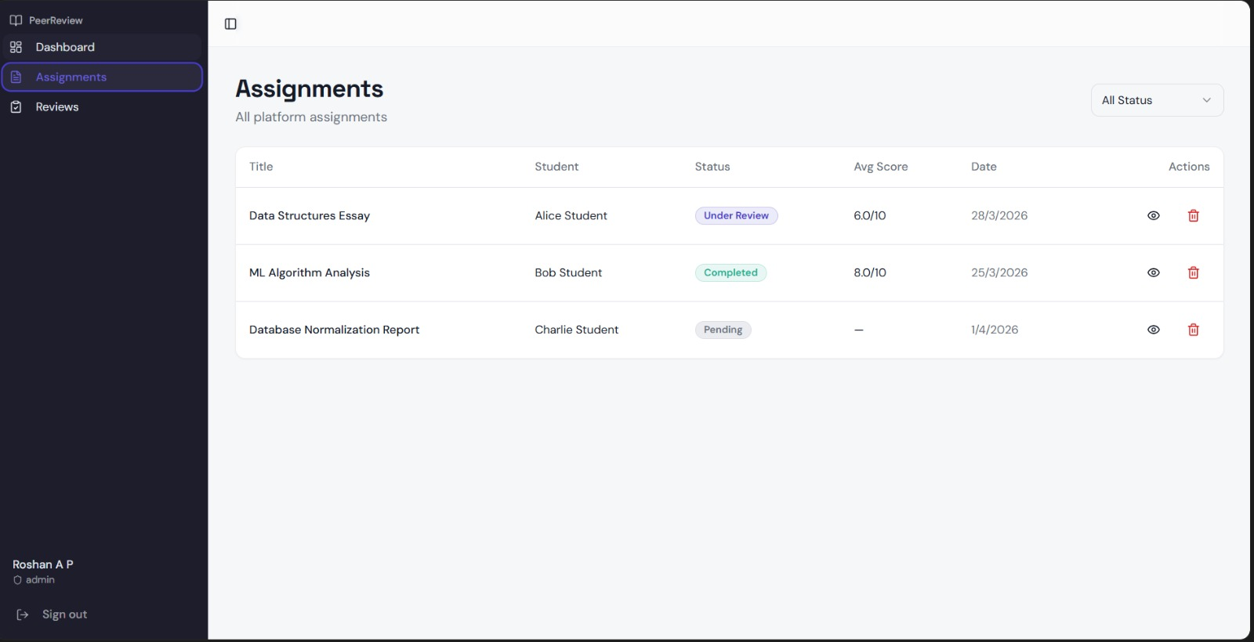
Review Monitoring (Admin Perspective)
- Admins can view all submitted reviews including:
  - Rubric scores
  - Feedback
  - Review timestamps
- The system allows faculty to:
  - Evaluate review quality
  - Ensure consistency across evaluations
  - Maintain academic integrity
- Anonymity is preserved throughout the process
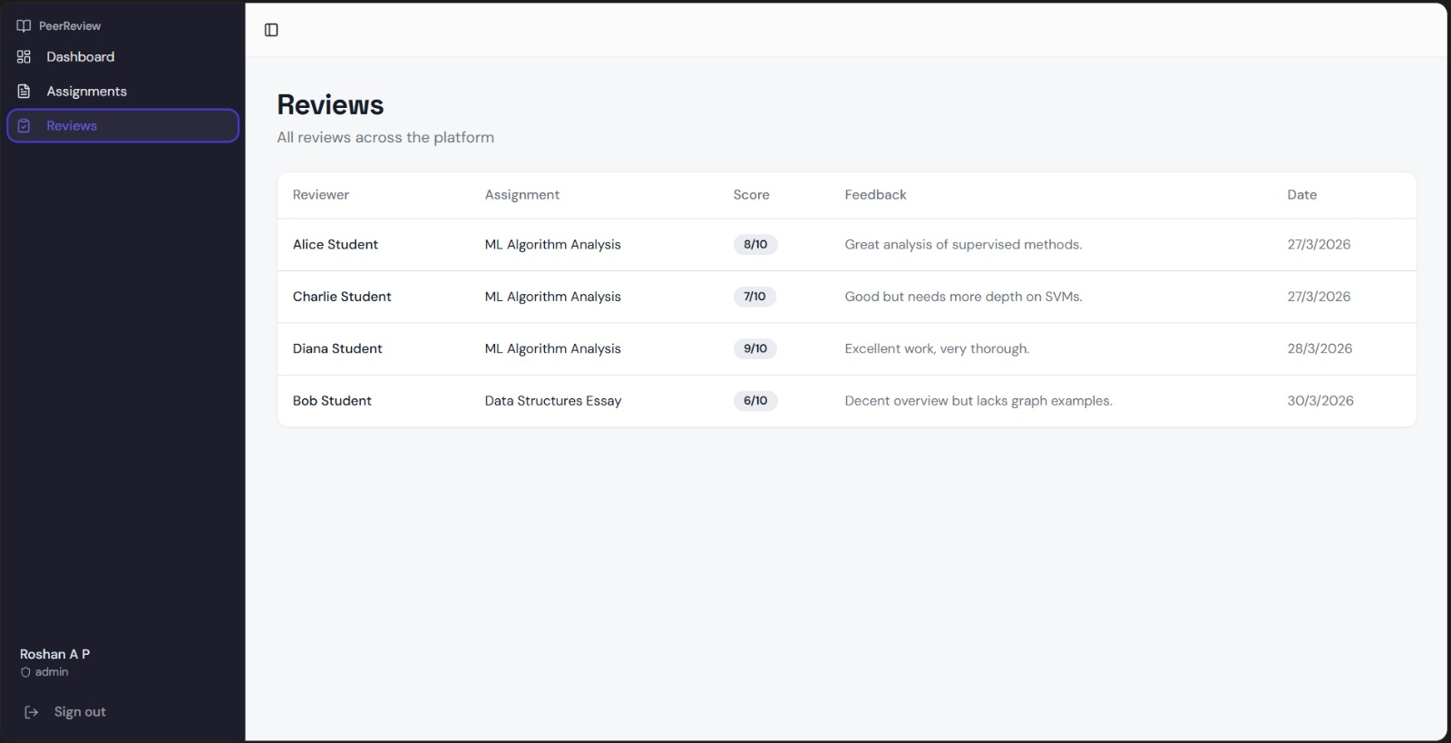
Performance Evaluation
- The system demonstrates:
  - Fast API response times
  - Efficient database operations using MongoDB
  - Smooth UI rendering and transitions
- Features like:
  - Pagination
  - Status filtering
  - Dashboard summaries
enhance scalability and performance.

VII. CONCLUSION
The Collaborative Peer Review Platform successfully automates the process of peer evaluation in an academic setting. By ensuring fair reviewer assignment, structured feedback, and strict validation rules, the system eliminates inefficiencies present in manual review processes.
The use of Node.js, Express.js, and MongoDB enables the development of a scalable and maintainable backend architecture. The system effectively handles assignment submission, reviewer allocation, and review tracking with minimal manual intervention.
Future enhancements may include:
- Integration with a frontend UI
- Role-based authentication (students/admin)
- AI-based reviewer matching
- Analytics dashboard for performance insights
In conclusion, the project provides a robust foundation for building scalable peer review systems and demonstrates the practical application of backend development concepts in solving real-world problems.

