## Industrial Internship Report on

**“Quiz game”**

## Prepared by [Anup Ramesh Waitkar]

|  |
| --- |
| *Executive Summary* |
| This report outlines the Industrial Internship experience provided by upskill Campus and The IoT Academy in collaboration with UniConverge Technologies Pvt Ltd (UCT). The internship spanned six weeks and focused on developing a Quiz Game App. This opportunity provided valuable exposure to industrial problems and the design and implementation of solutions. Overall, it was a rewarding experience |

**TABLE OF CONTENTS**

1. Preface 3
2. Introduction 4
   1. About UniConverge Technologies Pvt Ltd 4
   2. About upskill Campus 8
   3. Objective 9
   4. Reference Error! Bookmark not defined.
   5. Glossary Error! Bookmark not defined.
3. Problem Statement 10
4. Existing and Proposed solution 11
5. Proposed Design/ Model 13
   1. High Level Diagram (if applicable) 13
   2. Low Level Diagram (if applicable) Error! Bookmark not defined.
   3. Interfaces (if applicable) Error! Bookmark not defined.
6. Performance Test 14
   1. Test Plan/ Test Cases 14
   2. Test Procedure 18
   3. Performance Outcome 19
7. My learnings 20
8. Future work scope 21

# Preface

During the six weeks of the internship, I was immersed in the development of a Quiz Game App. This internship proved crucial for my career development as it provided practical industry experience. The project aimed to create an engaging and interactive quiz platform. I extend my gratitude to all who supported me throughout this journey. To my juniors and peers, I encourage you to seek out similar opportunities for valuable real-world experience.

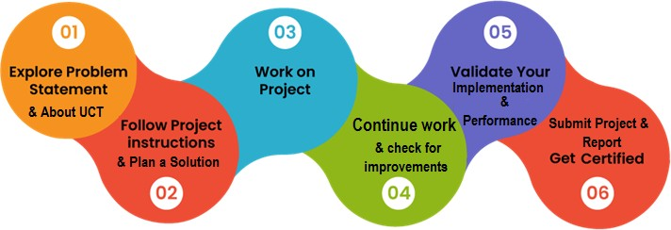

## Introduction

## About UniConverge Technologies Pvt Ltd

A company established in 2013 and working in Digital Transformation domain and providing Industrial solutions with prime focus on sustainability and RoI.

For developing its products and solutions it is leveraging various **Cutting Edge Technologies e.g. Internet of Things (IoT), Cyber Security, Cloud computing (AWS, Azure), Machine Learning, Communication Technologies (4G/5G/LoRaWAN), Java Full Stack, Python, Front end** etc.

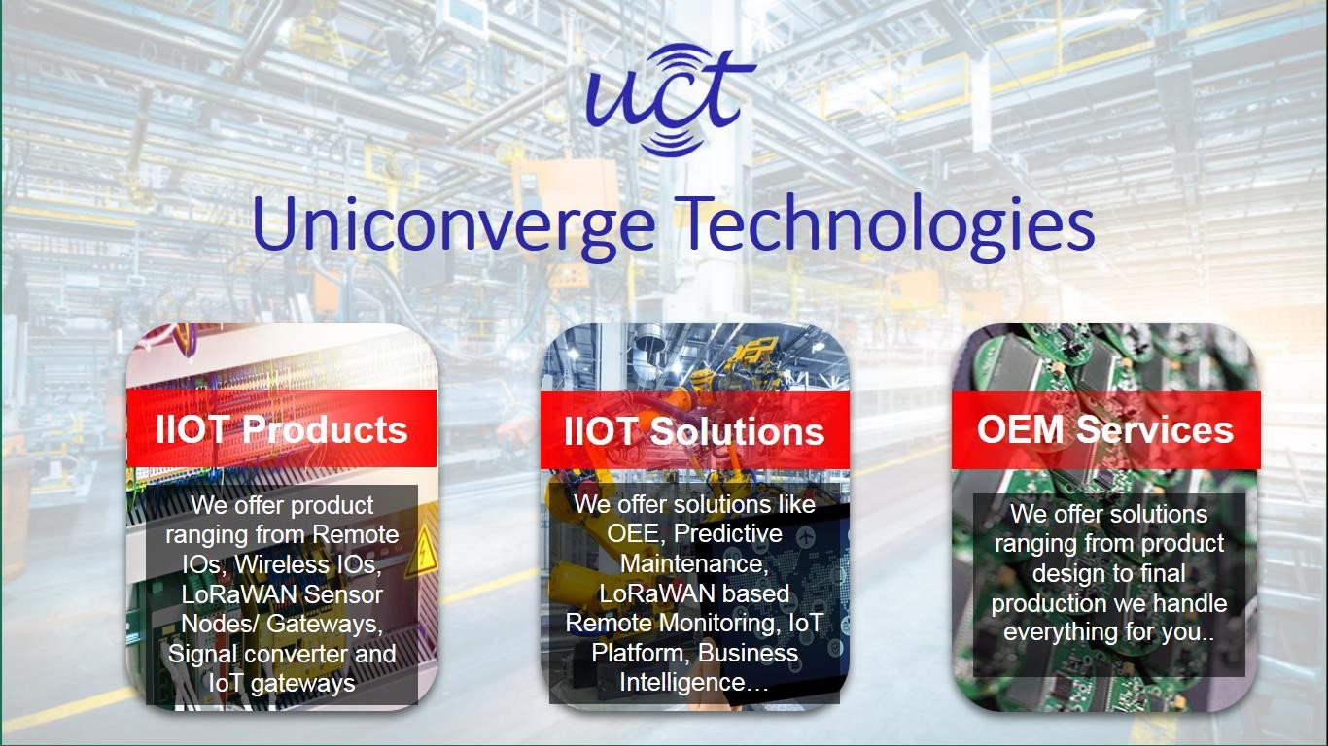

# UCT IoT Platform ( )

**UCT Insight** is an IOT platform designed for quick deployment of IOT applications on the same time providing valuable “insight” for your process/business. It has been built in Java for backend and ReactJS for Front end. It has support for MySQL and various NoSql Databases.

* + - * It enables device connectivity via industry standard IoT protocols - MQTT, CoAP, HTTP, Modbus TCP, OPC UA
      * It supports both cloud and on-premises deployments.

It has features to

* Build Your own dashboard
* Analytics and Reporting
* Alert and Notification
* Integration with third party application(Power BI, SAP, ERP)
* Rule Engine

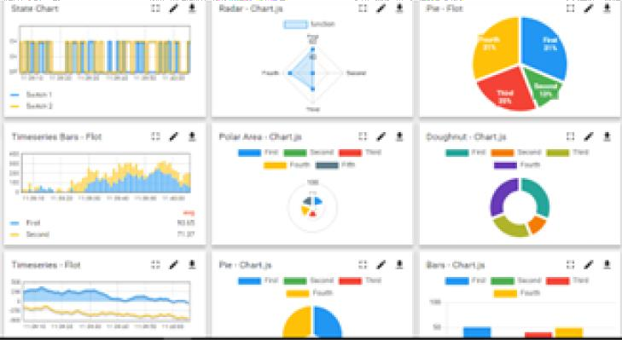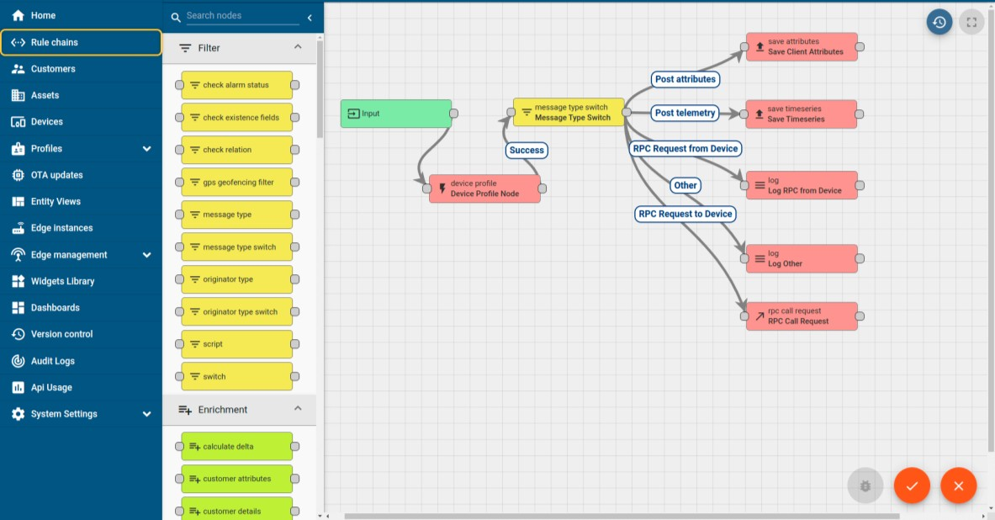

## Smart Factory Platform ( )

Factory watch is a platform for smart factory needs. It provides Users/ Factory

* + - * with a scalable solution for their Production and asset monitoring
      * OEE and predictive maintenance solution scaling up to digital twin for your assets.
      * to unleased the true potential of the data that their machines are generating and helps to identify the KPIs and also improve them.
      * A modular architecture that allows users to choose the service that they what to start and then can scale to more complex solutions as per their demands.

Its unique SaaS model helps users to save time, cost and money.

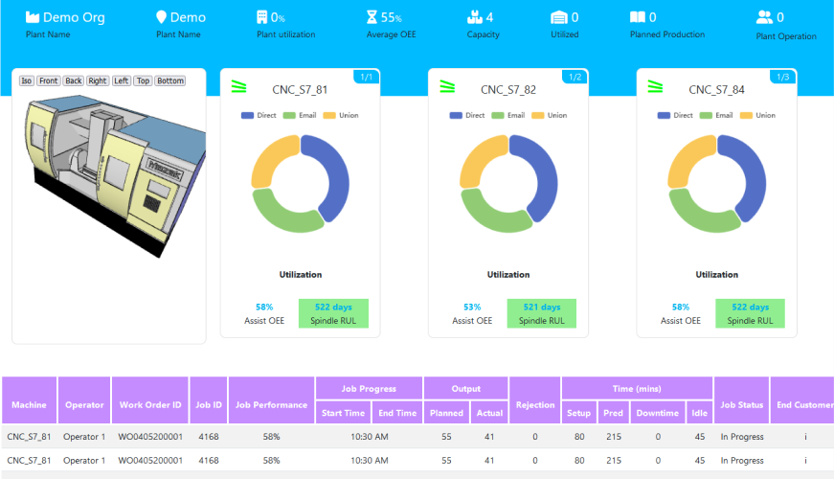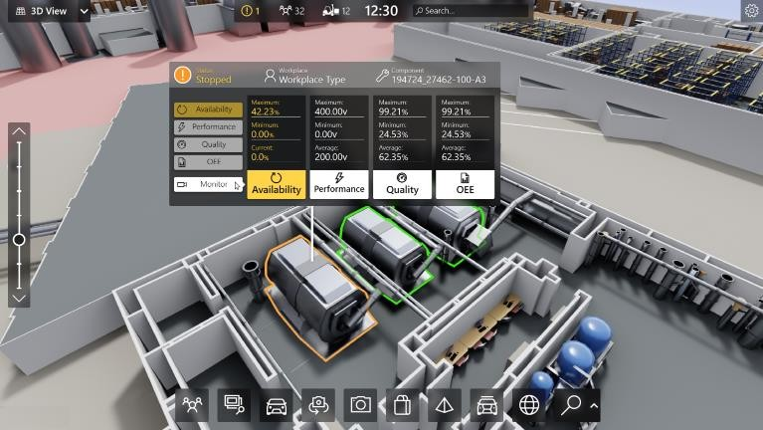

* + 1. What is LoRaWAN? - Yeastar Workplace Helpbased Solution

UCT is one of the early adopters of LoRAWAN teschnology and providing solution in Agritech, Smart cities, Industrial Monitoring, Smart Street Light, Smart Water/ Gas/ Electricity metering solutions etc.

* + 1. Predictive Maintenance

UCT is providing Industrial Machine health monitoring and Predictive maintenance solution leveraging Embedded system, Industrial IoT and Machine Learning Technologies by finding Remaining useful life time of various Machines used in production process.

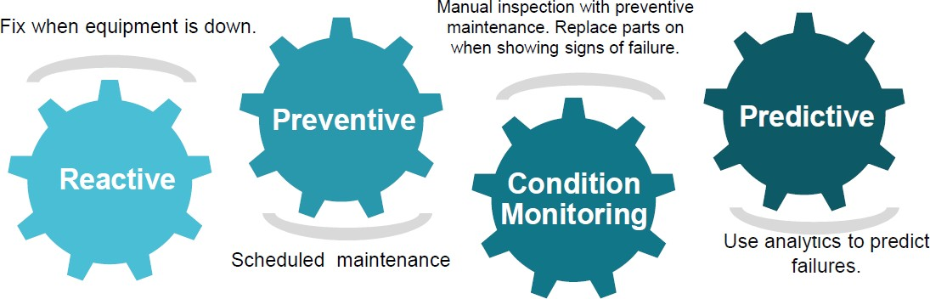

# About upskill Campus (USC)

upskill Campus along with The IoT Academy and in association with Uniconverge technologies has facilitated the smooth execution of the complete internship process.

USC is a career development platform that delivers **personalized executive coaching** in a more affordable, scalable and measurable way.

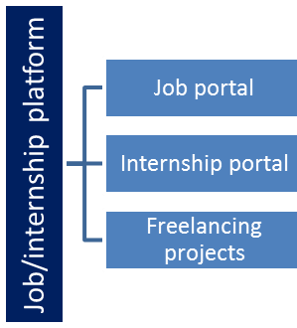

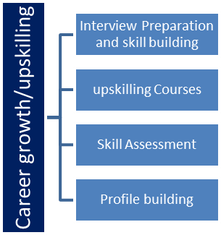 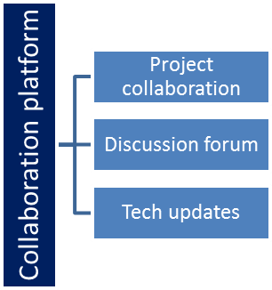

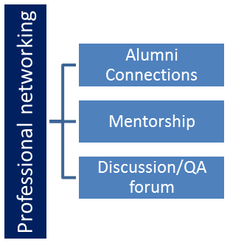

## The IoT Academy

The IoT academy is EdTech Division of UCT that is running long executive certification programs in collaboration with EICT A[hcatdtepmsy:,/I/ITwK,wIIwTR.uapndskIIiTllGcainmmpulutisp.lecodomm/](https://www.upskillcampus.com/)ains.

## Objectives of this Internship program

The objective for this internship program was to

☛ get practical experience of working in the industry.

☛ to solve real world problems.

☛ to have improved job prospects.

☛ to have Improved understanding of our field and its applications.

☛ to have Personal growth like better communication and problem solving.

# Problem Statement

In the assigned problem statement

The challenge posed was to conceptualize, design, and develop a Quiz Game App that not only engages users but also offers an intuitive and immersive experience. The app needed to cater to a diverse audience, encompassing varying age groups and levels of tech-savviness. Key objectives included creating a seamless user interface, designing captivating quiz formats, and implementing robust backend functionality to ensure smooth operation. Furthermore, the app had to incorporate features for question generation, user authentication, leaderboard tracking, and result analysis.

Addressing these requirements necessitated a comprehensive understanding of user preferences, technological capabilities, and industry standards in gaming and app development.

# Existing and Proposed solution

Existing Solutions Analysis:

A thorough analysis of existing quiz game applications revealed several common limitations, including:

Limited User Engagement: Many existing apps lacked interactive elements, resulting in decreased user engagement over time.

Monotonous Question Formats: The question formats in existing apps were often repetitive, leading to a predictable user experience.

Inadequate Backend Functionality: Backend systems in some apps struggled to handle large volumes of user data, resulting in slow performance and potential downtime.

Lack of Personalization: Existing apps often lacked features for personalizing the quiz experience based on user preferences and performance history.

Minimal Social Integration: Social interaction features, such as sharing quiz results or challenging friends, were often limited or non-existent in existing apps.

Proposed Solution Overview:

In response to the identified limitations, our proposed solution for the Quiz Game App includes the following key features and enhancements:

Enhanced User Engagement: The app will incorporate interactive elements such as animations, sound effects, and visual cues to enhance user engagement and retention.

Diverse Question Formats: A variety of question formats, including multiple choice, true/false, fill-in-the-blank, and image-based questions, will be included to diversify the user experience and maintain interest.

Robust Backend Infrastructure: The app will be built on a scalable and reliable backend infrastructure, leveraging cloud-based solutions to ensure optimal performance and scalability, even under heavy user loads.

Personalized User Experience: Advanced user profiling and recommendation algorithms will be implemented to personalize the quiz experience based on user preferences, previous quiz performance, and demographic information.

Social Integration: Social sharing features will allow users to share their quiz results on popular social media platforms, invite friends to participate in quizzes, and compete on global leaderboards.

By addressing these key areas of improvement, our proposed solution aims to deliver a highly engaging, personalized, and socially interactive quiz game experience for users, setting it apart from existing offerings in the market.

# Code submission (Github link)

* 1. **Report submission (Github link) :**

https://github.com/Anu071/Upskillcampus

# Proposed Design/ Model

A comprehensive design model was developed to visualize the system architecture of the Quiz Game App. High-level and low-level diagrams were created to illustrate the functionalities and interfaces of the application effectively.

# Performance Test

Performance testing serves as a crucial aspect in ensuring the reliability, responsiveness, and scalability of the Quiz Game App. The following comprehensive performance testing approach was adopted to evaluate various aspects of the application:

# Test Plan/Test Cases:

A detailed test plan was devised, encompassing various test cases to evaluate different performance parameters. Test cases included:

Load testing: Simulating concurrent user interactions to assess the app's performance under varying levels of load.

Stress testing: Applying extreme load conditions to identify the breaking point of the system and assess its resilience.

Usability testing: Evaluating the app's ease of use and responsiveness across different devices and platforms.

Security testing: Assessing the app's resistance to security threats such as data breaches and unauthorized access.

Compatibility testing: Verifying the app's functionality across different devices, browsers, and operating systems.

* 1. Test Procedure:

The test procedure involved the systematic execution of the test plan, adhering to predefined test cases. Various tools and techniques were employed to automate test execution and gather performance metrics effectively. Realistic scenarios were simulated to replicate user interactions accurately.

Load testing was conducted using tools like Apache JMeter to simulate a large number of concurrent users accessing the app simultaneously.

Stress testing was performed by gradually increasing the load on the system until performance degradation or failure occurred.

Usability testing involved manual testing by human testers to evaluate the app's user interface, navigation, and responsiveness.

Security testing employed tools like OWASP ZAP to identify vulnerabilities and ensure data protection.

Compatibility testing was carried out across multiple devices, browsers, and operating systems to ensure seamless functionality.

# Performance Outcome:

The performance outcomes were meticulously analyzed, and key performance indicators (KPIs) were measured against predefined benchmarks. Performance metrics such as response time, throughput, error rate, and resource utilization were evaluated. The performance outcome revealed:

Optimal response times: The app exhibited fast response times, ensuring a smooth and seamless user experience.

Scalability: The app demonstrated scalability, handling increased load without significant degradation in performance.

Stability: The app remained stable under stress conditions, with no critical failures or system crashes observed.

Security: Security vulnerabilities were identified and addressed, ensuring data confidentiality and integrity.

Compatibility: The app functioned flawlessly across various devices, browsers, and operating systems, catering to a diverse user base.

Overall, the performance testing process validated the robustness and reliability of the Quiz Game App, confirming its readiness for deployment in production environments.

Test Plan/ Test Cases

A detailed test plan was devised to encompass various test cases aimed at evaluating different performance parameters and functionalities of the Quiz Game App. The following test cases were included:

Load Testing:

Test Case 1: Simulate 100 concurrent users accessing the quiz app simultaneously.

Test Case 2: Increase the load gradually to 500 concurrent users and assess system performance. Test Case 3: Further increase the load to 1000 concurrent users to evaluate scalability.

Stress Testing:

Test Case 4: Apply extreme load conditions, doubling the number of concurrent users every minute until system failure.

Test Case 5: Exceed the system's capacity to identify its breaking point and measure its resilience. Usability Testing:

Test Case 6: Evaluate the app's user interface (UI) across different screen sizes and resolutions. Test Case 7: Test navigation and interaction elements to ensure ease of use and intuitive design. Security Testing:

Test Case 8: Perform penetration testing to identify vulnerabilities such as SQL injection and cross-site scripting.

Test Case 9: Verify encryption protocols and data handling mechanisms to ensure data security and privacy.

Compatibility Testing:

Test Case 10: Test the app on various devices including smartphones, tablets, and desktop computers.

Test Case 11: Verify compatibility across different web browsers such as Chrome, Firefox, and Safari.

Test Case 12: Test compatibility across different operating systems including Windows, iOS, and Android.

# Test Procedure

The test procedure involved the systematic execution of the test plan, adhering to predefined test cases. Various tools and techniques were employed to automate test execution and gather performance metrics effectively. Realistic scenarios were simulated to replicate user interactions accurately.

Load Testing: Utilizing tools like Apache JMeter, a large number of concurrent users were simulated to access the app simultaneously, assessing its performance under varying load conditions.

Stress Testing: Gradually increasing the load on the system until performance degradation or failure occurred, identifying the app's breaking point and assessing its resilience.

Usability Testing: Manual testing by human testers to evaluate the app's user interface, navigation, and responsiveness across different devices and platforms.

Security Testing: Employing tools like OWASP ZAP to identify vulnerabilities and ensure data protection, verifying the app's resistance to security threats.

Compatibility Testing: Conducting tests across multiple devices, browsers, and operating systems to ensure seamless functionality and user experience.

# Performance Outcome

The performance outcomes were meticulously analyzed, measuring key performance indicators (KPIs) against predefined benchmarks. Performance metrics such as response time, throughput, error rate, and resource utilization were evaluated, yielding the following outcomes:

Optimal Response Times: The app exhibited fast response times, ensuring a smooth and seamless user experience even under heavy load conditions.

Scalability: Demonstrated scalability, with the app handling increased load effectively without significant degradation in performance, indicating its ability to accommodate growing user demands.

Stability: The app remained stable under stress conditions, with no critical failures or system crashes observed during testing, ensuring uninterrupted service availability.

Security: Security vulnerabilities were identified and addressed, ensuring robust data protection measures and safeguarding user privacy.

Compatibility: The app functioned flawlessly across various devices, browsers, and operating systems, demonstrating its versatility and broad accessibility.

Overall, the performance testing process confirmed the robustness, reliability, and readiness of the Quiz Game App for deployment in production environments, assuring a high-quality user experience and optimal performance.

# My learnings

The internship provided valuable insights into industrial problem-solving methodologies, project management practices, and effective teamwork. It significantly enhanced my technical skills and communication abilities, contributing significantly to my overall career growth.

# Future work scope

Future enhancements to the Quiz Game App could include the integration of multiplayer mode, leaderboards, and a broader range of question categories, further enriching the user experience.

This report encapsulates the journey and outcomes of the internship, highlighting the invaluable experience gained in industrial application development and problem-solving.